**EEE206 - PROGRAMMING**

**PROJECT 2 REPORT**

**GROUP 1**

**Voting System**

*Submitted by:*

Kaan Kılıçsaymaz (EEE)

Özge Zeynep Yılmaz (EEE)

Rumeysa Türkmen (EEE)

Project Mentor:

Dr. Doğan Çörüş

Kadir Has University

Faculty of Engineering and Natural Sciences

Spring 2022

**TABLE OF CONTENTS**

|  |  |
| --- | --- |
| 1  INTRODUCTION …………………………………………………………………….. | 3 |
| 1.1 Project Description ………………………………………………………………… | 3 |
| 1.1.1 Level 1 ………………………………………………………………………... | 3 |
| 1.1.2 Level 2 ………………………………………………………………………... | 3 |
| 2  PROGRAMMING  ……………………………………………………………………. | 4 |
| 2.1 Level 1 ……..……………………………………………………………………… | 4 |
| 2.2 Level 2 ……...……………………………………………………………………... | 7 |
| 3  CONCLUSION  ..…………………………………………………………………….... | 11 |
| REFERENCES ………………………………………………………………………... | 12 |

# 1 INTRODUCTION

Thanks to the developing technology, coding is now inevitable for us and helps to make our lives easier. Thanks to coding, even a simple “hello world” can be written, while even mathematical operations can be performed. At the same time, as in this project, coding also occurs when a vote is to be held on a specific issue.

**1.1 Project Description**

In this project, we will write a voting program based on yes, no or abstention options. We will create it by performing tasks of different levels.

**1.1.1 Level 1**

For the first level, we will create different usernames and passwords that each user will enter. For this purpose, we will use different techniques that we will explain in more detail in the following sections. The user will be able to log in to the system by writing their username and password, and according to him, they will be able to use the vote, which consists only of yes or no options. When all users enter their votes, the program we wrote will be able to show the voting result as soon as the voting ends, while the user will not be able to change the vote they entered.

**1.1.2 Level 2**

In the last step, level 2, we will go through level 1, which we have already prepared. In this step, except for the yes or no options, the user will now be able to indicate that they are abstaining. In addition, the user will be able to change their username and password. If the program ends before the end of the voting process, the user should be able to see the final status of the vote when we retest the program.

# 2 PROGRAMMING

**2.1 Level 1**

We explained how level 1 will be in the previous section. We have defined libraries as the first step of our code. Then we used an array of 3 characters using the char data type. We declared the password entry and created a variable indicating the number of yes and no before the voting began. Additionally, we have defined a vote counter. For each vote used, we set it to 1 as the counter will increase by 1. Since the number of votes was 0 before the voting began, we equated them to zero.

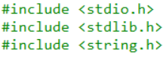

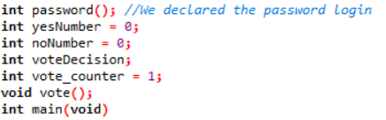

Then we created a for loop so that we could run the voting over and over again. Accordingly, our variable, our votes will start from zero and continue until 3, increasing one by one.

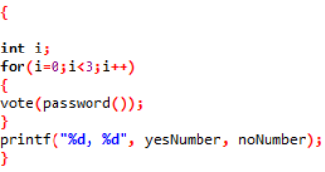

Since we declared the password at the very beginning of the code, we are now defining the password entry. Then we created our usernames for each user using the char type again. Since our usernames consist of 11 characters, we have written 11 in parentheses and created our usernames. In this step, we used our school numbers as our usernames. Then we created a string to store the usernames that we will receive from the user. We did the same for passwords. First, we set a four-digit password using the char type. Then we created a string to store the passwords that we will receive from the user.

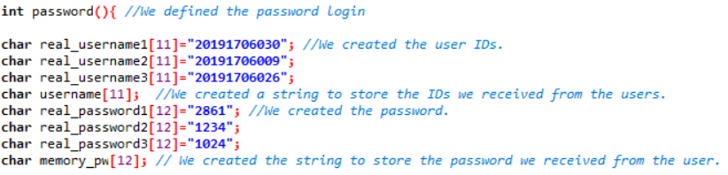

We have created variables for the username and password of each user. Then we used the strcmp string function to test whether the username and password were correct. Then, using if-else, we specified 6 different results as if the input was approved if the variables we specified were equal to zero. If it is not equal to zero, then we used a “printf” that will show on the screen that the username or password is incorrect. We have ensured that the user is redirected back to interface in case of an error.

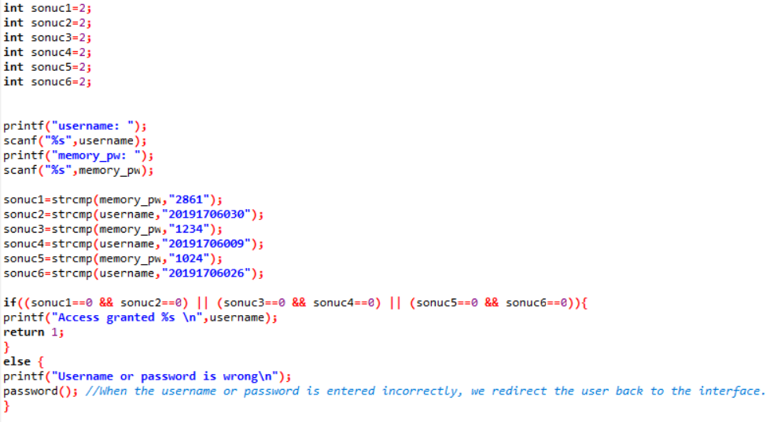

Finally, we have started the voting. We asked the user a question about whether they were happy and got the feedback from there. We proceeded through the fact that the vote used was yes, and we used strcmp again. If the vote used is yes, the number of yesNumber will increase by one, if no, the number of noNumber will increase by one, and the voting will end.

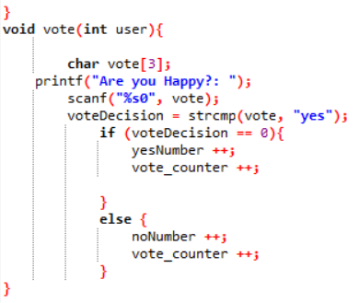

**2.2 Level 2**

We explained the basic stages of Level 2 in the introduction section. As the first step of our code, we defined the libraries. Then we created a struct named student and using the char data type in it, we created number for student ID, password for password, and answer to answer the vote. We defined a 50-character field for the data types we created.

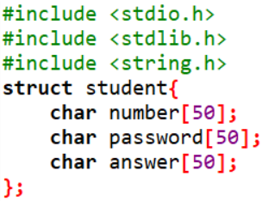

In our main function, we used the FILE *fp, *fp2 pointers to define our file. Then, using the fp = fopen("file.txt","r") command, we open the file where we store our master data and we can read it. Using the command fp2 = fopen("file2.txt","w") we create a file where we write the new data. Then we defined the student type array consisting of 3 students. Then we created a for loop where 3 users can login, and inside this for loop, we put the fscanf(fp,"%s %s %s",&s[i].number,&s[i].password,&s[i].answer) command we defined. At this stage, we are reading the fp, that is, the data in our first file, together with fscanf. With the command "%s %s %s",&s[i].number,&s[i].password,&s[i].answer, for example, we define the number, password and answer of the 1st student, that is, we write the data we read from the file here. Then we close the pointer with the fclose(fp) command.

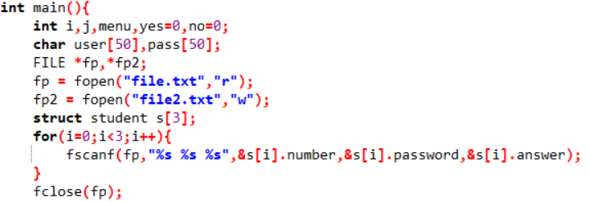

In this part, first, inside a while loop, printf("1.Vote\n2.Change Vote\n3.Change Password\n4.Exit\nSelect Menu[1/2/3/4]: ");scanf("%d By entering the command ",&menu), we create an interface for our voting system.

In the first case of the interface, we check whether the username exists by using the strcmp command to log in. If username is not registered, we say the username not found. If the username is registered, we make people vote. However, if the registered person has already voted, we redirect the user to the interface by saying you have already answered. To do this, we use the command if(strcmp("-",s[i].answer)==0). If the answer is not "-", we understand that the user has voted.

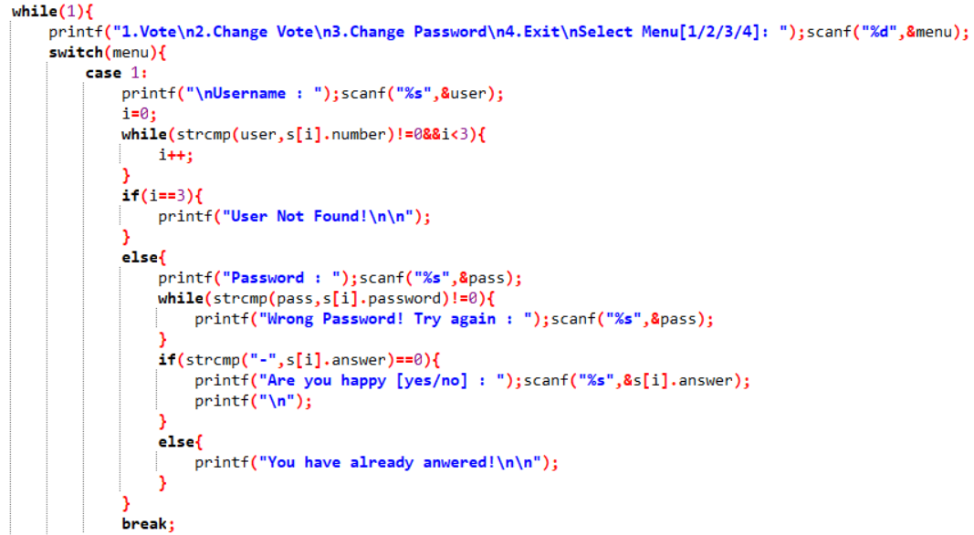

In case 2, we perform the same steps as in case 1 in order to change votes. However, as a difference, in case 2, if a person who has not voted before wants to change the game, we ask the question “Are you happy?” by saying you are voting first time. To do this, we use the command if(strcmp("-",s[j].answer)==0). If the answer is "-", we understand that the user has not voted before.

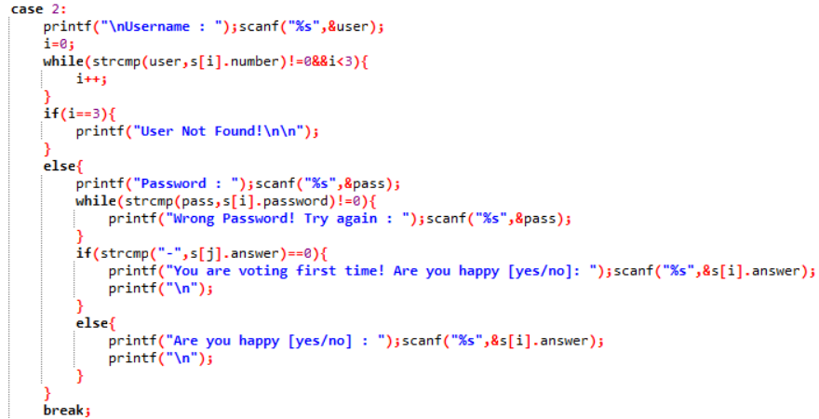

In order to change the password in Case 3, we perform the steps in case 1 and case 2 in the same way. The only difference is that the variables we change change. For example, instead of scanf("%s",&s[i].answer) command, we use scanf("%s",&s[i].password) command, that is, we write password instead of answer in the section inside the command.

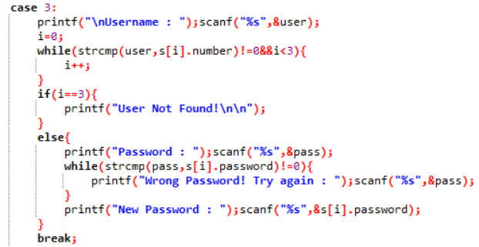

In Case 4, by using the if(strcmp("yes",s[i].answer)==0){ yes++; } and, else if(strcmp("no",s[i].answer)==0){ no++} commands, we can count the yes and no votes.

Then, using the fprintf command, we write the new information in the same format as the file to the file2 we created with the fp2 = fopen("file2.txt","w") command and close it with the fclose(fp2) command. Next, we delete the file and rename file2 to file. To do this, we use the remove("file.txt") and rename("file2.txt","file.txt") commands. Then we exit to see the numbers of yes and no votes. In addition, we use the printf("\n\nYes:%d\nNo:%d",yes,no) command to display the vote numbers on the screen.

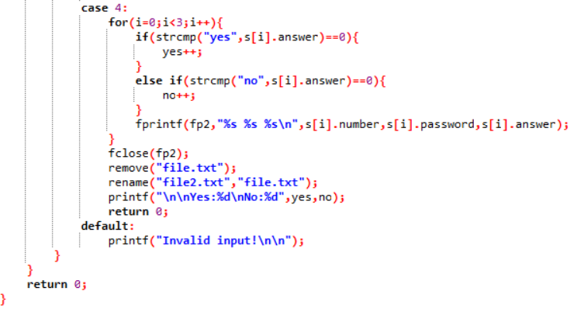

# 

# 3 CONCLUSION

Although we received setbacks for the first level of the project, we fixed them for the second level. The user will be able to vote yes, no or abstain and change their username and password. Our system will be able to count the votes used, store them, and finally show you how many votes were cast from which option. So we will have a voting system.

# 

# REFERENCES

[1] Seacord, R. (2020). Effective C: An Introduction to Professional C Programming. San Francisco: No Starch Press, Inc.