Testing with

Testing with Ensemble Algorithms

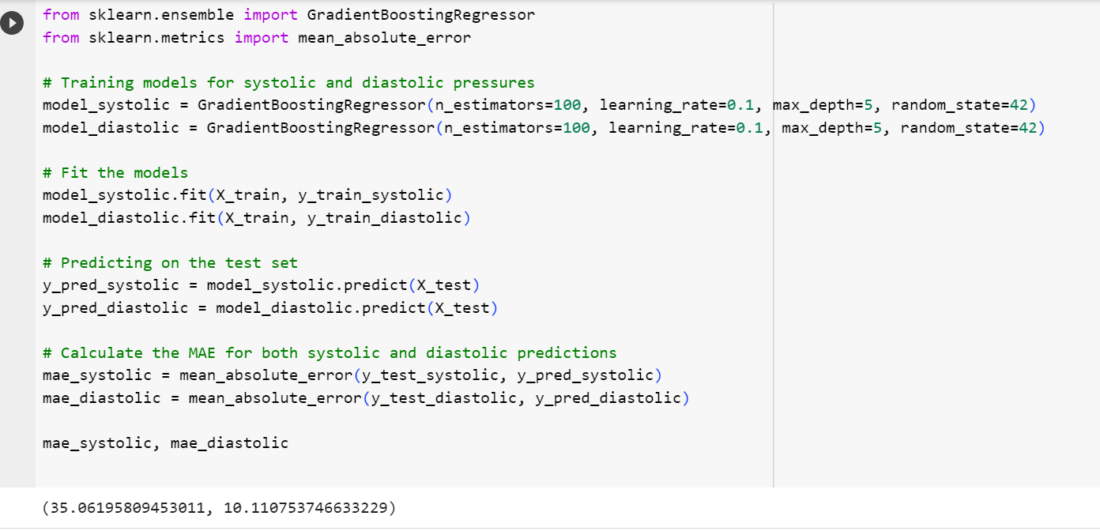

Testing with simple neural networks

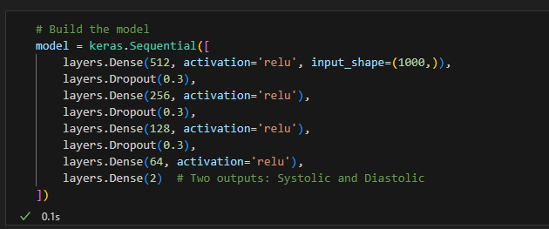

The output is

Test MAE for Systolic BP: 44.26901359863281

Test MAE for Diastolic BP: 10.206892533874512

What is the reason for it performs better than ?

Table

No improvement in NN

If tuning hyperparameters and altering the architecture didn't significantly improve the performance of your neural network model, there could be several reasons for this. Here are some possibilities:

**Data Issues**

1. **Quality of Data**: If the data is noisy or contains many outliers, even a well-tuned model might perform poorly.
2. **Insufficient Features**: The sensor data might not contain enough information to predict Systolic and Diastolic blood pressure accurately.
3. **Imbalanced Data**: If the data is skewed towards specific values of Systolic or Diastolic blood pressure, the model may have trouble generalizing.

**Model Complexity**

1. **Underfitting**: If the model is too simple, it may not capture the underlying patterns in the data.
2. **Overfitting**: On the flip side, if the model is too complex, it may perform well on the training data but poorly on unseen data.

**Evaluation Metrics**

1. **Local Optima**: The optimization algorithm might get stuck in a local minimum rather than finding the global minimum.

**Architectural Issues**

1. **Non-Linearity**: If the relationship between the sensor data and blood pressure is non-linear and complex, a simple feedforward network might not suffice.
2. **Sequence Patterns**: If the sequence of the sensor data plays a crucial role in predicting S and D, then using LSTM or other sequence models may be more appropriate.

**Other Factors**

1. **Random Initialization**: Neural networks are initialized with random weights, and sometimes different initializations can lead to different results.
2. **Learning Rate**: A learning rate that's too high can cause the model to oscillate, while a learning rate that's too low may make the model too slow to learn.

You might want to consider these aspects and iteratively refine the model. Also, if the initial model performance is very poor, incremental improvements through hyperparameter tuning may not be sufficient; a different architecture or approach might be required.

Top of Form