## **Data Wrangling**

The first step is data wrangling. As mentioned, this is synthetic data. Mostly data is clean. And there are no outliers present. I check all the steps of data wrangling. This is time series data and regression problem.

Here is the code for data wrangling.

<https://github.com/rumman-adnan/Assignment-Sensors-Data/blob/main/Assignment(sensors)/EDA.ipynb>

The data is converted into csv data for better analysis

## **Training Supervised Machine Learning Algorithms**

Different machine learning algorithm is tested and here is the summary.

|  |  |  |
| --- | --- | --- |
| **Algorithm** | **Mean Absolute Error for Systolic BP** | **Mean Absolute Error for Diastolic BP** |
| Ridge Regression | 44.536 | 10.205 |
| Linear Regression | 25.27 | 83.8463 |
| SVR | 36.243 | 10.2026 |
| SVR (after scaling data) | 24.58 | 48.70 |

Here is the code. <https://github.com/rumman-adnan/Assignment-Sensors-Data/blob/main/Assignment(sensors)/supervised_ML.ipynb>

## **Training Ensemble Algorithm and Neural Network**

Ensemble algorithm performs well on time series data. Here is the result after training algorithm

|  |  |  |
| --- | --- | --- |
| **Algorithm** | **Mean Absolute Error for Systolic BP** | **Mean Absolute Error for Diastolic BP** |
| Ensemble Algorithm | 35.0619 | 10.11075 |
| Neural Network | 44.269 | 10.206 |
| Neural Network (tunning parameters) | 44.497 | 10.202 |

Code for Ensemble Algorithm

<https://github.com/rumman-adnan/Assignment-Sensors-Data/blob/main/EnsembleAlgorithm.ipynb>

File for Neural Network algorithms

<https://github.com/rumman-adnan/Assignment-Sensors-Data/blob/main/Assignment(sensors)/tensorflow_nn.ipynb>

**Some Code Snippets**

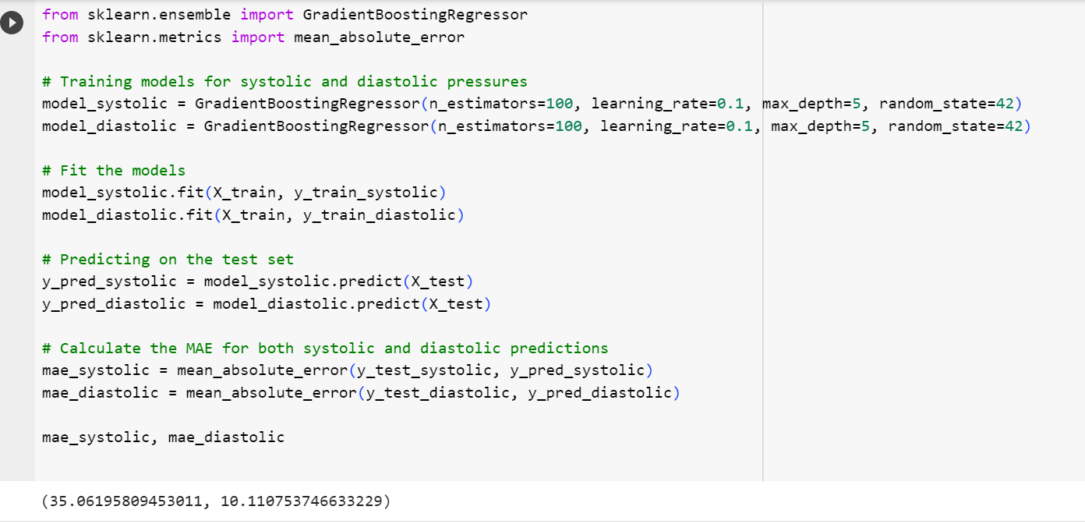

**Neural Network**

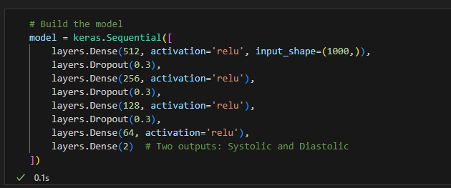

Test MAE for Systolic BP: 44.26901359863281, Test MAE for Diastolic BP: 10.206892533874512

### **Deep Learning Algorithms**

Now we train advanced deep learning algorithms. Here are the results attached.

**CNN**

Now I started testing Deep learning algorithms. Mostly they train on GPU. The link of google colab code file is uploaded on GitHub and attached below.

MAE was achieved with CNN algorithm.

|  |  |  |
| --- | --- | --- |
| **Algorithm** | **Mean Absolute Error for Systolic BP** | **Mean Absolute Error for Diastolic BP** |
| CNN (Base model) | 159.4602992392715 | 79.91103181238296 |
| After fine tunning |  |  |
| CNN (10 epochs) | 45.12046623 | 10.34711438 |
| CNN (40 epochs) | 45.96306772 | 10.21365163 |
| CNN (50 epochs) | 46.15780802 | 10.2061519 |
|  |  |  |

This is the CNN algorithm results tested on google colab

<https://github.com/rumman-adnan/Assignment-Sensors-Data/blob/main/sensors_data_analytics_cnn_f.ipynb>

**LSTM Model**

|  |  |  |
| --- | --- | --- |
| **Algorithm** | **Mean Absolute Error for Systolic BP** | **Mean Absolute Error for Diastolic BP** |
| LSTM | 351 | 938 |
| LSTM (10 epochs) | 45.6076 | 10.2580 |
| LSTM (50 epochs) | 44.4879 | 10.2097 |

The link of google colab file is uploaded on GitHub and attached below.

<https://github.com/rumman-adnan/Assignment-Sensors-Data/blob/main/sensors_data_analytics_LSTM_f.ipynb>

Both LSTM (Long Short-Term Memory) and CNN (Convolutional Neural Network) are powerful neural network architectures, but they are optimized for different types of data and tasks. LSTM designed for sequential data. It can remember patterns over long sequences. Primarily designed for grid-like data such as images. CNNs can identify hierarchical patterns using convolution layers.

LSTMs are inherently designed for such tasks, It can capture short term and long term patterns in the data which allow them to remember or forget information selectively so LSTM performance is somewhat better than CNN.

**Advance DL Algorithms**

A lot of deep learning algorithms are tried, the results of some algorithms are in this file. Including inception time

<https://github.com/rumman-adnan/Assignment-Sensors-Data/blob/main/AdvanceDL.ipynb>

**TCN Algorithm**

|  |  |  |
| --- | --- | --- |
| **Algorithm** | **Mean Absolute Error for Systolic BP** | **Mean Absolute Error for Diastolic BP** |
| TCN (50 epochs, Shuffle=ON) | 21.79 | 9.79 |
| TCN (80 epochs, Shuffle=Off) | 25.8 | 12.01 |
| TabTransformer Model | 50 | 11.17 |
| Inception time Model | 61 | 13 |

Both Temporal Convolutional Networks (TCN) and Fully Convolutional Networks (FCN) are types of neural network architectures used for sequence modeling tasks, but they have different design principles and use-cases. **TCN** usually employs dilated convolutions to capture long-range dependencies without increasing the number of parameters or computation. **FCNs** generally have a simpler architecture consisting of a stack of convolutional layers followed by a global pooling layer.

**FCN Algorithms**

|  |  |  |
| --- | --- | --- |
| **Algorithm** | **Mean Absolute Error for Systolic BP** | **Mean Absolute Error for Diastolic BP** |
| FCN (50 epochs) | 21.79 | 9.79 |
| FCN (80 epochs) | 25.8 | 12.01 |
| FCN Plus (50 epochs) | 8.913 | 5.0389 |
| FCN Plus (80 epochs) | 4.393 | 4.3867 |

Final TCN, FCN and FCN_plus algorithms are trained in this document. Different scaling methods are tried with different algorithms and a lot of hyperparameters are tuned in all the algorithms to get the best results.

<https://github.com/rumman-adnan/Assignment-Sensors-Data/blob/main/Advance_DL3.ipynb>

Testing file

<https://github.com/rumman-adnan/Assignment-Sensors-Data/blob/main/FCN_FCN_PLUS_testing.ipynb>

**Results:**

**Systolic BP**

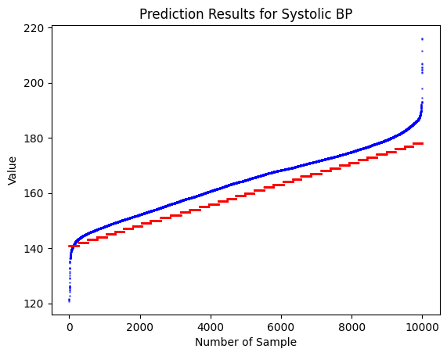

**Diastolic Blood Pressure**

**Conclusion:**

The choice of architecture is problem specific. FCN-Plus is an extended version of the Fully Convolutional Network (FCN) that typically includes additional features like attention mechanisms or other sophisticated layers to improve performance. FCN plus have more complex layers and mechanism, such as attention layers, to better capture the important features in the sequence.

The added complexity could help the model learn to better capture dependencies in the sequence, making it more suited for tasks like time-series forecasting. The extra layers in FCN-Plus could be more effective in extracting useful features from your specific dataset, thereby improving the model's performance.