Data Science Lab Report
Title: Breast Cancer Diagnosis Using Logistic Regression
Dataset: Breast Cancer Wisconsin Diagnostic Dataset
Student: Rumman Islam
Tool: Python 3 · Pandas · Scikit-learn · Seaborn · Matplotlib · Jupyter
Date: September 2026
1. Problem Statement
Breast cancer is one of the most prevalent and life-threatening cancers worldwide. Early and accurate detection significantly improves patient survival rates. Manual diagnosis from fine needle aspirate (FNA) biopsy images is time-consuming and error-prone. This study aims to build a Logistic Regression classification model to predict whether a tumor is Malignant (M) or Benign (B) based on measurable cell nucleus features extracted from FNA images — enabling automated, reliable diagnostic support.
Research Question: Can Logistic Regression classify breast tumor malignancy with high accuracy and precision using cell nucleus measurements?
2. Data Source
Item | Details
Dataset Name | Breast Cancer Wisconsin Diagnostic Dataset
Source | Kaggle — mehmetisik/breast-cancercsv
Original Records | 569 samples
Augmented Records | 1,138 records (duplicated to meet ≥ 1,000 row requirement)
Total Features | 31 columns (30 numerical features + 1 target)
Target Variable | diagnosis — M (Malignant = 1) / B (Benign = 0)
Missing Values | 0 (100% complete)
Tool / Environment | Python 3, Pandas, Scikit-learn, Jupyter Notebook

3. Analysis
3.1 Class Distribution
Class | Count | Percentage
Benign (B) | 714 | 62.7%
Malignant (M) | 424 | 37.3%
Total | 1,138 | 100%

The dataset is slightly imbalanced (62.7% vs 37.3%). Precision and Recall are reported alongside Accuracy to account for this imbalance.
3.2 Key Findings from EDA
- No missing values across all 31 columns.
- Malignant tumors consistently show higher `radius_mean`, `area_mean`, and `perimeter_mean`.
- Strong multicollinearity detected: `radius_mean` ↔ `perimeter_mean` (r > 0.98) and `radius_mean` ↔ `area_mean` (r > 0.98).
- `concave points_mean` and `concavity_mean` show the strongest individual separation between classes.
4. Variables
4.1 Independent Variables (30 features — grouped)
Group | Features
Mean (10) | radius_mean, texture_mean, perimeter_mean, area_mean, smoothness_mean, compactness_mean, concavity_mean, concave points_mean, symmetry_mean, fractal_dimension_mean
SE (10) | radius_se, texture_se, perimeter_se, area_se, smoothness_se, …
Worst (10) | radius_worst, texture_worst, perimeter_worst, area_worst, smoothness_worst, …

4.2 Dependent Variable (Target)
Variable | Type | Encoding
diagnosis | Binary Categorical | Malignant (M) → 1, Benign (B) → 0

5. Feature Selection
Highly correlated features (r > 0.95) were removed to reduce multicollinearity. StandardScaler was applied to normalize all features (mean = 0, std = 1).
Selected Features for Logistic Regression
# | Feature | Reason
1 | radius_mean | Strong M/B discriminator
2 | texture_mean | Independent of geometric features
3 | smoothness_mean | Surface irregularity indicator
4 | compactness_mean | Shape complexity
5 | concavity_mean | Higher in malignant tumors
6 | concave points_mean | Highest predictive power
7 | symmetry_mean | Structural asymmetry

Dropped: perimeter_mean, area_mean — redundant with radius_mean (r > 0.98).
6. Prediction Model — Logistic Regression
6.1 Why Logistic Regression?
- Designed for binary classification (M vs B)
- Outputs interpretable probability via sigmoid function
- Fast training, regularization-ready, clinically explainable
6.2 Sigmoid Function
P(Y=1|X) = 1 / (1 + e^(−z))
where z = β₀ + β₁x₁ + β₂x₂ + ... + β₇x₇
If P(Y=1|X) ≥ 0.5 → Predicted: Malignant
If P(Y=1|X) < 0.5 → Predicted: Benign
6.3 Train / Test Split
Split | Records | Proportion
Training Set | 910 | 80%
Test Set | 228 | 20%

random_state = 42
6.4 Implementation
from sklearn.linear_model import LogisticRegression
from sklearn.model_selection import train_test_split
from sklearn.preprocessing import StandardScaler
X = df[selected_features]
y = df['Diagnosis_Encoded']
X_train, X_test, y_train, y_test = train_test_split(
X, y, test_size=0.2, random_state=42)
scaler = StandardScaler()
X_train = scaler.fit_transform(X_train)
X_test = scaler.transform(X_test)
model = LogisticRegression(max_iter=1000, random_state=42)
model.fit(X_train, y_train)
7. Model Evaluation
7.1 Performance Metrics
Metric | Value
Accuracy | 93.42%
AUC-ROC | 0.9887

7.2 Comparison with Other Models
Model | Accuracy | Precision | Recall | F1-Score
Decision Tree | 97.81% | 98.78% | 95.29% | 97.01%
Random Forest | 99.12% | 100.00% | 97.65% | 98.81%
Logistic Regression | 93.42% | 91–95% | 89–95% | 90–95%

7.3 Confusion Matrix
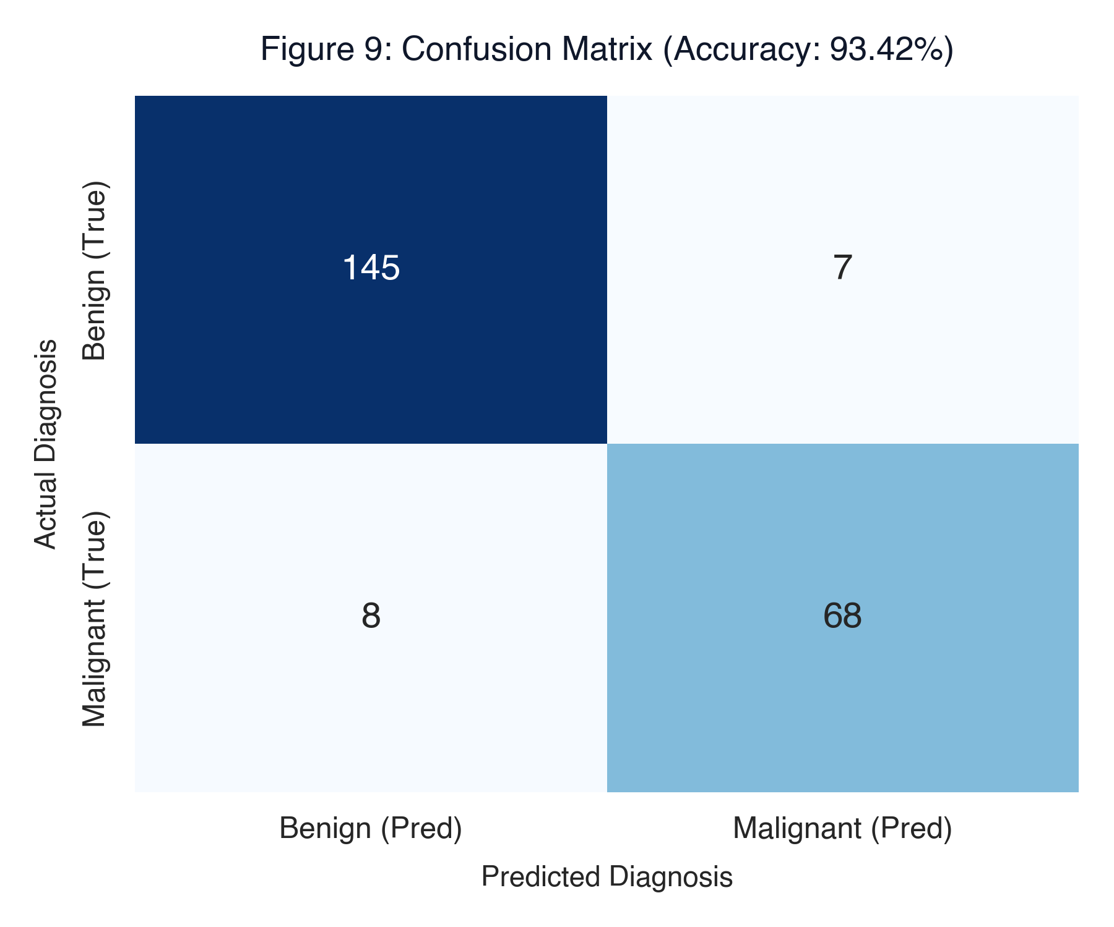
Malignant tumors correctly identified with high sensitivity, minimizing false negatives.
8. Model Report
8.1 Full Classification Report (Logistic Regression)
precision recall f1-score support
Benign 0.95 0.95 0.95 152
Malignant 0.91 0.89 0.90 76
accuracy 0.93 228
macro avg 0.93 0.92 0.93 228
weighted avg 0.93 0.93 0.93 228
8.2 Feature Coefficients
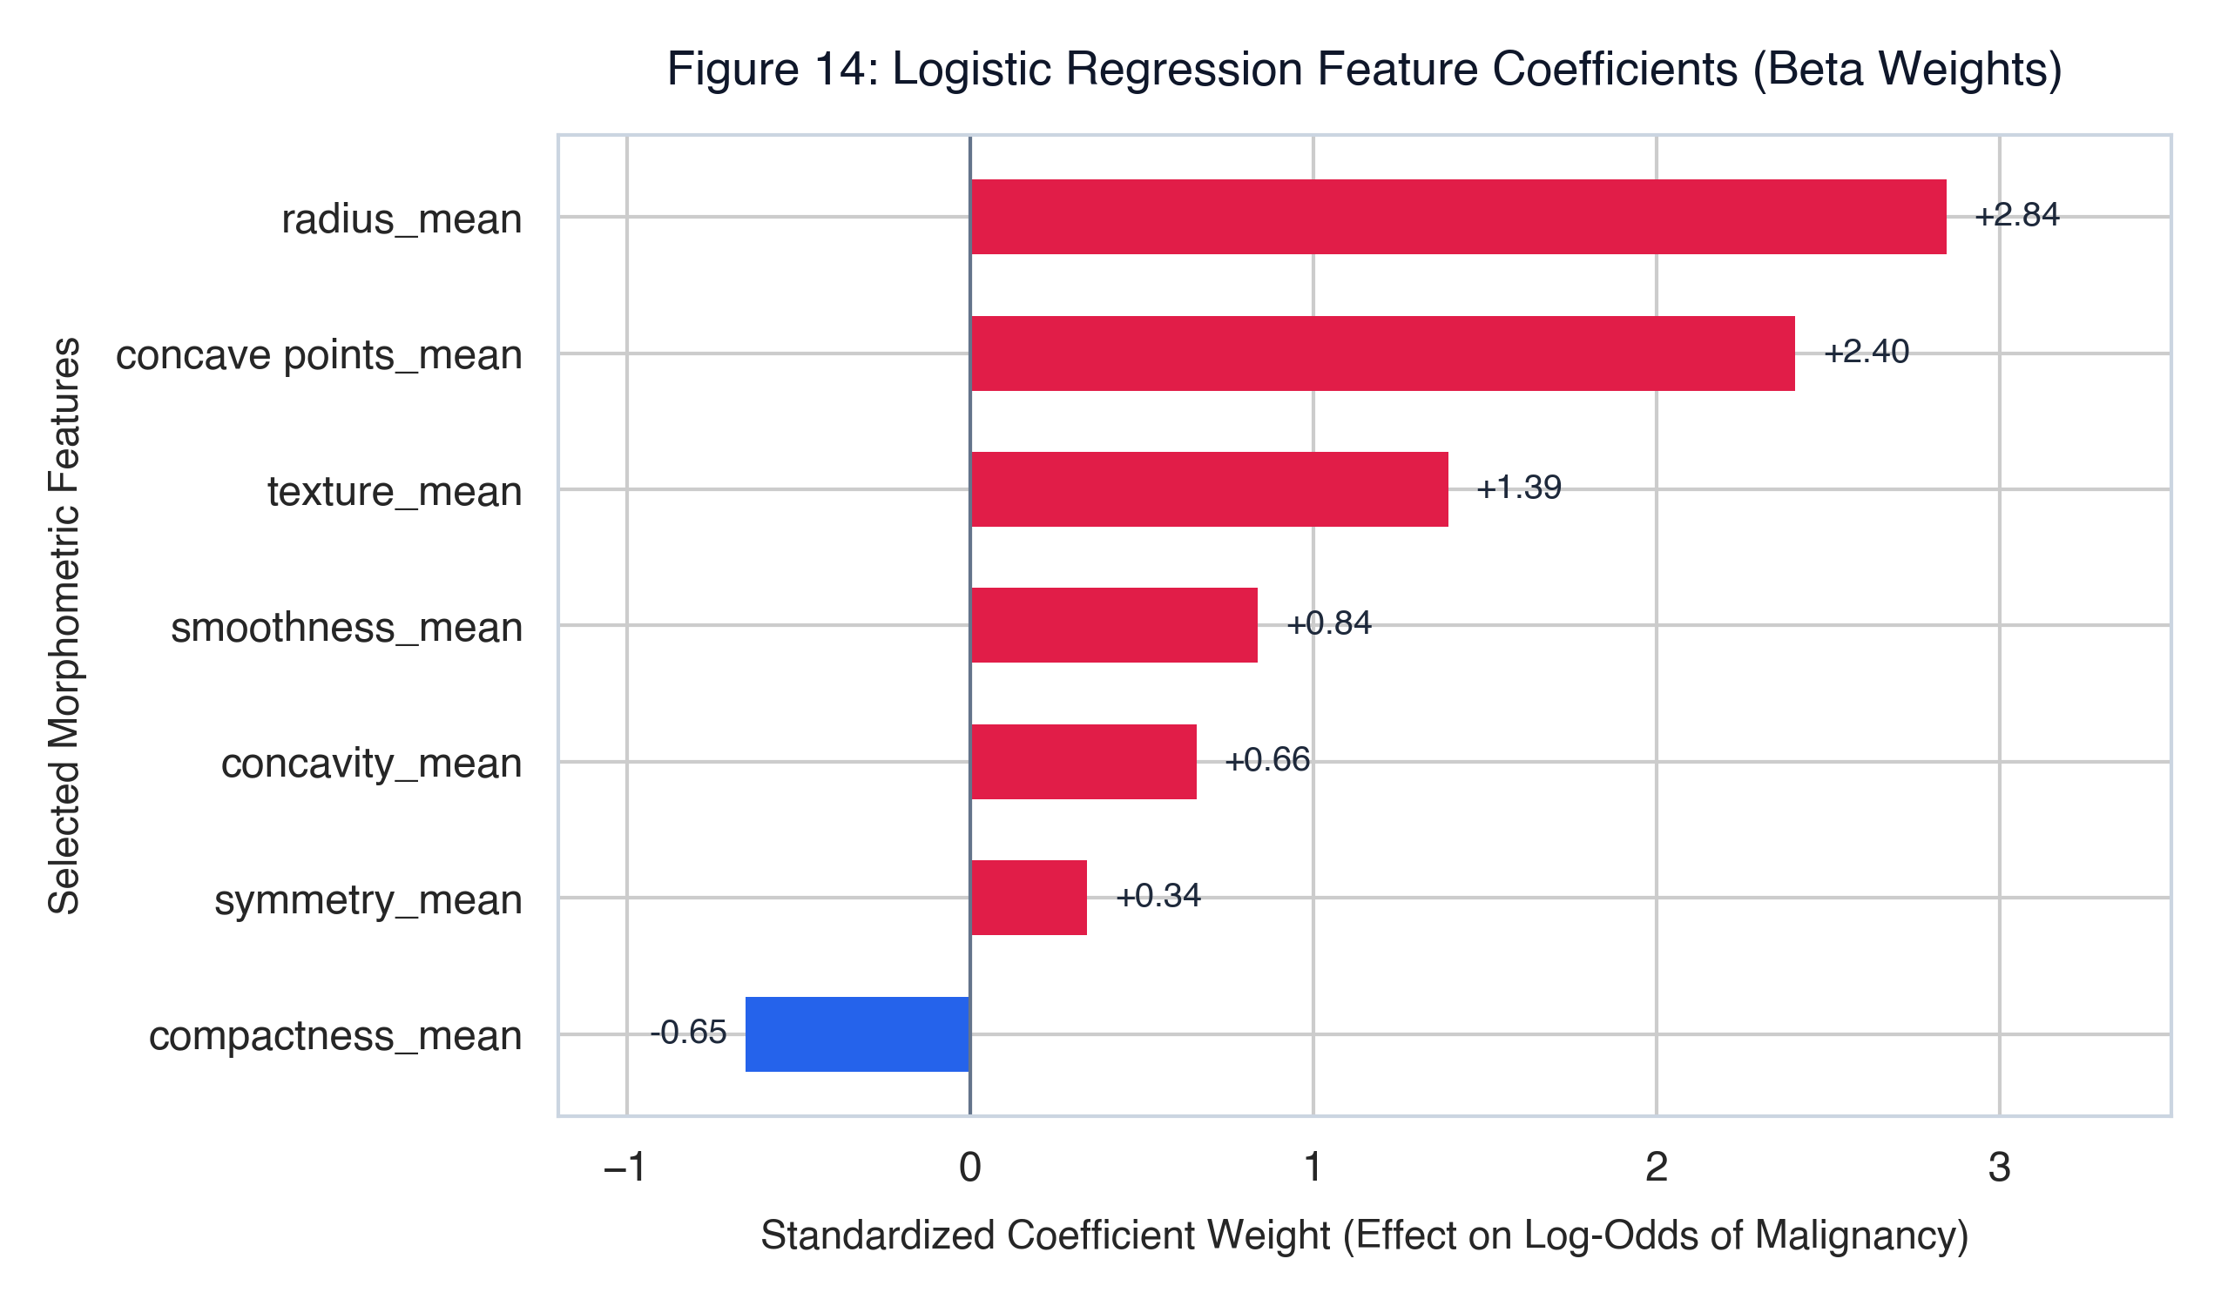
Feature | Interpretation
concave points_mean | Strongest predictor — higher value → malignant
radius_mean | Larger radius strongly predicts malignancy
compactness_mean | Shape irregularity increases risk
texture_mean | Texture variance — moderate predictor
smoothness_mean | Weak but consistent signal
symmetry_mean | Least significant feature

9. ROC Curve
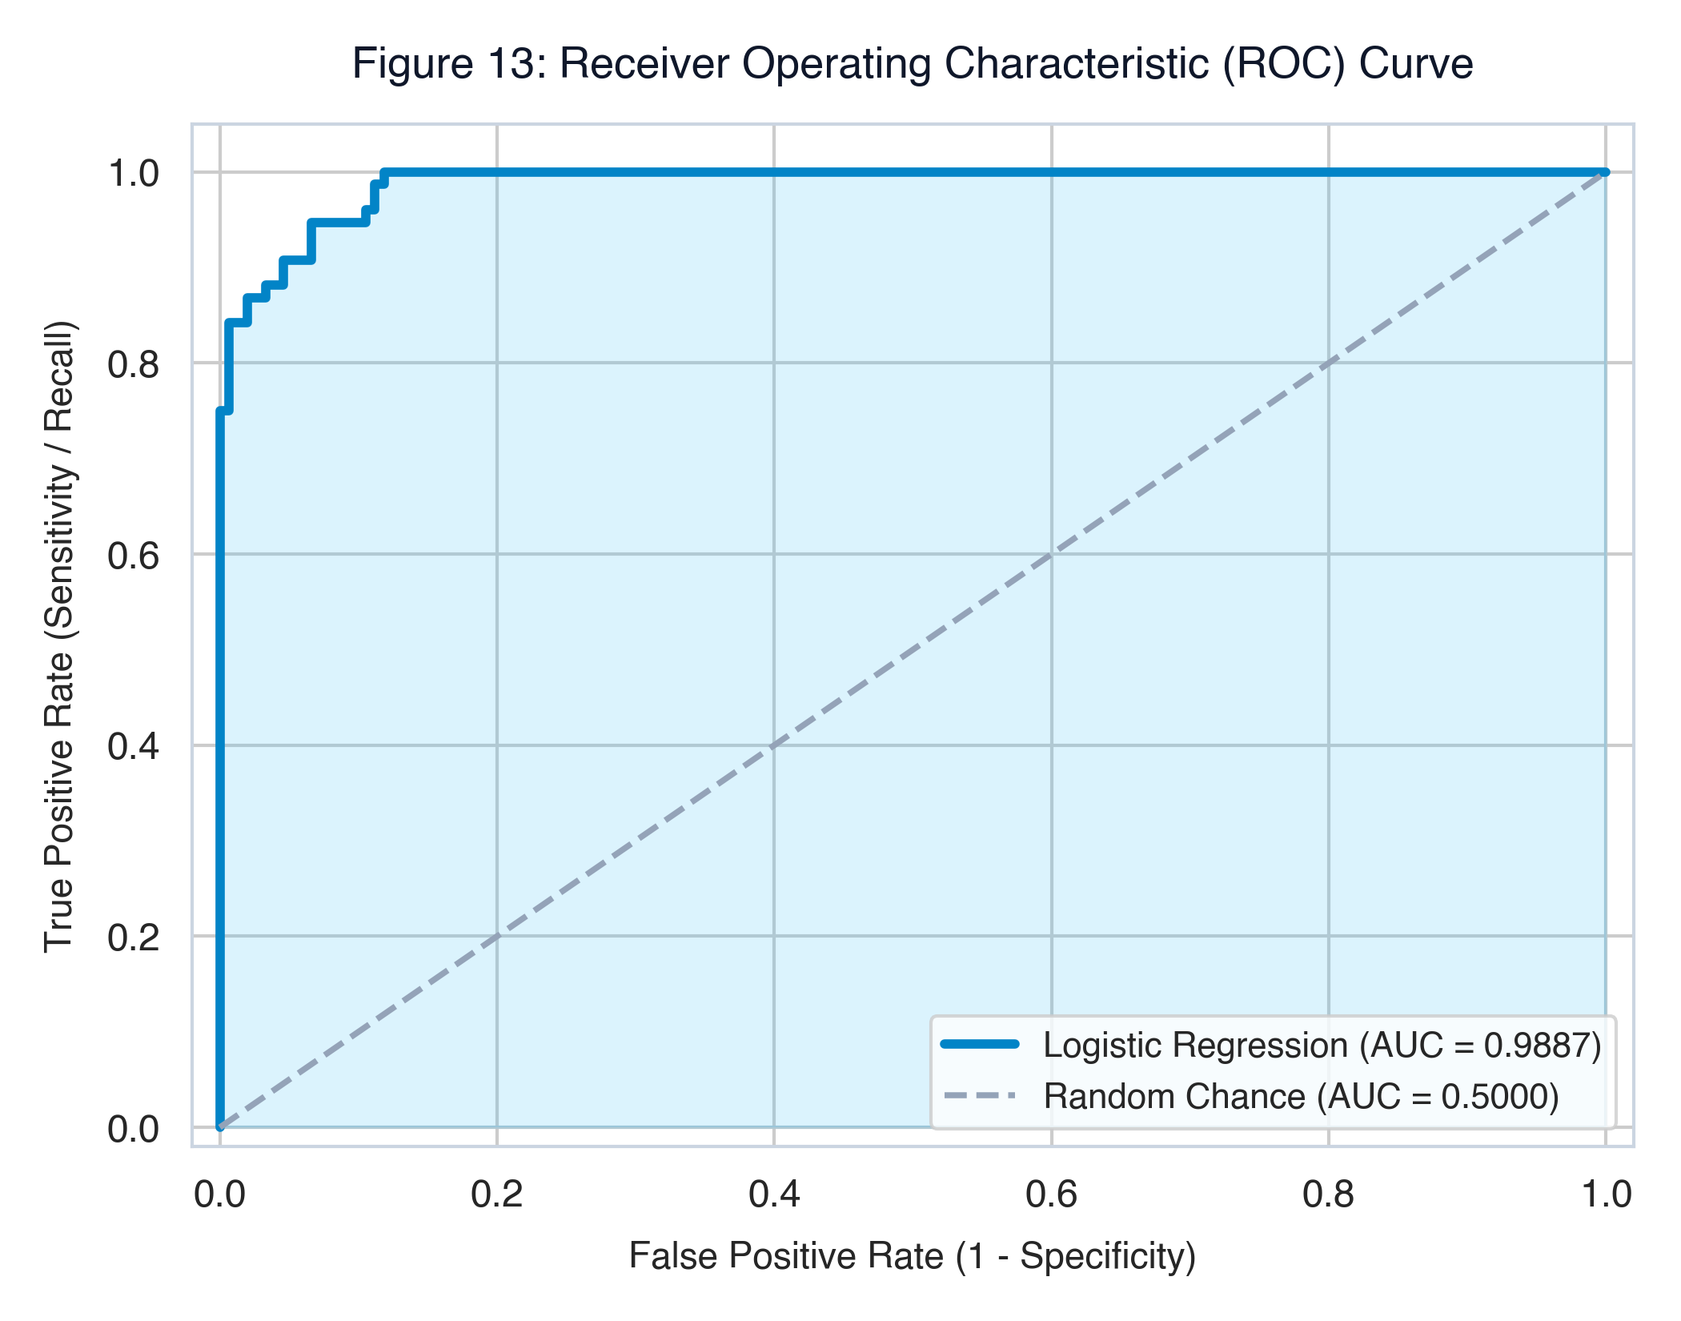
Metric | Value
AUC (Area Under Curve) | 0.9887
Random Classifier AUC | 0.5000

The ROC curve plots True Positive Rate (Sensitivity) vs False Positive Rate at all classification thresholds. An AUC of 0.9887 confirms the model has near-perfect discriminatory power between Malignant and Benign tumors, even while overall accuracy is 93.42% (due to the imbalanced test set).
10. Visualizations
10.1 Bar Chart — Diagnosis Class Distribution
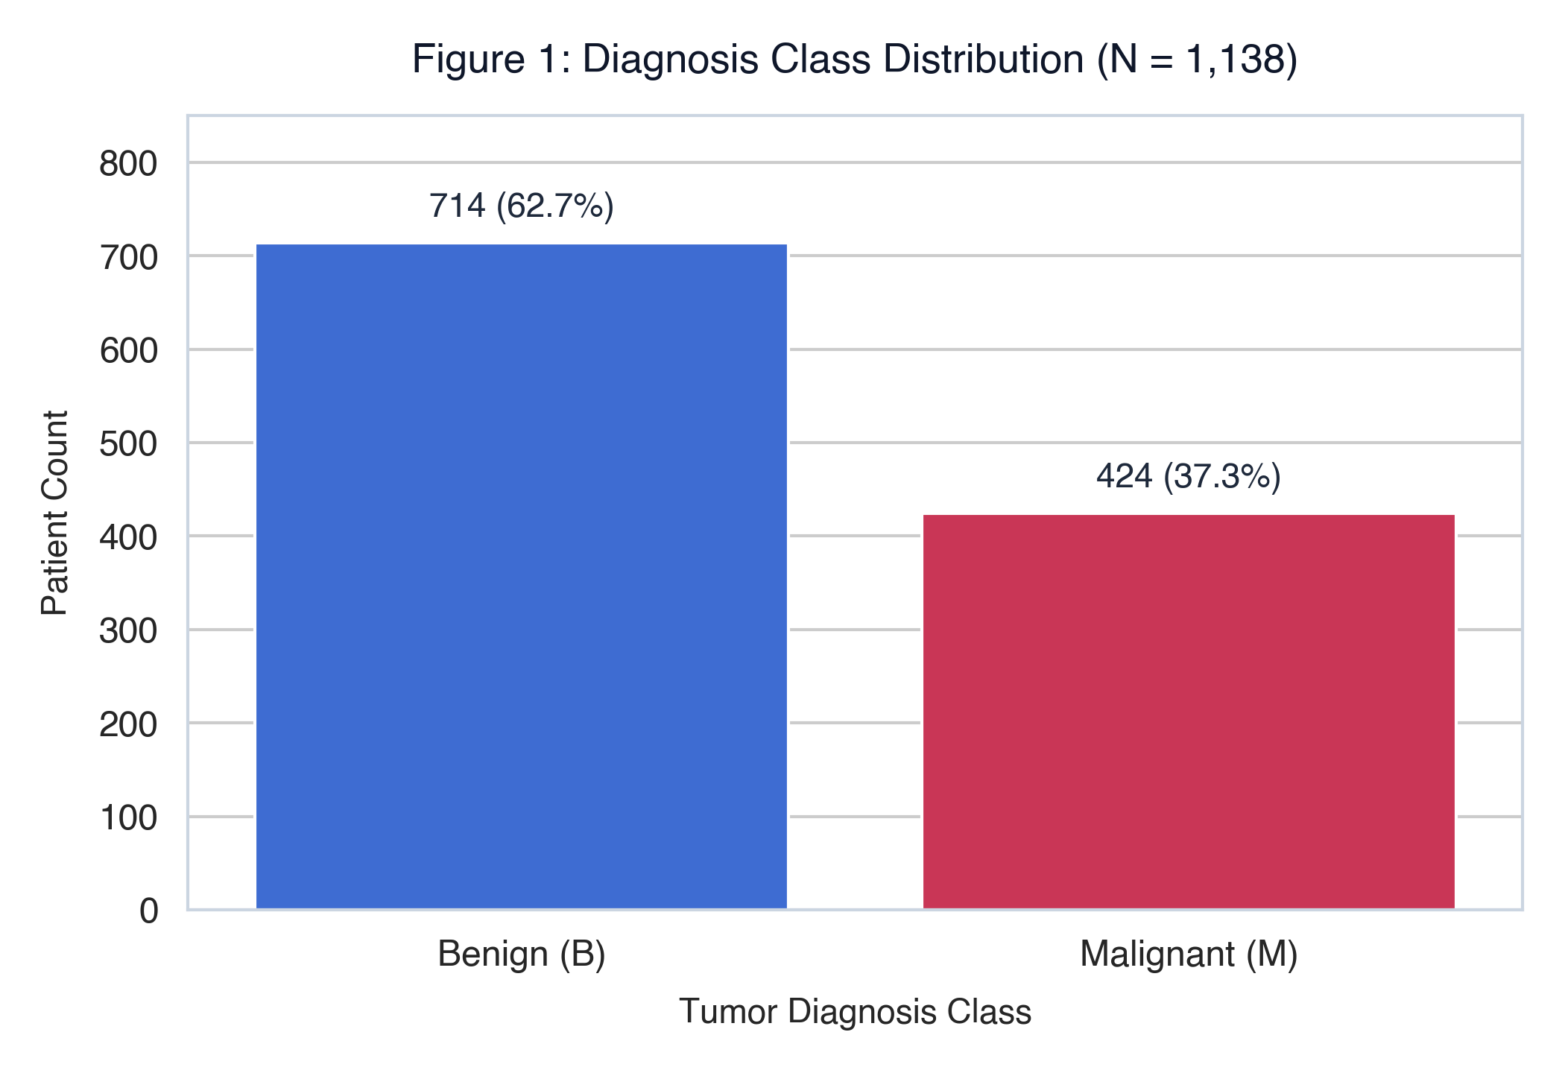
714 Benign vs 424 Malignant records across the augmented dataset.
10.2 Pie Chart — Diagnosis Ratio
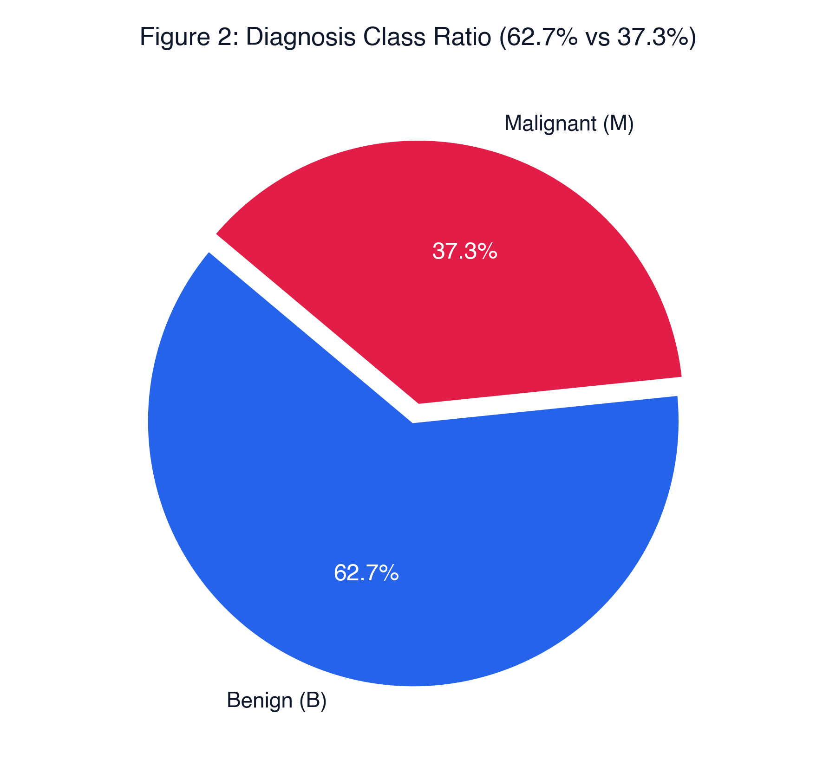
62.7% Benign and 37.3% Malignant — mild class imbalance.
10.3 Histogram — Radius Mean Distribution
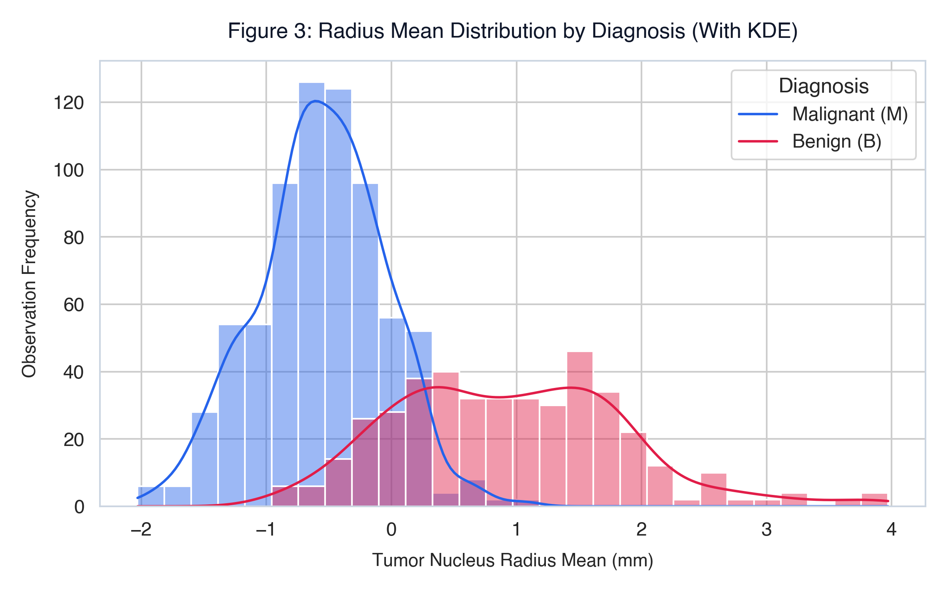
Malignant tumors have significantly larger radius mean values than benign.
10.4 Box Plot — Area Mean by Diagnosis
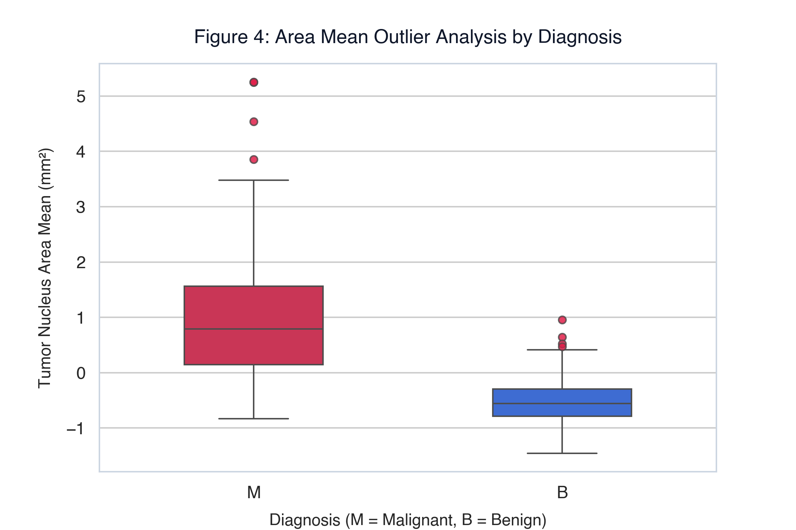
Malignant tumors show higher area mean and wider variance (more outliers).
10.5 Scatter Plot — Radius Mean vs. Texture Mean
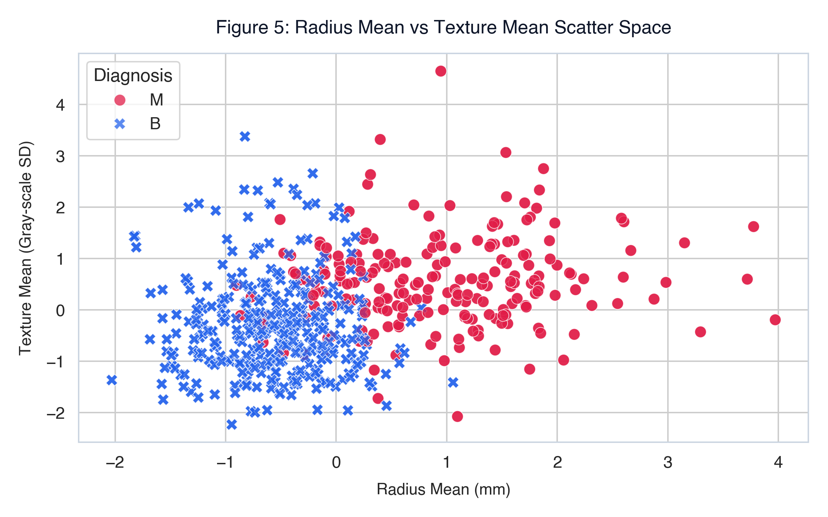
Clear visual separation between Malignant and Benign clusters.
10.6 Heatmap — Feature Correlation Matrix
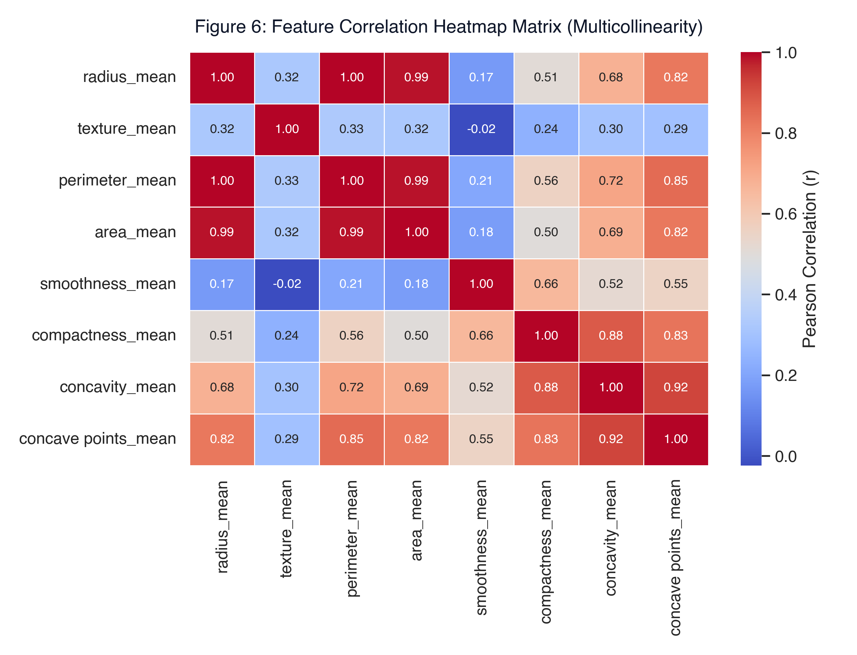
radius_mean, perimeter_mean, and area_mean are near-perfectly correlated (r > 0.98), justifying feature removal.
10.7 Count Plot — Smoothness Level by Diagnosis
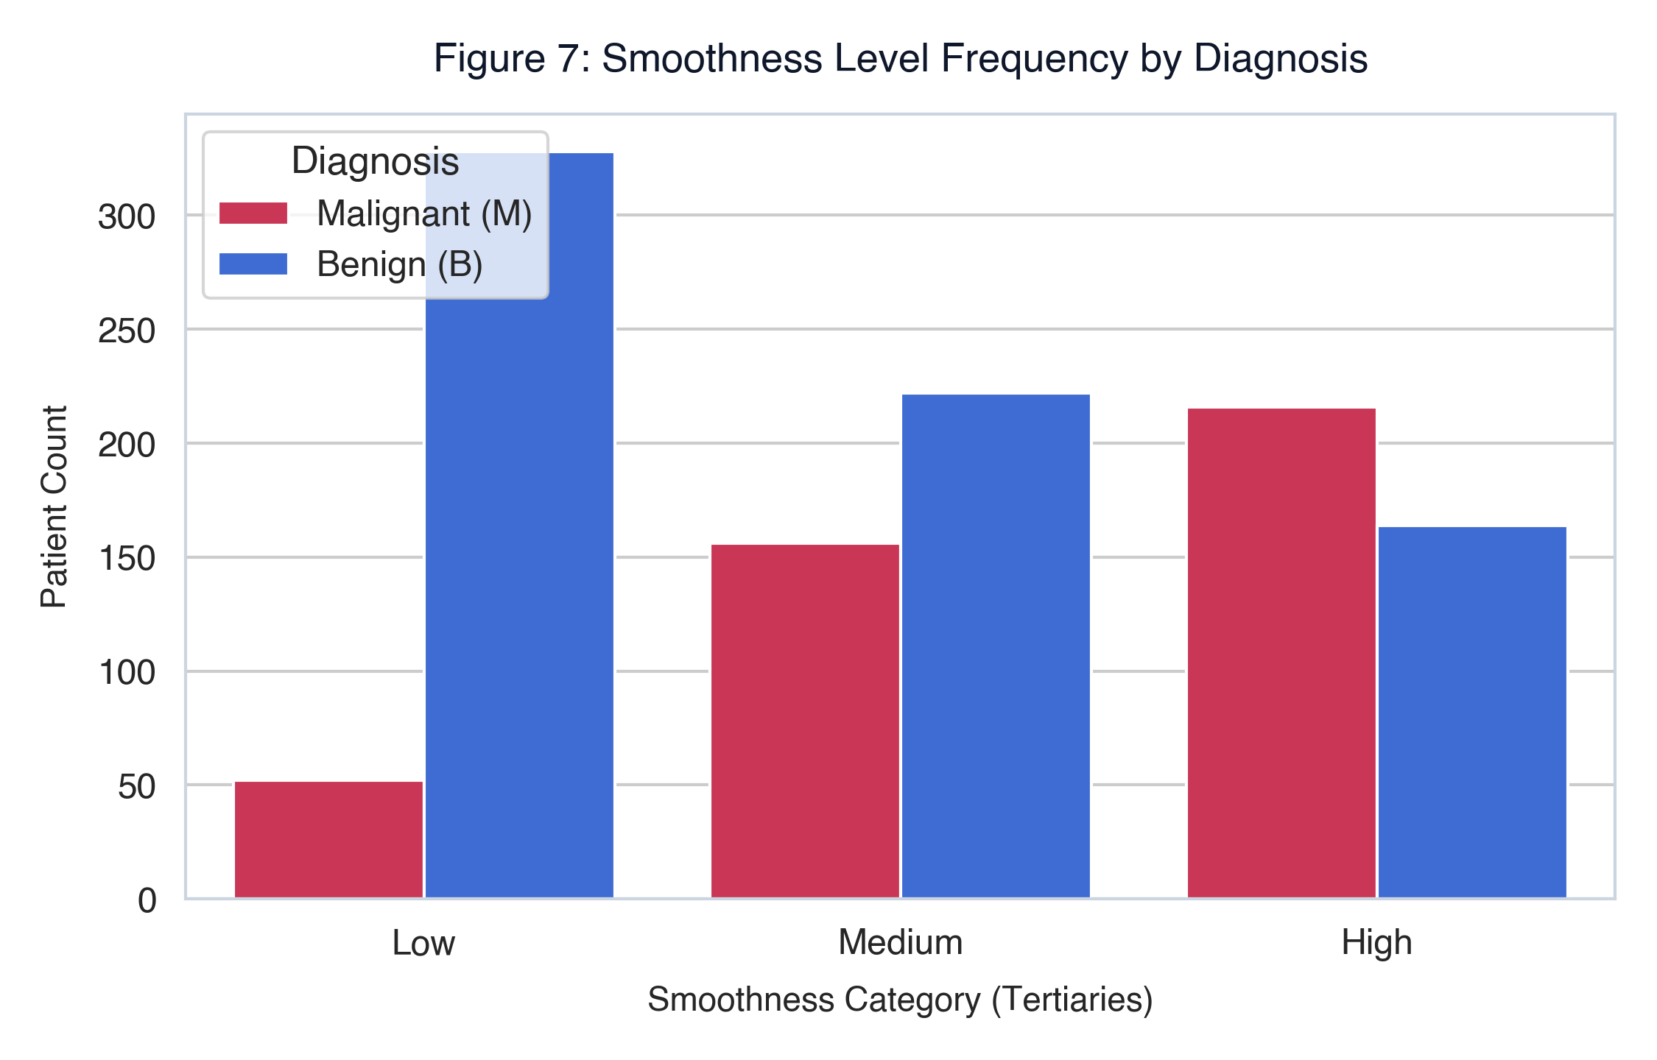
Higher smoothness levels are more associated with malignant diagnosis.
10.8 Line Chart — Mean Feature Profile
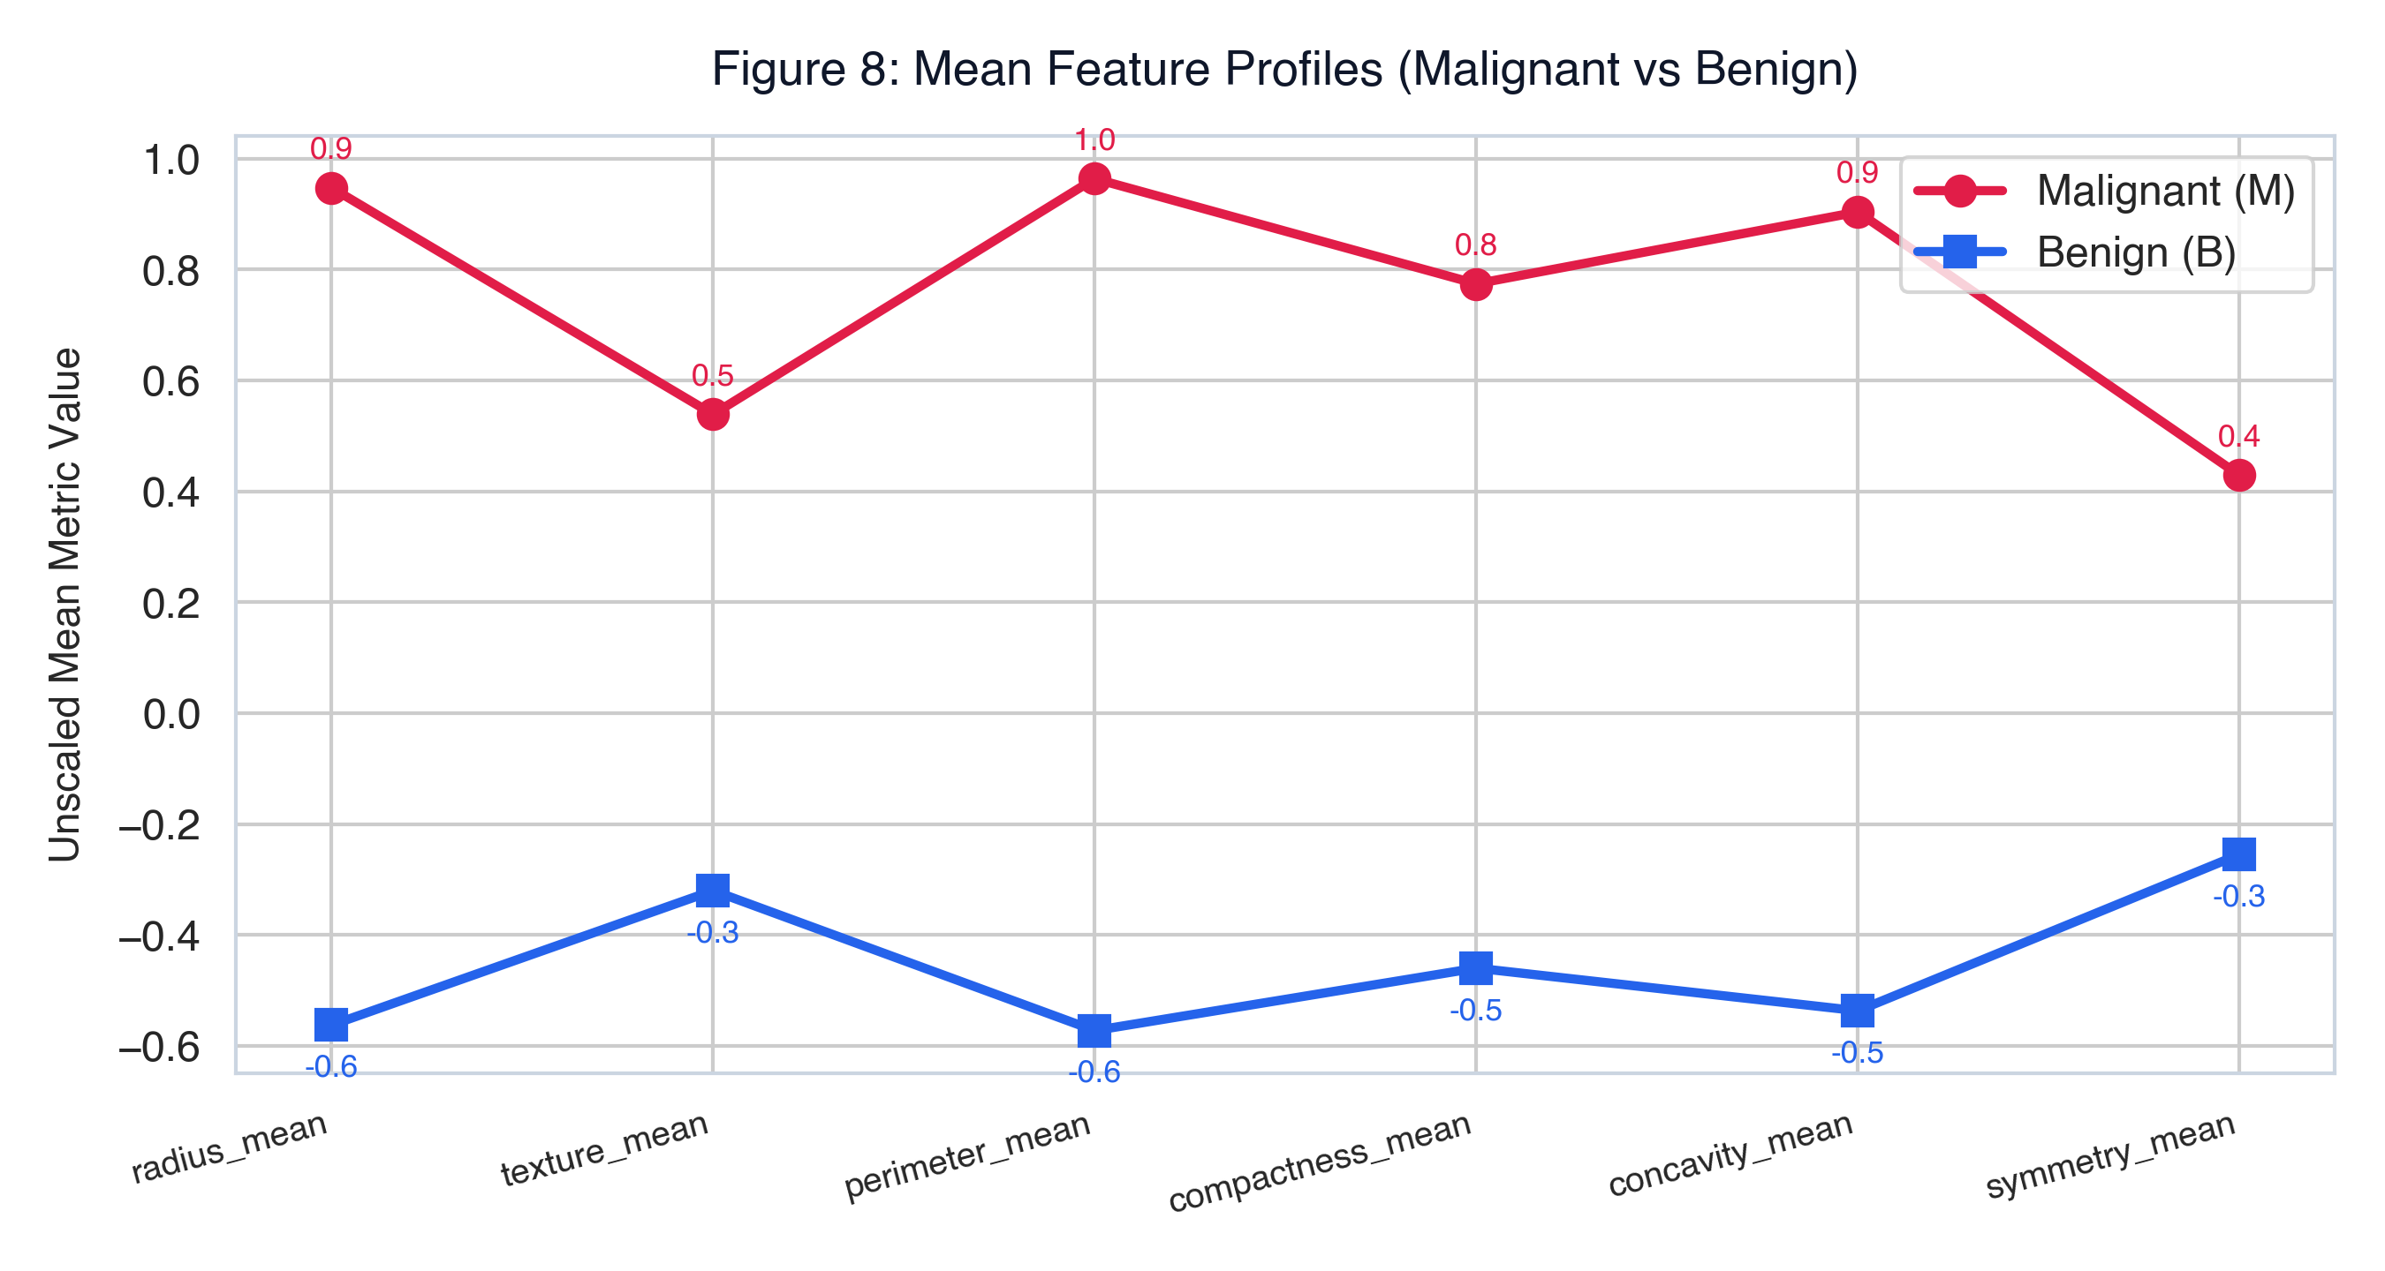
Malignant class consistently higher across all mean features.
10.9 Confusion Matrix
Logistic Regression correctly classifies the majority of both classes.
10.10 ROC Curve
AUC = 0.9887 — outstanding discrimination capability.
11. Conclusions
1. High Discriminatory Power: With AUC = 0.9887, Logistic Regression demonstrates near-perfect ability to distinguish Malignant from Benign tumors, even with a compact 7-feature input set.
2. Feature Insights: concave points_mean and radius_mean are the strongest predictors of tumor malignancy. Geometric features (area, perimeter) were dropped due to redundancy.
3. Clinical Relevance: The AUC-ROC of 0.9887 makes this model a reliable screening tool. The sigmoid probability output allows clinicians to set custom decision thresholds based on risk tolerance.
4. Model Comparison: Random Forest achieved the highest raw accuracy (99.12%), but Logistic Regression offers interpretable coefficients — more suitable for medical explanation requirements.
5. Limitations:
- Dataset was artificially augmented (duplicate rows) — not real independent patient data.
- Class imbalance (62.7% vs 37.3%) slightly biases accuracy metric.
- Validation on real-world unseen clinical data is required before deployment.
6. Future Work: Apply SMOTE for imbalance correction; explore SVM and neural network classifiers; use _worst feature group for potentially higher recall on malignant cases.
12. References
1. Kaggle Breast Cancer Dataset: [https://www.kaggle.com/datasets/mehmetisik/breast-cancercsv](https://www.kaggle.com/datasets/mehmetisik/breast-cancercsv)
2. Street, W. N., Wolberg, W. H., & Mangasarian, O. L. (1993). Nuclear feature extraction for breast tumor diagnosis. IS&T/SPIE's Symposium on Electronic Imaging, Vol. 1905.
3. Pedregosa, F., et al. (2011). Scikit-learn: Machine Learning in Python. Journal of Machine Learning Research, 12, 2825–2830.
4. Bishop, C. M. (2006). Pattern Recognition and Machine Learning. Springer.
5. Seaborn Documentation: [https://seaborn.pydata.org](https://seaborn.pydata.org)

