Practice and practice we can improve our skills.

Retrieve the required information using SQL language.
Part I. Give a database schema for a library management system as the following picture.
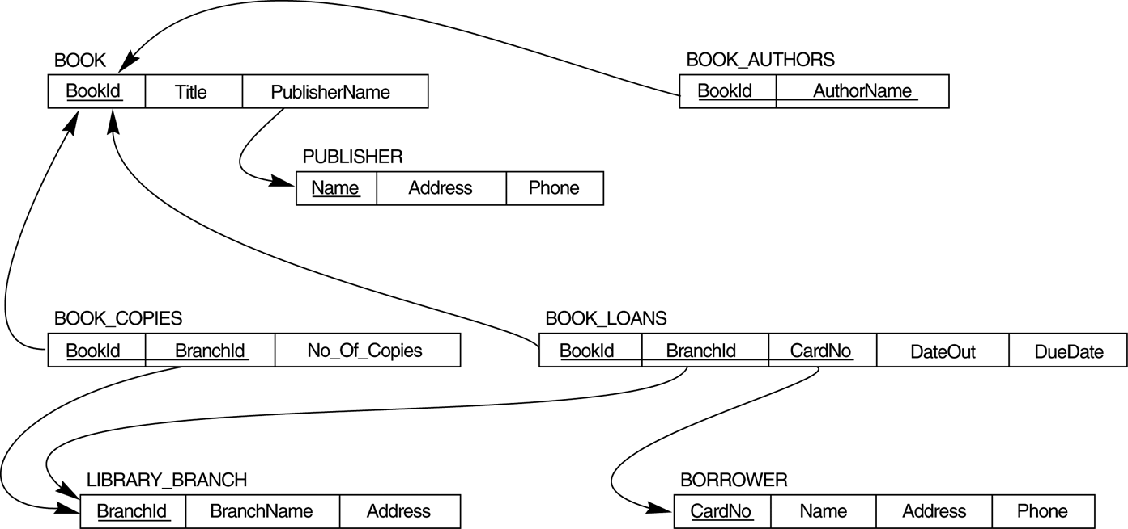

- How many copies of the book titled The Lost Tribe are owned by the library branch whose name is "Sharpstown"?

SELECT COUNT (No_Of_Copies)
FROM BOOK COPIES
JOIN BOOK
ON Book.BookId = Book_Copies.BookId
WHERE BOOK.Title = “The Lost Tribe”
JOIN LIBRARY_BRANCH
ON LIBRARY_BRANCH.BranchID = Book_Copies.BranchId
WHERE LIBRARY_BRANCH.BranchName = “Sharpstown”;

- How many copies of the book titled The Lost Tribe are owned by each library branch?

SELECT COUNT(No_Of_Copies)
FROM BOOK COPIES
JOIN BOOK
ON Book.BookId = Book_Copies.BookId
JOIN LIBRARY_BRANCH
ON LIBRARY_BRANCH.BranchID = Book_Copies.BranchId
WHERE BOOK.TITLE = ‘The Lost Tribe’
GROUP BY LIBRARY_BRANCH.BranchName;

- Retrieve the names of all borrowers who do not have any books checked out.

SELECT Name
FROM BORROWER
JOIN BOOK_LOANS
ON BOOK_LOANS.CardNo = BORROWER.CardNo
WHERE BOOK_LOANS.DateOut IS NULL;

- For each book that is loaned out from the "Sharpstown" branch and whose DueDate is today, retrieve the book title, the borrower's name, and the borrower's address.

- For each library branch, retrieve the branch name and the total number of books loaned out from that branch.

SELECT LIBRARY_BRANCH.BranchName, COUNT(BOOK_LOANS.BookId)
FROM LIBRARY_BRANCH
JOIN BOOK_LOANS
ON LIBRARY_BRANCH.BranchId = BOOK_LOANS.BranchId
GROUP BY LIBRARY_BRANCH.BranchName;

- Retrieve the names, addresses, and number of books checked out for all borrowers who have more than five books checked out.

- For each book authored (or co-authored) by "Stephen King", retrieve the title and the number of copies owned by the library branch whose name is "Central"

Part II – Automation test

Create a Test Automation Framework using Java / Selenium Web Driver (our recommendation is to use Java, but it not a must – you can use other programming languages if it will be easier for you). Process the following steps:

1. Open page https://www.degiro.co.uk/fees/calculator

2. Fill sample data in all fields of the form (for country/exchange select United Kingdom, Product type - > ETFs)

3. Submit form (click on “Add” button) - check the result page on the right as follow

4 Read the information hint on field “Total costs”. Show this hint as message in the Automation test if value of the filed “Total costs” is lower than 5 GBP, otherwise show as Message – “Big amount”
Show the Information hint in a different message (Product costs field)

