Hi developerName,

During the testing of the toDo functionality I’ve come up with some ideas and I wanted to share them with you.

1. ToDo list to be placed below the new item field. With this we will fix the issue that we have when there are a lot of items added to the list and we want to Add a new one, for that we need to scroll down to the bottom of the list.
2. Implement a Filter with Completed and Uncompleted tasks. With that the user will easily filter the uncompleted/completed tasks.
3. Add date and time just below of each task. This could be a useful information for the user.
4. We can implement a checkbox just on the left side of each item, so that the user can easily mark If the task is completed or not.
5. We can change the delete and edit icon – we can use the one from screenshot.
6. We can set a minimum and a maximum number of characters for the Add item field.

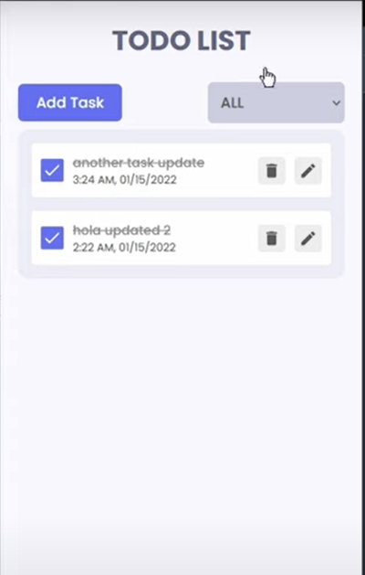

Let me know when you have some time and we can have some discussion about this.

Regards,

Rumen