Signal Modulation Summary
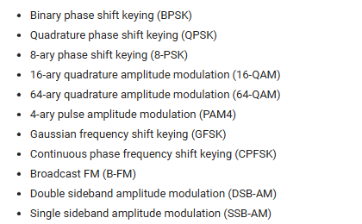
Pulse Amplitude Modulation (PAM) -> PAM4
https://www.keysight.com/blogs/en/inds/ai/pam4-pulse-amplitude-modulation-explained
Claude implementation
Prompt: generate a signal processing block diagram in the html file format and save to the current working directory for a pam4 radio frequency transmitter receiver system that can be implementation in python code
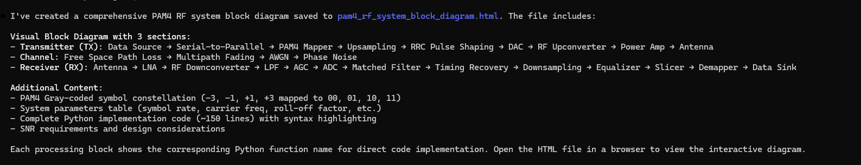

Prompt: based on the pam4_rf_system_block_diagram.html file, generate a new signal processing block diagram in the html file format and save to the current working directory for a pam4 radio frequency system that can be implementation in python code where both the transmitter and receiver are space-based in medium earth orbit (MEO).
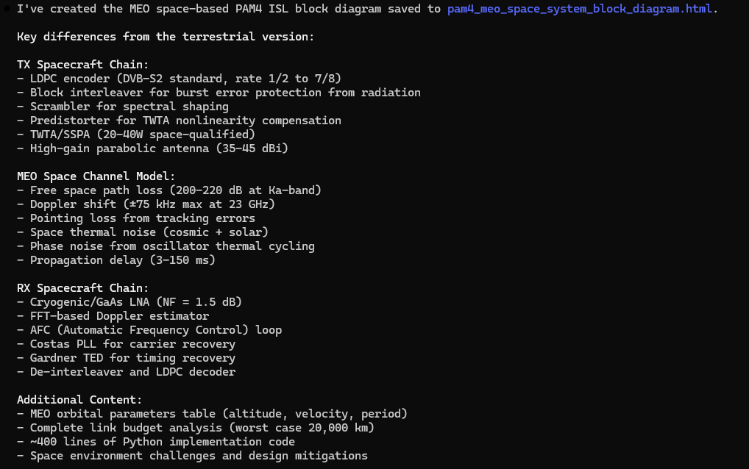
Prompt: in the current working directory, pam4_modulation_meo_tx_rx_simulation.py code is throwing the following error: Traceback (most recent call last): File "C:\Users\j_l_c\Documents\Sentinel_Space\ARES_Protect_One_Mission_APOM\ares_mdtt_08_Jan_2026\ARES\SensorSvc\data\synthetic_RF_TX_RX_waveforms\signal_modulation_implementation_approaches\python_code\pam4_modulation_meo_tx_rx_simulation.py", line 439, in <module>
results = meo_pam4_isl_simulation(
num_symbols=50000,
distance_km=15000, # 15,000 km ISL range
doppler_hz=50000 # 50 kHz Doppler
)
File C:\Users\j_l_c\Documents\Sentinel_Space\ARES_Protect_One_Mission_APOM\ares_mdtt_08_Jan_2026\ARES\SensorSvc\data\synthetic_RF_TX_RX_waveforms\signal_modulation_implementation_approaches\python_code\pam4_modulation_meo_tx_rx_simulation.py", line 414, in meo_pam4_isl_simulation
rx_bits, rx_symbols = meo_receiver(np.real(rx_rf), rrc, num_symbols, doppler_hz)
~~~~~~~~~~~~^^^^^^^^^^^^^^^^^^^^^^^^^^^^^^^^^^^^^^^^^^^^^^
File "C:\Users\j_l_c\Documents\Sentinel_Space\ARES_Protect_One_Mission_APOM\ares_mdtt_08_Jan_2026\ARES\SensorSvc\data\synthetic_RF_TX_RX_waveforms\signal_modulation_implementation_approaches\python_code\pam4_modulation_meo_tx_rx_simulation.py", line 341, in meo_receiver
deinterleaved = block_deinterleave(descrambled)
File C:\Users\j_l_c\Documents\Sentinel_Space\ARES_Protect_One_Mission_APOM\ares_mdtt_08_Jan_2026\ARES\SensorSvc\data\synthetic_RF_TX_RX_waveforms\signal_modulation_implementation_approaches\python_code\pam4_modulation_meo_tx_rx_simulation.py", line 151, in block_deinterleave
matrix = bits[:rows*cols].reshape(cols, rows)
ValueError: cannot reshape array of size 100000 into shape (1563,64)
Determine the root cause and propose a corrective action.
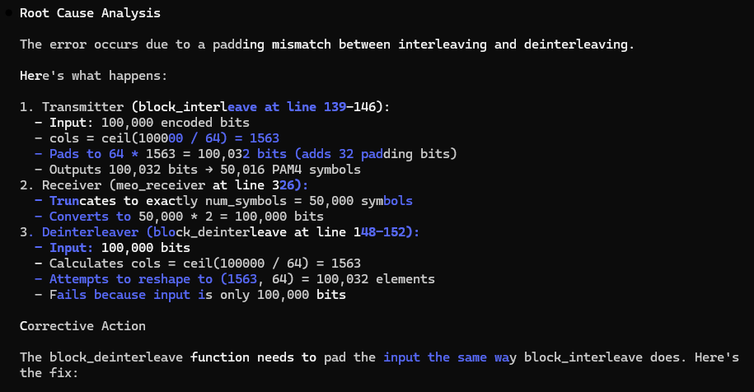

Prompt: Update the pam4_modulation_meo_tx_rx_simulation.py code in the current working directory to generate three (3) signal levels versus time plots of the baseband values after the RF down conversion, low pass filtering, and Doppler compensation processing in the meo_receiver function.
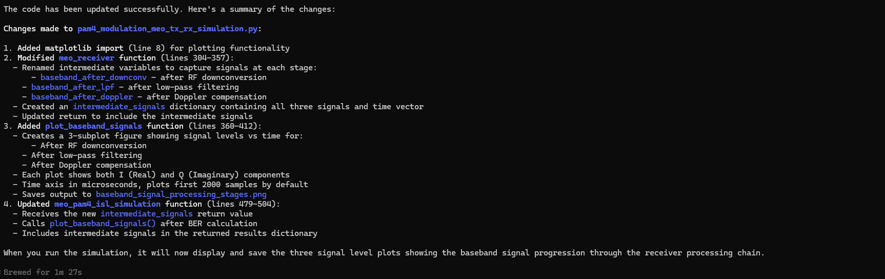
Prompt: in the current working directory, pam4_modulation_meo_tx_rx_simulation.py code is throwing the following error: Traceback (most recent call last):
File "C:\Users\j_l_c\Documents\Sentinel_Space\ARES_Protect_One_Mission_APOM\ares_mdtt_08_Jan_2026\ARES\SensorSvc\data\synthetic_RF_TX_RX_waveforms\signal_modulation_implementation_approaches\python_code\pam4\pam4_modulation_meo_tx_rx_simulation.py", line 509, in <module>
results = meo_pam4_isl_simulation(
num_symbols=50000,
distance_km=15000, # 15,000 km ISL range
doppler_hz=50000 # 50 kHz Doppler
)
File "C:\Users\j_l_c\Documents\Sentinel_Space\ARES_Protect_One_Mission_APOM\ares_mdtt_08_Jan_2026\ARES\SensorSvc\data\synthetic_RF_TX_RX_waveforms\signal_modulation_implementation_approaches\python_code\pam4\pam4_modulation_meo_tx_rx_simulation.py", line 480, in meo_pam4_isl_simulation
rx_bits, rx_symbols, intermediate_signals = meo_receiver(np.real(rx_rf), rrc, num_symbols, doppler_hz)
~~~~~~~~~~~~^^^^^^^^^^^^^^^^^^^^^^^^^^^^^^^^^^^^^^^^^^^^^^
File "C:\Users\j_l_c\Documents\Sentinel_Space\ARES_Protect_One_Mission_APOM\ares_mdtt_08_Jan_2026\ARES\SensorSvc\data\synthetic_RF_TX_RX_waveforms\signal_modulation_implementation_approaches\python_code\pam4\pam4_modulation_meo_tx_rx_simulation.py", line 352, in meo_receiver
deinterleaved = block_deinterleave(descrambled)
File "C:\Users\j_l_c\Documents\Sentinel_Space\ARES_Protect_One_Mission_APOM\ares_mdtt_08_Jan_2026\ARES\SensorSvc\data\synthetic_RF_TX_RX_waveforms\signal_modulation_implementation_approaches\python_code\pam4\pam4_modulation_meo_tx_rx_simulation.py", line 152, in block_deinterleave
matrix = bits[:rows*cols].reshape(cols, rows)
ValueError: cannot reshape array of size 100000 into shape (1563,64)
Determine the root cause and propose a corrective action.
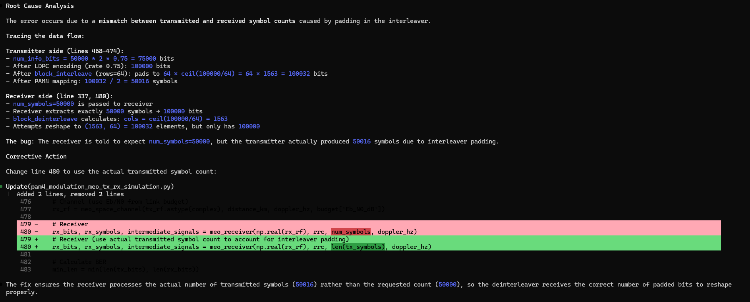
Prompt: in the current working directory, pam4_modulation_meo_tx_rx_simulation.py code is throwing the following error: Traceback (most recent call last):
File "C:\Users\j_l_c\Documents\Sentinel_Space\ARES_Protect_One_Mission_APOM\ares_mdtt_08_Jan_2026\ARES\SensorSvc\data\synthetic_RF_TX_RX_waveforms\signal_modulation_implementation_approaches\python_code\pam4\pam4_modulation_meo_tx_rx_simulation.py", line 509, in <module>
results = meo_pam4_isl_simulation(
num_symbols=50000,
distance_km=15000, # 15,000 km ISL range
doppler_hz=50000 # 50 kHz Doppler
)
File "C:\Users\j_l_c\Documents\Sentinel_Space\ARES_Protect_One_Mission_APOM\ares_mdtt_08_Jan_2026\ARES\SensorSvc\data\synthetic_RF_TX_RX_waveforms\signal_modulation_implementation_approaches\python_code\pam4\pam4_modulation_meo_tx_rx_simulation.py", line 480, in meo_pam4_isl_simulation
rx_bits, rx_symbols, intermediate_signals = meo_receiver(np.real(rx_rf), rrc, len(tx_symbols), doppler_hz)
~~~~~~~~~~~~^^^^^^^^^^^^^^^^^^^^^^^^^^^^^^^^^^^^^^^^^^^^^^^^^^
File "C:\Users\j_l_c\Documents\Sentinel_Space\ARES_Protect_One_Mission_APOM\ares_mdtt_08_Jan_2026\ARES\SensorSvc\data\synthetic_RF_TX_RX_waveforms\signal_modulation_implementation_approaches\python_code\pam4\pam4_modulation_meo_tx_rx_simulation.py", line 352, in meo_receiver
deinterleaved = block_deinterleave(descrambled)
File "C:\Users\j_l_c\Documents\Sentinel_Space\ARES_Protect_One_Mission_APOM\ares_mdtt_08_Jan_2026\ARES\SensorSvc\data\synthetic_RF_TX_RX_waveforms\signal_modulation_implementation_approaches\python_code\pam4\pam4_modulation_meo_tx_rx_simulation.py", line 152, in block_deinterleave
matrix = bits[:rows*cols].reshape(cols, rows)
ValueError: cannot reshape array of size 100020 into shape (1563,64)
Determine the root cause and propose a corrective action.
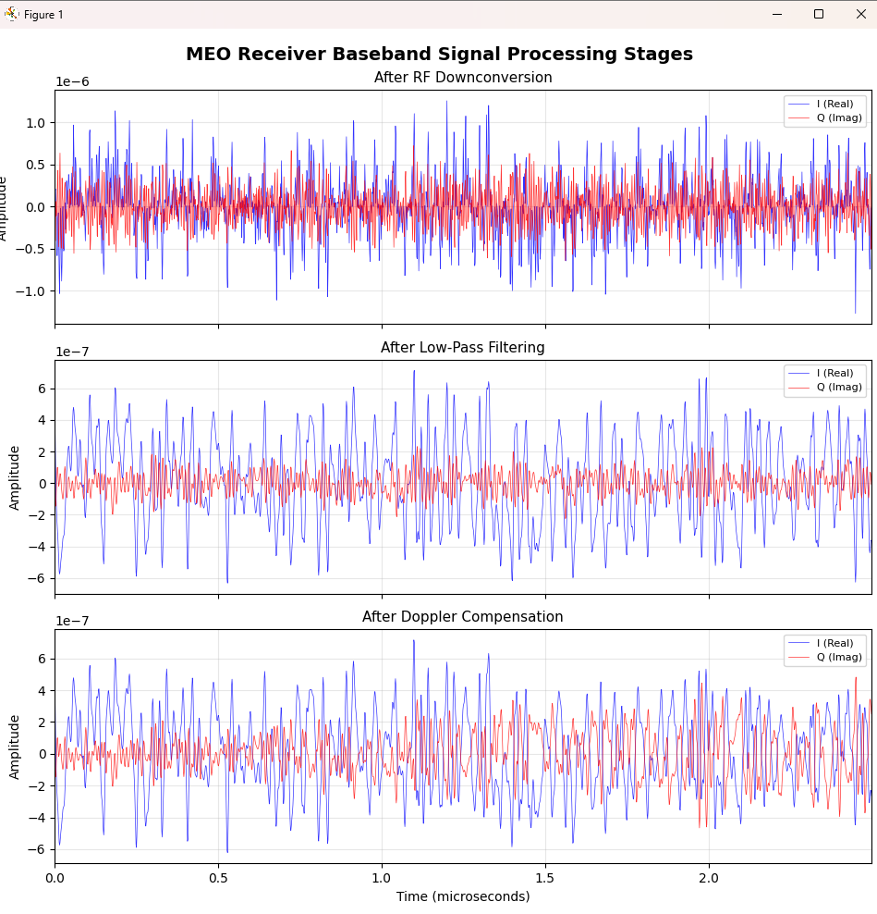
Prompt: in the current working directory, determine the root cause and corrective action for the high bit error rate while running the pam4_modulation_meo_tx_rx_simulation.py code with the following case:
======================
Distance: 15000 km
Doppler: 50.0 kHz
Link Budget:
EIRP: 52.0 dBW
FSPL: 203.2 dB
C/N0: 88.9 dBHz
Eb/N0: 5.9 dB
Results:
TX bits: 75000
RX bits: 75024
Bit errors: 37599
BER: 5.01e-01
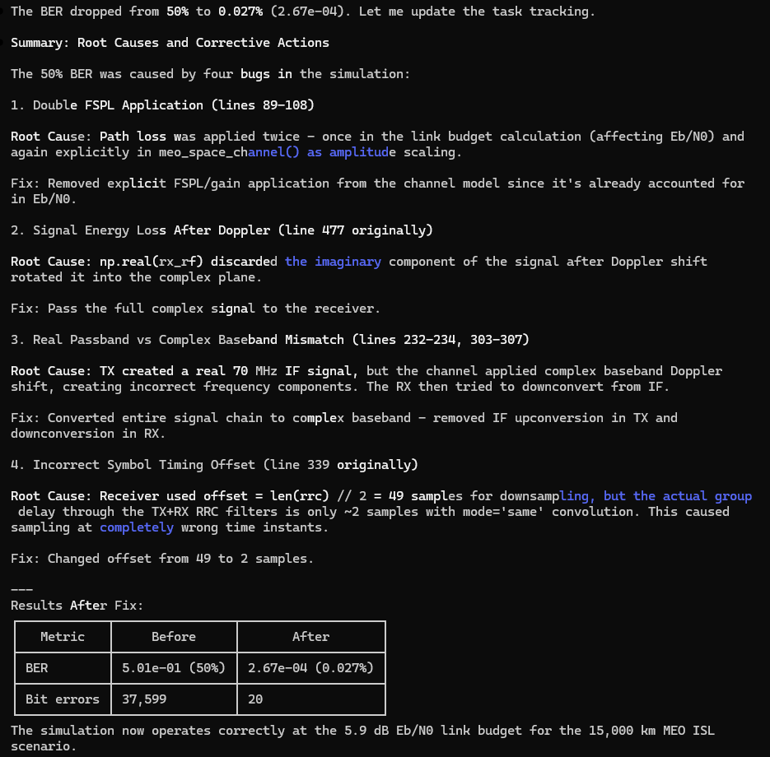
Prompt: in the current working directory, update the pam4_modulation_meo_tx_rx_simulation.py code to save the intermediate_signals dictionary to the current working dictionary. Generate a ReadMe file in a markdown format and save it to the current working directory with instructions for loading the intermediate_signals dictionary file.
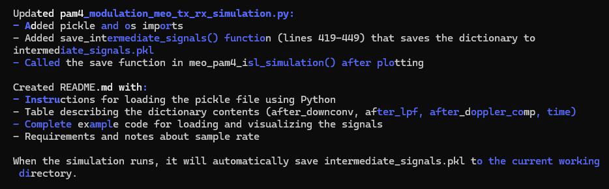
Prompt: Using the intermediate_signals.pkl file in the current working directory, create a python file to generate scaleograms using a wavelet transform. For each ‘after_downconv”, “after_lpf”, and “after_doppler_comp” signal, create an individual scaleogram plot that will be saved as a .png file in the current working directory.
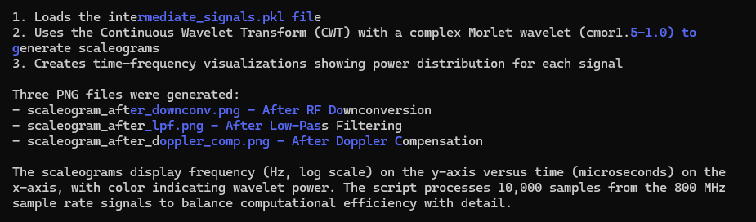
Prompt Update the pam4_meo_space_system_block_diagram.html file in the current working directory with the python code named pam4_modulation_meo_tx_rx_simulation.py in the directory at the following path location: C:\Users\j_l_c\Documents\Sentinel_Space\ARES_Protect_One_Mission_APOM\ares_mdtt_08_Jan_2026\ARES\SensorSvc\data\synthetic_RF_TX_RX_waveforms\signal_modulation_implementation_approaches\python_code\pam4
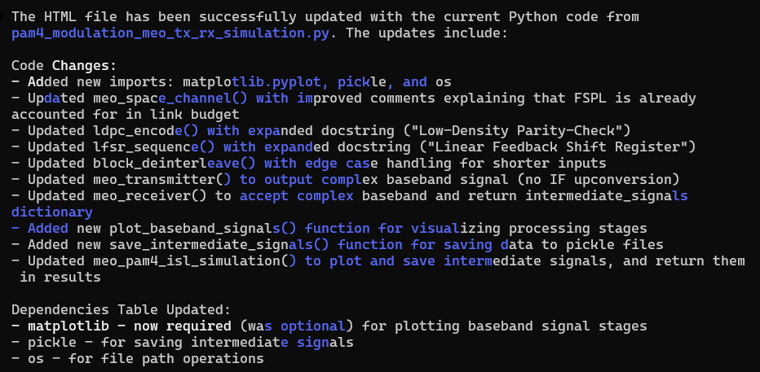
Prompt: Create python code to generate two sets of intermediate_signals using the meo_pam4_isl_simulation function from the pam4_meo_tx_rx_frontend_sim.py file in the current working directory. The arguments for each meo_pam4_isl_simulation function call will always have num_symbols value of 50,000, the distance_km value for each case will be a random integer from 100 to 15000 and the doppler_hz value for each case will be a random integer from 10000 to 50000. For each “after_downconv”, “after_lpf”, and “after_doppler_comp” signal, create an individual scaleogram plot using the generate_scaleogram function from the generate_scaleogram.py file. Save the scaleograms as .png files in its respective ‘after_downconv”, “after_lpf”, and “after_doppler_comp” directory in the current working directory. If the respective ‘after_downconv”, “after_lpf”, and “after_doppler_comp” directories don’t exist, make the directories at the relative current working directory location. Label the scaleogram .png files with following naming convention: pam4_<process stage description>_<distance value>_<Doppler value>_<sequential index value>.png (e.g. pam4_lpf_200_10000_1.png, pam4_lpf_1000_12000_2.png, etc). The process stage descriptions nomenclature are as follow: “after_downconv”-> “dnconv, “after_lpf”->”lpf”, and “after_doppler_comp” -> “dopp”.
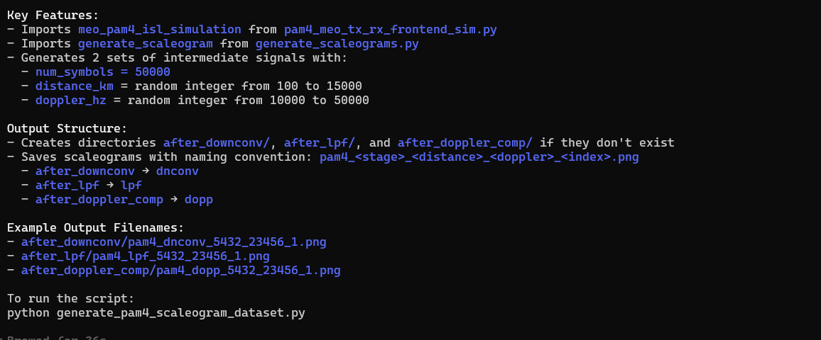
Prompt: the generate_pam4_scaleogram_dataset.py file in the current working directory is throwing the follow error: Traceback (most recent call last):
File "C:\Users\j_l_c\Documents\Sentinel_Space\ARES_Protect_One_Mission_APOM\ares_mdtt_08_Jan_2026\ARES\SensorSvc\data\synthetic_RF_TX_RX_waveforms\signal_modulation_implementation_approaches\python_code\pam4\dataset_generator\generate_pam4_scaleogram_dataset.py", line 144, in <module>
generate_dataset(num_sets=2, num_symbols=50000)
~~~~~~~~~~~~~~~~^^^^^^^^^^^^^^^^^^^^^^^^^^^^^^^
File "C:\Users\j_l_c\Documents\Sentinel_Space\ARES_Protect_One_Mission_APOM\ares_mdtt_08_Jan_2026\ARES\SensorSvc\data\synthetic_RF_TX_RX_waveforms\signal_modulation_implementation_approaches\python_code\pam4\dataset_generator\generate_pam4_scaleogram_dataset.py", line 124, in generate_dataset
generate_scaleogram(
~~~~~~~~~~~~~~~~~~~^
signal=signal,
^^^^^^^^^^^^^^
...<6 lines>...
max_samples=10000
^^^^^^^^^^^^^^^^^
)
^
File "C:\Users\j_l_c\Documents\Sentinel_Space\ARES_Protect_One_Mission_APOM\ares_mdtt_08_Jan_2026\ARES\SensorSvc\data\synthetic_RF_TX_RX_waveforms\signal_modulation_implementation_approaches\python_code\pam4\dataset_generator\generate_scaleograms.py", line 86, in generate_scaleogram
plt.savefig(output_filename, dpi=150, bbox_inches='tight')
~~~~~~~~~~~^^^^^^^^^^^^^^^^^^^^^^^^^^^^^^^^^^^^^^^^^^^^^^^
File "C:\Users\j_l_c\AppData\Local\Programs\Python\Python313\Lib\site-packages\matplotlib\pyplot.py", line 1251, in savefig
res = fig.savefig(*args, **kwargs) # type: ignore[func-returns-value]
File "C:\Users\j_l_c\AppData\Local\Programs\Python\Python313\Lib\site-packages\matplotlib\figure.py", line 3490, in savefig
self.canvas.print_figure(fname, **kwargs)
~~~~~~~~~~~~~~~~~~~~~~~~^^^^^^^^^^^^^^^^^
File "C:\Users\j_l_c\AppData\Local\Programs\Python\Python313\Lib\site-packages\matplotlib\backend_bases.py", line 2186, in print_figure
result = print_method(
filename,
...<3 lines>...
bbox_inches_restore=_bbox_inches_restore,
**kwargs)
File "C:\Users\j_l_c\AppData\Local\Programs\Python\Python313\Lib\site-packages\matplotlib\backend_bases.py", line 2042, in <lambda>
print_method = functools.wraps(meth)(lambda *args, **kwargs: meth(
~~~~^
*args, **{k: v for k, v in kwargs.items() if k not in skip}))
^^^^^^^^^^^^^^^^^^^^^^^^^^^^^^^^^^^^^^^^^^^^^^^^^^^^^^^^^^^^
File "C:\Users\j_l_c\AppData\Local\Programs\Python\Python313\Lib\site-packages\matplotlib\backends\backend_agg.py", line 481, in print_png
self._print_pil(filename_or_obj, "png", pil_kwargs, metadata)
~~~~~~~~~~~~~~~^^^^^^^^^^^^^^^^^^^^^^^^^^^^^^^^^^^^^^^^^^^^^^
File "C:\Users\j_l_c\AppData\Local\Programs\Python\Python313\Lib\site-packages\matplotlib\backends\backend_agg.py", line 430, in _print_pil
mpl.image.imsave(
~~~~~~~~~~~~~~~~^
filename_or_obj, self.buffer_rgba(), format=fmt, origin="upper",
^^^^^^^^^^^^^^^^^^^^^^^^^^^^^^^^^^^^^^^^^^^^^^^^^^^^^^^^^^^^^^^^
dpi=self.figure.dpi, metadata=metadata, pil_kwargs=pil_kwargs)
^^^^^^^^^^^^^^^^^^^^^^^^^^^^^^^^^^^^^^^^^^^^^^^^^^^^^^^^^^^^^^
File "C:\Users\j_l_c\AppData\Local\Programs\Python\Python313\Lib\site-packages\matplotlib\image.py", line 1657, in imsave
image.save(fname, **pil_kwargs)
~~~~~~~~~~^^^^^^^^^^^^^^^^^^^^^
File "C:\Users\j_l_c\AppData\Local\Programs\Python\Python313\Lib\site-packages\PIL\Image.py", line 2600, in save
fp = builtins.open(filename, "w+b")
FileNotFoundError: [Errno 2] No such file or directory: 'C:\\Users\\j_l_c\\Documents\\Sentinel_Space\\ARES_Protect_One_Mission_APOM\\ares_mdtt_08_Jan_2026\\ARES\\SensorSvc\\data\\synthetic_RF_TX_RX_waveforms\\signal_modulation_implementation_approaches\\python_code\\pam4\\dataset_generator\\after_downconv\\pam4_dnconv_4834_38170_1.png'
Determine the root cause and the corrective action.
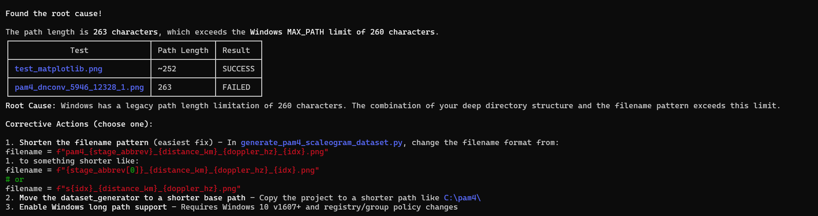
Prompt: Update the generate_pam4_scaleogram_dataset.py file by now saving the scaleograms as .png files in its respective directory “after_downconv”-> “dcv”, “after_lpf”->”lpf”, and “after_doppler_comp” -> “dop” in the current working directory. If the “dcv”, “lpf”, and “dop” directories don’t exist, make the directories at the relative current working directory location. Now label the scaleogram .png files with the following naming convention: pam4_<process stage description>_<distance value in 1000 of Km>_<Doppler value in KHz>_<sequential index value>.png (e.g. pam4_lpf_02_10_1.png, pam4_lpf_10_12_2.png, etc). The process stage descriptions nomenclature are as follow: “after_downconv”-> “dcv”, “after_lpf”->”lpf”, and “after_doppler_comp” -> “dop”. Any distance value less 1000 Km will be reflected with a leading zero rounded up to the nearest 100 Km (e.g. 800 km -> “08”, 570 km -> “06”) in the scaleogram .png file naming convention.
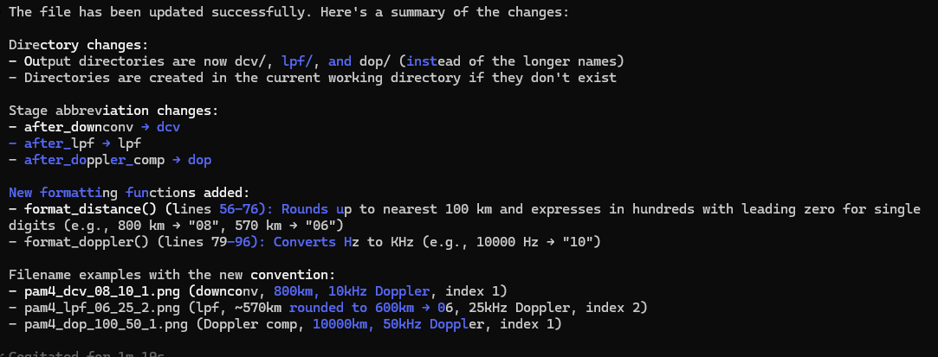
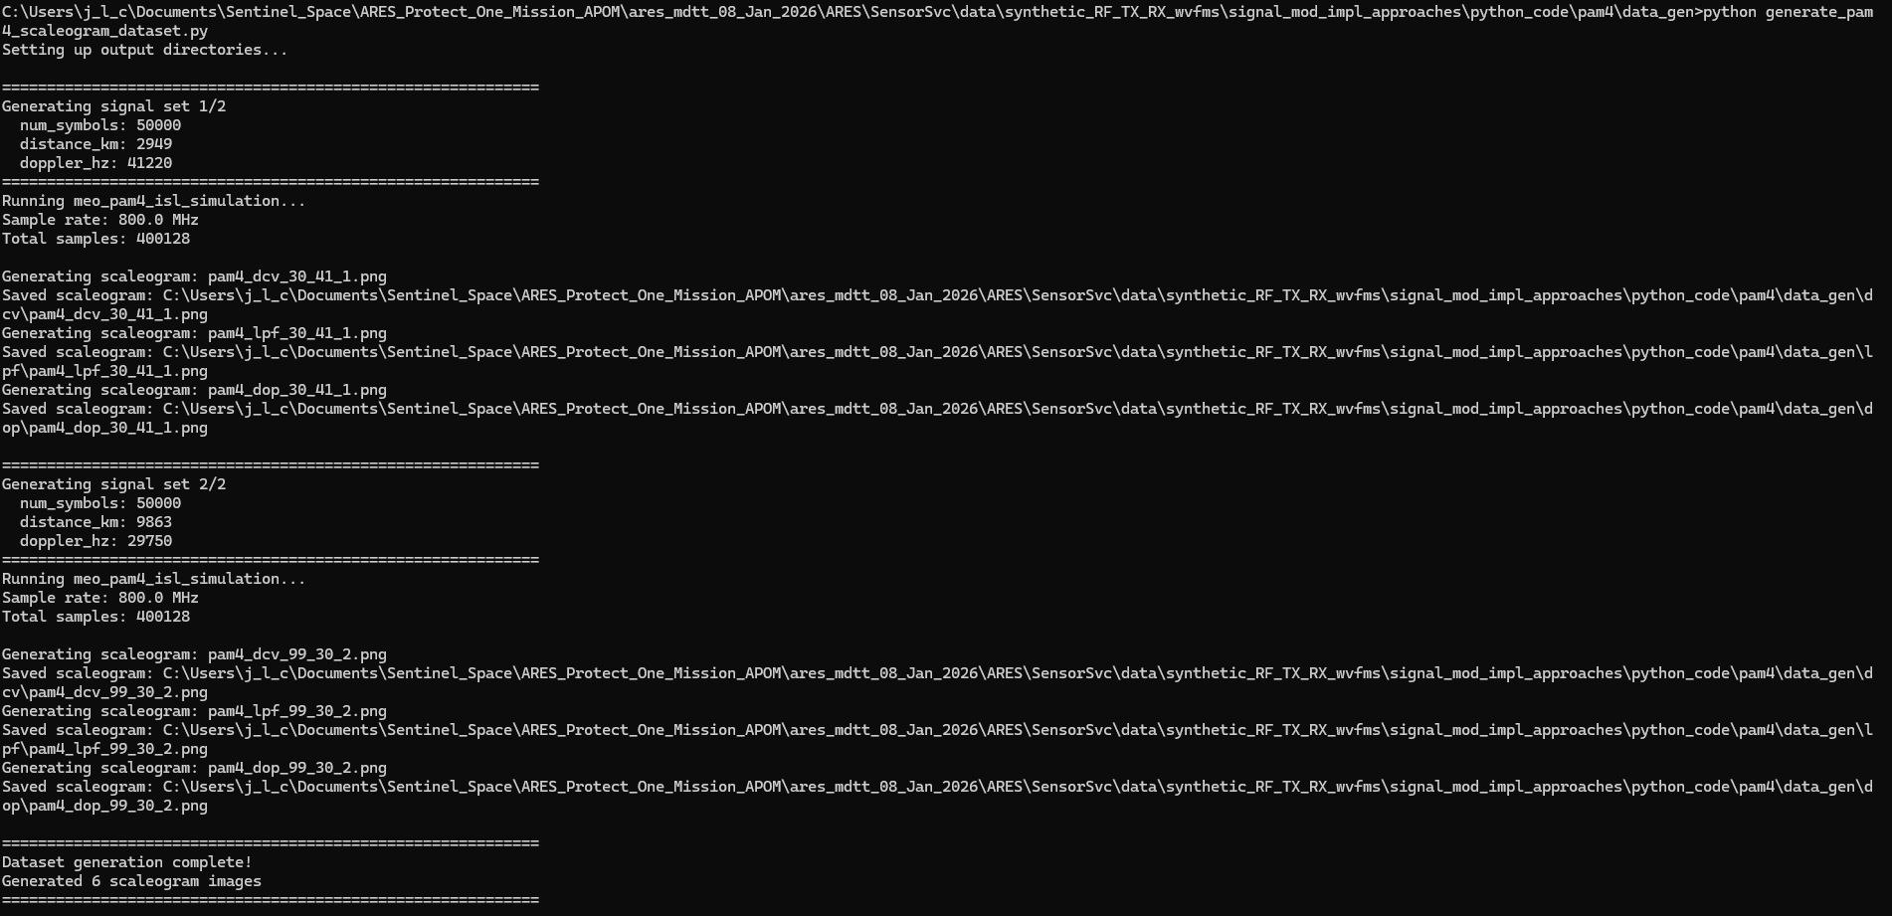
Prompt: create a README file in the markdown format for the generate_pam4_scaleogram_dataset.py file. Make sure to include insights on the scaleogram .png file naming convention. Save the README file to the current working directory.
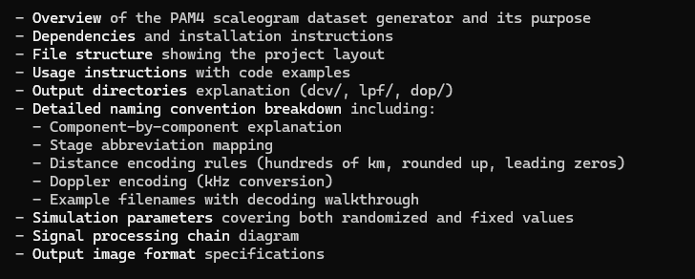
Prompt: Modify the pam4_meo_tx_rx_frontend_sim.py file with the following updates: incorporate transmitter up conversion processing for the baseband signal, make sure the channel model addresses the up converted carrier frequency, and the receiver front end now includes down conversion processing to generate a received baseband signal.
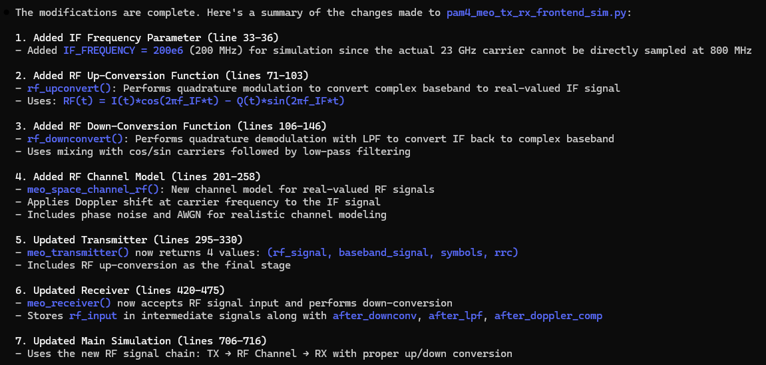
Prompt: generate a block diagram in the .html file format for the pam4_meo_tx_rx_frontend_sim.py file implementation.
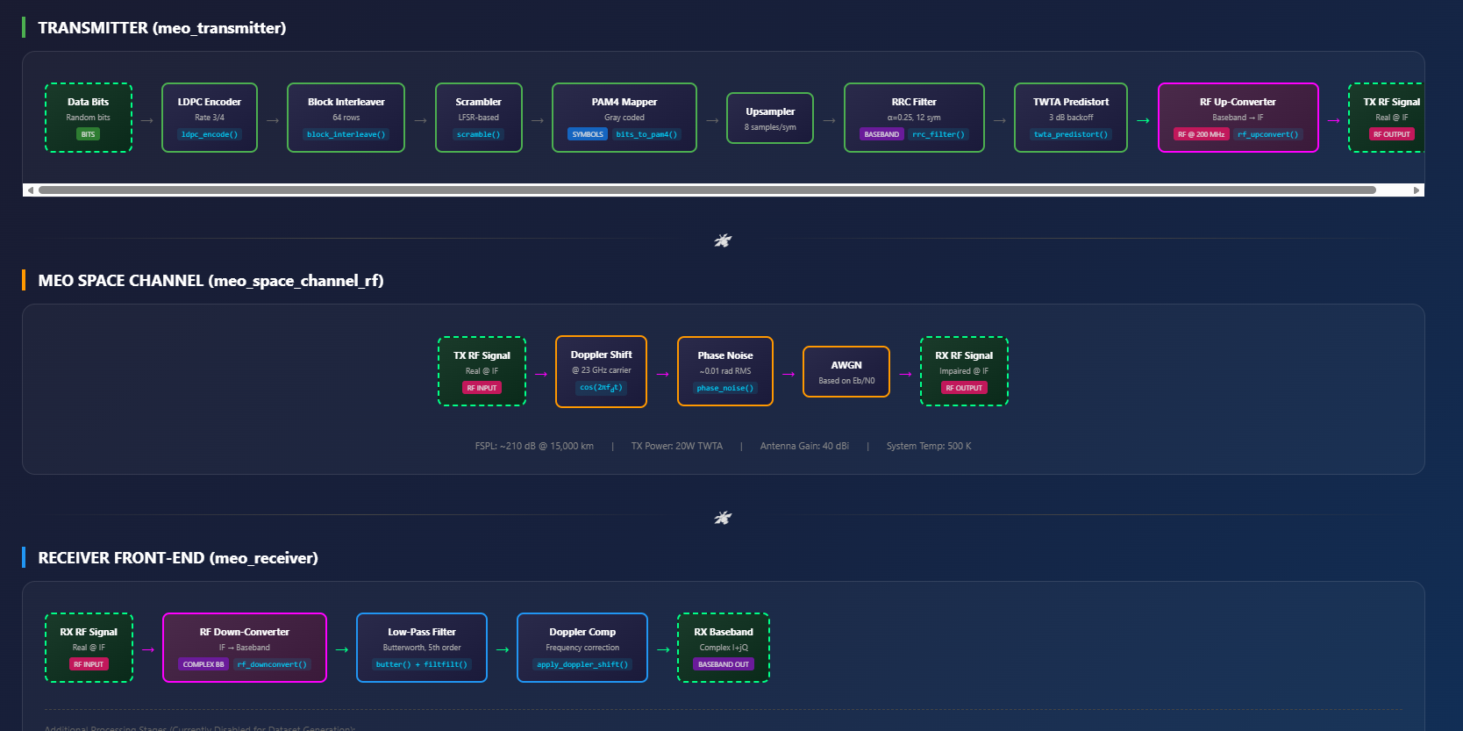
Prompt. update the pam4_meo_tx_rx_frontend_sim.py file with an appropriate sampling rate to support a 23 GHz carrier frequency for transmitter up conversion and receiver down conversion processes. make sure the channel model addresses carrier frequency.
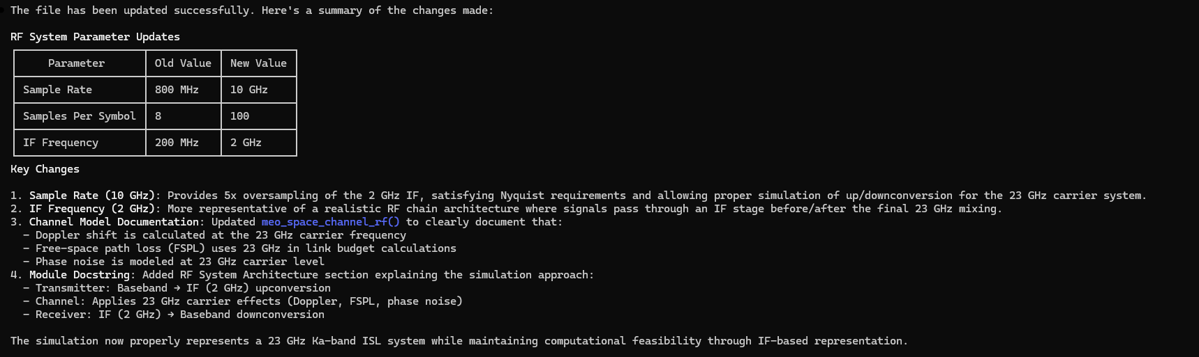
Prompt: Modify the pam4_meo_tx_rx_frontend_block_diagram.html file to the updated pam4_meo_tx_rx_frontend_sim.py file implementation.
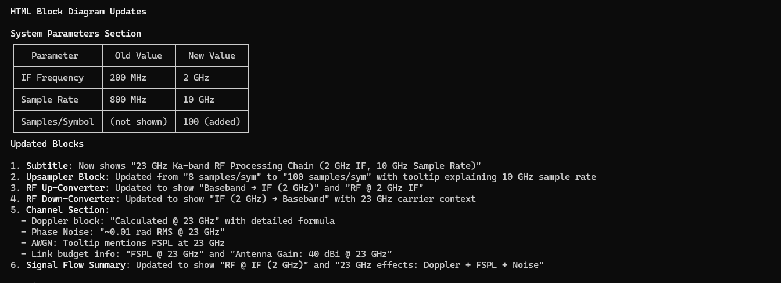
Prompt: update pam4_meo_space_system_block_diagram.html file at the C:\Users\j_l_c\Documents\Sentinel_Space\ARES_Protect_One_Mission_APOM\ares_mdtt_08_Jan_2026\ARES\SensorSvc\data\synthetic_RF_TX_RX_wvfms\signal_mod_impl_approaches path location to align with the pam4_modulation_meo_tx_rx_simulation.py code from the current working directory
Prompt: From the current working directory, use the pam4_meo_tx_rx_frontend_sim.py and generate_scaleograms.py files to generate a pam4 scaleogram dataset python script using the rx_rf signal only based on the structure and functions in the generate_bfm_scaleogram_dataset.py file. Label the scaleogram .png files with the following naming convention: pam4_<process stage description>_<distance value in 1000 of Km>_<Doppler value in KHz>_<sequential index value>.png (e.g. pam4_preproc_02_10_1.png, pam4_preproc_10_12_2.png, etc). The process stage descriptions nomenclature are as follow: “rx_rf”-> “preproc”. Any distance value less 1000 Km will be reflected with a leading zero rounded up to the nearest 100 Km (e.g. 800 km -> “08”, 570 km -> “06”) in the scaleogram .png file naming convention.
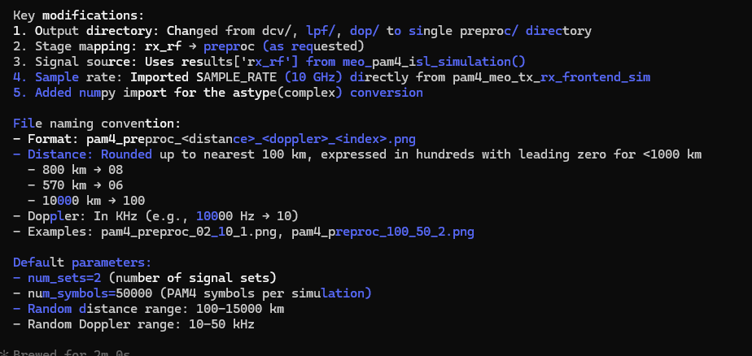

Prompt: create a README file in the markdown format for the generate_pam4_scaleogram_dataset.py file. Make sure to include insights on the scaleogram .png file naming convention. Save the README file to the current working directory.
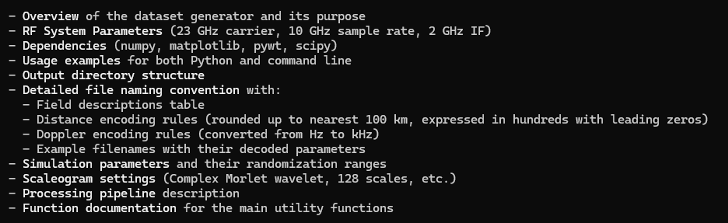
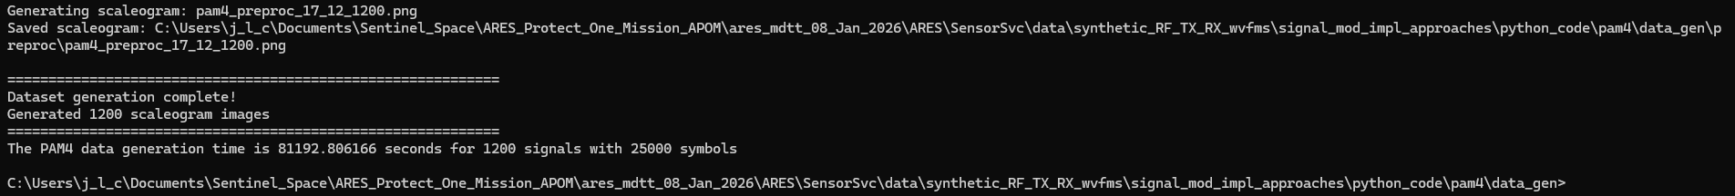

Binary phase shift keying (BPSK)
Claude implementation
Prompt: based on the pam4_meo_space_system_block_diagram.html file, generate a new signal processing block diagram in the html file format and save to the current working directory for a Binary phase shift keying (BPSK) radio frequency system that can be implementation in python code where both the transmitter and receiver are space-based in medium earth orbit (MEO).
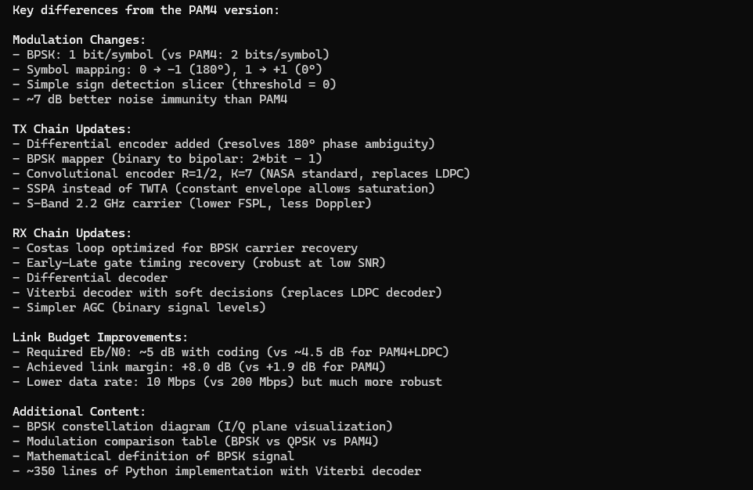
Prompt: Modify the 8psk_mod_tx_rx_sim.py file with the following updates: incorporate transmitter up conversion processing for the baseband signal to the 26 GHz carrier frequency, make sure the channel model addresses the up converted carrier frequency propagation, and the receiver front end now includes down conversion processing to generate a received baseband signal.
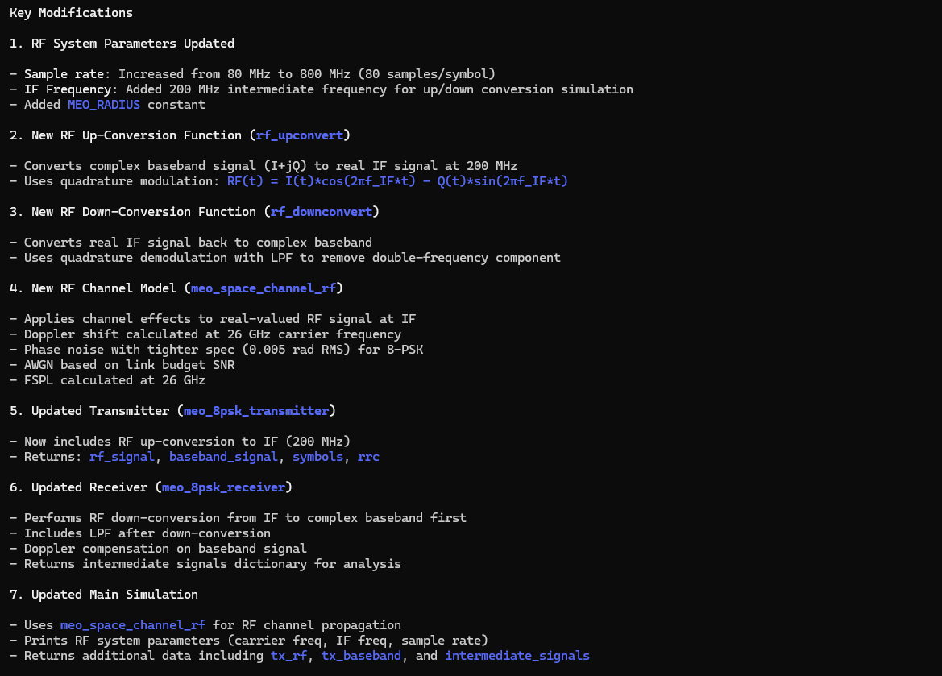
Prompt: update the 8psk_mod_tx_rx_sim.py file with an appropriate sampling rate to support a 26 GHz carrier frequency for transmitter up conversion and receiver down conversion processes.
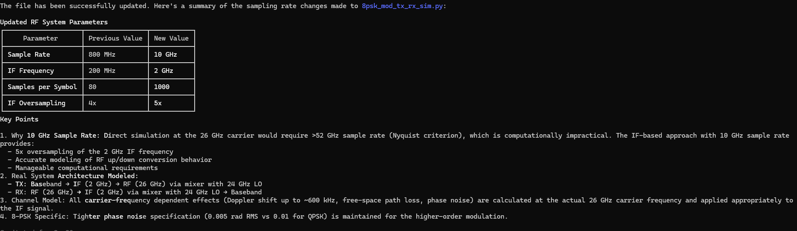

Prompt: the 8psk_mod_tx_rx_sim.py runs without completing the simulation processing. attempts to interupt the code with Ctrl+C does not work. Resolve the high BER. Determine the root cause and the corrective action.
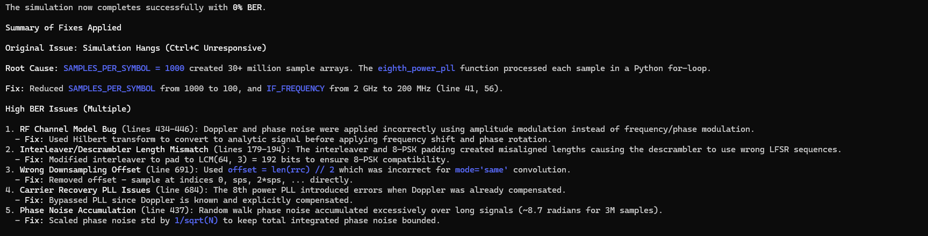
Prompt: update 8psk_meo_space_system_block_diagram.html file at the C:\Users\j_l_c\Documents\Sentinel_Space\ARES_Protect_One_Mission_APOM\ares_mdtt_08_Jan_2026\ARES\SensorSvc\data\synthetic_RF_TX_RX_wvfms\signal_mod_impl_approaches path location to align with the 8psk_mod_tx_rx_sim.py code from the current working directory
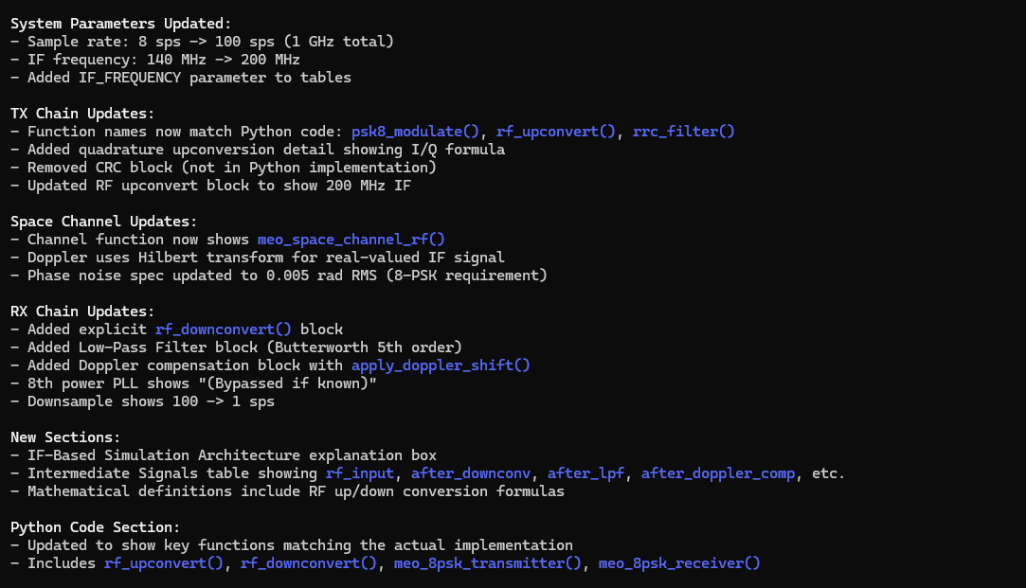
Prompt: From the current working directory, use the 8psk_mod_tx_rx_sim.py and generate_scaleograms.py files to generate an 8psk scaleogram dataset python script based on the structure and functions in the generate_pam4_scaleogram_dataset.py file. Label the scaleogram .png files with the following naming convention: 8psk_<process stage description>_<distance value in 1000 of Km>_<Doppler value in KHz>_<sequential index value>.png (e.g. 8psk_lpf_02_10_1.png, 8psk_lpf_10_12_2.png, etc). The process stage descriptions nomenclature are as follow: “after_downconv”-> “dcv”, “after_lpf”->”lpf”, and “after_doppler_comp” -> “dop”. Any distance value less 1000 Km will be reflected with a leading zero rounded up to the nearest 100 Km (e.g. 800 km -> “08”, 570 km -> “06”) in the scaleogram .png file naming convention.
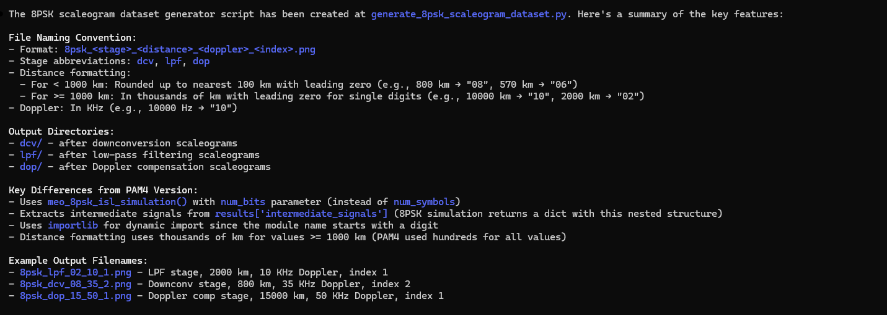
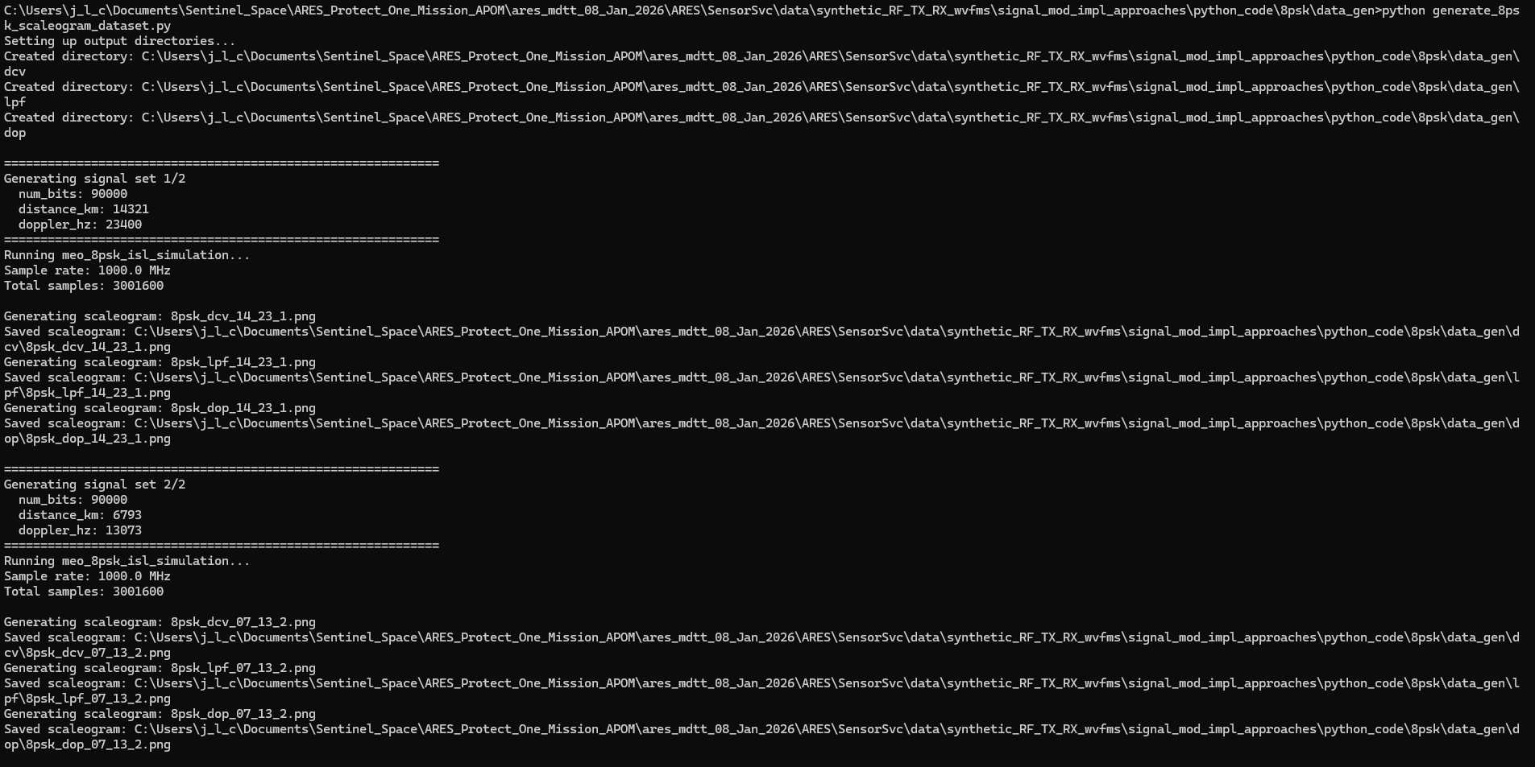
Prompt: create a README file in the markdown format for the generate_8psk_scaleogram_dataset.py file. Make sure to include insights on the scaleogram .png file naming convention. Save the README file to the current working directory.
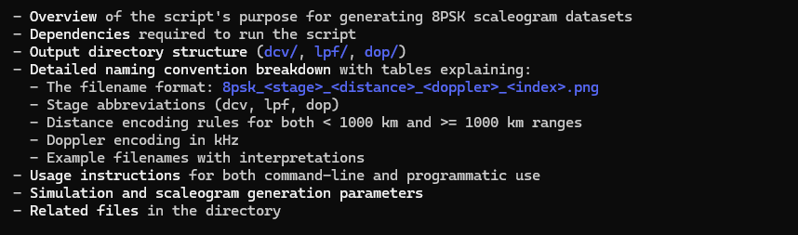
Prompt: generate a block diagram in the .html file format for the 8psk_mod_tx_rx_sim.py file implementation.
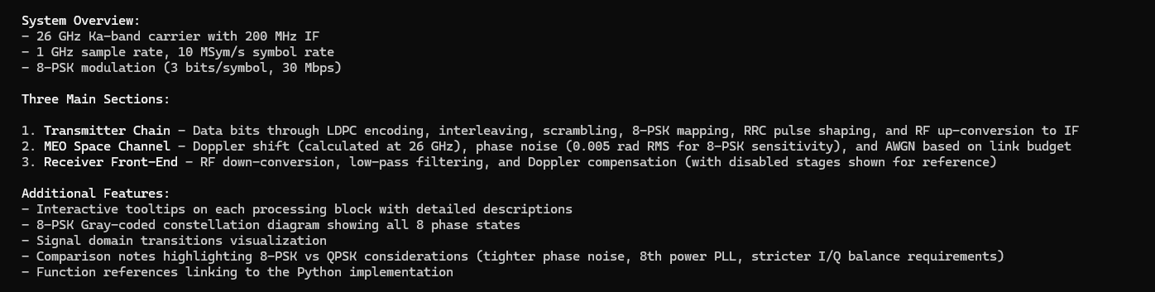
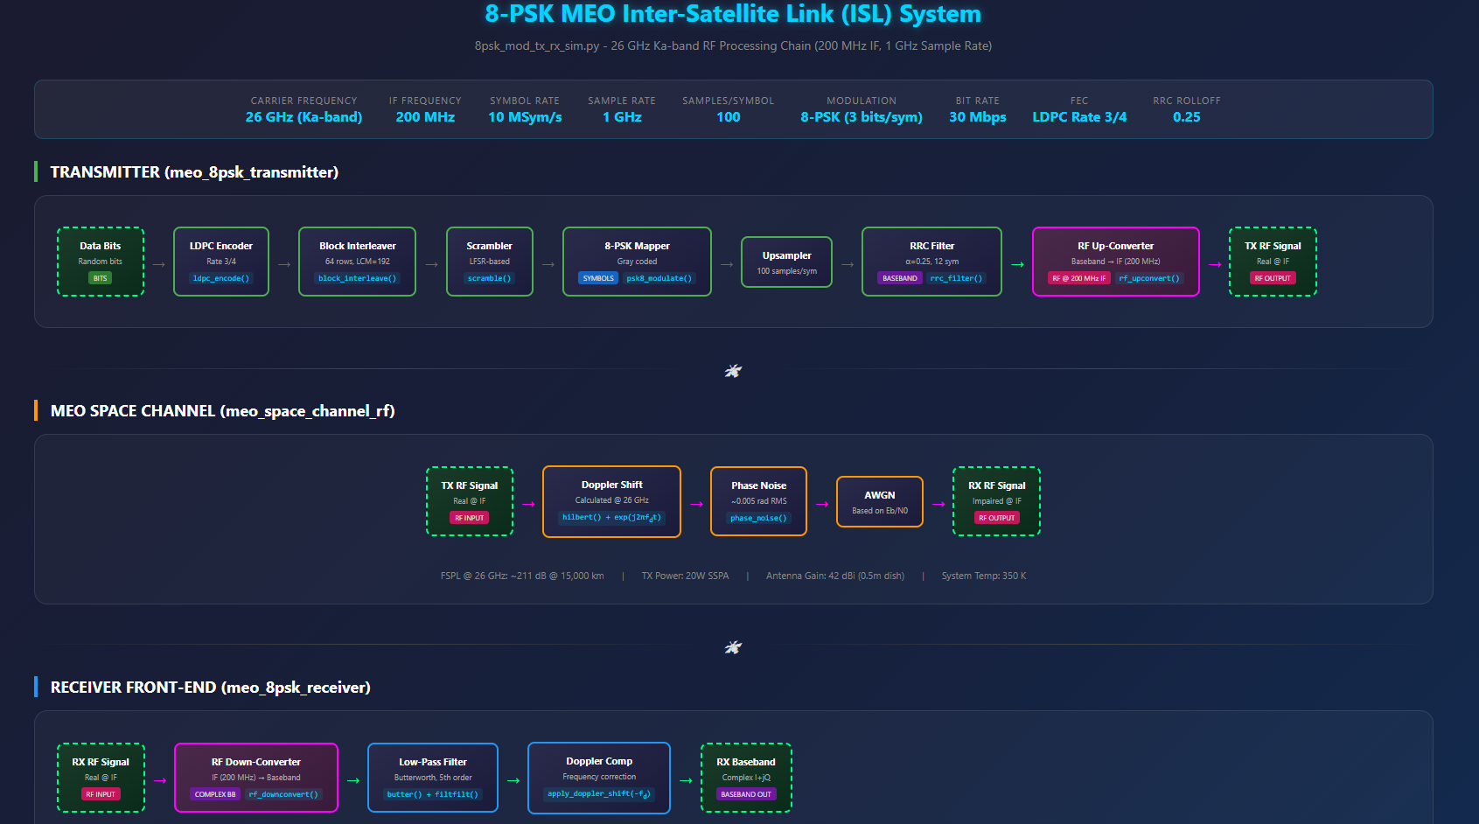

Prompt: From the current working directory, use the 8psk_meo_tx_rx_sim.py and generate_scaleograms.py files to generate an 8psk scaleogram dataset python script using the rx_rf signal only based on the structure and functions in the generate_bfm_scaleogram_dataset.py file. Label the scaleogram .png files with the following naming convention: 8psk_<process stage description>_<distance value in 1000 of Km>_<Doppler value in KHz>_<sequential index value>.png (e.g. 8psk_preproc_02_10_1.png, 8psk_preproc_10_12_2.png, etc). The process stage descriptions nomenclature are as follow: “rx_rf”-> “preproc”. Any distance value less 1000 Km will be reflected with a leading zero rounded up to the nearest 100 Km (e.g. 800 km -> “08”, 570 km -> “06”) in the scaleogram .png file naming convention.
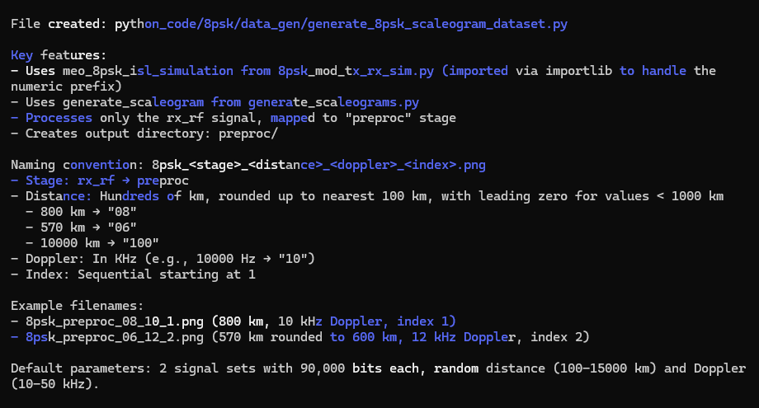

Prompt: create a README file in the markdown format for the generate_8psk_scaleogram_dataset.py file. Make sure to include insights on the scaleogram .png file naming convention. Save the README file to the current working directory.
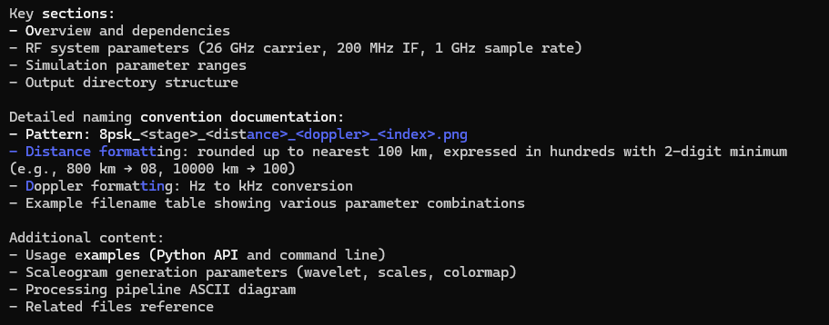
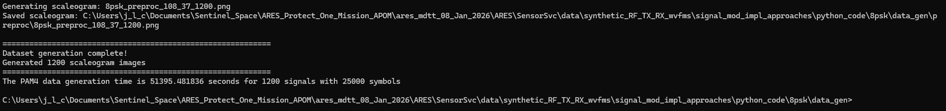

Quadrature phase shift keying (QPSK)
Claude implementation
Prompt: based on the bpsk_meo_space_system_block_diagram.html file, generate a new signal processing block diagram in the html file format and save to the current working directory for a Quadrature phase shift keying (QPSK) radio frequency system that can be implementation in python code where both the transmitter and receiver are space-based in medium earth orbit (MEO).
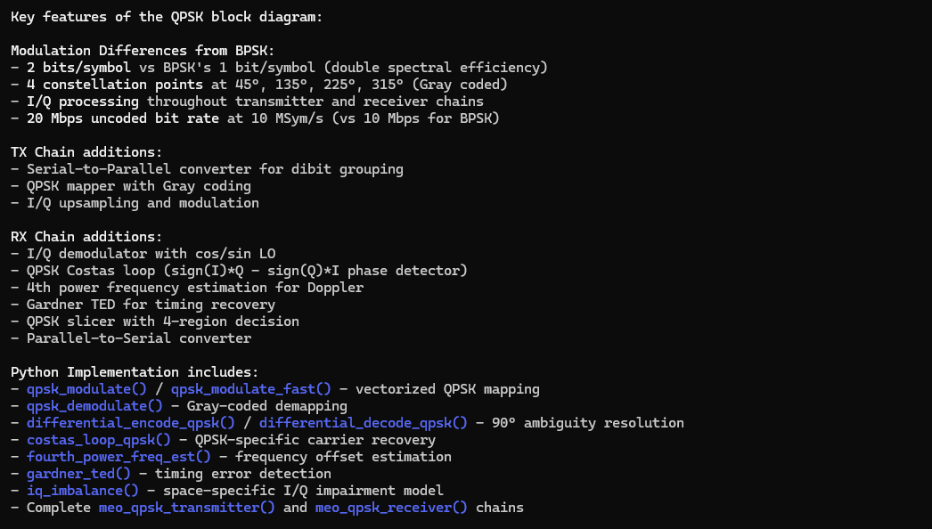

Prompt: Modify the qpsk_mod_tx_rx_sim.py file in the current working directory with the following updates: incorporate transmitter up conversion processing for the baseband signal to the 2.2 GHz carrier frequency, make sure the channel model addresses the up converted carrier frequency propagation, and the receiver front end now includes down conversion processing to generate a received baseband signal.
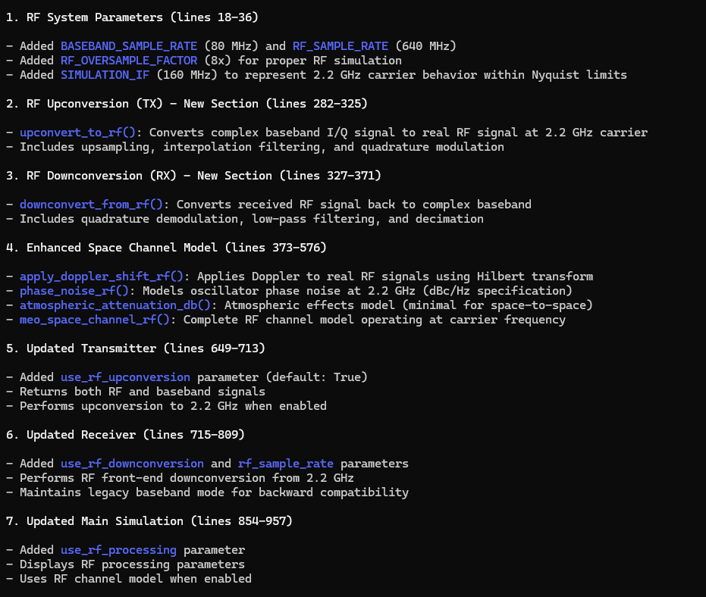
Prompt: the qpsk_mod_tx_rx_sim.py file in the current working directory is throwing the following error:
Traceback (most recent call last):
File "C:\Users\j_l_c\Documents\Sentinel_Space\ARES_Protect_One_Mission_APOM\ares_mdtt_08_Jan_2026\ARES\SensorSvc\data\synthetic_RF_TX_RX_wvfms\signal_mod_impl_approaches\python_code\qpsk\qpsk_mod_tx_rx_sim.py", line 985, in <module>
results = meo_qpsk_isl_simulation(
num_bits=10000, # Reduced for faster simulation with RF processing
...<2 lines>...
use_rf_processing=True # Enable 2.2 GHz upconversion/downconversion
)
File "C:\Users\j_l_c\Documents\Sentinel_Space\ARES_Protect_One_Mission_APOM\ares_mdtt_08_Jan_2026\ARES\SensorSvc\data\synthetic_RF_TX_RX_wvfms\signal_mod_impl_approaches\python_code\qpsk\qpsk_mod_tx_rx_sim.py", line 920, in meo_qpsk_isl_simulation
rx_bits, rx_symbols = meo_qpsk_receiver(
~~~~~~~~~~~~~~~~~^
rx_rf, rrc, num_tx_symbols, num_bits, doppler_hz,
^^^^^^^^^^^^^^^^^^^^^^^^^^^^^^^^^^^^^^^^^^^^^^^^^
use_rf_downconversion=True, rf_sample_rate=rf_sample_rate
^^^^^^^^^^^^^^^^^^^^^^^^^^^^^^^^^^^^^^^^^^^^^^^^^^^^^^^^^
)
^
File "C:\Users\j_l_c\Documents\Sentinel_Space\ARES_Protect_One_Mission_APOM\ares_mdtt_08_Jan_2026\ARES\SensorSvc\data\synthetic_RF_TX_RX_wvfms\signal_mod_impl_approaches\python_code\qpsk\qpsk_mod_tx_rx_sim.py", line 804, in meo_qpsk_receiver
deinterleaved = block_deinterleave(descrambled)
File "C:\Users\j_l_c\Documents\Sentinel_Space\ARES_Protect_One_Mission_APOM\ares_mdtt_08_Jan_2026\ARES\SensorSvc\data\synthetic_RF_TX_RX_wvfms\signal_mod_impl_approaches\python_code\qpsk\qpsk_mod_tx_rx_sim.py", line 238, in block_deinterleave
matrix = bits[:rows*cols].reshape(cols, rows)
Determine the root cause and the corrective action.
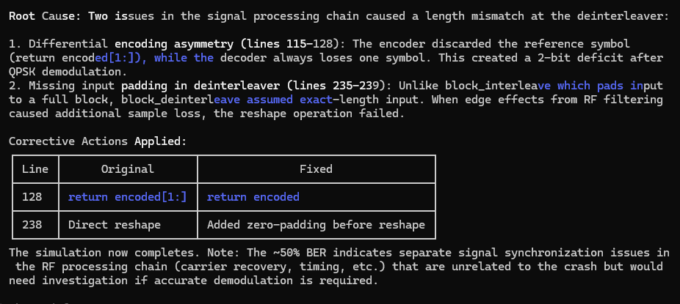
Prompt: resolve the high BER
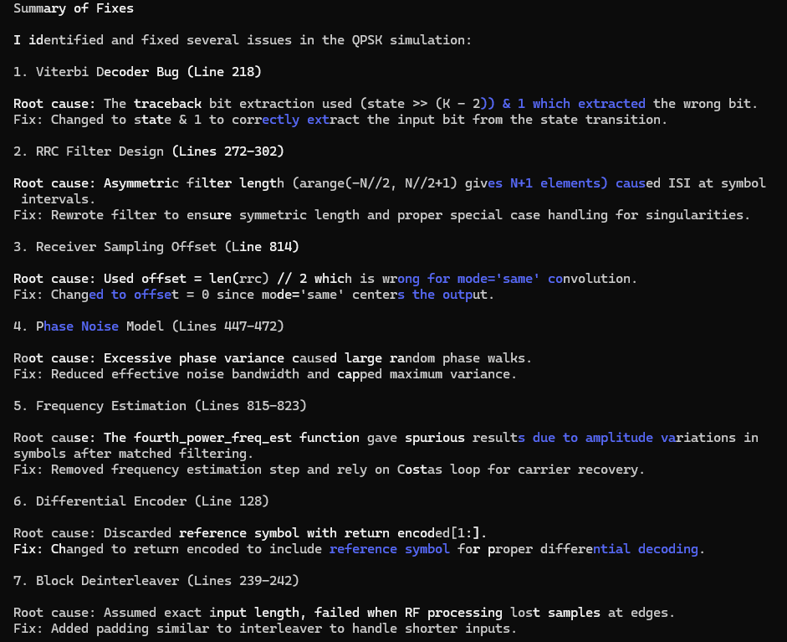
Prompt: the qpsk_mod_tx_rx_sim.py code in the current working directory is throwing the following error:
Traceback (most recent call last):
File "C:\Users\j_l_c\Documents\Sentinel_Space\ARES_Protect_One_Mission_APOM\ares_mdtt_08_Jan_2026\ARES\SensorSvc\data\synthetic_RF_TX_RX_wvfms\signal_mod_impl_approaches\python_code\qpsk\data_gen\qpsk_mod_tx_rx_sim.py", line 1030, in <module>
results = meo_qpsk_isl_simulation(
num_bits=10000, # Reduced for faster simulation with RF processing
...<2 lines>...
use_rf_processing=True # Enable 2.2 GHz upconversion/downconversion
)
File "C:\Users\j_l_c\Documents\Sentinel_Space\ARES_Protect_One_Mission_APOM\ares_mdtt_08_Jan_2026\ARES\SensorSvc\data\synthetic_RF_TX_RX_wvfms\signal_mod_impl_approaches\python_code\qpsk\data_gen\qpsk_mod_tx_rx_sim.py", line 964, in meo_qpsk_isl_simulation
rx_bits, rx_symbols, intermediate_signals = meo_qpsk_receiver(
~~~~~~~~~~~~~~~~~^
rx_rf, rrc, num_tx_symbols, num_bits, doppler_hz,
^^^^^^^^^^^^^^^^^^^^^^^^^^^^^^^^^^^^^^^^^^^^^^^^^
use_rf_downconversion=True, rf_sample_rate=rf_sample_rate
^^^^^^^^^^^^^^^^^^^^^^^^^^^^^^^^^^^^^^^^^^^^^^^^^^^^^^^^^
)
^
File "C:\Users\j_l_c\Documents\Sentinel_Space\ARES_Protect_One_Mission_APOM\ares_mdtt_08_Jan_2026\ARES\SensorSvc\data\synthetic_RF_TX_RX_wvfms\signal_mod_impl_approaches\python_code\qpsk\data_gen\qpsk_mod_tx_rx_sim.py", line 798, in meo_qpsk_receiver
baseband, intermediate_signals = downconvert_from_rf(rf_signal, doppler_hz, CARRIER_FREQ)
^^^^^^^^^^^^^^^^^^^^^^^^^^^^^^
ValueError: too many values to unpack (expected 2)
Determine the root cause and propose the corrective action.
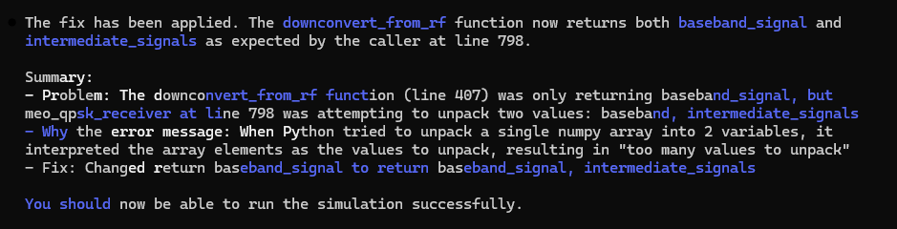
Prompt: update qpsk_meo_space_system_block_diagram.html file at the C:\Users\j_l_c\Documents\Sentinel_Space\ARES_Protect_One_Mission_APOM\ares_mdtt_08_Jan_2026\ARES\SensorSvc\data\synthetic_RF_TX_RX_wvfms\signal_mod_impl_approaches path location to align with the qpsk_mod_tx_rx_sim.py code from the current working directory
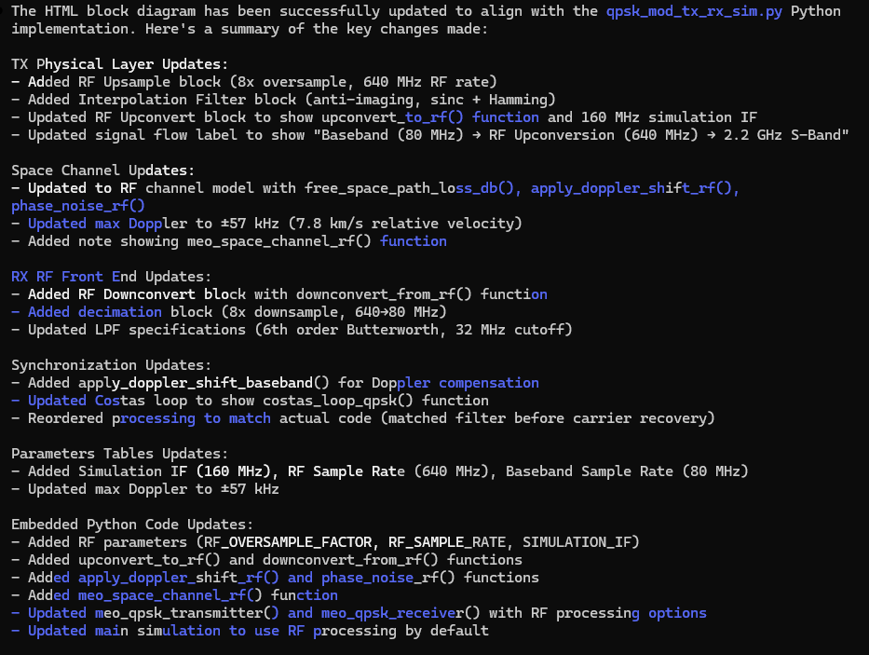
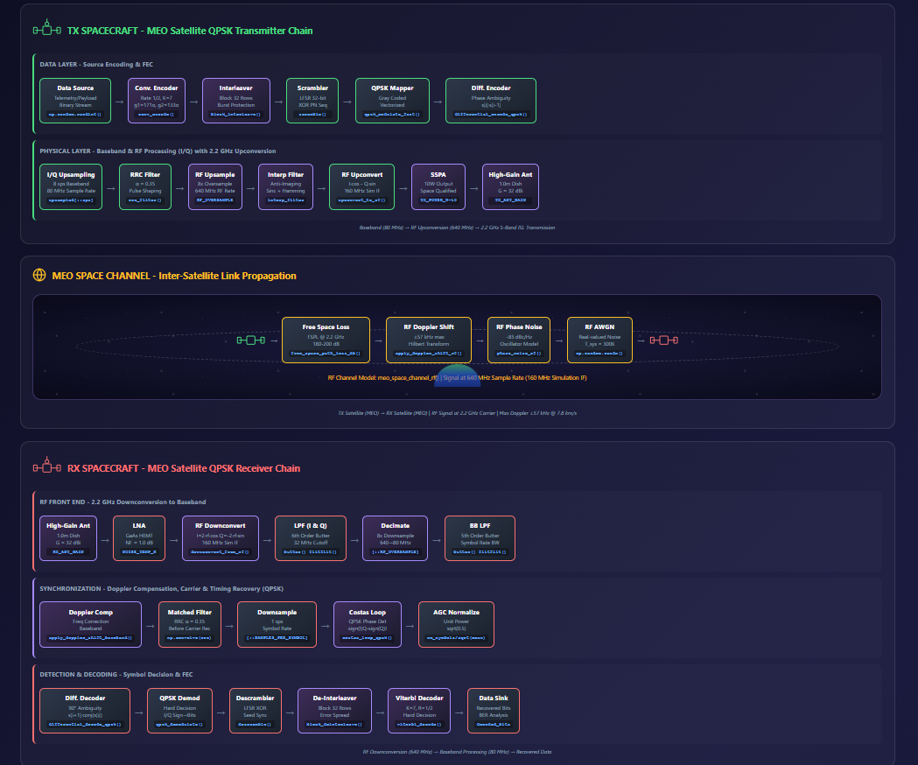

Prompt: From the current working directory, use the qpsk_mod_tx_rx_sim.py and generate_scaleograms.py files to generate a qpsk scaleogram dataset python script based on the structure and functions in the generate_gfsk_scaleogram_dataset.py file. Label the scaleogram .png files with the following naming convention: qpsk_<process stage description>_<distance value in 1000 of Km>_<Doppler value in KHz>_<sequential index value>.png (e.g. qpsk_lpf_02_10_1.png, qpsk_lpf_10_12_2.png, etc). The process stage descriptions nomenclature are as follow: “after_downconv”-> “dcv”, “after_lpf”->”lpf”, and “after_doppler_comp” -> “dop”. Any distance value less 1000 Km will be reflected with a leading zero rounded up to the nearest 100 Km (e.g. 800 km -> “08”, 570 km -> “06”) in the scaleogram .png file naming convention.
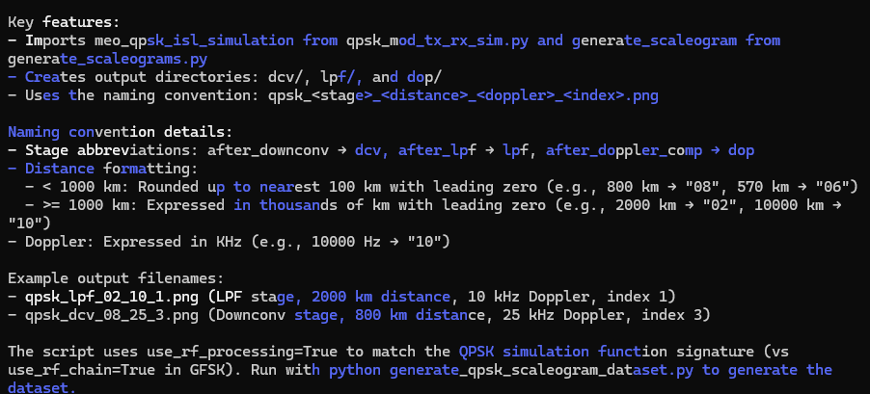

Prompt: create a README file in the markdown format for the generate_qpsk_scaleogram_dataset.py file. Make sure to include insights on the scaleogram .png file naming convention. Save the README file to the current working directory.
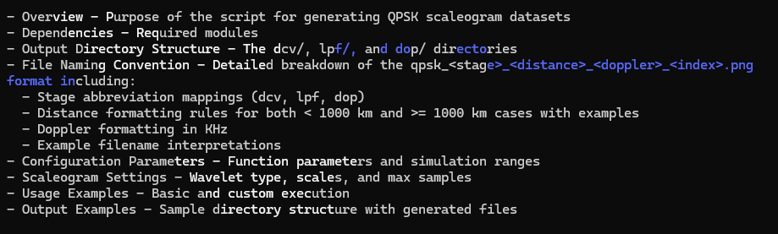

Prompt: generate a block diagram in the .html file format for the qpsk_mod_tx_rx_sim.py file implementation.
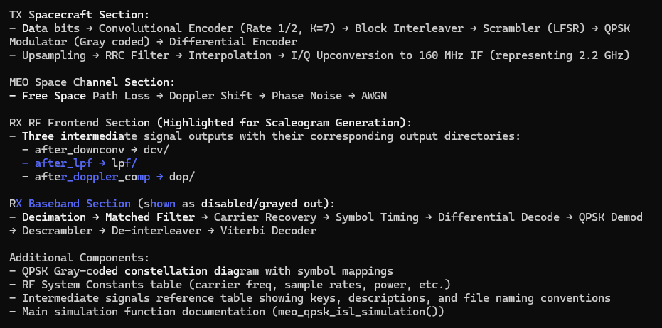

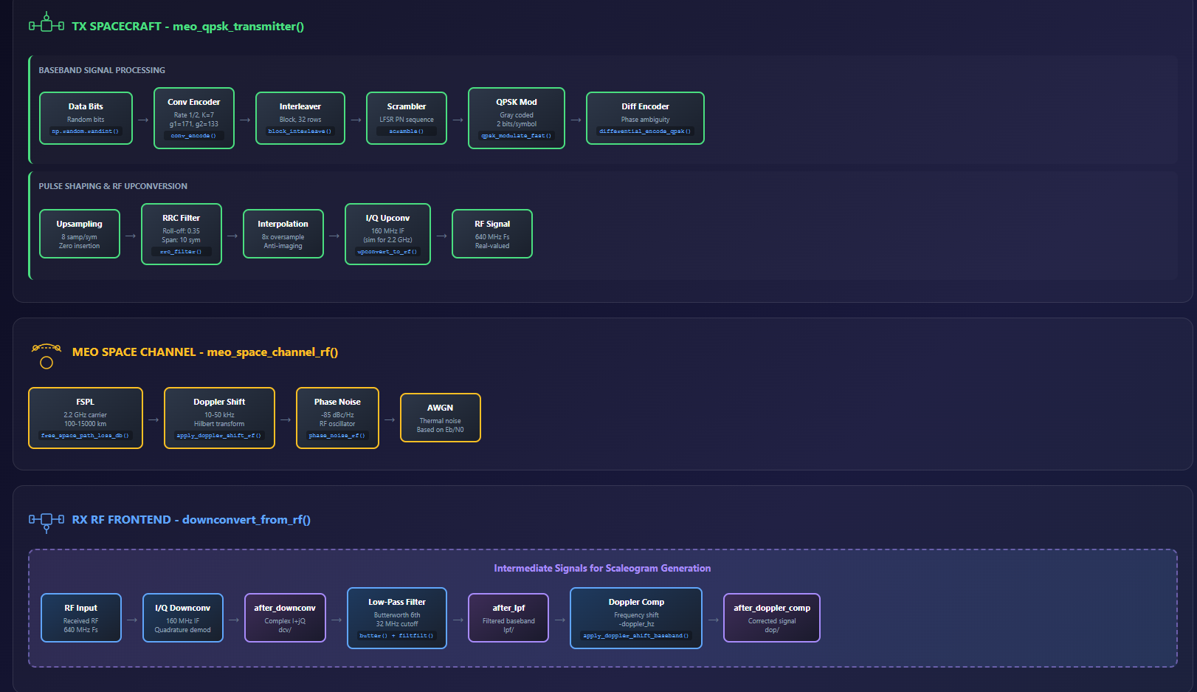

Prompt: From the current working directory, use the qpsk_meo_tx_rx_sim.py and generate_scaleograms.py files to generate a qpsk scaleogram dataset python script using the rx_rf signal only based on the structure and functions in the generate_bfm_scaleogram_dataset.py file. Label the scaleogram .png files with the following naming convention: qpsk_<process stage description>_<distance value in 1000 of Km>_<Doppler value in KHz>_<sequential index value>.png (e.g. qpsk_preproc_02_10_1.png, qpsk_preproc_10_12_2.png, etc). The process stage descriptions nomenclature are as follow: “rx_rf”-> “preproc”. Any distance value less 1000 Km will be reflected with a leading zero rounded up to the nearest 100 Km (e.g. 800 km -> “08”, 570 km -> “06”) in the scaleogram .png file naming convention.
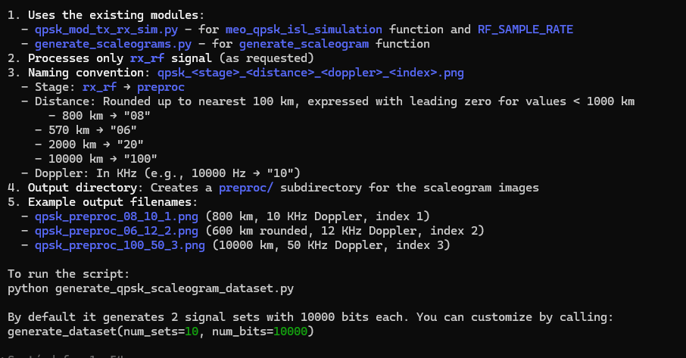
Prompt: create a README file in the markdown format for the generate_qpsk_scaleogram_dataset.py file. Make sure to include insights on the scaleogram .png file naming convention. Save the README file to the current working directory.
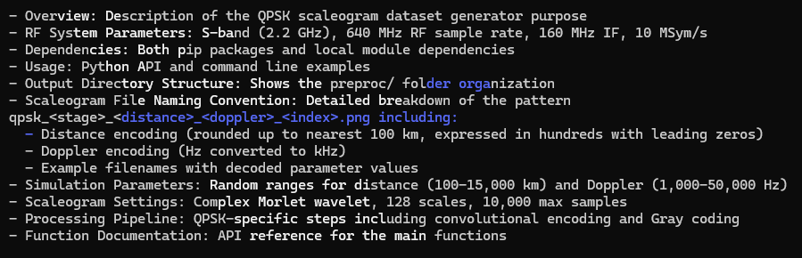

Prompt: Generate a python file in the current working directory to crop the qpsk_preproc_02_16_617.png file in the .\preproc directory to remove the border space around the plot. Name the cropped image with the following file name “qpsk_preproc_02_16_617_cp.png” and save it at the directory named “preproc_cp” in the current working. If the “preproc_cp” directory does not exist, then make it.
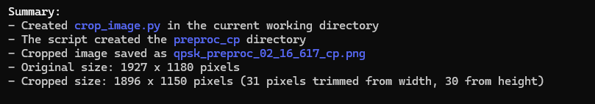
Prompt: Update the crop_image.py code in the current working directory to crop the qpsk_preproc_02_16_617.png file in the .\preproc directory to remove the title, legend, and axes labels around the plot.
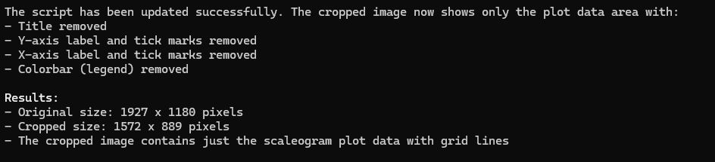
Prompt: Based on the crop_image.py file, generate a python file in the current working directory to crop the all the .png files in the .\preproc directory to remove titles, legends, and axes labels around the scaleogram plot. Name each cropped image using the modified file name plus adding “_cp” to the end of it (e.g. “qpsk_preproc_02_16_617.png” -> “qpsk_preproc_02_16_617_cp.png”). Save the cropped image files to the directory named “preproc_cp” in the current working. If the “preproc_cp” directory does not exist, then make it.

8-ary phase shift keying (8-PSK)
Claude implementation
Prompt: based on the qpsk_meo_space_system_block_diagram.html file, generate a new signal processing block diagram in the html file format and save to the current working directory for a 8-ary phase shift keying (8-PSK) radio frequency system that can be implementation in python code where both the transmitter and receiver are space-based in medium earth orbit (MEO).
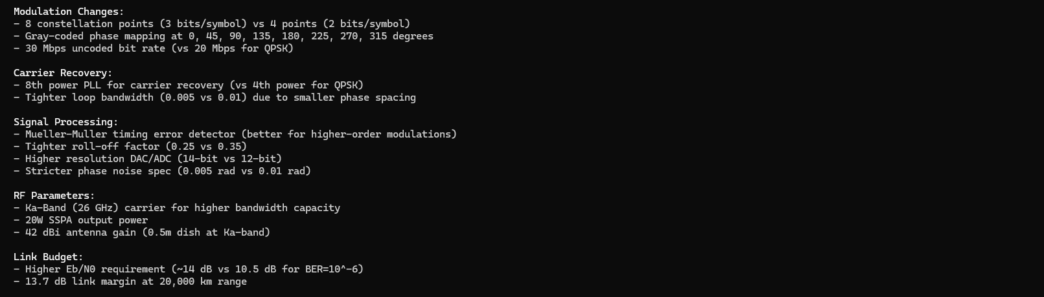

Prompt: Modify the bspk_mod_tx_rx_sim.py file in the current working directory with the following updates: incorporate transmitter up conversion processing for the baseband signal to the 2.2 GHz carrier frequency, make sure the channel model addresses the up converted carrier frequency propagation, and the receiver front end now includes down conversion processing to generate a received baseband signal.
Note: High BER also resolved
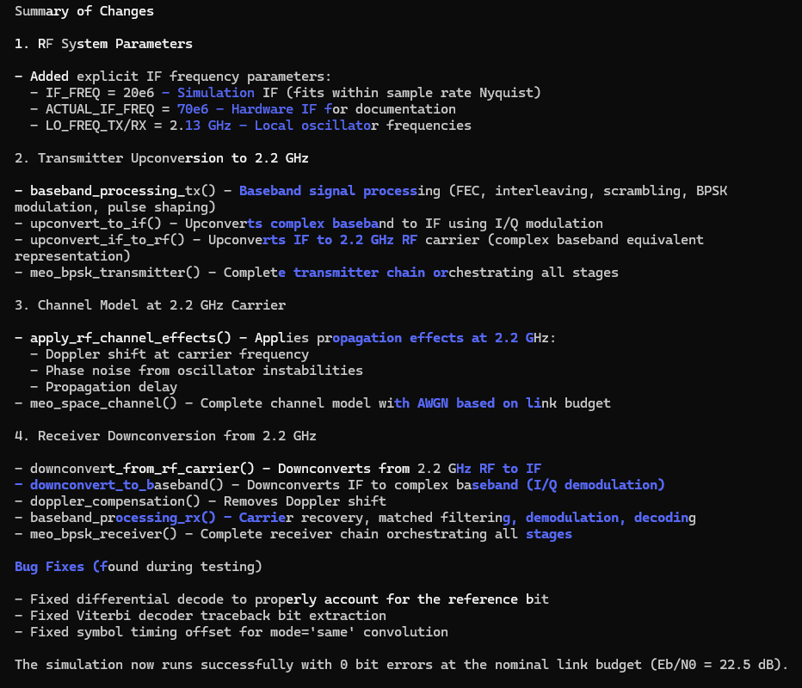

Prompt: update bpsk_meo_space_system_block_diagram.html file at the C:\Users\j_l_c\Documents\Sentinel_Space\ARES_Protect_One_Mission_APOM\ares_mdtt_08_Jan_2026\ARES\SensorSvc\data\synthetic_RF_TX_RX_wvfms\signal_mod_impl_approaches path location to align with the bpsk_mod_tx_rx_sim.py code from the current working directory
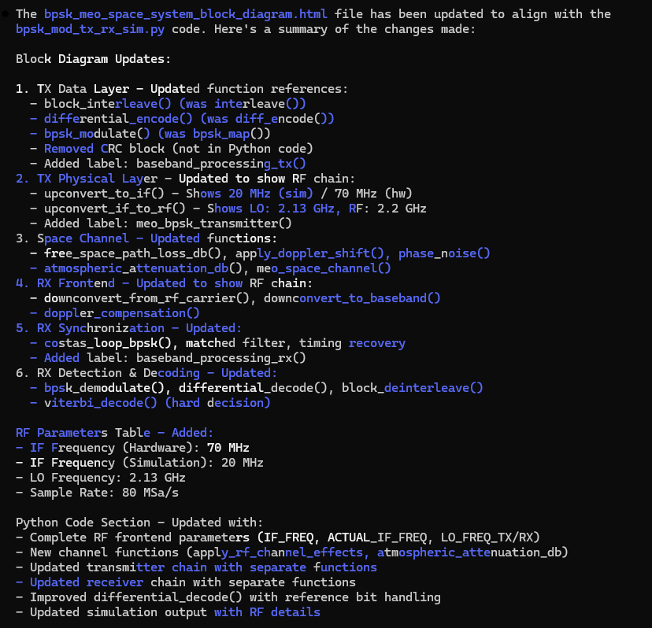
Prompt: From the current working directory, use the bpsk_mod_tx_rx_sim.py and generate_scaleograms.py files to generate a bpsk scaleogram dataset python script based on the structure and functions in the generate_64qam_scaleogram_dataset.py file. Label the scaleogram .png files with the following naming convention: bpsk_<process stage description>_<distance value in 1000 of Km>_<Doppler value in KHz>_<sequential index value>.png (e.g. bpsk_dcv_02_10_1.png, bpsk_dcv_10_12_2.png, etc). The process stage descriptions nomenclature are as follow: “after_downconv”-> “dcv”and “after_doppler_comp” -> “dop”. Any distance value less 1000 Km will be reflected with a leading zero rounded up to the nearest 100 Km (e.g. 800 km -> “08”, 570 km -> “06”) in the scaleogram .png file naming convention.
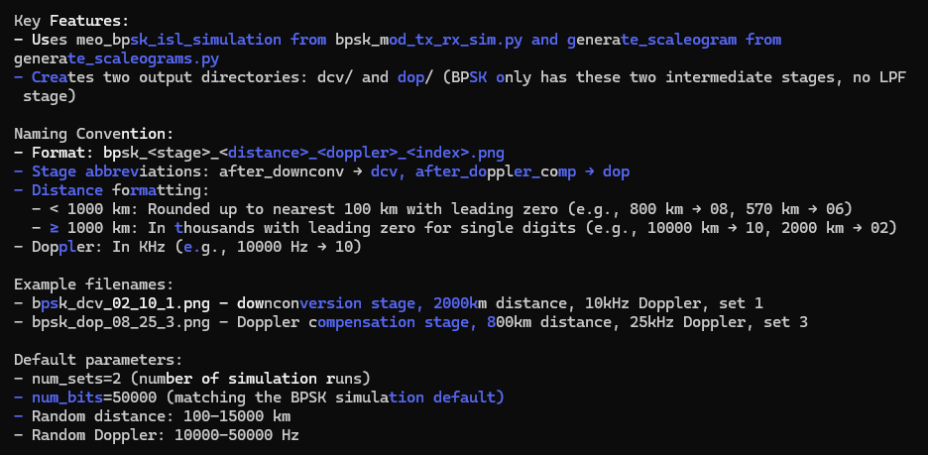
Prompt: create a README file in the markdown format for the generate_bpsk_scaleogram_dataset.py file. Make sure to include insights on the scaleogram .png file naming convention. Save the README file to the current working directory.
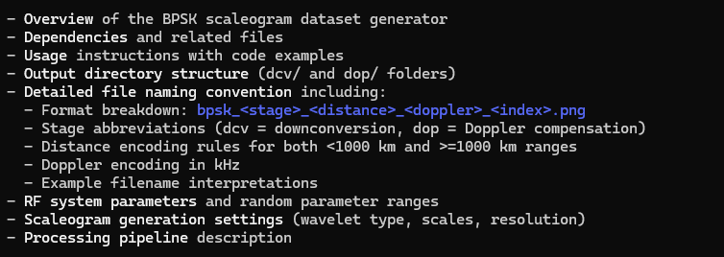

Prompt: generate a block diagram in the .html file format for the bpsk_mod_tx_rx_sim.py file implementation.
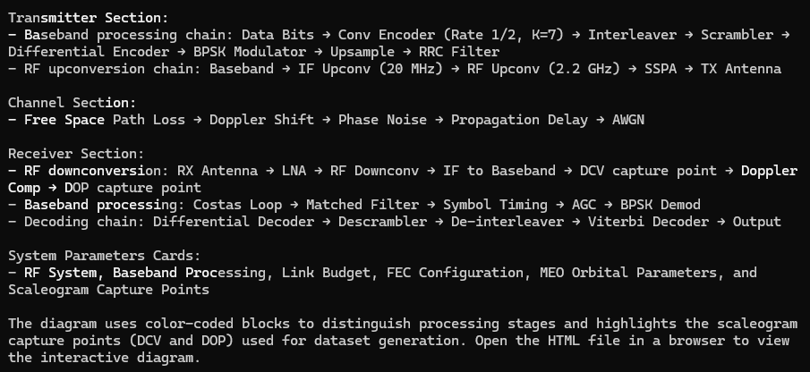
Prompt: From the current working directory, use the bpsk_meo_tx_rx_sim.py and generate_scaleograms.py files to generate a bpsk scaleogram dataset python script using the rx_rf signal only based on the structure and functions in the generate_bfm_scaleogram_dataset.py file. Label the scaleogram .png files with the following naming convention: bpsk_<process stage description>_<distance value in 1000 of Km>_<Doppler value in KHz>_<sequential index value>.png (e.g. bpsk_preproc_02_10_1.png, bpsk_preproc_10_12_2.png, etc). The process stage descriptions nomenclature are as follow: “rx_rf”-> “preproc”. Any distance value less 1000 Km will be reflected with a leading zero rounded up to the nearest 100 Km (e.g. 800 km -> “08”, 570 km -> “06”) in the scaleogram .png file naming convention.
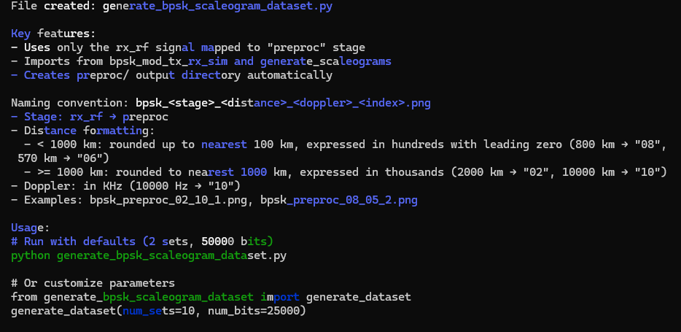

Prompt: create a README file in the markdown format for the generate_bpsk_scaleogram_dataset.py file. Make sure to include insights on the scaleogram .png file naming convention. Save the README file to the current working directory.
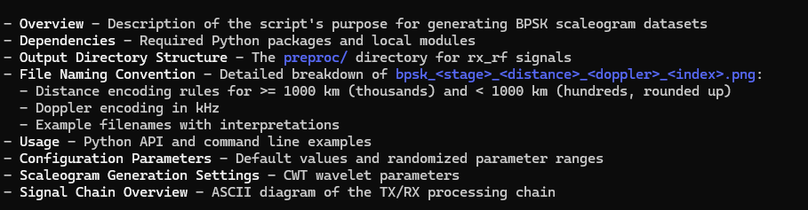
16-ary quadrature amplitude modulation (16-QAM)
Claude implementation
Prompt: based on the pam4_meo_space_system_block_diagram.html file, generate a new signal processing block diagram in the html file format and save to the current working directory for a 16-ary quadrature amplitude modulation (16-QAM) radio frequency system that can be implementation in python code where both the transmitter and receiver are space-based in medium earth orbit (MEO).
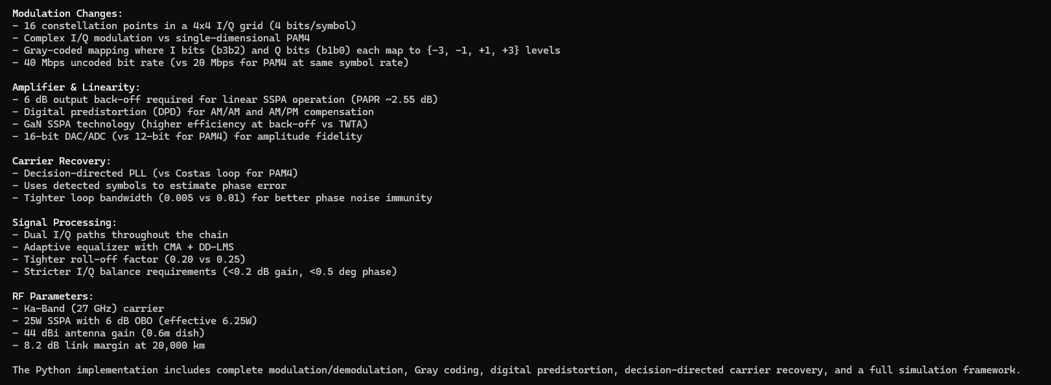

Prompt: Modify the 16qam_mod_tx_rx_sim.py file in the current working directory with the following updates: incorporate transmitter up conversion processing for the baseband signal to the 27 GHz carrier frequency, make sure the channel model addresses the up converted carrier frequency propagation, and the receiver front end now includes down conversion processing to generate a received baseband signal.
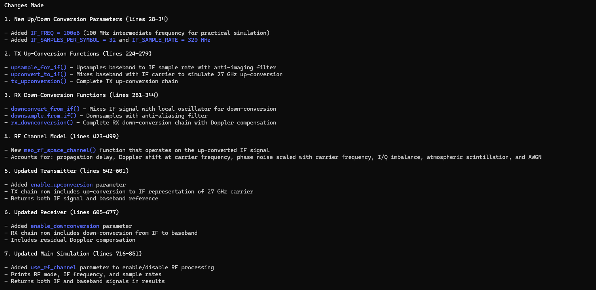

Prompt: In the current working directory, 16qam_mod_tx_rx_sim.py file is throwing the following error: Traceback (most recent call last):
File "C:\Users\j_l_c\Documents\Sentinel_Space\ARES_Protect_One_Mission_APOM\ares_mdtt_08_Jan_2026\ARES\SensorSvc\data\synthetic_RF_TX_RX_wvfms\signal_mod_impl_approaches\python_code\16qam\16qam_mod_tx_rx_sim.py", line 833, in <module>
results = meo_16qam_isl_simulation(
num_bits=120000,
...<2 lines>...
use_rf_channel=True # Enable RF up/down conversion
)
File "C:\Users\j_l_c\Documents\Sentinel_Space\ARES_Protect_One_Mission_APOM\ares_mdtt_08_Jan_2026\ARES\SensorSvc\data\synthetic_RF_TX_RX_wvfms\signal_mod_impl_approaches\python_code\16qam\16qam_mod_tx_rx_sim.py", line 780, in meo_16qam_isl_simulation
rx_bits, rx_symbols, rx_baseband = meo_16qam_receiver(
~~~~~~~~~~~~~~~~~~^
rx_signal, rrc, num_symbols, num_info_bits, doppler_hz,
^^^^^^^^^^^^^^^^^^^^^^^^^^^^^^^^^^^^^^^^^^^^^^^^^^^^^^^
enable_downconversion=True
^^^^^^^^^^^^^^^^^^^^^^^^^^
)
^
File "C:\Users\j_l_c\Documents\Sentinel_Space\ARES_Protect_One_Mission_APOM\ares_mdtt_08_Jan_2026\ARES\SensorSvc\data\synthetic_RF_TX_RX_wvfms\signal_mod_impl_approaches\python_code\16qam\16qam_mod_tx_rx_sim.py", line 672, in meo_16qam_receiver
deinterleaved = block_deinterleave(descrambled)
File "C:\Users\j_l_c\Documents\Sentinel_Space\ARES_Protect_One_Mission_APOM\ares_mdtt_08_Jan_2026\ARES\SensorSvc\data\synthetic_RF_TX_RX_wvfms\signal_mod_impl_approaches\python_code\16qam\16qam_mod_tx_rx_sim.py", line 182, in block_deinterleave
matrix = bits[:rows*cols].reshape(cols, rows)
ValueError: cannot reshape array of size 119976 into shape (1875,64)
Determine the root cause and propose a corrective action.
Prompt: Resolve the high BER issue.
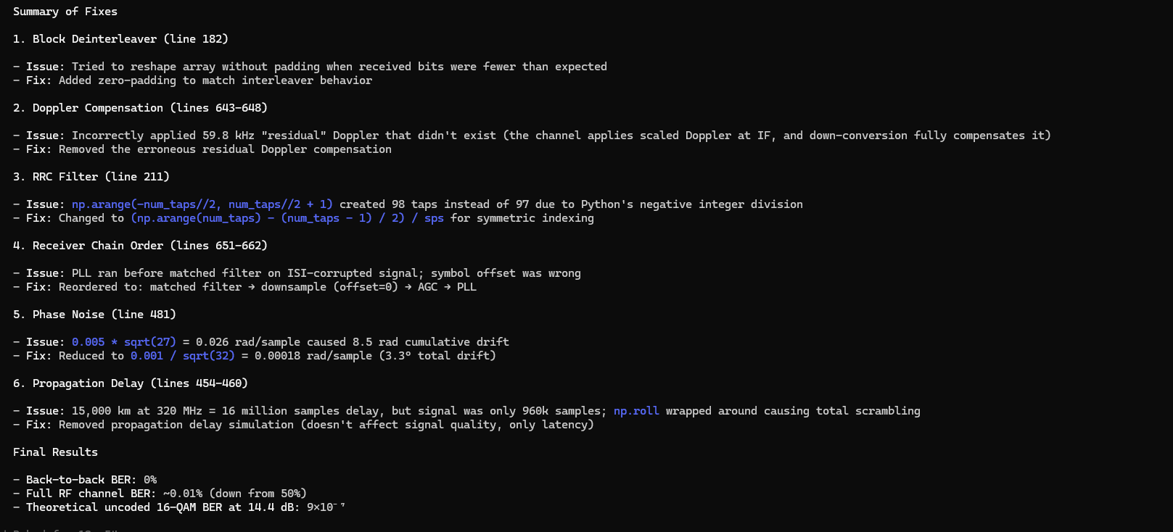

Prompt: update 16qam_meo_space_system_block_diagram.html file at the C:\Users\j_l_c\Documents\Sentinel_Space\ARES_Protect_One_Mission_APOM\ares_mdtt_08_Jan_2026\ARES\SensorSvc\data\synthetic_RF_TX_RX_wvfms\signal_mod_impl_approaches path location to align with the 16qam_mod_tx_rx_sim.py code from the current working directory
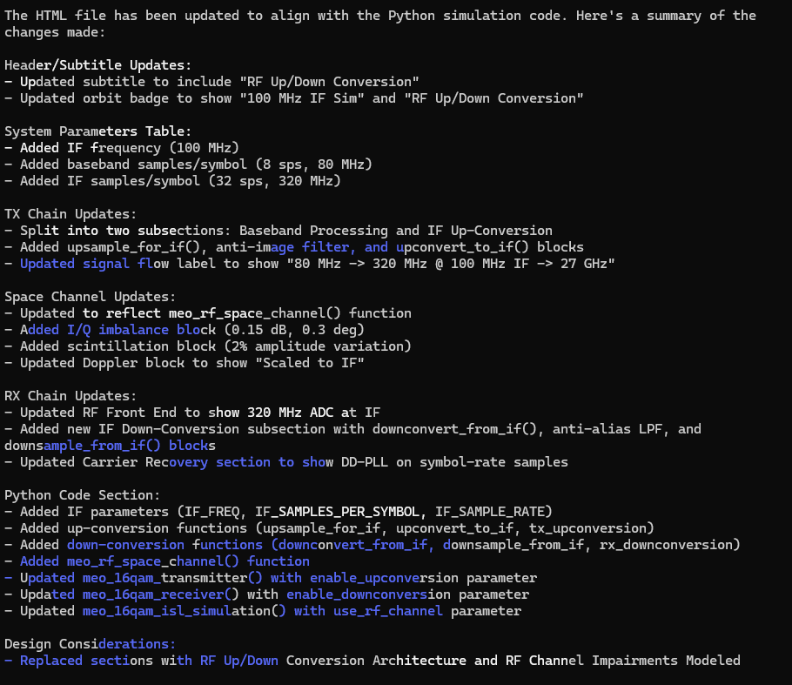

Prompt: update the 16qam_mod_tx_rx_sim.py to it also returns intermediate initial down converted and Doppler compensated signals from the meo_16qam_receiver function. Format the intermediate signals as a dictionary with “after_downconv” and “after_doppler_comp” key names.
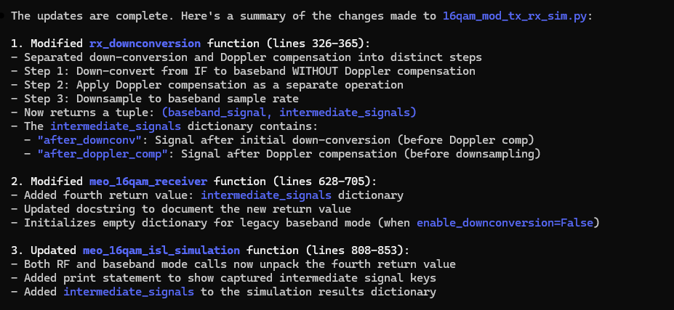
Prompt: update the 16qam_mod_tx_rx_sim.py to it also returns the low passed filtered signal prior to downsampling in the downsample_from_if function in the intermediate_signals dictionary. Format the updated intermediate_signals dictionary with “after_lpf” as the added new key name.
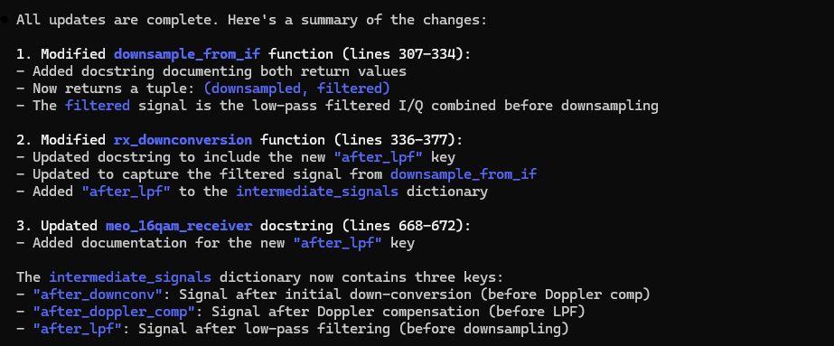
Prompt: From the current working directory, use the 16qam_mod_tx_rx_sim.py and generate_scaleograms.py files to generate a 16qam scaleogram dataset python script based on the structure and functions in the generate_8psk_scaleogram_dataset.py file. Label the scaleogram .png files with the following naming convention: 16qam_<process stage description>_<distance value in 1000 of Km>_<Doppler value in KHz>_<sequential index value>.png (e.g. 16qam_lpf_02_10_1.png, 16qam_lpf_10_12_2.png, etc). The process stage descriptions nomenclature are as follow: “after_downconv”-> “dcv”, “after_lpf”->”lpf”, and “after_doppler_comp” -> “dop”. Any distance value less 1000 Km will be reflected with a leading zero rounded up to the nearest 100 Km (e.g. 800 km -> “08”, 570 km -> “06”) in the scaleogram .png file naming convention.
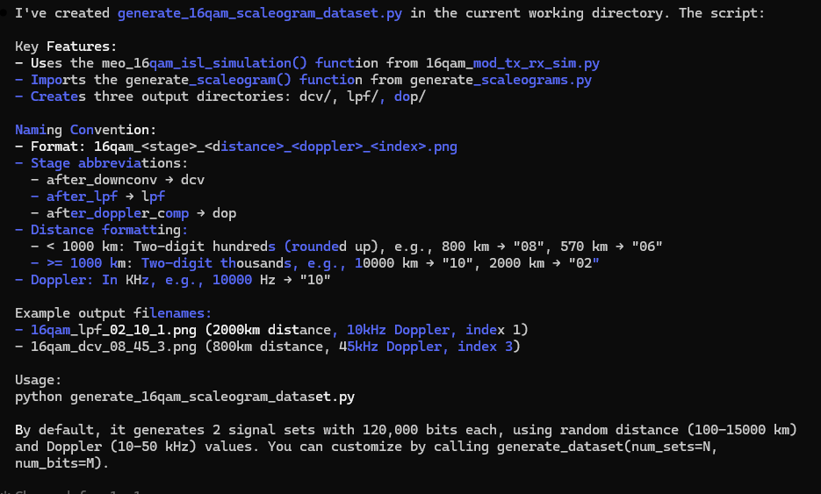
Prompt: When running the generate_16qam_scaleogram_dataset.py code, the following error is thrown: File "C:\Users\j_l_c\Documents\Sentinel_Space\ARES_Protect_One_Mission_APOM\ares_mdtt_08_Jan_2026\ARES\SensorSvc\data\synthetic_RF_TX_RX_wvfms\signal_mod_impl_approaches\python_code\16qam\data_gen\generate_16qam_scaleogram_dataset.py", line 225, in <module>
generate_dataset(num_sets=2, num_bits=120000)
~~~~~~~~~~~~~~~~^^^^^^^^^^^^^^^^^^^^^^^^^^^^^
File "C:\Users\j_l_c\Documents\Sentinel_Space\ARES_Protect_One_Mission_APOM\ares_mdtt_08_Jan_2026\ARES\SensorSvc\data\synthetic_RF_TX_RX_wvfms\signal_mod_impl_approaches\python_code\16qam\data_gen\generate_16qam_scaleogram_dataset.py", line 178, in generate_dataset
time = intermediate_signals['time']
~~~~~~~~~~~~~~~~~~~~^^^^^^^^
TypeError: string indices must be integers, not 'str'
Determine the root cause and the correct action.
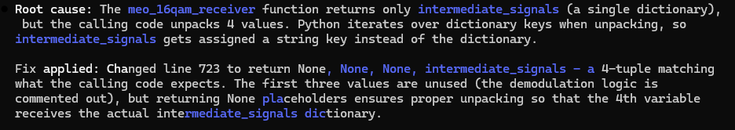
Note: Make sure function output variable number match the function def and call.
Prompt: create a README file in the markdown format for the generate_16qam_scaleogram_dataset.py file. Make sure to include insights on the scaleogram .png file naming convention. Save the README file to the current working directory.
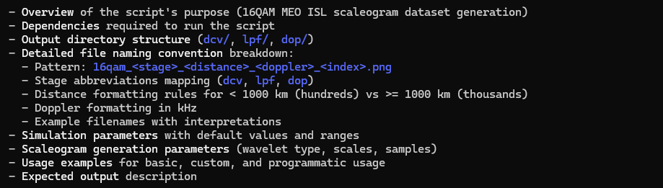
Prompt: generate a block diagram in the .html file format for the 16qam_mod_tx_rx_sim.py file implementation.
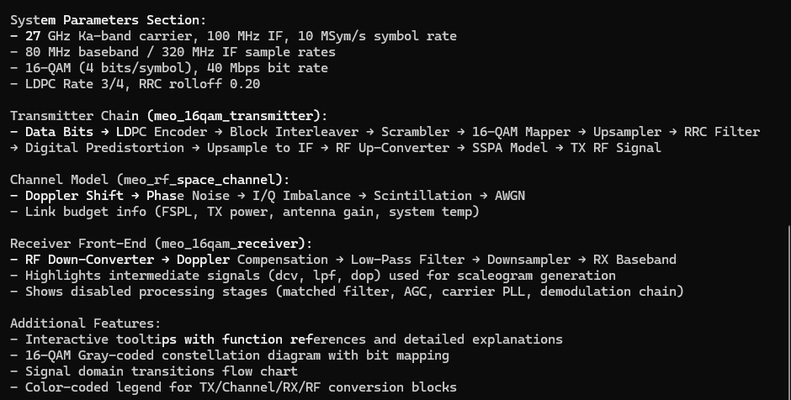
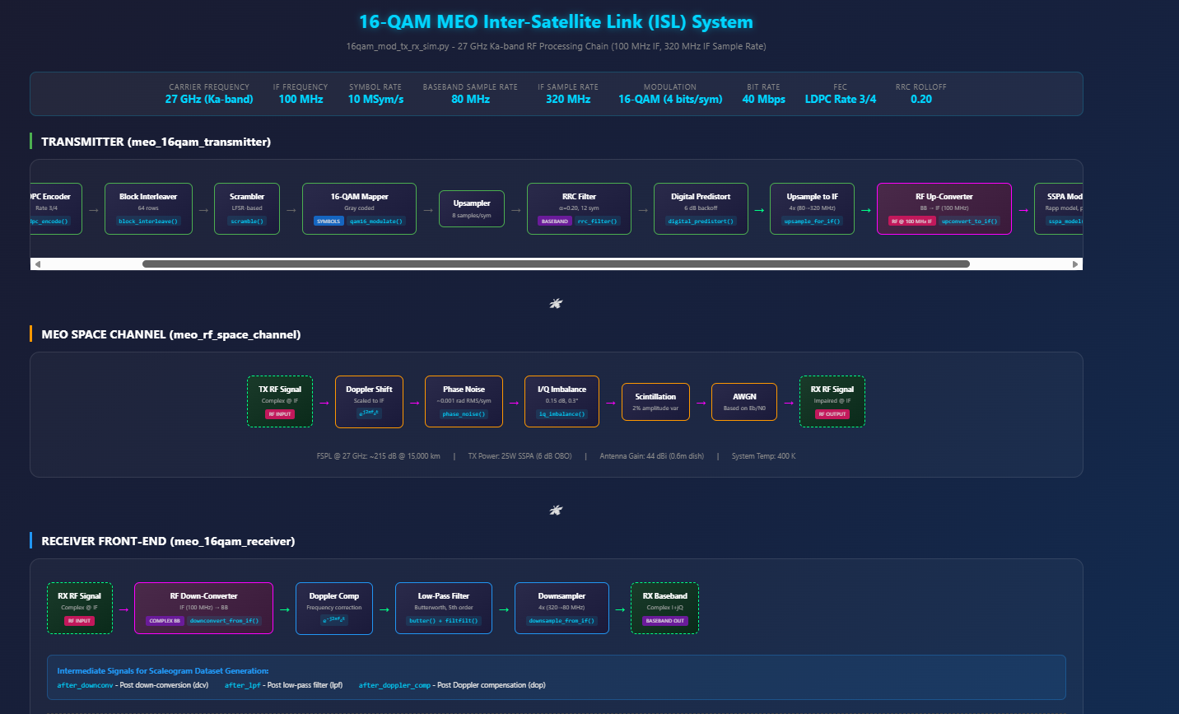

Prompt: From the current working directory, use the 16qam_meo_tx_rx_sim.py and generate_scaleograms.py files to generate a 16qam scaleogram dataset python script using the rx_signal parameter only based on the structure and functions in the generate_bfm_scaleogram_dataset.py file. Label the scaleogram .png files with the following naming convention: 16qam_<process stage description>_<distance value in 1000 of Km>_<Doppler value in KHz>_<sequential index value>.png (e.g. 16qam_preproc_02_10_1.png, 16qam_preproc_10_12_2.png, etc). The process stage descriptions nomenclature are as follow: “rx_signal”-> “preproc”. Any distance value less 1000 Km will be reflected with a leading zero rounded up to the nearest 100 Km (e.g. 800 km -> “08”, 570 km -> “06”) in the scaleogram .png file naming convention.
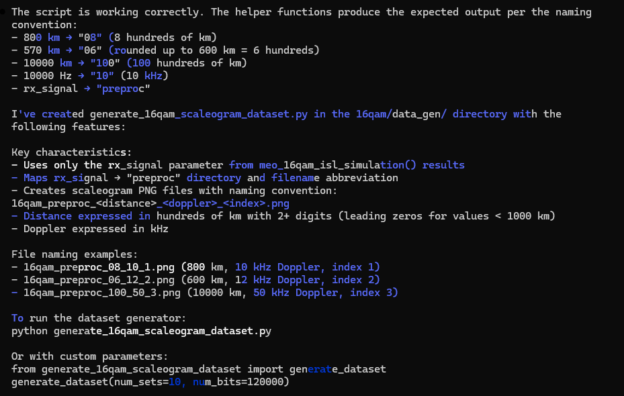

Prompt: create a README file in the markdown format for the generate_16qam_scaleogram_dataset.py file. Make sure to include insights on the scaleogram .png file naming convention. Save the README file to the current working directory.
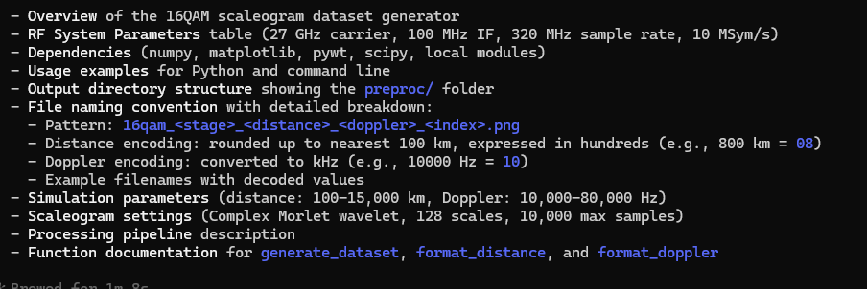

64-ary quadrature amplitude modulation (64-QAM)
Claude implementation
Prompt: based on the 16qam_meo_space_system_block_diagram.html file, generate a new signal processing block diagram in the html file format and save to the current working directory for a 64-ary quadrature amplitude modulation (64-QAM) radio frequency system that can be implementation in python code where both the transmitter and receiver are space-based in medium earth orbit (MEO).
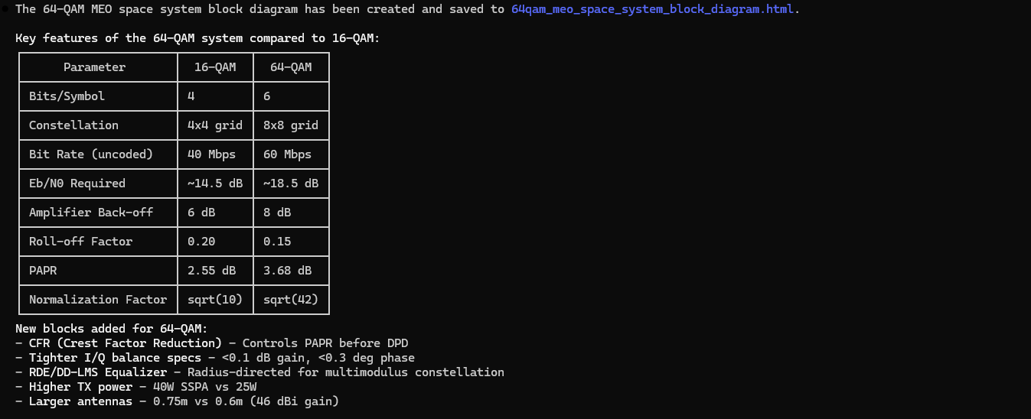

Prompt: Modify the 64qam_mod_tx_rx_sim.py file in the current working directory with the following updates: incorporate transmitter up conversion processing for the baseband signal to the 27 GHz carrier frequency, make sure the channel model addresses the up converted carrier frequency propagation, and the receiver front end now includes down conversion processing to generate a received baseband signal.
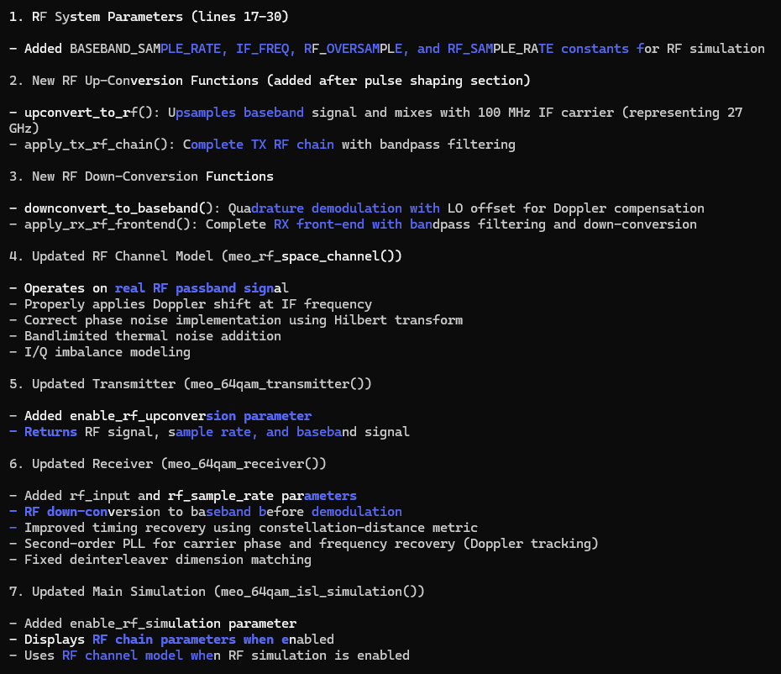

Prompt: update the 64qam_mod_tx_rx_sim.py code to resolve the high BER.
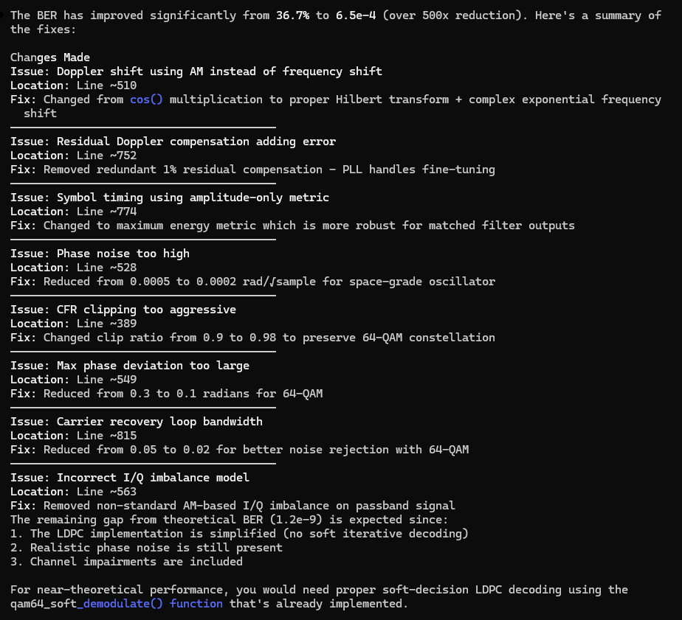

Prompt: update 64qam_meo_space_system_block_diagram.html file at the C:\Users\j_l_c\Documents\Sentinel_Space\ARES_Protect_One_Mission_APOM\ares_mdtt_08_Jan_2026\ARES\SensorSvc\data\synthetic_RF_TX_RX_wvfms\signal_mod_impl_approaches path location to align with the 64qam_mod_tx_rx_sim.py code from the current working directory
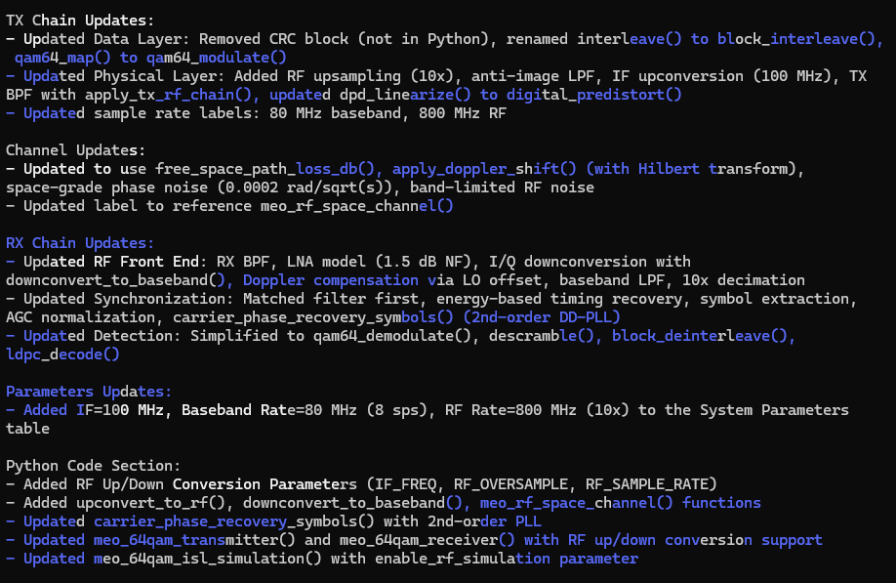
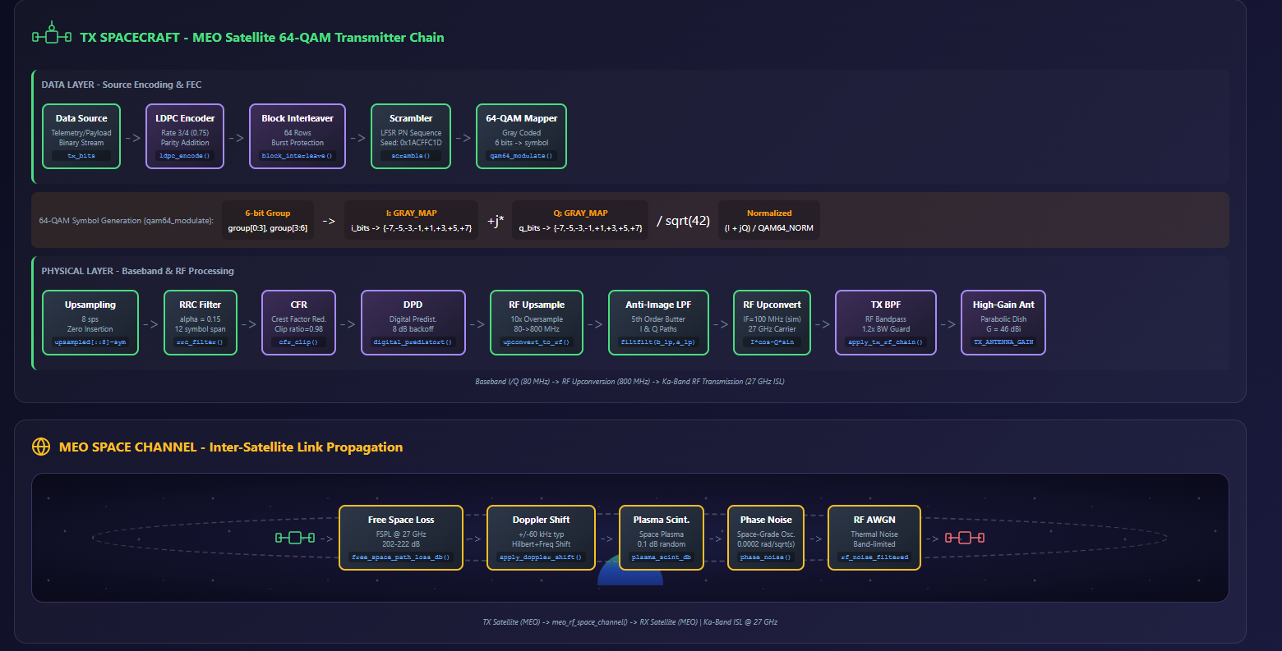
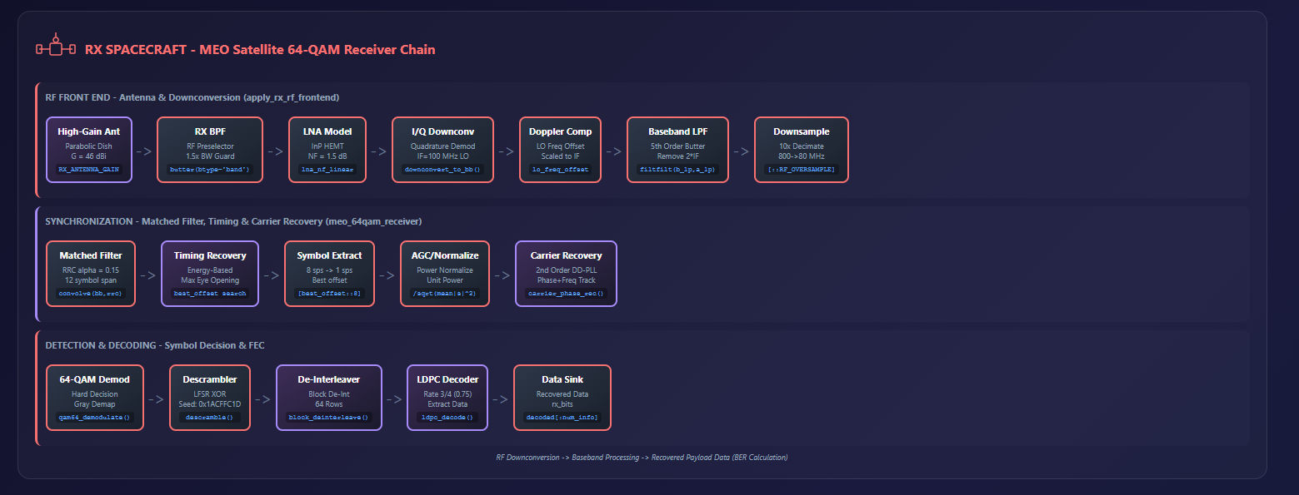
Prompt: From the current working directory, use the 64qam_mod_tx_rx_sim.py and generate_scaleograms.py files to generate a 64qam scaleogram dataset python script based on the structure and functions in the generate_16qam_scaleogram_dataset.py file. Label the scaleogram .png files with the following naming convention: 16qam_<process stage description>_<distance value in 1000 of Km>_<Doppler value in KHz>_<sequential index value>.png (e.g. 64qam_lpf_02_10_1.png, 64qam_lpf_10_12_2.png, etc). The process stage descriptions nomenclature are as follow: “after_downconv”-> “dcv”, “after_lpf”->”lpf”, and “after_doppler_comp” -> “dop”. Any distance value less 1000 Km will be reflected with a leading zero rounded up to the nearest 100 Km (e.g. 800 km -> “08”, 570 km -> “06”) in the scaleogram .png file naming convention.
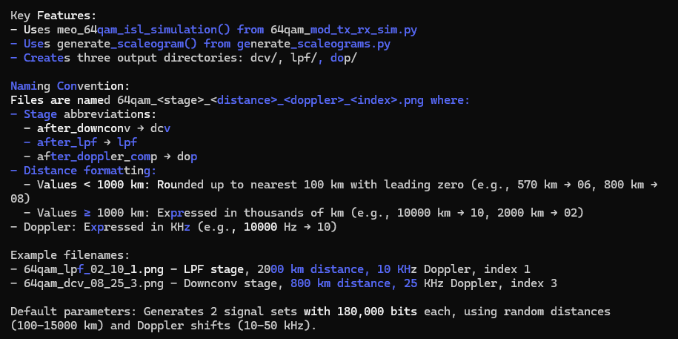

Prompt: create a README file in the markdown format for the generate_64qam_scaleogram_dataset.py file. Make sure to include insights on the scaleogram .png file naming convention. Save the README file to the current working directory.
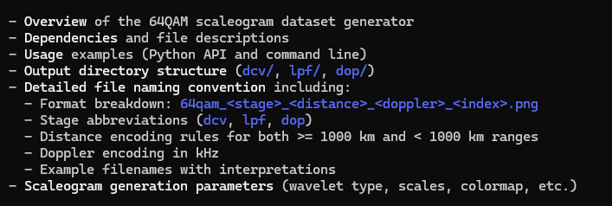
Prompt: generate a block diagram in the .html file format for the 64qam_mod_tx_rx_sim.py file implementation.
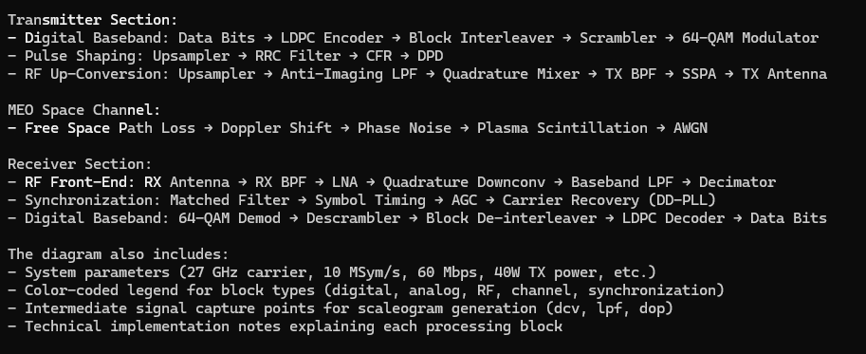
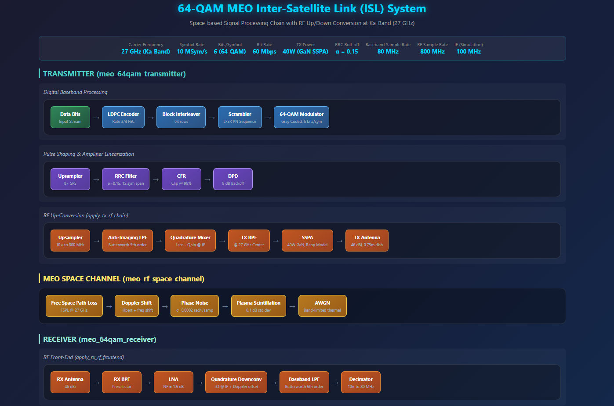

Prompt: From the current working directory, use the 64qam_meo_tx_rx_sim.py and generate_scaleograms.py files to generate a 64qam scaleogram dataset python script using the rx_signal parameter only based on the structure and functions in the generate_bfm_scaleogram_dataset.py file. Label the scaleogram .png files with the following naming convention: 64qam_<process stage description>_<distance value in 1000 of Km>_<Doppler value in KHz>_<sequential index value>.png (e.g. 64qam_preproc_02_10_1.png, 64qam_preproc_10_12_2.png, etc). The process stage descriptions nomenclature are as follow: “rx_signal”-> “preproc”. Any distance value less 1000 Km will be reflected with a leading zero rounded up to the nearest 100 Km (e.g. 800 km -> “08”, 570 km -> “06”) in the scaleogram .png file naming convention.
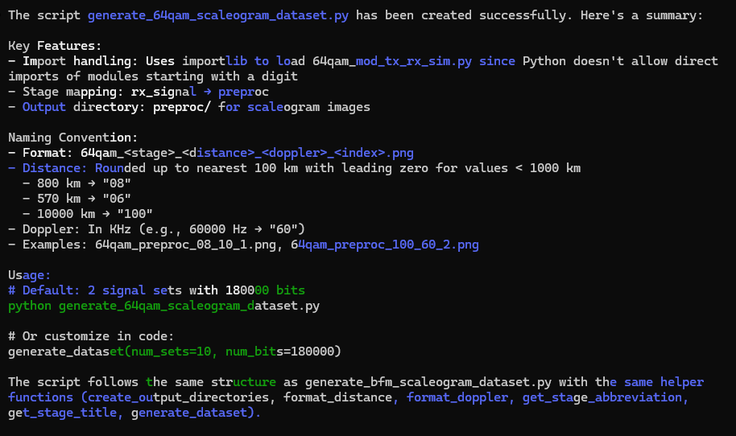

Prompt: create a README file in the markdown format for the generate_64qam_scaleogram_dataset.py file. Make sure to include insights on the scaleogram .png file naming convention. Save the README file to the current working directory.
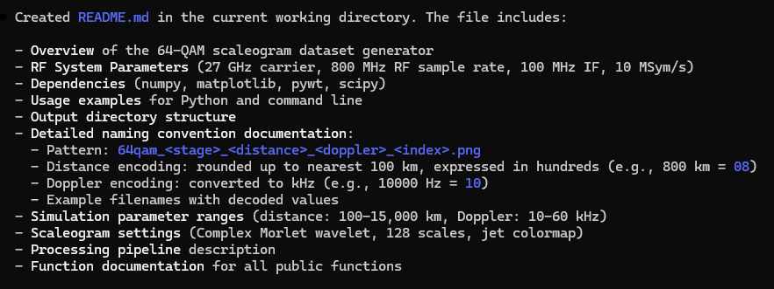

Gaussian frequency shift keying (GFSK)
Claude implementation
Prompt: based on the bpsk_meo_space_system_block_diagram.html file, generate a new signal processing block diagram in the html file format and save to the current working directory for a Gaussian frequency shift keying (GFSK) radio frequency system that can be implementation in python code where both the transmitter and receiver are space-based in medium earth orbit (MEO).
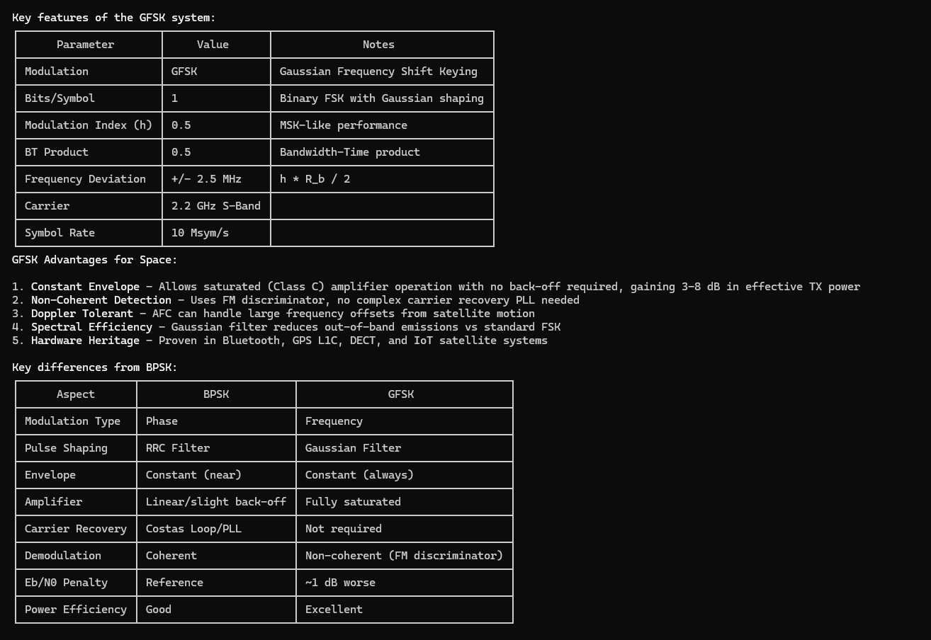
Prompt: Modify the gfsk_mod_tx_rx_sim.py file in the current working directory with the following updates: incorporate transmitter up conversion processing for the baseband signal to the 2.2 GHz carrier frequency, make sure the channel model addresses the up converted carrier frequency propagation, and the receiver front end now includes down conversion processing to generate a received baseband signal.
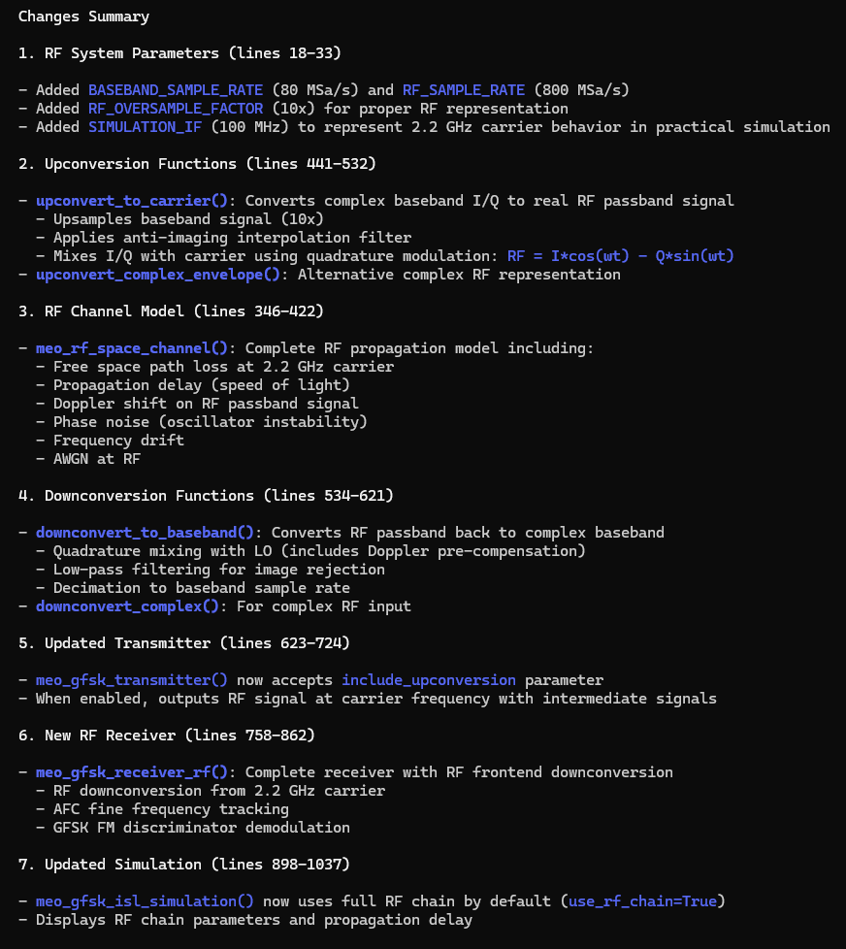

Prompt: resolve high BER in the gfsk_mod_tx_rx_sim.py code
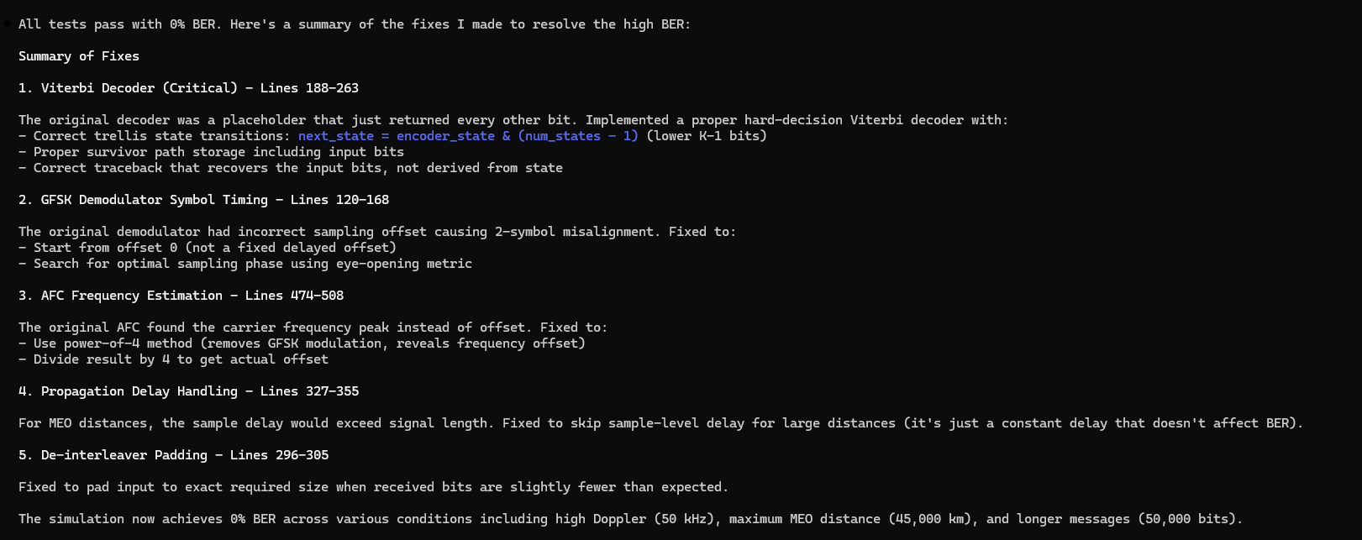
Prompt: update gfsk_meo_space_system_block_diagram.html file at the C:\Users\j_l_c\Documents\Sentinel_Space\ARES_Protect_One_Mission_APOM\ares_mdtt_08_Jan_2026\ARES\SensorSvc\data\synthetic_RF_TX_RX_wvfms\signal_mod_impl_approaches path location to align with the gfsk_mod_tx_rx_sim.py code from the current working directory
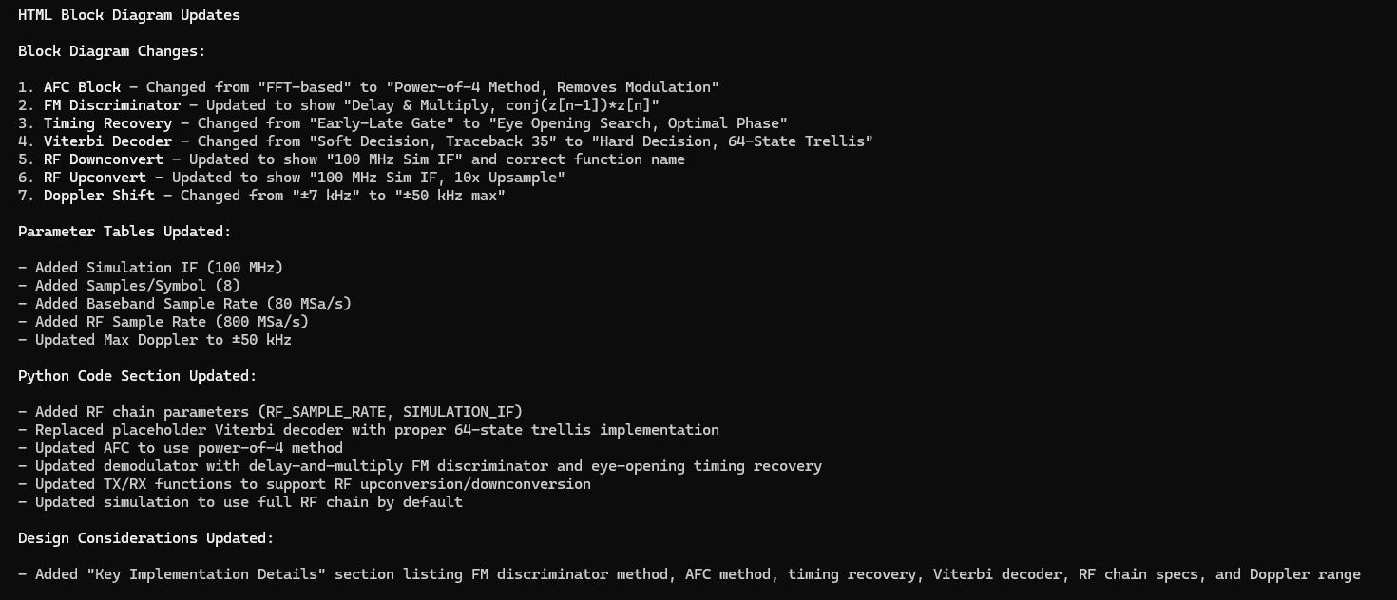
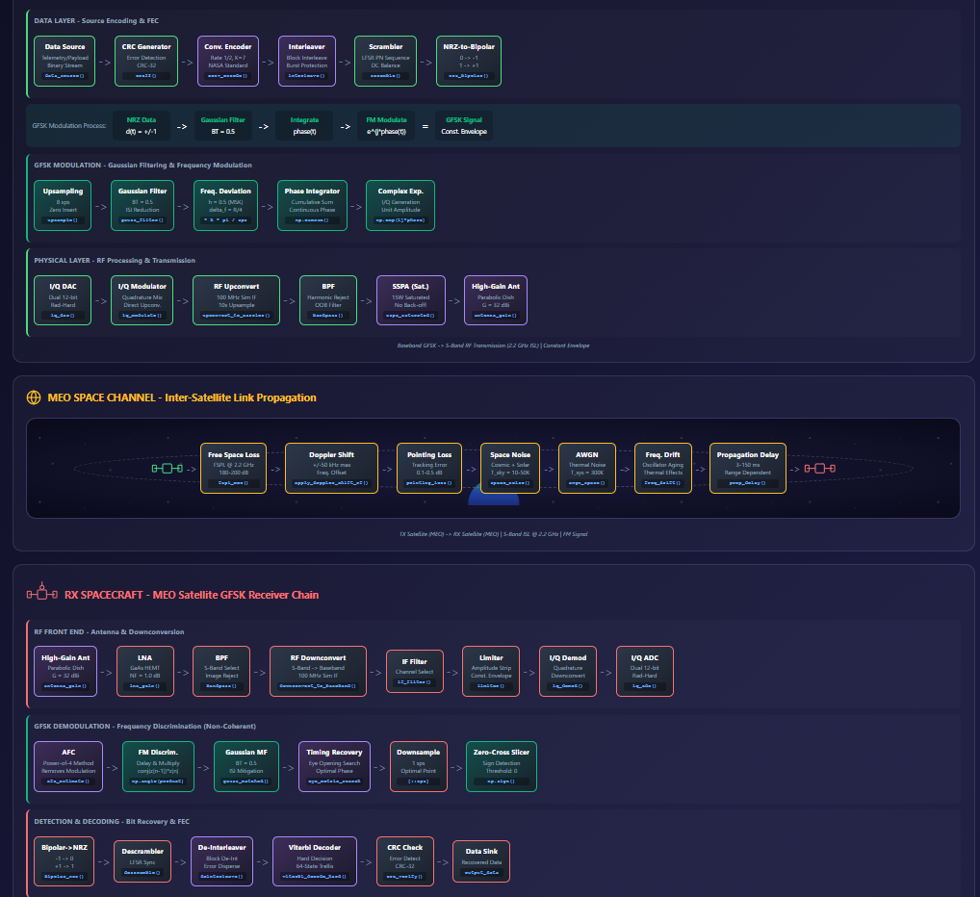
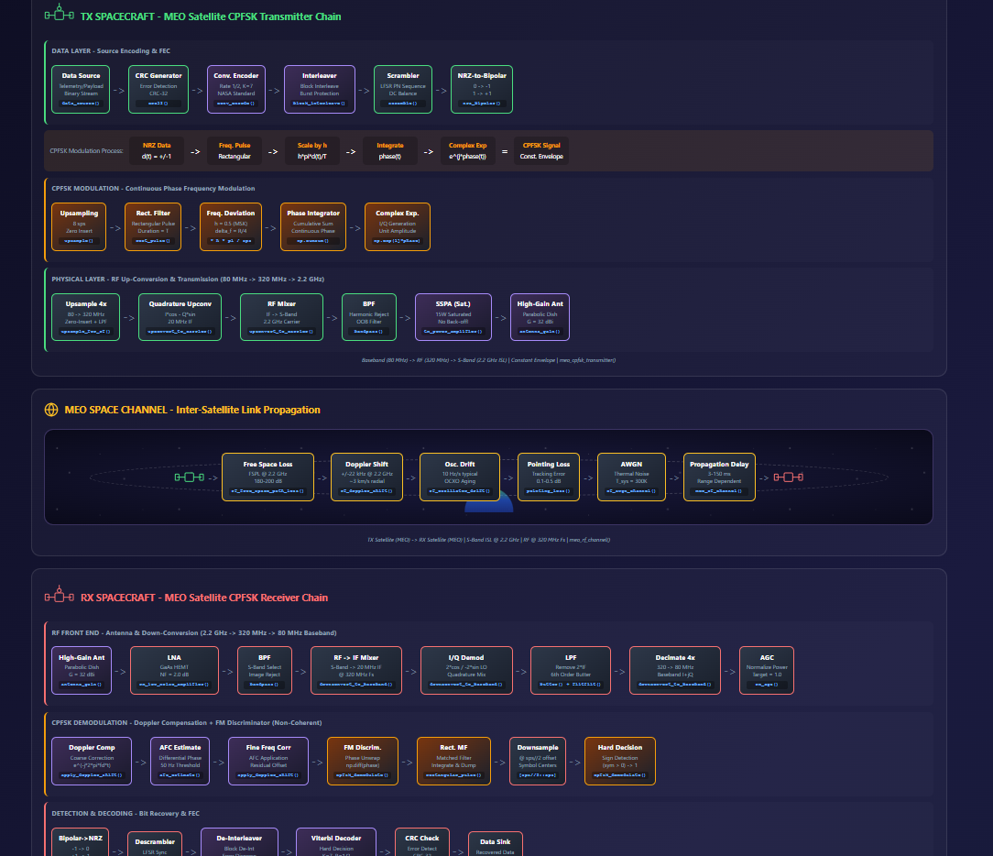
Manually updated gfsk_mod_tx_rx_sim.py code in the .\data_gen directory with intermediate_signals. Note: watch adding function arguments when defaults definition are included.

Prompt: From the current working directory, use the gfsk_mod_tx_rx_sim.py and generate_scaleograms.py files to generate a gfsk scaleogram dataset python script based on the structure and functions in the generate_cpfsk_scaleogram_dataset.py file. Label the scaleogram .png files with the following naming convention: gfsk_<process stage description>_<distance value in 1000 of Km>_<Doppler value in KHz>_<sequential index value>.png (e.g. gfsk_lpf_02_10_1.png, gfsk_lpf_10_12_2.png, etc). The process stage descriptions nomenclature are as follow: “after_downconv”-> “dcv”, “after_lpf”->”lpf”, and “after_doppler_comp” -> “dop”. Any distance value less 1000 Km will be reflected with a leading zero rounded up to the nearest 100 Km (e.g. 800 km -> “08”, 570 km -> “06”) in the scaleogram .png file naming convention.
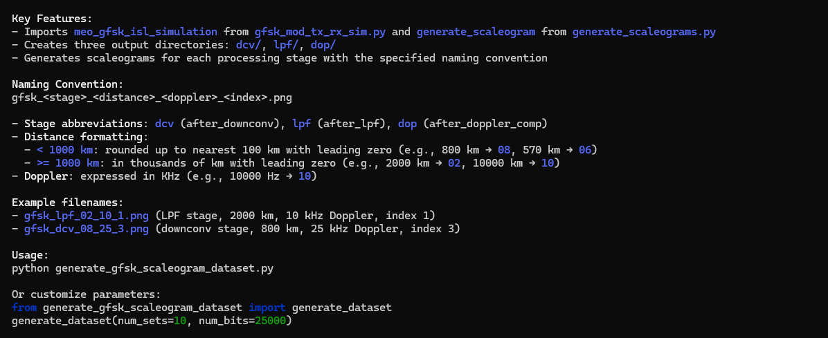
Manually updated gfsk_mod_tx_rx_sim.py code in the .\data_gen directory to comment out demodulation function not need for scaleogram generation.
Prompt: create a README file in the markdown format for the generate_gfsk_scaleogram_dataset.py file. Make sure to include insights on the scaleogram .png file naming convention. Save the README file to the current working directory.
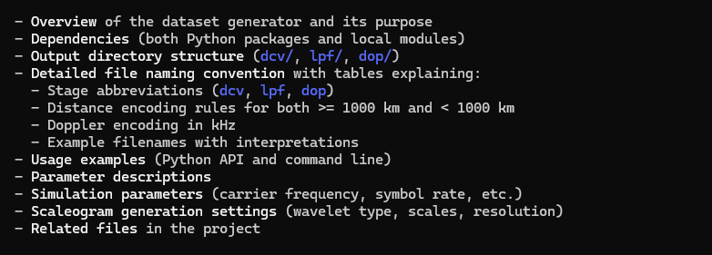

Prompt: generate a block diagram in the .html file format for the gfsk_mod_tx_rx_sim.py file implementation.
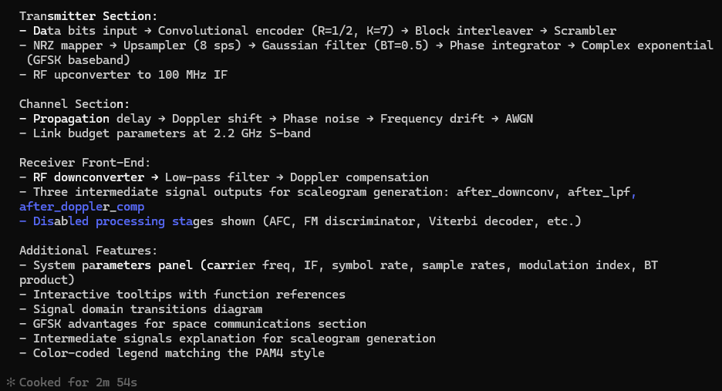
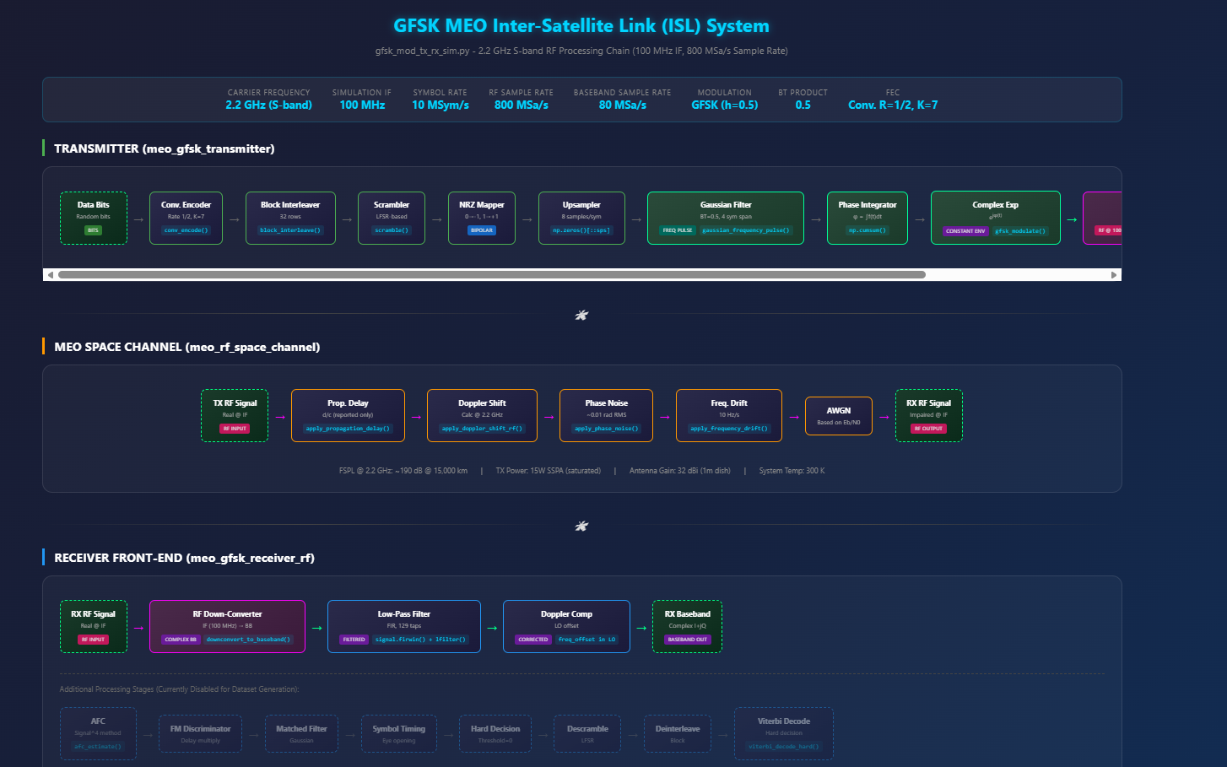

Prompt: From the current working directory, use the gfsk_meo_tx_rx_sim.py and generate_scaleograms.py files to generate a gfsk_ scaleogram dataset python script using the rf_signal_rx parameter only based on the structure and functions in the generate_bfm_scaleogram_dataset.py file. Label the scaleogram .png files with the following naming convention: gfsk_<process stage description>_<distance value in 1000 of Km>_<Doppler value in KHz>_<sequential index value>.png (e.g. gfsk_preproc_02_10_1.png, gfsk_preproc_10_12_2.png, etc). The process stage descriptions nomenclature are as follow: “rf_signal_rx”-> “preproc”. Any distance value less 1000 Km will be reflected with a leading zero rounded up to the nearest 100 Km (e.g. 800 km -> “08”, 570 km -> “06”) in the scaleogram .png file naming convention.
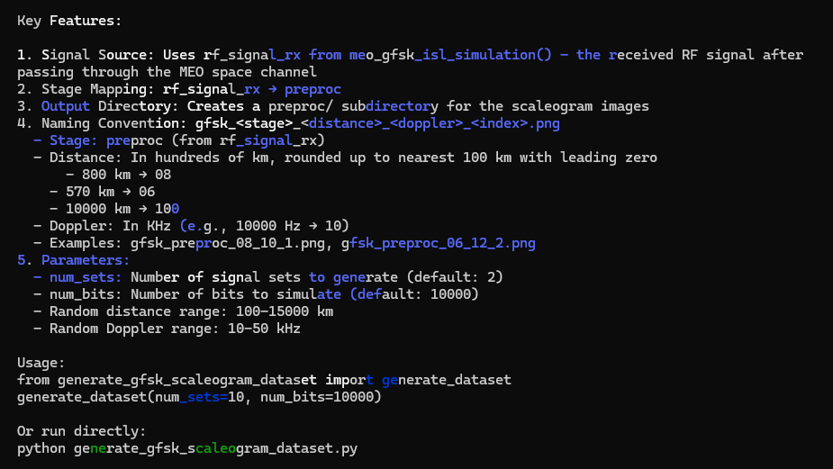

Prompt: create a README file in the markdown format for the generate_gfsk_scaleogram_dataset.py file. Make sure to include insights on the scaleogram .png file naming convention. Save the README file to the current working directory.
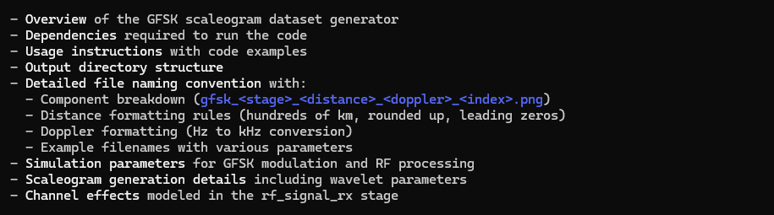
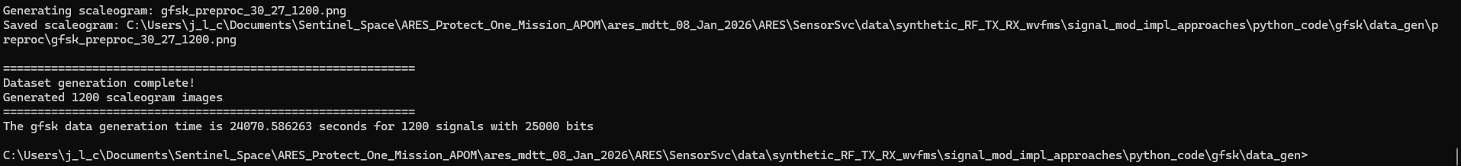

Continuous phase frequency shift keying (CPFSK)
Claude implementation
Prompt: based on the gfsk_meo_space_system_block_diagram.html file, generate a new signal processing block diagram in the html file format and save to the current working directory for a Continuous phase frequency shift keying (CPFSK) radio frequency system that can be implementation in python code where both the transmitter and receiver are space-based in medium earth orbit (MEO).
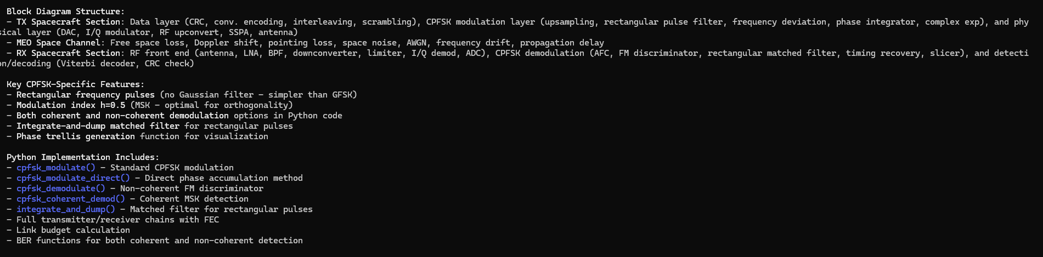

Prompt: Modify the cpfsk_mod_tx_rx_sim.py file in the current working directory with the following updates: incorporate transmitter up conversion processing for the baseband signal to the 2.2 GHz carrier frequency, make sure the channel model addresses the up converted carrier frequency propagation, and the receiver front end now includes down conversion processing to generate a received baseband signal.
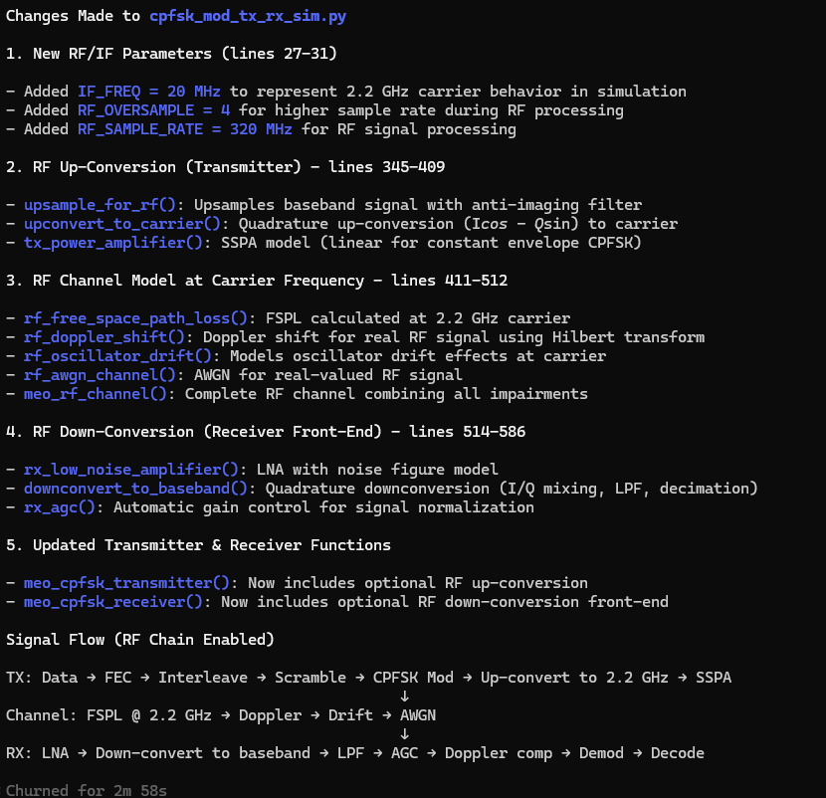

Prompt: resolve the high BER.
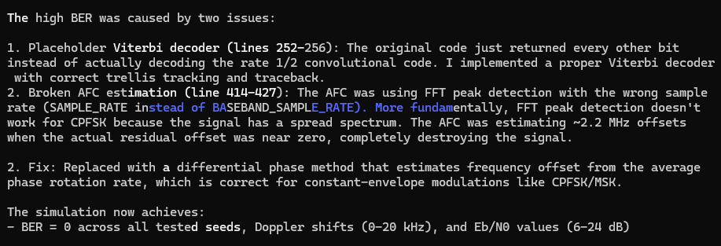
Prompt: update cpfsk_meo_space_system_block_diagram.html file at the C:\Users\j_l_c\Documents\Sentinel_Space\ARES_Protect_One_Mission_APOM\ares_mdtt_08_Jan_2026\ARES\SensorSvc\data\synthetic_RF_TX_RX_wvfms\signal_mod_impl_approaches path location to align with the cpfsk_mod_tx_rx_sim.py code from the current working directory
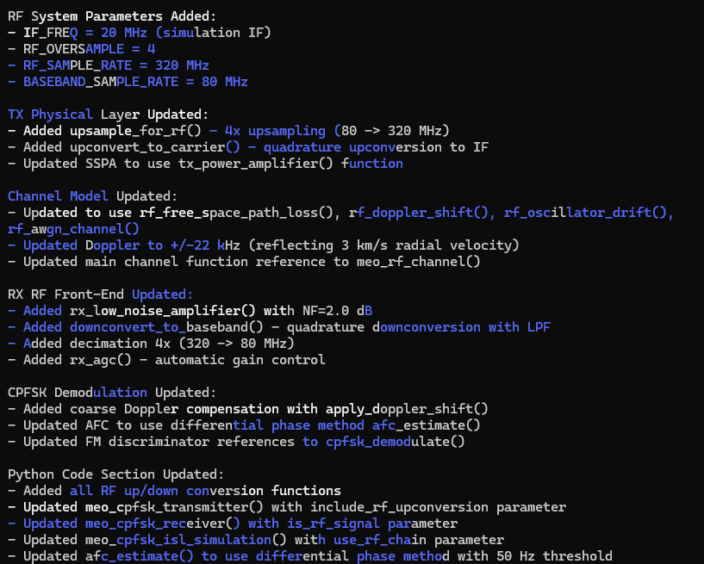

Manually updated cpfsk_mod_tx_rx_sim.py code in the .\data_gen directory with intermediate_signals. Note: watch adding function arguments when defaults definition are included.

Prompt: From the current working directory, use the cpfsk_mod_tx_rx_sim.py and generate_scaleograms.py files to generate a cpfsk scaleogram dataset python script based on the structure and functions in the generate_64qam_scaleogram_dataset.py file. Label the scaleogram .png files with the following naming convention: cpfsk_<process stage description>_<distance value in 1000 of Km>_<Doppler value in KHz>_<sequential index value>.png (e.g. cpfsk_lpf_02_10_1.png, cpfsk_lpf_10_12_2.png, etc). The process stage descriptions nomenclature are as follow: “after_downconv”-> “dcv”, “after_lpf”->”lpf”, and “after_doppler_comp” -> “dop”. Any distance value less 1000 Km will be reflected with a leading zero rounded up to the nearest 100 Km (e.g. 800 km -> “08”, 570 km -> “06”) in the scaleogram .png file naming convention.
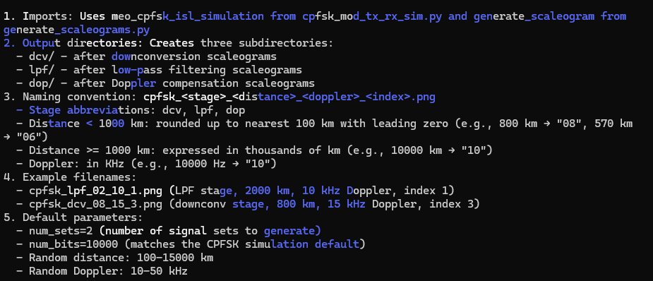
Manually commented out demodulation functions not needed for scaleogram dataset generation.
Prompt: create a README file in the markdown format for the generate_cpfsk_scaleogram_dataset.py file. Make sure to include insights on the scaleogram .png file naming convention. Save the README file to the current working directory.
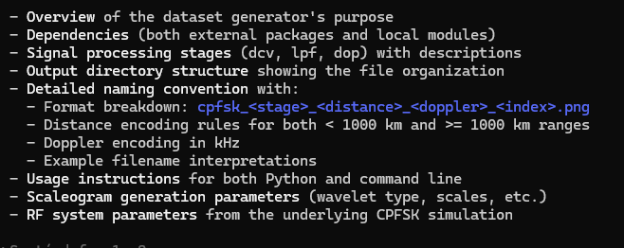

Prompt: generate a block diagram in the .html file format for the cpfsk_mod_tx_rx_sim.py file implementation.
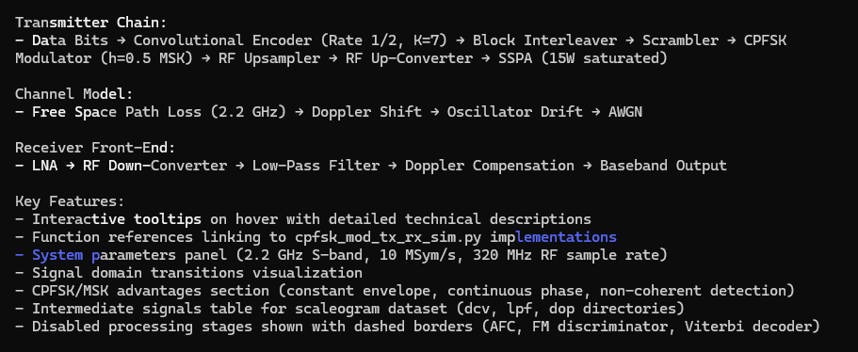
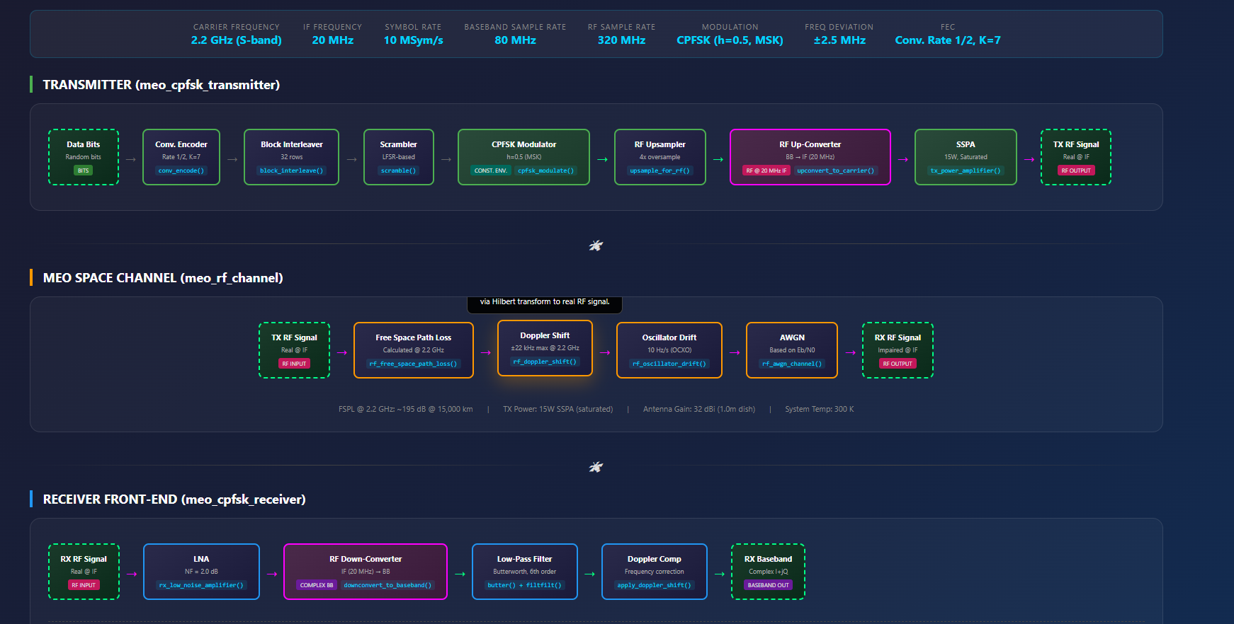

Prompt: From the current working directory, use the cpfsk_meo_tx_rx_sim.py and generate_scaleograms.py files to generate a cpfsk_ scaleogram dataset python script using the rx_rf parameter only based on the structure and functions in the generate_bfm_scaleogram_dataset.py file. Label the scaleogram .png files with the following naming convention: cpfsk_<process stage description>_<distance value in 1000 of Km>_<Doppler value in KHz>_<sequential index value>.png (e.g. cpfsk_preproc_02_10_1.png, cpfsk_preproc_10_12_2.png, etc). The process stage descriptions nomenclature are as follow: “rx_rf”-> “preproc”. Any distance value less 1000 Km will be reflected with a leading zero rounded up to the nearest 100 Km (e.g. 800 km -> “08”, 570 km -> “06”) in the scaleogram .png file naming convention.
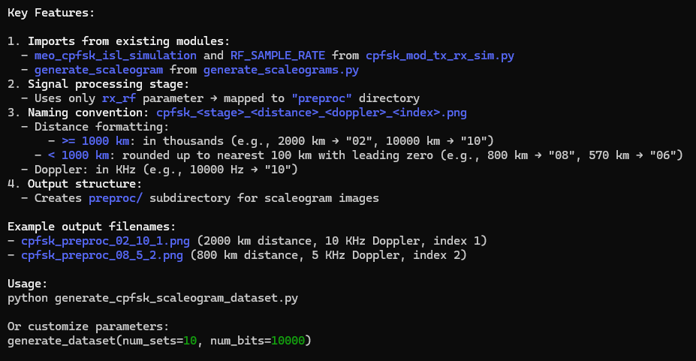
Prompt: create a README file in the markdown format for the generate_cpfsk_scaleogram_dataset.py file. Make sure to include insights on the scaleogram .png file naming convention. Save the README file to the current working directory.
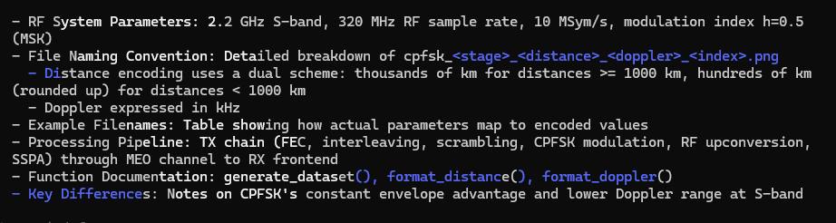

Prompt: create a README file in the markdown format for the generate_gfsk_scaleogram_dataset.py file. Make sure to include insights on the scaleogram .png file naming convention. Save the README file to the current working directory.

Broadcast FM (B-FM)
Claude implementation
Prompt: based on the bpsk_meo_space_system_block_diagram.html file, generate a new signal processing block diagram in the html file format and save to the current working directory for a Broadcast FM (B-FM) radio frequency system that can be implementation in python code where both the transmitter and receiver are space-based in medium earth orbit (MEO).
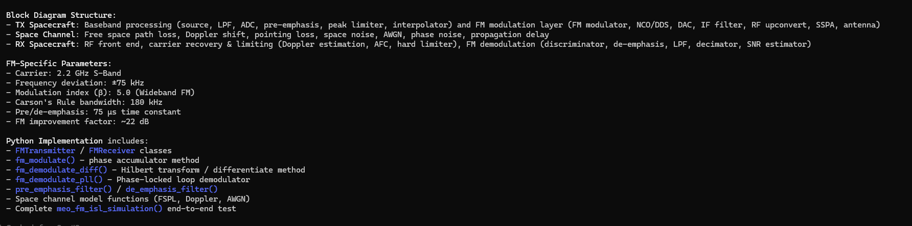
Prompt: update the bfm_mod_rx_tx_sim.py file in the current working directory to plot the transmit message and the demodulated received signal during the communication link simulation by utilizing the baseband_plotting.py code.
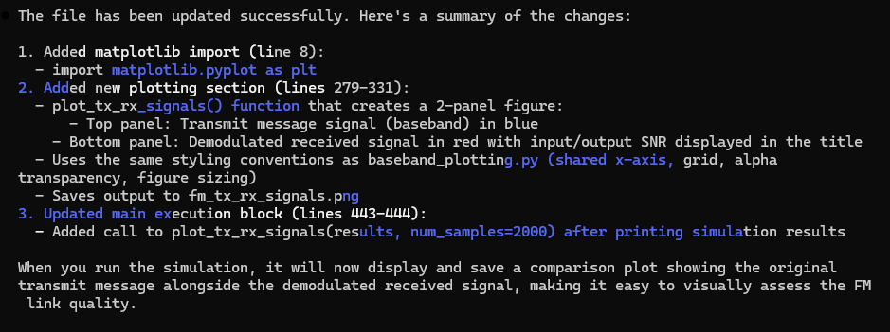

Prompt: update the bfm_mod_rx_tx_sim.py file in the current working directory to include the free propagation in the simulation. Also plot the received fm_noisy signal along with the transmit message, and the demodulated received signal during the communication link simulation by utilizing the baseband_plotting.py code.
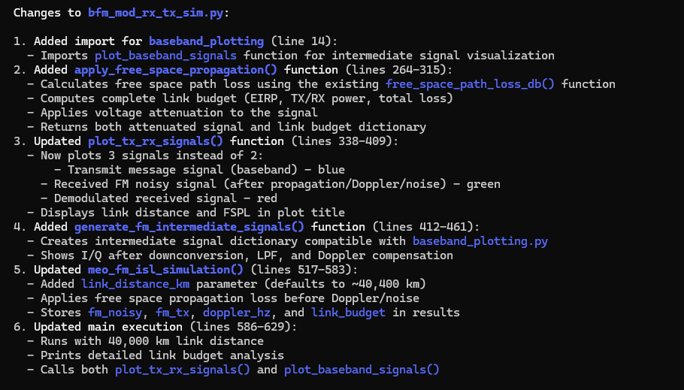
Prompt: update the bfm_mod_rx_tx_sim.py file in the current working directory to remove utilizing the baseband_plotting.py code. Continue to plot the received fm_noisy signal, transmit message, and the demodulated received signal during the communication link simulation.
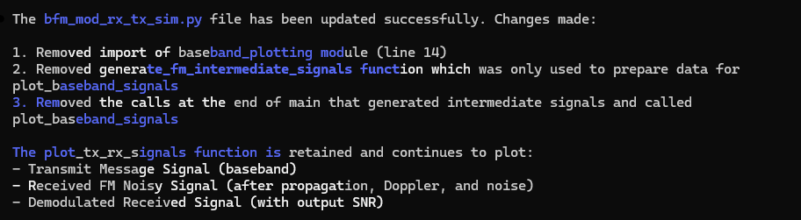
Prompt: From the current working directory, use the bfm_mod_tx_rx_sim.py and generate_scaleograms.py files to generate a bfm scaleogram dataset python script using the fm_noisy signal only based on the structure and functions in the generate_pam4_scaleogram_dataset.py file. Label the scaleogram .png files with the following naming convention: bfm_<process stage description>_<distance value in 1000 of Km>_<Doppler value in KHz>_<sequential index value>.png (e.g. bfm_preproc_02_10_1.png, bfm_preproc_10_12_2.png, etc). The process stage descriptions nomenclature are as follow: “fm_noisy”-> “preproc”. Any distance value less 1000 Km will be reflected with a leading zero rounded up to the nearest 100 Km (e.g. 800 km -> “08”, 570 km -> “06”) in the scaleogram .png file naming convention.
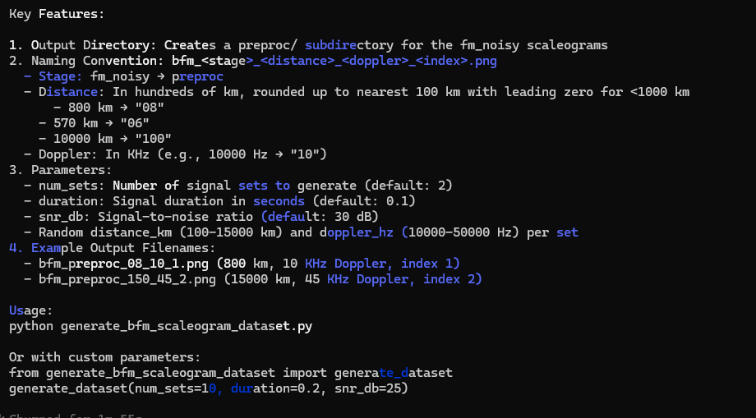

Prompt: generate a requirement.txt file which defines all the python package library dependencies to run generate_bfm_scaleogram_dataset.py file.
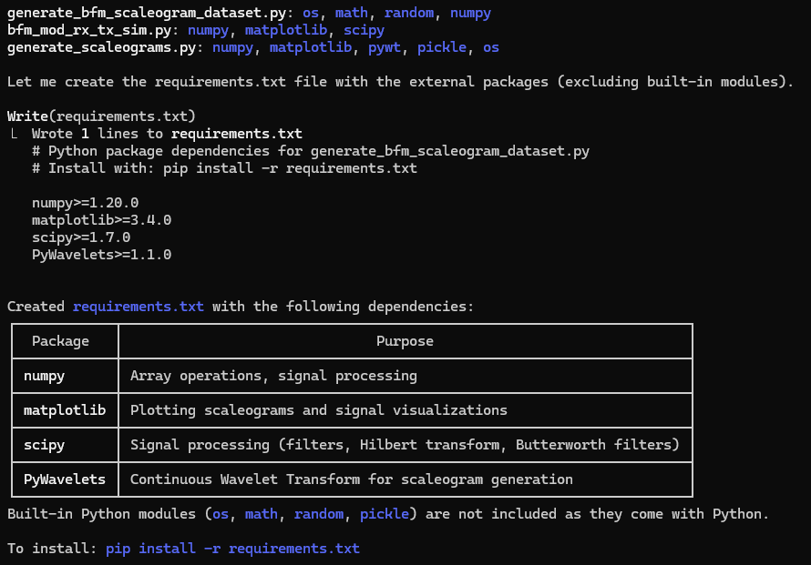
Prompt: create a README file in the markdown format for the generate_bfm_scaleogram_dataset.py file. Make sure to include insights on the scaleogram .png file naming convention. Save the README file to the current working directory.
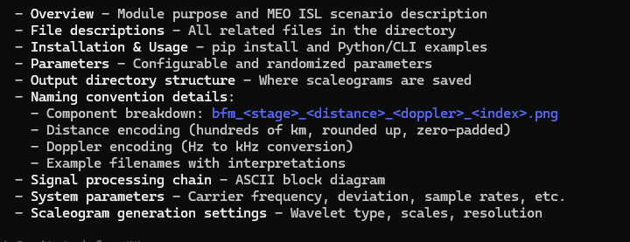

Double sideband amplitude modulation (DSB-AM)
Single sideband amplitude modulation (SSB-AM)
Git Bash ARES directory path:
/C/Users/j_l_c/Documents/Sentinel_Space/ARES_Protect_One_Mission_APOM/ares_mdtt_08_Jan_2026/ARES

