***Zomato Restaurant Data Analysis.***

***Market insights and observation.***

***Tools Used :- SQL(MS SQL Server.)***

***Prepared by :- Ayon Das.***

***Date :- 04/09/2025***

***Objective:***

*The objective of this project is to perform a comprehensive analysis of restaurant market data using SQL to derive actionable insights about pricing, customer preferences, and service adoption trends. The analysis focuses on both the Indian restaurant industry and global comparisons, aiming to:*

* *Assess the overall market penetration and performance of restaurants across India and key international markets.*
* *Identify top-performing cities, cuisines, and restaurant types in India.*
* *Understand customer preferences based on pricing segments, ratings, and votes.*
* *Compare the adoption of digital services like online delivery and table booking.*
* *Highlight cuisine diversity, service offerings, and dining cost trends for strategic decision-making.*

*🔹 Q1. Overall Statistics for the Indian Restaurant Market*

**

***Insights:-***

*From this query, we can conclude:*

* *🔹 The average cost for two in Indian restaurants is 623.*
* *🔹 The average rating across all Indian restaurants is 2.78 stars.*
* *🔹 There are a total of 8652 restaurants listed in India.*
* *🔹 These restaurants are spread across 43 different cities in India.*

*🔹 Q2. Top 10 Indian Cities by Number of Restaurants, Average Rating, and Average Cost*

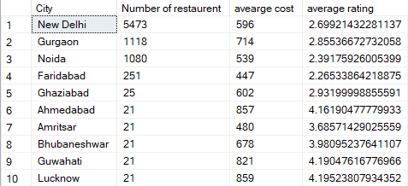

***Insights***

From this query, we can see:

* 🔹 The top 10 cities with the highest number of restaurants in India.
* 🔹 These cities are sorted by number of restaurants (highest first).
* 🔹 Alongside, we also get the average cost for two and average rating for each city.
* 🔹 This helps identify restaurant density hotspots and their pricing trends.

🔹 Q3. Pricing Segments and Their Relationship with Ratings in India.

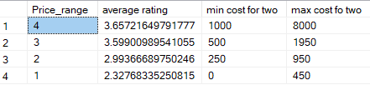

***Insights***

*From this query, we can observe:*

* 🔹 Restaurants are segmented into price ranges (1 = lowest, 4 = highest).
* 🔹 We get the average rating for each price segment, which helps understand higher-priced restaurants have better ratings.
* 🔹 The minimum and maximum costs for two in each price segment ***are*** shown for clarity.
* 🔹 This gives a clear picture of how pricing influences customer perception (ratings) in India.

🔹 Q4. Compare Restaurant Types Based on Service Offerings in India (Online Delivery vs Dine-In)

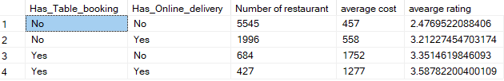

**Insights**

* 🔹 This query compares restaurant types based on service availability:
  + Restaurants offering only table booking
  + Restaurants offering only online delivery
  + Restaurants offering both services
  + Restaurants offering none.
  + Restaurants offering both have higher average rating (3.59) stars.
* 🔹 We can see the number of restaurants in each category, their averagecost, and average ratings.
* 🔹 This helps identify customer trends, such as whether **online delivery** restaurants tend to be cheaper or if **dine-in only** restaurants have higher ratings.

🔹 Q5. Top 15 Most Popular Cuisine Types and Their Performance Metrics in India

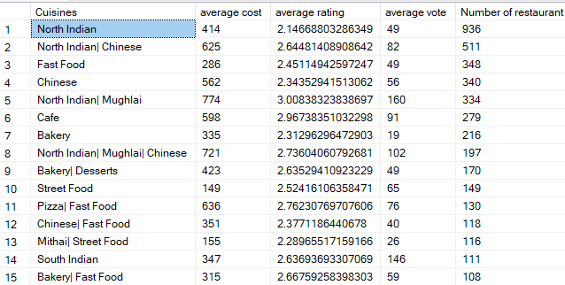

**Insights**

* 🔹 This query lists the top 15 cuisine types in India based on the number of restaurants serving them based on that North Indian is at the top, followed by lowest average rating (2.14) stars.
* 🔹 Displays each cuisine’s average cost, rating, and votes, which helps measure popularity and performance.
* 🔹 Identifying customer preferences and popular cuisines to target in marketing campaigns or restaurant strategy.

🔹 Q6. Budget vs Premium Restaurant Segments in India.



**Insights**

* 🔹 This query categorizes restaurants into Budget (Price range 1–2) and Premium (Price range 3–4).
* 🔹 Shows the number of restaurants, average cost, maximum cost, average votes, and average ratings for each segment, based on that number of budget restaurants are more but have lower average rating (2.6) stars.
* 🔹 Highlights how many restaurants offer table booking and online delivery in each category.
* 🔹 Useful for understanding market segmentation and identifying whether premium restaurants invest more in service offerings.

🔹 Q7. City-wise Rating Distribution in Top 5 Indian Cities

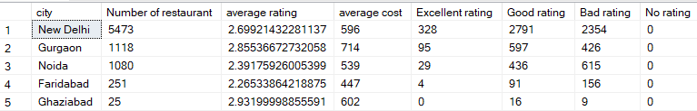

:

**Insights:-**

* 🔹 The top 5 Indian cities are ranked based on the highest number of restaurants, where New Delhi have far more restaurants.(5473)
* 🔹 We get a breakdown of ratings: Excellent (≥4), Good (3–4),

Bad (1–3), and No Rating (0), where New Delhi restaurants get most of the excellent and good ratings.

* 🔹 The average cost for two and average rating per city help identify pricing trends and customer satisfaction levels, where Gurgaon restaurants get maximum average cost. (approx. 600 rupees)
* 🔹 This gives a city-level comparison of restaurant availability, quality perception, and pricing in India.

🔹 Q8. Average Dining Costs Across Countries)

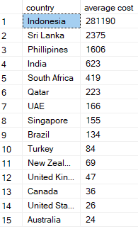

**Insights:-**

🔹 Countries are ranked by average dining cost for two (highest to lowest).

🔹 This highlights which countries are the most and least expensive for dining out, where Indonesia has the maximum average cost followed by Australia has the lowest average cost.

🔹 Q9: Digital Service Adoption Across Indian Cities

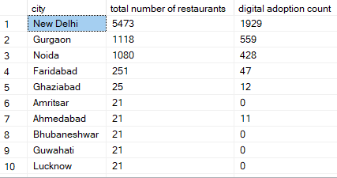

**Insights:-**

🔹 New Delhi ranked by the total number of restaurants (highest first).

🔹 The digital adoption count shows how many restaurants offer online delivery or table booking services, where New Delhi has the highest adoption.

🔹 This reveals which cities have higher penetration of digital services in the restaurant industry.

🔹 Q10. Top-Rated Restaurants in India with High Vote Count

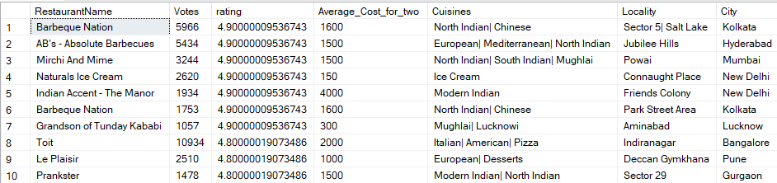

**Insights:-**

🔹 Lists restaurants in India with a rating of 4+ and 1,000+ votes, ensuring only popular and trusted restaurants are included, where Barbeque Nation has the maximum number of voting approx. (6000) votes followed by AB’s-Absolute Barbecues having almost (5500) votes.

🔹 Displays details such as average cost for two, cuisines, locality, and city for better context, where again Toit restaurant takes highest average cost having (2000 rupees) average cost.

🔹 The ordering (by rating first, then votes) highlights highly rated and widely reviewed restaurants where Barbecue nation gets top marks.

🔹 Q11. India vs Other Countries - Service Features Comparison.



**Insights:-**

🔹India has the higher number of restaurants (8652) having lower average cost (623 rupees).

🔹Other Countries average rating is way ahead of India having (4.05) stars where India has only (2.77) stars.

🔹In terms of digital adoption, Indian restaurant holds the top spot having almost (2000) online delivery and (684) online table booking and (627) both service.

🔹 Average votes (346 votes) is also more for other countries restaurants than Indian restaurants.

🔹 Q12. Market Penetration Analysis - India vs International.

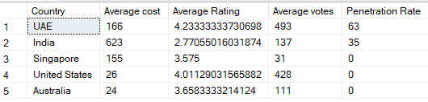

**Insights:-**

🔹UAE has the highest number of average rating (4.23 stars) followed by United States having (4 stars).

🔹while talking about digital adoption penetration rate then UAE takes number one spot having 63% of penetration followed by India having 35%.

🔹Q13. Cuisine Diversity Analysis by Indian Cities

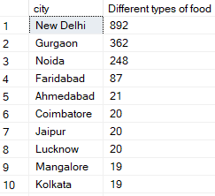

**Insights:-**

🔹In terms of cuisine diversity in Indian restaurants then New Delhi serves almost 900 different types of foods which is way ahead of other city restaurants.