TEST STRATEGY DOCUMENT

PROJECT NAME | SAMPLE INC
PREPARED BY | JOSEPH JEAN
VERSION NO | Draft
DATE | 07-DEC-2015

Contents
DISTRIBUTION LIST 3
REVISION HISTORY 3
Introduction 4
Overview 4
Reference Material 4
Definitions and acronyms 4
Scope and Limitations 5
Scope 5
Limitations and exclusions 5
Testing approach 6
Scope 6
Test types 7
Unit or Code Coverage Testing 7
Smoke testing or Health check testing 7
System Integration testing 7
Functional Integration testing 8
Regression testing 9
User acceptance testing 10
Project task tracking: 10
Unified Testing process in JIRA: 11
Defect Tracking Process in JIRA: 12
RACI Matrix: 12
Organisation: 13
Testing Deliverables and Milestones: 13
Milestones: 13
Deliverables: 13
Roles and Responsibilities: 14
Communication Plan: 14
Entry and Exit Criteria: 14
Entry Criteria : 14
Exit Criteria: 15
Resources 15
People 15
Software 16
Critical Success Factor. 16
Internal success will be measured by: 16
Metrics for this are: 16
Assumptions , dependencies and constraints 16
Risk Management 17
Conclusion 17

DISTRIBUTION LIST

Role | Name
Test /QA Manager
Test Lead
Sponsor
Development Manager
Product Manager
Production support / Documentation manager
Software quality engineer

REVISION HISTORY

Name | Date | Reason for change | Version
Joseph Jean Pierre | 10-Dec-15 | Initial document | Draft
 |  |  | 1.0
 |  |  | 2.0
 |  |  | 3.0
 |  |  | 4.0
 |  |  | 5.0
 |  |  | 6.0

Introduction

Overview
This is the Test Strategy for Sample inc. This document shall be completed and used by the project test team to guide how testing will be managed for this project. The test effort will be prioritized and executed based on the project priorities as defined in the Project Plan and Requirements Specification. This is a living document that may be refined as the project progresses. The QA / Test Manager, Test Team Lead, Product Manager, Project Manager, and Development Manager etc.,
shall review and approve the final version of the Test Strategy document.

Reference Material

- JIRA Work orders for the Requirements Analysis
- JIRA subtasks for the allocation, planning and tracking
- Product Project plan for the Major milestones
- Data flow, System flow and user case diagrams for high level and low level design
- Test plan in Microsoft project for the testing milestones dates , ownership

Definitions and acronyms

- Project Name : Sample inc.
Sample inc is a software platform for all the south Indian actors/actress portfolios.
- Ad Hoc Testing
Testing contrived for only the specific purpose or problem at hand; testing not carefully
Planned in advance.
- Scenario
Detailed description (specific instance) of a use case, including rules, exceptions,
boundaries, limits, etc.
- Test Case
A specific set of test data along with expected results for a particular test objective.
- Test Coverage
Describes how much of a system has been tested.
- Test Design
Describes how a feature or function shall be tested.
- Test Plan
Test Strategy
- Test Procedure
Describes the steps for executing a set of test cases and analyzing their results.
- Test Script
Step by step description for specific tests.
- Test Strategy
Describes the scope, approach, resources and schedule for the testing activities of the
project. This includes defining what will be tested, who will perform testing, how testing
will be managed, and the associated risks and contingencies. Also referred to as a Test Plan.
- Use Case
Describes a sequence of interactions between a system and an external actor that results in
the actor accomplishing a task that provides benefit to someone. An actor is a person or
other entity external to the software system being specified who interacts with the system
to accomplish tasks. Different actors often correspond to different user classes, or roles,
Identified from the customer community that will use the product.

Scope and Limitations

Scope

The Sample inc<version no> is being released to bring All south Indian actors/actress portfolio in one place. Testing will cover Whitebox and Black box testing. In white box tools like Emma will be used for code coverage etc., and in Black box testing we will cover Adhoc, Functional, Regression, UAT and Pre-production testing as per the requirements detailed in the requirements document.

Installation will be tested on the different platforms as described in the requirements specification. The testing for this will cover the installation on these platforms, as well as a set of critical functions to determine that the code will work on all platforms.

Limitations and exclusions

- Functionality from the requirements document only will be tested. Any new functionality testing added before the testing phase will have the testing window to change.

- If resources are used on a sharing basis for the project testing then the priority will be set by the project manager in discussion with the Product sponsor to continue further with conditional testing with the required time frame or move to the exit criteria.

- Any damages in production due to the conditional sign-off apart from the scope of the conditional sign-off document. Testing team will not be held responsible.

- Testing team will not be held responsible for delays due to Natural disasters and other acts which is not in our control.

- Testing team is liable for any defects missed in the testing phase which is found in the production environment provided the functionalities which is tested is in the scope of the detailed requirement spec.

- Setting up the test environment like hardware and software should be with the IT team and not the test team. Health check should be done by the IT on the product to cover critical and basis functionality like network connection, accessibility outside firewall, bandwidth, installation testing, environment setting , correct versions checks, database connectivity and correct pointers to the right database etc.,

- Testing will happen in the respective department timings and the timings can change with request from the product manager.

- Testing will not proceed if no proper communication and timeframe given by the Development/Product manager or if it does not follow the entry criteria of testing.

Testing approach

Scope

White box or Code coverage testing will be done by the developer or a tester to find if the code coverage is fine and provide inputs to the development team of any major issue in the code in the earlier stages saving lot of time and cost.

If code coverage tool is not available we can do a code walkthrough to see the code meets the coding standards and other pre-requisites.

Functionality testing or Black box testing will be done for the current version of the product including System Integration testing, Functional Integration testing, User acceptance testing and if needed Performance and Security testing. The testing window (timeframe) will be provided to the product or development manager from the test manager. The test manager will estimate the timeframe, resources, cost for testing from the requirements with expert judgement or complexity analysis estimation model. For example on expert judgement model : Normally the resource estimation will be 3:1 ratio for developer : tester.

During the test case/scenario development phase the environment has to be setup by the IT team.
Once the Environment has been setup the test data has to be updated in the test database by the test team.

The IT team will do a sample smoke or health check to see if all the critical components work together. Normally an automated smoke tests from an automation tool or do a manual execution of the smoke test cases.

Once the critical components work together then the entry criteria should be checked and testing should begin. Depending on the requirements anyone of the below testing should start in the following order.
- Unit or Code Coverage testing
- Smoke testing/ Health check testing
- System integration testing
- Functional integration testing
- Regression testing
- User acceptance testing
- Usability testing
- Pre-production testing
- Security testing
- Performance testing

Test types

Unit or Code Coverage Testing

Unit testing/Code Coverage testing is testing performed to determine that individual program modules perform per the design specifications.

Owners
Corresponding Lead Developers.

Implementation Approach
At the discretion of the Developer/Quality Engineer

Tools/Techniques
At the discretion of the Developer

Smoke testing or Health check testing

Smoke testing or Health check testing is a good practice testing to be performed before any major testing to identify any failures or blockers in the Sample inc product. Basically the critical components will be tested to see if they work fine certifying the stability and health of the product for further testing.

Owners
Corresponding IT team and optional tester.

Implementation Approach
At the discretion of IT team and optional tester

Tools/Techniques
At the discretion of the IT team.

System Integration testing
System Integration testing is the process of testing an integrated system to verify that it meets specified requirements. This testing will determine if the results generated by information systems and their components are accurate and that the system performs according to specifications.

Owners
Testing team with 3:1 Developer: Tester Ratio with a test lead.

Implementation Approach
The objective of system testing is to verify the correctness of the newly designed items, and their interaction with the existing functions. Testing will focus on functionality of Sample inc whether every screen and controls in the screen works fine and every module works fine integrated with the presentation, business and data layers.

Testing will be accomplished through an organized testing process that will have repeatable tests. This process will be accomplished by use of the test cases or automation scripts created and designed to match the requirements.

Planning the execution of test scripts for new functionality and regression tests will be done in coordination with the plan. Testing and development will be executed in parallel, based on phased implementations wherever possible
.
Test scripts will be structured to give a full range of coverage to the converted functions in both a Positive and Negative fashion, simulating what a potentially unfamiliar user might do during use. Positive test cases will reflect that the application functions as expected and described in the Requirements Specification and the Project Plan.

Negative test cases are tests that exercise the limits and boundaries outside the expected designs. The results of this testing will give us some idea as to the stability for the application and its components.

Additional testing beyond the scripted test may be done where feasible to exercise the application to verify error handling and system recovery due to incorrect data or entry into fields.

Tools/Techniques
The information and expected results will be documented and controlled in Test case management tool like Test Rail.

In case of automated scripts it will be stored in the repository of the automation tool.
eg., Test Architect tool repository.

Functional Integration testing

FIT testing involves complete testing of the entire product as per the requirements or Functional specification. All the critical non critical areas of the product is tested.

Owners
Testing team with 3:1 Developer:Tester Ratio with a Test lead.

Implementation Approach
Test Team will do a pass through all the test scripts that were developed for this project. This will encompass the re-testing of each item in each test script. It will also cover the install and the different platforms. This testing is normal done after the system integration testing once the product is stable.

The Sample inc Test Team will perform all test scenarios as is feasible.

Tools/Techniques
The information and expected results will be documented and controlled in Test case management tool like Test Rail.

In case of automated scripts it will be stored in the repository of the automation tool.
eg., Test Architect tool repository.

Regression testing

Regression testing involves re-testing a previously tested program following modification to ensure that faults have not been introduced or uncovered as a result of the changes made. In this release this will be covered by the ongoing use of manual tests being executed after each successful build of the application, prior to release of the build for general testing use.

Owners
Testing team with 3:1 Developer:Tester Ratio with a Test lead.

Implementation Approach
Test Team will do a pass through all the test scripts that were developed for this project. This will encompass the re-testing of each item in each test script as well as the re-verification of each repaired defect that is decided on as an items to be regressed based on the severity of the defect and the knowledge of the Sample inc development staff as to which areas of the application are the most volatile due to new features being implemented.

Additionally the re-test of the install and platforms will be done a final time. This must be done after the application is stable and considered Code Complete. Any defect found during this process must be determined to be “Must Fix” before release or deferred to the next release.

The Sample inc Test Team will perform as many test scenarios as is feasible. Testing of the application will include limits and boundaries. The functional testing of the application will be covered this way. Positive test cases will reflect that the application functions as expected. Negative test cases are tests that exercise the limits and boundaries outside the expected designs. The idea is that the application should be able to recover and / or set error messaging as needed to accommodate this type of testing. This is important in this release as no design specification for the individual control objects exist other then the past functionality of Sample inc releases. The results of this testing will give us some idea as to the design parameters and stability for the components.

Tools/Techniques
The information and expected results will be documented and controlled in Test case management tool like Test Rail.

In case of automated scripts it will be stored in the repository of the automation tool.
eg., Test Architect tool repository.

User acceptance testing

The user acceptance testing is done along with a typical end user(s) of the product who will test the application as per the user scenarios end to end with false data.

Owners
End users with support from the testing and IT team.

Implementation approach

The users will write test cases based on user scenarios and they will execute the test cases and provide sign-off of the product.

Tools/Techniques
The information and expected results will be documented and controlled in Test case management tool like Test Rail.

Project task tracking:
JIRA Contains Story boards or Dashboards which shows the progress/status for every ticket/requirement in Agile or Kanban way.

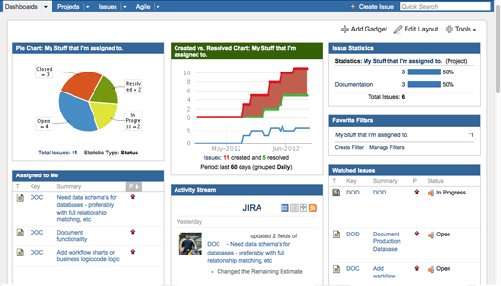

Unified Testing process in JIRA:
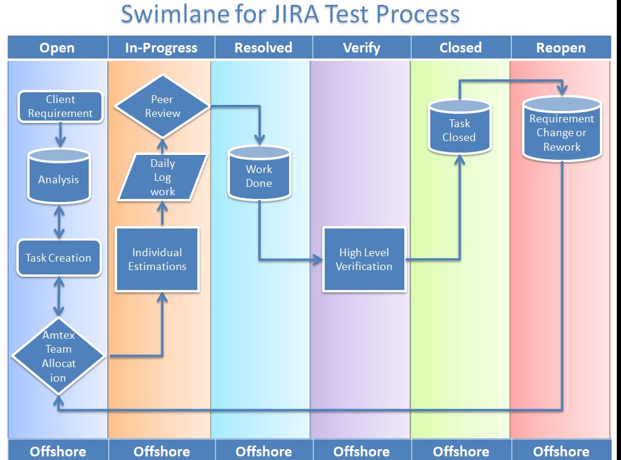

Defect Tracking Process in JIRA:
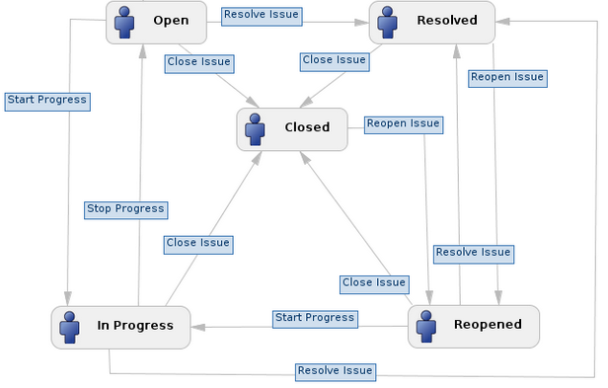

RACI Matrix:

Testing | Responsible | Accountable | Consulting | Informed
Unit/Code coverage testing | Test Manager and Test team | Development manager | Product owner | Distribution List
Smoke testing | IT team, Test Team | IT team | Product owner | Distribution List
SIT | IT team, Test team | Test Team | Product owner | Distribution List
FIT | IT team, Test team | Test Team | Product owner | Distribution List
Regression Testing | IT team, Test team | Test Team | Product owner | Distribution List
UAT | UAT testers | UAT Manager | Product owner | Distribution List
Performance Testing | PT testers | PT Manager | Product owner | Distribution List
Pre-Production Testing | P-PAT testers | P-PAT Manager | Product owner | Distribution List

Organisation:

Testing Deliverables and Milestones:

Milestones:
Milestones are basically higher level WBS tasks for the project. This can be planned in Microsoft project or in Excel sheet depending on the discretion of the Test/QA manager. Kindly find the simple milestones for a testing project.

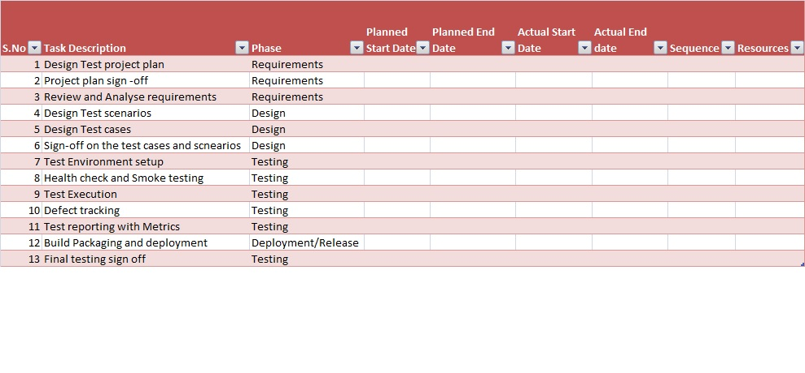

Deliverables:

Deliverables are as follows;

- Test cases complete, signed off by the team managers.(M)
- Test scenarios complete , signed off by the team managers.
- Traceability Matrix complete
- Automation scripts
- Test status reports(M)
- MoM
- Project plan(M)
- Test Strategy document(M)
- Test data

M denotes Mandatory deliverables and others can be optional accordingly.

Roles and Responsibilities:
Role | Responsibilities
Test / QA Manager | Manages the testing engagement
Test Leads | Allocation , tracking and monitor tasks assigned to test engineers.
Test Designers | Write/Review scenarios and test cases
Test Engineers | Execute test cases and report defects and results
IT Engineers | Maintain the test environment, Installation and configuration, Healthcheck testing and populate test data
Build Manager | Monitors and Updates automated build procedures
Product/Development Manager | Product management and Development

Communication Plan:
- Development manager or the product manager should involve the test manager and the test leads in the Requirements discussion and the development deliverables in the requirement stage like requirements doc, functional specification, design docs to be shared with the test team for preparation of test scenarios and test cases
- Testing team to be in the Informed through emails or MoM for matters which involve the testing team directly or indirectly.
For example: It is not mandatory to inform the testing team about Scrum/Agile stand-ups but anything to do with the new features or existing features to be kept updated.
- Development team to share the existing defects list to the test team on the product.
- Development team to share the source code of the product with the test team during white box testing.
- Test environment should be separate and dedicated from the Development environment

Entry and Exit Criteria:

Entry Criteria :
Entry criteria is the minimum eligibility or the minimum set of conditions that should be met in order to start the testing work . Entry criteria are documented and signed off during the test planning phase and is included in the relevant test plans.
Typical entry criteria may include the following:
- All test hardware platforms must have been successfully installed , configured, and functioning properly.
- All the necessary documentation, design, and requirements information should be available that will allow testers to operate the system and judge the correct behavior.
- All the standard software tools including the testing tools must have been successfully installed and functioning properly.
- All personnel involved in the testing effort must be trained in the tools to be used in the testing process.
- Proper test data is available.
- The test environment such as, lab, hardware, software, and system administration support should be ready.
If any of the conditions specified in the Entry criteria ( that is already documented and signed off) cannot be met due to some reasons, an approval is needed from all the stakeholders that were involved during the signing off as Conditional Entry documenting the RISKS involved.

Exit Criteria:
Exit criteria is the minimum eligibility or the set of conditions that should be met in order to close a particular project phase. Exit criteria are documented and signed off during the test planning phase and are included in the relevant test plans.
Typical Exit criteria may include the following:
- All Test plans have been run.
- A certain level of requirements coverage has been achieved.
- No high priority or severe bugs are left outstanding.
- All high-risk areas have been fully tested, with only minor residual risks left outstanding.
- Cost – when the budget has been spent.
- The schedule has been achieved.
Exit criteria should have been agreed as early as possible in the SDLC cycle; however, it may get subjected to controlled changes as the details of the project become more clear.
Due to the increasing complexity and size of the project that we see nowadays, the need for Entry and Exit criteria is mandatory for the success of any project.

Resources

People
Designation | Skill sets | Names | Constraints
Test Manager | Test Management, MS-Project | Joe PMP | Other Projects
Product Manager | Good Knowledge in Sample inc |  | Other Projects
Test Lead | JIRA,Test Rail, TA,MS office |  | Other Projects
Test Engineer | Testing concepts, JIRA,Test Rail, TA,MS office |  | Other Projects
IT Engineer | Hardware and Software Installation, config and troubleshooting |  | Other Projects

Software
Areas | Software names
Operating systems | Windows,Linux
Application server | Tomcat
WebServer | IIS
AUT(Application under test) | Sample inc
Utility software | Adobe, MS-office,Winzip
Languages | Java,VB, C++

Critical Success Factor.
Critical success for this project is based on delivery on time with all script passes completed and all defects closed and regressed.

Internal success will be measured by:
- Completion of application test scripts (written, reviewed, and approved) when scheduled
- Completion of the scheduled test cycles in a timely fashion (as scheduled in the project timeline in the project schedule)

Metrics for this are:
- The completed test scripts with notations concerning defects logged / repaired.
- Impact factors for the completion of the above are as follows:
- Failure of development to return “Repaired” defects in a timely fashion.
- Failure of scheduled builds as needed to verify new functions and defects.
- Additional features being added that are outside the scope of this release.

Assumptions , dependencies and constraints

- Resources must be assigned full time to the test team in order to carry out the intended test cycles.
- Resources other than the Test team will be the Development Staff, Product manager, Research and additional testers if available from other areas within the company.
- Institutionalized knowledge of the Sample inc application by some test team members is critical for successful testing.

The following deliverables need to be in place:
- Accurate Project plans
- Complete Requirements
- Complete Test Scripts
- Quick and accurate repairs of defects logged into the defect tracking tool.
- Available resources to provide the above in the time line defined in the project plan.

Risk Management

Risks to be documented and mitigated in the Risk Register.

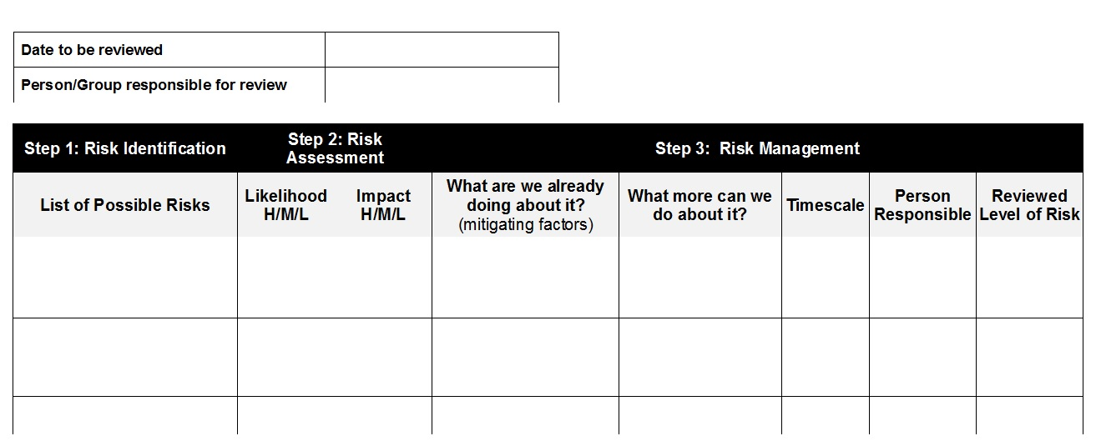

Conclusion
This software test strategy documents all the necessary elements to be covered during the test process and lifecycle. We have gone through details in-depth in some areas and higher level in other areas. Depending on the nature of the project the details in this document can be modified accordingly. This document will help in streamlining the testing process across Amtex for all its testing projects and will serve as a guideline.

