IE 306 Term Project — Reinforcement Learning for City-Scale Drone Delivery
Team: Sezen Balkan (Role A), Ozan Karhan (Role B), Tuba Nur Büyükata (Role C). Offline RL and multi-agent control are joint components.
The primary metric is mean cost_per_order; lower is better. Unless stated otherwise, the final table uses configs/eval_standard.yaml and environment seeds 0, 1, and 2. It is reproduced with:
python run_all.py --config configs/eval_standard.yaml --seeds 0,1,2

1. Baselines
Policy | cost/order, mean ± std | success rate
random | 18.78 ± 1.27 | 0.653
greedy_nearest | 4.57 ± 0.85 | 0.855
milp_rolling | 4.72 ± 1.38 | 0.836
greedy_nearest is the required bar. MILP is slightly worse on these seeds because its single-epoch Manhattan-distance matching can make poor assignments around no-fly geometry.

2. Role A — Value-based methods (Sezen Balkan)

2.1 Methods
The first implementation used a flat observation vector and a replay-buffer DQN. Invalid actions were masked both during action selection and Bellman backup. We then introduced Double DQN to separate next-action selection from target evaluation, Dueling DQN to separate state value and action advantage, and three-step returns to improve delayed credit assignment.
The flat network remained unstable and did not beat greedy. The final Role-A method is therefore a factored Double DQN. Shared heads score every drone-order assignment and every charging action. Features include routed pickup/delivery distance, deadline feasibility, battery feasibility, current SoC, and global demand. The network is warm-started by supervised imitation of the Role-C depth-1 planner, then updated using replay, a target network, and Double-DQN TD targets. The warm start is disclosed because presenting it as a from-scratch DQN would be misleading.

2.2 Results
Value-based method | cost/order | success
DQN n=3 | 20.67 ± 6.57 | 0.495
Double DQN n=3, flat MLP | 6.76 ± 1.80 | 0.749
Dueling DQN n=3 | 26.07 ± 3.49 | 0.428
Factored Double DQN, selected checkpoint | 1.72 ± 0.05 | 0.914
Across three independent training seeds, the best factored Double-DQN checkpoints achieved costs 1.72, 2.65, and 2.50, giving 2.29 ± 0.41. All three beat greedy. The selected saved model is training seed 0 at 5,000 TD steps. Continuing to 10,000 steps caused late divergence, so checkpoint selection is necessary rather than assuming more training is always better.
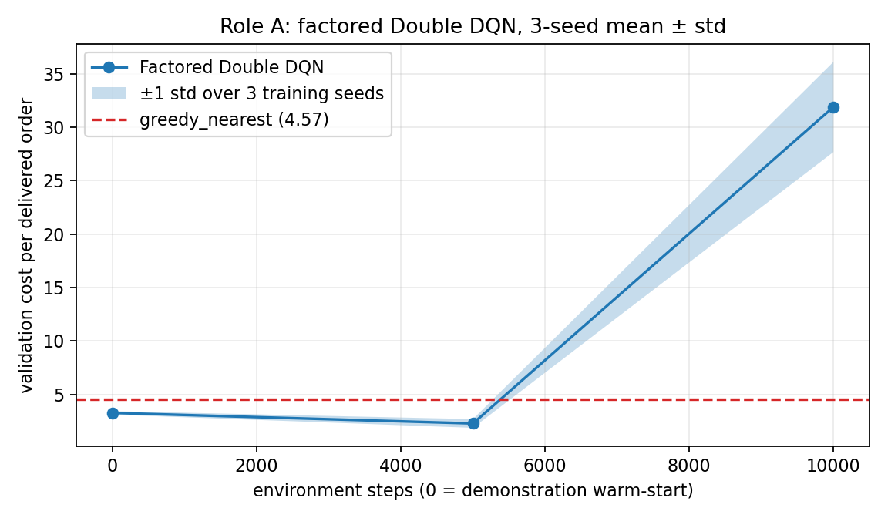
Factored Double DQN learning curve

2.3 Required ablation: target network
For the controlled flat Double-DQN run, target-network ON updates the target every 1,000 steps; OFF copies the online network every step.
Setting | best cost | final cost
Target network ON | 10.19 | 14.90
Target network OFF | 13.18 | 25.66
Removing the delayed target worsens both the best checkpoint and the endpoint. The result supports the diagnosis that bootstrapping instability, not simply insufficient compute, was the main flat-DQN failure.

2.4 What broke
The original flat representation mixed a 20×20 grid with entity rows and a large action head. It learned passive charging/no-op behavior and later diverged. Increasing training to millions of steps did not fix the representation. Factored action scoring supplied the relational information needed for assignment. Even then, TD learning could destroy a good warm start, which is why validation checkpoints and three training seeds are reported.

3. Role B — Policy-based methods (Ozan Karhan)

3.1 Methods
REINFORCE uses likelihood-ratio policy gradients with a learned value baseline and GAE. A2C uses the same factored actor-critic but collects fixed-length rollouts and bootstraps from the critic, reducing variance. Invalid dispatch actions are masked. DDPG uses a deterministic continuous actor, Q critic, replay buffer, target networks, Polyak averaging, and OU exploration on DroneControl-v0.

3.2 Dispatch results
Method | cost/order, mean ± std | success
REINFORCE + GAE | 2.72 ± 0.73 | 0.878
A2C | 1.09 ± 0.43 | 0.976
A2C is the most reliable learned dispatcher. Its three saved training models also beat greedy on seeds 0–4, whereas REINFORCE is highly seed-sensitive. The difference is consistent with the lower-variance bootstrapped updates used by A2C.
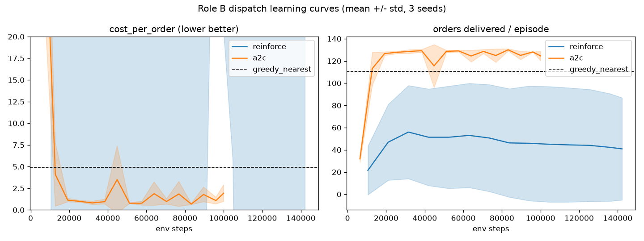
Role B dispatch curves

3.3 Required ablation: GAE λ
The A2C sweep used λ ∈ {0, 0.9, 0.95, 0.99, 1.0}, two training seeds, and a 40k-step budget.
λ | mean best validation cost
0.0 | 13.82
0.9 | 0.77
0.95 | 0.76
0.99 | 0.89
1.0 | 0.90
One-step advantages are too myopic; λ around 0.9–0.95 balances bias and variance. Although the main methods have three training seeds, this reduced ablation has two seeds and should be interpreted as a controlled design check.
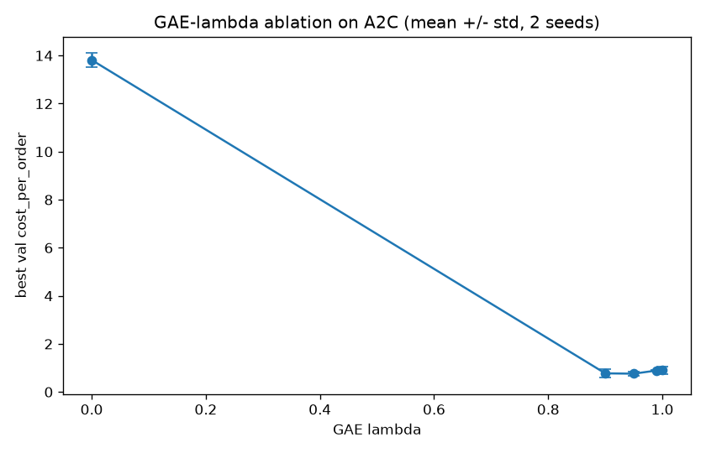
GAE ablation

3.4 DDPG result and failure
On seeds 0–2, the current go-straight controller obtains mean return 26.37, success 1.00, and 11.7 steps. The selected DDPG checkpoint obtains return −69.66, success 0.00, and 234.3 steps. DDPG therefore does not beat its controller baseline. It learned conservative movement that avoided some large penalties but failed to reach the target. This remains an unresolved Role-B weakness rather than a successful result.
The main engineering fix for A2C was reward scaling and Huber value loss: unscaled value targets produced losses around 25,000 and suppressed useful policy gradients.

4. Role C — Planning (Tuba Nur Büyükata)
Role C implements a deterministic decision-time planner. It evaluates every valid assignment using routed pickup distance, full delivery distance, remaining deadline, battery shortfall, order age, and charging readiness. All coefficients are stored in configs/role_c_rollout.yaml. Routed distances are computed by student-side BFS using only the frozen observation grid.
The depth ablation is:
- depth 0: nearest-pickup rule with a battery guard;
- depth 1: adds delivery distance, deadline risk, and battery feasibility;
- depth 2: adds post-delivery distance to a charger.
Method | cost/order | success | on-time | delivered
depth 0 | 4.570 | 0.855 | 0.903 | 118.3
depth 1 | 2.923 | 0.881 | 0.982 | 126.3
depth 2 | 3.331 | 0.869 | 0.982 | 124.3
Depth 1 is selected. Depth 2 is more conservative and sacrifices good current assignments for future charger proximity. The implementation is a shallow rollout-style scoring planner, not a full cloned-state MCTS tree; this is a deliberate limitation and is stated explicitly.

5. Joint component — Offline RL
The pooled dataset contains 420,103 transitions from 3,969 episodes. Its checksum and validation command are in DATASET.md. It combines trajectories from all three role policies and includes mixed-quality behavior.
Naive offline DQN performs Bellman regression over the static data. Because the dataset does not store masks, its maximum ranges over all 169 actions, including unsupported actions. CQL adds α(logsumexp Q(s,a) − Q(s,a_data)); BC directly clones logged actions.
Method | cost/order, 3 training seeds | success
BC | 18.45 ± 3.79 | 0.542 ± 0.058
naive offline DQN | 13.96 ± 2.72 | 0.537 ± 0.055
CQL | 7.06 ± 1.10 | 0.717 ± 0.030
CQL beats both required offline baselines. The selected CQL seed scores 5.72. Naive final maximum Q-values were approximately 6,785, 4,170, and 5,982; CQL reduced them to 839, 792, and 745. Thus the OOD over-estimation failure is visible in every training seed, not only in one lucky run.

6. Joint component — Multi-agent IDQN
Eight decentralized drone agents share one Q-network and one replay buffer on DroneDispatchMA-v0. Each receives its local 59-dimensional observation and chooses accept, move, charge, or idle. The cost metric now counts on-time deliveries from their actual deadlines rather than using a reward threshold.
Three equal 30k-step training runs produced:
training seed | cost/order | delivered/episode
0 | 55.33 | 26.0
1 | 44.17 | 30.3
2 | 17.90 | 71.7
mean ± std | 39.14 ± 15.69 | 42.7 ± 20.6
The random MA baseline costs 9.23, so these equal-budget runs do not converge. An earlier extended 60k seed-0 checkpoint reaches 6.65, delivers 100.7 orders, and beats random, but it is not presented as a robust three-seed result. It also does not beat the best centralized A2C (1.09) or Role-C planner (2.92). This corrects the earlier claim that IDQN generally beat the centralized policy.
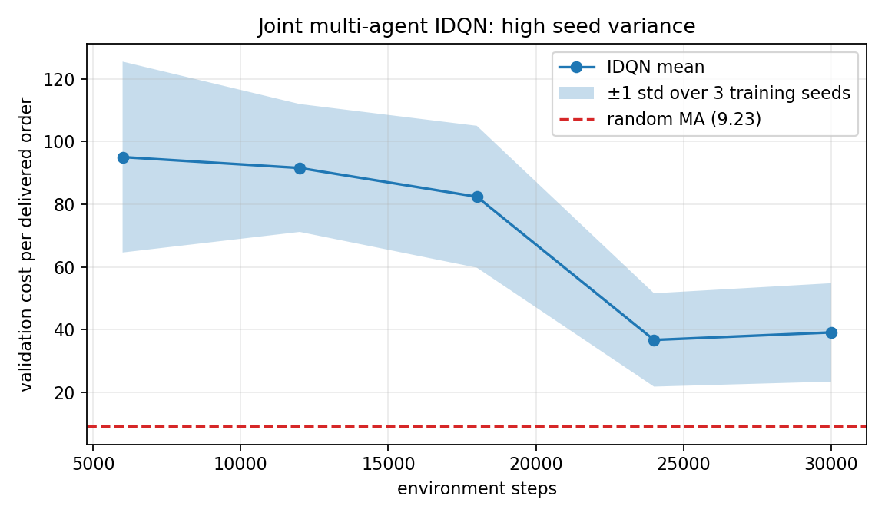
Multi-agent three-seed curve
The high variance illustrates non-stationarity: from one drone’s perspective, the other seven agents change their behavior while the shared network learns. Parameter sharing reduces but does not remove this moving-target problem.

7. Method origins
- DQN: Mnih et al., Human-level control through deep reinforcement learning (2015), chosen as the canonical replay/target-network value method.
- Double DQN: van Hasselt, Guez & Silver (2016), chosen to reduce max-operator over-estimation.
- Dueling DQN: Wang et al. (2016), chosen to separate state value from action-specific advantage.
- REINFORCE: Williams (1992), the likelihood-ratio policy-gradient baseline.
- GAE: Schulman et al. (2016), chosen for its explicit bias/variance λ knob.
- A2C/A3C: Mnih et al. (2016); we use the synchronous A2C variant.
- DDPG: Lillicrap et al. (2016), chosen for continuous speed/heading actions.
- Rollout planning: Sutton & Barto, Chapter 8, and Tesauro & Galperin (1996), motivating decision-time policy improvement.
- CQL: Kumar et al. (2020), chosen to penalize unsupported offline actions.
- IDQN/parameter sharing: Tampuu et al. (2017) and Gupta et al. (2017).

8. Reproducibility and final assessment
All experimental numbers are in YAML configs; dependencies are pinned. offline_pool.npz is included with SHA-256 verification. run_all.py loads the final saved policies for every role and both joint components. The simulator tests pass 17/17.
The strongest methods are A2C, factored Double DQN, and the depth-1 planner. Offline CQL satisfies the required failure-and-fix comparison. DDPG and three-seed IDQN remain honest negative results: they run end-to-end, but do not meet their respective baselines reliably.

