MySQL Activity

Database: Ruña_jonalyn

PART I: Database Tables

Table 1: Appointments

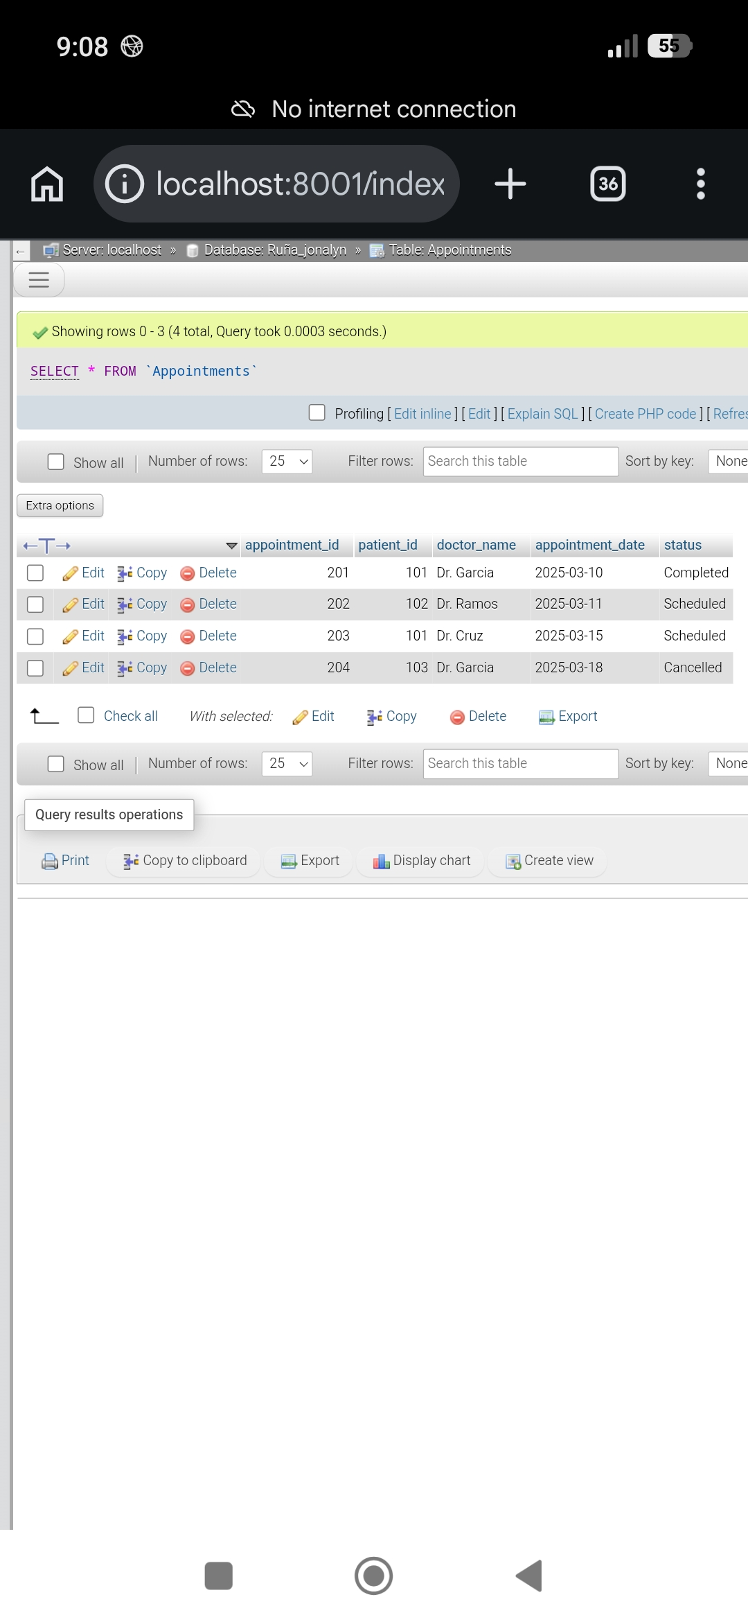

Table 2: Patients

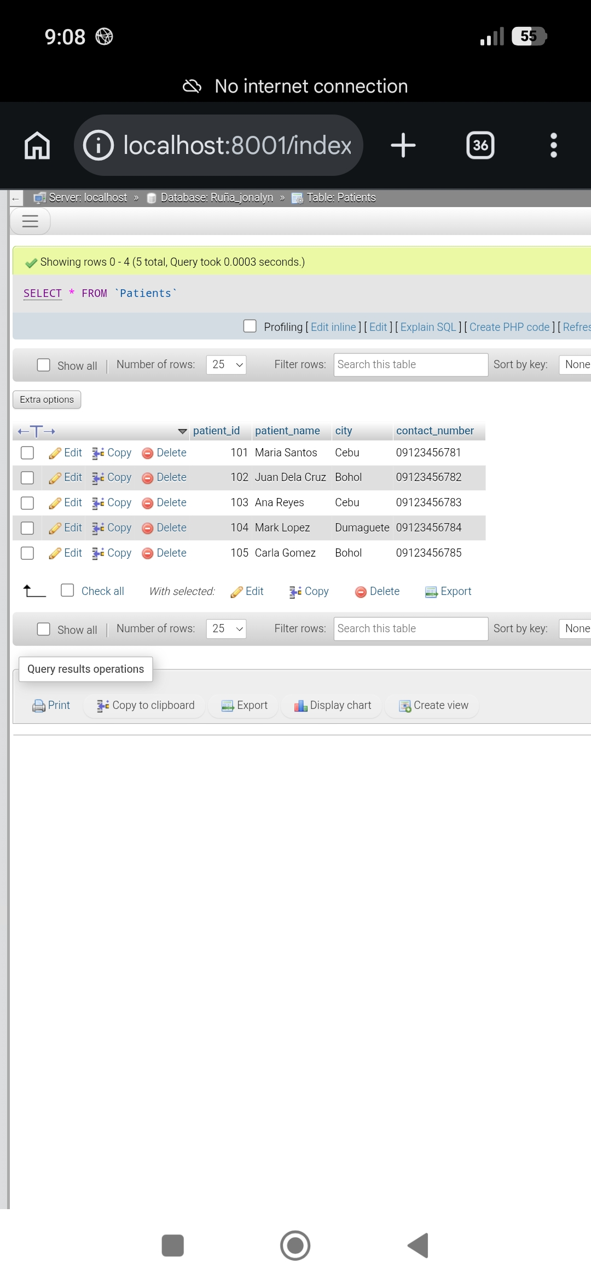

PART II: SQL Query Results

Part A & B: INNER JOIN Queries

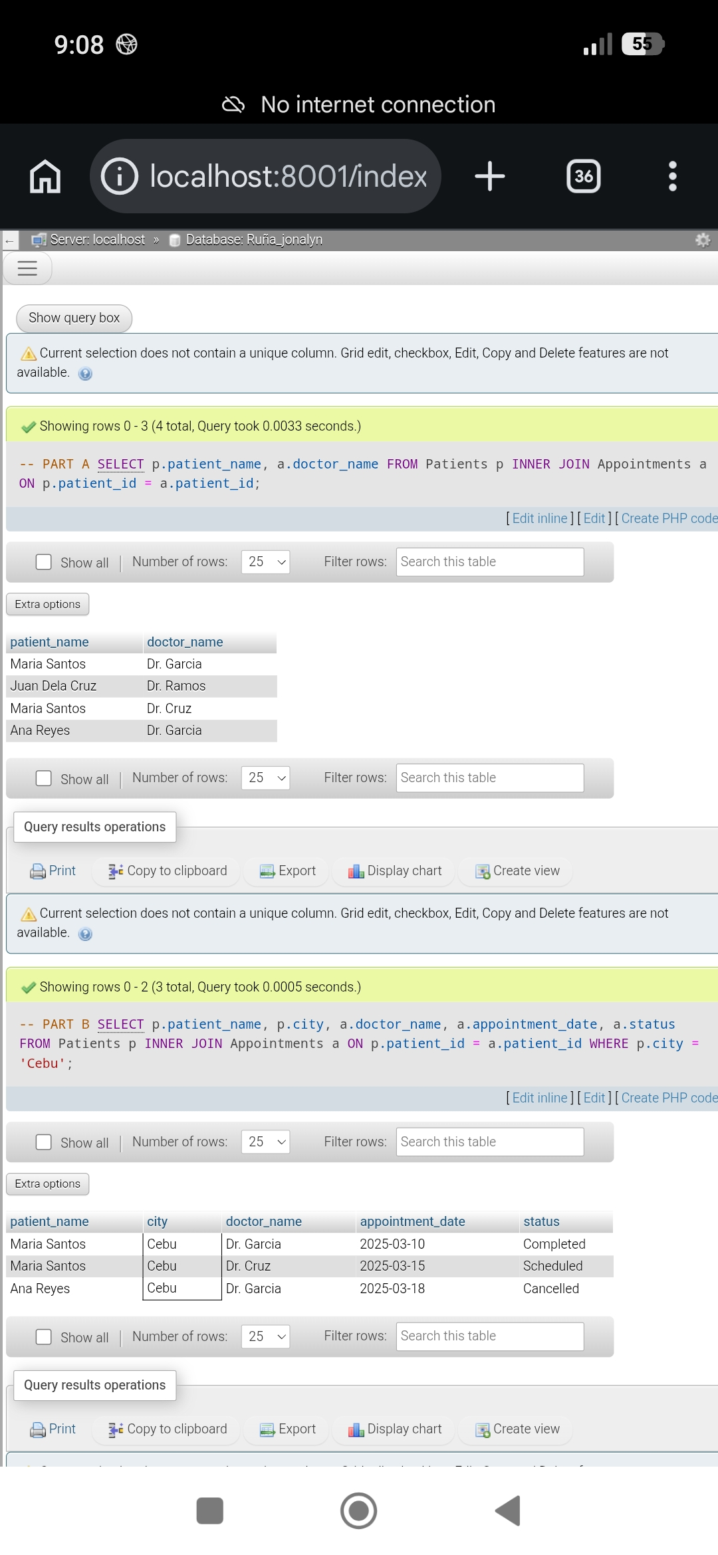

Part C: LEFT JOIN & RIGHT JOIN Queries (Part 1)

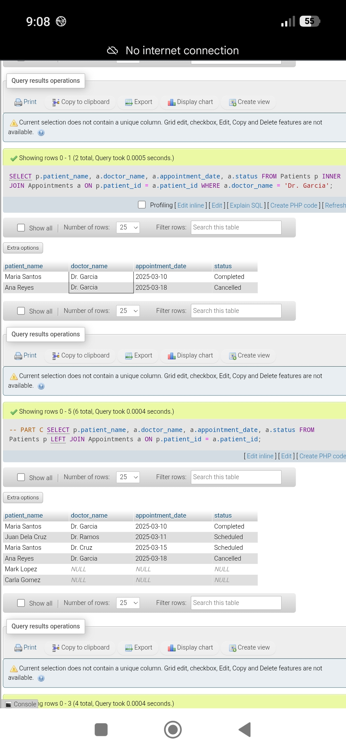

Part C: LEFT JOIN & RIGHT JOIN Queries (Part 2)

