**ESP32 Pinout | ESP-WROOM-32 Pinout**

<https://www.electronicshub.org/esp32-pinout/>

**Video ESP32 Pin Configuration -**

https://www.youtube.com/watch?v=DvUvWrdaCQY

**Pinout of ESP32-WROOM-32 GPIOs:**

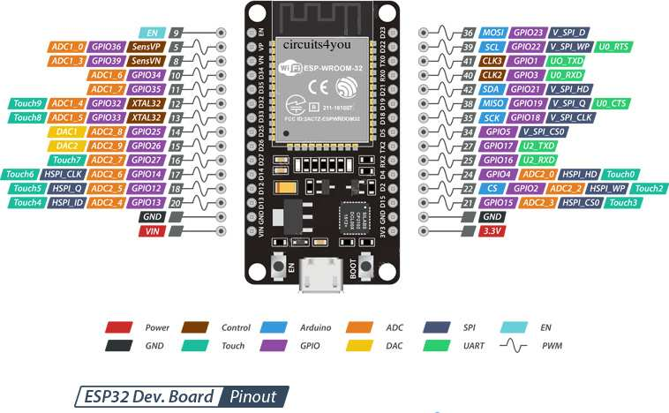

1. **ESP32 with DHT11/DHT22 Temperature and Humidity Sensor using Arduino IDE [Digital] –**

<https://randomnerdtutorials.com/esp32-dht11-dht22-temperature-humidity-sensor-arduino-ide/>

1. **LDR Light Sensor Module LM393 [Analog]–**

* Sensor - <https://www.electronicscomp.com/ldr-light-sensor-module-india>
* Tutorial - <https://www.instructables.com/LDR-Sensor-Module-Users-Manual-V10\>

1. **pH Sensor [Analog]-**

* Analog PH Sensor Kit for Arduino -https://www.electronicscomp.com/analog-ph-sensor-kit-for-arduino
* Tutorial - <https://www.circuitschools.com/diy-ph-meter-using-arduino-and-ph-sensor-and-calibrating-it-for-accuracy/>

1. **TDS Sensor [Analog] -**

* Tutorial - <https://create.arduino.cc/projecthub/GAURAVK5/dfrobot-tds-meter-sensor-with-arduino-and-lcd-measure-92853d>