信 息 工 程 学 院
《云计算》实验报告
学院: 信息工程学院 | 班级: 数科2102 | 姓名: 陈 | 学号:202101 | 成绩:
- 实验题目
MapReduce编程
- 实验目的
掌握MapReduce编程。
理解MapReduce原理。
- 实验平台
希冀平台
- 实验过程及步骤
实验3
环境准备
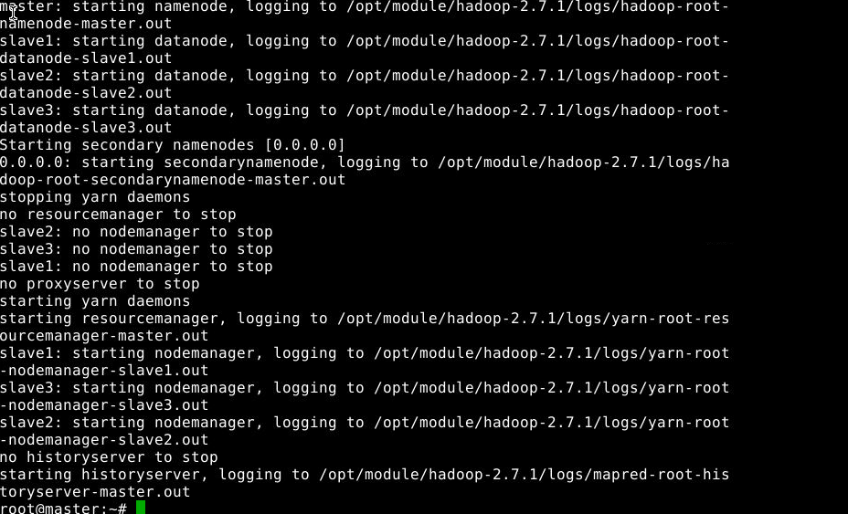
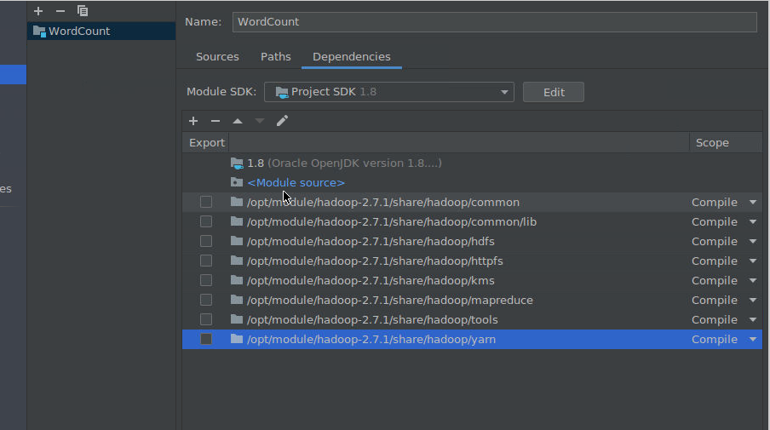
WordCount测试数据准备
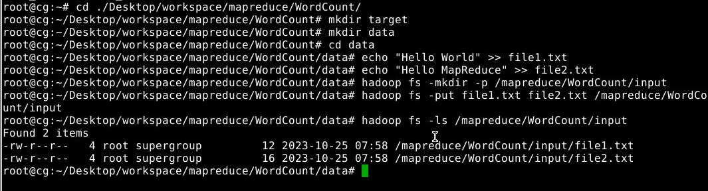
WordCount运行结果
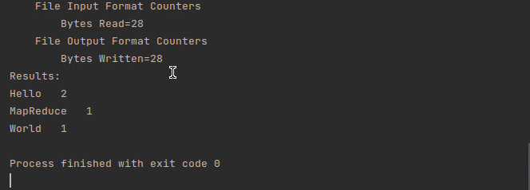
Relation测试数据准备
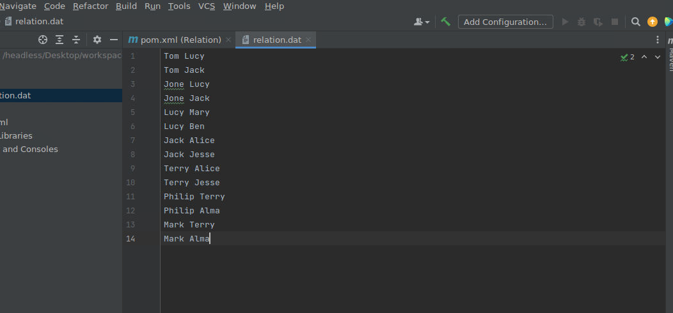
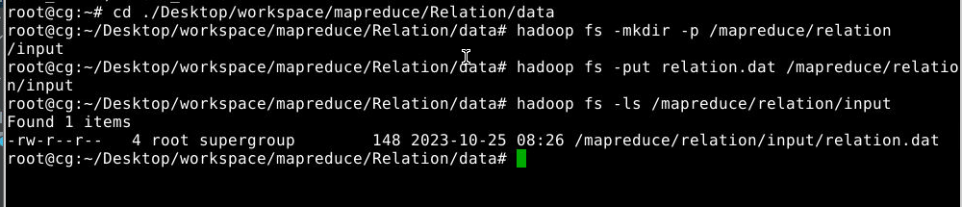
Relation实验结果
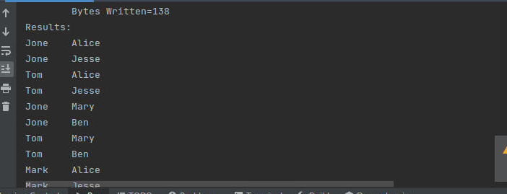
Inverted测试数据准备
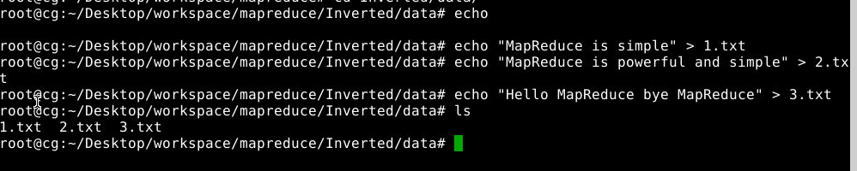
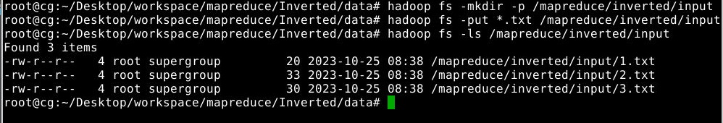
Inverted实验结果
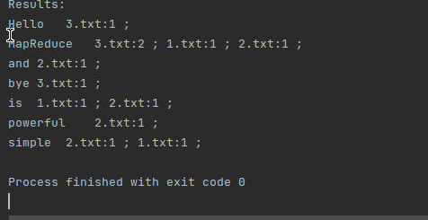
PageRank测试数据准备
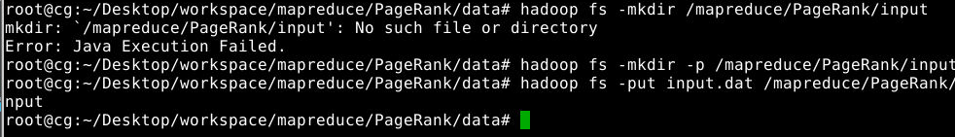
PageRank实验结果
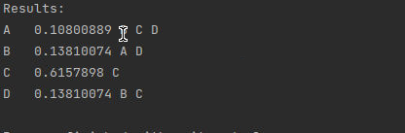
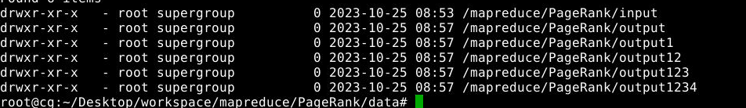
流量统计
测试数据准备
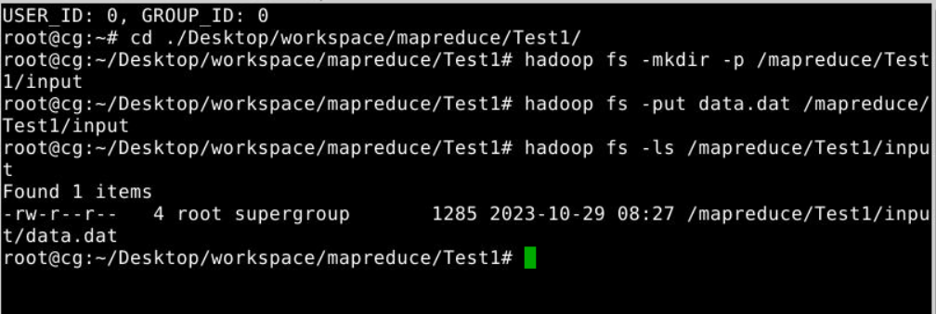
运行结果
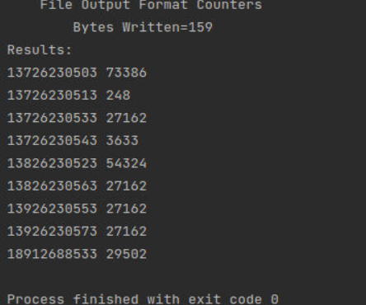
代码：
MyMapper：
import java.io.IOException;
import org.apache.commons.lang.StringUtils;
import org.apache.hadoop.io.LongWritable;
import org.apache.hadoop.io.Text;
import org.apache.hadoop.mapreduce.Mapper;

public class MyMapper extends Mapper<LongWritable, Text, Text, LongWritable>{
@Override
protected void map(LongWritable key, Text value, Context context)
throws IOException, InterruptedException {
String str = value.toString();
String[] mes = StringUtils.split(str," ");
int i=0;
for(String tmp : mes){
if(i == mes.length-2 || i == mes.length-3){
context.write(new Text(mes[0]), new LongWritable(Integer.parseInt(tmp)));
}
i++;
}
}
}
MyReducer：
import java.io.IOException;
import org.apache.hadoop.io.LongWritable;
import org.apache.hadoop.io.Text;
import org.apache.hadoop.mapreduce.Reducer;

public class MyReducer extends Reducer<Text, LongWritable, Text, LongWritable>{
@Override
protected void reduce(Text key, Iterable<LongWritable> values,Context context)
throws IOException, InterruptedException {
long cnt = 0;
for(LongWritable value : values){
cnt += value.get();
}
context.write(key, new LongWritable(cnt));
}
}
MyRunner：
import java.io.IOException;
import org.apache.hadoop.conf.Configuration;
import org.apache.hadoop.fs.Path;
import org.apache.hadoop.io.LongWritable;
import org.apache.hadoop.io.Text;
import org.apache.hadoop.mapreduce.Job;
import org.apache.hadoop.mapreduce.lib.input.FileInputFormat;
import org.apache.hadoop.mapreduce.lib.output.FileOutputFormat;
import java.util.Scanner;
import org.apache.hadoop.fs.FSDataInputStream;
import org.apache.hadoop.fs.FileSystem;
import java.net.URI;

public class MyRunner {
public static void main(String[] args) throws IOException, ClassNotFoundException, InterruptedException {
Configuration conf = new Configuration();
Job job = Job.getInstance(conf);

job.setJarByClass(MyRunner.class);

job.setMapperClass(MyMapper.class);
job.setReducerClass(MyReducer.class);

job.setOutputKeyClass(Text.class);
job.setOutputValueClass(Text.class);

job.setMapOutputKeyClass(Text.class);
job.setMapOutputValueClass(LongWritable.class);

Scanner sc = new Scanner(System.in);
System.out.print("inputPath:");
String inputPath = sc.next();
System.out.print("outputPath:");
String outputPath = sc.next();

FileInputFormat.setInputPaths(job, new Path("hdfs://master:9000"+inputPath));

FileOutputFormat.setOutputPath(job, new Path("hdfs://master:9000"+outputPath));

job.waitForCompletion(true);

try {
FileSystem fs = FileSystem.get(new URI("hdfs://master:9000"), new Configuration());
Path srcPath = new Path(outputPath+"/part-r-00000");

FSDataInputStream is = fs.open(srcPath);
System.out.println("Results:");
while(true) {
String line = is.readLine();
if(line == null) {
break;
}
System.out.println(line);
}
is.close();
}catch(Exception e) {
e.printStackTrace();
}
}
}
实验4
开启服务
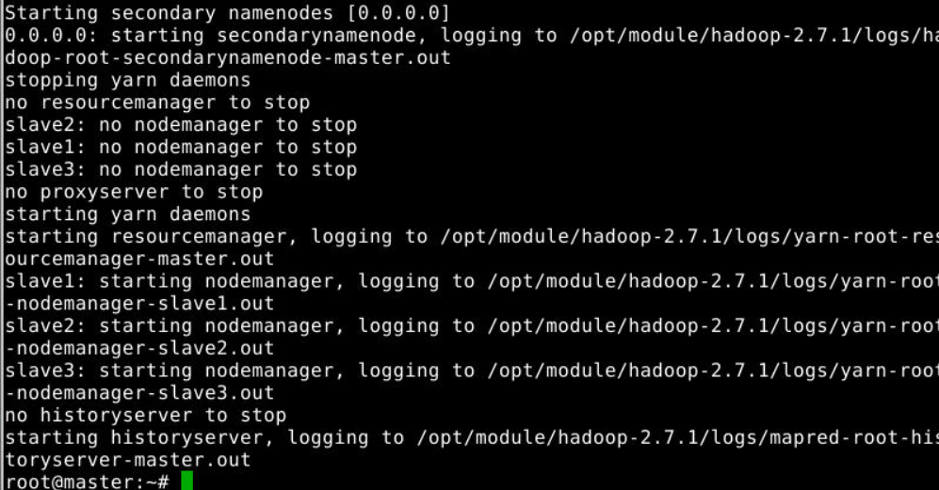
数据准备
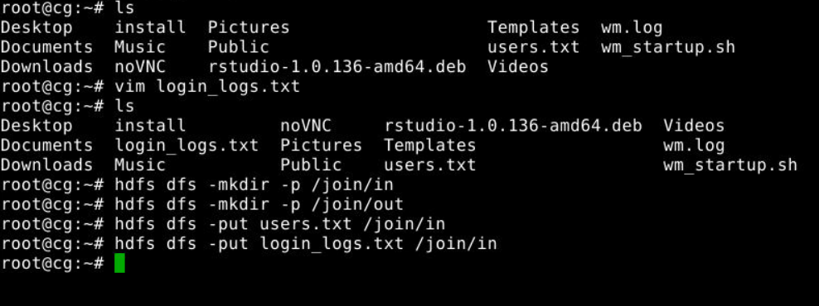
运行结果1
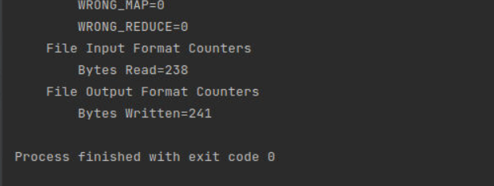
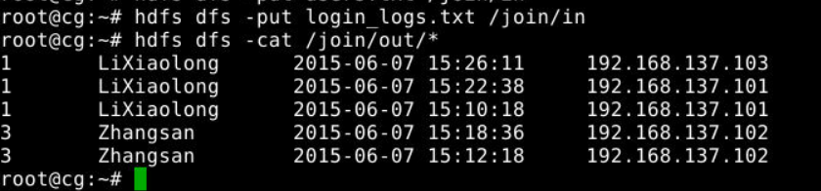
运行结果2
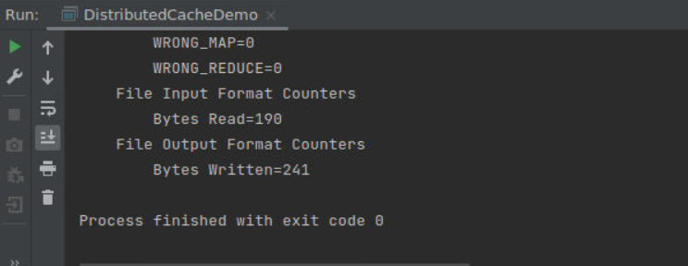
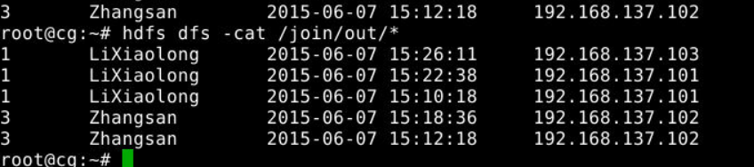
启动mysql服务
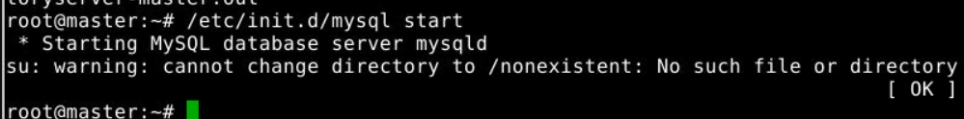
创建目录
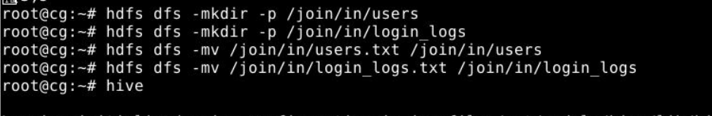
创建外部表
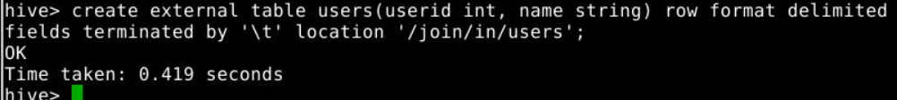
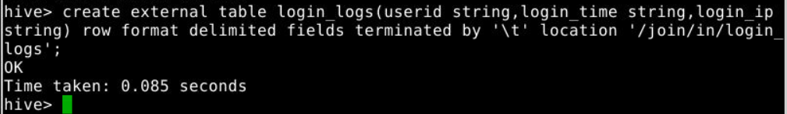
执行连接查询并保持结果
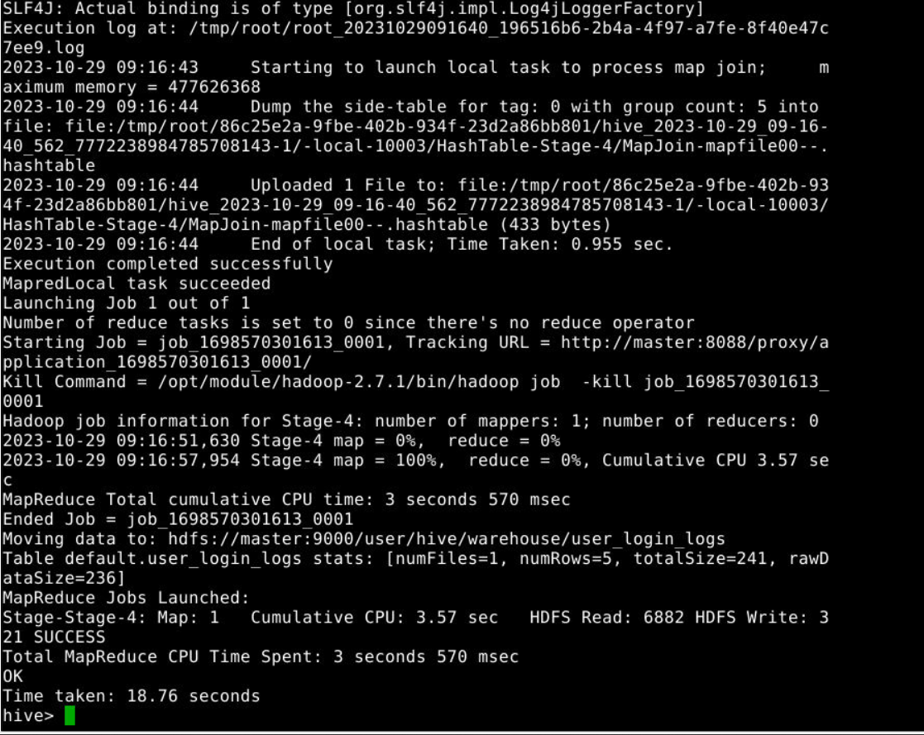
查看结果
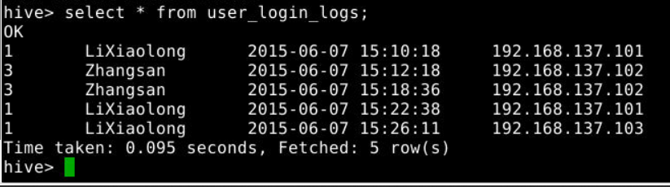
- 实验总结
通过本次实验我学习了MapReduce编程，并且针对一些简单的问题进行处理，进一步了解了Map阶段对任务进行分解，Reduce阶段对任务进行合并的过程。也学习到了如何通过编写MapReduce程序来完成join操作。并知道了在执行效率上map-join>SemiJoin>reduce-join。

实验报告的内容与格式按任课教师的要求书写。

