Module 1b

Moving the Robot

Introduction to Motor Blocks

Motors
The motors are used to make your robot perform actions. There are 2 sizes of motors, the medium and the large.

Medium
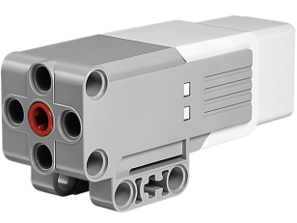

Large
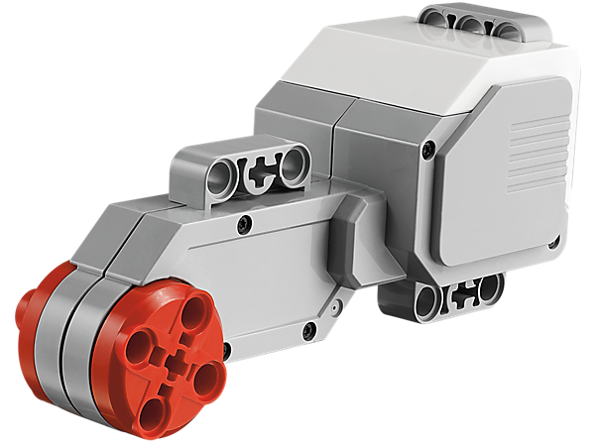

Single Motor Blocks
The blocks used to control these motors are explained below.

Medium
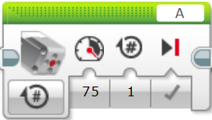
Menu
Power
Distance
Speed
Motor Port

Large
This block is exactly the same except for the image of a large motor on it.

Double Motor Blocks

Move Steering
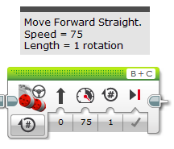
Left Motor Port
Right Motor Port
Direction of Movement
Power
Brake when finished
Distance
Menu

Move Tank
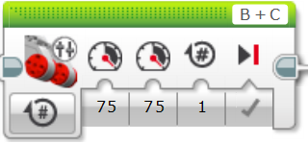
Left Motor Port
Right Motor Port
Left Motor Power
Right Motor Power
Brake when finished
Distance
Menu

Activity 1 – Moving Straight

Move Steering

Move Tank

Activity 2 – Turning

Move Steering

Move Tank

