 | STran Users’ Guide | 

Serial file transfer for ZARC, but may have other applications.
Written by Merlin Skinner-Oakes, 14/3/2021
Last updated 25/10/2024 for stran V2.0

Introduction
There are various options for transferring files over a serial line. The ZARC monitor’s tpadownload command works but is crude and manually entering the file length is prone to error. It also requires quite a bit of typing. Other options are gkermit and PCGET / PCPUT (Xmodem), but none seem to really do what I want them to do. Gkermit does work, but again is quite a bit of typing for each file. Scripts could ease this somewhat, but ideally I would like a single command from one end only that would transfer a file. It would be nice to be able to use wildcards or transfer an entire disk / directory as well.

Architecture
The basic structure is:
- A Python Linux program (“stran”) that would perform the PC side of the operation.
- A CP/M program (also called stran) that would act as a server.
The Linux side controls the transfers. There are some advantages to having the Linux (rather than the CP/M) side control things:
- Running the CP/M system with a single serial line and a terminal emulator on the PC is much simpler this way. Start the CP/M server using the terminal emulator, then exit and control things from the PC, optionally transferring data over the same line. Having the CP/M system in control would force the use of two serial lines, or one and a “built-in terminal” (display and keyboard).
- This keeps the CP/M side simple. This is advantageous, as this will need to be written in assembler.
- It will be easier to write scripts for operations such as drive backup in Python.

Protocol

Byte Encoding
ZARC serial ports are capable of full 8-bit operation with no special codes. However, some CP/M BIOS implementations remove bit 7, and other systems may use control codes such as XON and XOFF for special functions. For these reasons, a protocol that avoided use of control codes or bit 7 is preferred. Del (0x7f) is also avoided. Only codes 0x20 to 0x7e are used, with all but the packet start code (“*”) sent using codes 0x3f to 0x7e. The packet start code is chosen such that it cannot occur at any other point in a packet, thereby preventing byte synchronisation errors. Each three 8-bit bytes are encoded into four as follows:

Encoded Byte Number | Data
0 | <byte 0 bits 7 to 2> + 0x3f
1 | <byte 0 bits 1 to 0> <byte 1 bits 7 to 4> + 0x3f
2 | <byte 1 bits 3 to 0> <byte 2 bits 7 to 6> + 0x3f
3 | <byte 2 bits 5 to 0> + 0x3f

Zero padding is added as required to complete the four byte group when less than three bytes are to be sent at the end of a packet.

Packet Format
Block length (BLKLEN) is fixed at 512 bytes. This was chosen to be shorter than that known to cause issues with at least some USB RS-232 adaptors (1024 bytes). Note that this length defines the maximum size of the data portion of the packet only. Allowance must also be made for the 3 to 4 bytes encoding scheme overhead.
In normal operation, transfers are in the form of packets with the following general format:
Start Offset | Data | Description
0 | “*” (0x2a) | Start of packet (not encoded)
1 | 8 bits | Packet type (see below)
2 | 16 bits | Packet Sequence Number (“PSN”)
4 | 16 bits | Data length (0 to BLKLEN).
6 | Data | Packet data (if present)
 | 0 to 16 bits | Padding to align to a 3-byte boundary.
 | 16 bits | CRC16 / XMODEM checksum of all fields except start of packet byte. Initial CRC is zero.
 | 8 bits | Pad to align to a 3-byte boundary.

The entire packet is encoded using the 3 to 4 bytes encoding scheme with exception of the initial “*”. 16-bit values are sent LS byte first.

Packet Type Codes

Packet Type | Name | Source | Data Field Contents | Description
0x01 | ACK | PC or CP/M | No data or one byte *₂ | Positive acknowledgement.
0x02 | NAK | PC or CP/M | Reason for NAK (see below) | Negative acknowledgement.
0x03 | Exit | PC | No data | Exit CP/M stran and return to CP/M.
0x04 | Tx | PC | File descriptor block *₁ | Transmit file command (PC to CP/M).
0x05 | Rx | PC | File descriptor block *₁ | Receive file command (CP/M to PC).
0x06 | End | PC or CP/M | No data | Normal end of transfer.
0x07 | Reset | PC | No data | Reset transfer system.
0x08 | Dir | PC | Drive letter | Read directory.
0x09 | Data | PC or CP/M | Data block

*₁ <drive letter><8 character filename><3 character extension><Adler-32 checksum><CRC-16 (XMODEM)>.
*₂ One data byte is sent in response to Tx or Rx commands. This reports whether or not the PC and CP/M files are identical. See Transfer Required Reason Codes below.

NAK Reason Codes
These are sent as a single byte in the data field, so data length = 1.
Reason Code | Description
0x00 | CRC error
0x01 | Unexpected command
0x02 | Can’t open file
0x03 | BDOS file read / write error

Transfer Required Reason Codes
These are sent as a single byte in the data field, so data length = 1.
Reason Code | Description
0x00 | Files are identical (skip transfer)
0x01 | Forced (CP/M /f command line option)
0x02 | Bad file length
0x03 | File lengths differ
0x04 | Error calculating checksums
0x05 | CRC does not match
0x06 | Adler-32 does not match

State Diagrams
These diagrams show the state transitions at the Linux end.
Blue “Transmit States” and “Receive States” invoke the state sequences shown below.
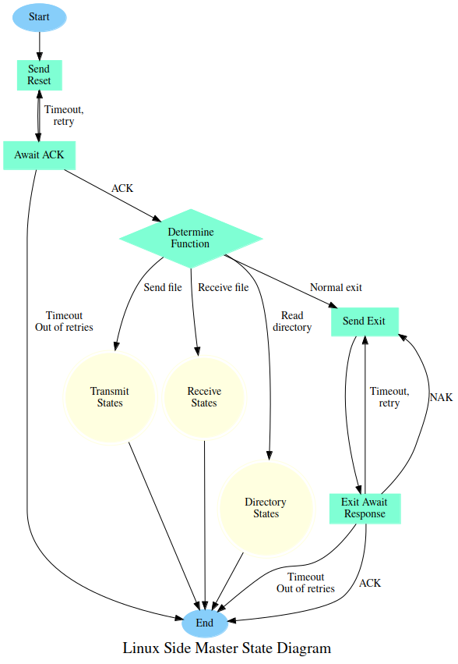
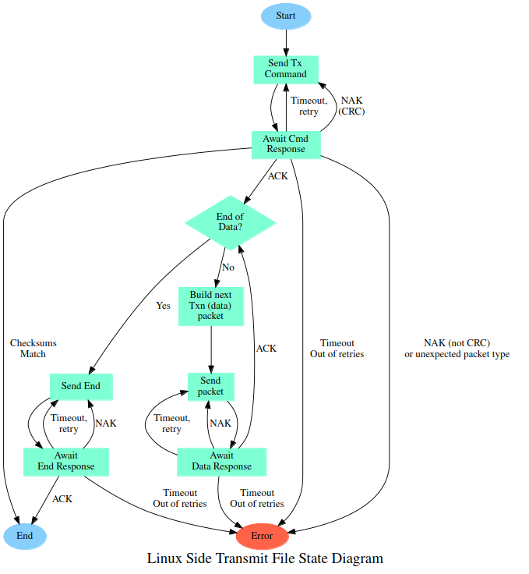
CP/M to PC file transfers are not implemented yet.

Serial Ports
The CP/M code is designed to be used under either CP/M 2.x or CP/M 3. It uses BIOS functions to access the serial ports. Data transfers may use either the console (CON:) or auxiliary (AUX:). Note that AUX: is called RDR: (input) and PUN: (output) on CP/M 2.2.

^C (Break) Behaviour
Control C (^C) on the console port may be used to exit CP/M stran. There is a catch with this, however. If running on CP/M 2.x without a ZARC BIOS and transferring data on the AUX: port, there is no way of checking whether or not a character is available before calling the read routine. In this case, stran will effectively lock up until a character arrives on the AUX: (data) port. Hence ^C will not work under such circumstances until a character arrives on the AUX port, thereby unlocking the system.

CP/M Command Line
The CP/M side may be started with the command stran. Options are available:
Command | Description
stran /c | Use CON: (console port) for data transfers.
stran /a | Use AUX: port (RDR: and PUN: on CP/M 2.x) for data transfers.
stran /b | Show build information and exit
stran /v | Show verbose messages (mainly for debugging)

Options may be combined, for example:
stran /cv

If neither /c or /a is specified, stran will accept data on either port. This is referred to as automatic port selection. This will not work on CP/M 2.x unless a ZARC BIOS is in use. This is because on such systems, there is no way for applications to determine whether or not a character is available on the READER: port without committing to a read (the required AUXIST and AUXOST BIOS functions are not supported).

Port Redirection
The CON: and AUX (RDR: and PUN:) ports may be redirected to various physical devices. The details differ between CP/M 2.x and CP/M 3.

CP/M 2.x
Under CP/M 2.x, this is normally achieved using the IOBYTE mechanism. Not all BIOSes implement this, however. The mappings may be changed using the CP/M STAT command.
STAT DEV:

shows the current device mapping. See https://www.seasip.info/Cpm/iobyte.html for further information.

CP/M 3
CP/M 3 does not use IOBYTE, but instead implements a more flexible system. See device command (CP/M 3 User's Guide) for details.

