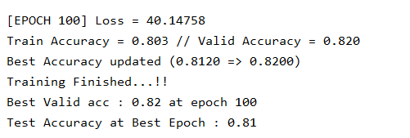

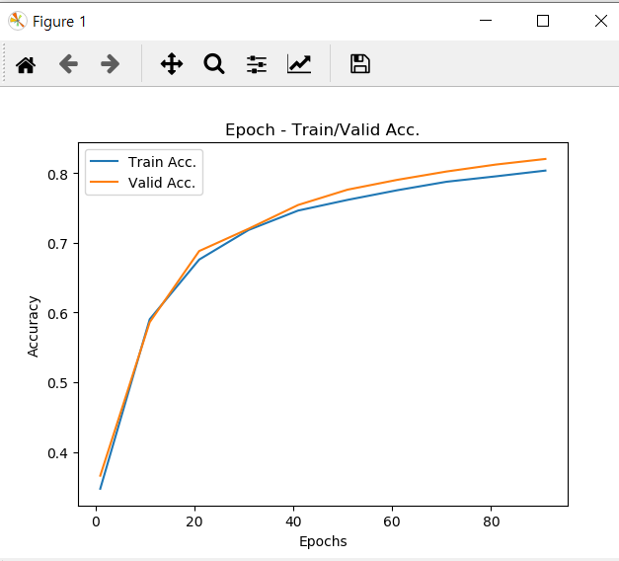

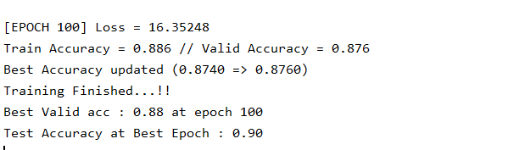

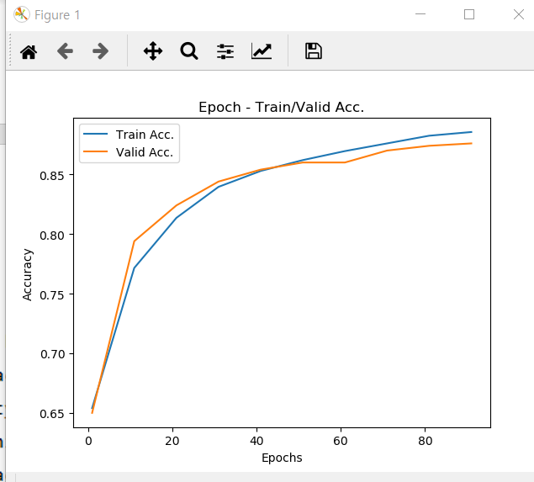

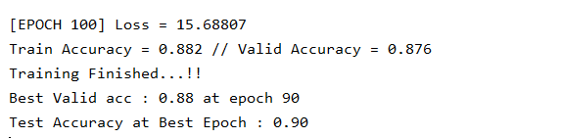

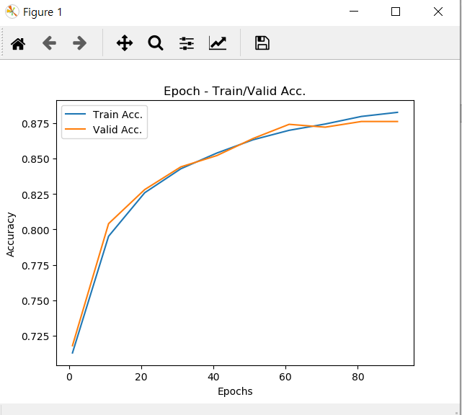

num_epochs = 500  
learning_rate = 0.001  
reg_lambda = 1e-8  
print_every = 10  
  
batch_size = 128

ReLU

784 – 500 – 10

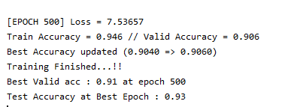

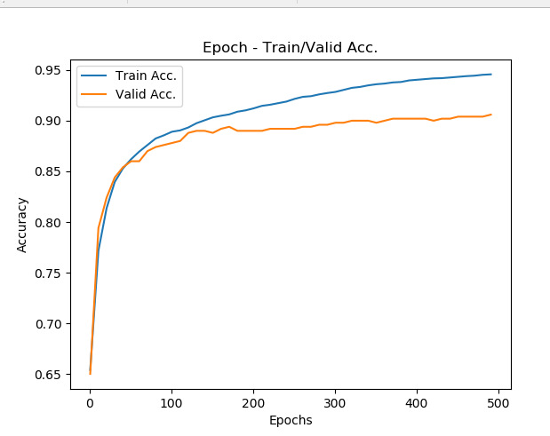

<똑같이 놓고 activation만 sigmoid로 했음>

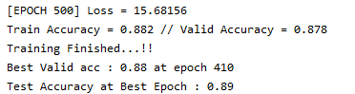

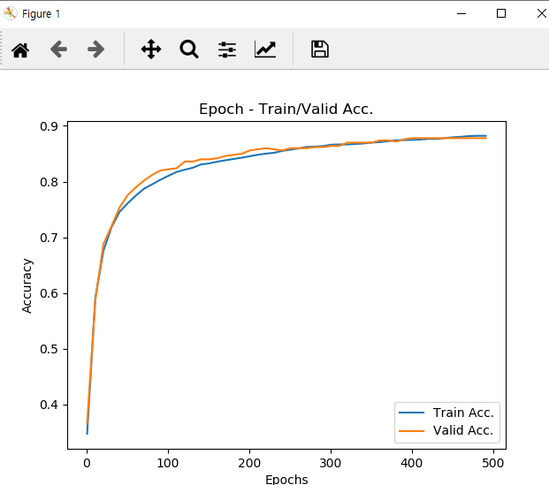

*# Hyper-parameters*num_epochs = 800  
learning_rate = 0.001  
reg_lambda = 1e-8  
print_every = 10  
  
batch_size = 128  
  
*# Add layers*model.add_layer(**'FC-1'**, FCLayer(784, 500))  
model.add_layer(**'ReLU'**, ReLU())  
model.add_layer(**'FC-2'**, FCLayer(500, 250))  
model.add_layer(**'ReLU'**, ReLU())  
model.add_layer(**'FC-3'**, FCLayer(250, 100))  
model.add_layer(**'ReLU'**, ReLU())  
model.add_layer(**'FC-4'**, FCLayer(100, 10))  
model.add_layer(**'Softmax Layer'**, SoftmaxLayer())

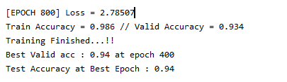

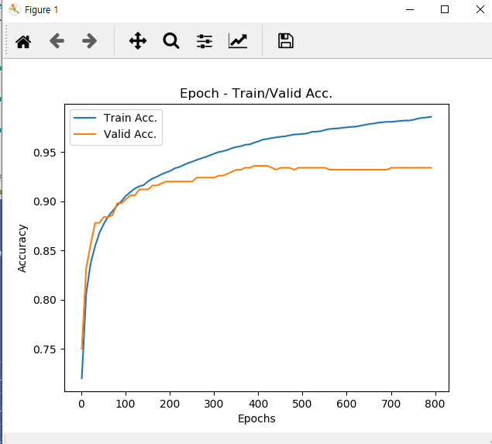

*# mnist / fashion_mnist*dataset = **'fashion_mnist'***# Hyper-parameters*num_epochs = 800  
learning_rate = 0.001  
reg_lambda = 1e-8  
print_every = 10  
  
batch_size = 128  
  
*# Add layers*model.add_layer(**'FC-1'**, FCLayer(784, 500))  
model.add_layer(**'ReLU'**, ReLU())  
model.add_layer(**'FC-2'**, FCLayer(500, 300))  
model.add_layer(**'ReLU'**, ReLU())  
model.add_layer(**'FC-3'**, FCLayer(300, 150))  
model.add_layer(**'ReLU'**, ReLU())  
model.add_layer(**'FC-4'**, FCLayer(150, 50))  
model.add_layer(**'ReLU'**, ReLU())  
model.add_layer(**'FC-5'**, FCLayer(50, 10))  
model.add_layer(**'Softmax Layer'**, SoftmaxLayer())

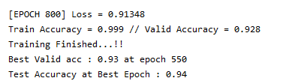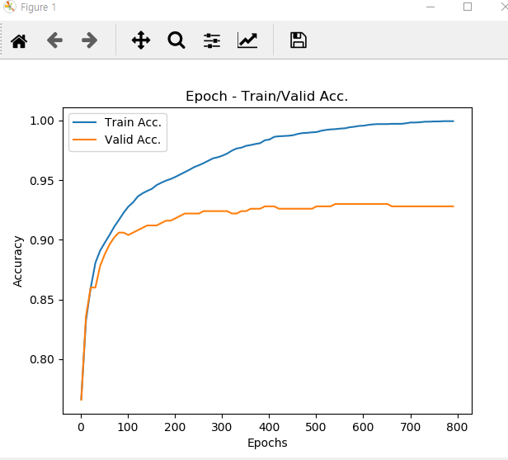

num_epochs = 1000  
learning_rate = 0.0005  
reg_lambda = 1e-6  
print_every = 10  
  
batch_size = 128  
  
*# Add layers*model.add_layer(**'FC-1'**, FCLayer(784, 500))  
model.add_layer(**'ReLU'**, ReLU())  
model.add_layer(**'FC-2'**, FCLayer(500, 300))  
model.add_layer(**'ReLU'**, ReLU())  
model.add_layer(**'FC-3'**, FCLayer(300, 150))  
model.add_layer(**'ReLU'**, ReLU())  
model.add_layer(**'FC-4'**, FCLayer(150, 50))  
model.add_layer(**'ReLU'**, ReLU())  
model.add_layer(**'FC-5'**, FCLayer(50, 10))  
model.add_layer(**'Softmax Layer'**, SoftmaxLayer())

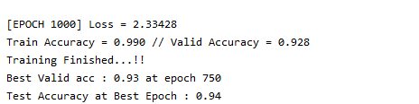

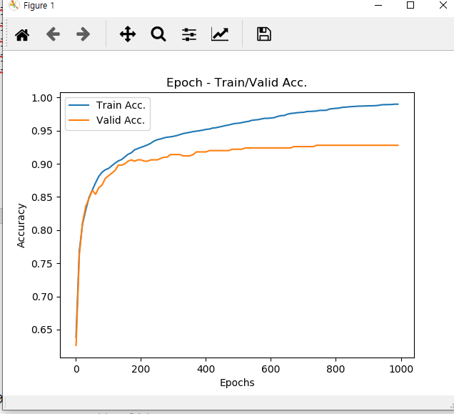

람다 값을 높였더니, 차이가 줄음.

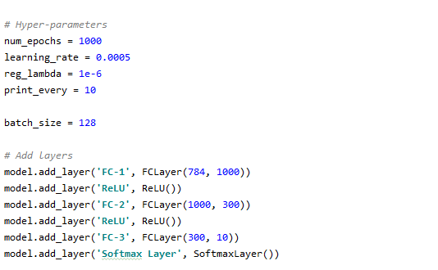

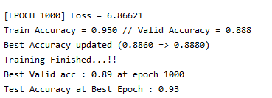

Test가 유독 높음(valid에 비해. Regualarization이 높아지면서 일반화가 잘됐다고 예측.

