**ASEN 2002 Lab 2 Supporting Document**

**Bennett Grow, Amanda Marlow, Zak Reichenbach, Cate Billings**

**Section A**

A.1: In order to compute the airspeed, we utilized Bernoulli’s Equation (Appendix A-A) for incompressible flow to relate the pressure at various locations to the square of the airspeed. Bernoulli’s Equation was combined with the equation of state for a perfect gas in order to develop a single equation that relates wind tunnel airspeed directly to the quantities that are directly measured in the wind tunnel system. These measurements were taken using both a pitot static tube and a venturi tube.

A.2: *Quad Chart.* See Appendix B-A and B-B. The measurements taken by the pressure transducer were extremely similar in error and value for both the pitot-static probe and venturi tube. The measurements taken by the U-tube manometer have very similar slopes but shifted values between the pitot-static probe and venturi tube.

A.3: The U-tube manometer is less accurate than the pressure transducer as illustrated by the greater similarity in pitot-static and venturi measurements from the pressure transducer than the U-tube manometer.

A.4: Averaged from our more accurate readings (pressure transducers) from the venturi and pitot devices, $Velocity = 6.14 *(Voltage) + 2.03$

**Section B**

B.1: The uncertainty decreases as airspeed increases. As seen for the pressure transducer (Appendix B-A) the error is initially $±$ ~52 m/s and decreases to $±$ ~2 m/s. For the U-tube manometer (Appendix B-B) the error is initially $±$ ~15 m/s, jumps to a maximum error of $±$ ~35 m/s, and decreases to $±$ ~2 m/s.

B.2: For the purposes of this lab, focus was put on the manufacturer’s quoted error. This means that the largest sources of uncertainty are due to the manufacture quoted range and calibration of each measurement device. System accuracy can be improved by replacing each device with a more powerful and better calibrated device that has an increased range.

B.3: The U-tube manometer provides a less accurate measurement of the velocity. See Appendix B-A and B-B for the comparison. This is because the visual height measurement is subject to human error, whereas the pressure transducer is not.

**Section C**

C.1: In order to compute the boundary layer, we began by calculating the airspeed at each y-position for each port location. Next, we created a plot of velocity vs. ELD Probe y-location for each port. Then we found the ELD Probe y-locations at each port where the velocity reached 95% of free stream, which gave us the thickness of the boundary layer.

C.2: Based on the plot of the boundary layer measurements, the thickness of the boundary layer increases as port location in the x-direction increases through the length of the test section.

C.3: Our measurements gave us an estimated boundary layer thickness between that of the ideal turbulent and laminar cases. Also looking at general slopes of the different boundary layer thickness’, our data has a slope of a similar steepness to that of the turbulent boundary layer more so than the laminar case.

C.4: See Appendix C-A. The boundary layer is turbulent. This is because the boundary layer thickness plotted against the port location has a slope that matches that of turbulent flow, and the thickness is high enough that it cannot be laminar flow. It likely doesn’t match the predictions of a turbulent boundary layer precisely because it started out laminar in the test section then became turbulent by position of the ports.

C.5: The centerline wind tunnel airspeed increases with streamwise location. This is expected because the boundary layer decreases the cross sectional area and to maintain continuity the velocity must increase. However, the difference is very small (within one meter/second), so this does interfere with our results.

**Section D**

D.1: The coefficient of pressure $C_{P}$ was calculated (equation Appendix D-A) for all of the scanivalves and the trailing edge, found by averaging the pressure at 3.5 in for lines of fit for the last two ports on the top and bottom of the airfoil. The values for $C_{n}$ and $C_{a}$ were calculated using the trapezoidal rule approximation for the $C_{p}$ over ratio of chord (equations Appendix D-B & D-C respectively) then values for $C_{l}$ and $C_{d}$ were calculated (equations Appendix D-D & D-E respectively).

D.2: The major sources of uncertainty in the calculations of $C_{l}$ and $C_{d}$ resides in the calculation of values for $C_{p}$, such as the pressure at the trailing edge and the accuracy of ±4.9768 Pa for the scanivalves.

D.3: The trailing edge $C_{p}$ was fairly accurate given the average difference between the top and bottom best fit estimations for trailing edge pressure was 4.6185 Pa, almost identical to the accuracy of the scanivalves, ±4.9768 Pa.

**Section E**

E.1: *Plot on Quad Chart.* See Appendix E-A.

E.2: There are observable differences in pressure distribution when airspeed increases from 9 m/s to 16 m/s, but there is very little variation in pressure distribution when airspeed increases from 16 m/s to 34 m/s. When airspeed increases from 9 m/s to 16 m/s, the pressure distribution varies more with percent of chord length.

E.3: At low angles of attack, variation in pressure distribution increases as angle of attack increases.

E.4: See Appendix E-B for graph. The largest difference in the surface pressures on the top and bottom of the airfoil occur before 10% of the chord length, before the aerodynamic center. This means that the pitching moment on a Clark Y-14 airfoil will cause the airfoil to pitch upward.

E.5: Yes, in the pressure coefficient vs angle of attack figures for 16m/s and 34m/s there is higher pressure on top of the wing at $α=10$ than $α=5$ indicating that in between these angles of attack flow separation occurs and slower moving, therefore higher pressure, air is left sitting on top of the wing. This can also be seen in the coefficient of lift graph (Appendix F-A) when there is a steep drop off because flow separation occurred.

**Section F**

F.1: *Plot on Quad Chart.* See Appendix F-A and F-B for graphs.

F.2: Generally, the coefficient of lift increases as angle of attack increases in a linear fashion until it reaches its stall point. Alternatively, the coefficient of drag values follow a negative parabolic shape with the drag coefficient increasing as you get further away from a 0 degree angle of attack. Our minimum pressure drag values fall where we have our minimum coefficients of drag [Cd = 0.0286591 at -4 degrees for 9 m/s], [Cd =0.0204697 at 2 degrees for 16 m/s], and [Cd = 0.00553483 at -1 degrees for 34 m/s]. The NACA data and the 9 m/s case do not stall, but the two cases that do stall, at 16 m/s and 34 m/s, both show leading edge stall characteristics.This is dependent on the cambered shape of the airfoil, and the high velocities creating larger pressure differentials on the leading edge of the airfoil.

F.3: The highest coefficient of lift we found is 1.5 and occurs at an angle of attack at 11 degrees and at 34 m/s. This large coefficient of lift only occurs at the higher wind tunnel velocity because the lower velocity has a lower stall angle of attack.

F.4: The coefficient of lift at 34 m/s and zero angle of attack is 0.59. It is not zero because this is a cambered airfoil that is designed to produce lift at low angles of attack.

F.5: Our graphs generally agree with that of the NACA data, but they have several variations. The coefficient of lift plot variation is comparably small: there is little variation in the linear region of the coefficient of lift graphs. The NACA data given comes from a Reynolds number that fits through the center of most of our data, which makes sense because it visually appears like it could be the average of our data. The slight divergence of our data from the NACA data likely arises because we do not account for the change in velocity when an object is added that constricts the flow. We could correct for this by calculating a new velocity based on the new cross sectional area at each port location (Cross sectional area of the test section - cross sectional area of the airfoil).

**Conclusions**

The preferred measurement configuration for the windtunnel airspeed is with either a pitot-static tube or a venturi tube connected to a pressure transducer. This is due to the greater accuracy of pressure transducers compared to U-tube manometers as well as the extremely similar results between pitot-static and venturi tube measurements when connected to a pressure transducer (see Appendix B-A and B-B). The tunnel wall boundary layers have a relatively insignificant impact (less than 1 m/s) on centerline airspeed given that the maximum measured boundary layer thickness is ~8 mm (Appendix C-A), far from the tunnel centerline. To avoid any influence from the boundary layer on results in future experiments, any measurements taken should be outside the boundary layer, at least 12 mm from the tunnel walls.

Comparing the different trends that are seen from the NACA data and the experimental data that our group found, a couple of insights could be made. Acknowledging that the NACA data is only represented by one line at an unspecified air speed with consistent non-jaggy lines like found experimentally, it can be assumed to represent a general fit for the airfoil as a whole. While this can be very helpful when looking at many different airfoil shapes, we believe that it falls short in representing a singular airfoil with the variation of airspeeds that we were testing for. The experimentally determined values of $C_{l}$ and $C_{d}$ have approximately the same slope and similar, but lower, values than the NACA data on the Clark Y-14 airfoil. Some air speeds provide different trends not included in the NACA data that would be important to know about. It wouldn't be a large issue to use the NACA or experimental data for drag calculations, as most all the lines are very similar. But for lift calculations starting near the positive integers of angle of attack, the NACA data does not match all the test cases, and does not include that stall characteristics that were found with experimental data. In the end, it would depend on what you need the data for. But for the purpose of knowing as much accurate data about an airfoil for its utilization, the experimental data provides crucial information not provided by the NACA data.

**Appendix**

A-A: $p_{1}+ \frac{1}{2}ρV_{1}^{2}=p_{2}+ \frac{1}{2}ρV_{2}^{2} =p_{3}+ \frac{1}{2}ρV_{3}^{2}$

B-A:

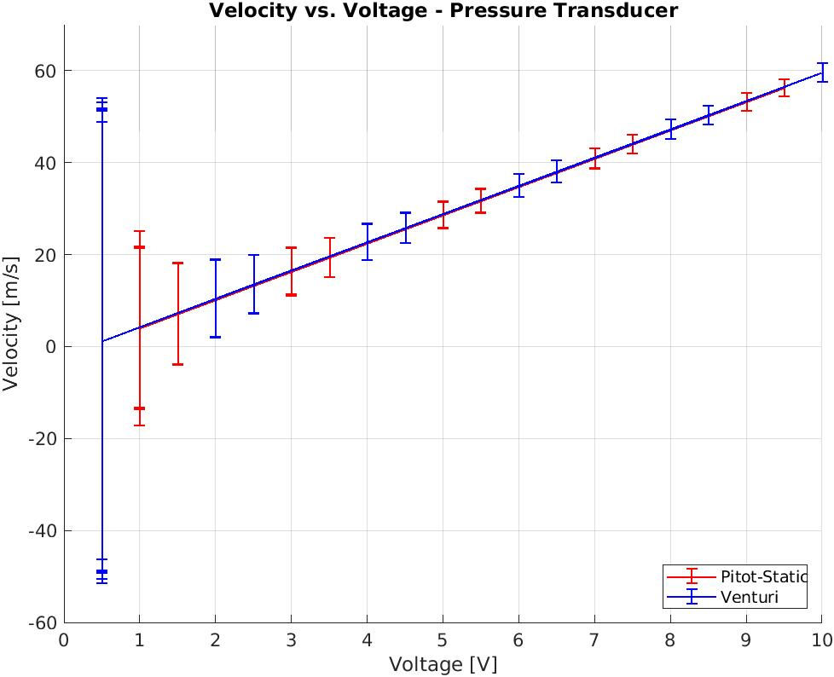

B-B:

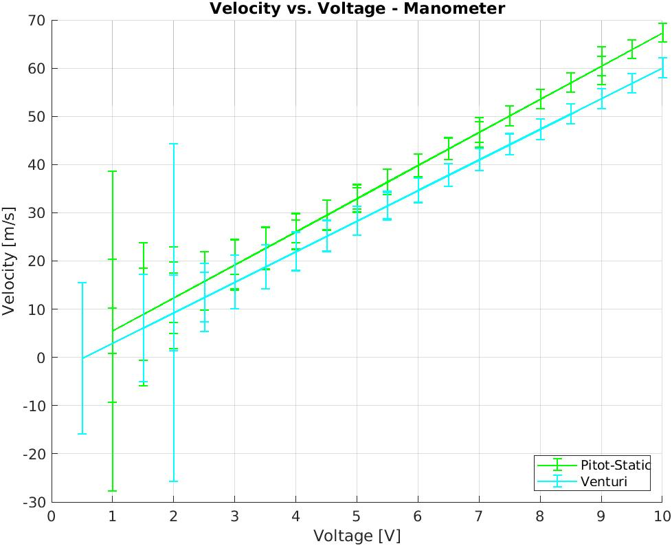

C-A:

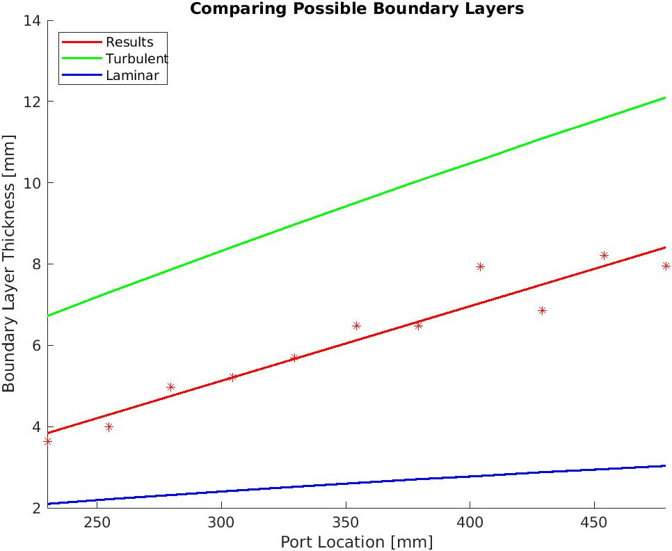

C-B:

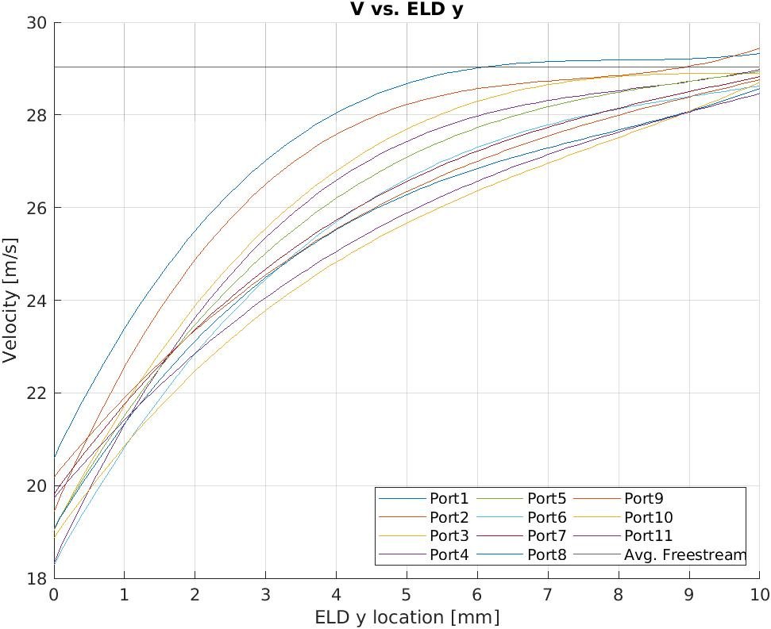

D-A: $C_{P}= \frac{p-p_{∞}}{\frac{1}{2}ρ_{∞}V{}_{∞}^{2}}$ where $p-p_{∞}$ is the pressure measured by the scanivalve ports, $ρ_{∞}$ is the average atmospheric density, and $V_{∞}$ is the airspeed.

D-B: $C_{n}= -\sum_{i=1}^{n}{}\frac{1}{2}(C_{Pi}+C_{Pi+1})\frac{Δx_{i}}{c}$

D-C: $C_{a}= \sum_{i=1}^{n}{}\frac{1}{2}(C_{Pi}+C_{Pi+1})\frac{Δy_{i}}{c}$

D-D: $C_{l}=C_{n} cos α - C_{a} sin α$

D-E: $C_{d}=C_{n} sin α - C_{a} cos α$

E-A:

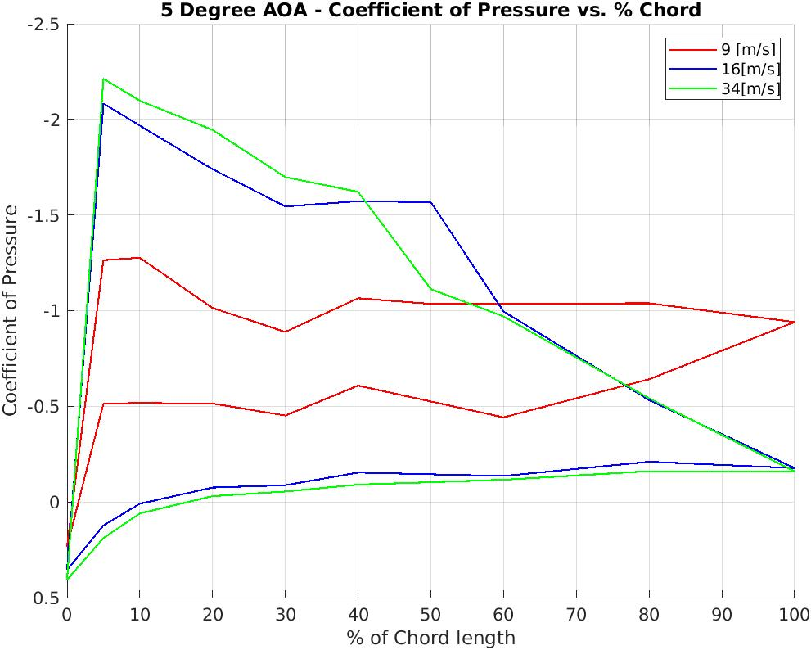

E-B:

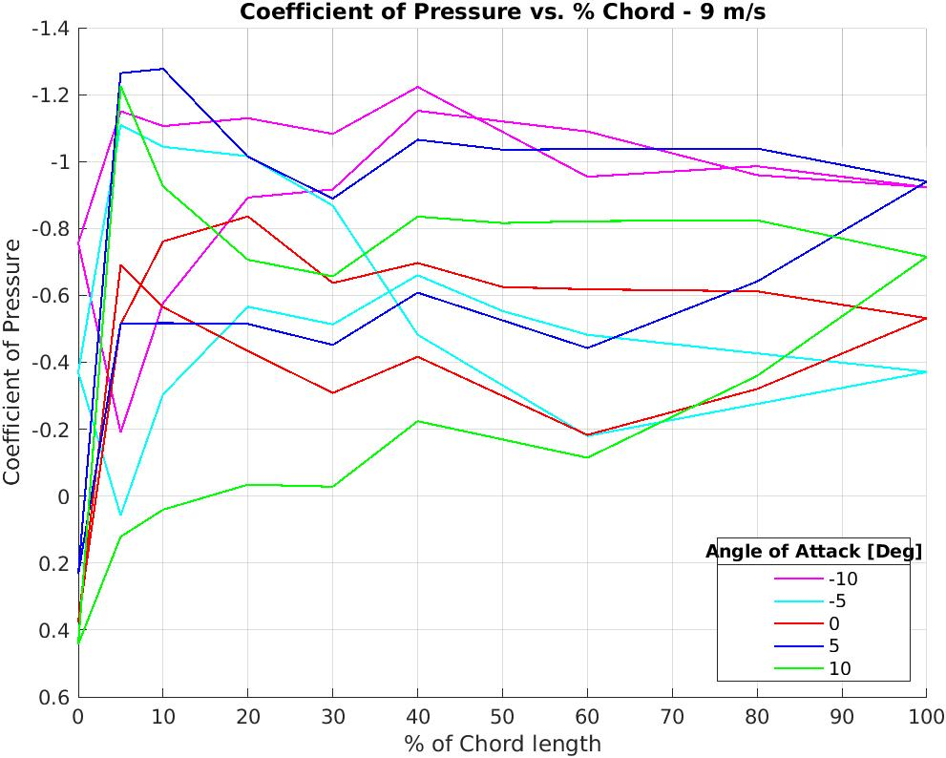

F-A:

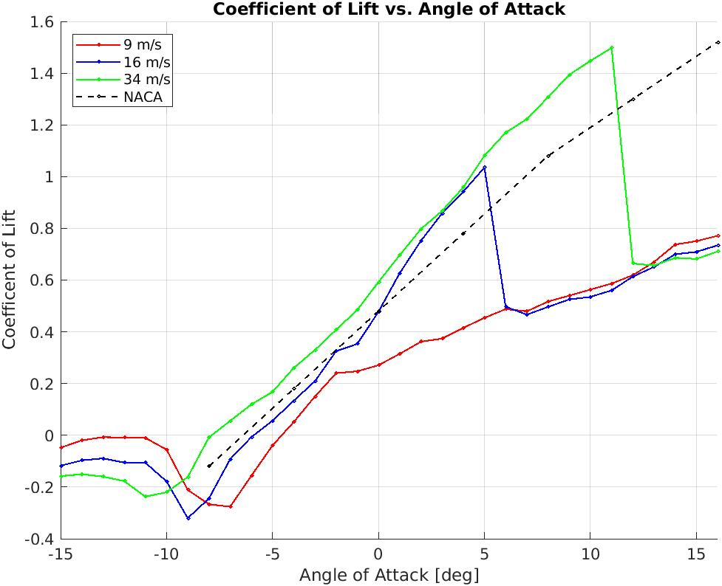

F-B:

