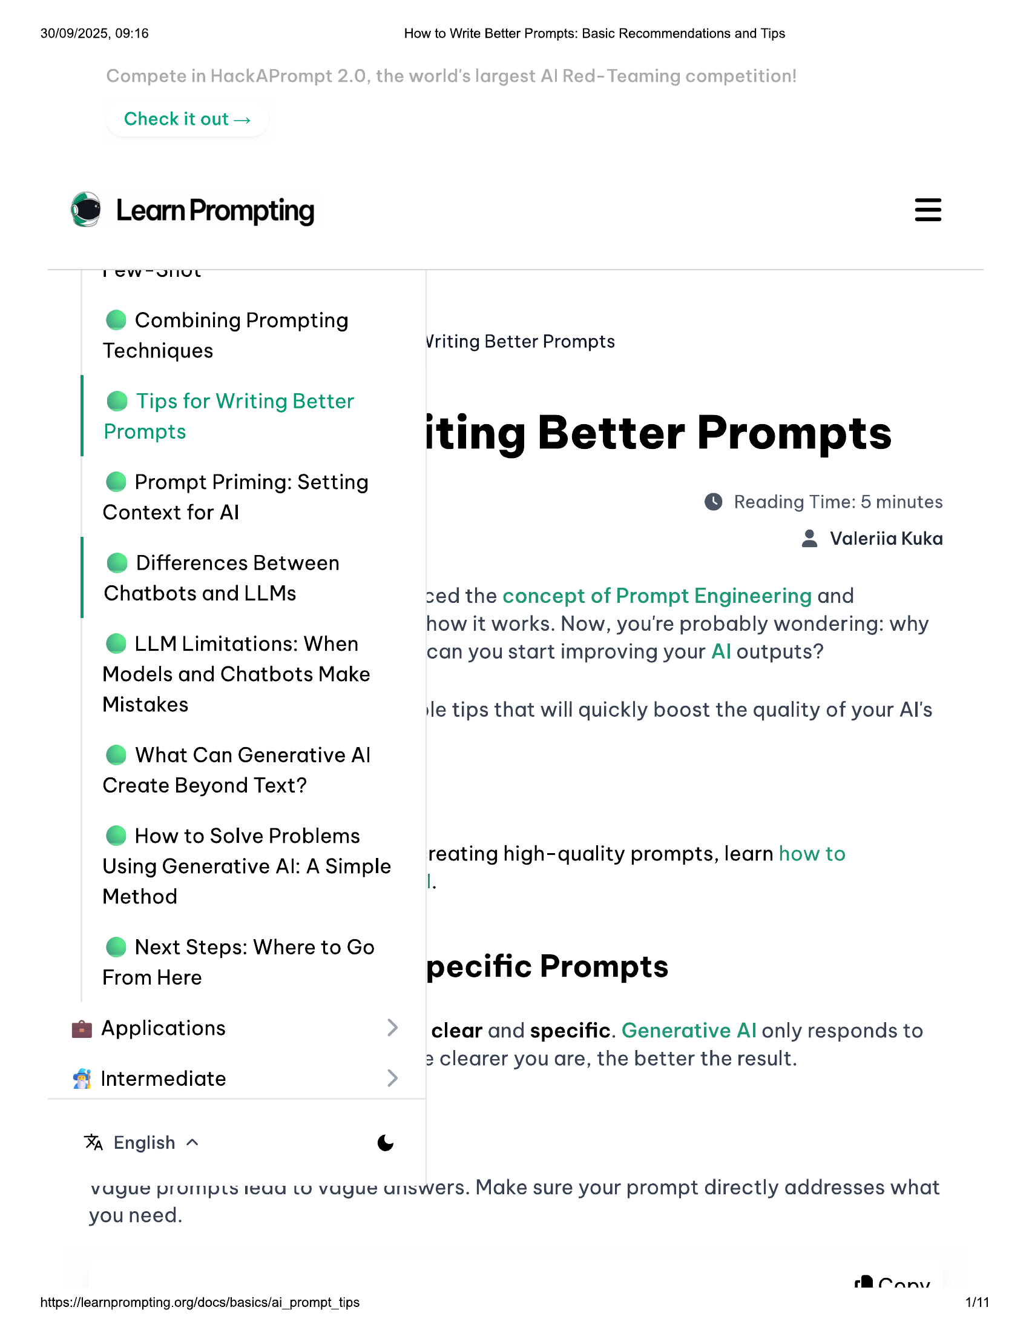

30/09/2025, 09:16 How to Write Better Prompts: Basic Recommendations and Tips  
  
Check it out >  
  
® LearnPrompting  
  
@ Combining Prompting  
  
Techniques Vriting Better Prompts  
  
@ Tips for Writing Better  
  
Prompts iting Better Prompts  
  
@ Prompt Priming: Setting  
  
Context for Al © Reading Time: 5 minutes  
  
Valeriia Kuka  
a  
 ] Di erences Betwee  
  
Chatbots and LLMs ced the concept of Prompt Engineering and  
oo how it works. Now, you're probably wondering: why  
@ LLM Limitations: When can you start improving your Al outputs?  
Models and Chatbots Make  
Mistakes le tips that will quickly boost the quality of your Al's  
  
@ What Can Generative Al  
Create Beyond Text?  
  
@ How to Solve Problems  
Using Generative Al: A Simple  
Method  
  
reating high-quality prompts, learn how to  
|  
  
@ Next Steps: Where to Go  
From Here  
  
pecific Prompts  
  
@ Applications clear and specific. Generative Al only responds to  
  
2 clearer you are, the better the result.  
& Intermediate  
  
% English ~ 6  
vague prompts teau Lo vague urswers. Make sure your prompt directly addresses what  
  
you need.  
  
rR Can,  
https://learnprompting.org/docs/basics/ai_prompt_tips 1/11

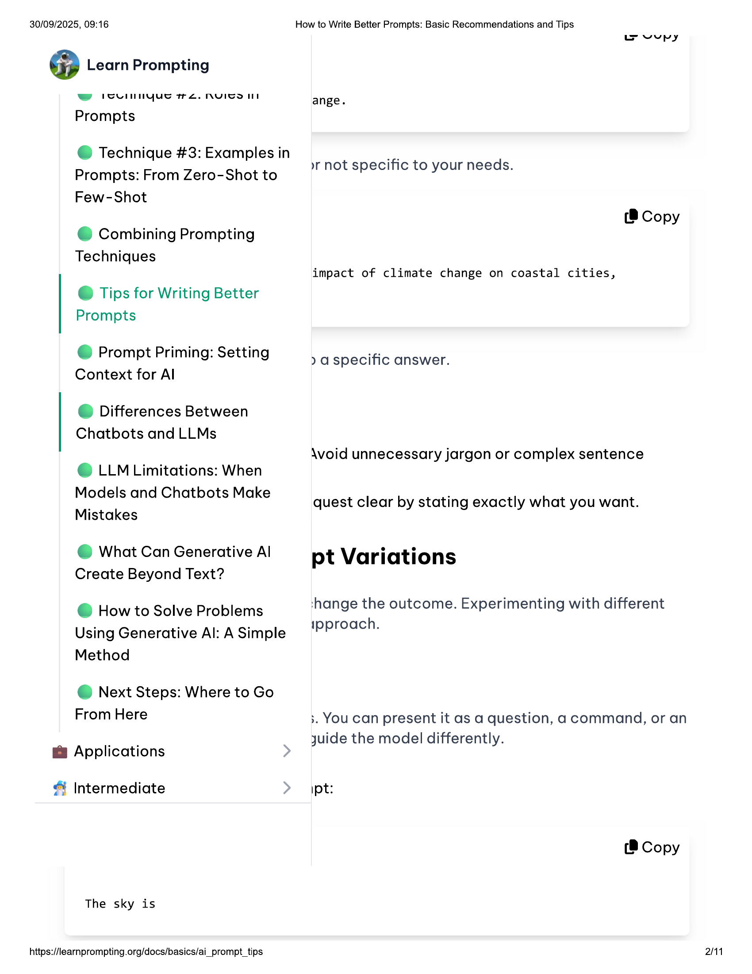

30/09/2025, 09:16 How to Write Better Prompts: Basic Recommendations and Tips  
  
@ Learn Prompting  
  
ww ICuUlnnyue re. NYVITS IT  
  
Prompts  
  
wvepy  
  
ange.  
  
@ Technique #3: Examples in  
Prompts: From Zero-Shot to  
Few-Shot  
  
»r not specific to your needs.  
  
(® Copy  
@ Combining Prompting  
  
Techniques  
impact of climate change on coastal cities,  
  
@ Tips for Writing Better  
Prompts  
  
@ Prompt Priming: Setting  
Context for Al  
  
) a specific answer.  
  
© Differences Between  
  
Chatbots and LLMs  
\Woid unnecessary jargon or complex sentence  
© LLM Limitations: When  
  
Models and Chatbots Make  
  
. quest clear by stating exactly what you want.  
Mistakes  
  
@ What Can Generative Al pt Variations  
Create Beyond Text?  
  
‘shange the outcome. Experimenting with different  
  
@ How to Solve Problems  
ipproach.  
  
Using Generative Al: A Simple  
Method  
  
@ Next Steps: Where to Go  
  
From Here ;. You can present it as a question, a command, or an  
  
& Applicati juide the model differently.  
pplications  
  
& Intermediate ipt:  
(8 Copy  
  
The sky is  
  
https://learnprompting.org/docs/basics/ai_prompt_tips 2/11

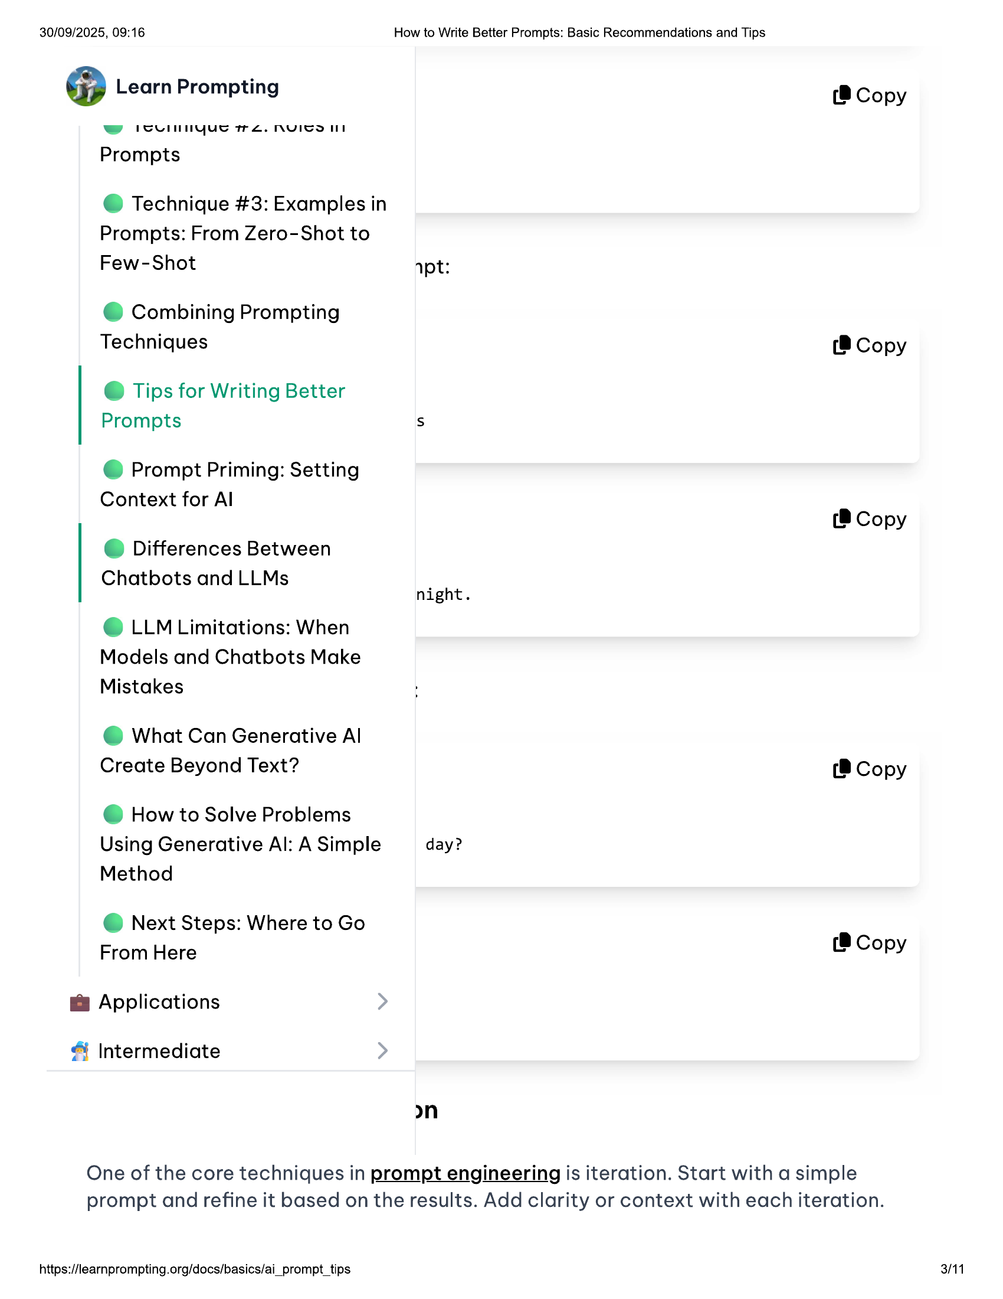

30/09/2025, 09:16 How to Write Better Prompts: Basic Recommendations and Tips  
  
@ Learn Prompting (8 Copy  
  
ww ICVUlnnyue re. NYVITS IT  
  
Prompts  
  
@ Technique #3: Examples in  
Prompts: From Zero-Shot to  
Few-Shot apt:  
  
© Combining Prompting  
Techniques (8 Copy  
  
@ Tips for Writing Better  
Prompts s  
  
@ Prompt Priming: Setting  
  
Context for Al  
(® Copy  
  
© Differences Between  
  
Chatbots and LLMs  
night.  
  
© LLM Limitations: When  
Models and Chatbots Make  
Mistakes  
  
@ What Can Generative Al  
Create Beyond Text? (8 Copy  
  
@ How to Solve Problems  
Using Generative Al: A Simple day?  
Method  
  
@ Next Steps: Where to Go  
  
From Here (8 Copy  
  
@ Applications  
& Intermediate  
  
an  
  
One of the core techniques in prompt engineering is iteration. Start with a simple  
prompt and refine it based on the results. Add clarity or context with each iteration.  
  
https://learnprompting.org/docs/basics/ai_prompt_tips 3/11

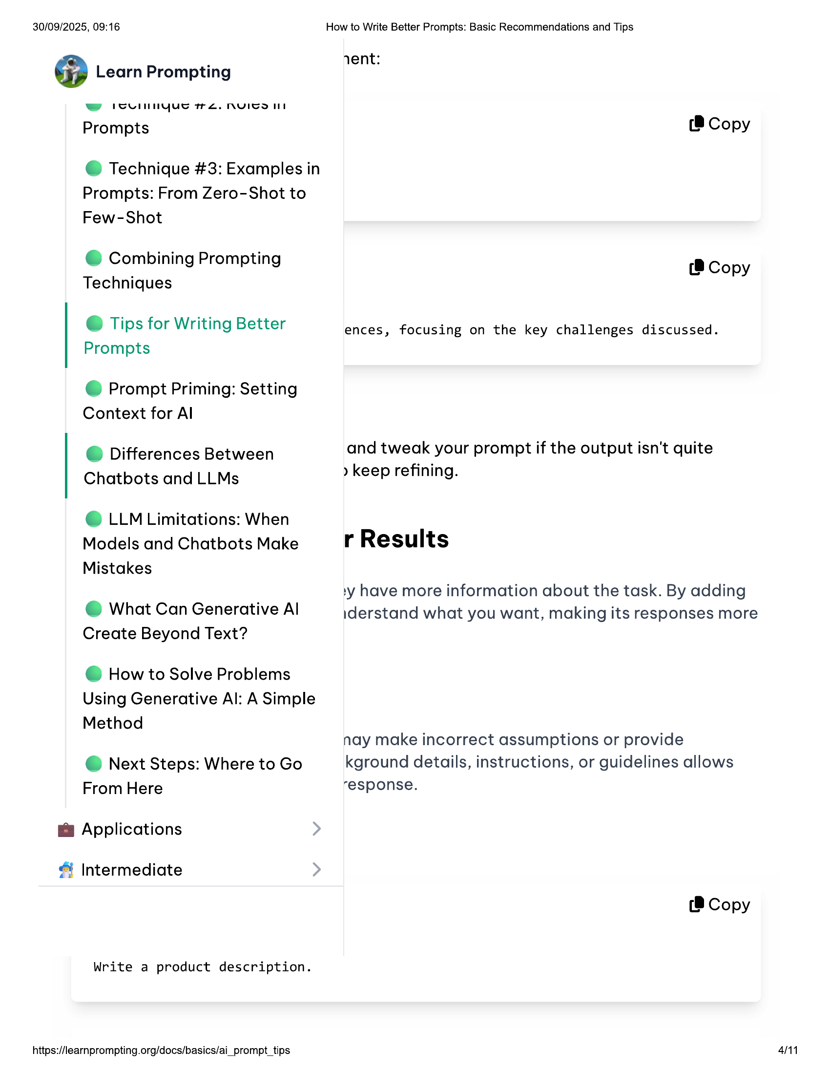

30/09/2025, 09:16 How to Write Better Prompts: Basic Recommendations and Tips  
  
. rent:  
@ Learn Prompting  
  
ww ICuUlnnyue re. NVITS IT  
  
Prompts (8 Copy  
  
@ Technique #3: Examples in  
Prompts: From Zero-Shot to  
  
Few-Shot  
  
e@ Combining Prompting (B Copy  
Techniques  
  
e Tips for Writing Better ences, focusing on the key challenges discussed.  
Prompts  
  
@ Prompt Priming: Setting  
Context for Al  
  
@ Ditferences Between and tweak your prompt if the output isn't quite  
  
Chatbots and LLMs keep refining.  
  
© LLM Limitations: When  
Models and Chatbots Make r Results  
  
Mistakes  
  
1y have more information about the task. By adding  
@ What Can Generative Al iderstand what you want, making its responses more  
Create Beyond Text?  
  
© How to Solve Problems  
Using Generative Al: A Simple  
  
Method  
  
nay make incorrect assumptions or provide  
@ Next Steps: Where to Go kground details, instructions, or guidelines allows  
From Here response.  
  
@ Applications  
  
Intermediate  
  
(8 Copy  
  
Write a product description.  
  
https://learnprompting.org/docs/basics/ai_prompt_tips  
  
4/11

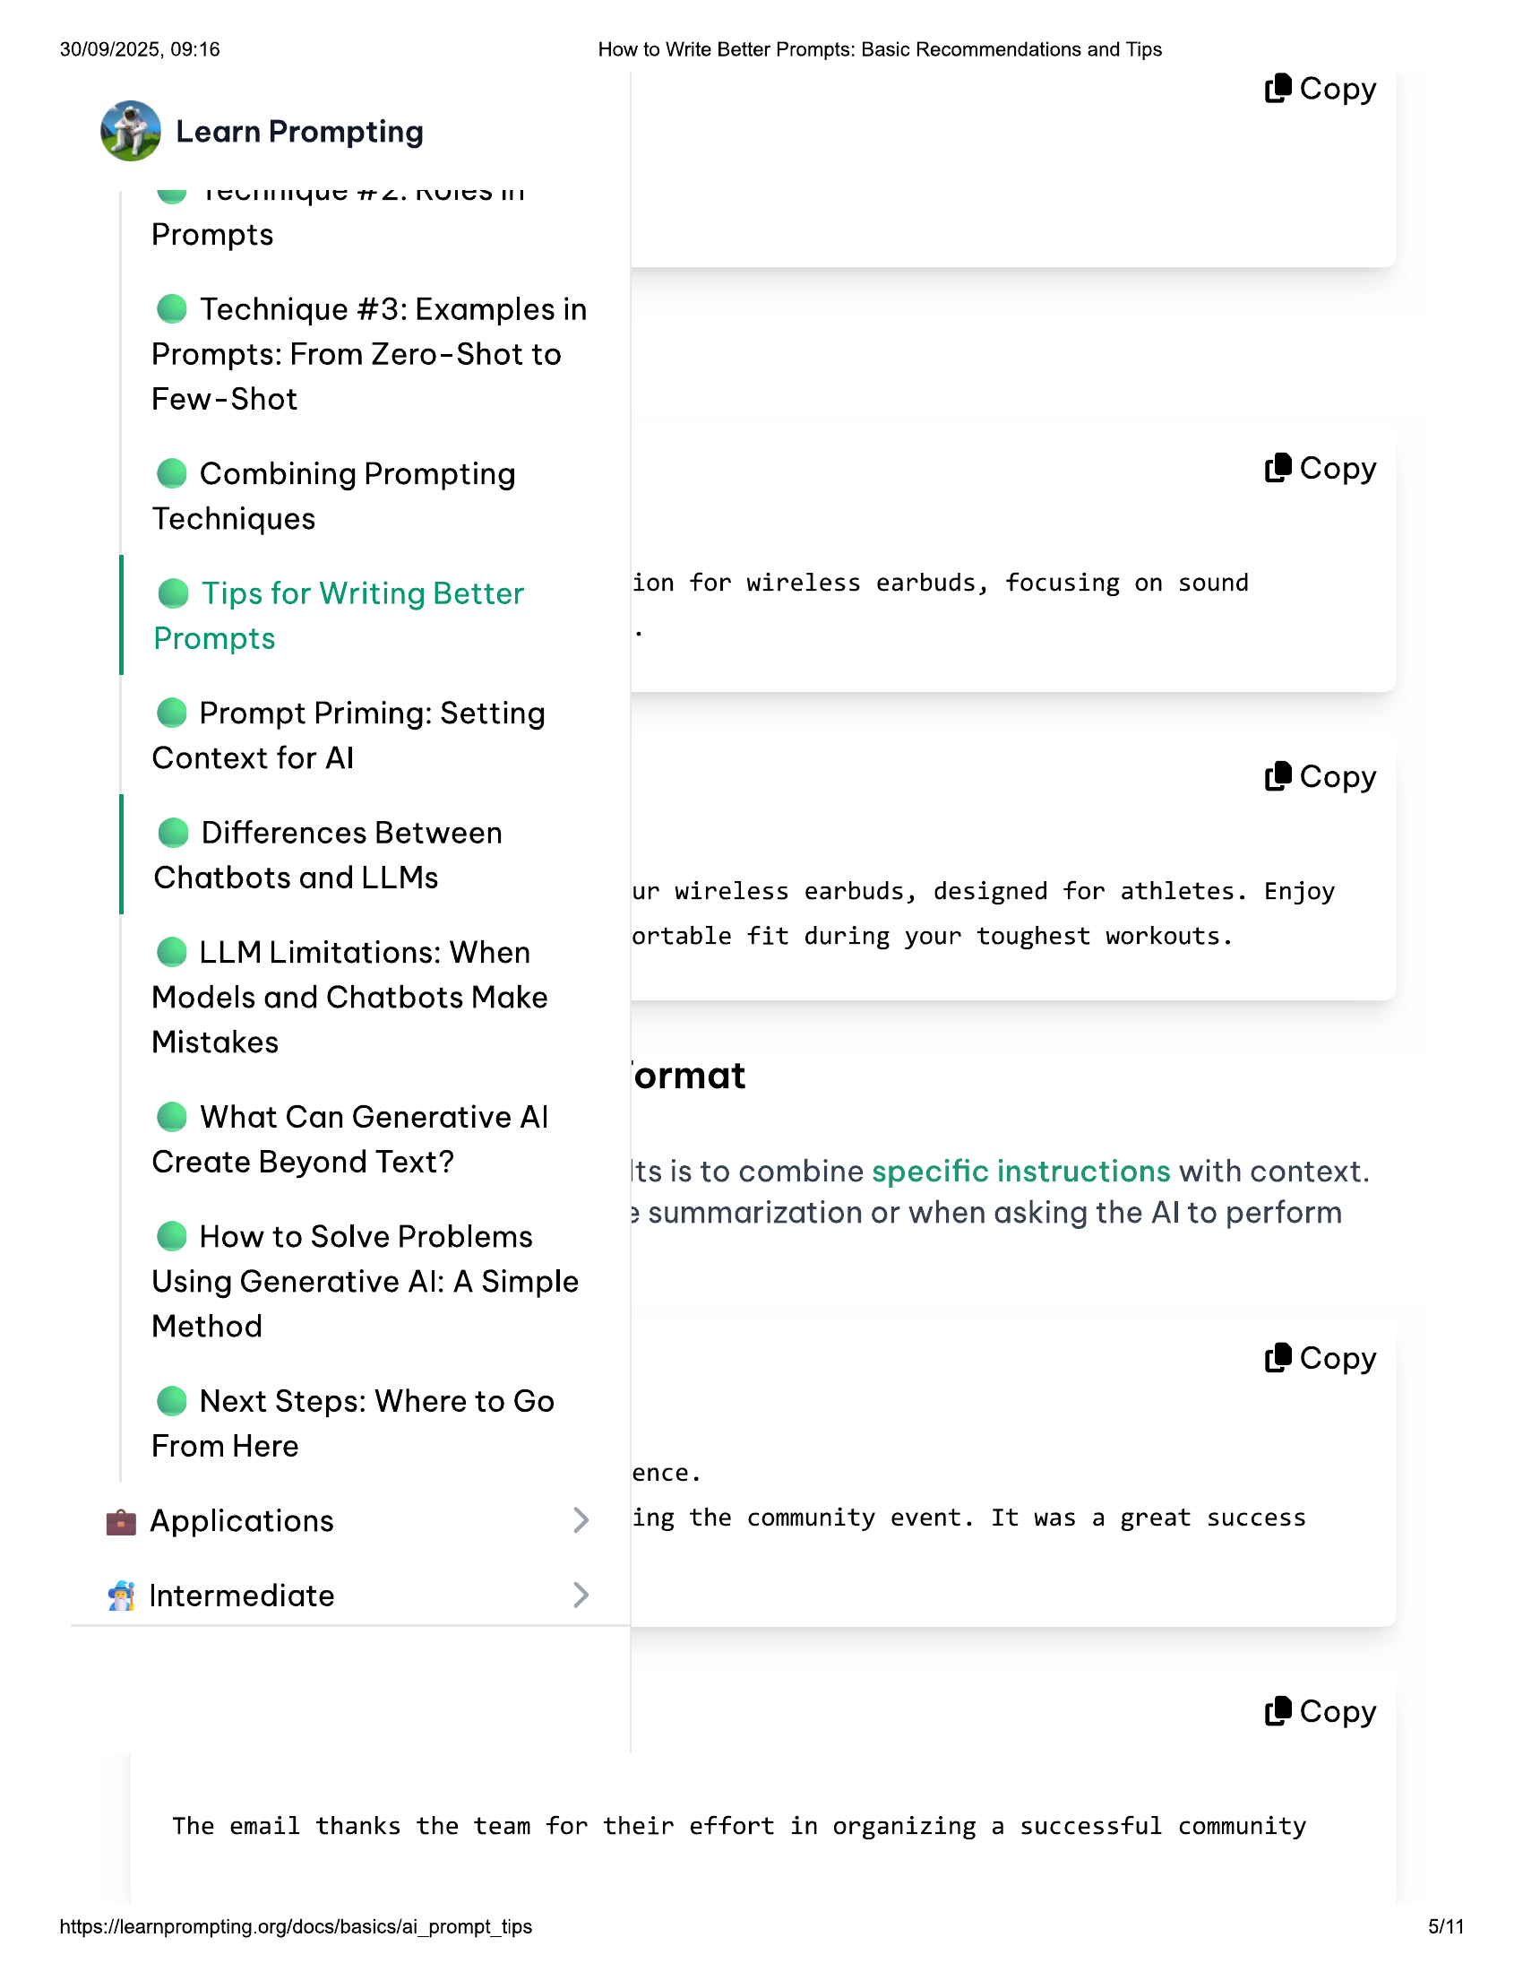

30/09/2025, 09:16 How to Write Better Prompts: Basic Recommendations and Tips  
  
(@ Copy  
@ Learn Prompting  
w cell nyue TTL. MNVICOIIN  
Prompts  
@ Technique #3: Examples in  
Prompts: From Zero-Shot to  
Few-Shot  
© Combining Prompting (8 Copy  
Techniques  
e Tips for Writing Better ion for wireless earbuds, focusing on sound  
Prompts  
@ Prompt Priming: Setting  
Context for Al (B Copy  
  
© Differences Between  
Chatbots and LLMs  
  
ur wireless earbuds, designed for athletes. Enjoy  
  
e LLM Limitations: When ortable fit during your toughest workouts.  
  
Models and Chatbots Make  
  
Mistakes |  
ormat  
  
@ What Can Generative Al  
Create Beyond Text? Its is to combine specific instructions with context.  
  
> summarization or when asking the Al to perform  
@ How to Solve Problems  
  
Using Generative Al: A Simple  
  
Method  
(8 Copy  
@ Next Steps: Where to Go  
From Here  
ence.  
@ Applications ing the community event. It was a great success  
& Intermediate  
(8 Copy  
  
The email thanks the team for their effort in organizing a successful community  
  
https://learnprompting.org/docs/basics/ai_prompt_tips 5/11

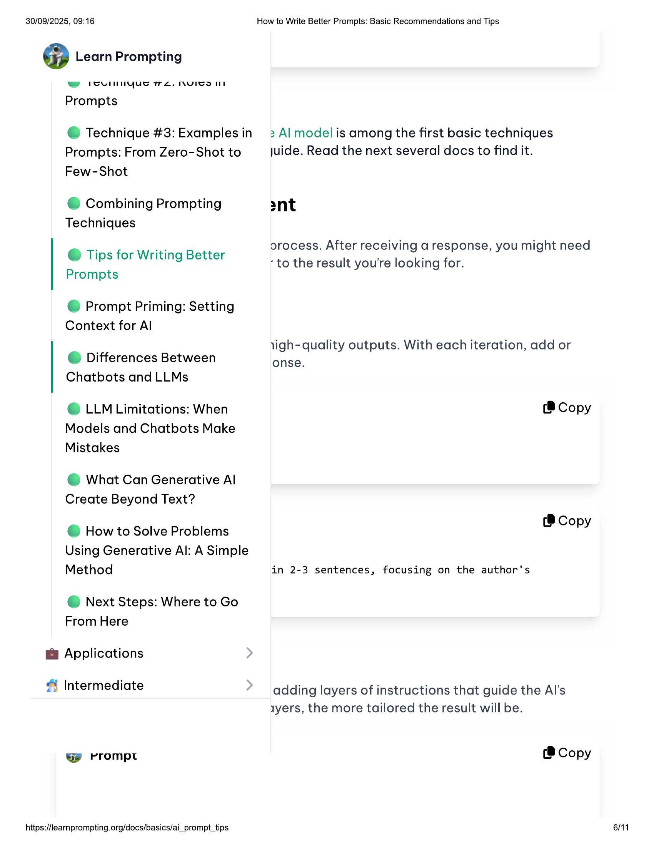

30/09/2025, 09:16  
  
@ Learn Prompting  
  
ww ICuUINNyue re. NYVITS IIT  
  
Prompts  
  
@ Technique #3: Examples in  
  
Prompts: From Zero-Shot to  
Few-Shot  
  
© Combining Prompting  
Techniques  
  
@ Tips for Writing Better  
Prompts  
  
@ Prompt Priming: Setting  
Context for Al  
  
© Differences Between  
Chatbots and LLMs  
  
© LLM Limitations: When  
Models and Chatbots Make  
Mistakes  
  
@ What Can Generative Al  
Create Beyond Text?  
  
@ How to Solve Problems  
  
Using Generative Al: A Simple  
  
Method  
  
@ Next Steps: Where to Go  
From Here  
  
@ Applications  
  
& Intermediate  
  
Gp rrompt  
  
https://learnprompting.org/docs/basics/ai_prompt_tips  
  
How to Write Better Prompts: Basic Recommendations and Tips  
  
> Al model is among the first basic techniques  
juide. Read the next several docs to find it.  
  
2nt  
  
orocess. After receiving a response, you might need  
“to the result you're looking for.  
  
ligh- quality outputs. With each iteration, add or  
onse.  
  
(8 Copy  
  
(8 Copy  
  
in 2-3 sentences, focusing on the author's  
  
adding layers of instructions that guide the Al's  
ayers, the more tailored the result will be.  
  
(8 Copy  
  
6/11

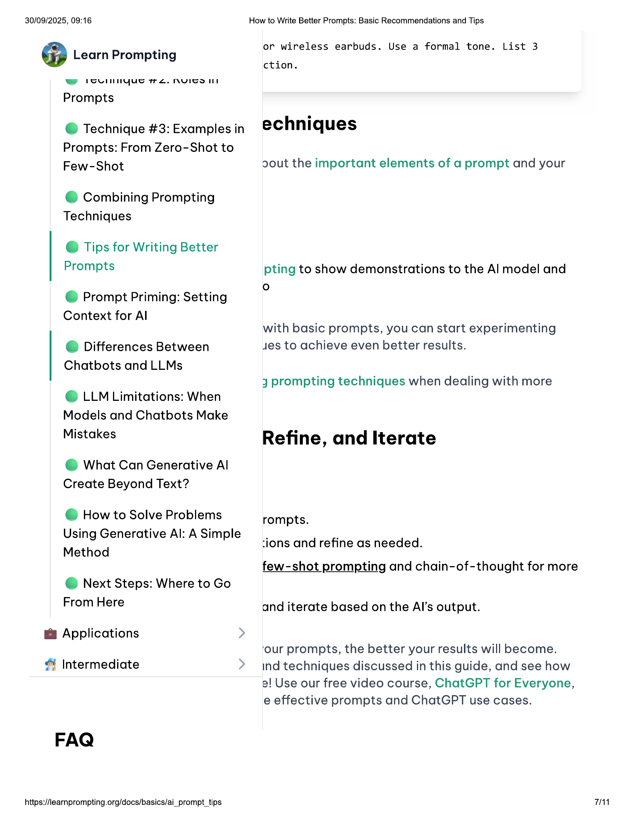

30/09/2025, 09:16  
  
@ Learn Prompting  
  
ww SuUlnnyue re. NVITS IT  
  
Prompts  
  
@ Technique #3: Examples in  
  
Prompts: From Zero-Shot to  
Few-Shot  
  
© Combining Prompting  
Techniques  
  
@ Tips for Writing Better  
Prompts  
  
@ Prompt Priming: Setting  
Context for Al  
  
© Differences Between  
Chatbots and LLMs  
  
© LLM Limitations: When  
Models and Chatbots Make  
Mistakes  
  
@ What Can Generative Al  
Create Beyond Text?  
  
@ How to Solve Problems  
  
Using Generative Al: A Simple  
  
Method  
  
@ Next Steps: Where to Go  
From Here  
  
@ Applications  
  
Intermediate  
  
FAQ  
  
https://learnprompting.org/docs/basics/ai_prompt_tips  
  
How to Write Better Prompts: Basic Recommendations and Tips  
  
or wireless earbuds. Use a formal tone. List 3  
  
ction.  
  
echniques  
  
cout the important elements of a prompt and your  
  
pting to show demonstrations to the Al model and  
°  
  
with basic prompts, you can start experimenting  
jes to achieve even better results.  
  
J prompting techniques when dealing with more  
  
Refine, and Iterate  
  
rompts.  
  
ions and refine as needed.  
  
few-shot prompting and chain-of-thought for more  
  
and iterate based on the Al’s output.  
  
‘our prompts, the better your results will become.  
ind techniques discussed in this guide, and see how  
a! Use our free video course, ChatGPT for Everyone,  
e effective prompts and ChatGPT use cases.  
  
7/11

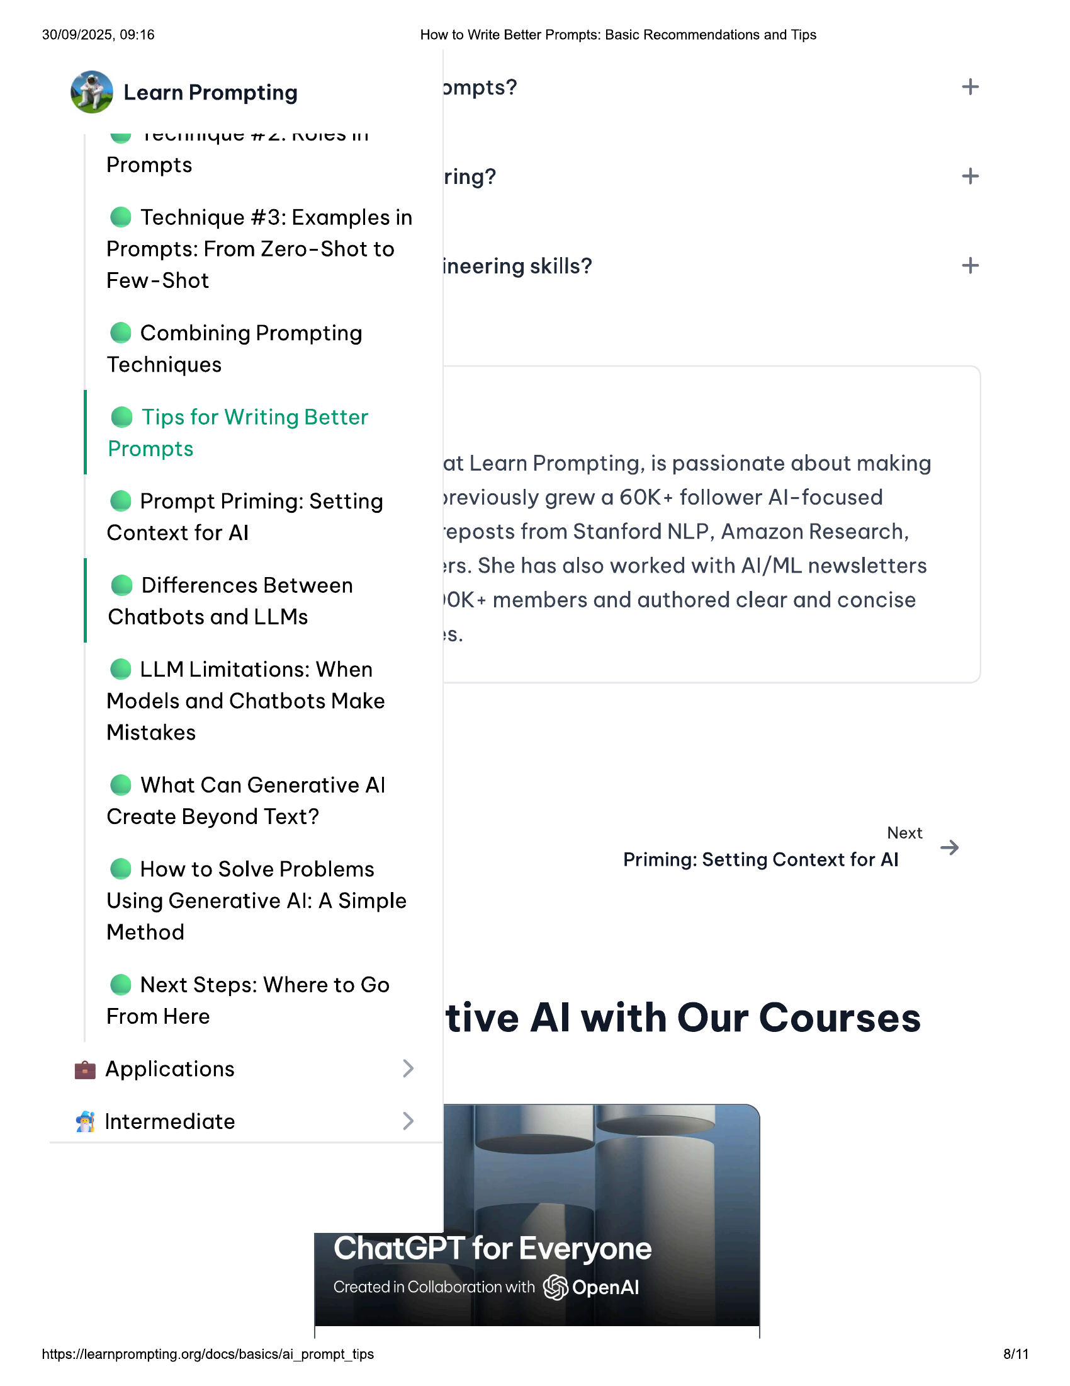

30/09/2025, 09:16 How to Write Better Prompts: Basic Recommendations and Tips  
  
@ Learn Prompting ompts? +  
ww PCUlninyue 2. NYICS II  
Prompts ring? n  
  
@ Technique #3: Examples in  
Prompts: From Zero-Shot to  
  
| . 169  
Few-Shot ineering skills? +  
  
© Combining Prompting  
Techniques  
  
@ Tips for Writing Better  
  
P t Lo, . .  
rompts at Learn Prompting, is passionate about making  
  
@ Prompt Priming: Setting »yreviously grew a 60K+ follower Al-focused  
  
Context for Al ‘eposts from Stanford NLP, Amazon Research,  
  
srs. She has also worked with Al/ML newsletters  
  
Differences Between .  
e 10K+ members and authored clear and concise  
  
Chatbots and LLMs  
1S.  
  
© LLM Limitations: When  
Models and Chatbots Make  
Mistakes  
  
@ What Can Generative Al  
  
Create Beyond Text?  
Next  
  
@ How to Solve Problems Priming: Setting Context for Al  
  
Using Generative Al: A Simple  
Method  
  
@ Next Steps: Where to Go  
From Here tive Al with Our Courses  
  
@ Applications  
  
& Intermediate  
  
ChatGPT for Everyone  
  
Created in Collaboration with 1S) OpenAl  
  
https://learnprompting.org/docs/basics/ai_prompt_tips 8/11

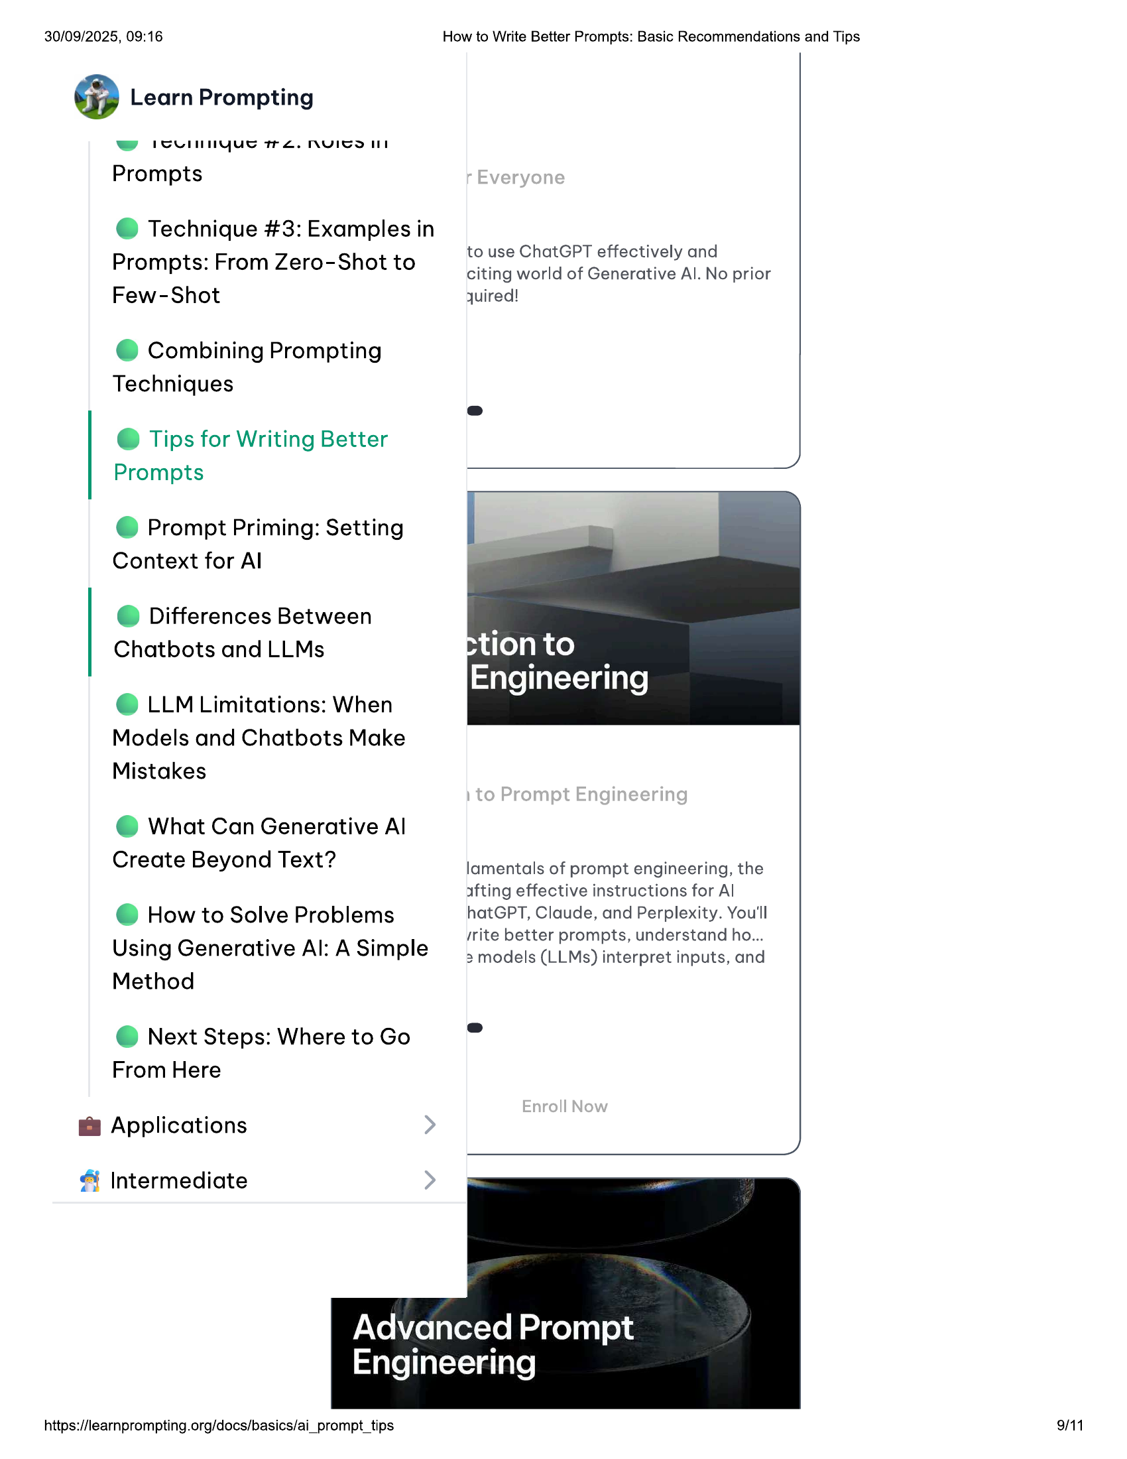

30/09/2025, 09:16 How to Write Better Prompts: Basic Recommendations and Tips  
  
@ Learn Prompting  
  
ww icunnyue we. nuico lt  
  
Prompts  
  
@ Technique #3: Examples in  
  
. _ to use ChatGPT effectively and  
Prompts: From Zero-Shot to citing world of Generative Al. No prior  
Few-Shot quired!  
  
© Combining Prompting  
Techniques  
  
@ Tips for Writing Better  
Prompts  
  
@ Prompt Priming: Setting  
Context for Al  
  
© Differences Between  
Chatbots and LLMs  
  
© LLM Limitations: When  
Models and Chatbots Make  
Mistakes  
  
@ What Can Generative Al  
  
Create Beyond Text? lamentals of prompt engineering, the  
afting effective instructions for Al  
e@ How to Solve Problems hatGPT, Claude, and Perplexity. You'll  
  
. . . . srite better prompts, understand ho...  
Using Generative Al: A Simple 3 models (LLMs) interpret inputs, and  
  
Method  
  
@ Next Steps: Where to Go  
From Here  
  
@ Applications  
  
& Intermediate  
  
Advanced Prompt  
Engineering  
  
https://learnprompting.org/docs/basics/ai_prompt_tips 9/11

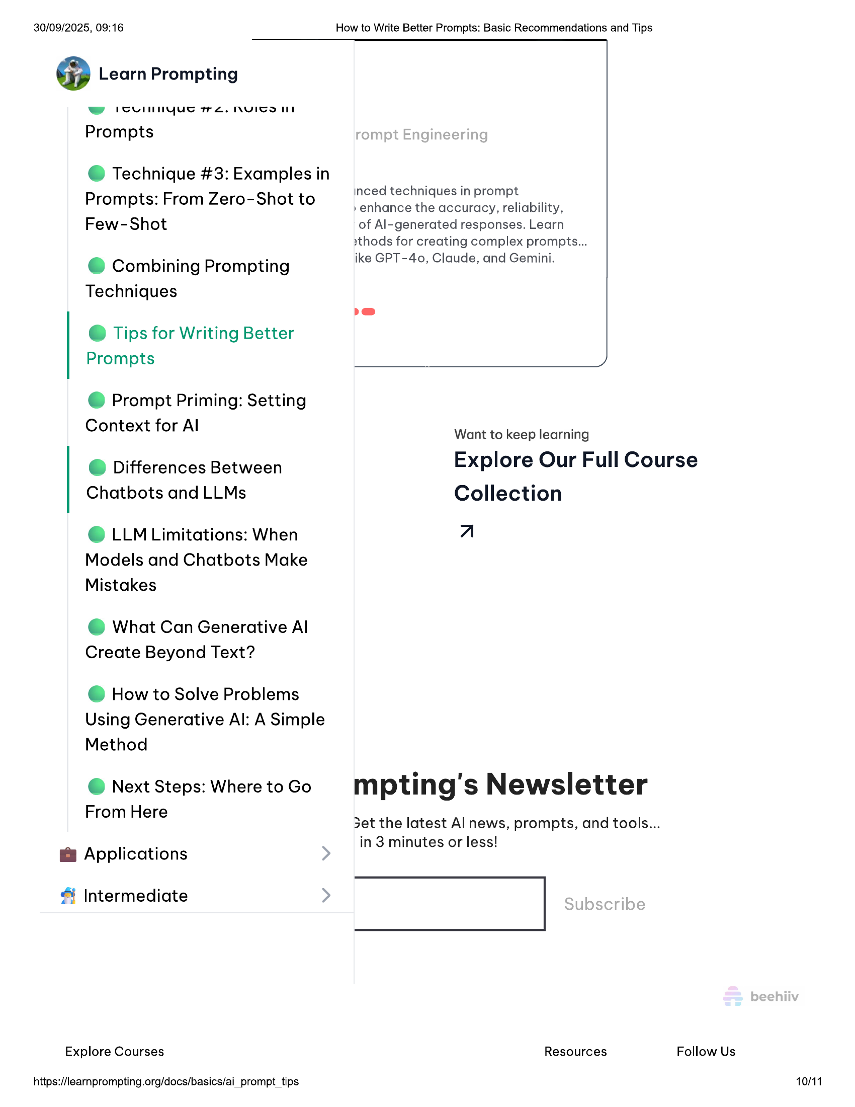

30/09/2025, 09:16 How to Write Better Prompts: Basic Recommendations and Tips  
  
@ Learn Prompting  
  
ww SuUlnnyue re. NVITS IIT  
  
Prompts  
  
@ Technique #3: Examples in  
. _ inced techniques in prompt  
Prompts: From Zero-Shot to »enhance the accuracy, reliability,  
  
Few-Shot of Al-generated responses. Learn  
2thods for creating complex prompts...  
woe . ike GPT- Cc , Gemini.  
e Combining Prompting ike GPT-40, Claude, and Gemini  
  
Techniques  
  
@ Tips for Writing Better  
Prompts )  
  
@ Prompt Priming: Setting  
Context for Al  
  
Want to keep learning  
  
©@ Differences Between Explore Our Full Course  
Chatbots and LLMs Collection  
  
© LLM Limitations: When A  
Models and Chatbots Make  
Mistakes  
  
@ What Can Generative Al  
Create Beyond Text?  
  
@ How to Solve Problems  
Using Generative Al: A Simple  
Method  
  
@ Next Steps: Where to Go mpting's Newsletter  
  
From Here L.  
3et the latest Al news, prompts, and tools...  
  
in 3 minutes or less!  
@& Applications  
  
& Intermediate |  
  
Explore Courses Resources Follow Us  
  
https://learnprompting.org/docs/basics/ai_prompt_tips 10/11

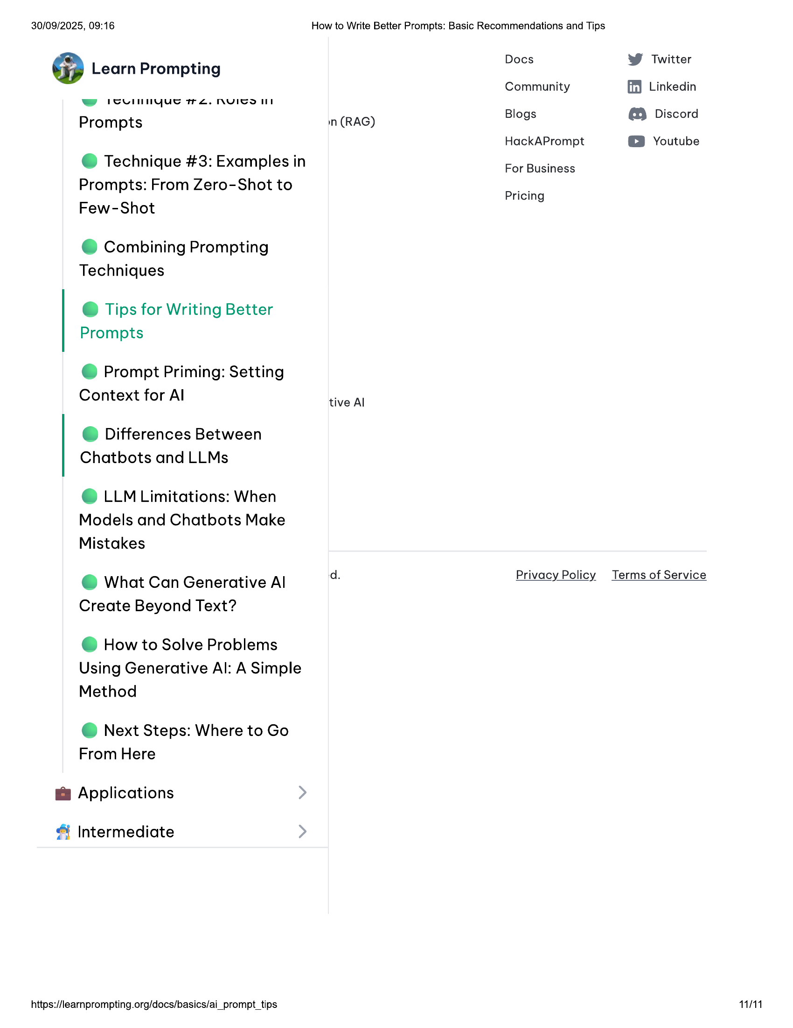

30/09/2025, 09:16 How to Write Better Prompts: Basic Recommendations and Tips  
  
: Docs Twitter  
@ Learn Prompting v  
Community ff) Linkedin  
w icvil niyue TL. NVICOII  
Blogs Discord  
Prompts in (RAG) g bia  
HackAPrompt @ Youtube  
  
@ Technique #3: Examples in  
Prompts: From Zero-Shot to  
Few-Shot  
  
For Business  
  
Pricing  
  
© Combining Prompting  
Techniques  
  
@ Tips for Writing Better  
Prompts  
  
@ Prompt Priming: Setting  
Context for Al tive Al  
  
© Differences Between  
Chatbots and LLMs  
  
© LLM Limitations: When  
Models and Chatbots Make  
Mistakes  
  
d. Privacy Policy Terms of Service  
  
@ What Can Generative Al  
Create Beyond Text?  
  
@ How to Solve Problems  
Using Generative Al: A Simple  
Method  
  
@ Next Steps: Where to Go  
From Here  
  
@ Applications  
  
Intermediate  
  
https://learnprompting.org/docs/basics/ai_prompt_tips 11/11