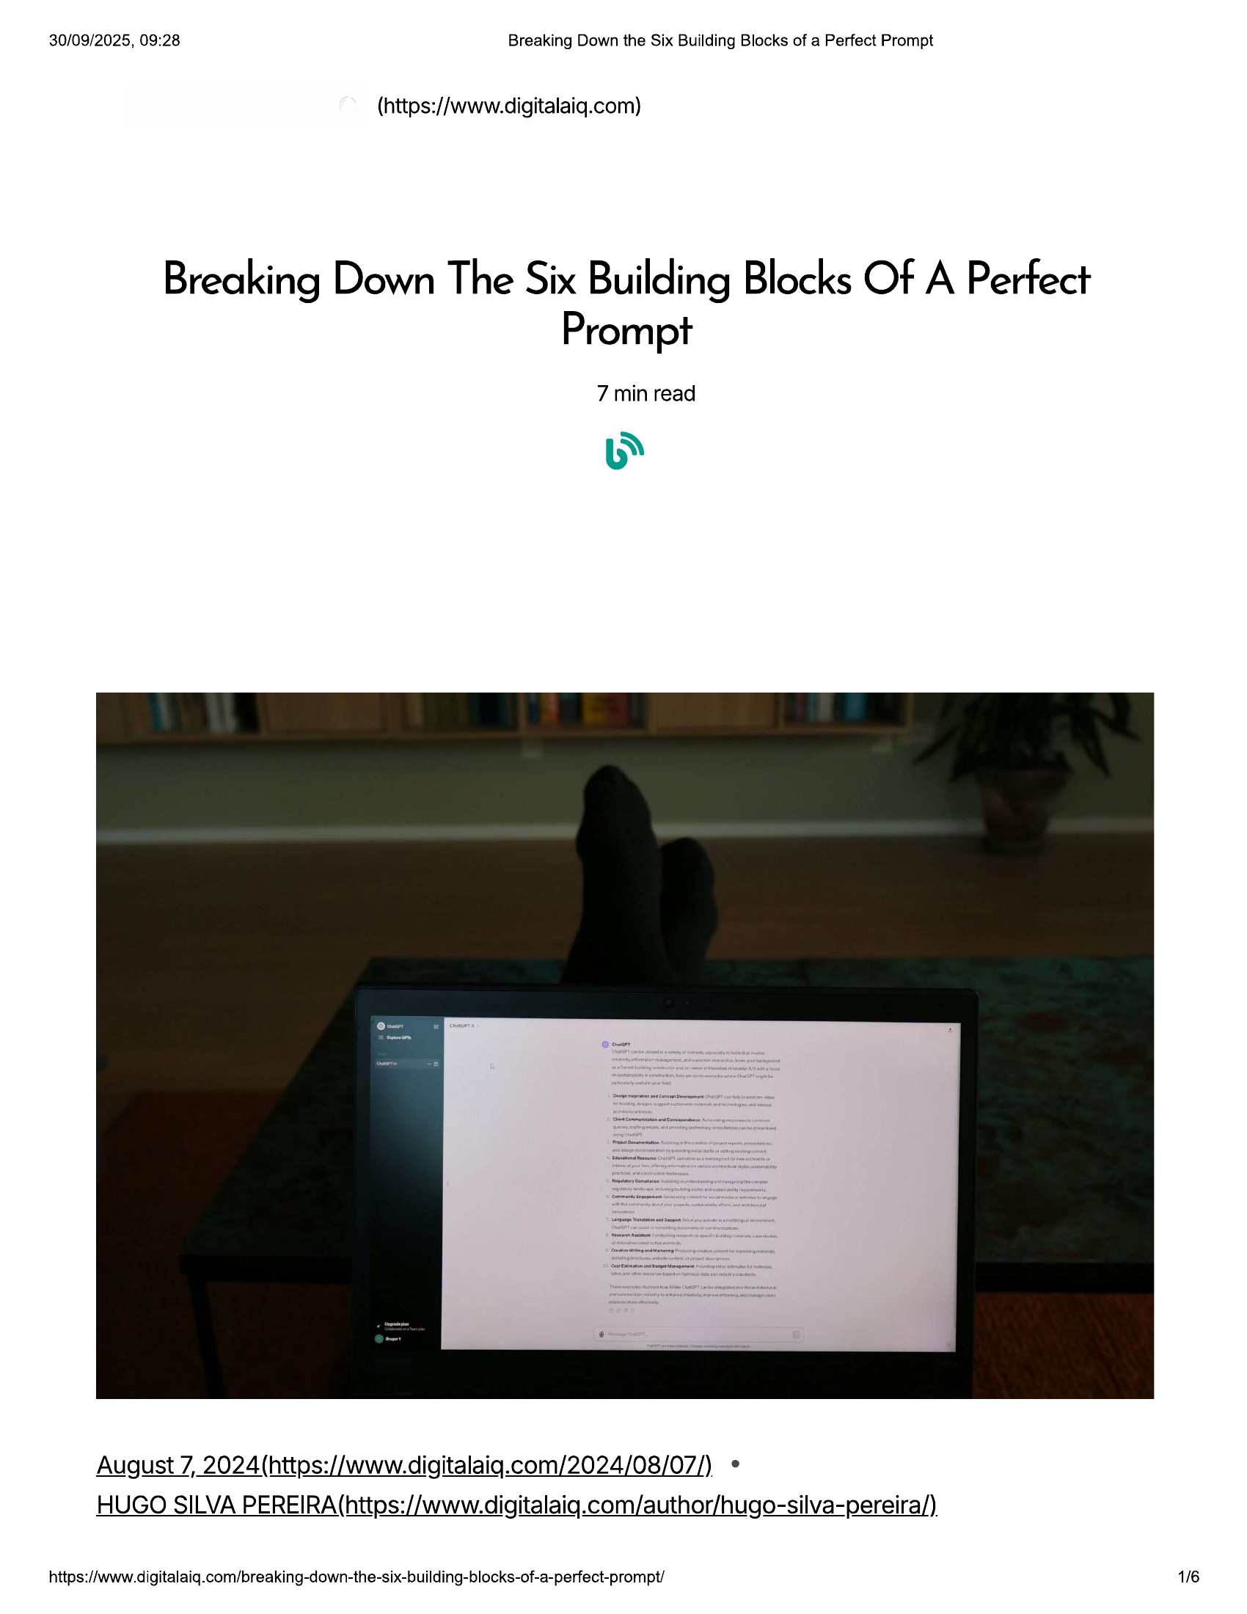

30/09/2025, 09:28 Breaking Down the Six Building Blocks of a Perfect Prompt  
  
(https://www.digitalaig.com)  
  
Breaking Down The Six Building Blocks Of A Perfect  
Prompt  
  
7 min read  
  
August 7, 2024 (httos://www.digitalaig.com/2024/08/07/)  
  
HUGO SILVA PEREIRA (https://www.digitalaiq.com/author/hugo-silva-pereira/)  
  
https://www.digitalaiq.com/breaking-down-the-six-building-blocks-of-a-perfect-prompt/ 1/6

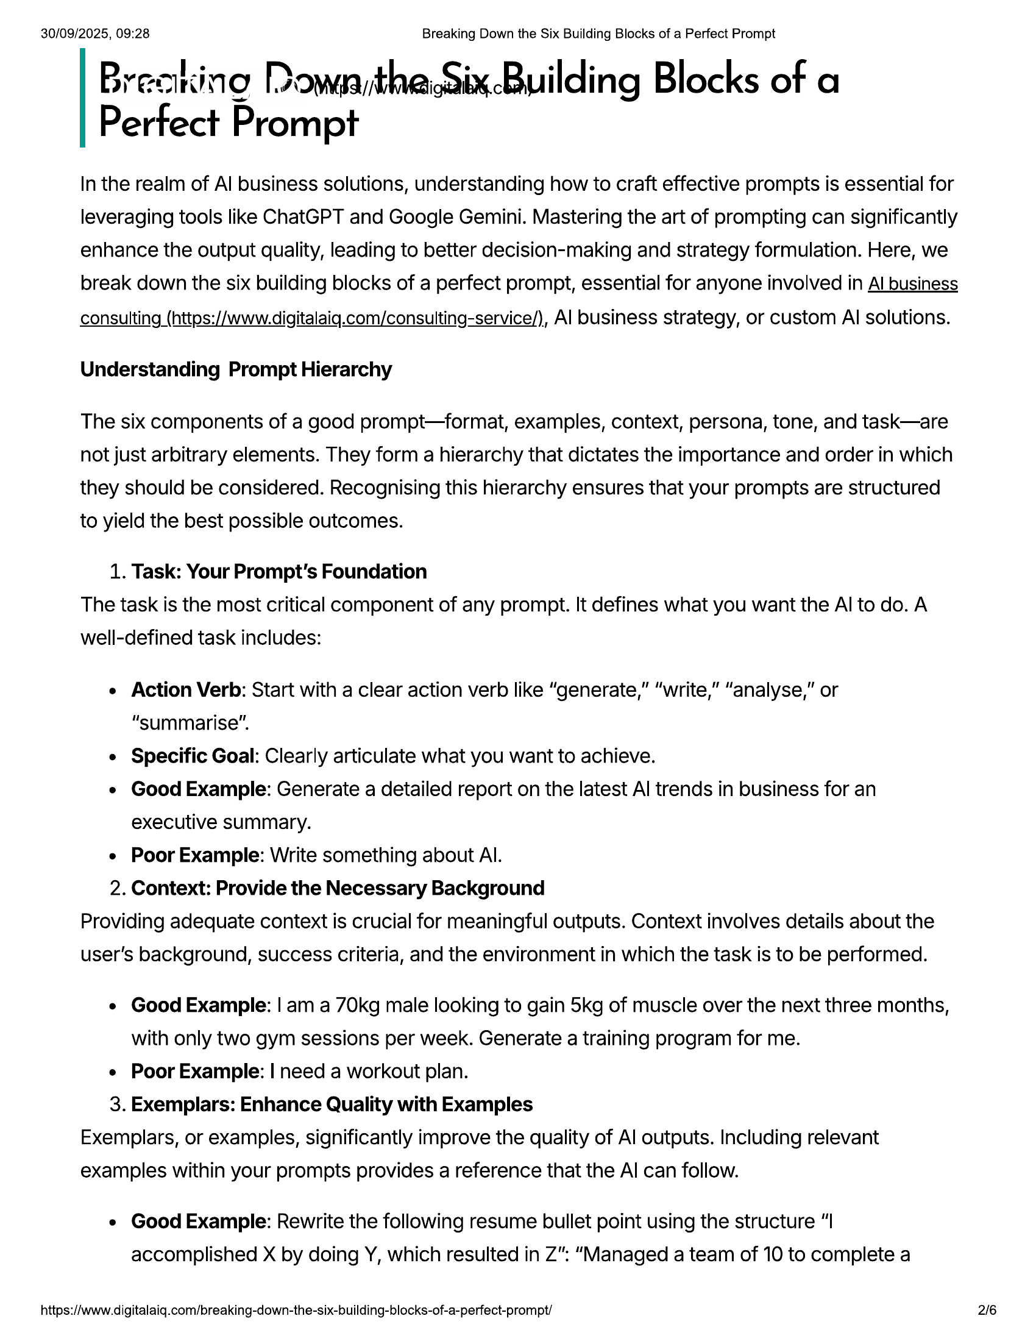

30/09/2025, 09:28 Breaking Down the Six Building Blocks of a Perfect Prompt  
  
Breanino Dowrtheaix.Building Blocks of a  
Perfect Prompt  
  
In the realm of Al business solutions, understanding how to craft effective prompts is essential for  
leveraging tools like ChatGPT and Google Gemini. Mastering the art of prompting can significantly  
enhance the output quality, leading to better decision-making and strategy formulation. Here, we  
  
break down the six building blocks of a perfect prompt, essential for anyone involved in Al business  
  
consulting (https://www.digitalaig.com/consulting-service/), Al business strategy, or custom Al solutions.  
  
Understanding Prompt Hierarchy  
  
The six components of a good prompt—format, examples, context, persona, tone, and task—are  
not just arbitrary elements. They form a hierarchy that dictates the importance and order in which  
they should be considered. Recognising this hierarchy ensures that your prompts are structured  
to yield the best possible outcomes.  
  
1. Task: Your Prompt's Foundation  
The task is the most critical component of any prompt. It defines what you want the Al to do. A  
well-defined task includes:  
  
e Action Verb: Start with a clear action verb like “generate,” “write,” “analyse,” or  
“summarise”.  
e Specific Goal: Clearly articulate what you want to achieve.  
e Good Example: Generate a detailed report on the latest Al trends in business for an  
executive summary.  
e Poor Example: Write something about Al.  
2. Context: Provide the Necessary Background  
Providing adequate context is crucial for meaningful outputs. Context involves details about the  
user's background, success criteria, and the environment in which the task is to be performed.  
  
e Good Example: | am a 70kg male looking to gain 5kg of muscle over the next three months,  
with only two gym sessions per week. Generate a training program for me.  
¢ Poor Example: | need a workout plan.  
3. Exemplars: Enhance Quality with Examples  
Exemplars, or examples, significantly improve the quality of Al outputs. Including relevant  
examples within your prompts provides a reference that the Al can follow.  
  
e Good Example: Rewrite the following resume bullet point using the structure “I  
accomplished X by doing Y, which resulted in Z": “Managed a team of 10 to complete a  
  
https://www.digitalaiq.com/breaking-down-the-six-building-blocks-of-a-perfect-prompt/ 2/6

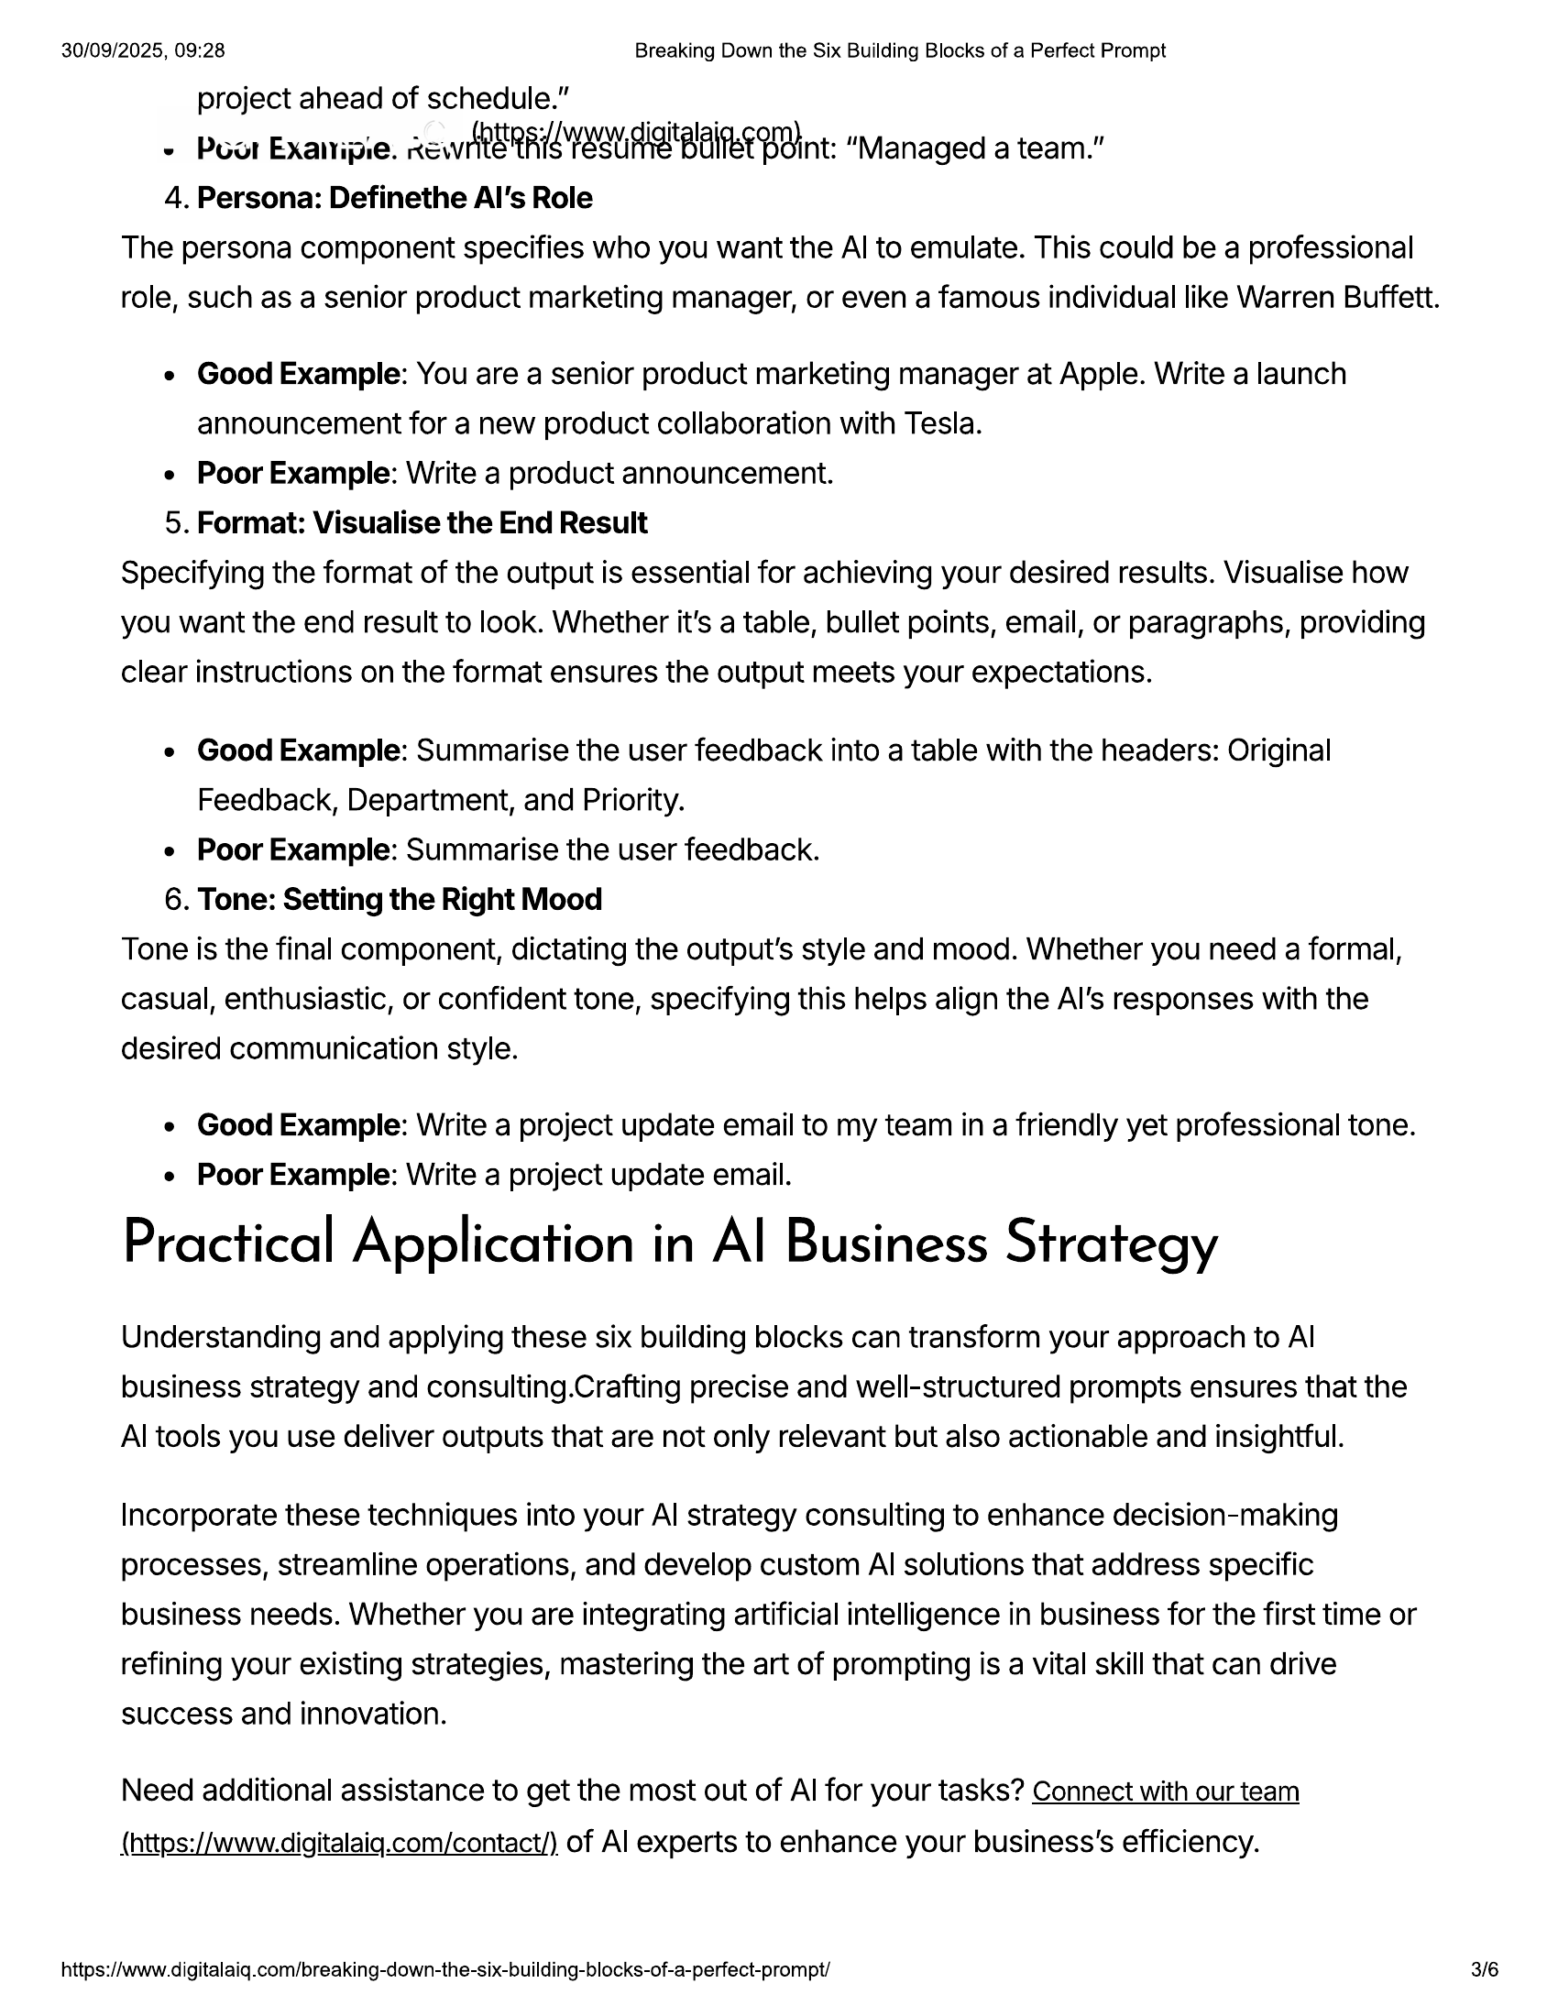

30/09/2025, 09:28 Breaking Down the Six Building Blocks of a Perfect Prompt  
project ahead of schedule.”  
~ Poor Exanipie. ewe RR ee BAe Bint: “Managed a team."  
4. Persona: Definethe Al's Role  
The persona component specifies who you want the Al to emulate. This could be a professional  
role, such as a senior product marketing manager, or even a famous individual like Warren Buffett.  
  
e Good Example: You are a senior product marketing manager at Apple. Write a launch  
announcement for a new product collaboration with Tesla.  
e Poor Example: Write a product announcement.  
5. Format: Visualise the End Result  
Specifying the format of the output is essential for achieving your desired results. Visualise how  
you want the end result to look. Whether it's a table, bullet points, email, or paragraphs, providing  
clear instructions on the format ensures the output meets your expectations.  
  
e Good Example: Summarise the user feedback into a table with the headers: Original  
Feedback, Department, and Priority.  
e Poor Example: Summarise the user feedback.  
6. Tone: Setting the Right Mood  
Tone is the final component, dictating the output’s style and mood. Whether you need a formal,  
casual, enthusiastic, or confident tone, specifying this helps align the Al's responses with the  
desired communication style.  
  
e Good Example: Write a project update email to my team in a friendly yet professional tone.  
e Poor Example: Write a project update email.  
  
Practical Application in Al Business Strategy  
  
Understanding and applying these six building blocks can transform your approach to Al  
business strategy and consulting.Crafting precise and well-structured prompts ensures that the  
Al tools you use deliver outputs that are not only relevant but also actionable and insightful.  
  
Incorporate these techniques into your Al strategy consulting to enhance decision-making  
processes, streamline operations, and develop custom Al solutions that address specific  
business needs. Whether you are integrating artificial intelligence in business for the first time or  
refining your existing strategies, mastering the art of prompting is a vital skill that can drive  
success and innovation.  
  
Need additional assistance to get the most out of Al for your tasks? Connect with our team  
  
(https://www.digitalaiq.com/contact/) of Al experts to enhance your business's efficiency.  
  
https://www.digitalaiq.com/breaking-down-the-six-building-blocks-of-a-perfect-prompt/ 3/6

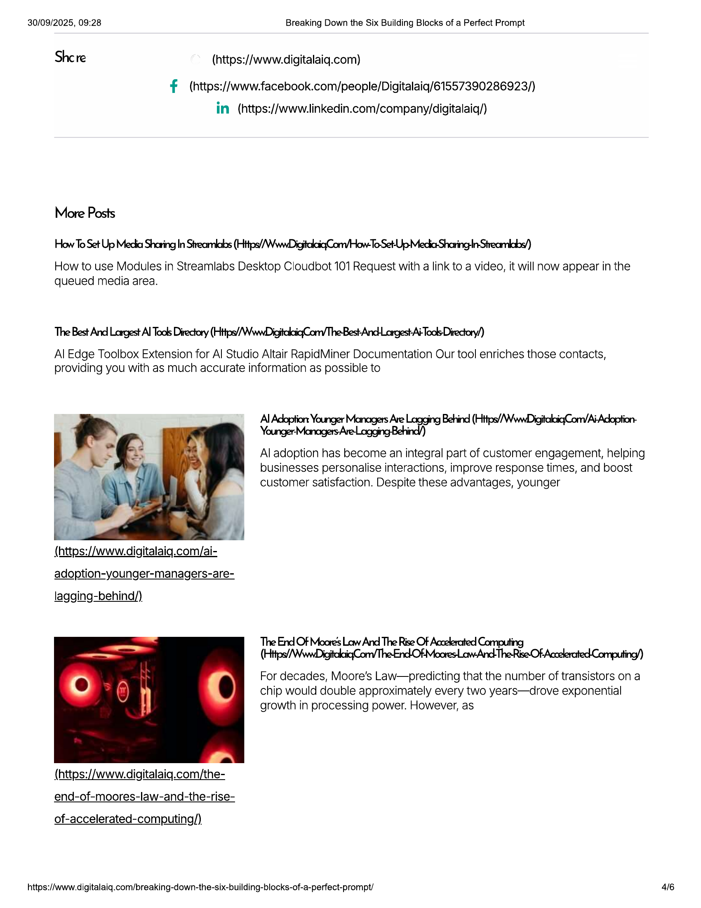

30/09/2025, 09:28  
  
Breaking Down the Six Building Blocks of a Perfect Prompt  
  
Shc re (https://www.digitalaig.com)  
  
(https://www.facebook.com/people/Digitalaig/61557390286923/)  
  
in. (https://www.linkedin.com/company/digitalaiq/)  
  
More Posts  
  
How To Set Up Mecka Shoring In Stteamlals (Https//\MwnDigitelaiq}Com/How-To Set Ute Mecko Shering In Stteamoboy)  
  
How to use Modules in Streamlabs Desktop Cloudbot 101 Request with a link to a video, it will now appear in the  
  
queued media area.  
  
The Best And Largest Al Tools Directory (Https//WwwDigitalaiqCony The Best-And-Largest-Ai- Tools Directory/)  
  
Al Edge Toolbox Extension for Al Studio Altair RapidMiner Documentation Our tool enriches those contacts,  
providing you with as much accurate information as possible to  
  
(https://www.digitalaiq.com/ai-  
adoption-younger-managers-are-  
  
lagging-behind/)  
  
(https://www.digitalaig.com/the-  
  
end-of-moores-law-and-the-rise-  
  
of-accelerated-computing/)  
  
Younger: Managers Are-Lagging Behind/)  
  
Al adoption has become an integral part of customer engagement, helping  
businesses personalise interactions, improve response times, and boost  
customer satisfaction. Despite these advantages, younger  
  
The End Of Moore's Law And The Rise Of Accelerated Computing  
  
(Https/ Www DigitalaigCom/The-End-Of Moores-Law-And-The-Rise-Of- Accelerated-Computing/)  
For decades, Moore’s Law—predicting that the number of transistors on a  
chip would double approximately every two years—drove exponential  
growth in processing power. However, as  
  
https://www.digitalaiq.com/breaking-down-the-six-building-blocks-of-a-perfect-prompt/ 4/6

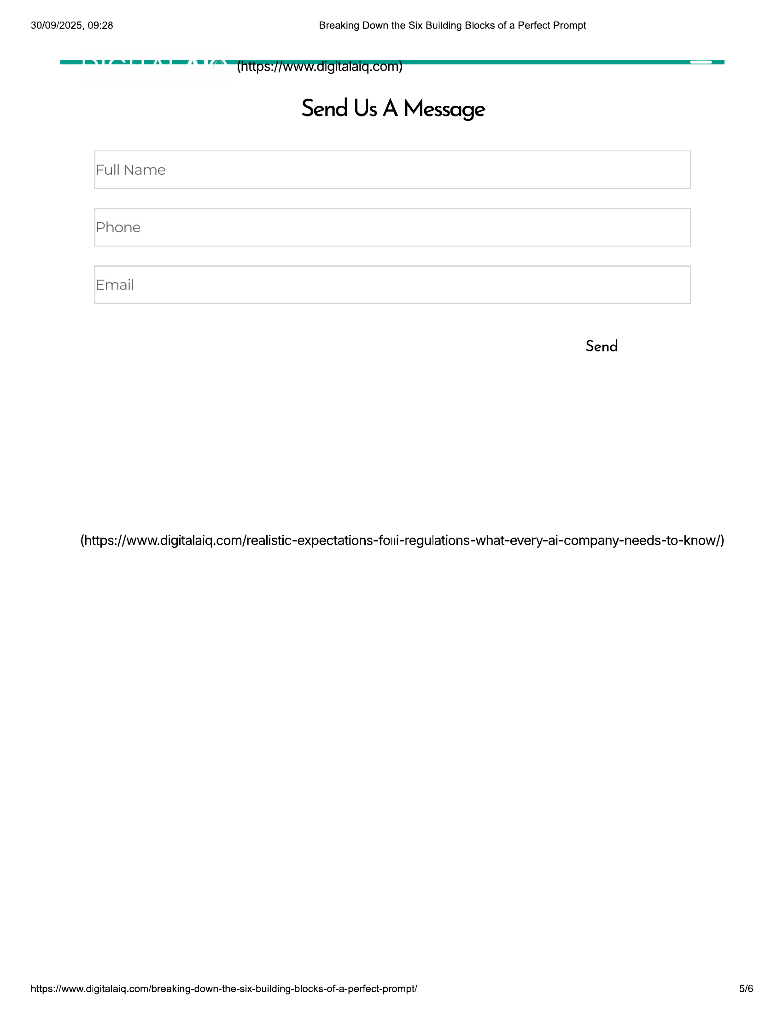

30/09/2025, 09:28 Breaking Down the Six Building Blocks of a Perfect Prompt  
—— ee EET OSI. COM ae  
Send Us A Message  
  
Full Name  
Phone  
  
Email  
  
Send  
  
(https://www.digitalaiq.com/realistic-expectations-foni-regulations-what-every-ai-company-needs-to-know/)  
  
https://www.digitalaiq.com/breaking-down-the-six-building-blocks-of-a-perfect-prompt/  
  
5/6



30/09/2025, 09:28 Breaking Down the Six Building Blocks of a Perfect Prompt  
  
(https://www.digitalaig.com)  
  
(ht  
ps:/  
fn  
fac ps:/  
ebo Iw  
ok. in  
HOME FODLOWaty:  
m :  
ABOUT US peo Onn  
ple/ Ico  
SERVICES Digi mp  
tala  
BLOG 155 /di  
739 gita  
CONTACT 02 laiq  
92  
3/)  
  
Enter you Email address to join our mailing list :)  
  
YES PLEASE  
  
© 2025 All Rights Reserved.  
  
https://www.digitalaiq.com/breaking-down-the-six-building-blocks-of-a-perfect-prompt/