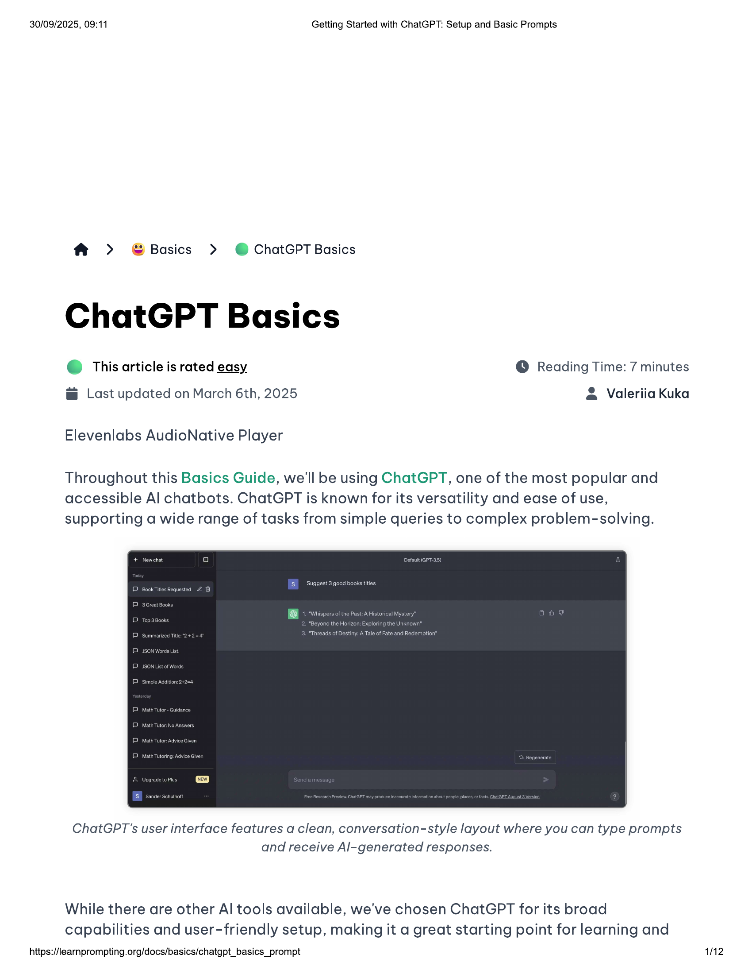

30/09/2025, 09:11 Getting Started with ChatGPT: Setup and Basic Prompts  
  
f > G©Basics > ©@ ChatGPT Basics  
  
ChatGPT Basics  
  
e@ This article is rated easy © Reading Time: 7 minutes  
  
@ Last updated on March 6th, 2025 & Valeriia Kuka  
Elevenlabs AudioNative Player  
Throughout this Basics Guide, we'll be using ChatGPT, one of the most popular and  
  
accessible Al chatbots. ChatGPT is known for its versatility and ease of use,  
supporting a wide range of tasks from simple queries to complex problem-solving.  
  
ChatGPT'’s user interface features a clean, conversation-style layout where you can type prompts  
and receive Al-generated responses.  
  
While there are other Al tools available, we've chosen ChatGPT for its broad  
capabilities and user-friendly setup, making it a great starting point for learning and  
  
https://learnprompting.org/docs/basics/chatgpt_basics_prompt  
  
12

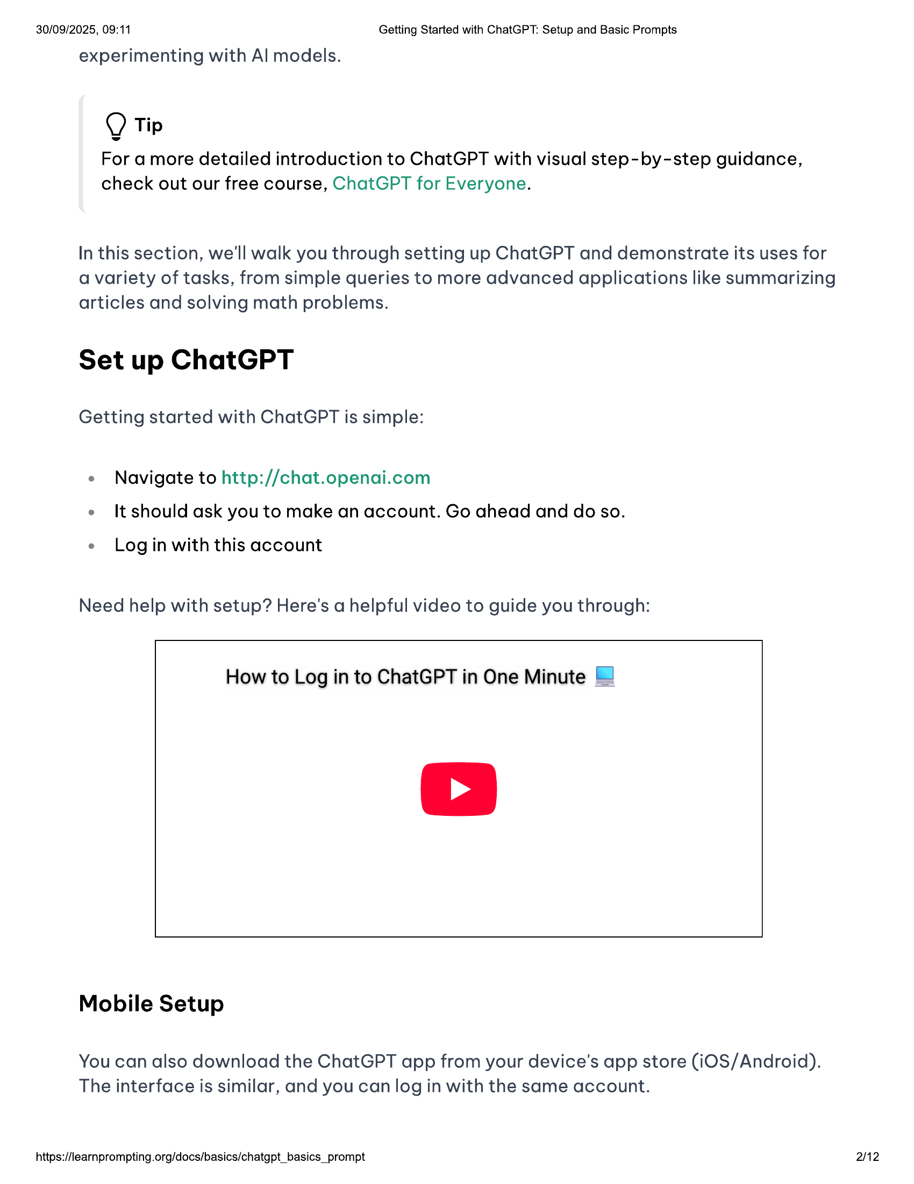

30/09/2025, 09:11 Getting Started with ChatGPT: Setup and Basic Prompts  
  
experimenting with Al models.  
  
Q Tip  
For a more detailed introduction to ChatGPT with visual step-by-step guidance,  
check out our free course, ChatGPT for Everyone.  
  
In this section, we'll walk you through setting up ChatGPT and demonstrate its uses for  
a variety of tasks, from simple queries to more advanced applications like summarizing  
articles and solving math problems.  
  
Set up ChatGPT  
  
Getting started with ChatGPT is simple:  
  
e Navigate to http://chat.openai.com  
e It should ask you to make an account. Go ahead and do so.  
  
e Login with this account  
  
Need help with setup? Here's a helpful video to guide you through:  
  
How to Log in to ChatGPT in One Minute ©  
  
Mobile Setup  
  
You can also download the ChatGPT app from your device's app store (iOS/Android).  
The interface is similar, and you can log in with the same account.  
  
https://learnprompting.org/docs/basics/chatgpt_basics_prompt  
  
2/12

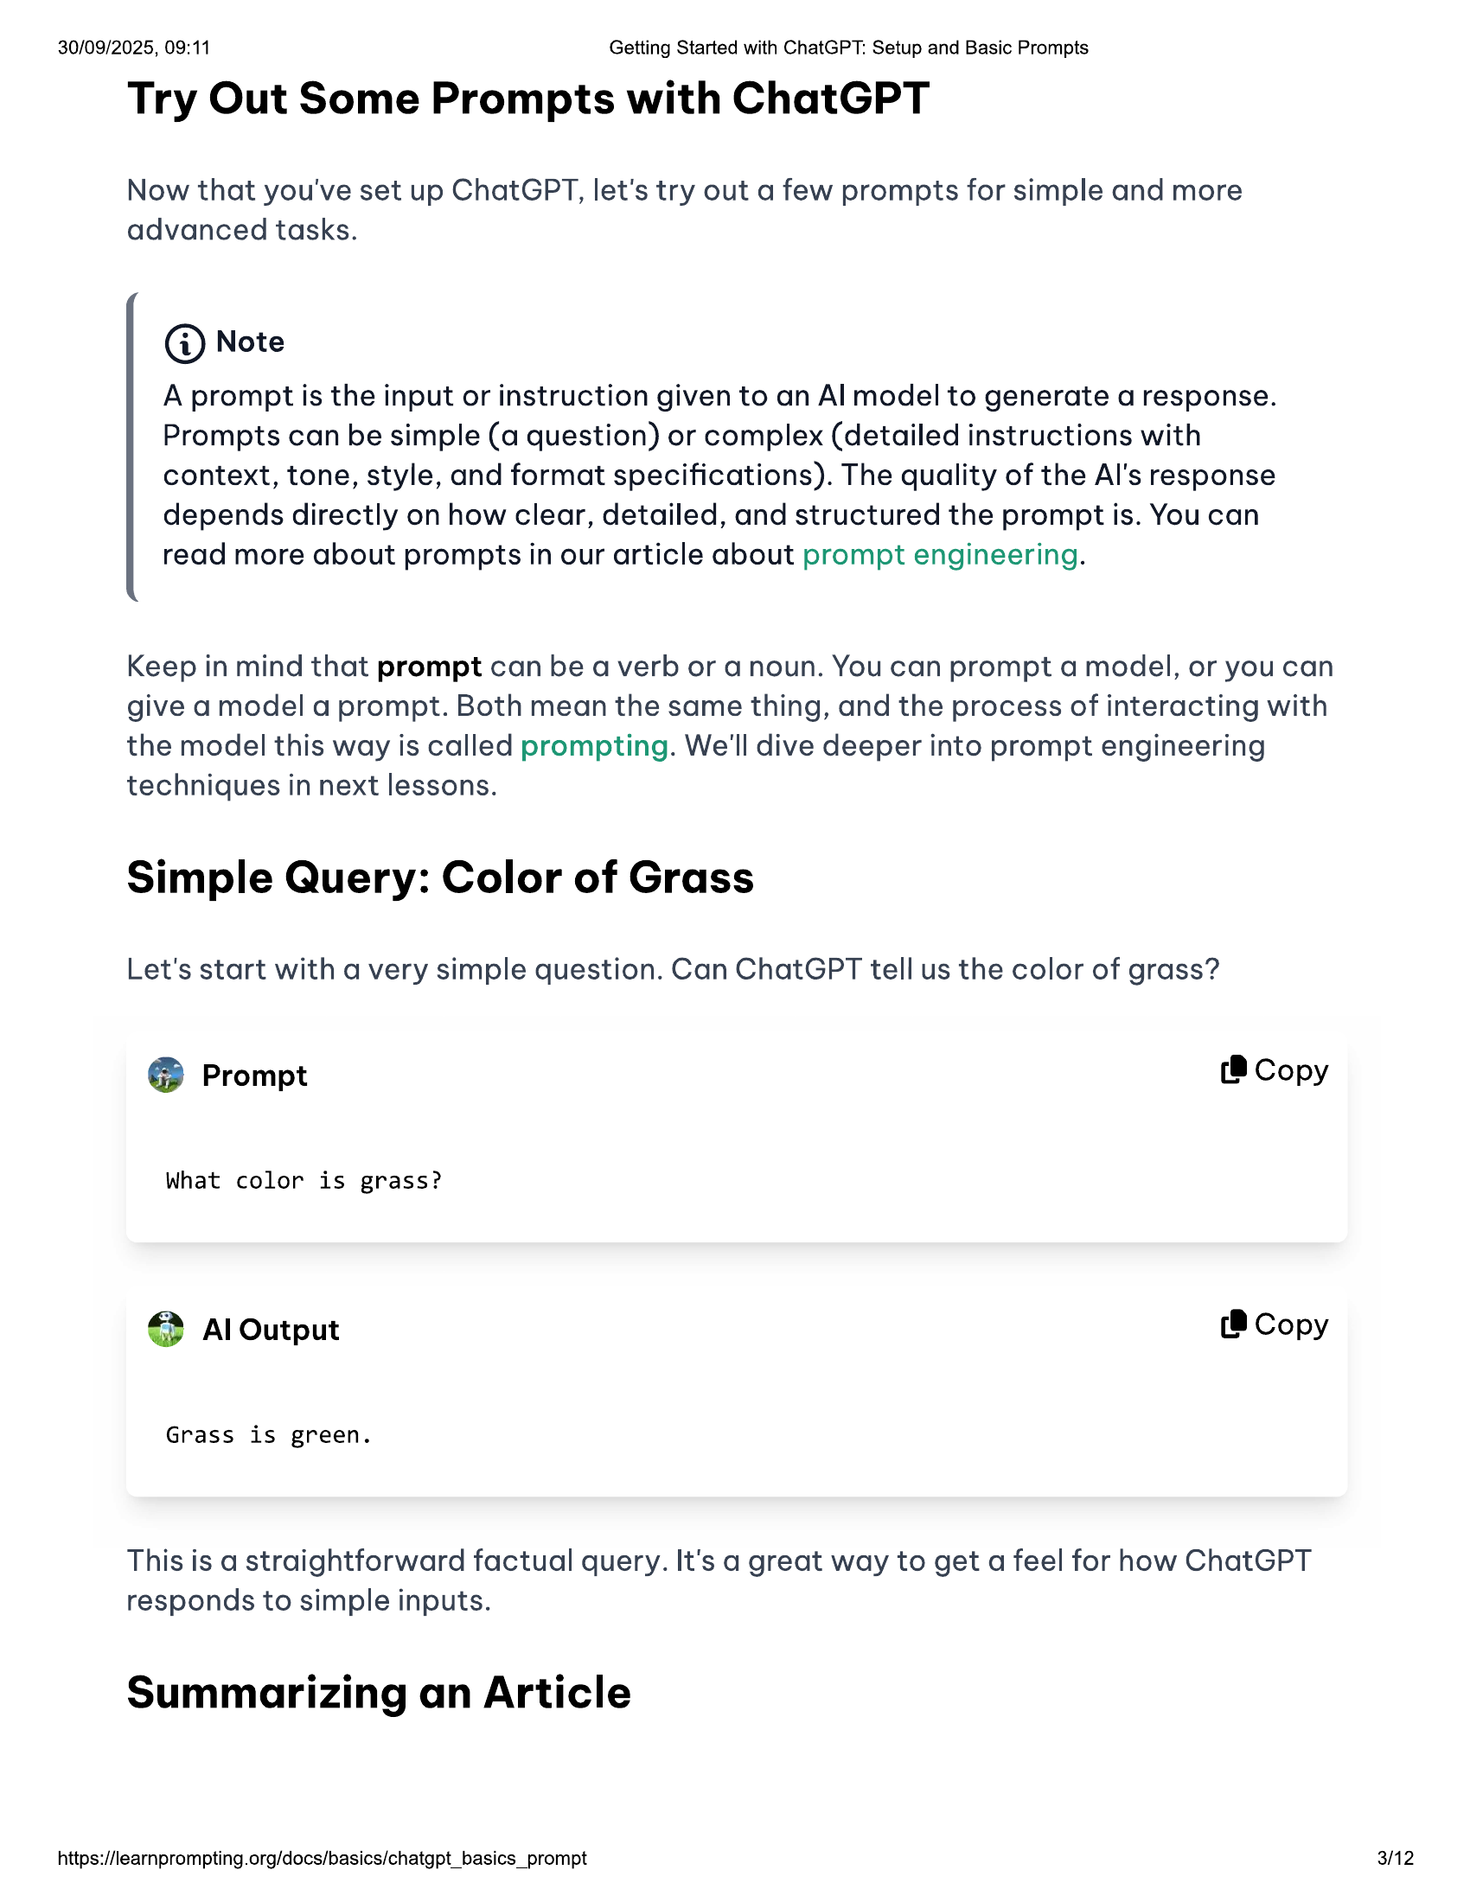

30/09/2025, 09:11 Getting Started with ChatGPT: Setup and Basic Prompts  
  
Try Out Some Prompts with ChatGPT  
  
Now that you've set up ChatGPT, let's try out a few prompts for simple and more  
advanced tasks.  
  
@ Note  
  
A prompt is the input or instruction given to an Al model to generate a response.  
Prompts can be simple (a question) or complex (detailed instructions with  
context, tone, style, and format specifications). The quality of the Al's response  
depends directly on how clear, detailed, and structured the prompt is. You can  
read more about prompts in our article about prompt engineering.  
  
Keep in mind that prompt can be a verb or a noun. You can prompt a model, or you can  
give a model a prompt. Both mean the same thing, and the process of interacting with  
the model this way is called prompting. We'll dive deeper into prompt engineering  
techniques in next lessons.  
  
Simple Query: Color of Grass  
  
Let's start with a very simple question. Can ChatGPT tell us the color of grass?  
@® Prompt (8 Copy  
  
What color is grass?  
© Al Output (B Copy  
Grass is green.  
  
This is a straightforward factual query. It's a great way to get a feel for how ChatGPT  
responds to simple inputs.  
  
Summarizing an Article  
  
https://learnprompting.org/docs/basics/chatgpt_basics_prompt 3/12

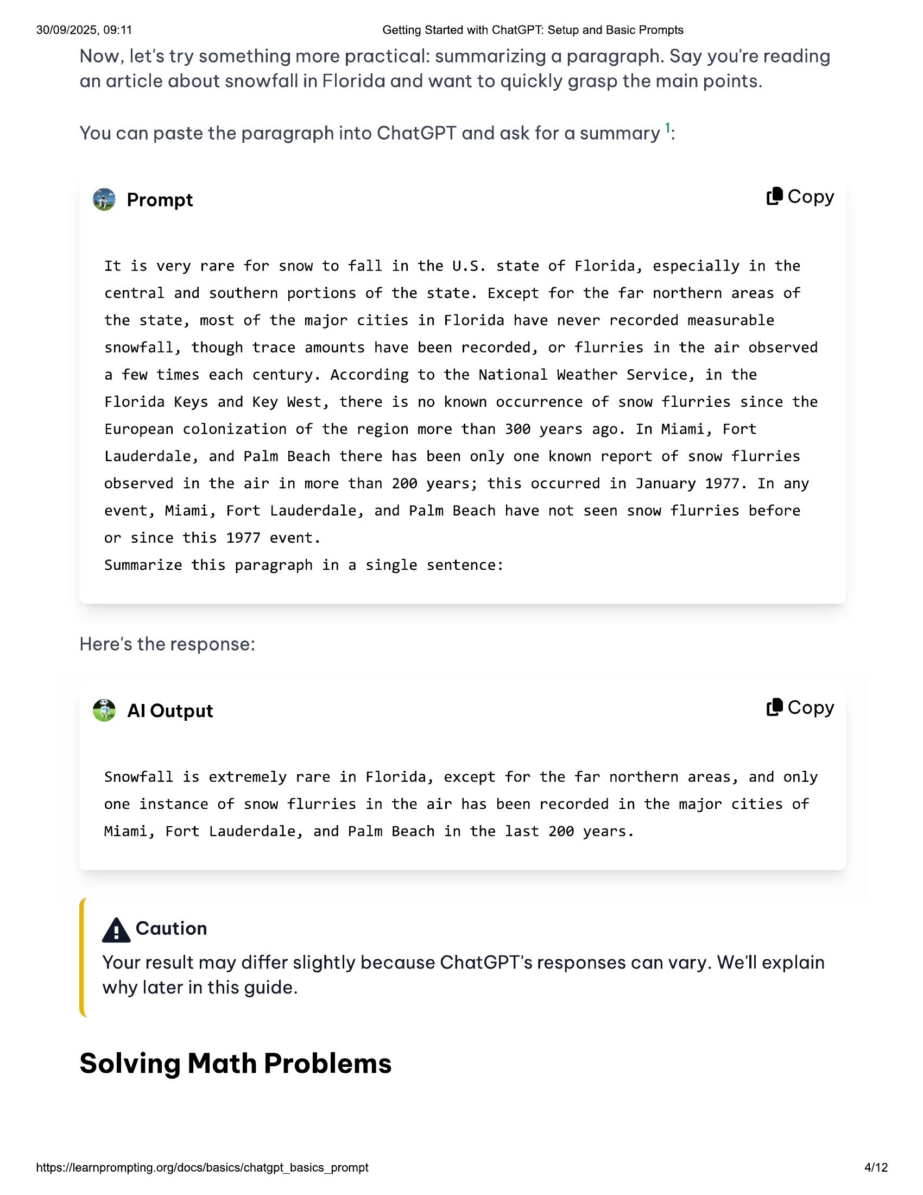

30/09/2025, 09:11 Getting Started with ChatGPT: Setup and Basic Prompts  
  
Now, let's try something more practical: summarizing a paragraph. Say you're reading  
an article about snowfall in Florida and want to quickly grasp the main points.  
  
You can paste the paragraph into ChatGPT and ask for a summary !:  
@® Prompt (® Copy  
  
It is very rare for snow to fall in the U.S. state of Florida, especially in the  
central and southern portions of the state. Except for the far northern areas of  
the state, most of the major cities in Florida have never recorded measurable  
snowfall, though trace amounts have been recorded, or flurries in the air observed  
a few times each century. According to the National Weather Service, in the  
Florida Keys and Key West, there is no known occurrence of snow flurries since the  
European colonization of the region more than 3@@ years ago. In Miami, Fort  
Lauderdale, and Palm Beach there has been only one known report of snow flurries  
observed in the air in more than 200 years; this occurred in January 1977. In any  
event, Miami, Fort Lauderdale, and Palm Beach have not seen snow flurries before  
or since this 1977 event.  
  
Summarize this paragraph in a single sentence:  
  
Here's the response:  
€} Al Output (8 Copy  
  
Snowfall is extremely rare in Florida, except for the far northern areas, and only  
one instance of snow flurries in the air has been recorded in the major cities of  
  
Miami, Fort Lauderdale, and Palm Beach in the last 200 years.  
  
A Caution  
  
Your result may differ slightly because ChatGPT's responses can vary. We'll explain  
why later in this guide.  
  
Solving Math Problems  
  
https://learnprompting.org/docs/basics/chatgpt_basics_prompt 412

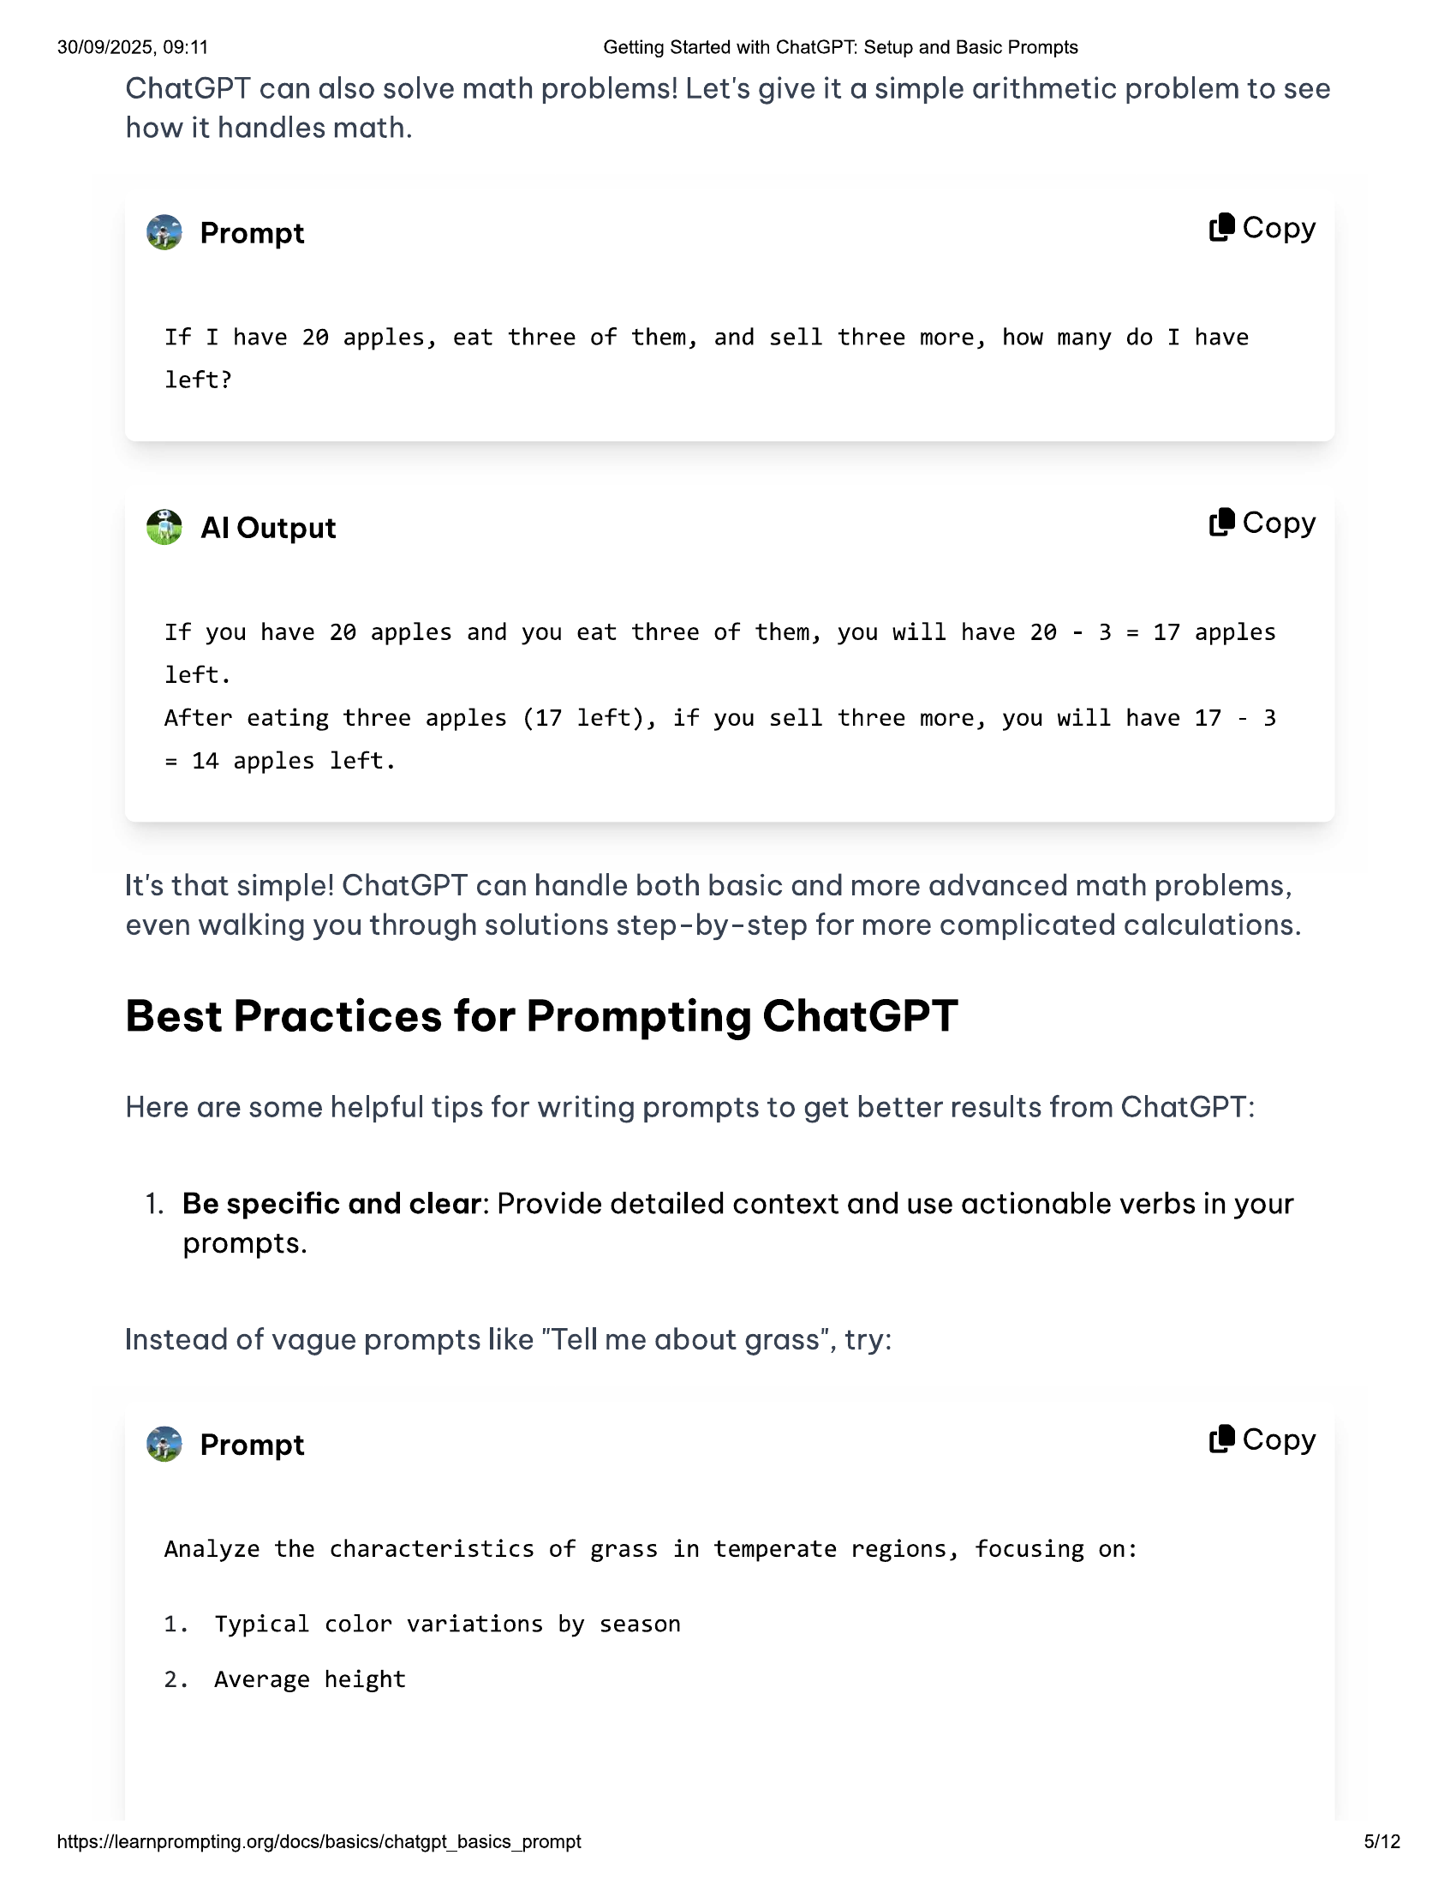

30/09/2025, 09:11 Getting Started with ChatGPT: Setup and Basic Prompts  
  
ChatGPT can also solve math problems! Let's give it a simple arithmetic problem to see  
how it handles math.  
  
@® Prompt (8 Copy  
  
If I have 2@ apples, eat three of them, and sell three more, how many do I have  
left?  
  
> Al Output (B Copy  
  
If you have 20 apples and you eat three of them, you will have 2@ - 3 = 17 apples  
left.  
  
After eating three apples (17 left), if you sell three more, you will have 17 - 3  
= 14 apples left.  
  
It's that simple! ChatGPT can handle both basic and more advanced math problems,  
even walking you through solutions step-by-step for more complicated calculations.  
  
Best Practices for Prompting ChatGPT  
  
Here are some helpful tips for writing prompts to get better results from ChatGPT:  
  
1. Be specific and clear: Provide detailed context and use actionable verbs in your  
prompts.  
  
Instead of vague prompts like "Tell me about grass”, try:  
  
@® Prompt (@ Copy  
  
Analyze the characteristics of grass in temperate regions, focusing on:  
  
1. Typical color variations by season  
  
2. Average height  
  
https://learnprompting.org/docs/basics/chatgpt_basics_prompt  
  
5/12

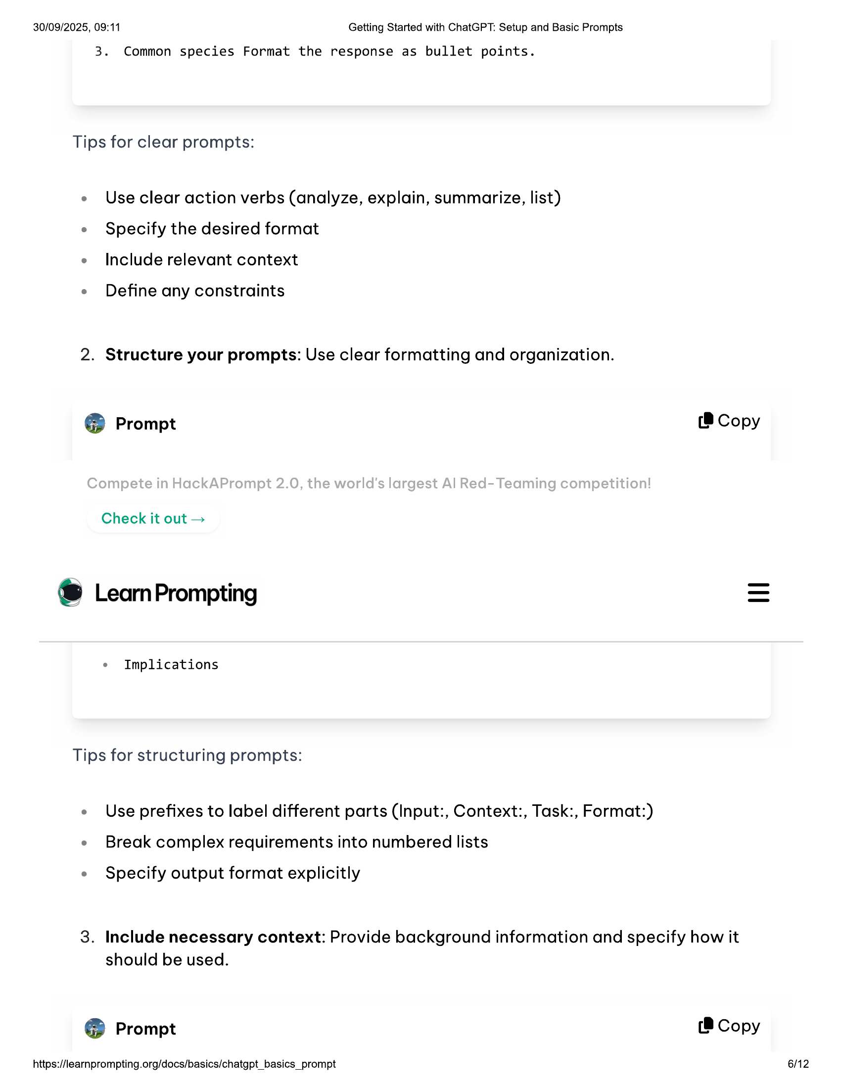

30/09/2025, 09:11 Getting Started with ChatGPT: Setup and Basic Prompts  
  
3. Common species Format the response as bullet points.  
  
Tips for clear prompts:  
  
e Useclear action verbs (analyze, explain, summarize, list)  
e Specify the desired format  
e Include relevant context  
  
e Define any constraints  
  
2. Structure your prompts: Use clear formatting and organization.  
  
@® Prompt (B Copy  
  
Check it out >  
  
® LearmPrompting  
  
e Implications  
  
Tips for structuring prompts:  
  
e Use prefixes to label different parts (Input:, Context:, Task:, Format:)  
e Break complex requirements into numbered lists  
  
e Specify output format explicitly  
  
3. Include necessary context: Provide background information and specify how it  
should be used.  
  
@® Prompt (8 Copy  
  
https://learnprompting.org/docs/basics/chatgpt_basics_prompt 6/12

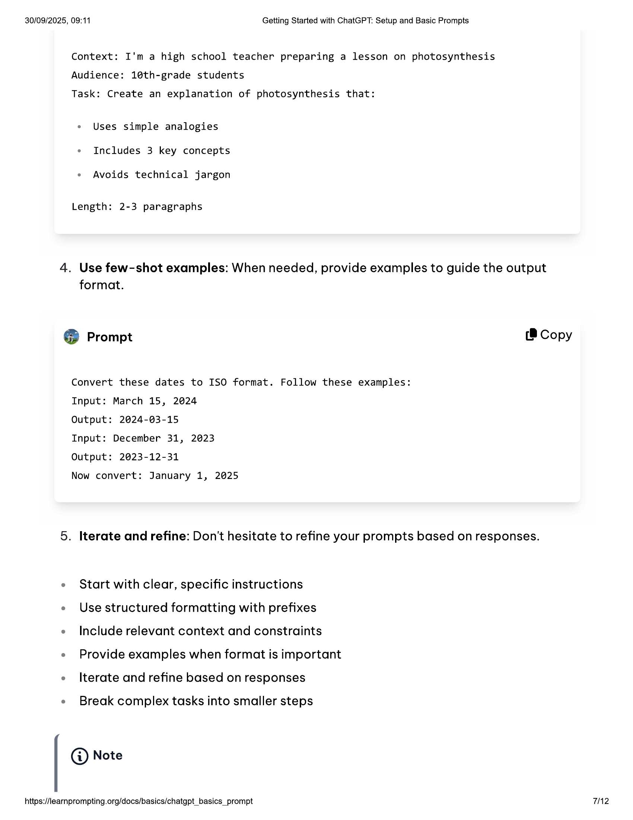

30/09/2025, 09:11 Getting Started with ChatGPT: Setup and Basic Prompts  
  
Context: I'm a high school teacher preparing a lesson on photosynthesis  
Audience: 1@th-grade students  
  
Task: Create an explanation of photosynthesis that:  
  
e Uses simple analogies  
e Includes 3 key concepts  
  
e Avoids technical jargon  
  
Length: 2-3 paragraphs  
  
4. Use few-shot examples: When needed, provide examples to guide the output  
format.  
  
Prompt (8 Copy  
7]  
  
Convert these dates to ISO format. Follow these examples:  
Input: March 15, 2024  
  
Output: 2024-03-15  
  
Input: December 31, 2023  
  
Output: 2023-12-31  
  
Now convert: January 1, 2025  
  
5. Iterate and refine: Don't hesitate to refine your prompts based on responses.  
  
e Start with clear, specific instructions  
  
e Use structured formatting with prefixes  
  
e Include relevant context and constraints  
  
e Provide examples when format is important  
e terate and refine based on responses  
  
e Break complex tasks into smaller steps  
  
@ Note  
  
https://learnprompting.org/docs/basics/chatgpt_basics_prompt 7H2

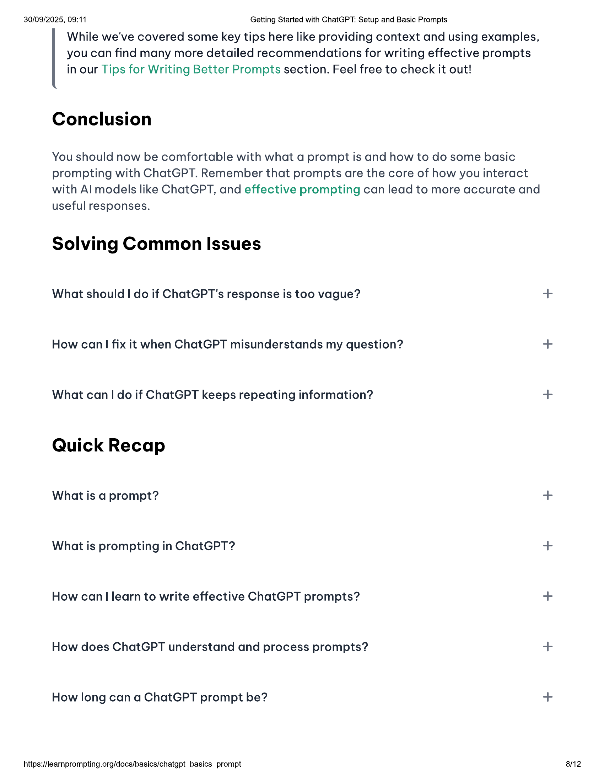

30/09/2025, 09:11 Getting Started with ChatGPT: Setup and Basic Prompts  
While we've covered some key tips here like providing context and using examples,  
you can find many more detailed recommendations for writing effective prompts  
in our Tips for Writing Better Prompts section. Feel free to check it out!  
  
Conclusion  
  
You should now be comfortable with what a prompt is and how to do some basic  
prompting with ChatGPT. Remember that prompts are the core of how you interact  
with Al models like ChatGPT, and effective prompting can lead to more accurate and  
useful responses.  
  
Solving Common Issues  
  
What should | do if ChatGPT's response is too vague? +  
How can| fix it when ChatGPT misunderstands my question? +  
What can! do if ChatGPT keeps repeating information? +  
Quick Recap  
  
What is a prompt? +  
What is prompting in ChatGPT? +  
How can| learn to write effective ChatGPT prompts? +  
How does ChatGPT understand and process prompts? +  
How long can a ChatGPT prompt be? +  
  
https://learnprompting.org/docs/basics/chatgpt_basics_prompt 8/12



30/09/2025, 09:11 Getting Started with ChatGPT: Setup and Basic Prompts  
  
Canl ask ChatGPT multiple questions in one conversation? +  
  
Footnotes  
  
1. This paragraph is from https://en.wikipedia.org/wiki/Snow _in_Florida ©  
  
Valeriia Kuka  
  
Valeriia Kuka, Head of Content at Learn Prompting, is passionate about making  
Aland ML accessible. Valeriia previously grew a 60K+ follower Al-focused  
social media account, earning reposts from Stanford NLP, Amazon Research,  
Hugging Face, and Al researchers. She has also worked with AI/ML newsletters  
and global communities with 1OOK+ members and authored clear and concise  
  
explainers and historical articles.  
  
@ Edit this page  
  
Previous Next  
@ What is Generative Al? th Interactive Learn Prompting Er  
  
Master Generative Al with Our Courses  
  
—  
;, = _  
  
ChatGPT for Everyone  
  
Created in Collaboration with GF OpenA  
https://learnprompting.org/docs/basics/chatgpt_basics_prompt  
  
9/12

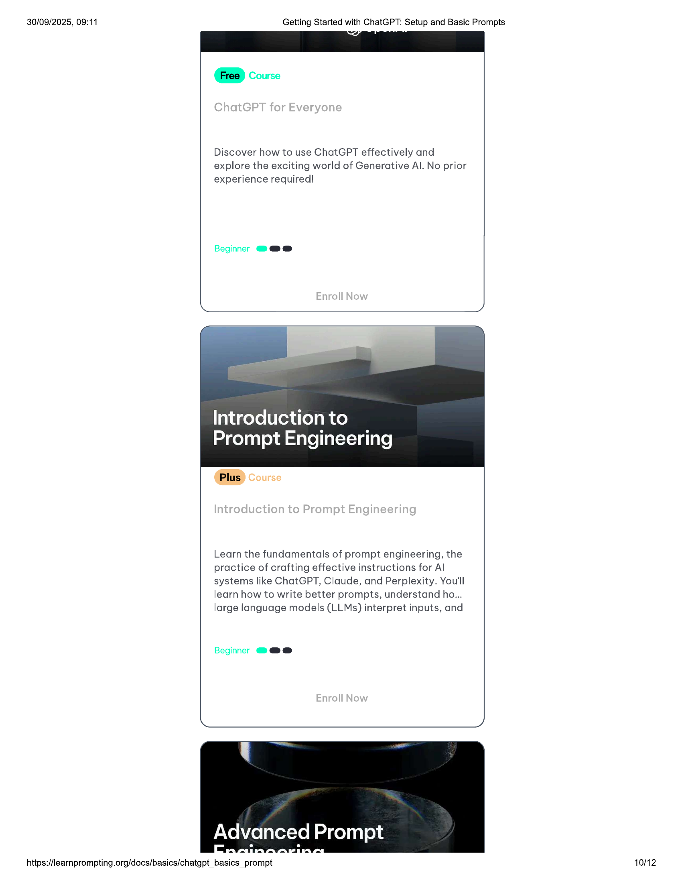

30/09/2025, 09:11  
  
Getting Started with ChatGPT: Setup and Basic Prompts  
  
ee  
© coe  
  
Discover how to use ChatGPT effectively and  
explore the exciting world of Generative Al. No prior  
experience required!  
  
Beginner @@e  
  
Introduction to  
  
Prompt Engineering  
  
Learn the fundamentals of prompt engineering, the  
practice of crafting effective instructions for Al  
  
systems like ChatGPT, Claude, and Perplexity. You'll  
learn how to write better prompts, understand ho...  
large language models (LLMs) interpret inputs, and  
  
Beginner @@@e  
  
Advanced Prompt  
  
https://learnprompting.org/docs/basics/chatgpt_basics_prompt  
  
10/12

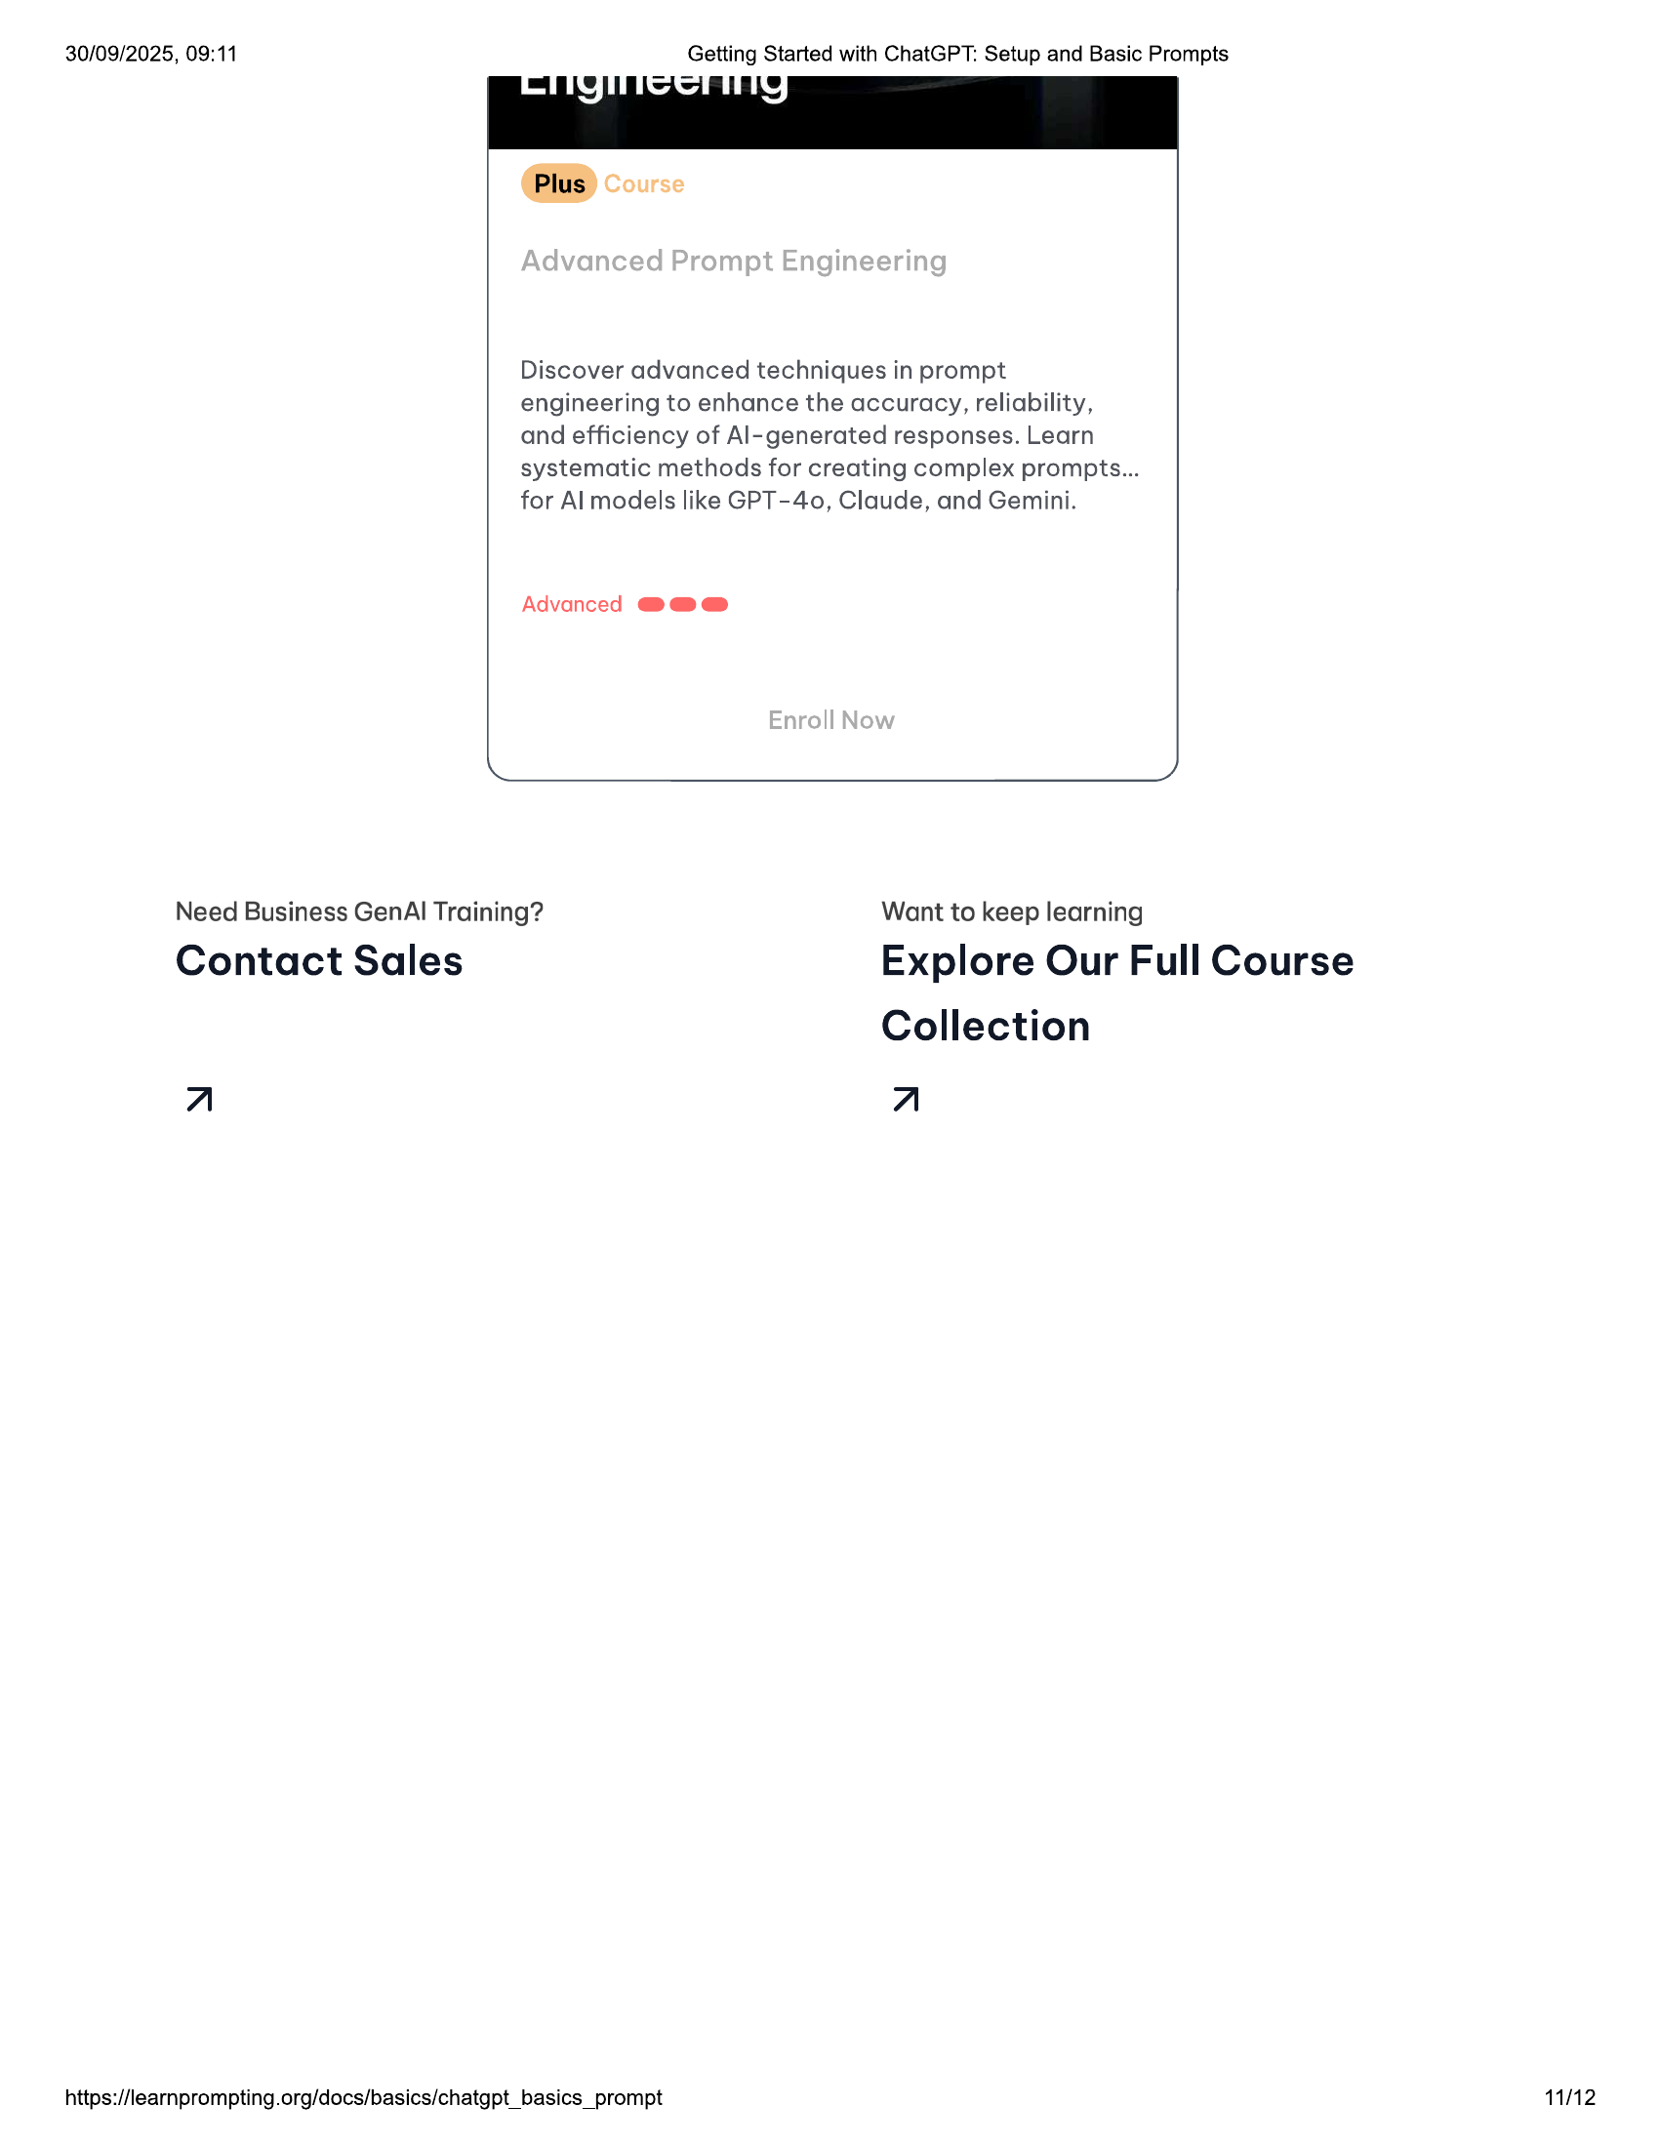

30/09/2025, 09:11 Getting Started with ChatGPT: Setup and Basic Prompts  
  
“Plus” Course  
  
Discover advanced techniques in prompt  
engineering to enhance the accuracy, reliability,  
and efficiency of Al- generated responses. Learn  
systematic methods for creating complex prompts...  
for Almodels like GPT-40, Claude, and Gemini.  
  
Advanced @@@®  
  
Ne S  
Need Business GenAl Training? Want to keep learning  
Contact Sales Explore Our Full Course  
Collection  
A A  
  
https://learnprompting.org/docs/basics/chatgpt_basics_prompt 11/12

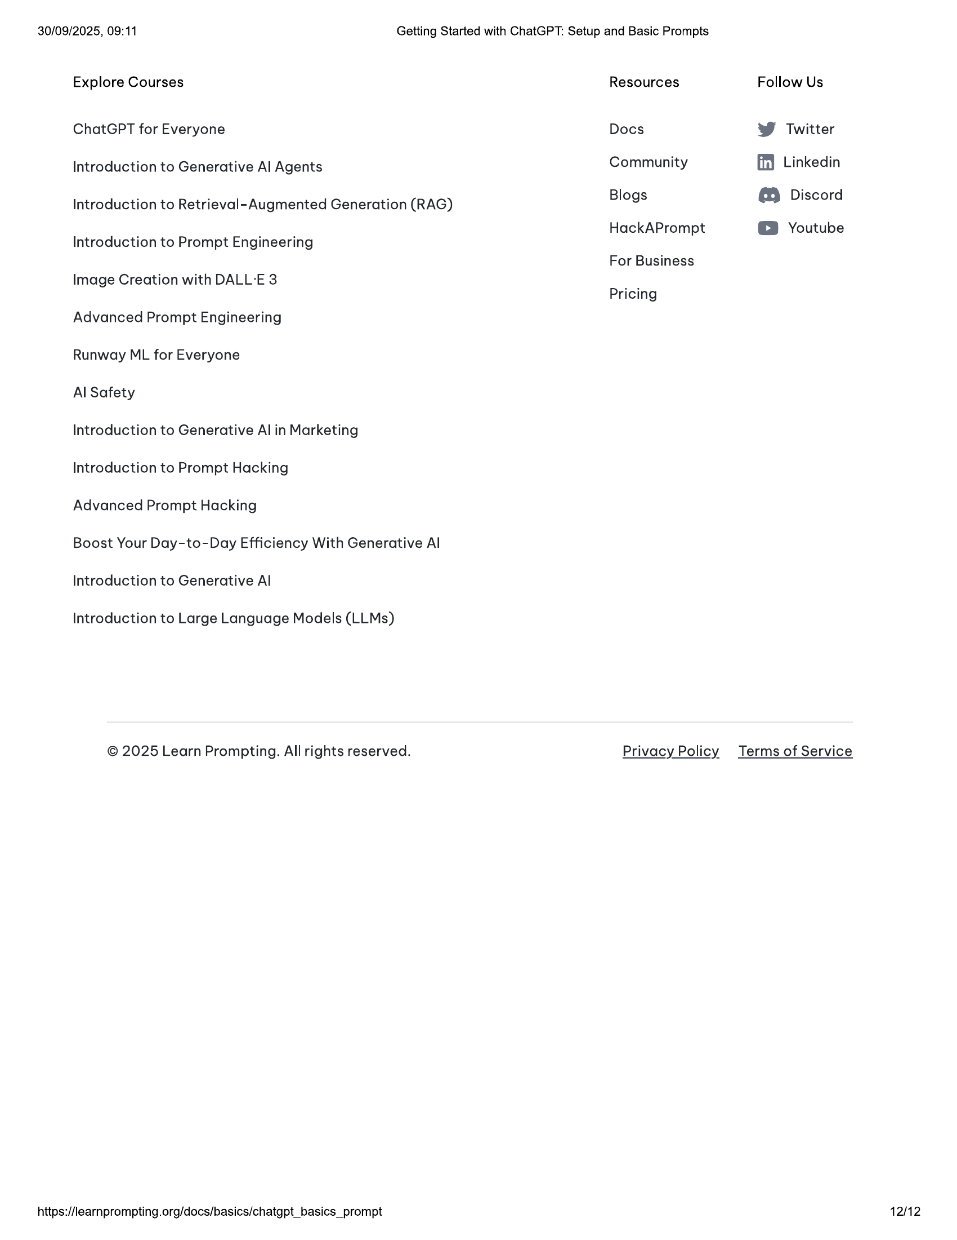

30/09/2025, 09:11 Getting Started with ChatGPT: Setup and Basic Prompts  
  
Explore Courses Resources Follow Us  
ChatGPT for Everyone Docs W Twitter  
Introduction to Generative Al Agents Community ff) Linkedin  
Introduction to Retrieval- Augmented Generation (RAG) Blogs @ Discord  
HackAPrompt @® Youtube  
  
Introduction to Prompt Engineering  
For Business  
Image Creation with DALL-E 3  
  
Pricing  
  
Advanced Prompt Engineering  
Runway ML for Everyone  
Al Safety  
Introduction to Generative Al in Marketing  
Introduction to Prompt Hacking  
Advanced Prompt Hacking  
Boost Your Day-to-Day Efficiency With Generative Al  
Introduction to Generative Al  
Introduction to Large Language Models (LLMs)  
  
© 2025 Learn Prompting. All rights reserved. Privacy Policy Terms of Service  
  
https://learnprompting.org/docs/basics/chatgpt_basics_prompt 12/12