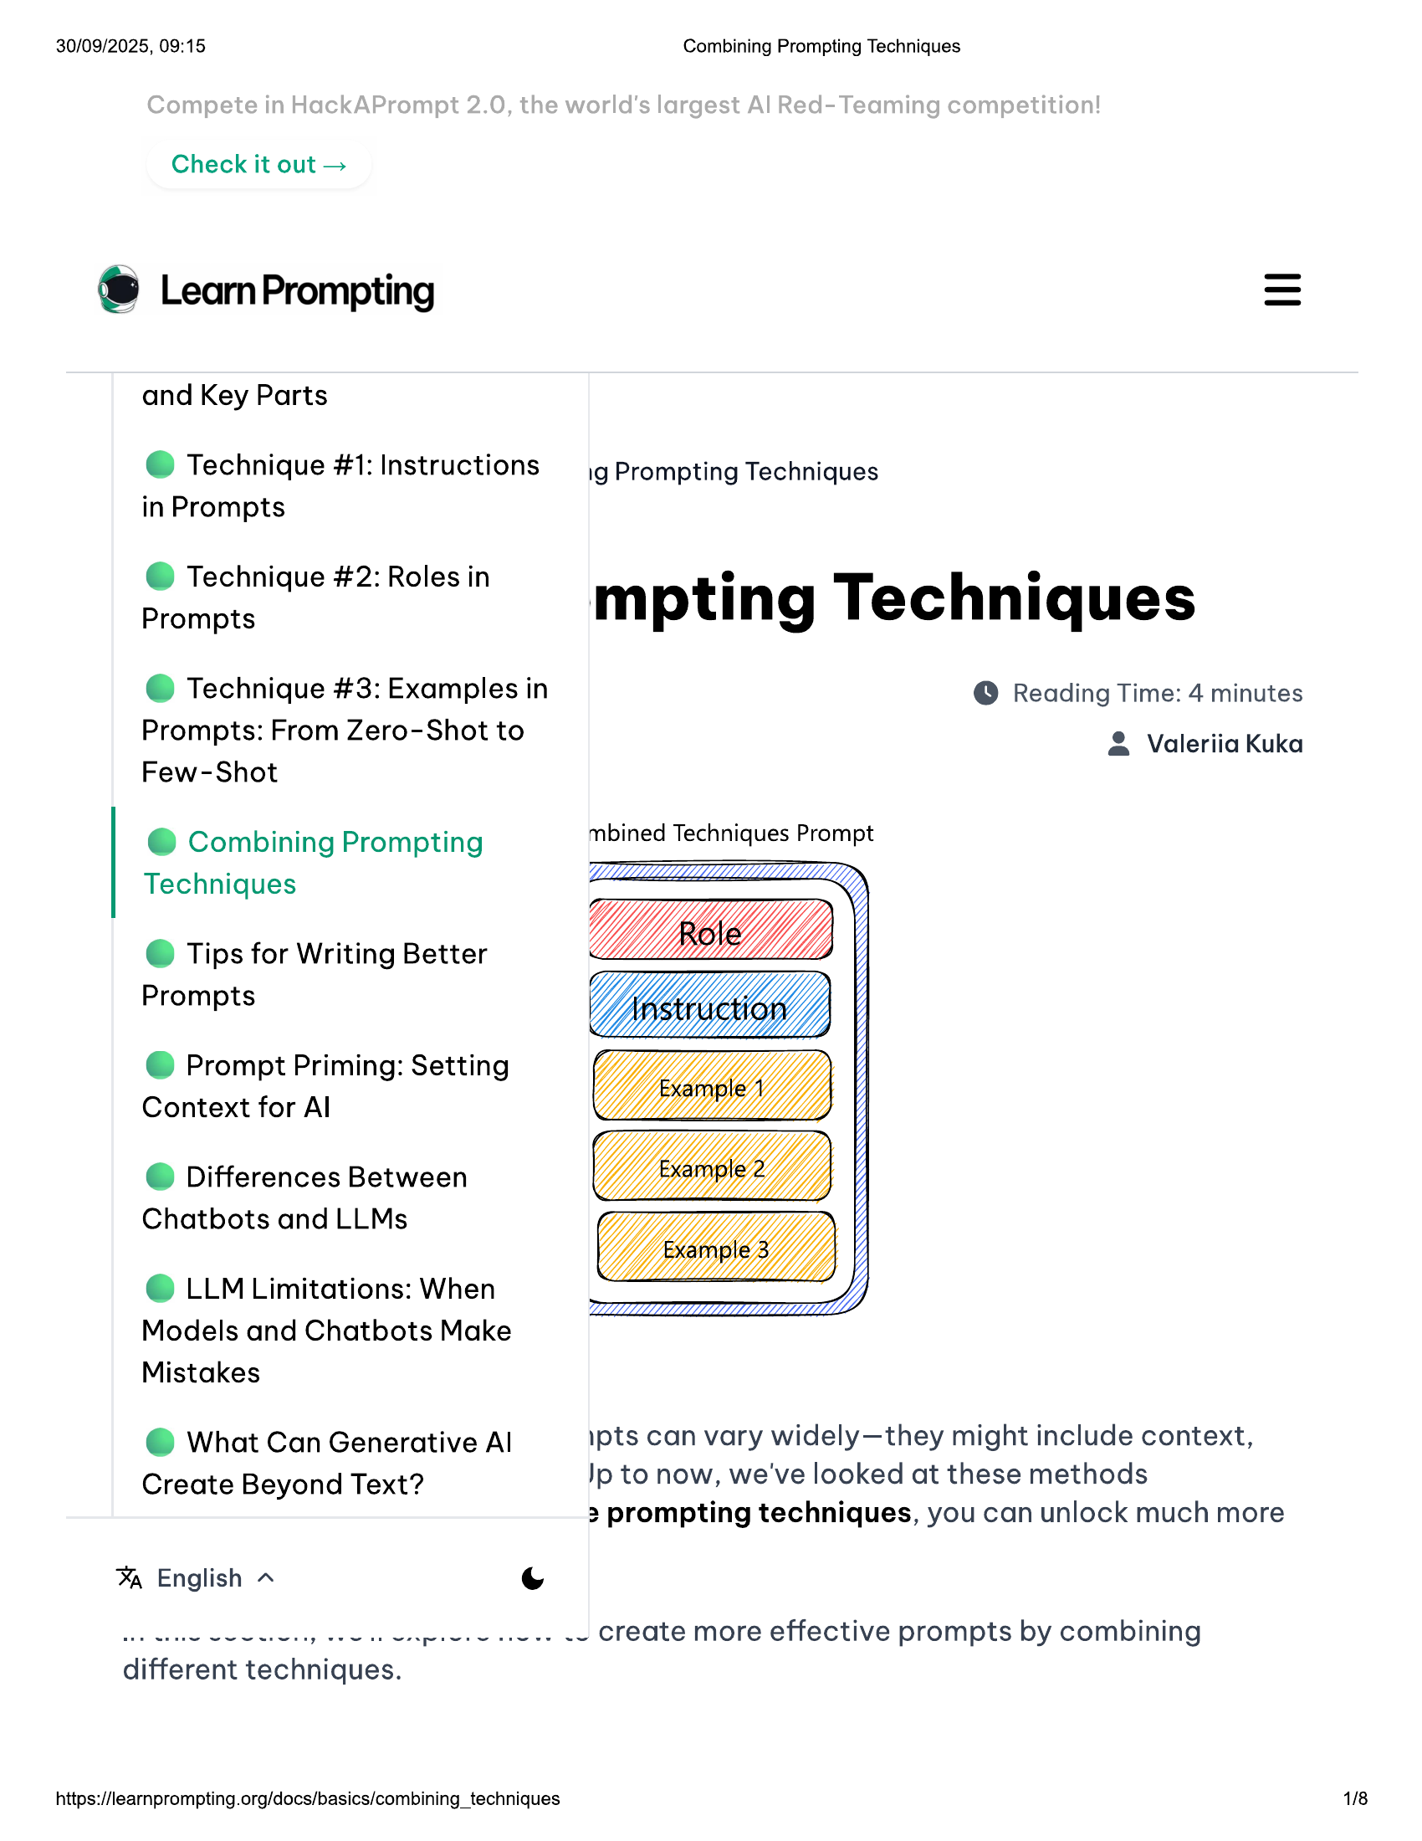

30/09/2025, 09:15  
  
Check it out >  
  
® LearnPrompting  
  
and Key Parts  
  
@ Technique #1: Instructions  
in Prompts  
  
@ Technique #2: Roles in  
Prompts  
  
@ Technique #3: Examples in  
Prompts: From Zero-Shot to  
Few-Shot  
  
@ Combining Prompting  
Techniques  
  
© Tips for Writing Better  
Prompts  
  
@ Prompt Priming: Setting  
Context for Al  
  
@ Differences Between  
Chatbots and LLMs  
  
© LLM Limitations: When  
Models and Chatbots Make  
Mistakes  
  
@ What Can Generative Al  
Create Beyond Text?  
  
% English ~ (Ss  
  
be wee Se eee eee  
  
different techniques.  
  
https://learnprompting.org/docs/basics/combining_techniques  
  
weer es cies  
  
Combining Prompting Techniques  
  
ig Prompting Techniques  
  
mpting Techniques  
  
© Reading Time: 4 minutes  
  
& Valeriia Kuka  
  
mbined Techniques Prompt  
  
pts can vary widely—they might include context,  
Jp to now, we've looked at these methods  
3 prompting techniques, you can unlock much more  
  
-~ create more effective prompts by combining  
  
1/8

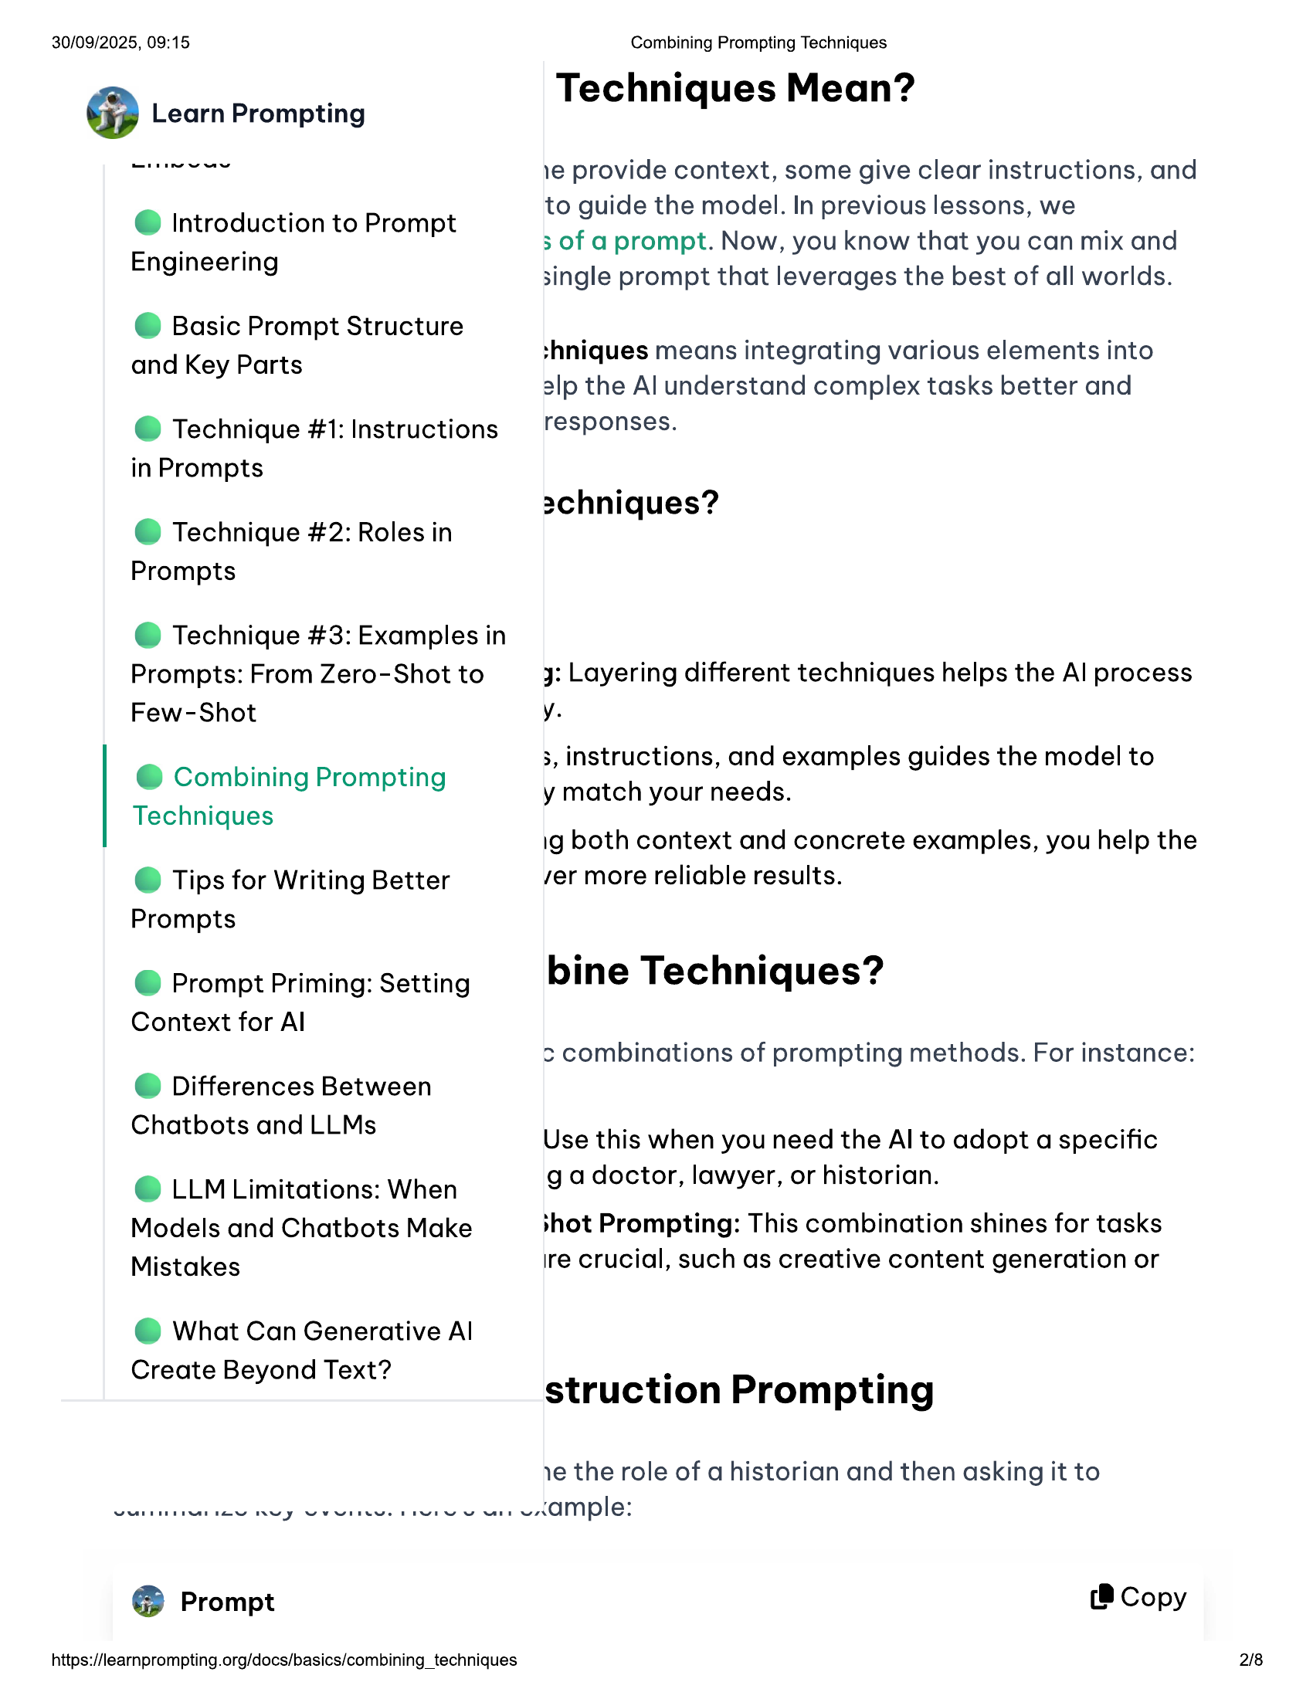

Vee Rey Vere  
  
30/09/2025, 09:15  
  
@ Introduction to Prompt  
Engineering  
  
© Basic Prompt Structure  
and Key Parts  
  
@ Technique #1: Instructions  
in Prompts  
  
@ Technique #2: Roles in  
Prompts  
  
@ Technique #3: Examples in  
  
Prompts: From Zero-Shot to  
Few-Shot  
  
@ Combining Prompting  
Techniques  
  
© Tips for Writing Better  
Prompts  
  
@ Prompt Priming: Setting  
Context for Al  
  
@ Differences Between  
Chatbots and LLMs  
  
© LLM Limitations: When  
Models and Chatbots Make  
Mistakes  
  
@ What Can Generative Al  
Create Beyond Text?  
  
@® Prompt  
  
https://learnprompting.org/docs/basics/combining_techniques  
  
Combining Prompting Techniques  
  
Techniques Mean?  
  
1e provide context, some give clear instructions, and  
to guide the model. In previous lessons, we  
  
3 of a prompt. Now, you know that you can mix and  
single prompt that leverages the best of all worlds.  
  
shniques means integrating various elements into  
alp the Al understand complex tasks better and  
responses.  
  
2chniques?  
  
yj: Layering different techniques helps the Al process  
y.  
  
3, instructions, and examples guides the model to  
  
y match your needs.  
  
ig both context and concrete examples, you help the  
ver more reliable results.  
  
bine Techniques?  
  
> combinations of prompting methods. For instance:  
  
Use this when you need the Al to adopt a specific  
g adoctor, lawyer, or historian.  
  
shot Prompting: This combination shines for tasks  
ire crucial, such as creative content generation or  
  
struction Prompting  
  
ye the role of a historian and then asking it to  
  
were ve eKMple:  
  
(8 Copy  
  
2/8

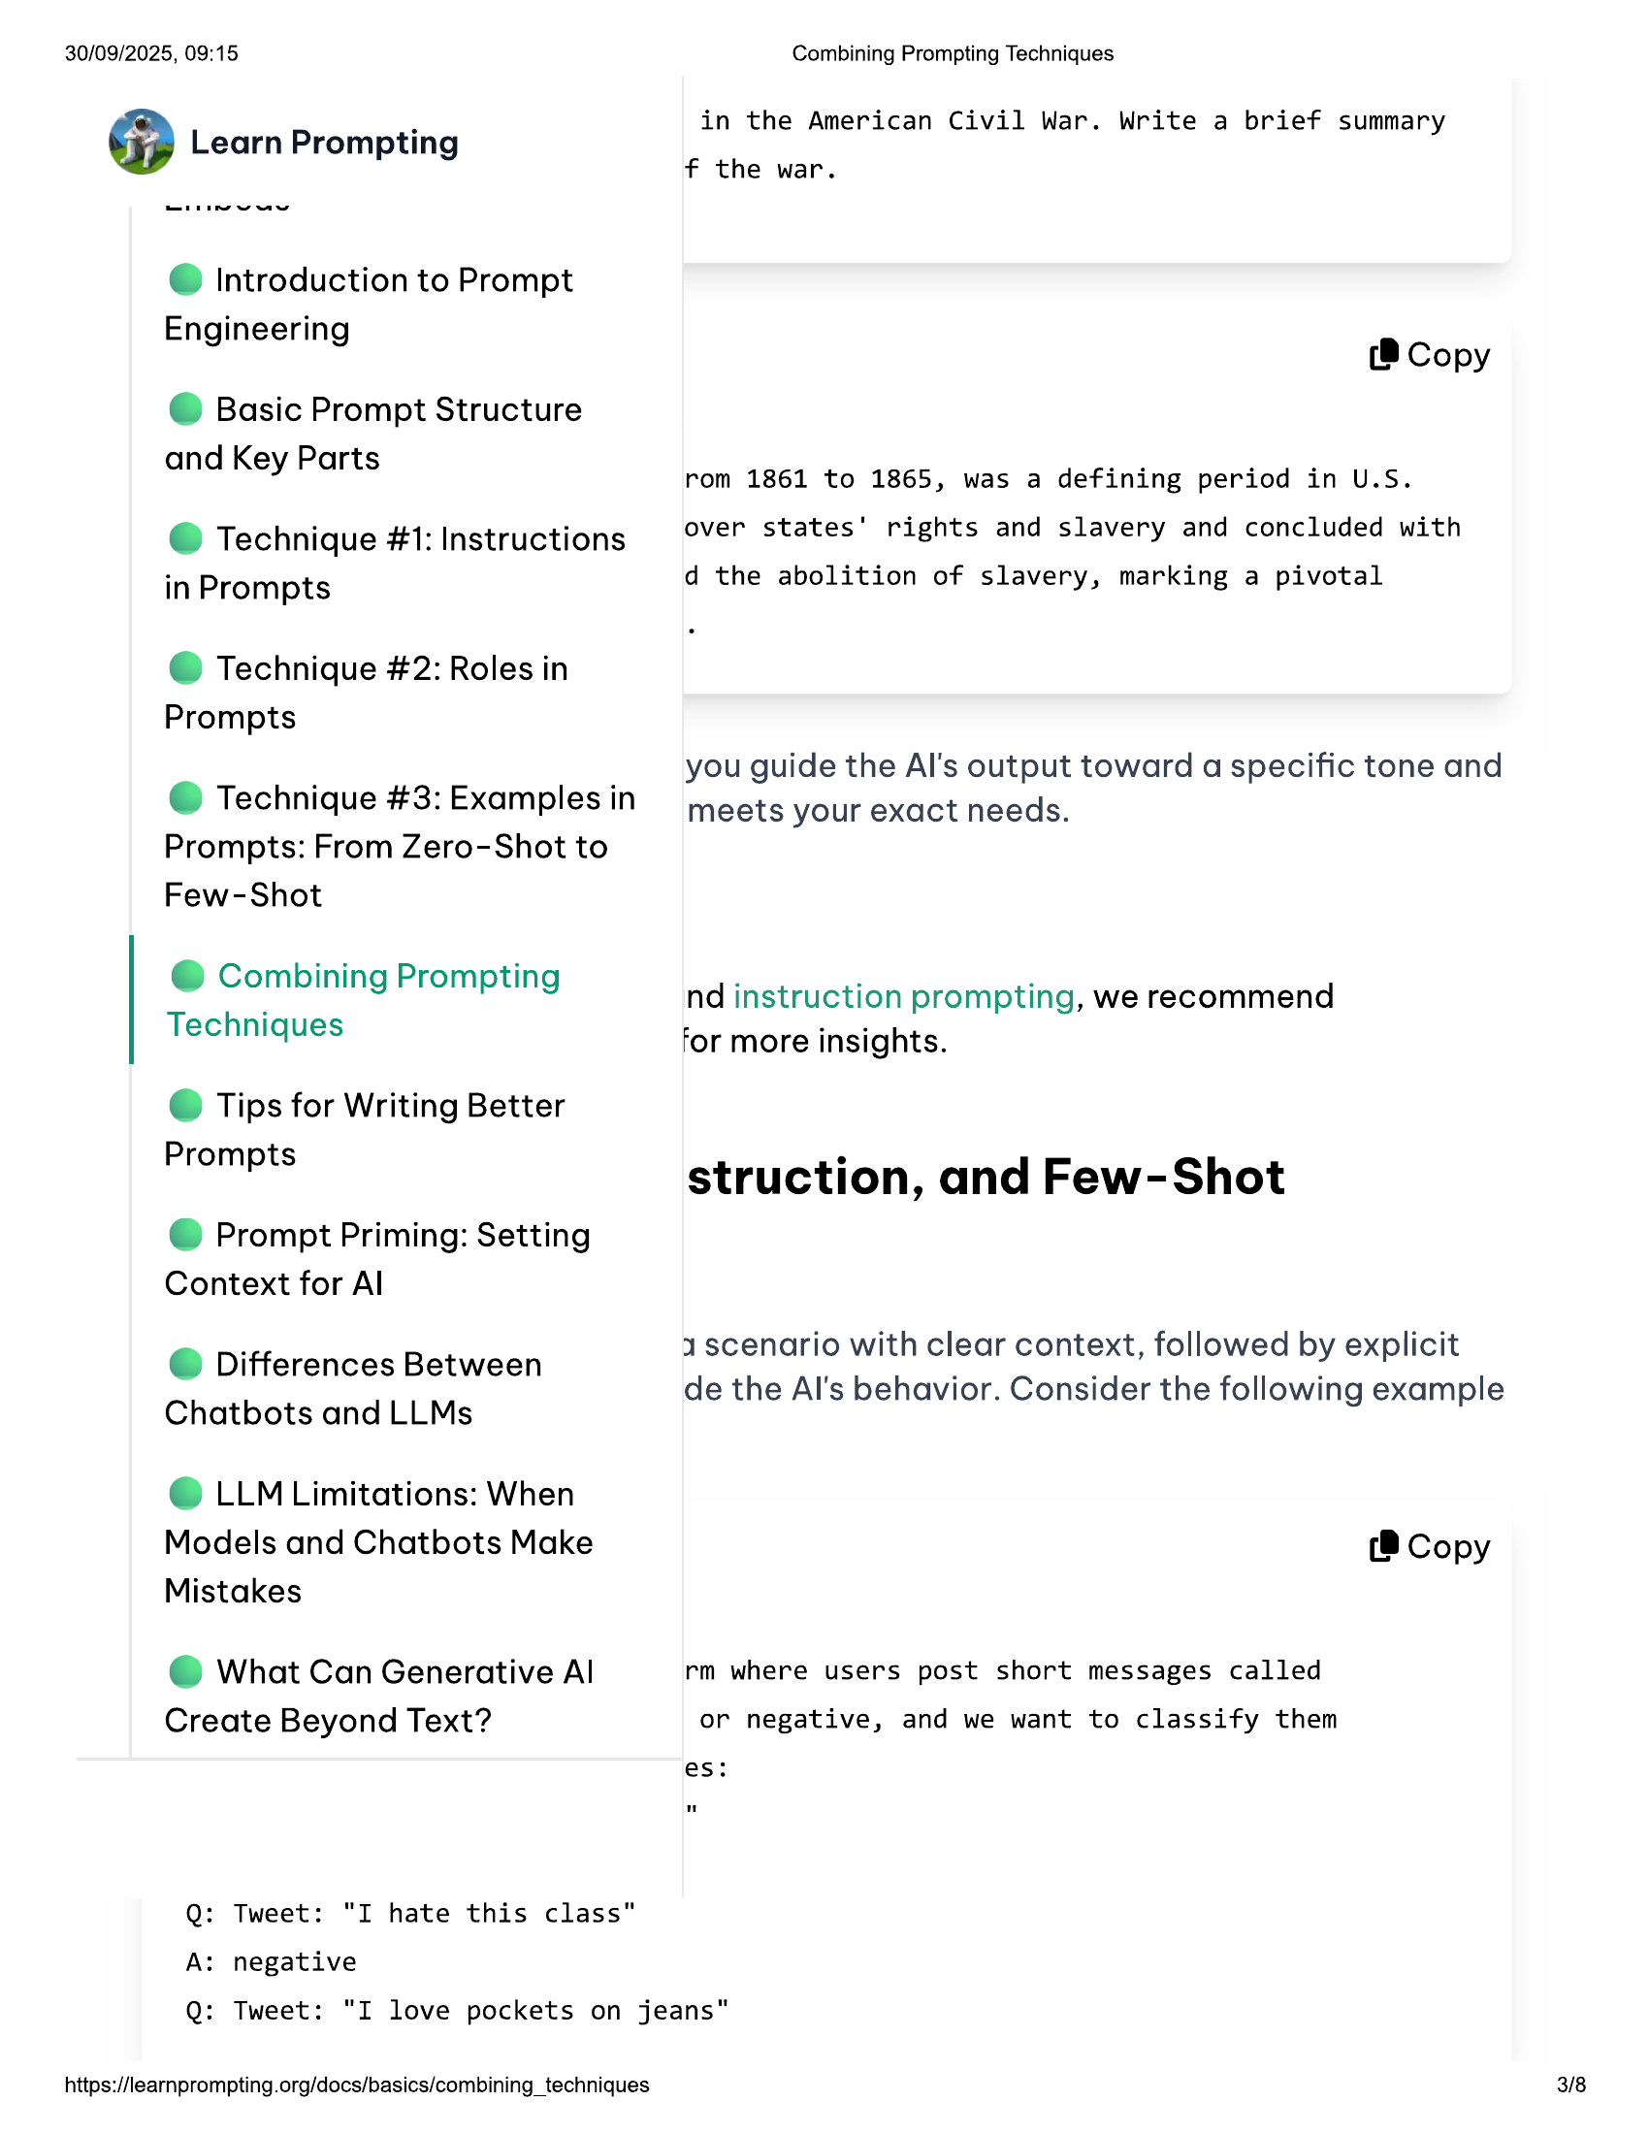

30/09/2025, 09:15 Combining Prompting Techniques  
  
. in the American Civil War. Write a brief summary  
Learn Prompting le th  
e war.  
  
@ Introduction to Prompt  
  
Engineerin  
9 9 (8 Copy  
  
© Basic Prompt Structure  
  
and Key Parts a ta  
y rom 1861 to 1865, was a defining period in U.S.  
  
e@ Technique #1: Instructions over states’ rights and slavery and concluded with  
  
in Prompts d the abolition of slavery, marking a pivotal  
  
@ Technique #2: Roles in  
Prompts  
  
: ; you guide the Al's output toward a specific tone and  
© Technique #3: Examplesin meets your exact needs.  
Prompts: From Zero-Shot to  
  
Few-Shot  
  
@ Combining Prompting  
  
. nd instruction prompting, we recommend  
Techniques  
  
for more insights.  
  
© Tips for Writing Better  
  
Prompts struction, and Few-Shot  
  
@ Prompt Priming: Setting  
Context for Al  
  
1 scenario with clear context, followed by explicit  
  
Differences Between . . :  
e de the Al's behavior. Consider the following example  
  
Chatbots and LLMs  
  
© LLM Limitations: When  
  
Models and Chatbots Make (8 Copy  
Mistakes  
e@ What Can Generative Al rm where users post short messages called  
Create Beyond Text? or negative, and we want to classify them  
es:  
  
Q: Tweet: "I hate this class"  
A: negative  
  
Q: Tweet: "I love pockets on jeans"  
  
https://learnprompting.org/docs/basics/combining_techniques 3/8

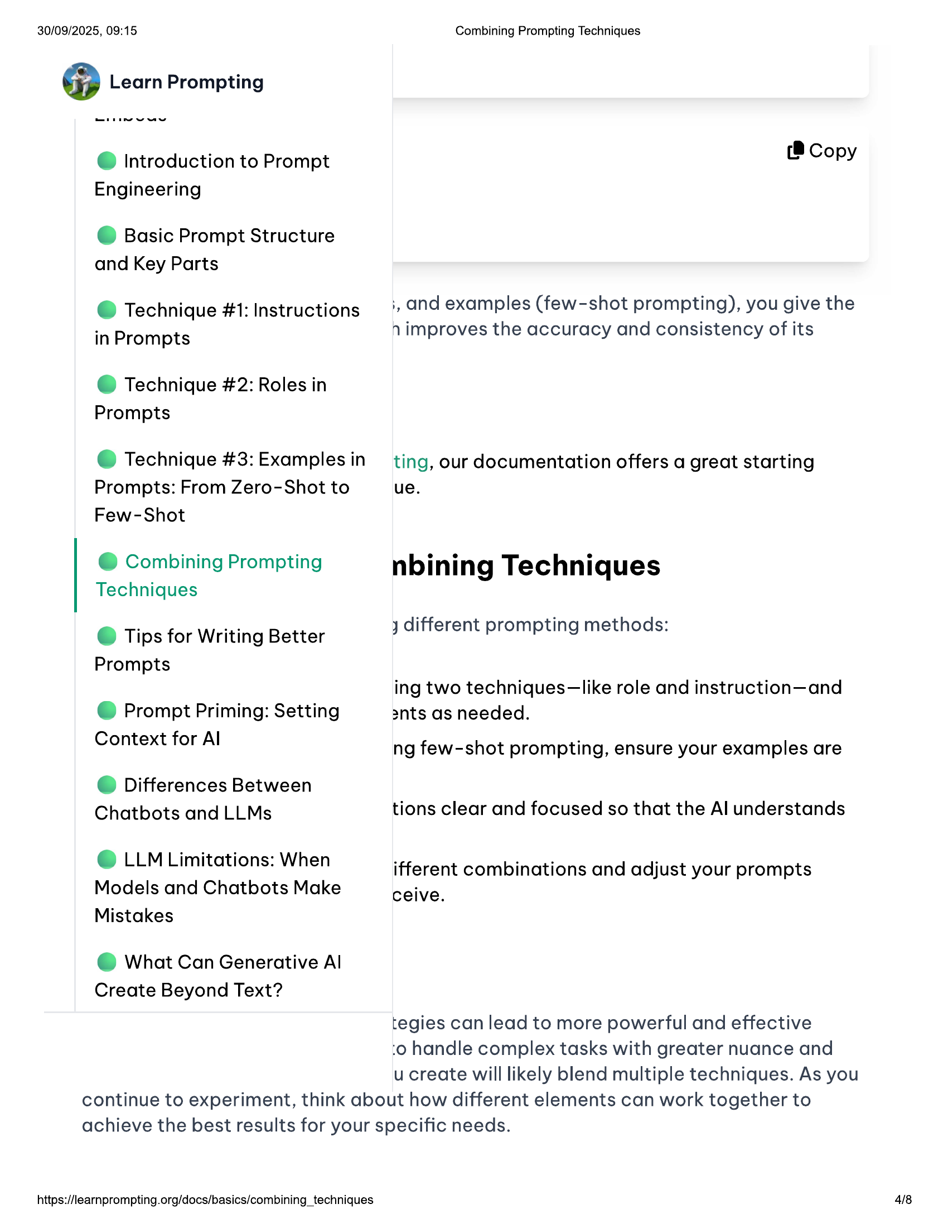

30/09/2025, 09:15  
  
@ Introduction to Prompt  
Engineering  
  
© Basic Prompt Structure  
and Key Parts  
  
@ Technique #1: Instructions  
in Prompts  
  
@ Technique #2: Roles in  
Prompts  
  
@ Technique #3: Examples in  
  
Prompts: From Zero-Shot to  
Few-Shot  
  
@ Combining Prompting  
Techniques  
  
© Tips for Writing Better  
Prompts  
  
@ Prompt Priming: Setting  
Context for Al  
  
@ Differences Between  
Chatbots and LLMs  
  
© LLM Limitations: When  
Models and Chatbots Make  
Mistakes  
  
@ What Can Generative Al  
Create Beyond Text?  
  
Combining Prompting Techniques  
  
(®@ Copy  
  
;, and examples (few-shot prompting), you give the  
n improves the accuracy and consistency of its  
  
ting, our documentation offers a great starting  
ue.  
  
nbining Techniques  
j different prompting methods:  
  
ing two techniques—like role and instruction—and  
ants as needed.  
  
ng few-shot prompting, ensure your examples are  
tions clear and focused so that the Al understands  
  
ifferent combinations and adjust your prompts  
ceive.  
  
tegies can lead to more powerful and effective  
:o handle complex tasks with greater nuance and  
ucreate will likely blend multiple techniques. As you  
  
continue to experiment, think about how different elements can work together to  
achieve the best results for your specific needs.  
  
https://learnprompting.org/docs/basics/combining_techniques 4/8

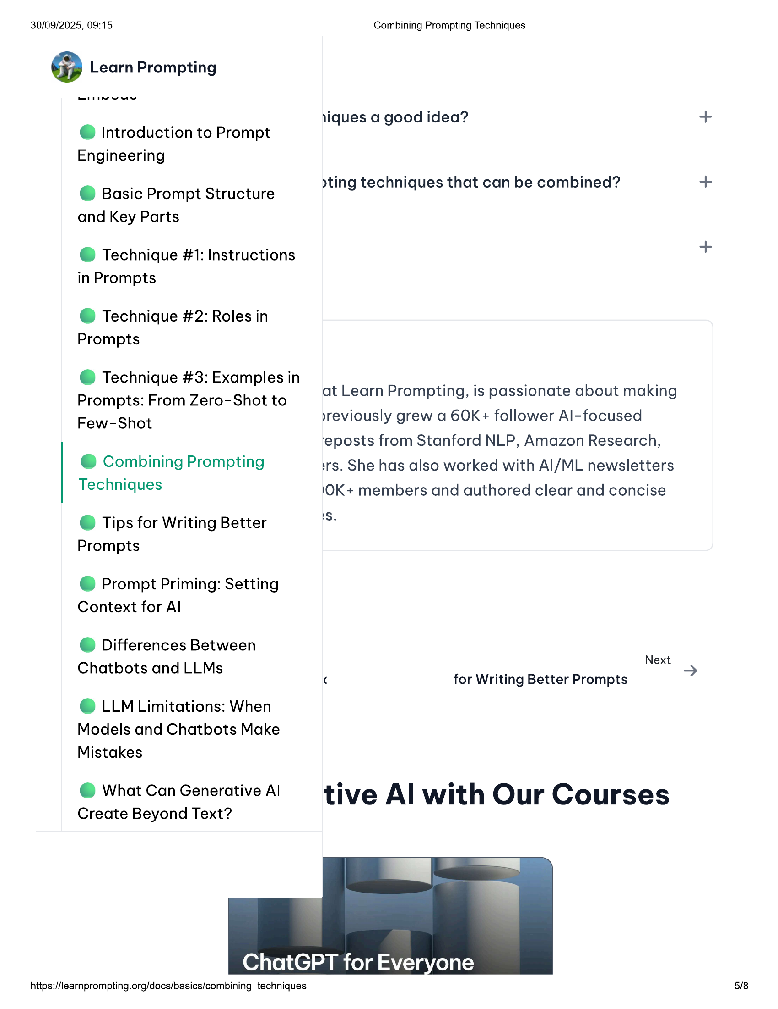

30/09/2025, 09:15 Combining Prompting Techniques  
  
@ Learn Prompting  
  
liques a good idea? +  
@ Introduction to Prompt  
Engineering  
@ Basic Prompt Structure yting techniques that can be combined? +  
and Key Parts  
+  
  
@ Technique #1: Instructions  
in Prompts  
  
@ Technique #2: Roles in  
Prompts  
  
@ Technique #3: Examples in  
  
Prompts: From Zero-Shot to at Learn Prompting, is passionate about making  
  
»yreviously grew a 60K+ follower Al-focused  
  
Few-Shot  
‘eposts from Stanford NLP, Amazon Research,  
@ Combining Prompting irs. She has also worked with Al/ML newsletters  
Techniques 1OK+ members and authored clear and concise  
© Tips for Writing Better fs  
Prompts  
@ Prompt Priming: Setting  
Context for Al  
© Differences Between  
Chatbots and LLMs _ Next  
¢ for Writing Better Prompts  
  
© LLM Limitations: When  
Models and Chatbots Make  
Mistakes  
  
@ What CanGenerativeAl tive Al with Our Courses  
  
Create Beyond Text?  
  
ChatGPT for Ever  
  
https://learnprompting.org/docs/basics/combining_techniques 5/8

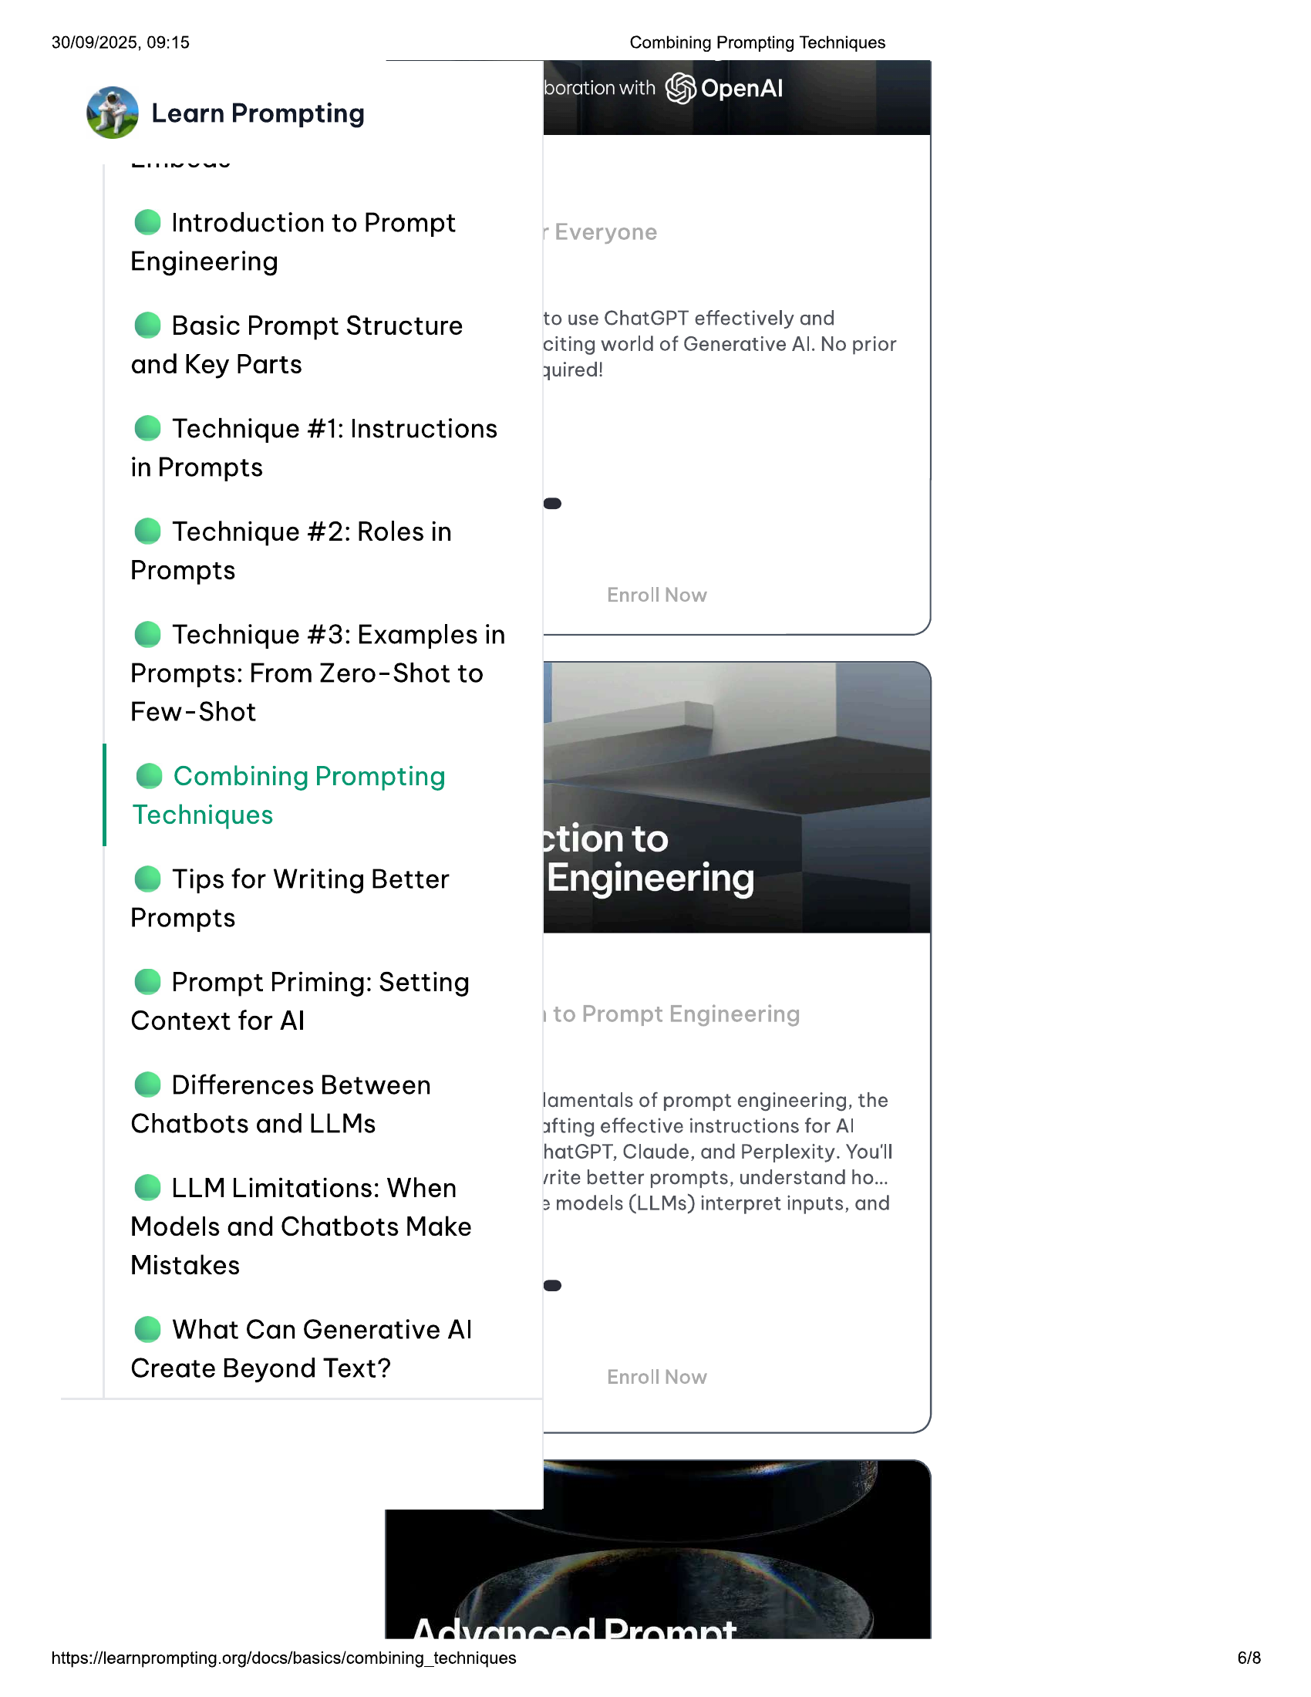

30/09/2025, 09:15  
  
lboration with G Openal  
@ Learn Prompting  
  
@ Introduction to Prompt  
Engineering  
  
© Basic Prompt Structure  
and Key Parts  
  
@ Technique #1: Instructions  
in Prompts  
  
@ Technique #2: Roles in  
Prompts  
  
@ Technique #3: Examples in  
Prompts: From Zero-Shot to  
Few-Shot  
  
@ Combining Prompting  
Techniques  
  
© Tips for Writing Better  
Prompts  
  
@ Prompt Priming: Setting  
Context for Al  
  
@ Differences Between  
Chatbots and LLMs  
  
© LLM Limitations: When  
Models and Chatbots Make  
Mistakes  
  
@ What Can Generative Al  
Create Beyond Text?  
  
https://learnprompting.org/docs/basics/combining_techniques  
  
Combining Prompting Techniques  
  
to use ChatGPT effectively and  
citing world of Generative Al. No prior  
quired!  
  
lamentals of prompt engineering, the  
afting effective instructions for Al  
  
hatGPT, Claude, and Perplexity. You'll  
rrite better prompts, understand ho...  
2 models (LLMs) interpret inputs, and  
  
6/8

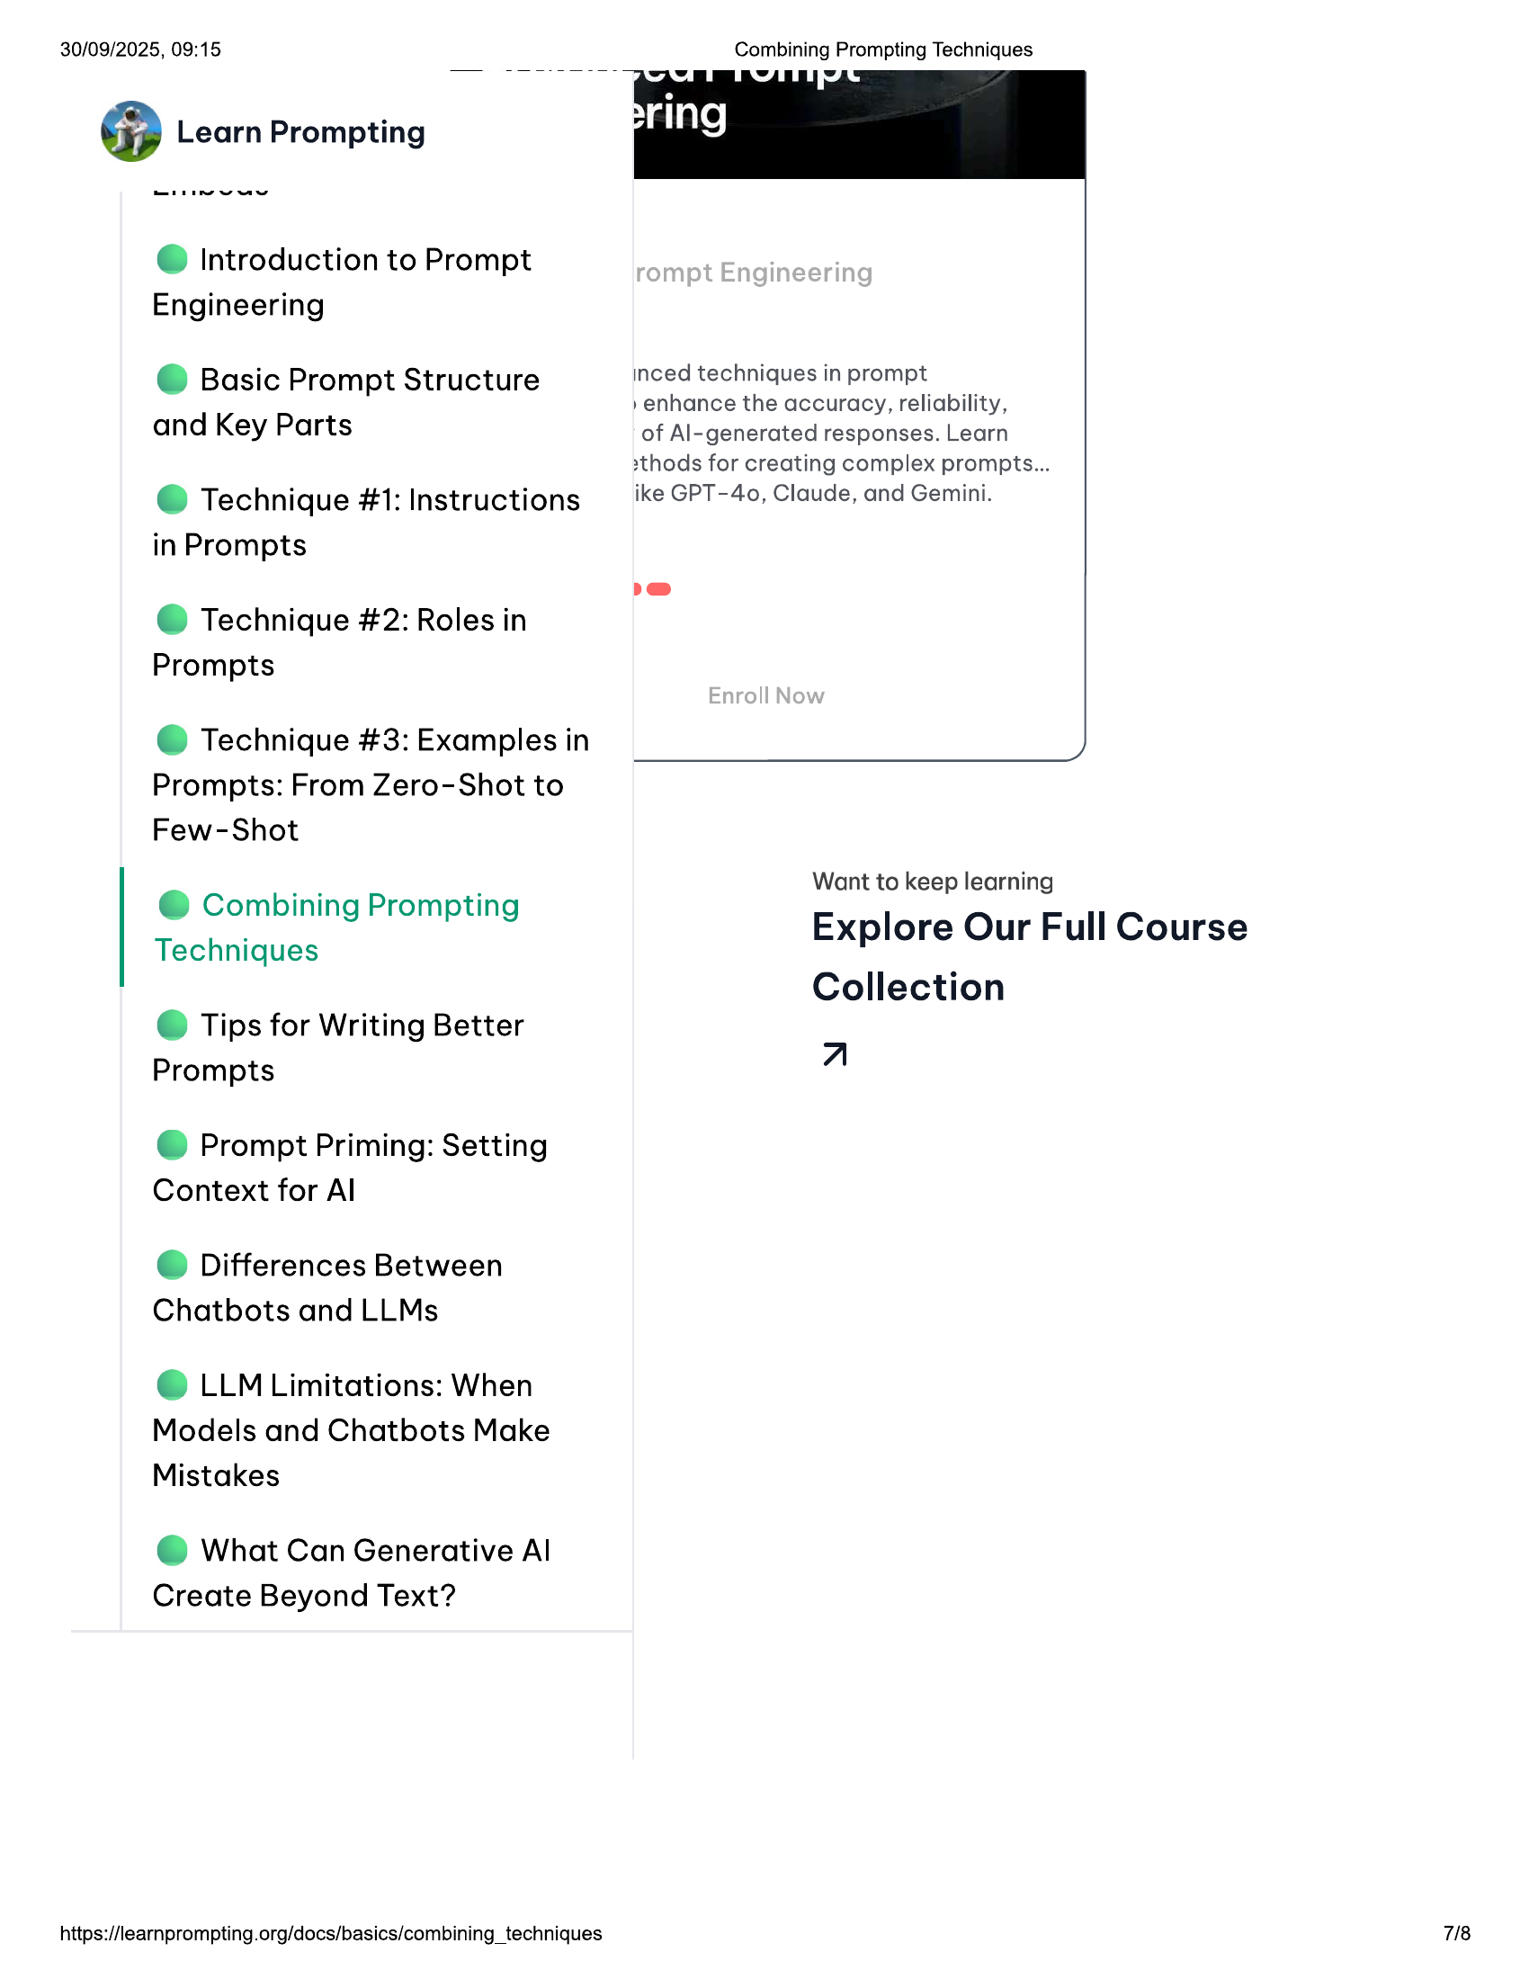

30/09/2025, 09:15 Combining Prompting Techniques  
  
@ Introduction to Prompt  
  
Engineering  
  
e@ Basic Prompt Structure inced techniques in prompt  
»enhance the accuracy, reliability,  
  
and Key Parts of Al-generated responses. Learn  
  
2thods for creating complex prompts...  
e@ Technique #1: Instructions ike GPT-40, Claude, and Gemini.  
  
in Prompts  
  
@ Technique #2: Roles in  
Prompts  
  
@ Technique #3: Examples in  
Prompts: From Zero-Shot to  
  
Few-Shot  
Want to keep learning  
  
Combining Promptin  
be g pang Explore Our Full Course  
  
Techniques  
Collection  
© Tips for Writing Better  
  
Prompts a  
  
@ Prompt Priming: Setting  
Context for Al  
  
© Differences Between  
Chatbots and LLMs  
  
© LLM Limitations: When  
Models and Chatbots Make  
Mistakes  
  
@ What Can Generative Al  
Create Beyond Text?  
  
https://learnprompting.org/docs/basics/combining_techniques

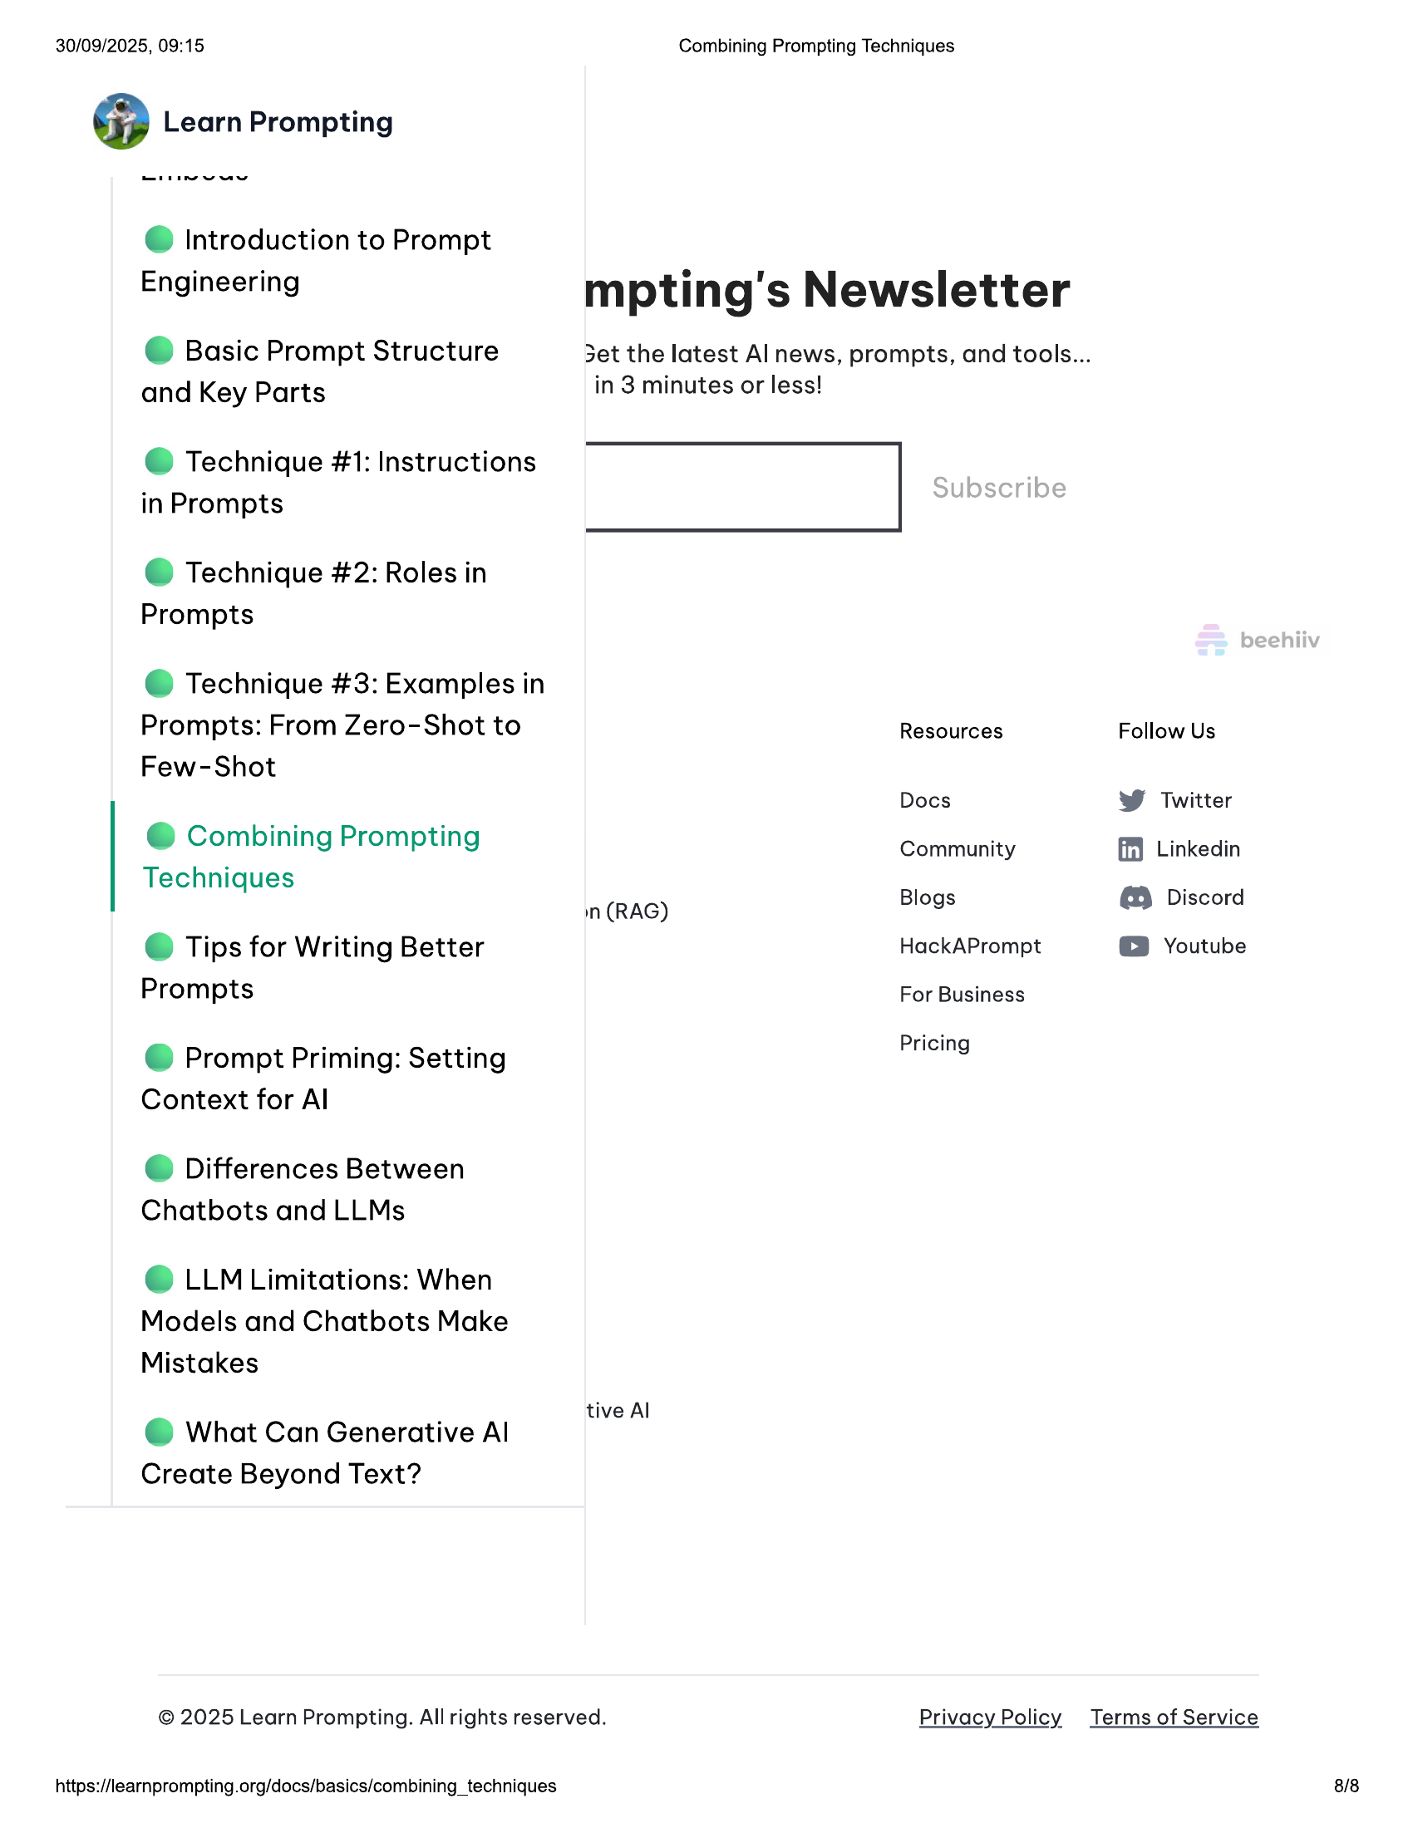

30/09/2025, 09:15 Combining Prompting Techniques  
  
@ Introduction to Prompt  
  
. . e ii  
  
Engineering mpting's Newsletter  
© Basic Prompt Structure Set the latest Al news, prompts, and tools...  
and Key Parts in 3 minutes or less!  
  
@ Technique #1: Instructions  
in Prompts  
  
@ Technique #2: Roles in  
Prompts  
  
@ Technique #3: Examples in  
  
Prompts: From Zero-Shot to Resources Follow Us  
Few-Shot  
Docs W Twitter  
  
@ Combining Prompting Community ff) Linkedin  
Techniques  
  
q n (RAG) Blogs @ Discord  
© Tips for Writing Better HackAPrompt © Youtube  
Prompts For Business  
@ Prompt Priming: Setting Pricing  
Context for Al  
© Differences Between  
Chatbots and LLMs  
© LLM Limitations: When  
Models and Chatbots Make  
Mistakes  
  
. tive Al  
@ What Can Generative Al  
Create Beyond Text?  
© 2025 Learn Prompting. All rights reserved. Privacy Policy Terms of Service  
  
https://learnprompting.org/docs/basics/combining_techniques  
  
8/8