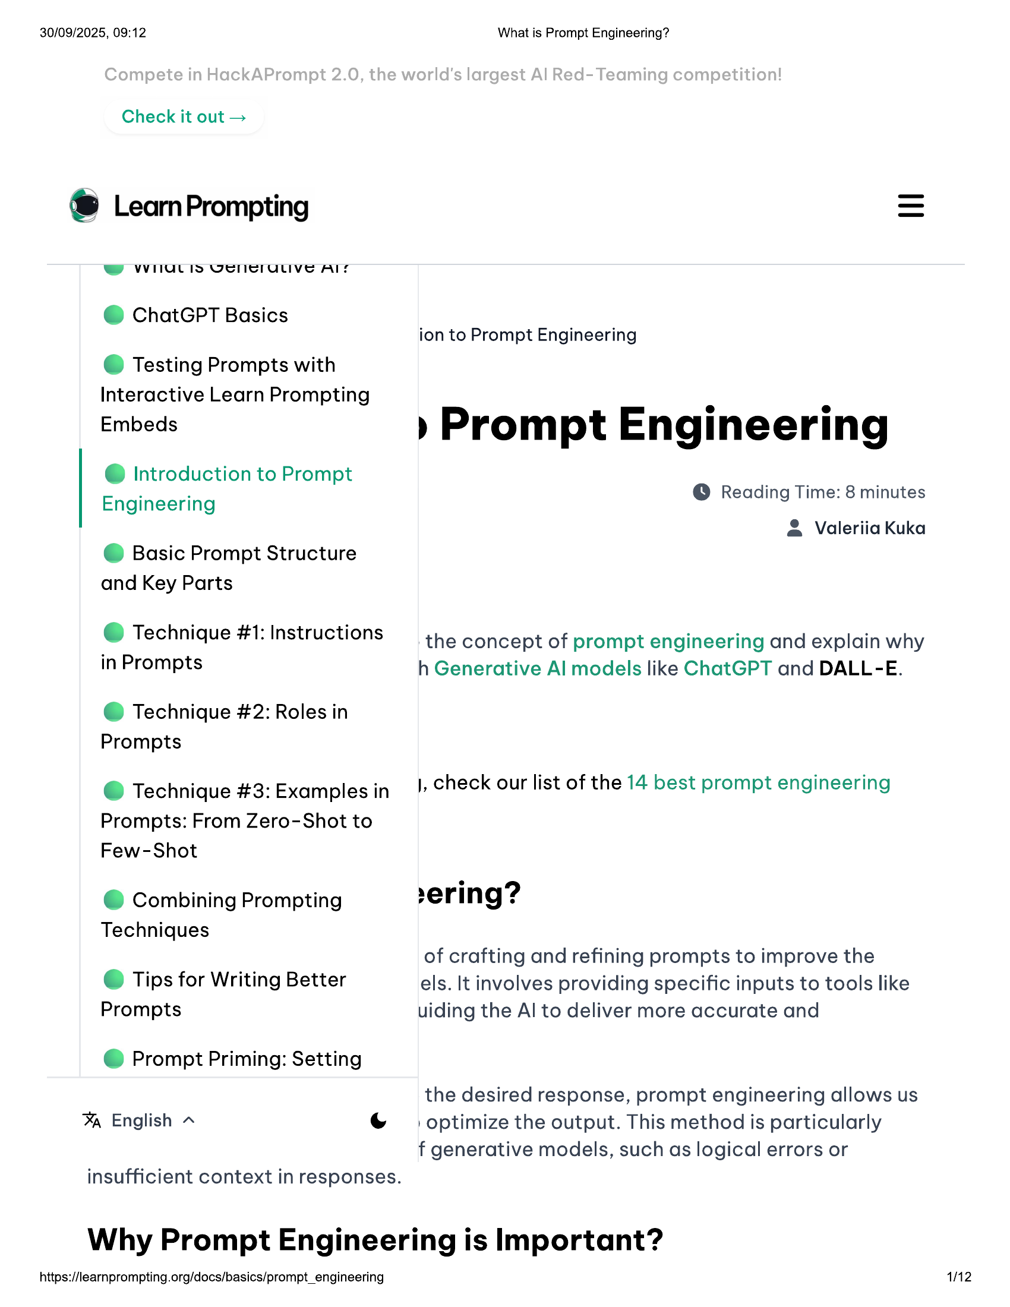

30/09/2025, 09:12  
  
Check it out >  
  
® LearnPrompting  
W WHIULIS VEIMCIULIVe AIS  
@ ChatGPT Basics  
  
© Testing Prompts with  
Interactive Learn Prompting  
Embeds  
  
@ Introduction to Prompt  
Engineering  
  
@ Basic Prompt Structure  
and Key Parts  
  
@ Technique #1: Instructions  
in Prompts  
  
@ Technique #2: Roles in  
Prompts  
  
@ Technique #3: Examples in  
  
Prompts: From Zero-Shot to  
Few-Shot  
  
© Combining Prompting  
Techniques  
  
© Tips for Writing Better  
Prompts  
  
@ Prompt Priming: Setting  
  
% English ~ (Ss  
  
insufficient context in responses.  
  
What is Prompt Engineering?  
  
ion to Prompt Engineering  
  
» Prompt Engineering  
  
@ Reading Time: 8 minutes  
  
& Valeriia Kuka  
  
the concept of prompt engineering and explain why  
h Generative Al models like ChatGPT and DALL-E.  
  
), check our list of the 14 best prompt engineering  
  
ering?  
  
of crafting and refining prompts to improve the  
els. It involves providing specific inputs to tools like  
uiding the Al to deliver more accurate and  
  
the desired response, prompt engineering allows us  
optimize the output. This method is particularly  
f generative models, such as logical errors or  
  
Why Prompt Engineering is Important?  
  
https://learnprompting.org/docs/basics/prompt_engineering  
  
12

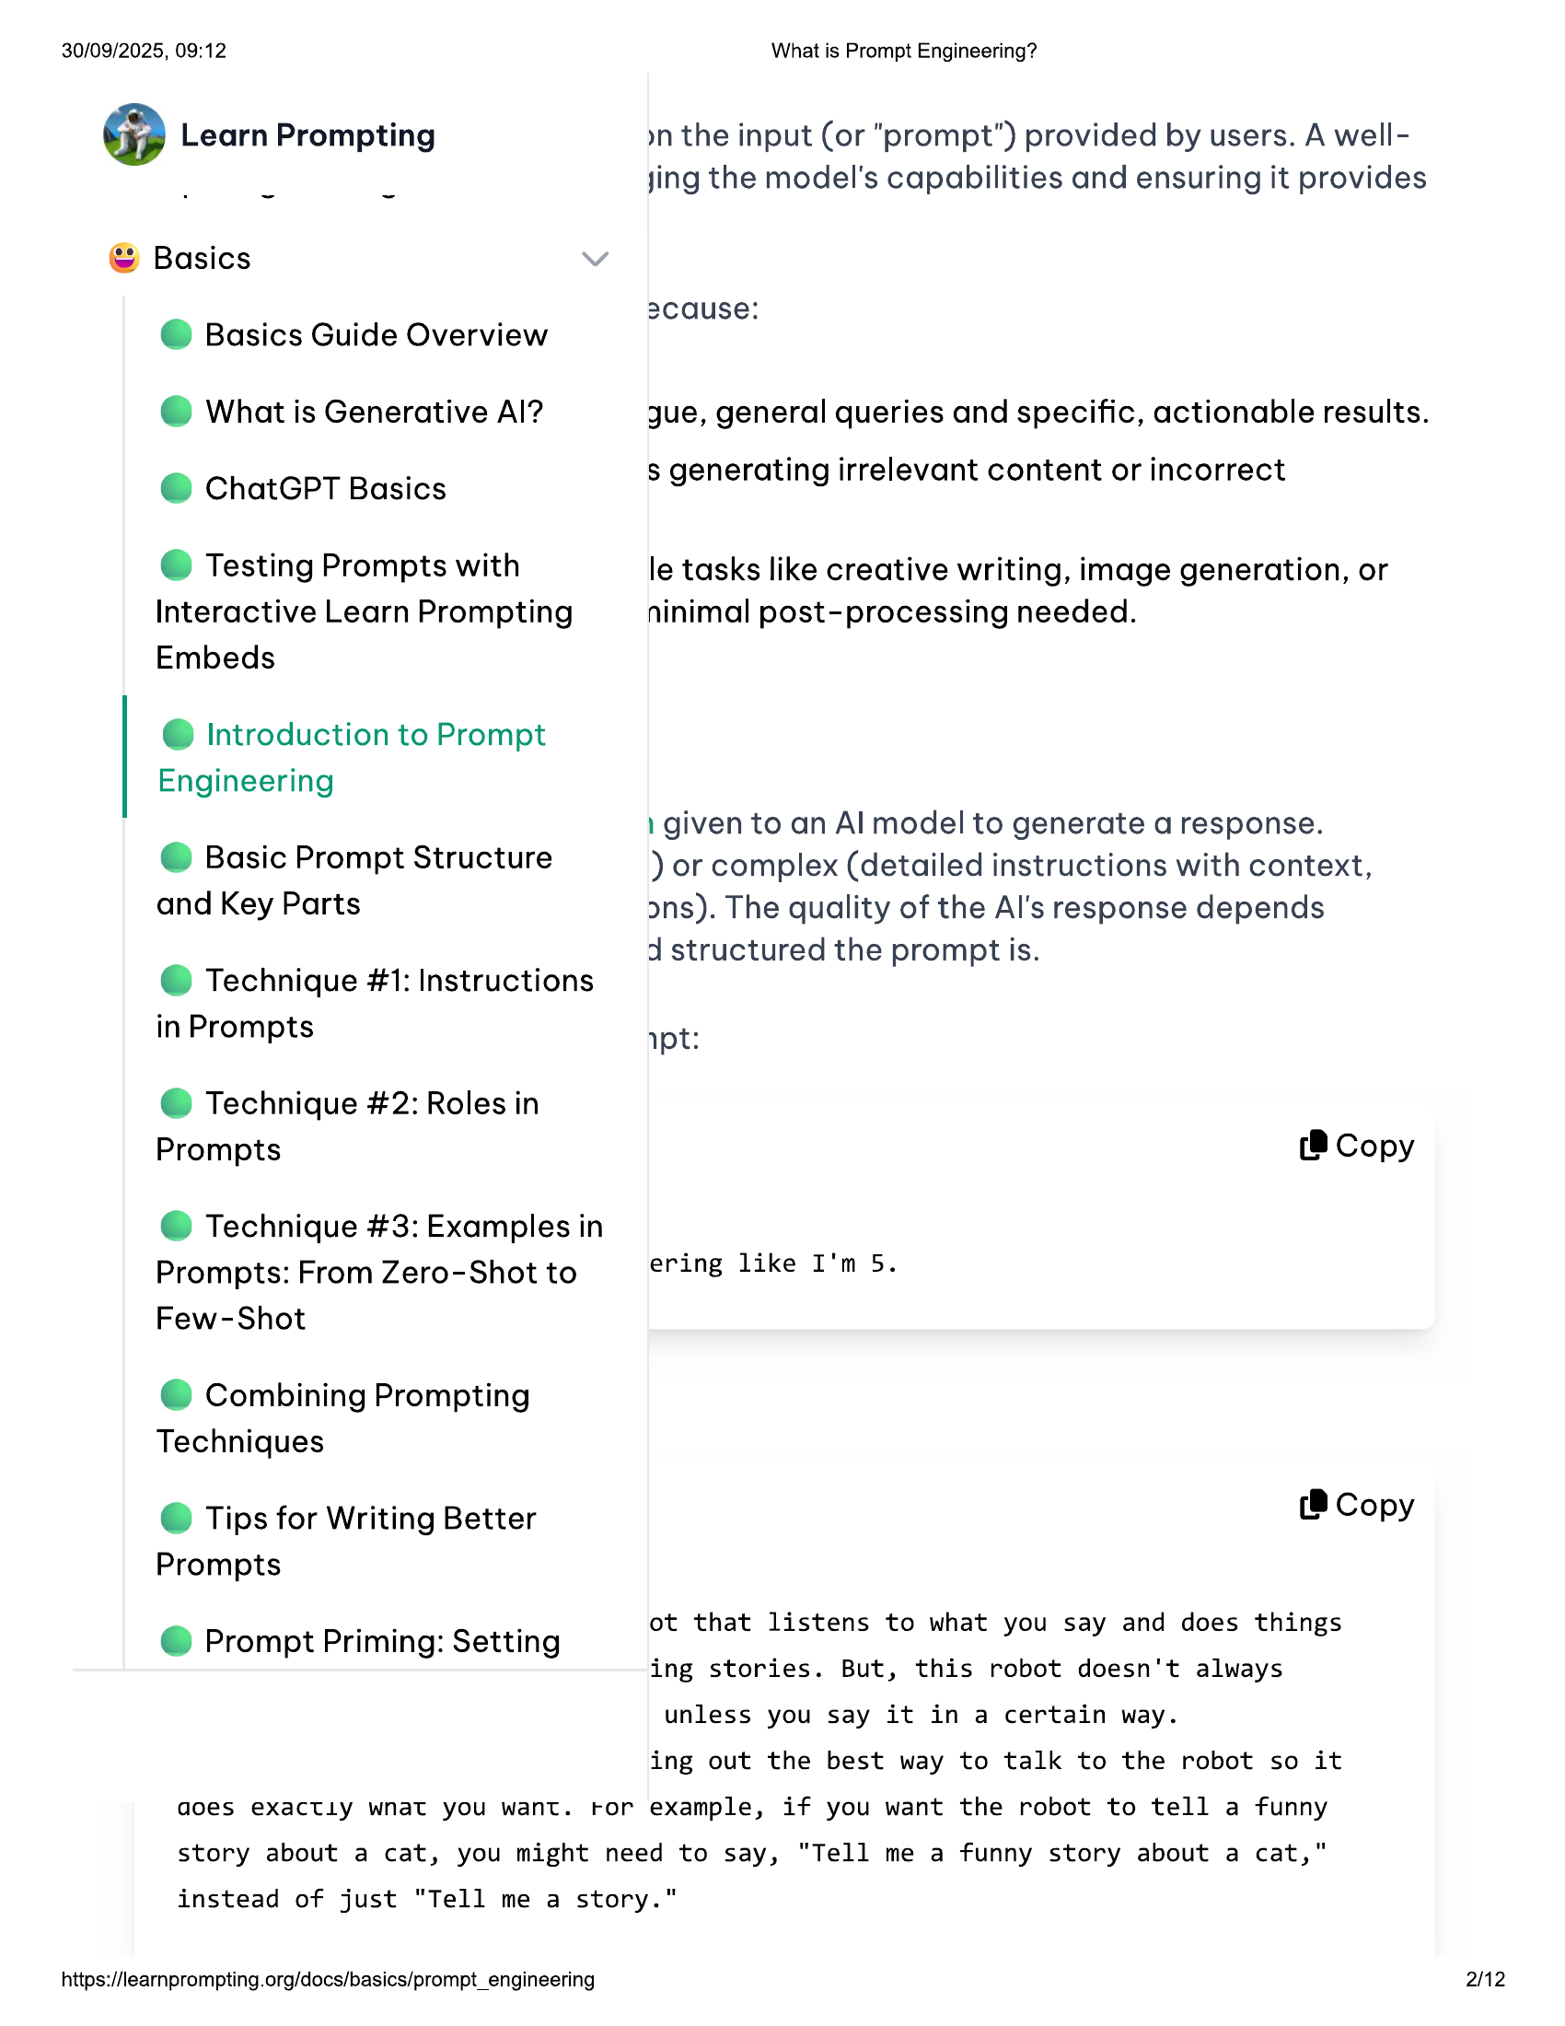

30/09/2025, 09:12  
  
@ Learn Prompting  
  
© Basics  
@ Basics Guide Overview  
@ What is Generative Al?  
@ ChatGPT Basics  
  
© Testing Prompts with  
Interactive Learn Prompting  
Embeds  
  
@ Introduction to Prompt  
Engineering  
  
@ Basic Prompt Structure  
and Key Parts  
  
@ Technique #1: Instructions  
in Prompts  
  
@ Technique #2: Roles in  
Prompts  
  
@ Technique #3: Examples in  
Prompts: From Zero-Shot to  
Few-Shot  
  
© Combining Prompting  
Techniques  
  
© Tips for Writing Better  
Prompts  
  
@ Prompt Priming: Setting  
  
What is Prompt Engineering?  
  
yn the input (or "prompt") provided by users. A well-  
jing the model's capabilities and ensuring it provides  
  
2cause:  
  
jue, general queries and specific, actionable results.  
  
$ generating irrelevant content or incorrect  
  
le tasks like creative writing, image generation, or  
ninimal post-processing needed.  
  
1 given to an Al model to generate a response.  
  
) or complex (detailed instructions with context,  
ons). The quality of the Al's response depends  
  
d structured the prompt is.  
  
ypt:  
  
(® Copy  
  
ering like I'm 5.  
  
(8 Copy  
  
ot that listens to what you say and does things  
ing stories. But, this robot doesn't always  
unless you say it in a certain way.  
  
ing out the best way to talk to the robot so it  
  
goes exactly wnat you want. ror example, if you want the robot to tell a funny  
  
story about a cat, you might need to say, "Tell me a funny story about a cat,"  
  
instead of just "Tell me a story."  
  
https://learnprompting.org/docs/basics/prompt_engineering  
  
2/12

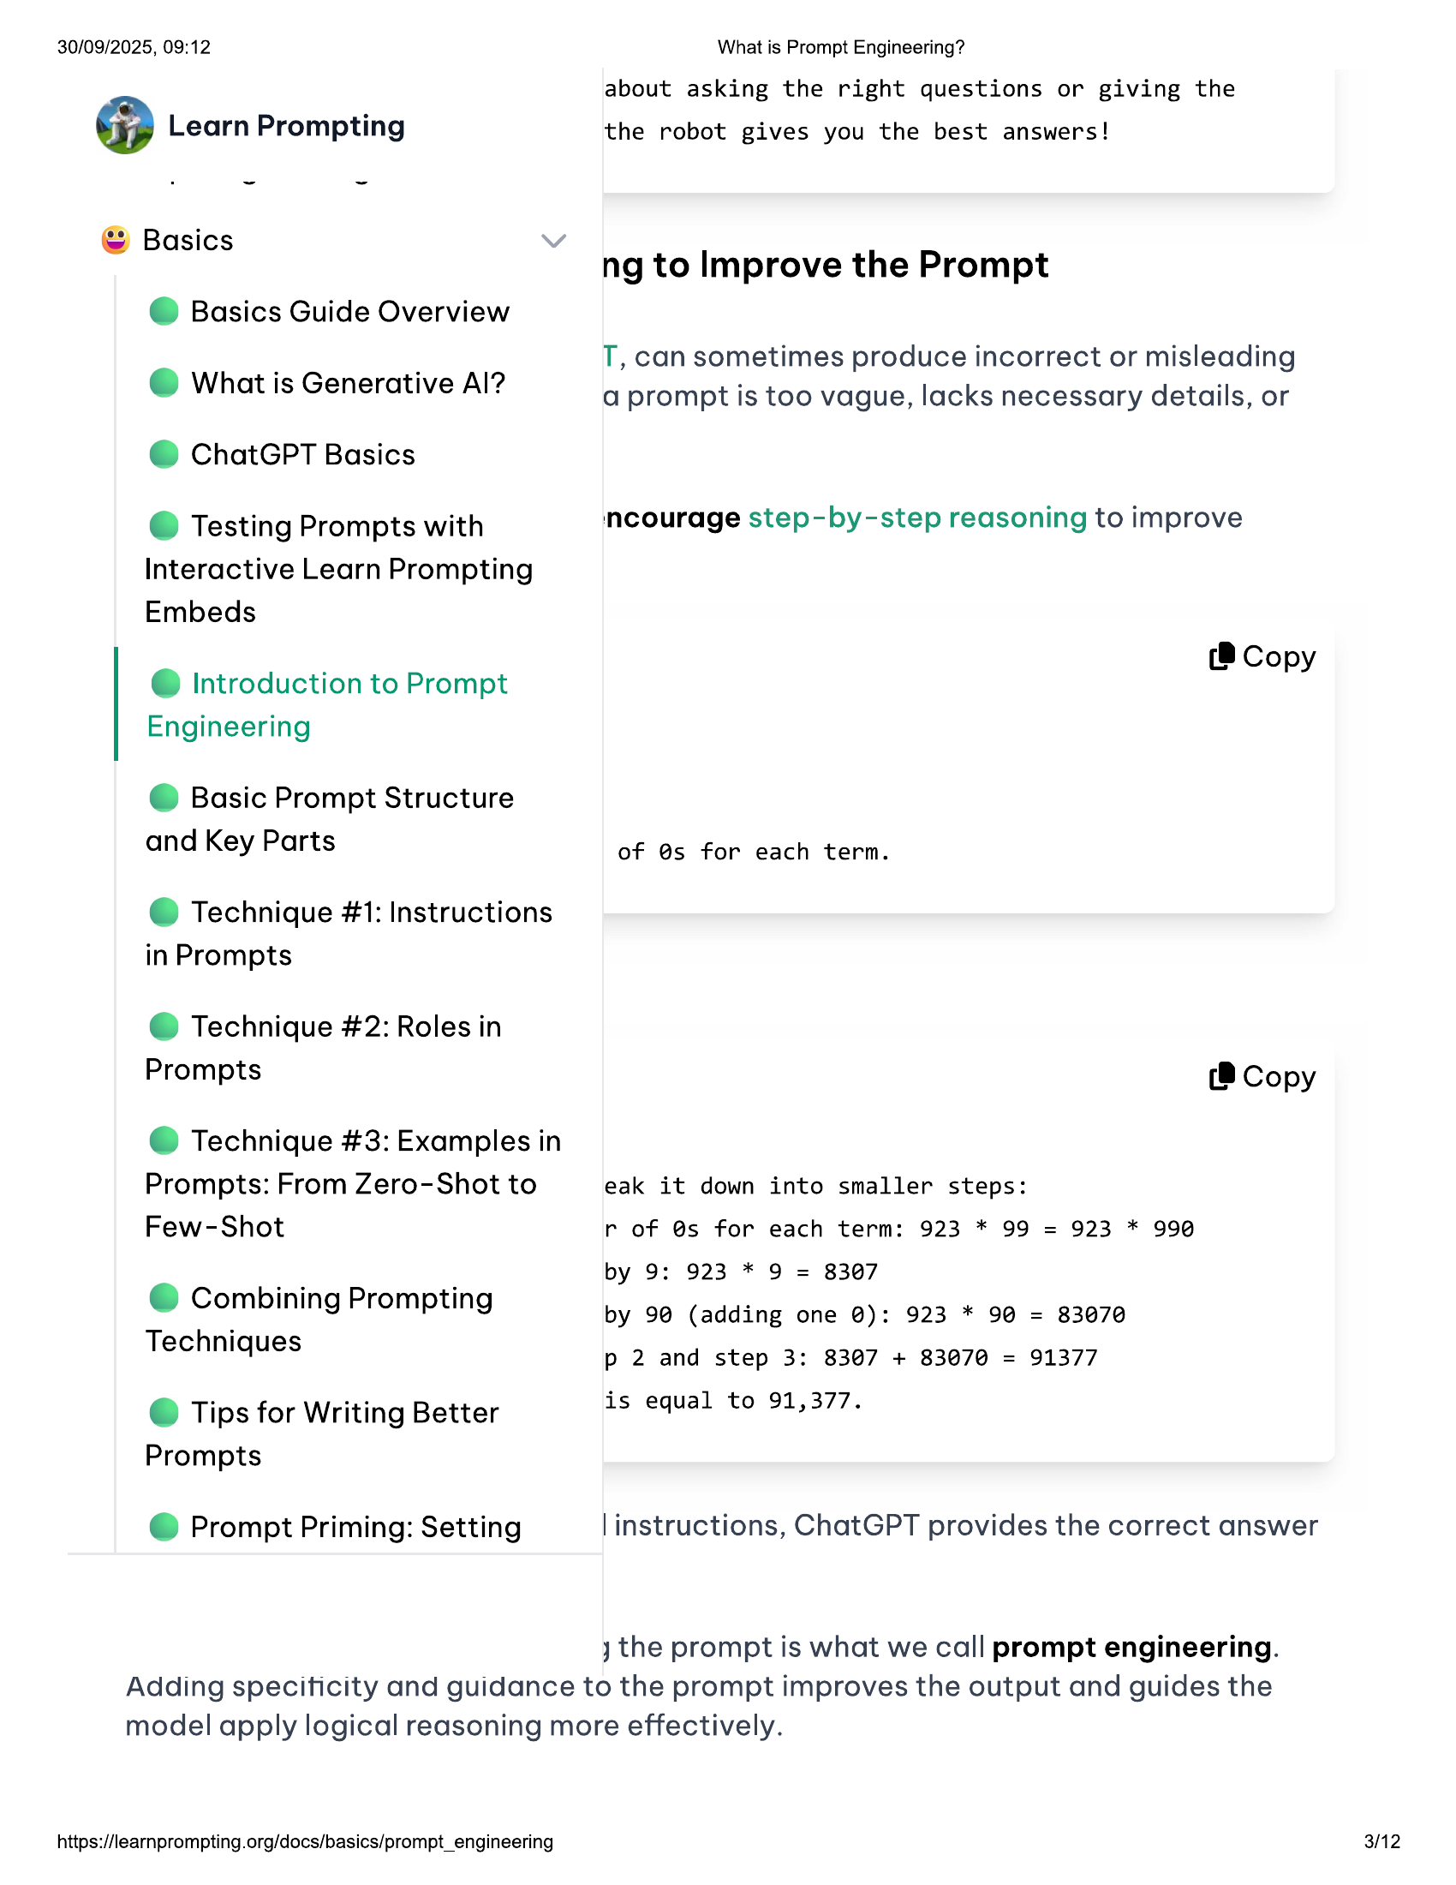

30/09/2025, 09:12 What is Prompt Engineering?  
about asking the right questions or giving the  
@ Learn Prompting the robot gives you the best answers!  
  
© Basics  
ng to Improve the Prompt  
  
@ Basics Guide Overview  
T, can sometimes produce incorrect or misleading  
  
i i 2 . .  
@ What is Generative Al? a prompt is too vague, lacks necessary details, or  
  
@ ChatGPT Basics  
  
@ Testing Prompts with ncourage step-by-step reasoning to improve  
Interactive Learn Prompting  
Embeds  
  
(8 Copy  
  
@ Introduction to Prompt  
Engineering  
  
@ Basic Prompt Structure  
and Key Parts  
  
of @s for each term.  
  
@ Technique #1: Instructions  
in Prompts  
  
@ Technique #2: Roles in  
  
Prompts (8 Copy  
@ Technique #3: Examples in  
  
Prompts: From Zero-Shot to eak it down into smaller steps:  
  
Few-Shot r of @s for each term: 923 * 99 = 923 * 990  
  
by 9: 923 * 9 = 8307  
  
© Combining Prompting by 9@ (adding one @): 923 * 90 = 83070  
  
Techniques p 2 and step 3: 8307 + 83070 = 91377  
  
© Tips for Writing Better is equal to 91,377.  
  
Prompts  
  
@ Prompt Priming: Setting |instructions, ChatGPT provides the correct answer  
  
jy the prompt is what we call prompt engineering.  
Adding speciticity and guidance to the prompt improves the output and guides the  
model apply logical reasoning more effectively.  
  
https://learnprompting.org/docs/basics/prompt_engineering 3/12

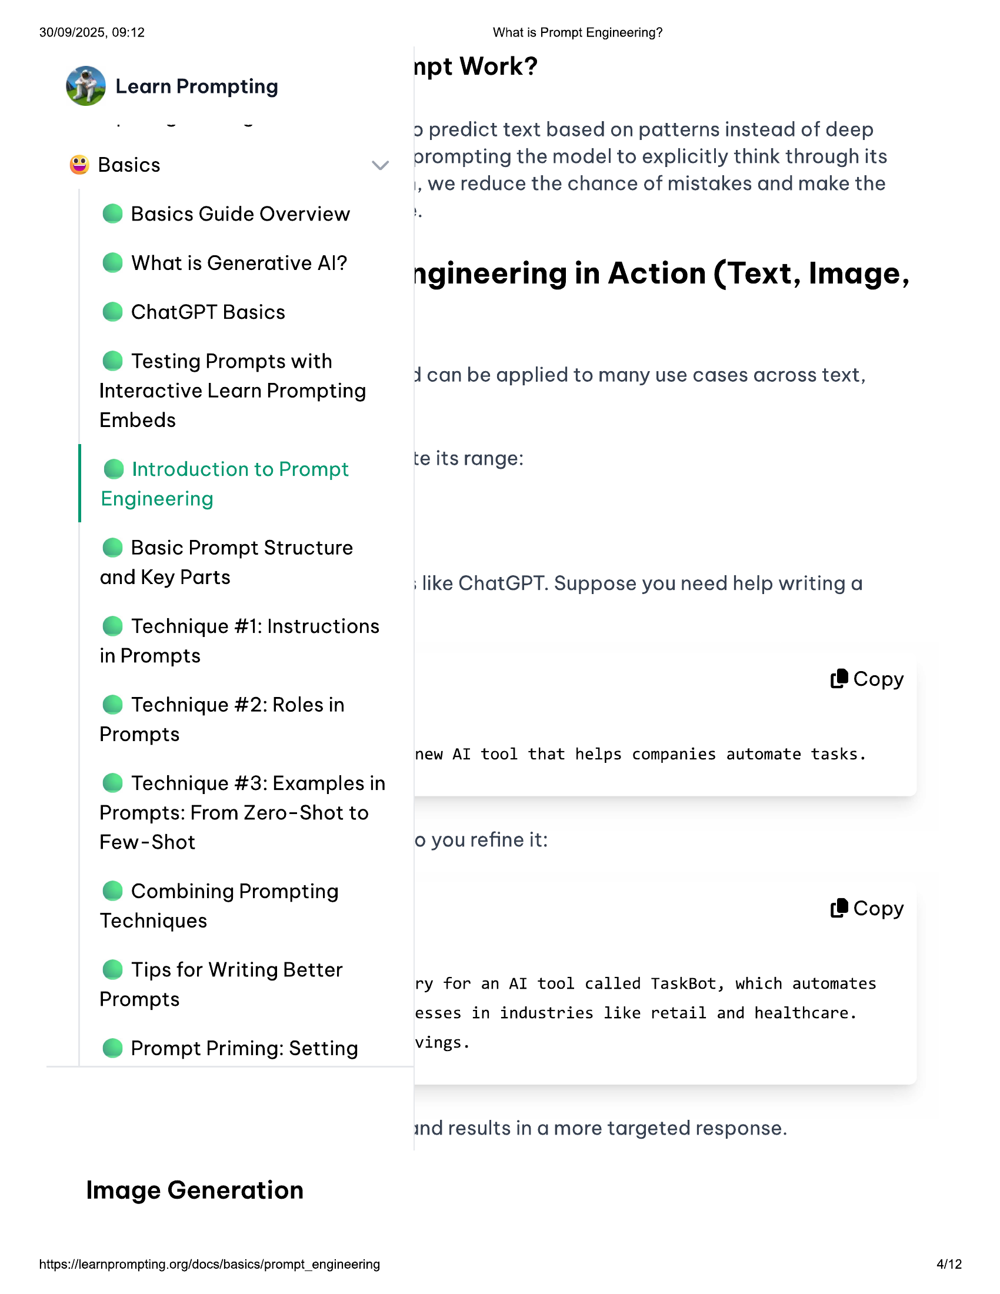

30/09/2025, 09:12  
  
@ Learn Prompting  
  
© Basics  
  
@ Basics Guide Overview  
@ What is Generative Al?  
@ ChatGPT Basics  
  
© Testing Prompts with  
Interactive Learn Prompting  
Embeds  
  
@ Introduction to Prompt  
Engineering  
  
© Basic Prompt Structure  
and Key Parts  
  
@ Technique #1: Instructions  
in Prompts  
  
@ Technique #2: Roles in  
Prompts  
  
@ Technique #3: Examples in  
Prompts: From Zero-Shot to  
Few-Shot  
  
© Combining Prompting  
Techniques  
  
© Tips for Writing Better  
Prompts  
  
@ Prompt Priming: Setting  
  
Image Generation  
  
https://learnprompting.org/docs/basics/prompt_engineering  
  
What is Prompt Engineering?  
  
npt Work?  
  
2 predict text based on patterns instead of deep  
orompting the model to explicitly think through its  
|, we reduce the chance of mistakes and make the  
  
ngineering in Action (Text, Image,  
ican be applied to many use cases across text,  
  
te its range:  
  
: like ChatGPT. Suppose you need help writing a  
  
(8 Copy  
  
new AI tool that helps companies automate tasks.  
  
o you refine it:  
(8 Copy  
  
ry for an AI tool called TaskBot, which automates  
esses in industries like retail and healthcare.  
  
vings.  
  
ind results in a more targeted response.  
  
42

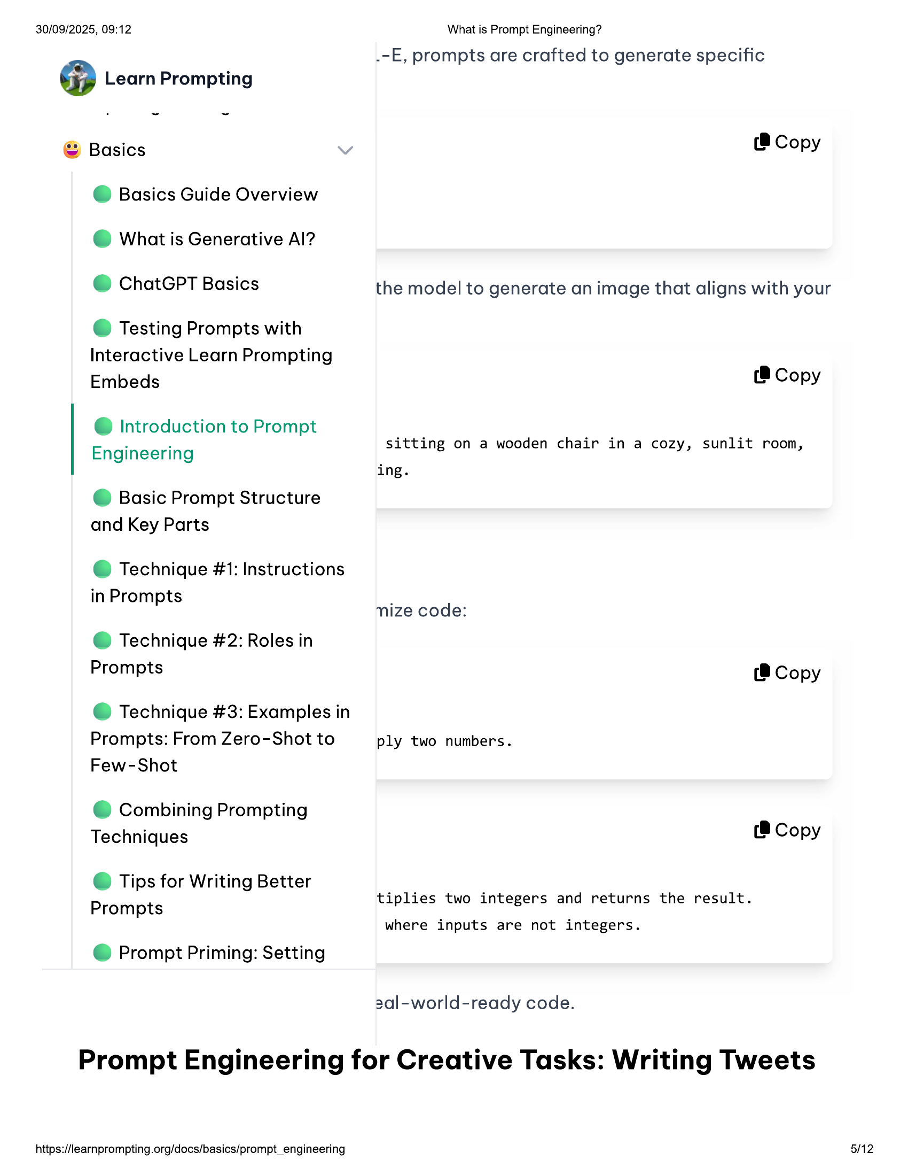

30/09/2025, 09:12 What is Prompt Engineering?  
  
.-E, prompts are crafted to generate specific  
@ Learn Prompting  
  
© Basics (®8 Copy  
@ Basics Guide Overview  
  
@ What is Generative Al?  
  
@ ChatGPT Basics the model to generate an image that aligns with your  
  
© Testing Prompts with  
  
Interactive Learn Prompting  
Embeds (® Copy  
  
@ Introduction to Prompt  
  
. . sitting on a wooden chair in a cozy, sunlit room,  
Engineering  
  
ing.  
@ Basic Prompt Structure  
and Key Parts  
  
@ Technique #1: Instructions  
  
in Prompts .  
nize code:  
  
@ Technique #2: Roles in  
Prompts (® Copy  
  
@ Technique #3: Examples in  
Prompts: From Zero-Shot to ply two numbers.  
Few-Shot  
  
© Combining Prompting  
Techniques (® Copy  
  
© Tips for Writing Better  
  
tiplies two integers and returns the result.  
Prompts  
  
where inputs are not integers.  
  
@ Prompt Priming: Setting  
  
2al-world-ready code.  
  
Prompt Engineering for Creative Tasks: Writing Tweets  
  
https://learnprompting.org/docs/basics/prompt_engineering 5/12

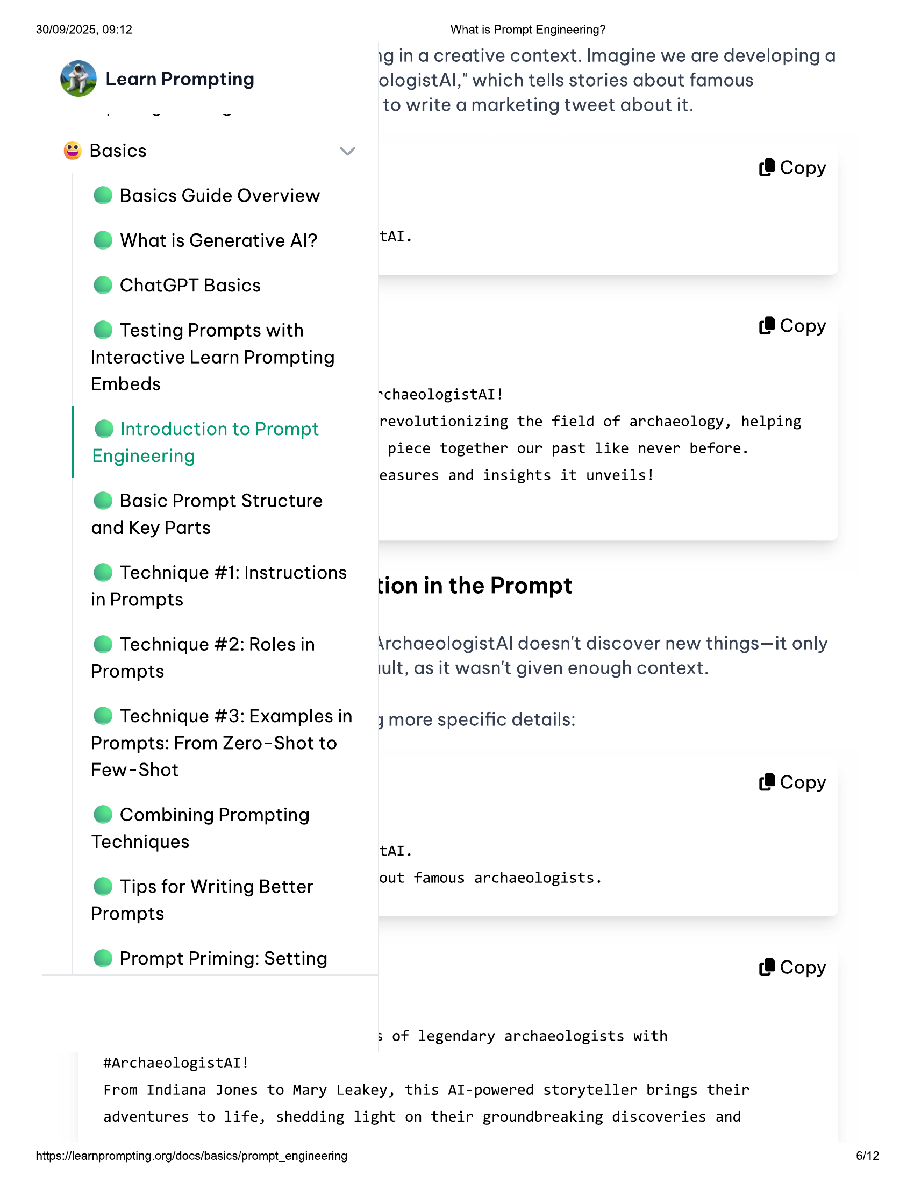

30/09/2025, 09:12  
  
@ Learn Prompting  
  
© Basics  
@ Basics Guide Overview  
@ What is Generative Al?  
@ ChatGPT Basics  
  
© Testing Prompts with  
Interactive Learn Prompting  
Embeds  
  
@ Introduction to Prompt  
Engineering  
  
@ Basic Prompt Structure  
and Key Parts  
  
@ Technique #1: Instructions  
  
in Prompts  
  
@ Technique #2: Roles in  
Prompts  
  
@ Technique #3: Examples in  
  
Prompts: From Zero-Shot to  
Few-Shot  
  
© Combining Prompting  
Techniques  
  
© Tips for Writing Better  
Prompts  
  
@ Prompt Priming: Setting  
  
#ArchaeologistAlI!  
  
What is Prompt Engineering?  
1g in a creative context. Imagine we are developing a  
ologistAl," which tells stories about famous  
to write a marketing tweet about it.  
  
(8 Copy  
  
tal.  
  
(8 Copy  
  
~chaeologistAI!  
revolutionizing the field of archaeology, helping  
piece together our past like never before.  
  
easures and insights it unveils!  
  
tion in the Prompt  
  
\rchaeologistAl doesn't discover new things—it only  
jult, as it wasn't given enough context.  
  
jymore specific details:  
(8 Copy  
  
tal.  
  
out famous archaeologists.  
  
(® Copy  
  
3 of legendary archaeologists with  
  
From Indiana Jones to Mary Leakey, this Al-powered storyteller brings their  
  
adventures to life, shedding light on their groundbreaking discoveries and  
  
https://learnprompting.org/docs/basics/prompt_engineering  
  
6/12

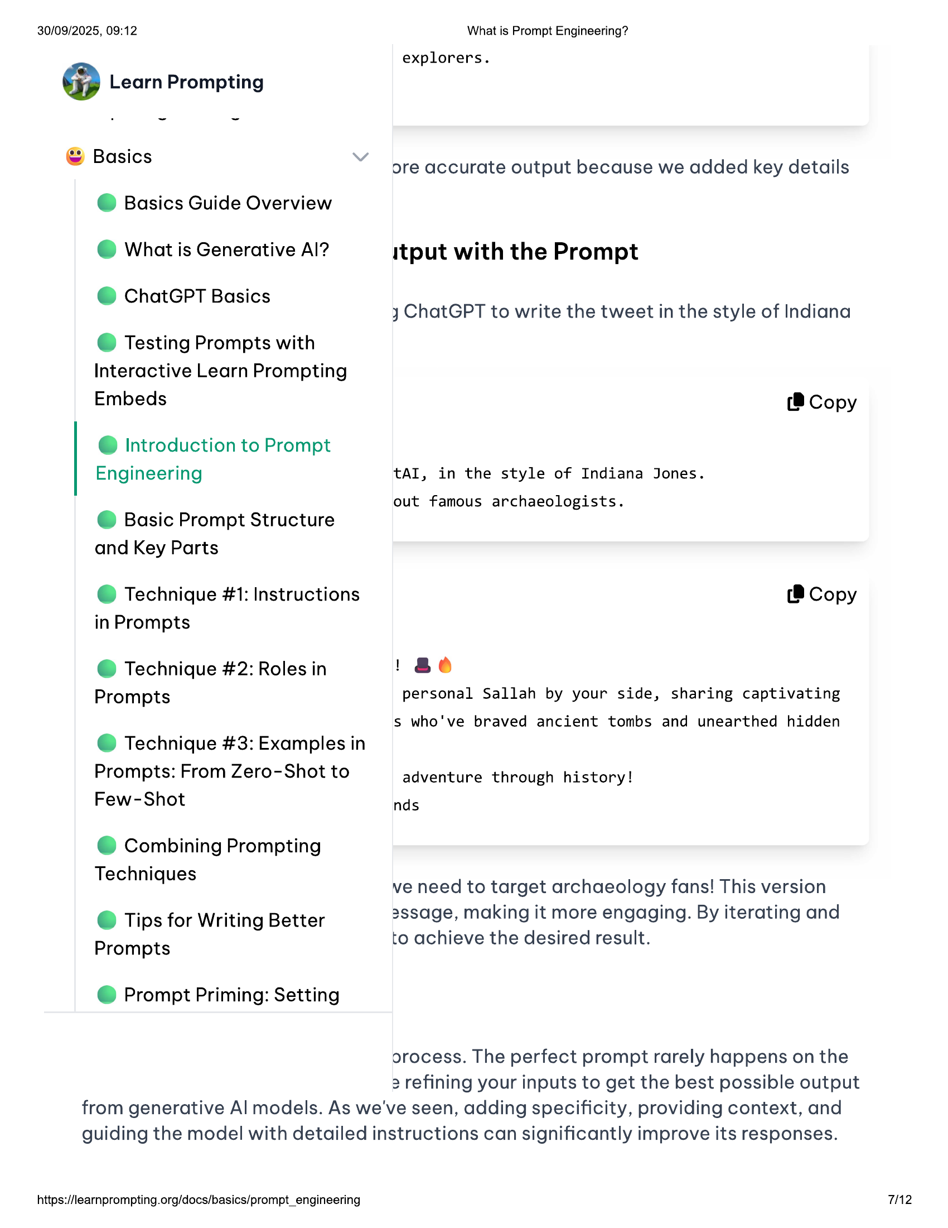

30/09/2025, 09:12  
  
@ Learn Prompting  
  
© Basics  
@ Basics Guide Overview  
@ What is Generative Al?  
@ ChatGPT Basics  
  
© Testing Prompts with  
Interactive Learn Prompting  
Embeds  
  
@ Introduction to Prompt  
Engineering  
  
@ Basic Prompt Structure  
and Key Parts  
  
@ Technique #1: Instructions  
  
in Prompts  
  
@ Technique #2: Roles in  
Prompts  
  
@ Technique #3: Examples in  
  
Prompts: From Zero-Shot to  
Few-Shot  
  
© Combining Prompting  
Techniques  
  
© Tips for Writing Better  
Prompts  
  
@ Prompt Priming: Setting  
  
What is Prompt Engineering?  
  
explorers.  
  
ore accurate output because we added key details  
  
itput with the Prompt  
  
y ChatGPT to write the tweet in the style of Indiana  
  
(8 Copy  
  
tAI, in the style of Indiana Jones.  
  
out famous archaeologists.  
  
(® Copy  
  
1 ae  
personal Sallah by your side, sharing captivating  
  
s who've braved ancient tombs and unearthed hidden  
  
adventure through history!  
  
nds  
  
ve need to target archaeology fans! This version  
3ssage, making it more engaging. By iterating and  
to achieve the desired result.  
  
orocess. The perfect prompt rarely happens on the  
2 refining your inputs to get the best possible output  
  
from generative Al models. As we've seen, adding specificity, providing context, and  
guiding the model with detailed instructions can significantly improve its responses.  
  
https://learnprompting.org/docs/basics/prompt_engineering  
  
7/2

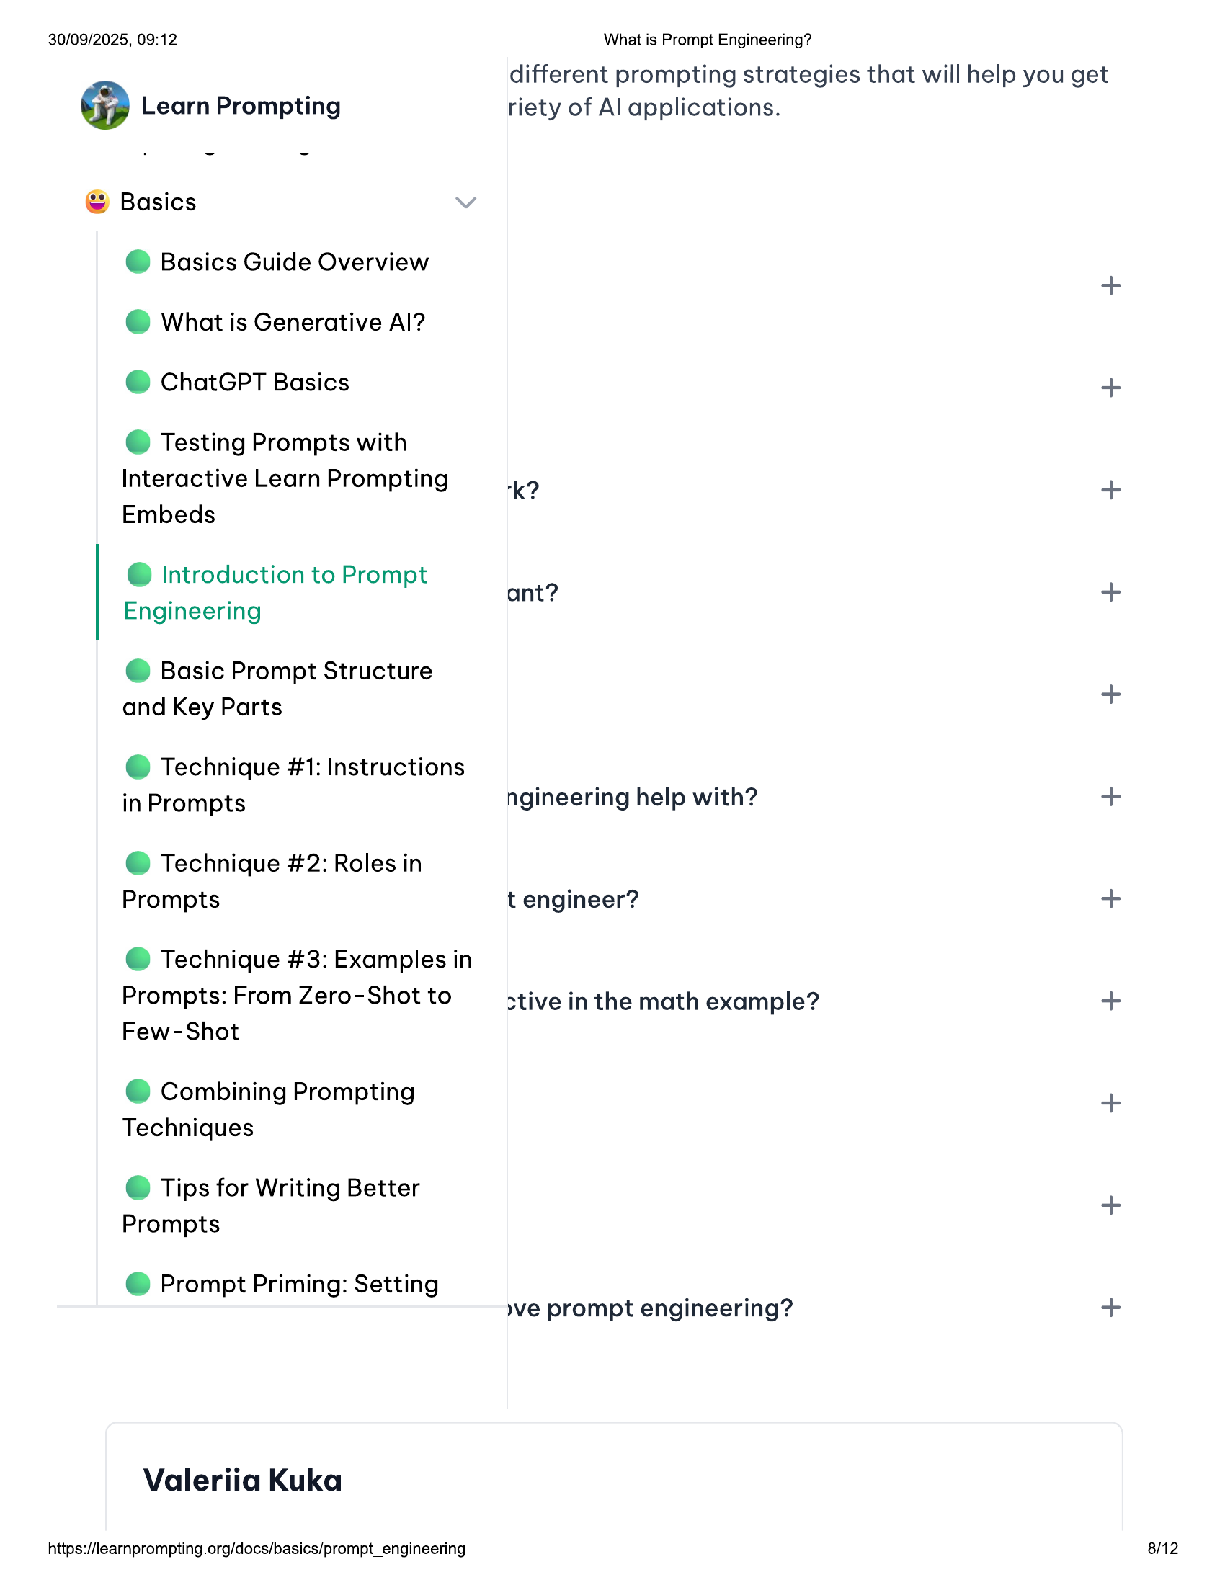

30/09/2025, 09:12 What is Prompt Engineering?  
  
different prompting strategies that will help you get  
  
@ Learn Prompting riety of Al applications.  
© Basics  
  
@ Basics Guide Overview n  
© What is Generative Al?  
© ChatGPT Basics +  
© Testing Prompts with  
Interactive Learn Prompting kK? +  
Embeds  
  
Introduction to Prompt  
be . . P ant? +  
Engineering  
© Basic Prompt Structure  
and Key Parts +  
@ Technique #1: Instructions  
in Prompts ngineering help with? +  
@ Technique #2: Roles in  
Prompts t engineer? +  
@ Technique #3: Examples in  
Prompts: From Zero-Shot to ative in the math example? +  
Few-Shot  
© Combining Prompting +  
Techniques  
© Tips for Writing Better +  
Prompts  
@ Prompt Priming: Setting  
  
»ve prompt engineering? +  
  
Valeriia Kuka  
  
https://learnprompting.org/docs/basics/prompt_engineering 8/12

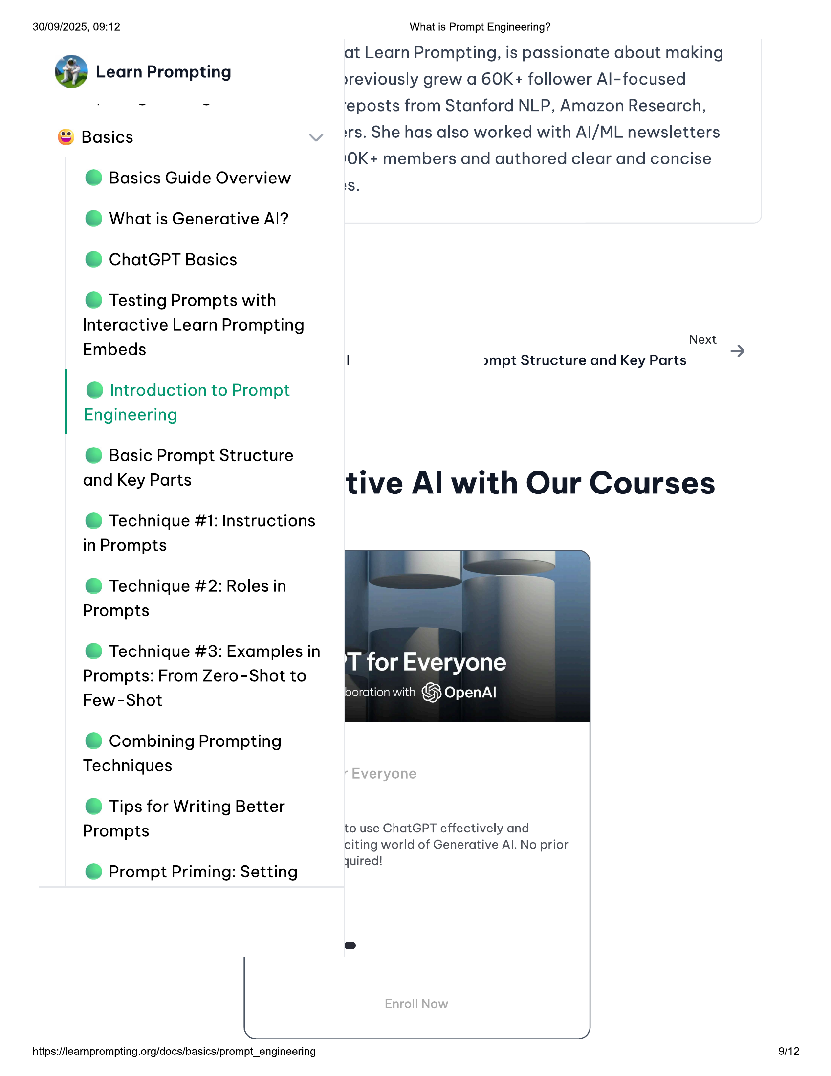

30/09/2025, 09:12 What is Prompt Engineering?  
at Learn Prompting, is passionate about making  
@ Learn Prompting »yreviously grew a 60K+ follower Al-focused  
. ~ ~ ‘eposts from Stanford NLP, Amazon Research,  
© Basics irs. She has also worked with Al/ML newsletters  
'OK+ members and authored clear and concise  
  
@ Basics Guide Overview ls  
  
@ What is Generative Al?  
@ ChatGPT Basics  
  
© Testing Prompts with  
Interactive Learn Prompting  
  
Embeds Next  
  
I »mpt Structure and Key Parts  
@ Introduction to Prompt  
Engineering  
  
@ Basic Prompt Structure  
and Key Parts tive Al with Our Courses  
  
@ Technique #1: Instructions  
in Prompts  
  
@ Technique #2: Roles in  
Prompts  
  
@ Technique #3: Examples in  
Prompts: From Zero-Shot to  
Few-Shot  
  
© Combining Prompting  
Techniques  
  
© Tips for Writing Better  
  
Prompts to use ChatGPT effectively and  
citing world of Generative Al. No prior  
oe : quired!  
@ Prompt Priming: Setting  
e  
  
https://learnprompting.org/docs/basics/prompt_engineering 9/12

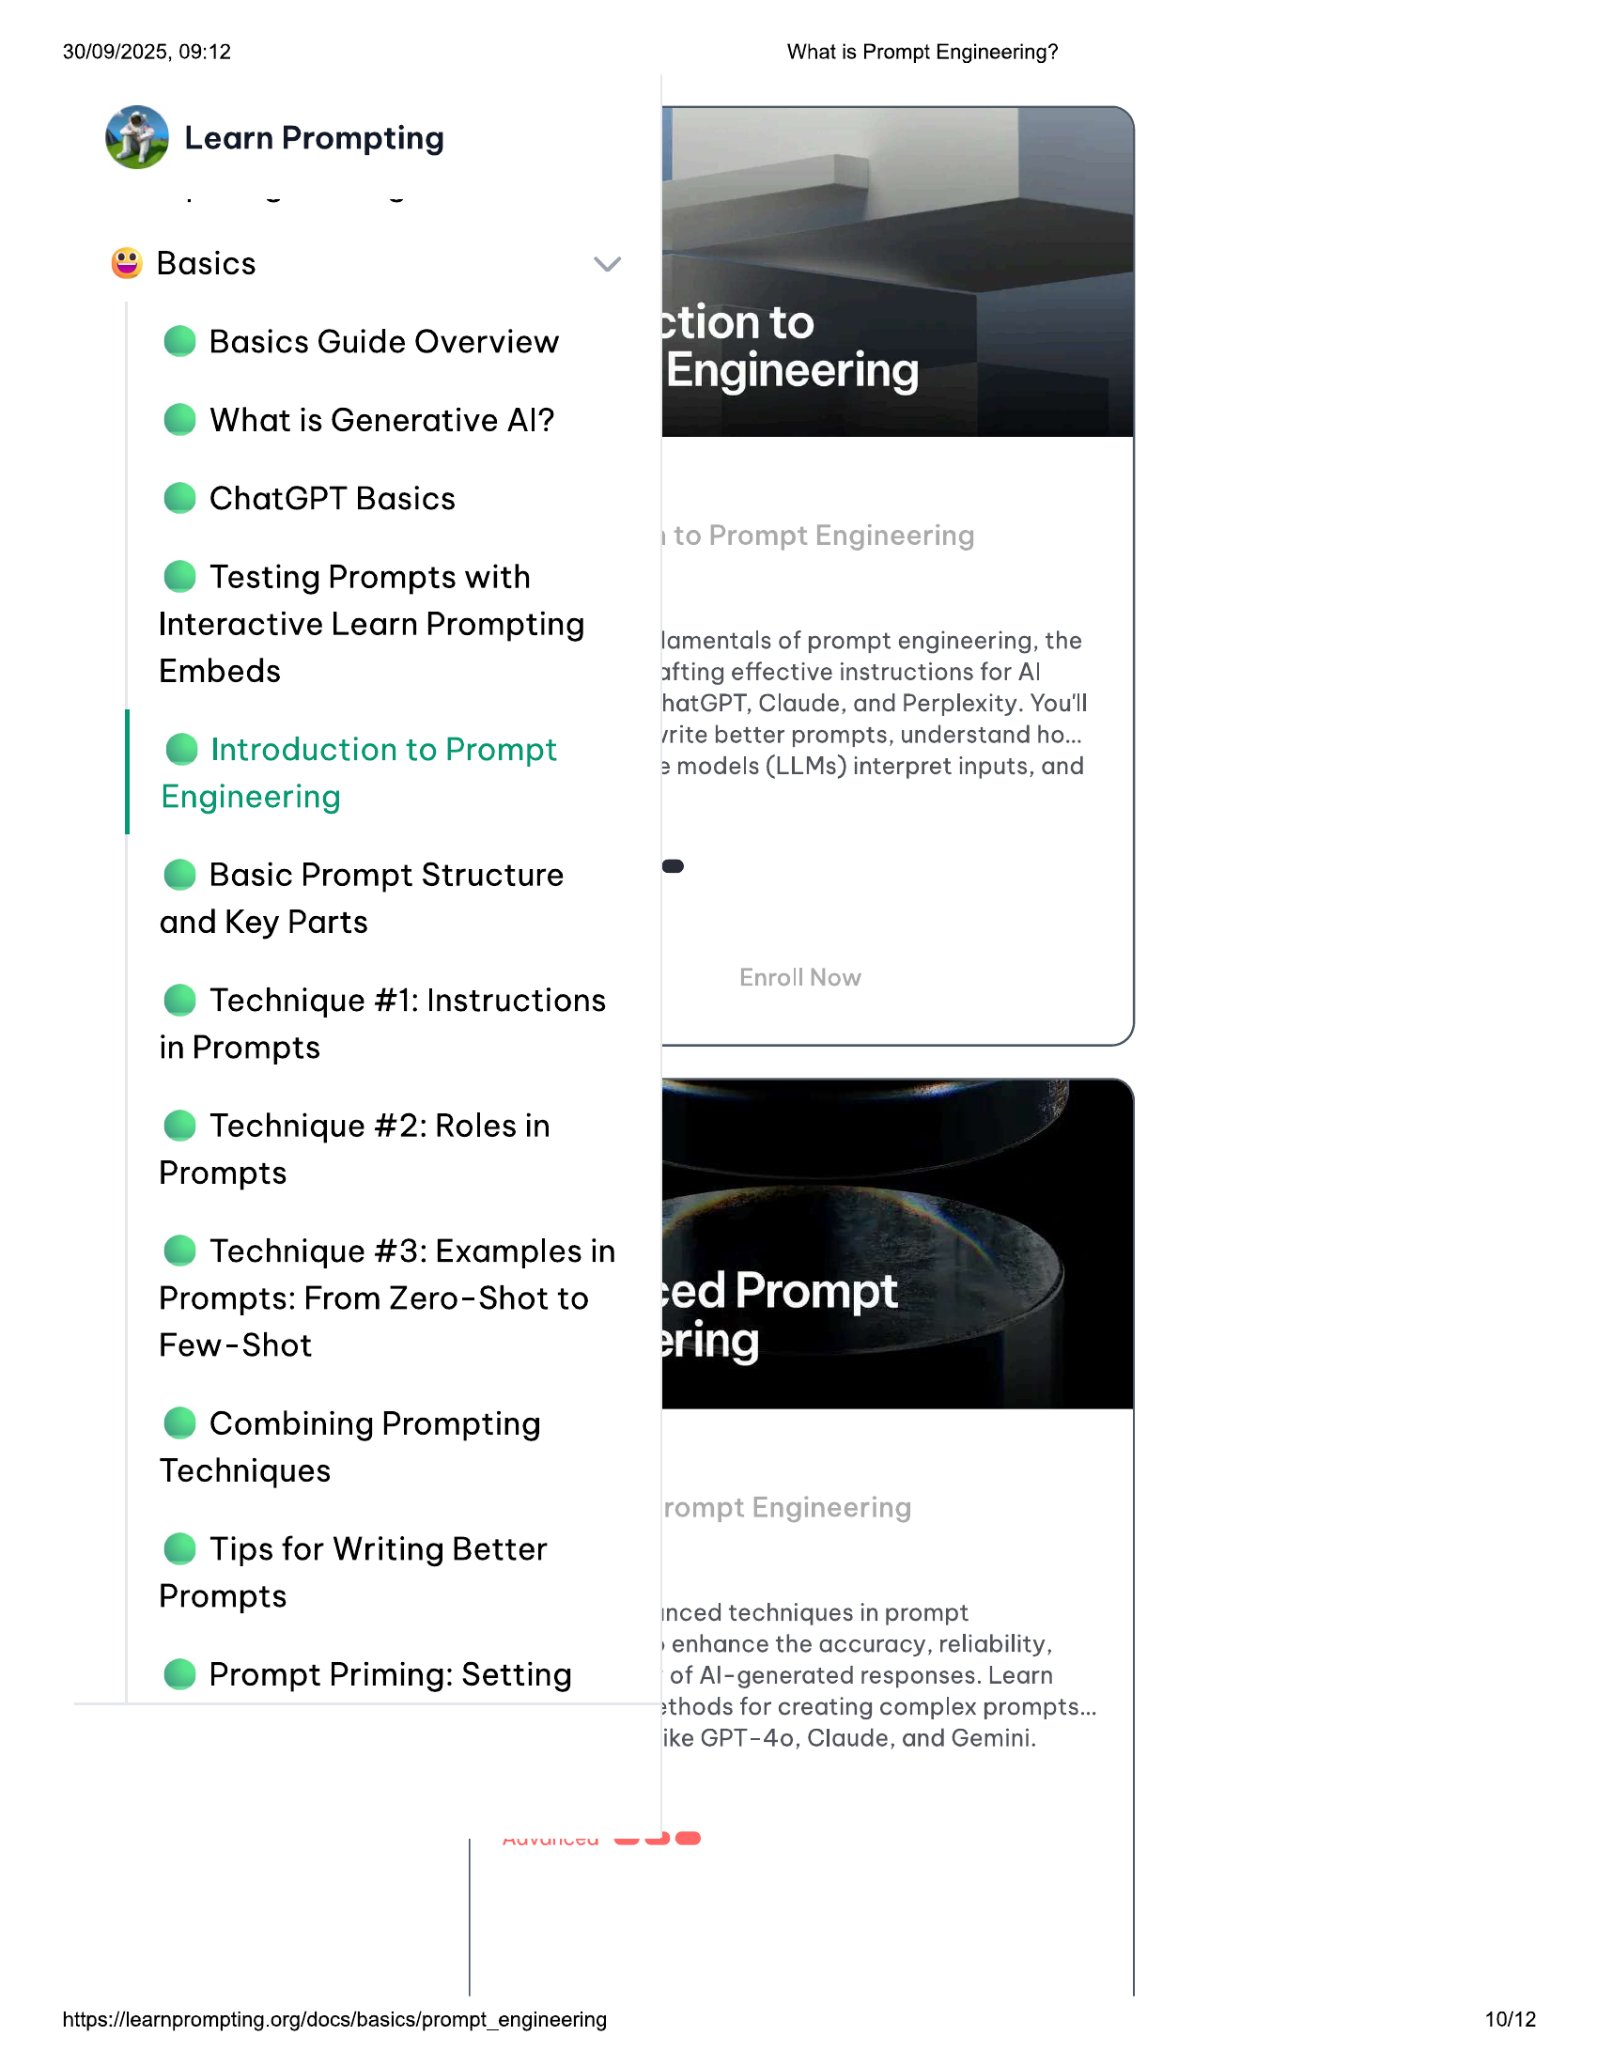

30/09/2025, 09:12  
  
@ Learn Prompting  
  
© Basics  
@ Basics Guide Overview  
@ What is Generative Al?  
@ ChatGPT Basics  
  
© Testing Prompts with  
Interactive Learn Prompting  
Embeds  
  
@ Introduction to Prompt  
Engineering  
  
© Basic Prompt Structure  
and Key Parts  
  
@ Technique #1: Instructions  
in Prompts  
  
@ Technique #2: Roles in  
Prompts  
  
@ Technique #3: Examples in  
Prompts: From Zero-Shot to  
Few-Shot  
  
© Combining Prompting  
Techniques  
  
© Tips for Writing Better  
Prompts  
  
@ Prompt Priming: Setting  
  
muvuiccu =D @®  
  
https://learnprompting.org/docs/basics/prompt_engineering  
  
What is Prompt Engineering?  
  
tion to  
Engineering  
  
lamentals of prompt engineering, the  
afting effective instructions for Al  
  
hatGPT, Claude, and Perplexity. You'll  
‘rite better prompts, understand ho...  
3 models (LLMs) interpret inputs, and  
  
inced techniques in prompt  
  
»enhance the accuracy, reliability,  
  
of Al-generated responses. Learn  
xthods for creating complex prompts...  
ike GPT-40, Claude, and Gemini.  
  
10/12

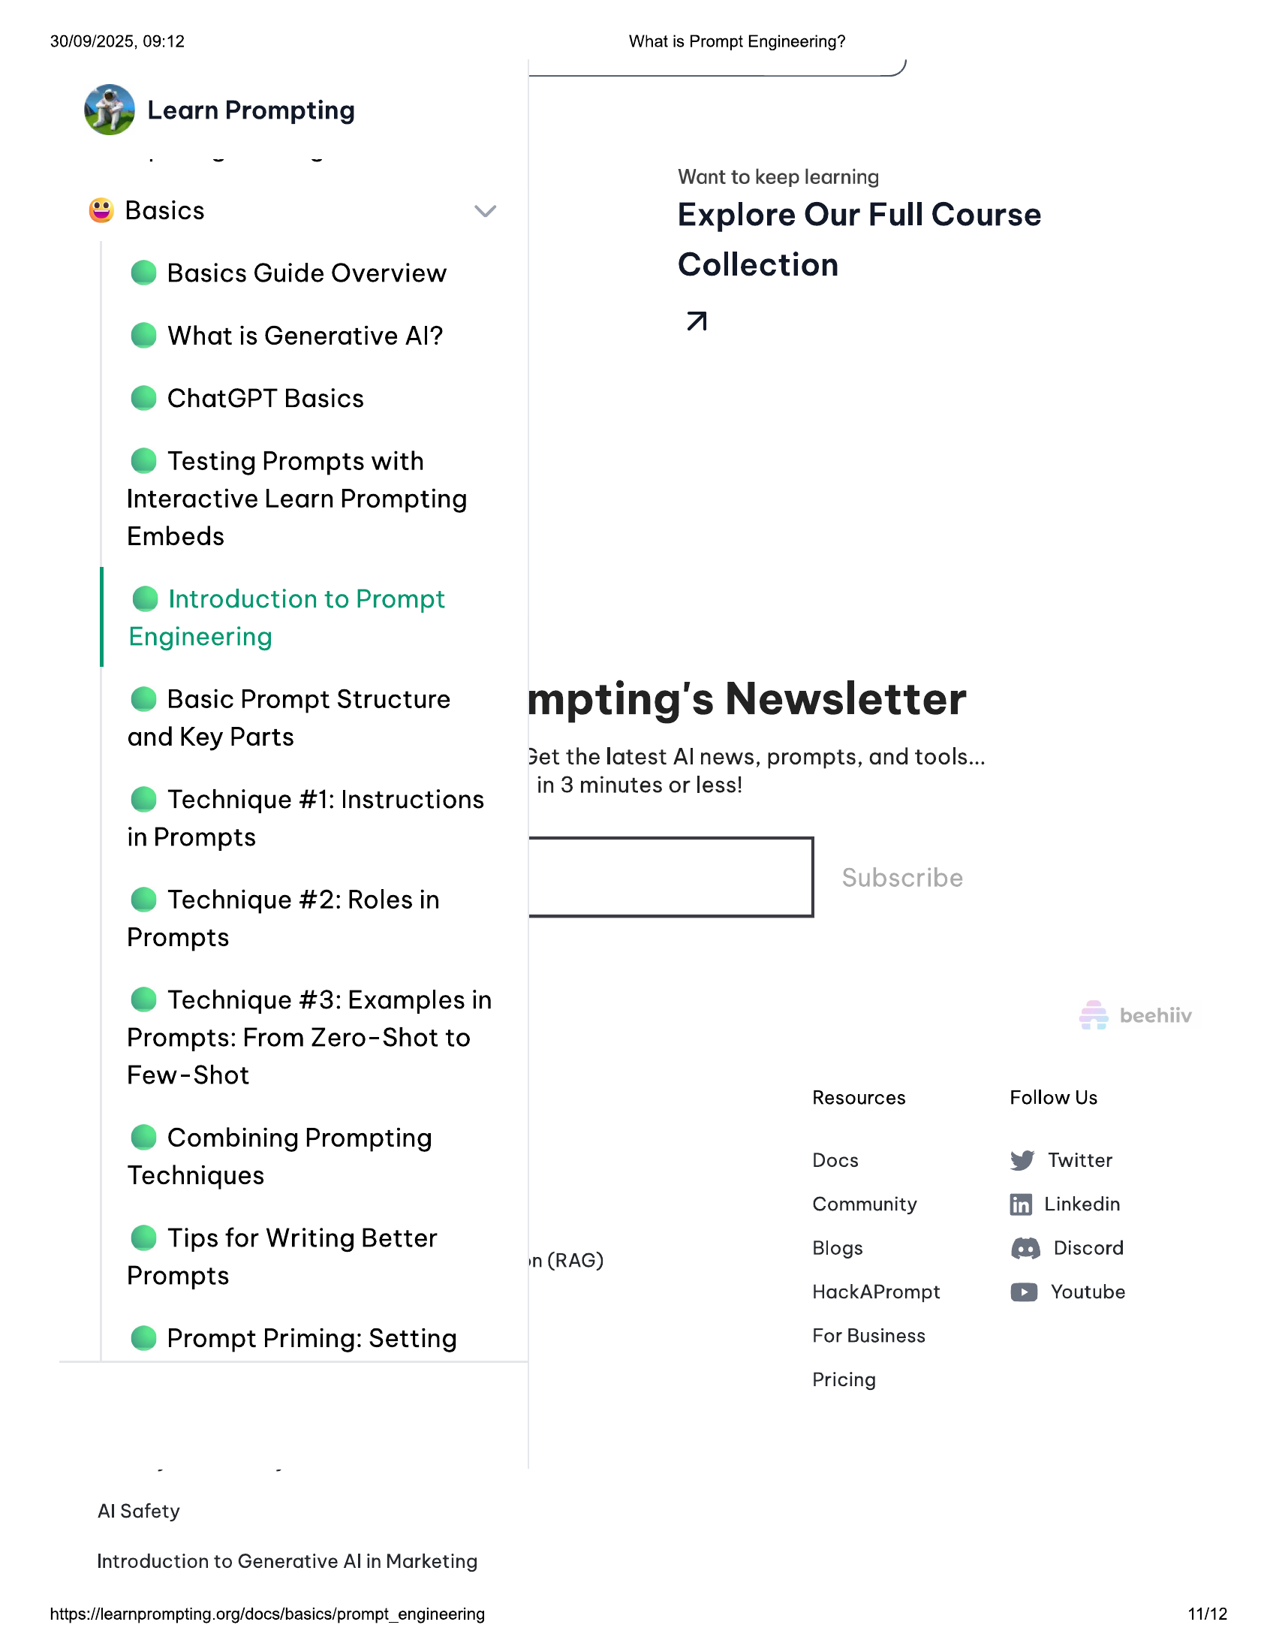

30/09/2025, 09:12 What is Prompt Engineering?  
  
@ Learn Prompting  
  
Want to keep learning  
© Basics Explore Our Full Course  
  
@ Basics Guide Overview Collection  
  
@ What is Generative Al? A  
  
@ ChatGPT Basics  
  
© Testing Prompts with  
Interactive Learn Prompting  
Embeds  
  
@ Introduction to Prompt  
Engineering  
  
@ Basic Prompt Structure mpting's Newsletter  
  
and Key Parts  
3et the latest Al news, prompts, and tools...  
  
. . in 3 minutes or less!  
@ Technique #1: Instructions  
  
in Prompts  
@ Technique #2: Roles in |  
Prompts  
  
@ Technique #3: Examples in  
Prompts: From Zero-Shot to  
  
Few-Shot  
Resources Follow Us  
© Combining Prompting  
. Docs W Twitter  
Techniques  
Community ff) Linkedin  
© Tips for Writing Better F  
Prompts in (RAG) Blogs @ Discord  
Pp HackAPrompt © Youtube  
@ Prompt Priming: Setting For Business  
Pricing  
Al Safety  
  
Introduction to Generative Al in Marketing  
  
https://learnprompting.org/docs/basics/prompt_engineering 11/112

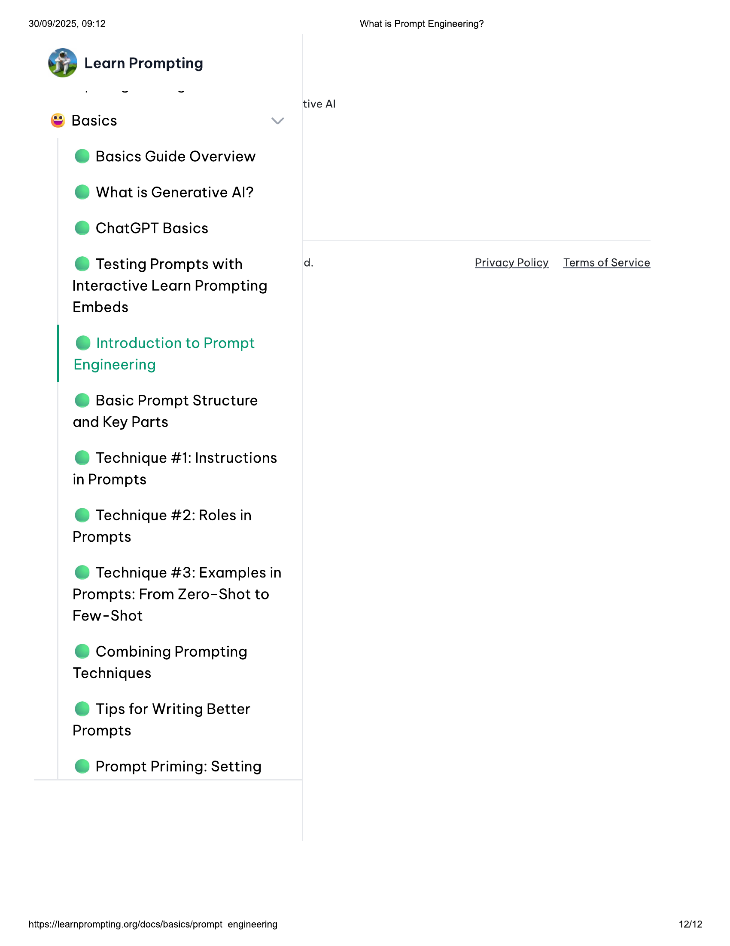

30/09/2025, 09:12 What is Prompt Engineering?  
  
@ Learn Prompting  
  
tive Al  
© Basics  
  
@ Basics Guide Overview  
@ What is Generative Al?  
@ ChatGPT Basics  
  
e@ Testing Prompts with d. Privacy Policy Terms of Service  
Interactive Learn Prompting  
Embeds  
  
@ Introduction to Prompt  
Engineering  
  
@ Basic Prompt Structure  
and Key Parts  
  
@ Technique #1: Instructions  
in Prompts  
  
@ Technique #2: Roles in  
Prompts  
  
@ Technique #3: Examples in  
Prompts: From Zero-Shot to  
Few-Shot  
  
© Combining Prompting  
Techniques  
  
© Tips for Writing Better  
Prompts  
  
@ Prompt Priming: Setting  
  
https://learnprompting.org/docs/basics/prompt_engineering 12/12