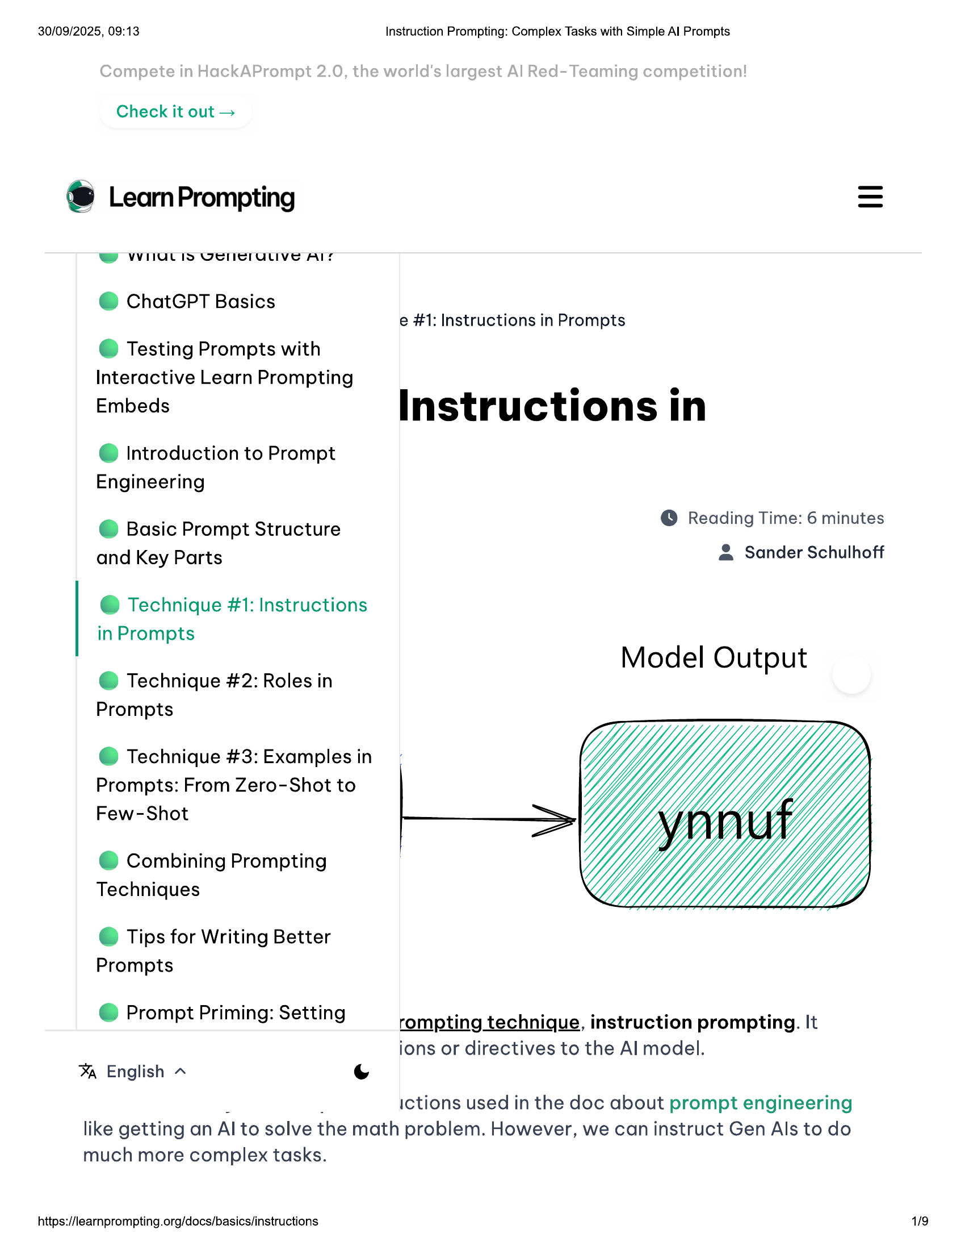

30/09/2025, 09:13  
  
Check it out >  
  
® LeamPrompting  
W WHIULIS VPICIULIVE AIS  
@ ChatGPT Basics  
  
© Testing Prompts with  
Interactive Learn Prompting  
Embeds  
  
@ Introduction to Prompt  
Engineering  
  
@ Basic Prompt Structure  
and Key Parts  
  
@ Technique #1: Instructions  
in Prompts  
  
@ Technique #2: Roles in  
Prompts  
  
@ Technique #3: Examples in  
Prompts: From Zero-Shot to  
Few-Shot  
  
© Combining Prompting  
Techniques  
  
© Tips for Writing Better  
Prompts  
  
@ Prompt Priming: Setting  
  
% English ~ (Ss  
  
Instruction Prompting: Complex Tasks with Simple Al Prompts  
  
e #1: Instructions in Prompts  
  
Instructions in  
  
© Reading Time: 6 minutes  
& Sander Schulhoff  
  
Model Output  
  
rompting technique, instruction prompting. It  
ions or directives to the Al model.  
  
ictions used in the doc about prompt engineering  
  
like getting an Al to solve the math problem. However, we can instruct Gen Als to do  
  
much more complex tasks.  
  
https://learnprompting.org/docs/basics/instructions  
  
119

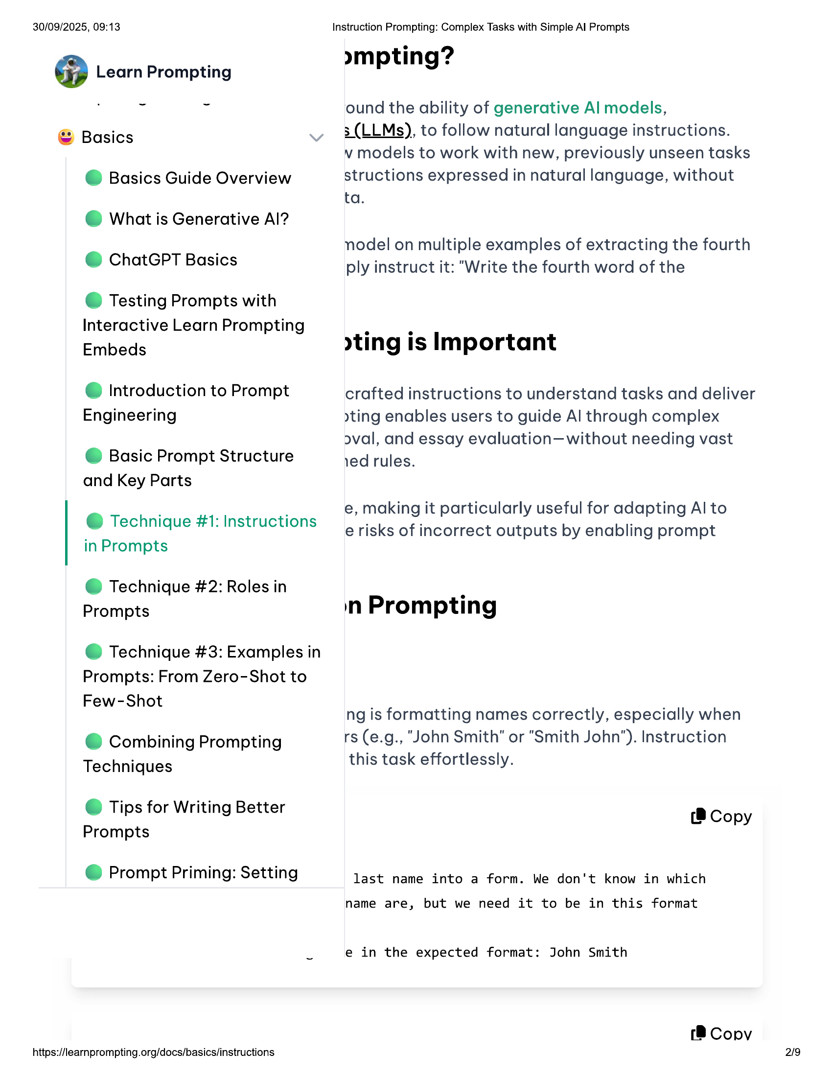

30/09/2025, 09:13  
  
@ Learn Prompting  
  
© Basics  
  
@ Basics Guide Overview  
@ What is Generative Al?  
@ ChatGPT Basics  
  
© Testing Prompts with  
Interactive Learn Prompting  
Embeds  
  
@ Introduction to Prompt  
Engineering  
  
@ Basic Prompt Structure  
and Key Parts  
  
@ Technique #1: Instructions  
in Prompts  
  
@ Technique #2: Roles in  
Prompts  
  
@ Technique #3: Examples in  
Prompts: From Zero-Shot to  
Few-Shot  
  
© Combining Prompting  
Techniques  
  
© Tips for Writing Better  
Prompts  
  
@ Prompt Priming: Setting  
  
https://learnprompting.org/docs/basics/instructions  
  
Instruction Prompting: Complex Tasks with Simple Al Prompts  
  
»mpting?  
  
ound the ability of generative Al models,  
  
3 (LLMs), to follow natural language instructions.  
  
v models to work with new, previously unseen tasks  
structions expressed in natural language, without  
ta.  
  
nodel on multiple examples of extracting the fourth  
ply instruct it: “Write the fourth word of the  
  
ting is Important  
  
crafted instructions to understand tasks and deliver  
yting enables users to guide Al through complex  
oval, and essay evaluation—without needing vast  
ed rules.  
  
e, making it particularly useful for adapting Al to  
e risks of incorrect outputs by enabling prompt  
  
in Prompting  
  
ng is formatting names correctly, especially when  
rs (e.g., “John Smith" or "Smith John’). Instruction  
this task effortlessly.  
  
(8 Copy  
  
last name into a form. We don't know in which  
  
name are, but we need it to be in this format  
  
e in the expected format: John Smith  
  
(8 Copy  
2/19

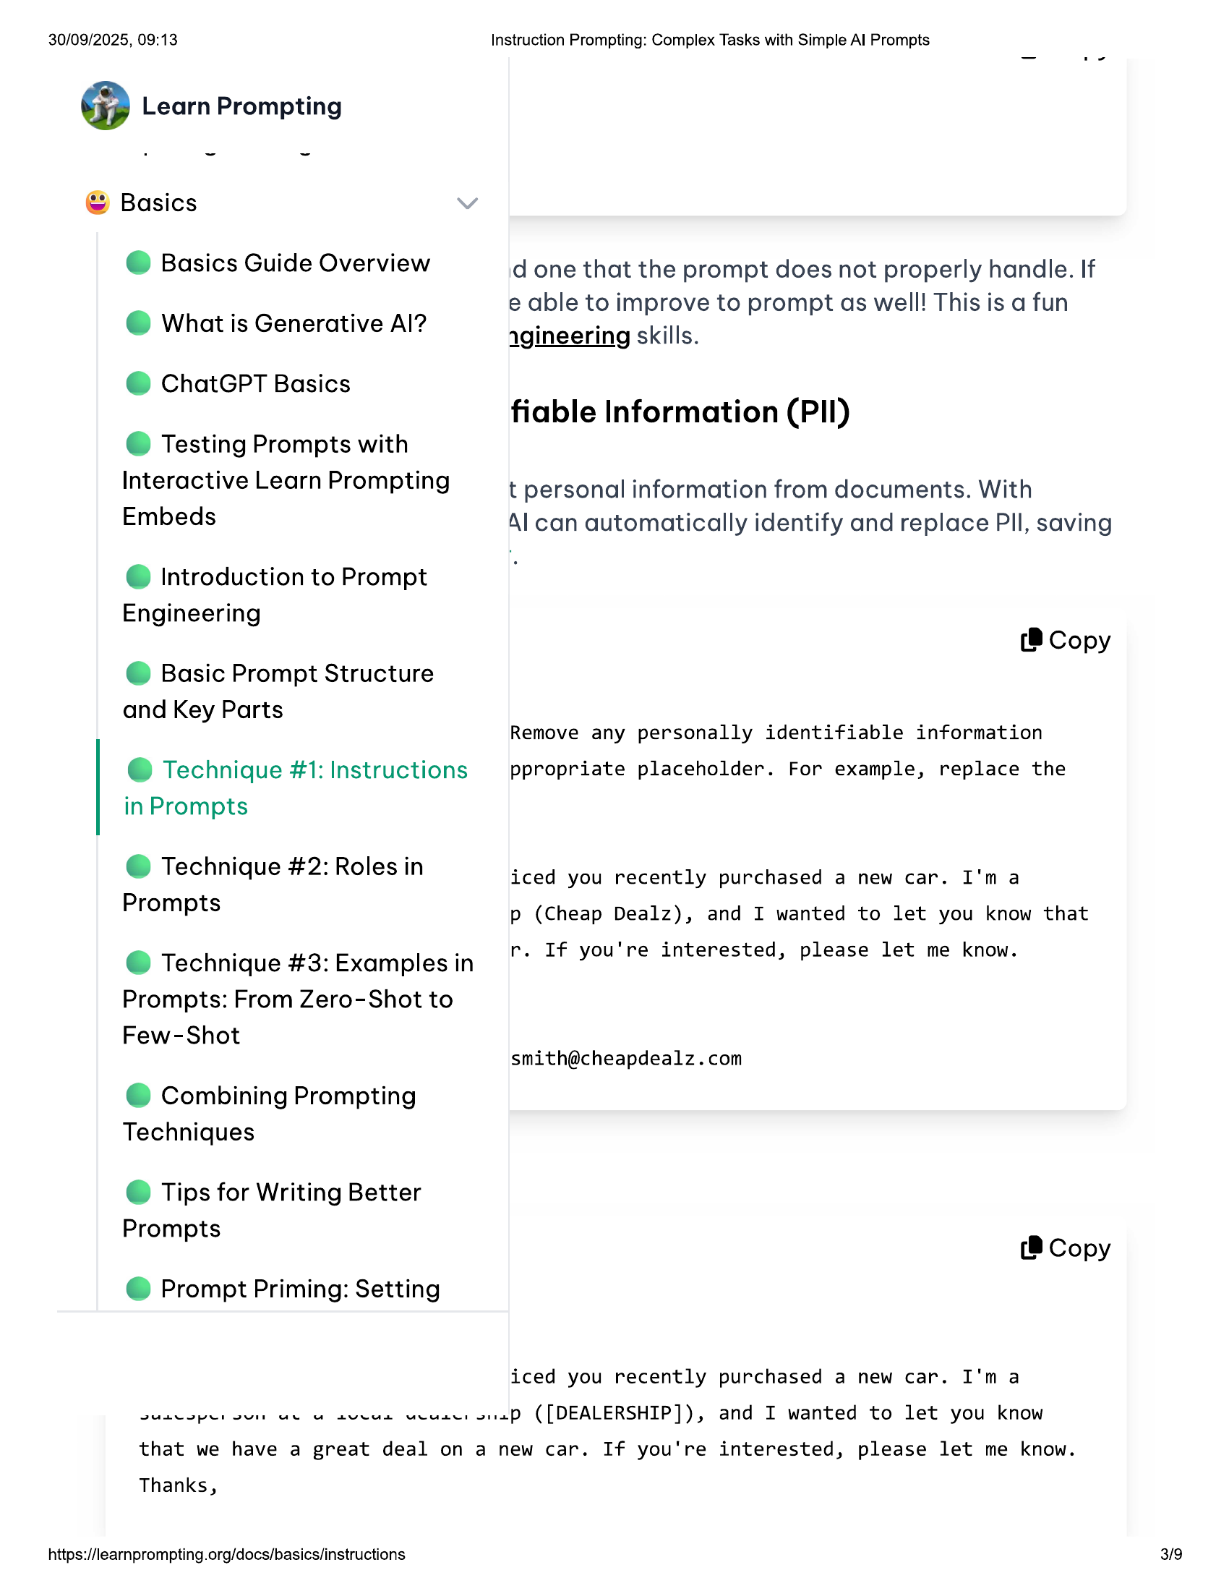

30/09/2025, 09:13 Instruction Prompting: Complex Tasks with Simple Al Prompts  
  
@ Learn Prompting  
  
© Basics  
  
@ Basics Guide Overview id one that the prompt does not properly handle. If  
e able to improve to prompt as well! This is a fun  
  
@ What is Generative Al? agineering skills.  
  
@ ChatGPT Basics . .  
fiable Information (PII)  
  
© Testing Prompts with  
  
Interactive Learn Prompting t personal information from documents. With  
Embeds Al can automatically identify and replace Pll, saving  
  
@ Introduction to Prompt  
Engineering  
  
(8 Copy  
@ Basic Prompt Structure  
  
and Key Parts  
Remove any personally identifiable information  
  
@ Technique #1: Instructions —_ ppropriate placeholder. For example, replace the  
in Prompts  
  
@ Technique #2: Roles in  
Prompts  
  
iced you recently purchased a new car. I'ma  
p (Cheap Dealz), and I wanted to let you know that  
  
e Technique #3: Examples in r. If you're interested, please let me know.  
  
Prompts: From Zero-Shot to  
  
Few-Shot  
smith@cheapdealz.com  
  
© Combining Prompting  
Techniques  
  
© Tips for Writing Better  
  
Prompts  
P (8 Copy  
  
@ Prompt Priming: Setting  
  
iced you recently purchased a new car. I'ma  
SU oper sun ue uw aveua Ucuser sap ([DEALERSHIP]), and I wanted to let you know  
that we have a great deal on a new car. If you're interested, please let me know.  
Thanks,  
  
https://learnprompting.org/docs/basics/instructions 3/9

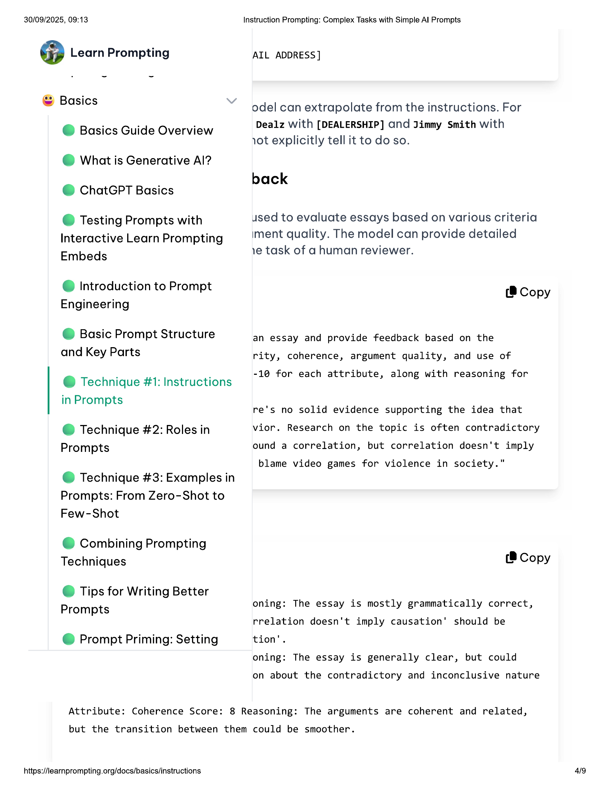

30/09/2025, 09:13  
  
@ Learn Prompting  
  
Instruction Prompting: Complex Tasks with Simple Al Prompts  
  
AIL ADDRESS]  
  
© Basics  
  
@ Basics Guide Overview  
@ What is Generative Al?  
@ ChatGPT Basics  
  
© Testing Prompts with  
Interactive Learn Prompting  
Embeds  
  
@ Introduction to Prompt  
Engineering  
  
@ Basic Prompt Structure  
and Key Parts  
  
@ Technique #1: Instructions  
in Prompts  
  
@ Technique #2: Roles in  
Prompts  
  
@ Technique #3: Examples in  
Prompts: From Zero-Shot to  
Few-Shot  
  
© Combining Prompting  
Techniques  
  
© Tips for Writing Better  
Prompts  
  
@ Prompt Priming: Setting  
  
odel can extrapolate from the instructions. For  
Dealz with [DEALERSHIP] Gnd Jimmy Smith with  
ot explicitly tell it to do so.  
  
back  
  
used to evaluate essays based on various criteria  
iment quality. The model can provide detailed  
ve task of a human reviewer.  
  
(8 Copy  
  
an essay and provide feedback based on the  
rity, coherence, argument quality, and use of  
  
-10 for each attribute, along with reasoning for  
  
re's no solid evidence supporting the idea that  
vior. Research on the topic is often contradictory  
ound a correlation, but correlation doesn't imply  
  
blame video games for violence in society."  
  
(® Copy  
  
oning: The essay is mostly grammatically correct,  
rrelation doesn't imply causation’ should be  
tion’.  
  
oning: The essay is generally clear, but could  
  
on about the contradictory and inconclusive nature  
  
Attribute: Coherence Score: 8 Reasoning: The arguments are coherent and related,  
  
but the transition between them could be smoother.  
  
https://learnprompting.org/docs/basics/instructions  
  
49

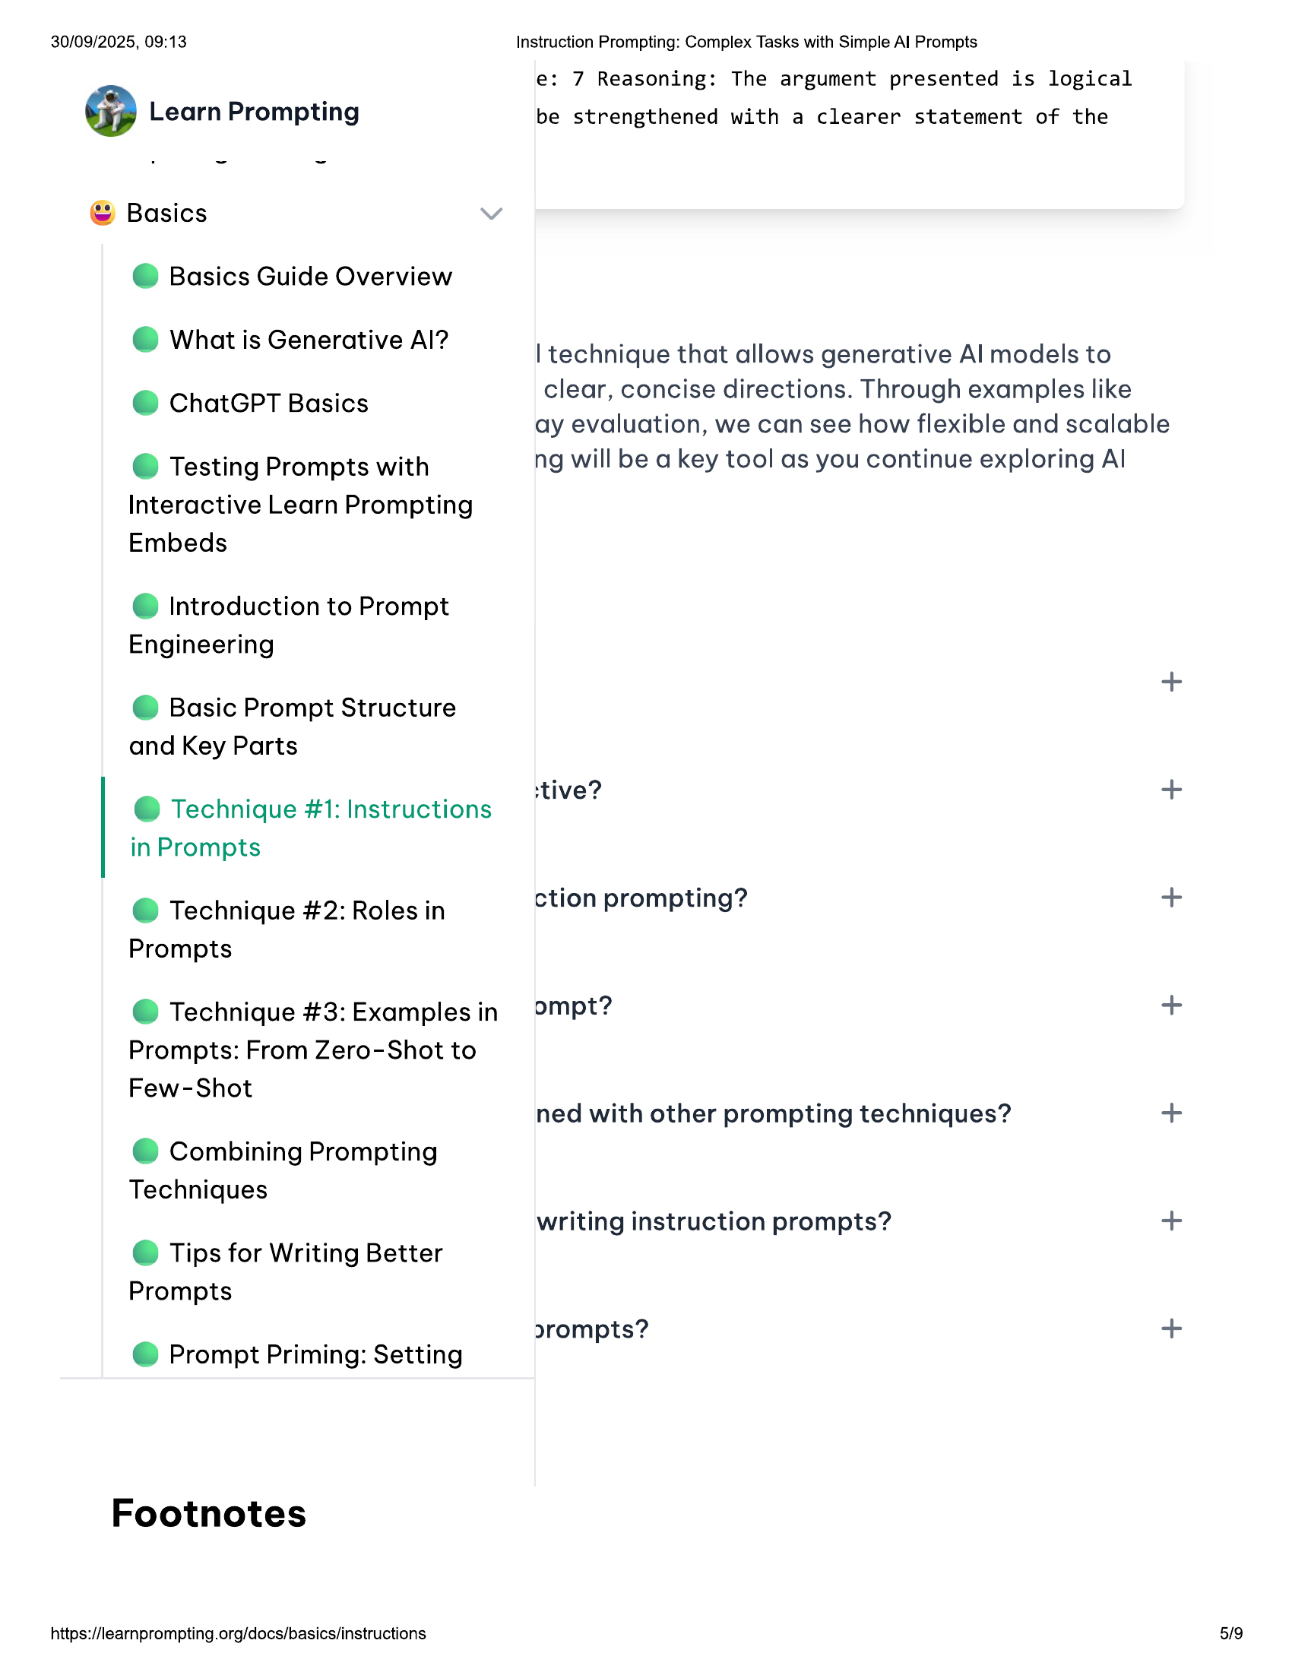

30/09/2025, 09:13 Instruction Prompting: Complex Tasks with Simple Al Prompts  
e: 7 Reasoning: The argument presented is logical  
@ Learn Prompting be strengthened with a clearer statement of the  
  
© Basics  
@ Basics Guide Overview  
. . 9  
© What is Generative Al? | technique that allows generative Al models to  
clear, concise directions. Through examples like  
  
ay evaluation, we can see how flexible and scalable  
@ Testing Prompts with ng will be a key tool as you continue exploring Al  
  
@ ChatGPT Basics  
  
Interactive Learn Prompting  
Embeds  
  
@ Introduction to Prompt  
  
Engineering  
@ Basic Prompt Structure  
and Key Parts  
  
‘tive? +  
@ Technique #1: Instructions Vv  
in Prompts  
@ Technique #2: Roles in ction prompting? +  
Prompts  
@ Technique #3: Examples in ompt? +  
Prompts: From Zero-Shot to  
Few-Shot  
  
ned with other prompting techniques? +  
© Combining Prompting  
Techniques  
  
writing instruction prompts? +  
© Tips for Writing Better  
Prompts  
  
orompts? +  
  
@ Prompt Priming: Setting  
  
Footnotes  
  
https://learnprompting.org/docs/basics/instructions

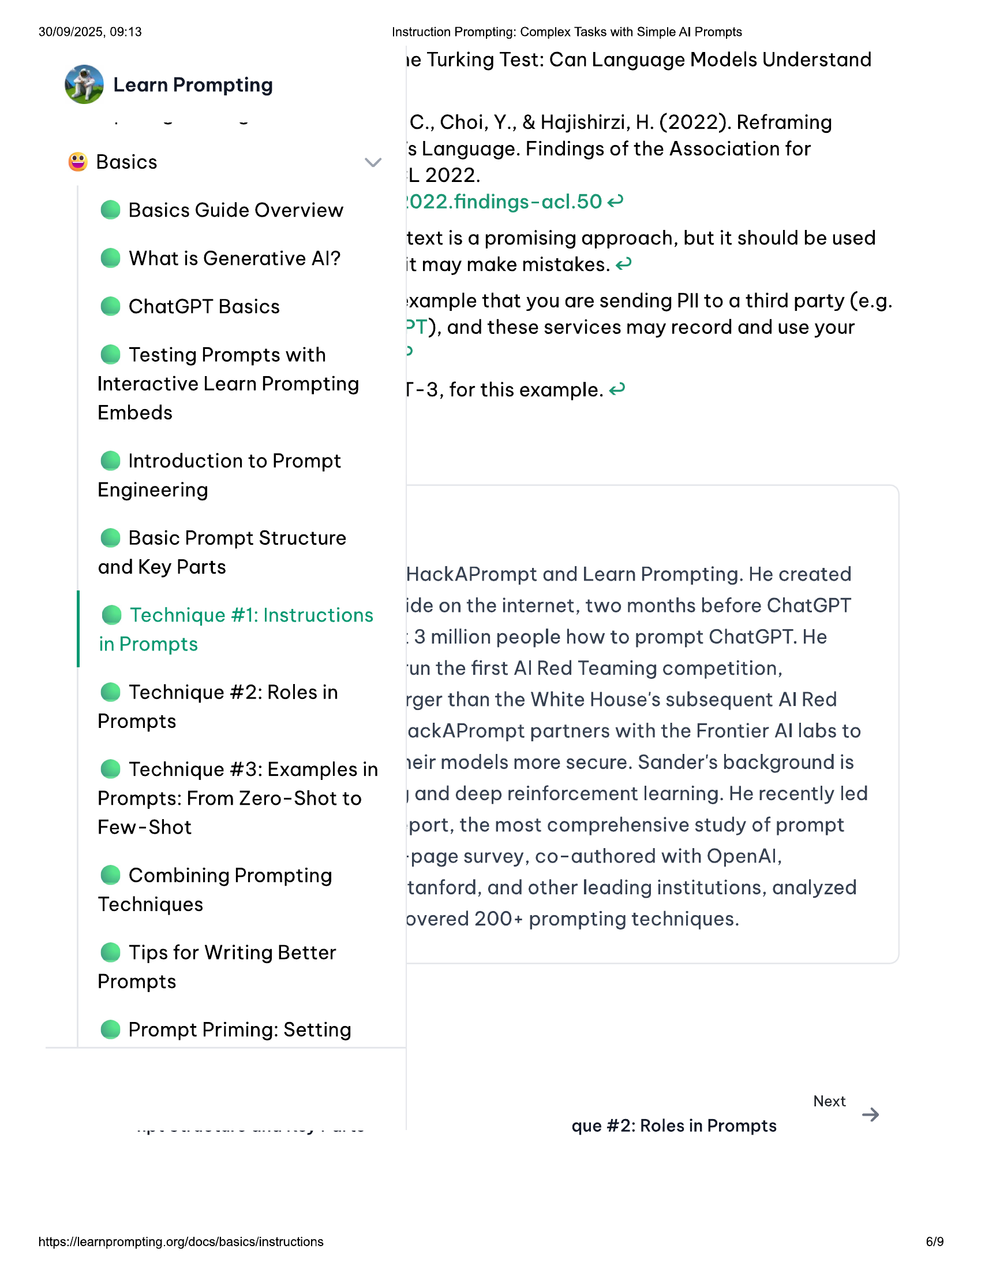

30/09/2025, 09:13  
  
@ Learn Prompting  
  
© Basics  
  
@ Basics Guide Overview  
@ What is Generative Al?  
@ ChatGPT Basics  
  
© Testing Prompts with  
Interactive Learn Prompting  
Embeds  
  
@ Introduction to Prompt  
Engineering  
  
© Basic Prompt Structure  
and Key Parts  
  
@ Technique #1: Instructions  
in Prompts  
  
@ Technique #2: Roles in  
Prompts  
  
@ Technique #3: Examples in  
Prompts: From Zero-Shot to  
Few-Shot  
  
© Combining Prompting  
Techniques  
  
© Tips for Writing Better  
Prompts  
  
@ Prompt Priming: Setting  
  
https://learnprompting.org/docs/basics/instructions  
  
Instruction Prompting: Complex Tasks with Simple Al Prompts  
  
ie Turking Test: Can Language Models Understand  
  
C., Choi, Y., & Hajishirzi, H. (2022). Reframing  
's Language. Findings of the Association for  
  
L 2022.  
  
1022.findings-acl.50 2  
  
text is a promising approach, but it should be used  
it may make mistakes. @  
  
‘xample that you are sending PII to a third party (e.g.  
  
°T), and these services may record and use your  
>  
  
[-3, for this example. @  
  
HackAPrompt and Learn Prompting. He created  
ide on the internet, two months before ChatGPT  
:3 million people how to prompt ChatGPT. He  
  
‘un the first Al Red Teaming competition,  
  
rger than the White House's subsequent Al Red  
ackAPrompt partners with the Frontier Al labs to  
1eir models more secure. Sander's background is  
} and deep reinforcement learning. He recently led  
port, the most comprehensive study of prompt  
-page survey, co-authored with OpenAl,  
tanford, and other leading institutions, analyzed  
overed 200+ prompting techniques.  
  
Next  
que #2: Roles in Prompts  
  
6/9

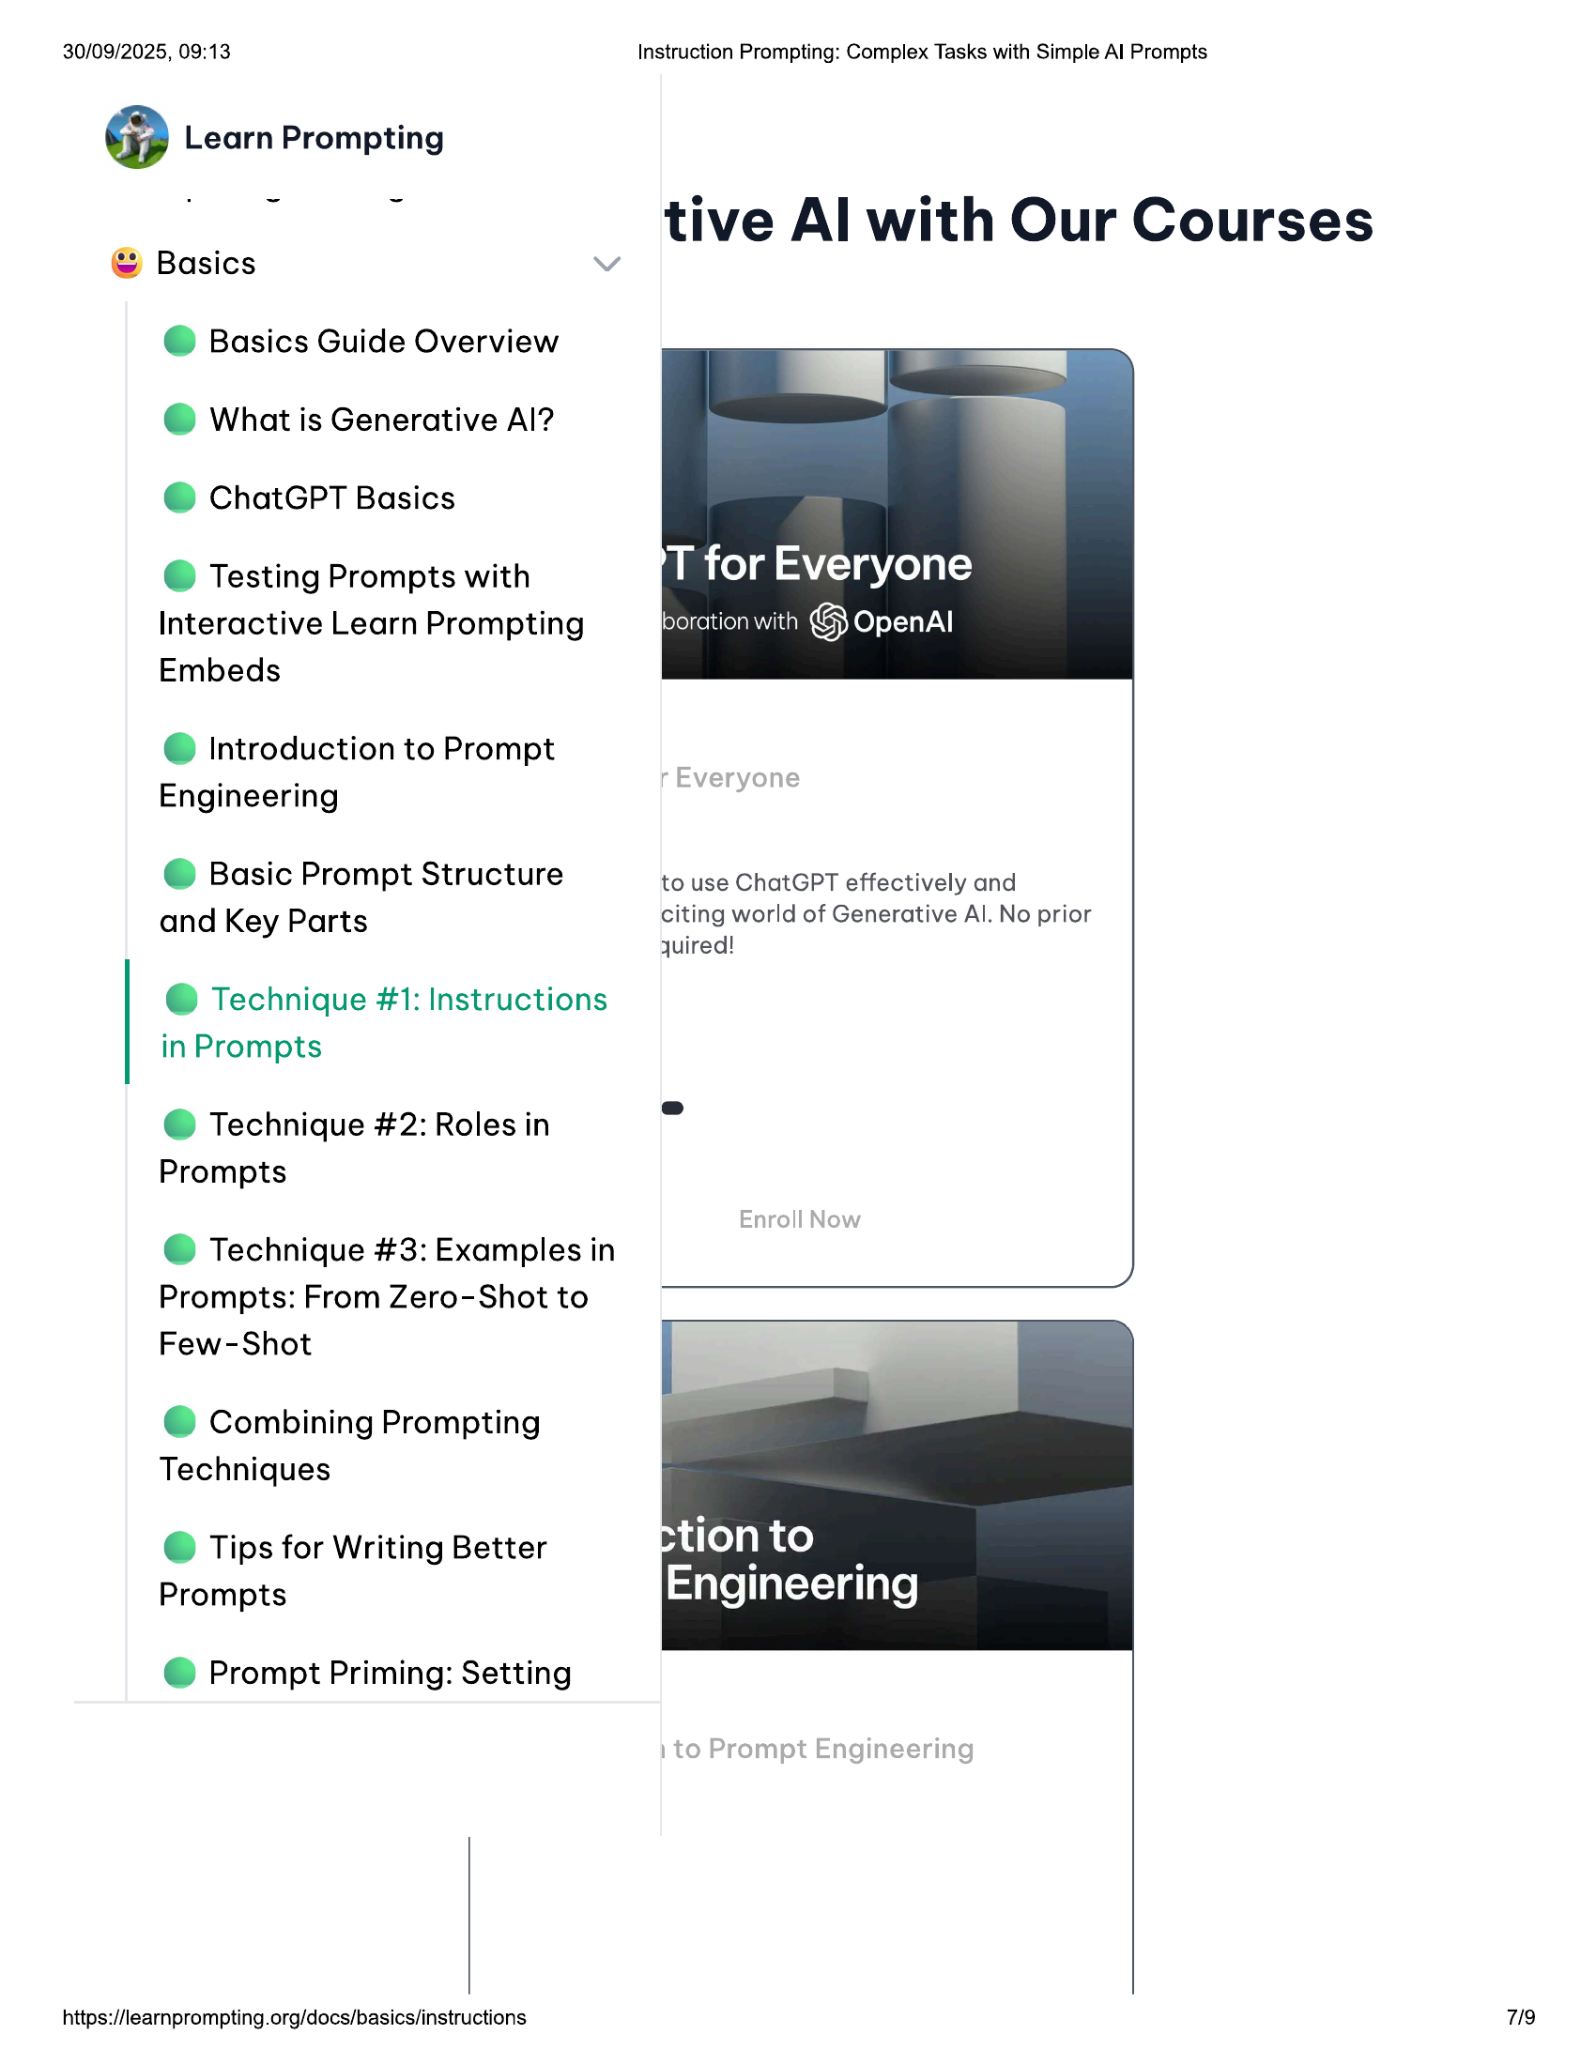

30/09/2025, 09:13  
@ Learn Prompting  
  
© Basics  
@ Basics Guide Overview  
@ What is Generative Al?  
@ ChatGPT Basics  
  
© Testing Prompts with  
Interactive Learn Prompting  
Embeds  
  
@ Introduction to Prompt  
Engineering  
  
© Basic Prompt Structure  
and Key Parts  
  
@ Technique #1: Instructions  
in Prompts  
  
@ Technique #2: Roles in  
Prompts  
  
@ Technique #3: Examples in  
Prompts: From Zero-Shot to  
Few-Shot  
  
© Combining Prompting  
Techniques  
  
© Tips for Writing Better  
Prompts  
  
@ Prompt Priming: Setting  
  
https://learnprompting.org/docs/basics/instructions  
  
Instruction Prompting: Complex Tasks with Simple Al Prompts  
  
tive Al with Our Courses  
  
to use ChatGPT effectively and  
citing world of Generative Al. No prior  
quired!  
  
7/9

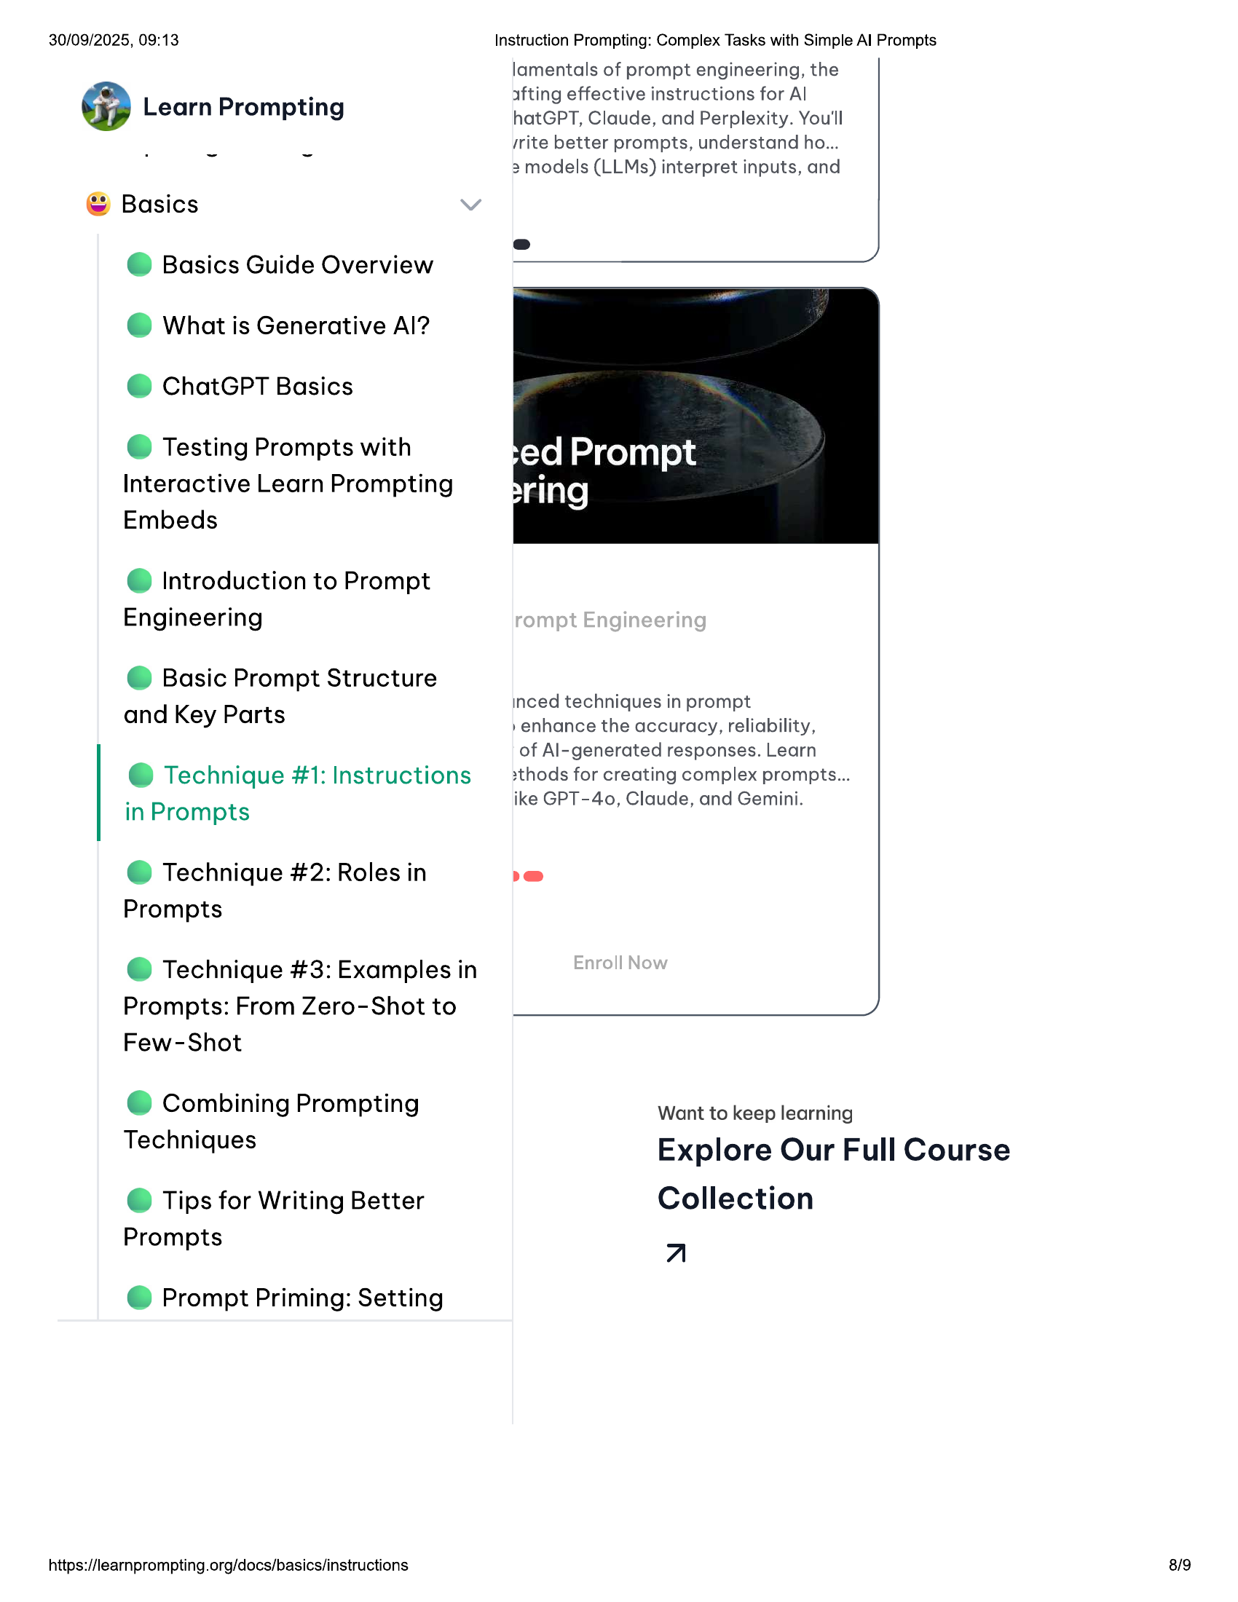

30/09/2025, 09:13 Instruction Prompting: Complex Tasks with Simple Al Prompts  
lamentals of prompt engineering, the  
  
* afting effective instructions for Al  
@ Learn Prompting hatGPT, Claude, and Perplexity. You'll  
/rite better prompts, understand ho...  
, ~ 3 models (LLMs) interpret inputs, and  
  
© Basics  
@ Basics Guide Overview  
© What is Generative Al?  
@ ChatGPT Basics  
  
© Testing Prompts with  
Interactive Learn Prompting  
Embeds  
  
@ Introduction to Prompt  
Engineering  
  
© Basic Prompt Structure  
and Key Parts  
  
inced techniques in prompt  
»enhance the accuracy, reliability,  
of Al-generated responses. Learn  
  
e@ Technique #1: Instructions 2thods for creating complex prompts...  
. ike GPT-40, Claude, and Gemini.  
in Prompts  
  
@ Technique #2: Roles in i)  
Prompts  
  
@ Technique #3: Examples in  
Prompts: From Zero-Shot to y,  
Few-Shot  
  
© Combining Prompting  
  
Want to keep learning  
  
Techniques Explore Our Full Course  
© Tips for Writing Better Collection  
Prompts z  
  
@ Prompt Priming: Setting  
  
https://learnprompting.org/docs/basics/instructions 8/9

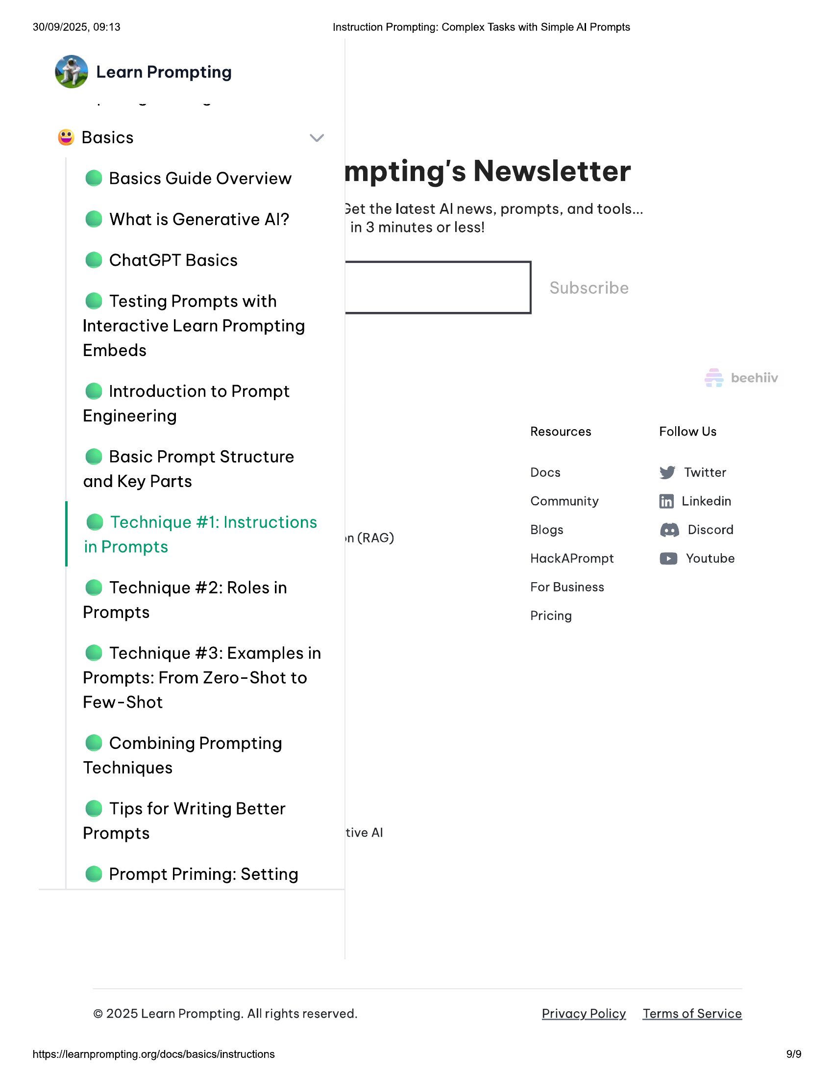

30/09/2025, 09:13 Instruction Prompting: Complex Tasks with Simple Al Prompts  
  
@ Learn Prompting  
  
© Basics  
@ Basics Guide Overview mpting's Newsletter  
  
3et the latest Al news, prompts, and tools...  
  
. . >  
© What is Generative Al? in 3 minutes or less!  
  
@ ChatGPT Basics  
  
© Testing Prompts with  
Interactive Learn Prompting  
Embeds  
  
@ Introduction to Prompt  
  
Engineering  
Resources Follow Us  
  
© Basic Prompt Structure  
  
and Key Parts Docs W Twitter  
Community ff} Linkedin  
  
@ Technique #1: Instructions n(RAG) Blogs (9 Discord  
  
in Prom  
  
ompts HackAPrompt © Youtube  
  
@ Technique #2: Roles in For Business  
  
Prompts Pricing  
  
@ Technique #3: Examples in  
  
Prompts: From Zero-Shot to  
  
Few-Shot  
  
© Combining Prompting  
  
Techniques  
  
© Tips for Writing Better  
  
Prompts tive Al  
  
@ Prompt Priming: Setting  
  
© 2025 Learn Prompting. All rights reserved. Privacy Policy Terms of Service  
  
https://learnprompting.org/docs/basics/instructions