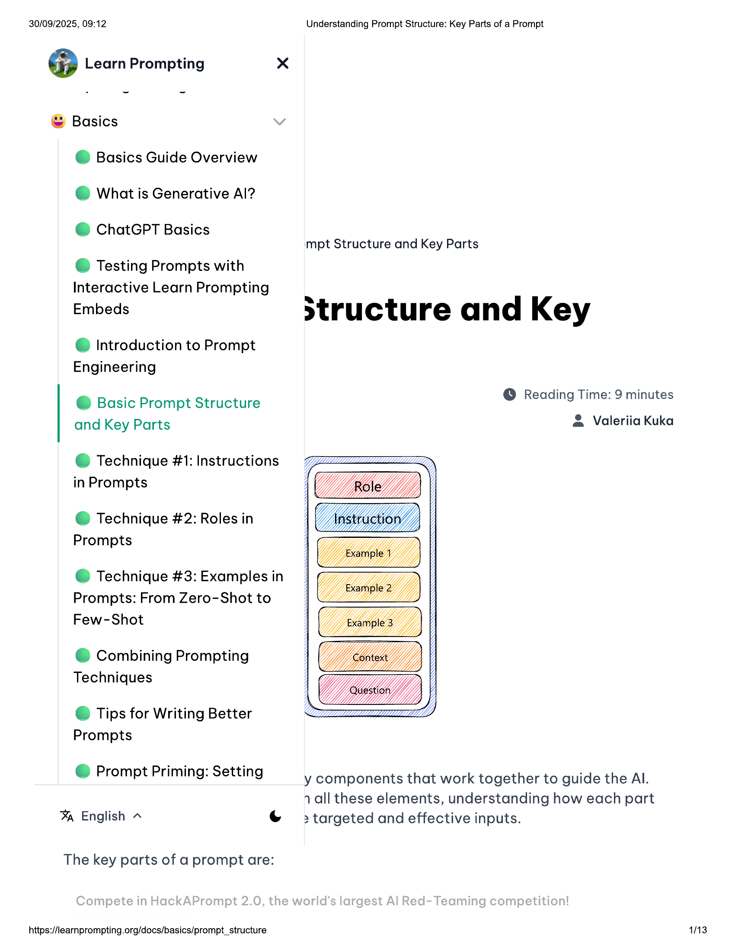

30/09/2025, 09:12 Understanding Prompt Structure: Key Parts of a Prompt  
  
@ Learn Prompting x  
  
© Basics  
@ Basics Guide Overview  
@ What is Generative Al?  
  
@ ChatGPT Basics  
mpt Structure and Key Parts  
  
© Testing Prompts with  
Interactive Learn Prompting  
  
Embeds structure and Key  
  
@ Introduction to Prompt  
Engineering  
  
@ Basic Prompt Structure © Reading Time: 9 minutes  
  
and Key Parts & Valeriia Kuka  
@ Technique #1: Instructions 77 ay  
  
in Prompts  
  
@ Technique #2: Roles in LED = j  
  
Prompts  
  
@ Technique #3: Examples in  
  
Prompts: From Zero-Shot to IL  
Few-Shot ZT  
  
© Tips for Writing Better  
Prompts  
  
© Prompt Priming: Setting y components that work together to guide the Al.  
  
1 all these elements, understanding how each part  
% English ~ © => targeted and effective inputs.  
  
The key parts of a prompt are:  
  
https://learnprompting.org/docs/basics/prompt_structure 1113

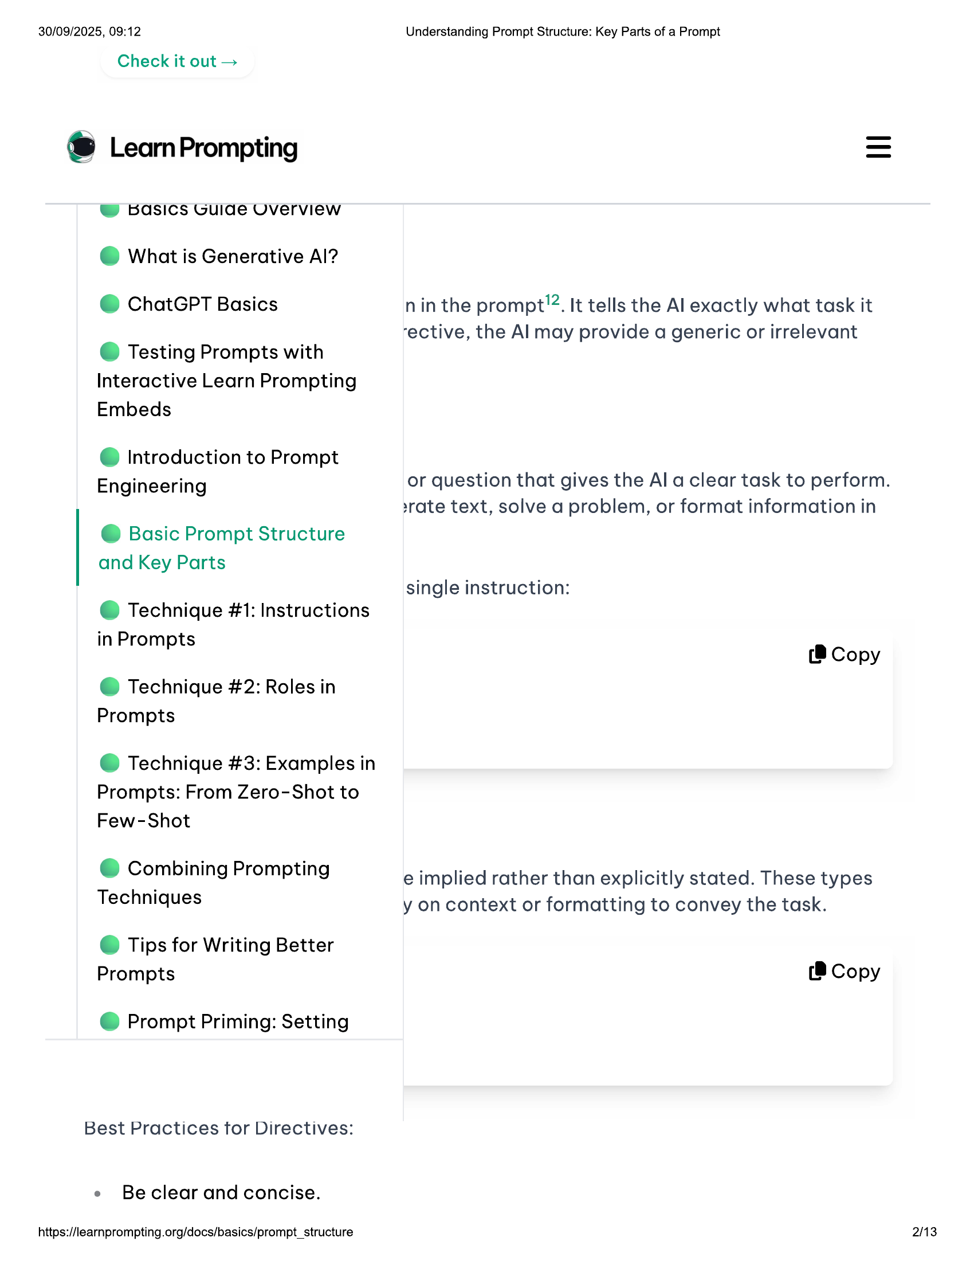

30/09/2025, 09:12 Understanding Prompt Structure: Key Parts of a Prompt  
  
Check it out =  
  
® LeamPrompting  
  
W basics Guide Uverview  
@ What is Generative Al?  
  
@ ChatGPT Basics nin the prompt”. It tells the Al exactly what task it  
  
-ective, the Al may provide a generic or irrelevant  
© Testing Prompts with  
  
Interactive Learn Prompting  
Embeds  
  
@ Introduction to Prompt  
Engineering or question that gives the Al a clear task to perform.  
  
srate text, solve a problem, or format information in  
@ Basic Prompt Structure  
  
and Key Parts  
single instruction:  
@ Technique #1: Instructions  
  
in Prompts  
P (8 Copy  
  
@ Technique #2: Roles in  
Prompts  
  
@ Technique #3: Examples in  
Prompts: From Zero-Shot to  
Few-Shot  
  
Ld Combining Prompting e implied rather than explicitly stated. These types  
Techniques y on context or formatting to convey the task.  
  
© Tips for Writing Better  
Prompts (8 Copy  
  
@ Prompt Priming: Setting  
  
Best Practices tor Directives:  
  
e Beclear and concise.  
  
https://learnprompting.org/docs/basics/prompt_structure 2/13

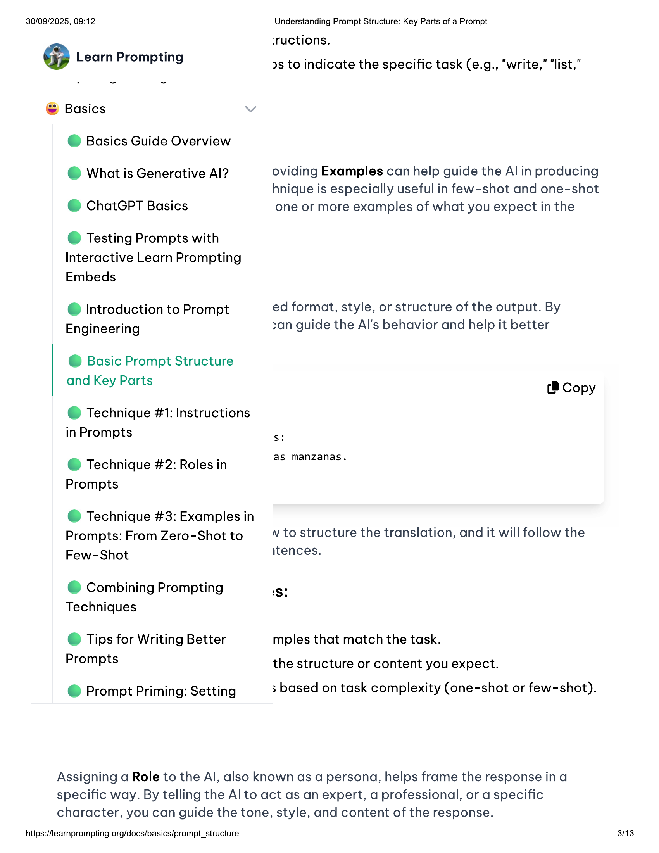

30/09/2025, 09:12  
@ Learn Prompting  
  
© Basics  
@ Basics Guide Overview  
@ What is Generative Al?  
@ ChatGPT Basics  
  
© Testing Prompts with  
Interactive Learn Prompting  
Embeds  
  
@ Introduction to Prompt  
Engineering  
  
@ Basic Prompt Structure  
and Key Parts  
  
@ Technique #1: Instructions  
in Prompts  
  
@ Technique #2: Roles in  
Prompts  
  
@ Technique #3: Examples in  
Prompts: From Zero-Shot to  
Few-Shot  
  
© Combining Prompting  
Techniques  
  
© Tips for Writing Better  
Prompts  
  
@ Prompt Priming: Setting  
  
Understanding Prompt Structure: Key Parts of a Prompt  
‘ructions.  
  
ys to indicate the specific task (e.g., “write,” “list,”  
  
oviding Examples can help guide the Al in producing  
hnique is especially useful in few-shot and one-shot  
one or more examples of what you expect in the  
  
ed format, style, or structure of the output. By  
san guide the Al's behavior and help it better  
  
(8 Copy  
  
Ss:  
  
as manzanas.  
  
nv to structure the translation, and it will follow the  
itences.  
  
'S?  
  
mples that match the task.  
the structure or content you expect.  
  
; based on task complexity (one-shot or few-shot).  
  
Assigning a Role to the Al, also known as a persona, helps frame the response ina  
specific way. By telling the Al to act as an expert, a professional, or a specific  
character, you can guide the tone, style, and content of the response.  
  
https://learnprompting.org/docs/basics/prompt_structure  
  
3/13

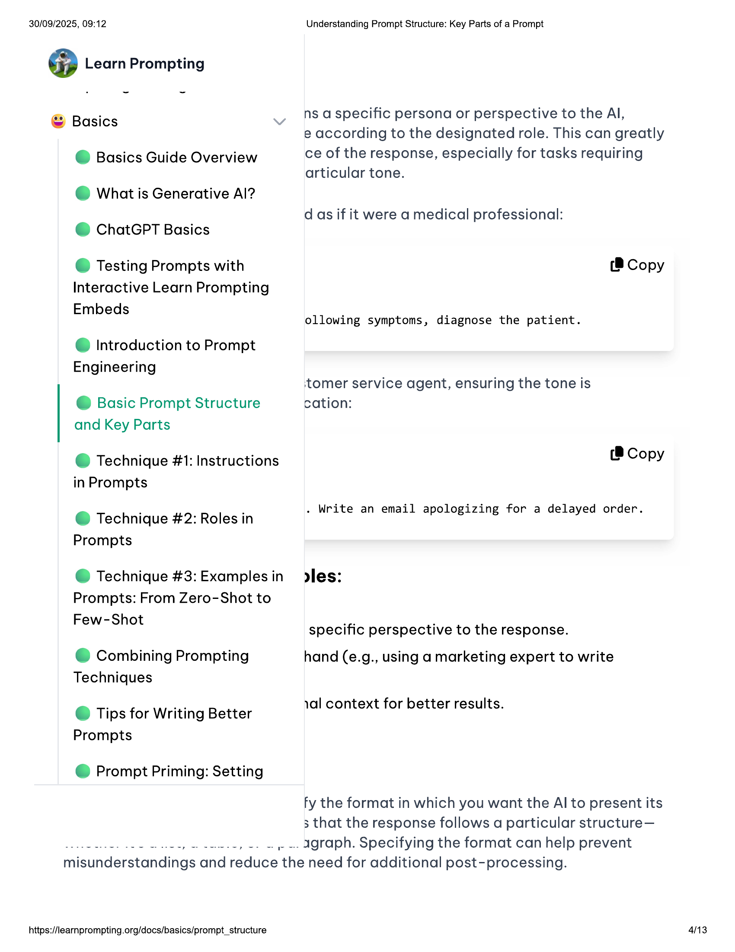

30/09/2025, 09:12  
  
@ Learn Prompting  
  
© Basics  
@ Basics Guide Overview  
© What is Generative Al?  
@ ChatGPT Basics  
  
© Testing Prompts with  
Interactive Learn Prompting  
Embeds  
  
@ Introduction to Prompt  
Engineering  
  
@ Basic Prompt Structure  
and Key Parts  
  
@ Technique #1: Instructions  
  
in Prompts  
  
@ Technique #2: Roles in  
Prompts  
  
@ Technique #3: Examples in  
  
Prompts: From Zero-Shot to  
Few-Shot  
  
© Combining Prompting  
Techniques  
  
© Tips for Writing Better  
Prompts  
  
@ Prompt Priming: Setting  
  
Understanding Prompt Structure: Key Parts of a Prompt  
  
ns a specific persona or perspective to the Al,  
  
@ according to the designated role. This can greatly  
ce of the response, especially for tasks requiring  
articular tone.  
  
d as if it were a medical professional:  
  
(® Copy  
ollowing symptoms, diagnose the patient.  
‘tomer service agent, ensuring the tone is  
cation:  
  
(8 Copy  
  
. Write an email apologizing for a delayed order.  
  
rles:  
  
specific perspective to the response.  
  
hand (e.g., using a marketing expert to write  
  
yal context for better results.  
  
fy the format in which you want the Al to present its  
3 that the response follows a particular structure—  
  
(oo, nee, -- ~ » -. Agraph. Specifying the format can help prevent  
  
misunderstandings and reduce the need for additional post-processing.  
  
https://learnprompting.org/docs/basics/prompt_structure  
  
43

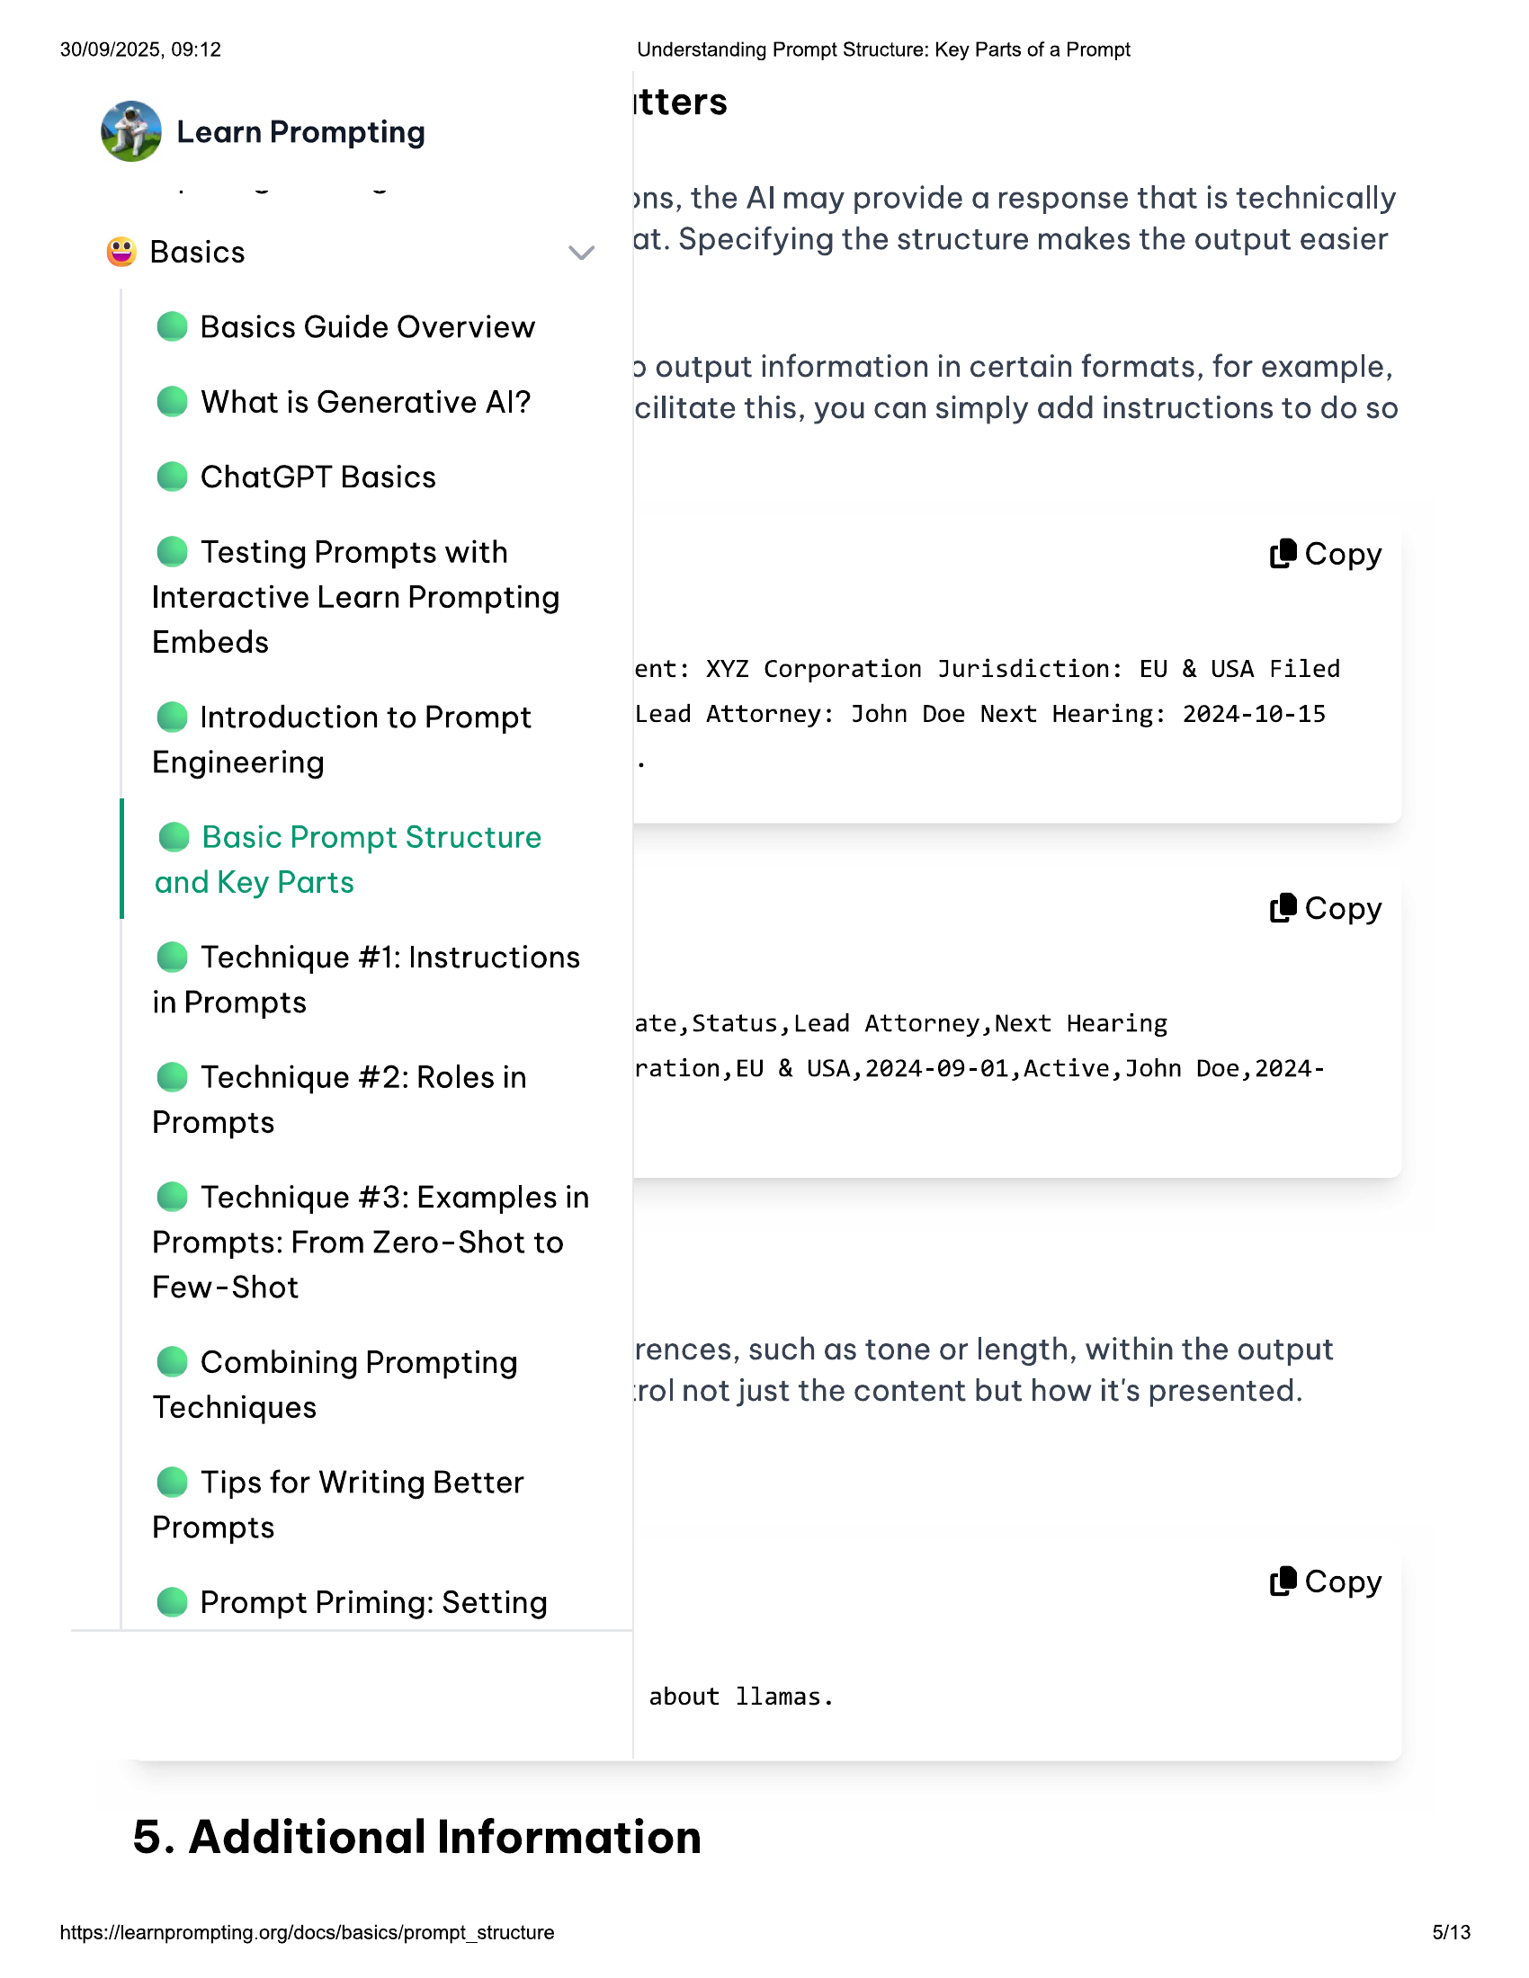

30/09/2025, 09:12  
@ Learn Prompting  
  
© Basics  
@ Basics Guide Overview  
@ What is Generative Al?  
@ ChatGPT Basics  
  
© Testing Prompts with  
Interactive Learn Prompting  
Embeds  
  
@ Introduction to Prompt  
Engineering  
  
@ Basic Prompt Structure  
and Key Parts  
  
@ Technique #1: Instructions  
in Prompts  
  
@ Technique #2: Roles in  
Prompts  
  
@ Technique #3: Examples in  
Prompts: From Zero-Shot to  
Few-Shot  
  
© Combining Prompting  
Techniques  
  
© Tips for Writing Better  
Prompts  
  
@ Prompt Priming: Setting  
  
Understanding Prompt Structure: Key Parts of a Prompt  
  
itters  
  
»ns, the Al may provide a response that is technically  
at. Specifying the structure makes the output easier  
  
2 output information in certain formats, for example,  
cilitate this, you can simply add instructions to do so  
  
(8 Copy  
  
ent: XYZ Corporation Jurisdiction: EU & USA Filed  
Lead Attorney: John Doe Next Hearing: 2024-10-15  
  
(8 Copy  
  
ate,Status,Lead Attorney,Next Hearing  
ration,EU & USA, 2024-09-@1,Active, John Doe, 2024-  
  
rences, such as tone or length, within the output  
‘rol not just the content but how it's presented.  
  
(8 Copy  
  
about llamas.  
  
5. Additional Information  
  
https://learnprompting.org/docs/basics/prompt_structure  
  
5/13

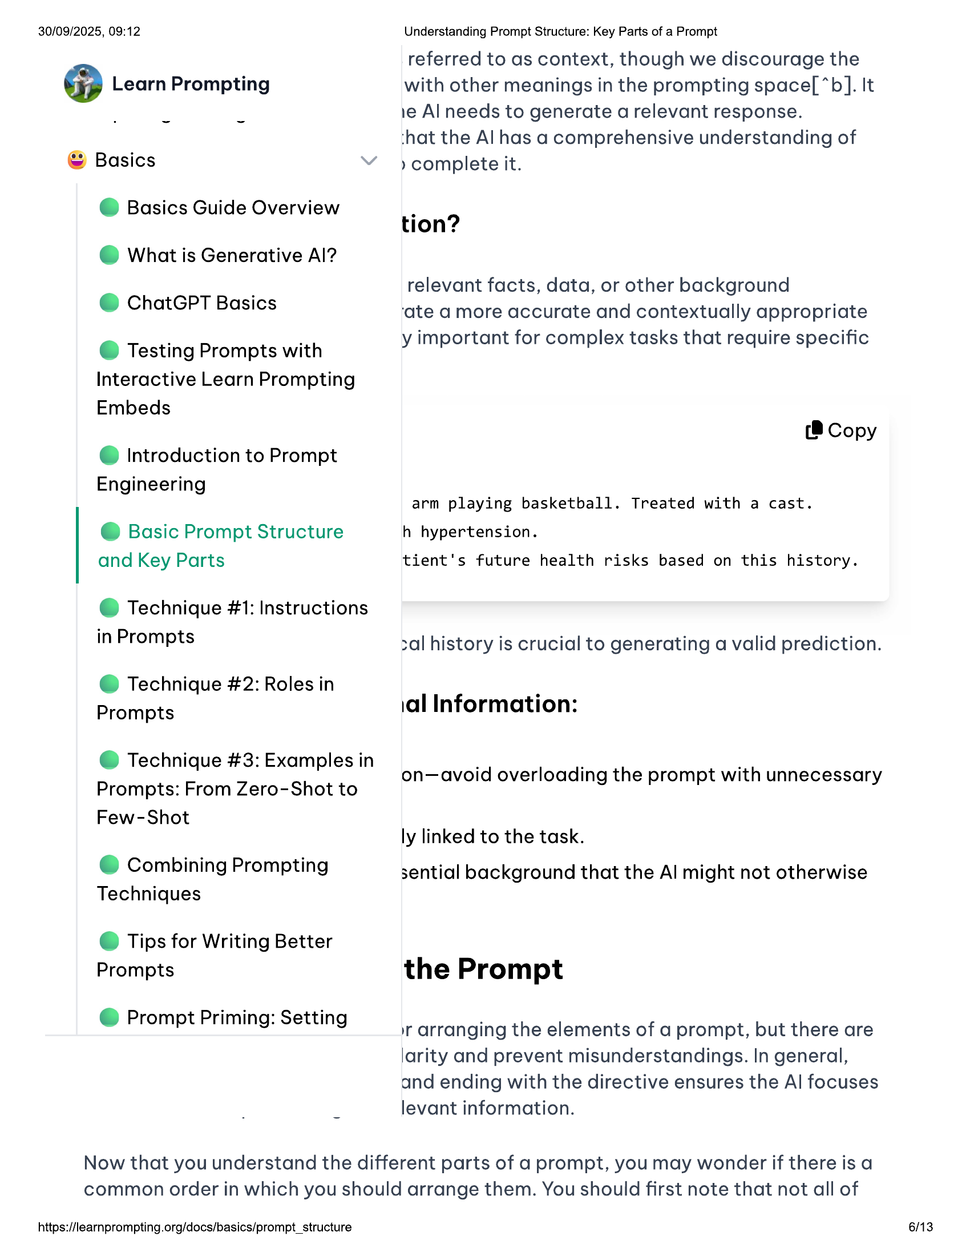

30/09/2025, 09:12  
  
@ Learn Prompting  
  
© Basics  
@ Basics Guide Overview  
@ What is Generative Al?  
@ ChatGPT Basics  
  
© Testing Prompts with  
Interactive Learn Prompting  
Embeds  
  
@ Introduction to Prompt  
Engineering  
  
@ Basic Prompt Structure  
and Key Parts  
  
@ Technique #1: Instructions  
  
in Prompts  
  
@ Technique #2: Roles in  
Prompts  
  
@ Technique #3: Examples in  
  
Prompts: From Zero-Shot to  
Few-Shot  
  
© Combining Prompting  
Techniques  
  
© Tips for Writing Better  
Prompts  
  
@ Prompt Priming: Setting  
  
Understanding Prompt Structure: Key Parts of a Prompt  
  
referred to as context, though we discourage the  
with other meanings in the prompting space[ “*b]. It  
1e Al needs to generate a relevant response.  
  
‘hat the Al has a comprehensive understanding of  
  
» complete it.  
  
tion?  
  
relevant facts, data, or other background  
‘ate a more accurate and contextually appropriate  
y important for complex tasks that require specific  
  
(®@ Copy  
  
arm playing basketball. Treated with a cast.  
h hypertension.  
  
tient's future health risks based on this history.  
  
zal history is crucial to generating a valid prediction.  
  
ial Information:  
  
on—avoid overloading the prompt with unnecessary  
  
ly linked to the task.  
  
sential background that the Al might not otherwise  
  
the Prompt  
  
1 arranging the elements of a prompt, but there are  
larity and prevent misunderstandings. In general,  
and ending with the directive ensures the Al focuses  
levant information.  
  
Now that you understand the different parts of a prompt, you may wonder if there is a  
common order in which you should arrange them. You should first note that not all of  
  
https://learnprompting.org/docs/basics/prompt_structure  
  
6/13

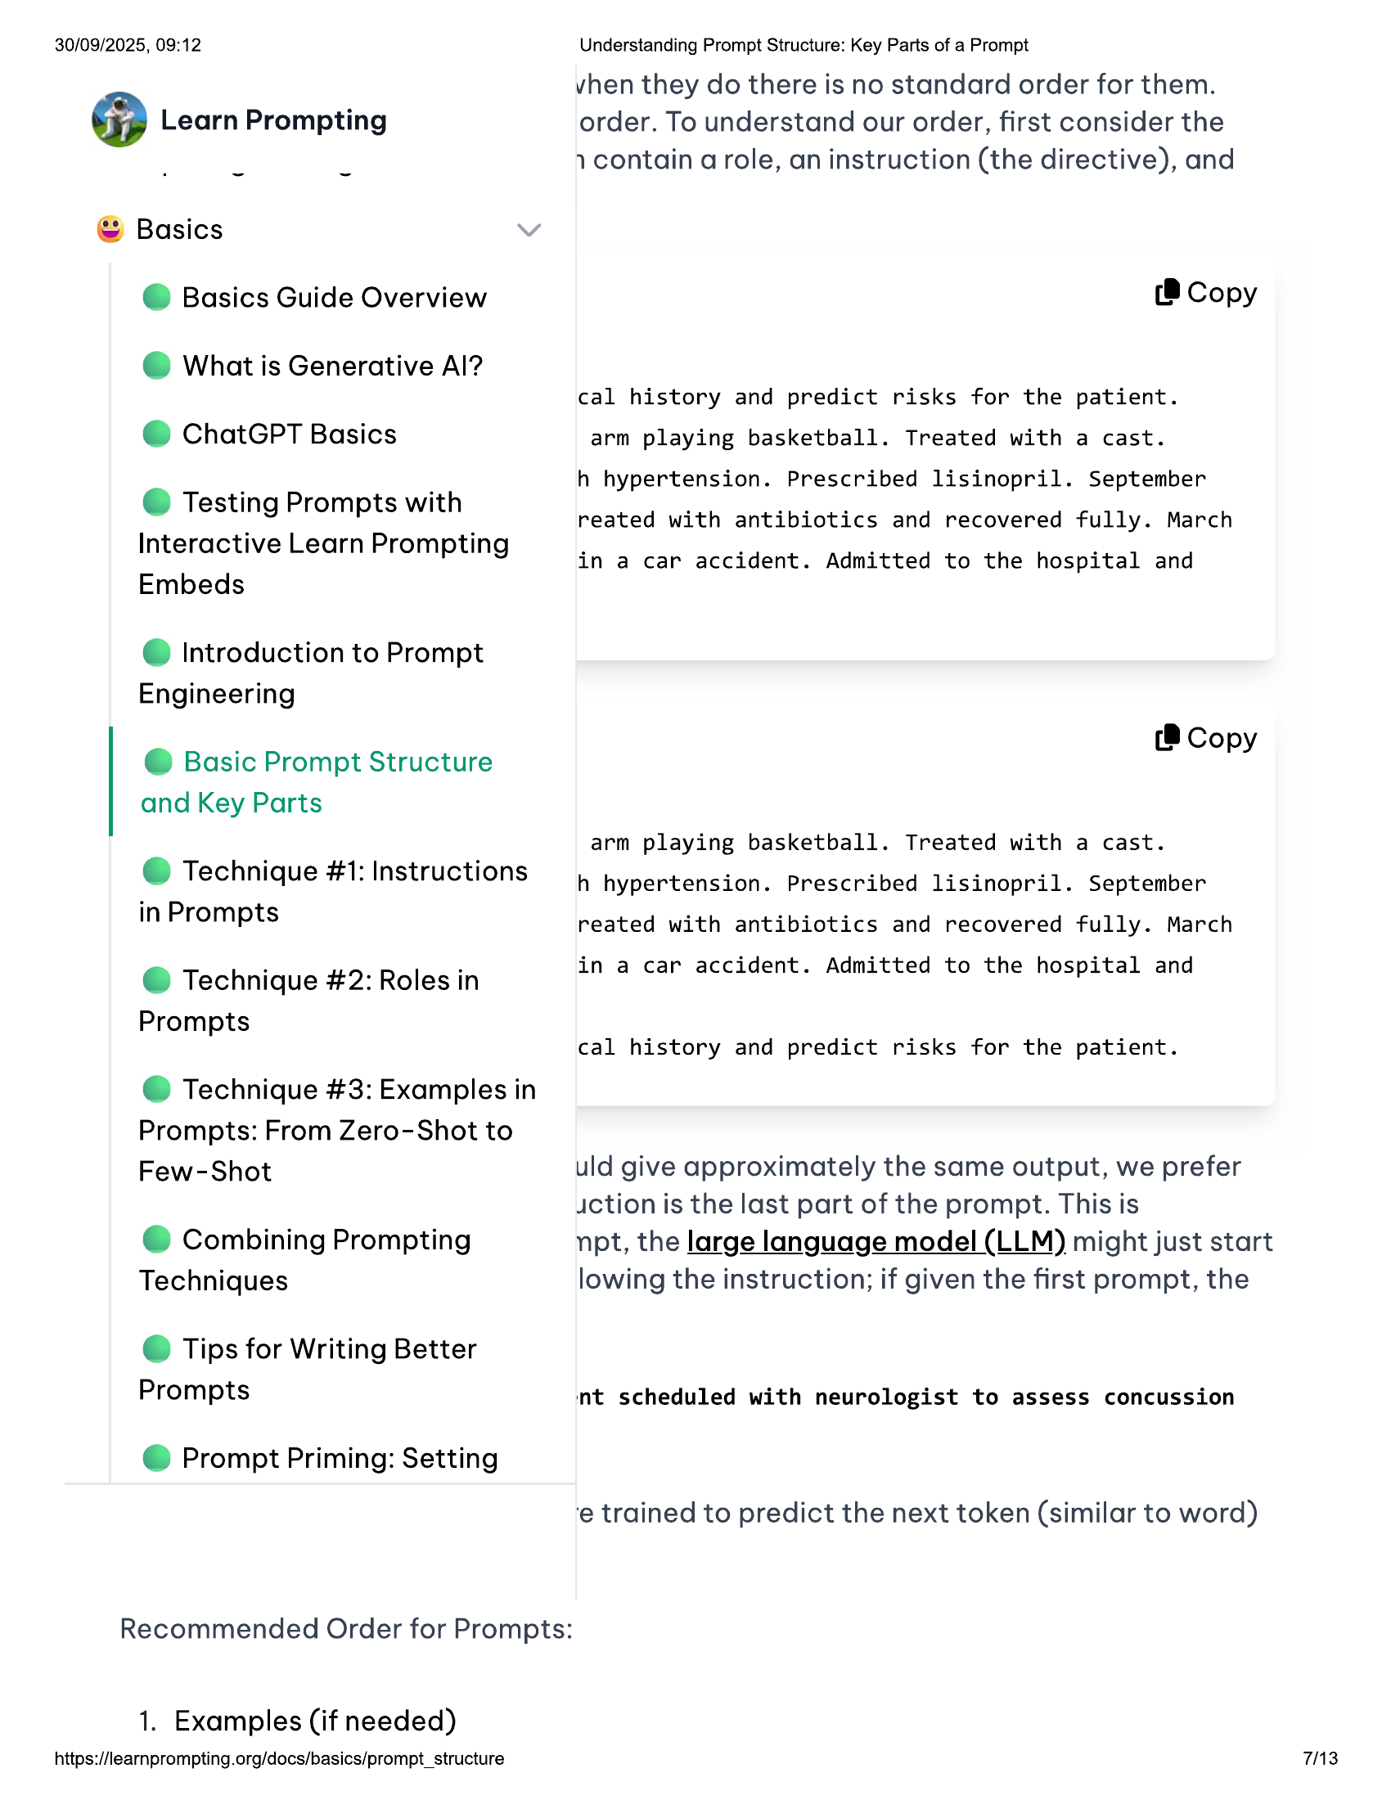

30/09/2025, 09:12  
  
@ Learn Prompting  
  
© Basics  
@ Basics Guide Overview  
© What is Generative Al?  
© ChatGPT Basics  
  
© Testing Prompts with  
Interactive Learn Prompting  
Embeds  
  
@ Introduction to Prompt  
Engineering  
  
@ Basic Prompt Structure  
and Key Parts  
  
@ Technique #1: Instructions  
  
in Prompts  
  
@ Technique #2: Roles in  
Prompts  
  
@ Technique #3: Examples in  
  
Prompts: From Zero-Shot to  
Few-Shot  
  
© Combining Prompting  
Techniques  
  
© Tips for Writing Better  
Prompts  
  
@ Prompt Priming: Setting  
  
Recommended Order for Prompts:  
  
1. Examples (if needed)  
  
https://learnprompting.org/docs/basics/prompt_structure  
  
Understanding Prompt Structure: Key Parts of a Prompt  
  
vhen they do there is no standard order for them.  
order. To understand our order, first consider the  
1 contain a role, an instruction (the directive), and  
  
(8 Copy  
  
cal history and predict risks for the patient.  
  
arm playing basketball. Treated with a cast.  
  
h hypertension. Prescribed lisinopril. September  
reated with antibiotics and recovered fully. March  
  
in a car accident. Admitted to the hospital and  
  
(® Copy  
  
arm playing basketball. Treated with a cast.  
h hypertension. Prescribed lisinopril. September  
reated with antibiotics and recovered fully. March  
  
in a car accident. Admitted to the hospital and  
  
cal history and predict risks for the patient.  
  
uld give approximately the same output, we prefer  
diction is the last part of the prompt. This is  
  
npt, the large language model (LLM) might just start  
lowing the instruction; if given the first prompt, the  
  
‘nt scheduled with neurologist to assess concussion  
  
‘e trained to predict the next token (similar to word)  
  
713

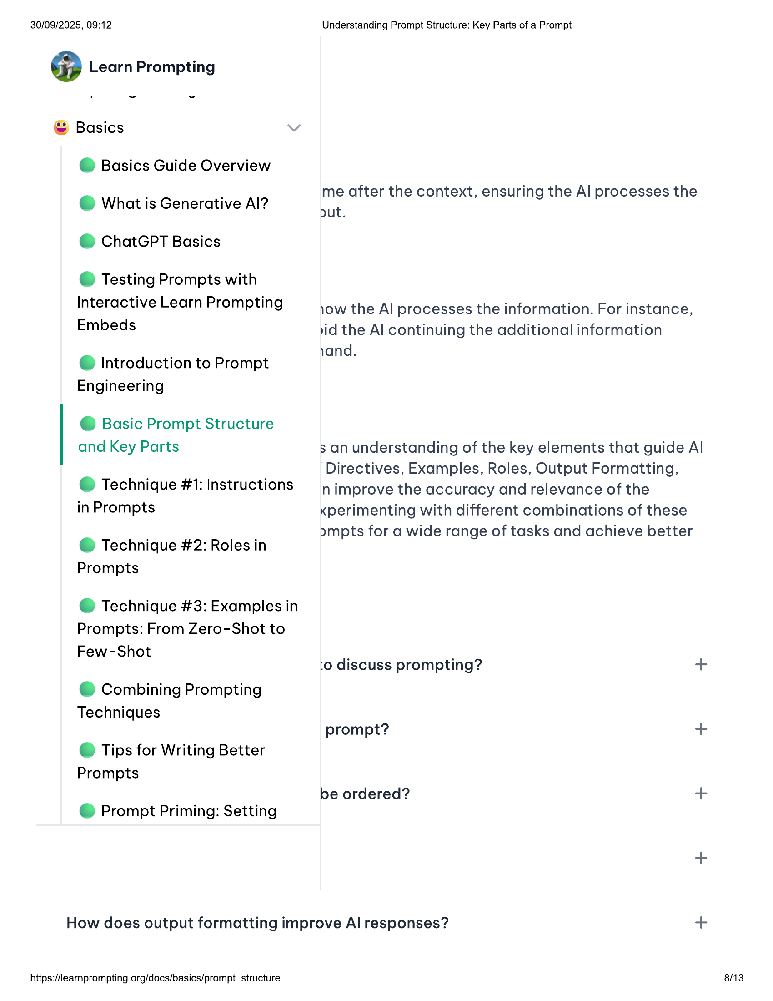

30/09/2025, 09:12  
@ Learn Prompting  
  
© Basics  
@ Basics Guide Overview  
@ What is Generative Al?  
© ChatGPT Basics  
  
© Testing Prompts with  
Interactive Learn Prompting  
Embeds  
  
@ Introduction to Prompt  
Engineering  
  
@ Basic Prompt Structure  
and Key Parts  
  
@ Technique #1: Instructions  
in Prompts  
  
@ Technique #2: Roles in  
Prompts  
  
@ Technique #3: Examples in  
Prompts: From Zero-Shot to  
Few-Shot  
  
Understanding Prompt Structure: Key Parts of a Prompt  
  
me after the context, ensuring the Al processes the  
ut.  
  
10w the Al processes the information. For instance,  
vid the Al continuing the additional information  
and.  
  
$ an understanding of the key elements that guide Al  
‘Directives, Examples, Roles, Output Formatting,  
  
in improve the accuracy and relevance of the  
xperimenting with different combinations of these  
ompts for a wide range of tasks and achieve better  
  
:o discuss prompting? +  
© Combining Prompting  
Techniques  
prompt? +  
© Tips for Writing Better  
Prompts  
be ordered? +  
@ Prompt Priming: Setting  
+  
How does output formatting improve Al responses? +  
  
https://learnprompting.org/docs/basics/prompt_structure  
  
8/13

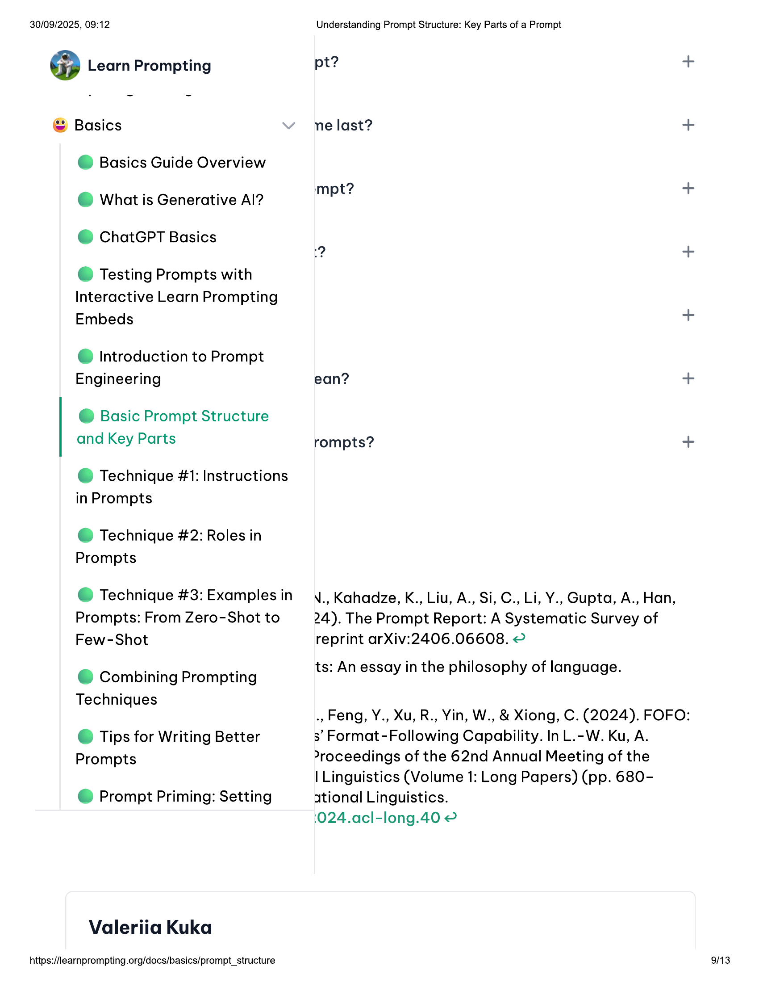

30/09/2025, 09:12  
@ Learn Prompting  
  
© Basics  
@ Basics Guide Overview  
© What is Generative Al?  
@ ChatGPT Basics  
  
© Testing Prompts with  
Interactive Learn Prompting  
Embeds  
  
@ Introduction to Prompt  
Engineering  
  
@ Basic Prompt Structure  
and Key Parts  
  
@ Technique #1: Instructions  
in Prompts  
  
@ Technique #2: Roles in  
Prompts  
  
@ Technique #3: Examples in  
Prompts: From Zero-Shot to  
Few-Shot  
  
© Combining Prompting  
Techniques  
  
© Tips for Writing Better  
Prompts  
  
@ Prompt Priming: Setting  
  
Valeriia Kuka  
  
https://learnprompting.org/docs/basics/prompt_structure  
  
Understanding Prompt Structure: Key Parts of a Prompt  
  
pt? +  
ne last? +  
impt? +  
? +  
  
+  
ean? +  
rompts? +  
  
N., Kahadze, K., Liu, A., Si, C., Li, Y., Gupta, A., Han,  
24). The Prompt Report: A Systematic Survey of  
reprint arXiv:2406.06608. 2  
  
ts: An essay in the philosophy of language.  
  
., Feng, Y., Xu, R., Yin, W., & Xiong, C. (2024). FOFO:  
3’ Format-Following Capability. In L.-W. Ku, A.  
>roceedings of the 62nd Annual Meeting of the  
  
| Linguistics (Volume 1: Long Papers) (pp. 680-  
ational Linguistics.  
  
1024.acl-long.40 2  
  
9/13

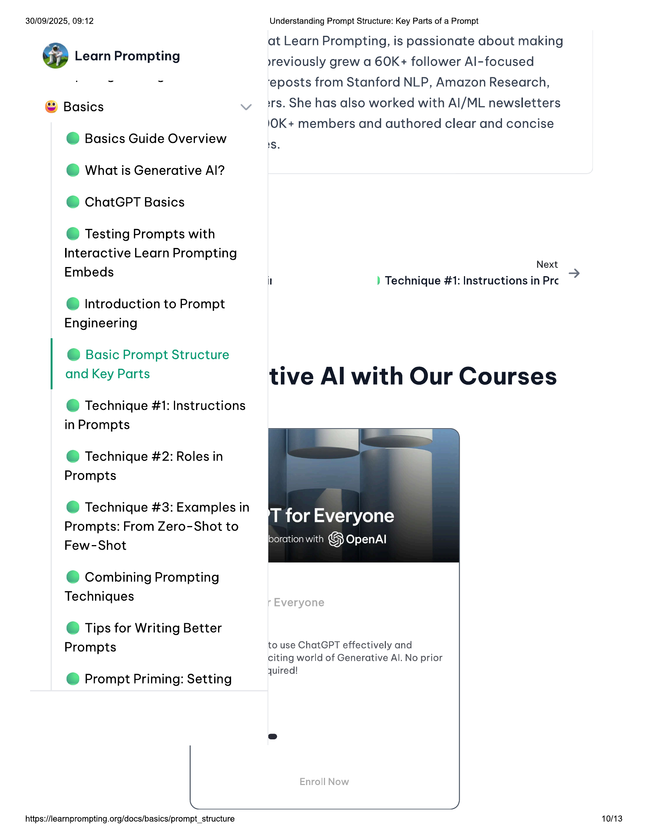

30/09/2025, 09:12 Understanding Prompt Structure: Key Parts of a Prompt  
at Learn Prompting, is passionate about making  
@ Learn Prompting »yreviously grew a 60K+ follower Al-focused  
. ~ ~ ‘eposts from Stanford NLP, Amazon Research,  
© Basics irs. She has also worked with Al/ML newsletters  
1OK+ members and authored clear and concise  
  
@ Basics Guide Overview Is  
  
© What is Generative Al?  
@ ChatGPT Basics  
  
© Testing Prompts with  
Interactive Learn Prompting  
Next  
  
Embeds i ) Technique #1: Instructions in Pre ?  
  
@ Introduction to Prompt  
Engineering  
  
@ Basic Prompt Structure  
  
and Key Parts tive Al with Our Courses  
@ Technique #1: Instructions  
  
in Prompts  
  
@ Technique #2: Roles in » |  
  
Prompts  
  
@ Technique #3: Examples in  
Prompts: From Zero-Shot to  
Few-Shot  
  
T for Everyone  
boration with 1S) OpenAl  
  
© Combining Prompting  
Techniques  
  
© Tips for Writing Better  
  
Prompts to use ChatGPT effectively and  
citing world of Generative Al. No prior  
oe : quired!  
@ Prompt Priming: Setting  
e  
  
https://learnprompting.org/docs/basics/prompt_structure 10/13

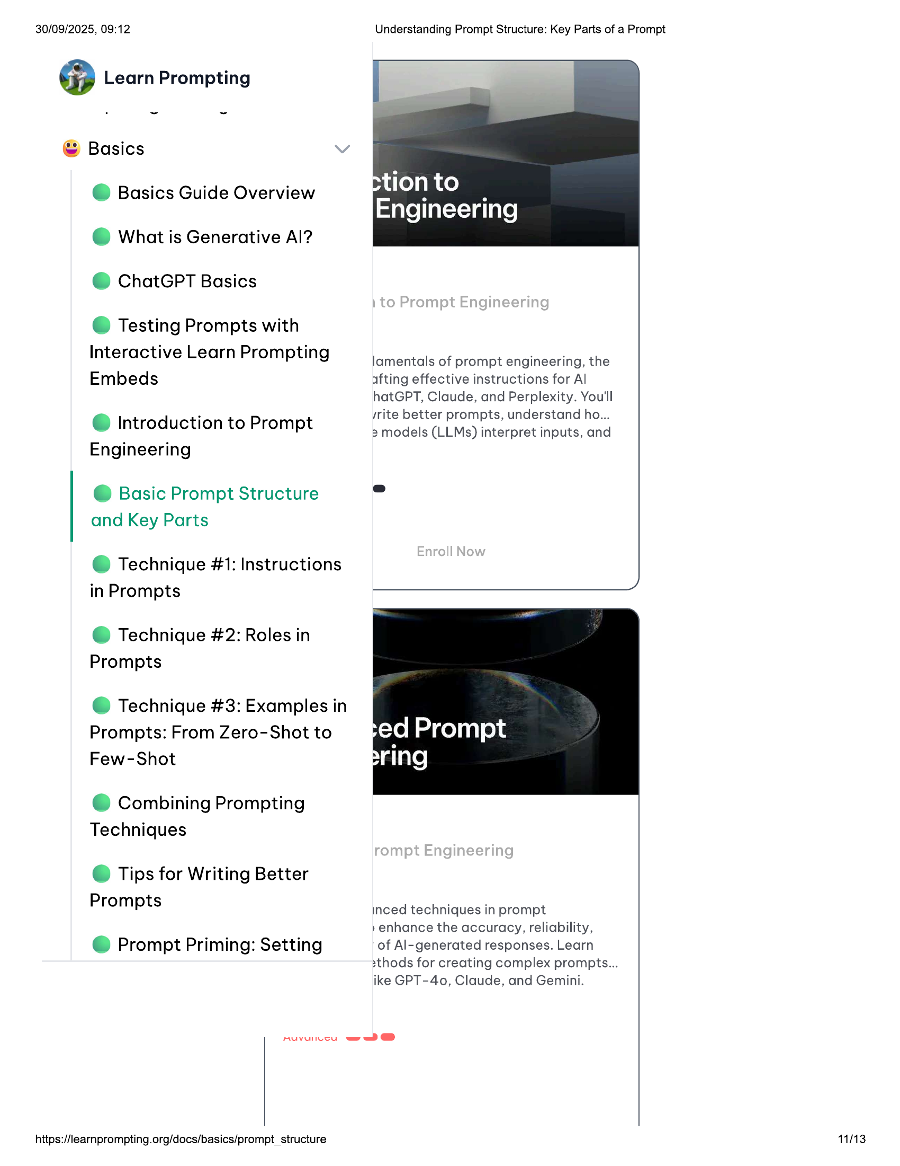

30/09/2025, 09:12  
  
@ Learn Prompting  
  
© Basics  
@ Basics Guide Overview  
@ What is Generative Al?  
@ ChatGPT Basics  
  
© Testing Prompts with  
Interactive Learn Prompting  
Embeds  
  
@ Introduction to Prompt  
Engineering  
  
@ Basic Prompt Structure  
and Key Parts  
  
@ Technique #1: Instructions  
in Prompts  
  
@ Technique #2: Roles in  
Prompts  
  
@ Technique #3: Examples in  
Prompts: From Zero-Shot to  
Few-Shot  
  
© Combining Prompting  
Techniques  
  
© Tips for Writing Better  
Prompts  
  
@ Prompt Priming: Setting  
  
muvunesu  
  
https://learnprompting.org/docs/basics/prompt_structure  
  
=ww@®@  
  
Understanding Prompt Structure: Key Parts of a Prompt  
  
tion to  
Engineering  
  
lamentals of prompt engineering, the  
afting effective instructions for Al  
  
hatGPT, Claude, and Perplexity. You'll  
rite better prompts, understand ho...  
2 models (LLMs) interpret inputs, and  
  
inced techniques in prompt  
  
»enhance the accuracy, reliability,  
  
of Al-generated responses. Learn  
xthods for creating complex prompts...  
ike GPT-40, Claude, and Gemini.  
  
11/13

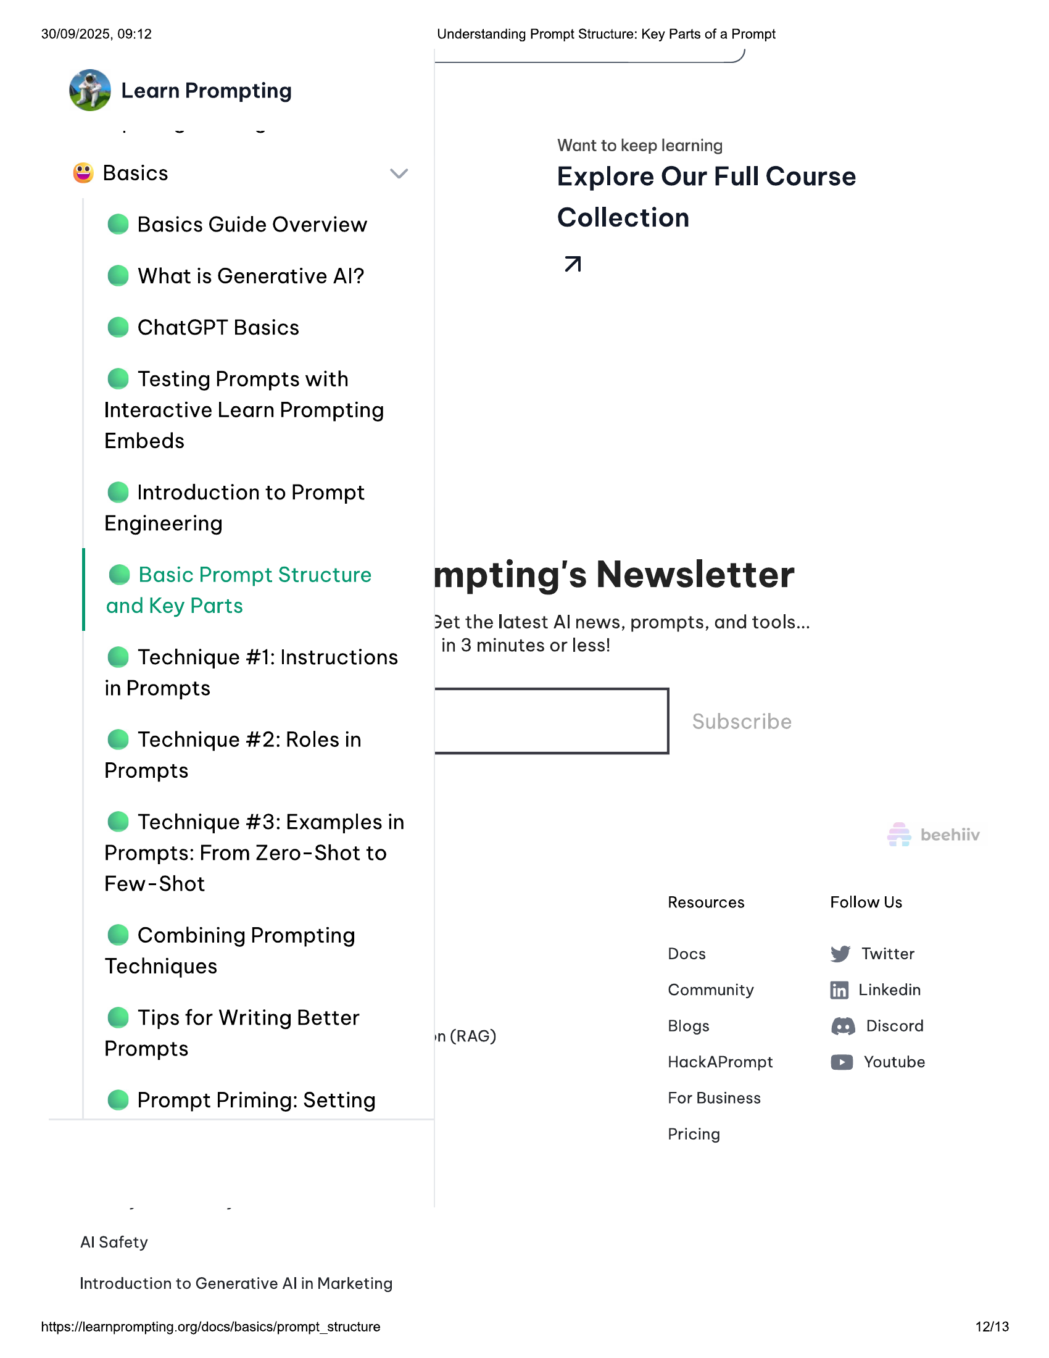

30/09/2025, 09:12  
@ Learn Prompting  
  
© Basics  
@ Basics Guide Overview  
@ What is Generative Al?  
@ ChatGPT Basics  
  
© Testing Prompts with  
Interactive Learn Prompting  
Embeds  
  
@ Introduction to Prompt  
Engineering  
  
@ Basic Prompt Structure  
and Key Parts  
  
@ Technique #1: Instructions  
in Prompts  
  
@ Technique #2: Roles in  
Prompts  
  
@ Technique #3: Examples in  
Prompts: From Zero-Shot to  
Few-Shot  
  
© Combining Prompting  
Techniques  
  
© Tips for Writing Better  
Prompts  
  
@ Prompt Priming: Setting  
  
Al Safety  
Introduction to Generative Al in Marketing  
  
https://learnprompting.org/docs/basics/prompt_structure  
  
Understanding Prompt Structure: Key Parts of a Prompt  
J  
  
Want to keep learning  
  
Explore Our Full Course  
Collection  
  
a  
  
mpting's Newsletter  
  
3et the latest Al news, prompts, and tools...  
in 3 minutes or less!  
  
|  
  
Resources Follow Us  
Docs W Twitter  
Community ff Linkedin  
n (RAG) Blogs @ Discord  
HackAPrompt © Youtube  
  
For Business  
  
Pricing  
  
12/13

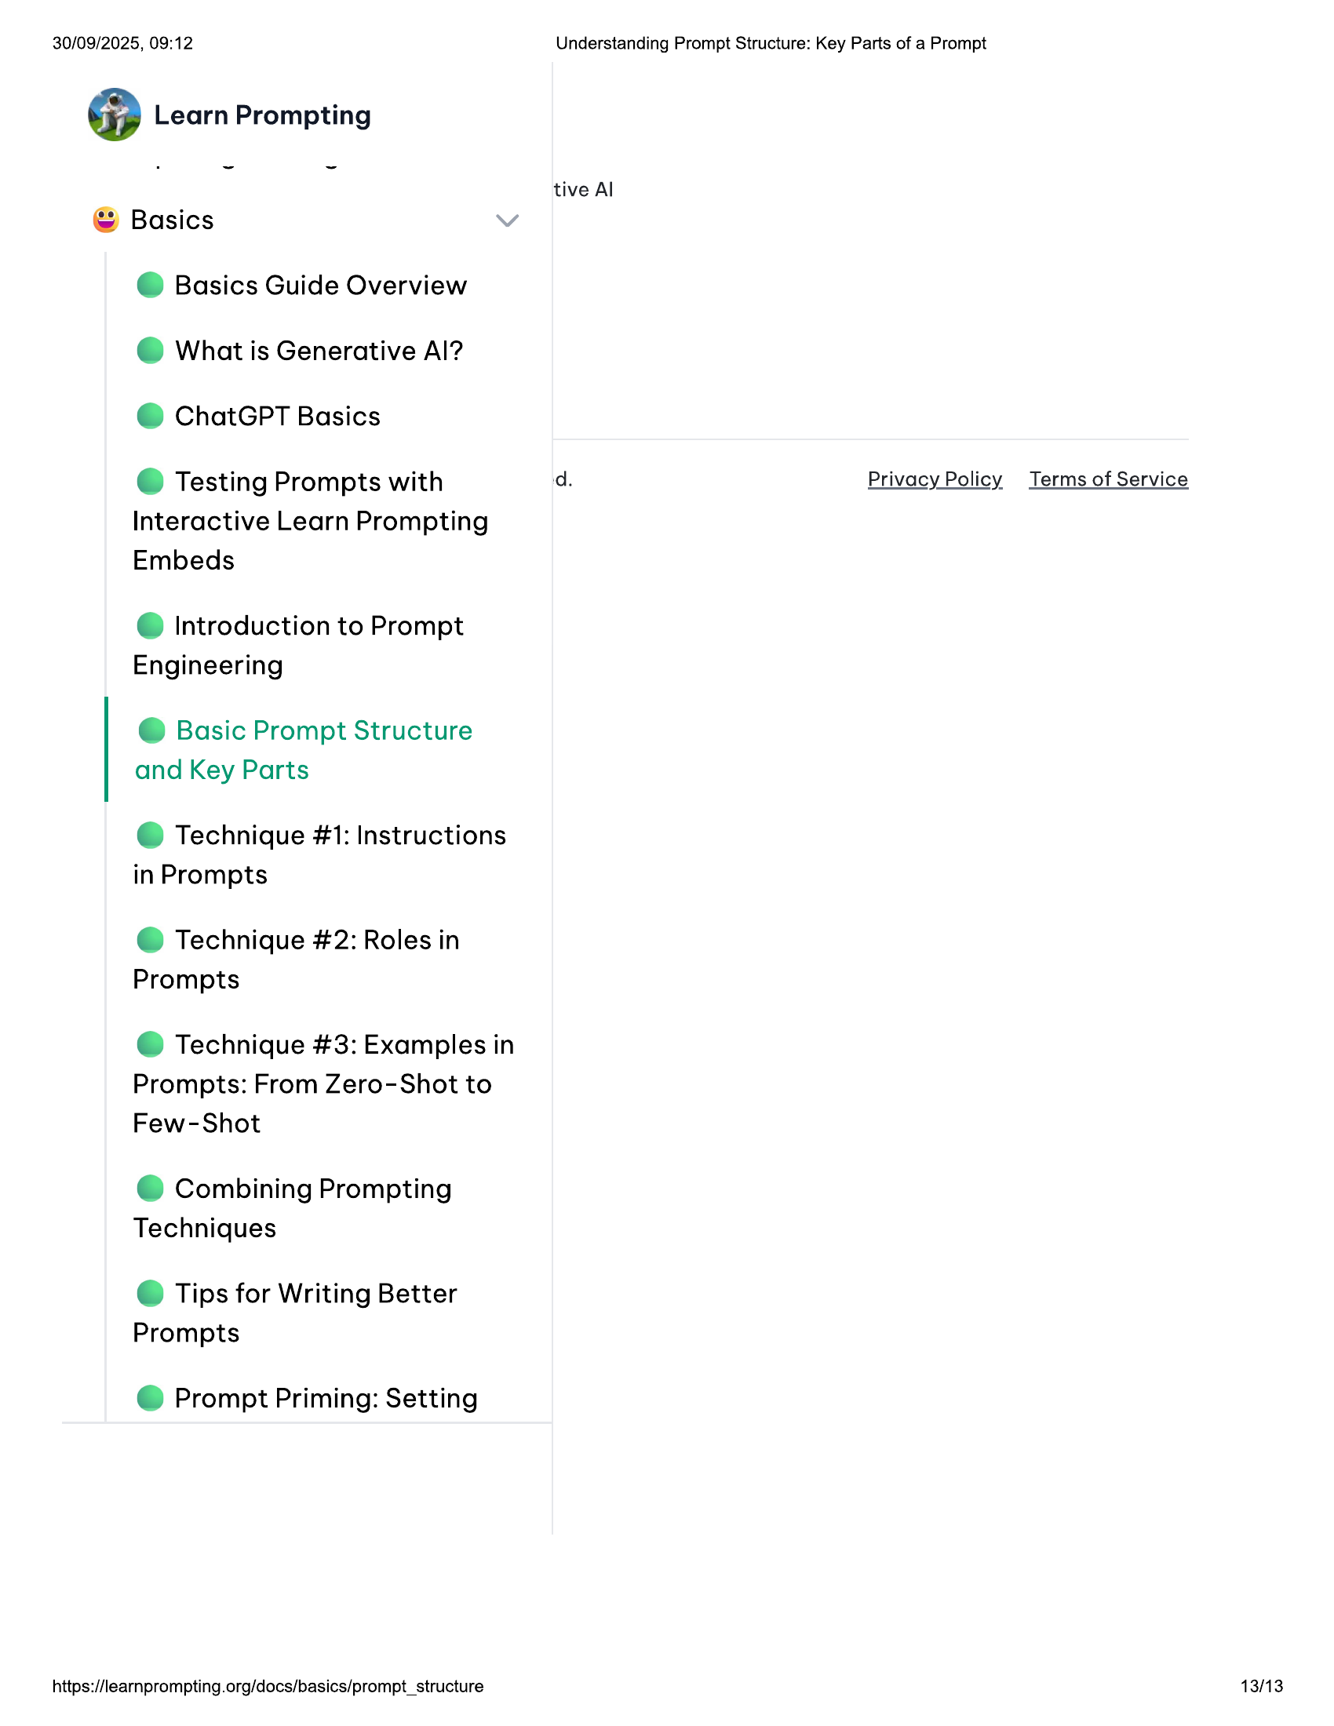

30/09/2025, 09:12  
@ Learn Prompting  
  
© Basics  
@ Basics Guide Overview  
@ What is Generative Al?  
@ ChatGPT Basics  
  
© Testing Prompts with  
Interactive Learn Prompting  
Embeds  
  
@ Introduction to Prompt  
Engineering  
  
@ Basic Prompt Structure  
and Key Parts  
  
@ Technique #1: Instructions  
in Prompts  
  
@ Technique #2: Roles in  
Prompts  
  
@ Technique #3: Examples in  
Prompts: From Zero-Shot to  
Few-Shot  
  
© Combining Prompting  
Techniques  
  
© Tips for Writing Better  
Prompts  
  
@ Prompt Priming: Setting  
  
https://learnprompting.org/docs/basics/prompt_structure  
  
Understanding Prompt Structure: Key Parts of a Prompt  
  
tive Al  
  
d. Privacy Policy  
  
Terms of Service  
  
13/13