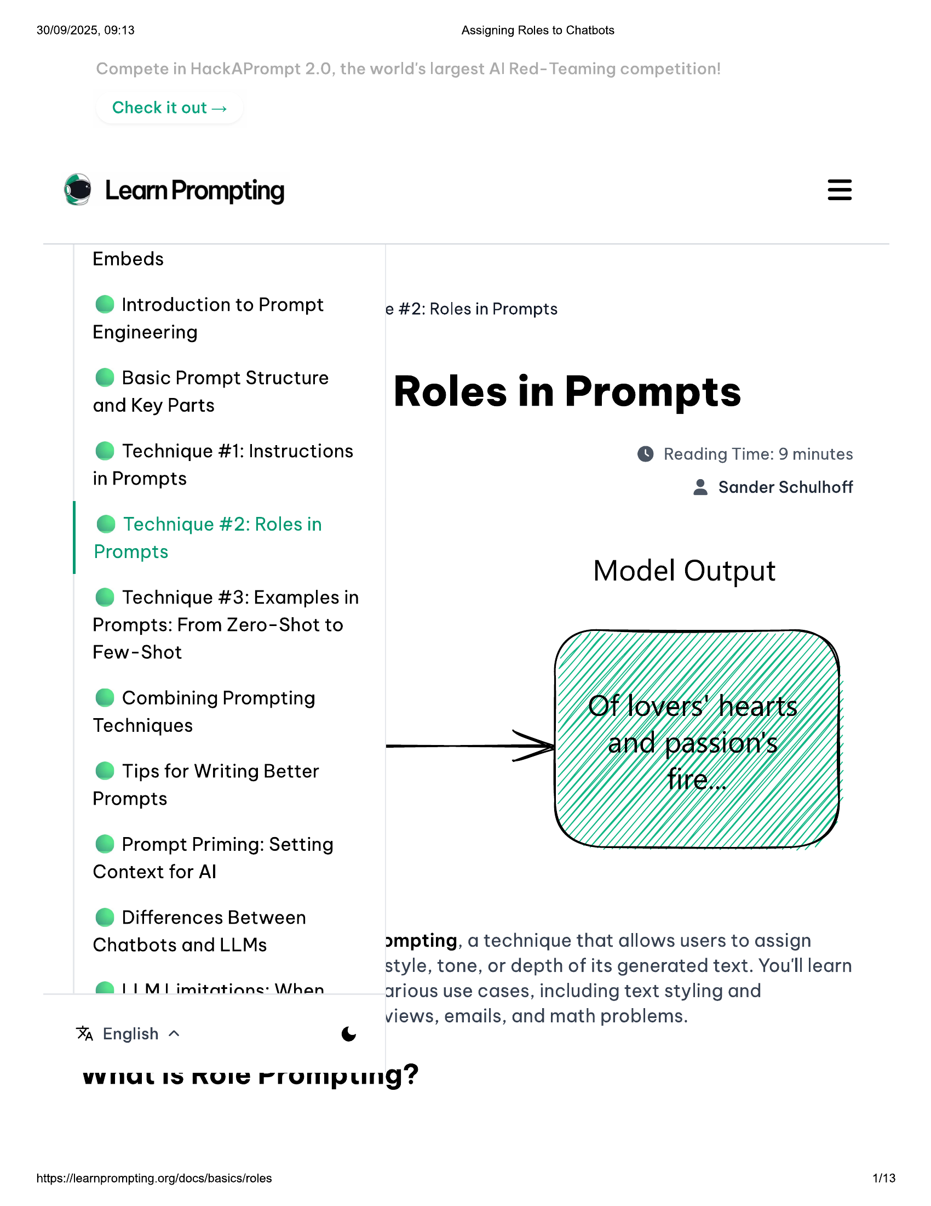

30/09/2025, 09:13 Assigning Roles to Chatbots  
  
Check it out >  
  
® LearnPrompting  
  
Embeds  
  
@ Introduction to Prompt e #2: Roles in Prompts  
Engineering  
  
© Basic Prompt Structure  
  
and Key Parts Roles in Prompts  
  
@ Technique #1: Instructions @ Reading Time: 9 minutes  
  
in Prompts & Sander Schulhoff  
  
@ Technique #2: Roles in  
Prompts  
  
Model Output  
  
@ Technique #3: Examples in  
Prompts: From Zero-Shot to  
Few-Shot  
  
@ Combining Prompting  
Techniques  
  
© Tips for Writing Better  
Prompts  
  
© Prompt Priming: Setting  
Context for Al  
  
@ Differences Between  
  
Chatbots and LLMs ompting, a technique that allows users to assign  
style, tone, or depth of its generated text. You'll learn  
@ IM 1 imitations: Whan arious use cases, including text styling and  
  
views, emails, and math problems.  
% English ~  
  
WHULIS NUOIE rrompung?  
  
https://learnprompting.org/docs/basics/roles 1113

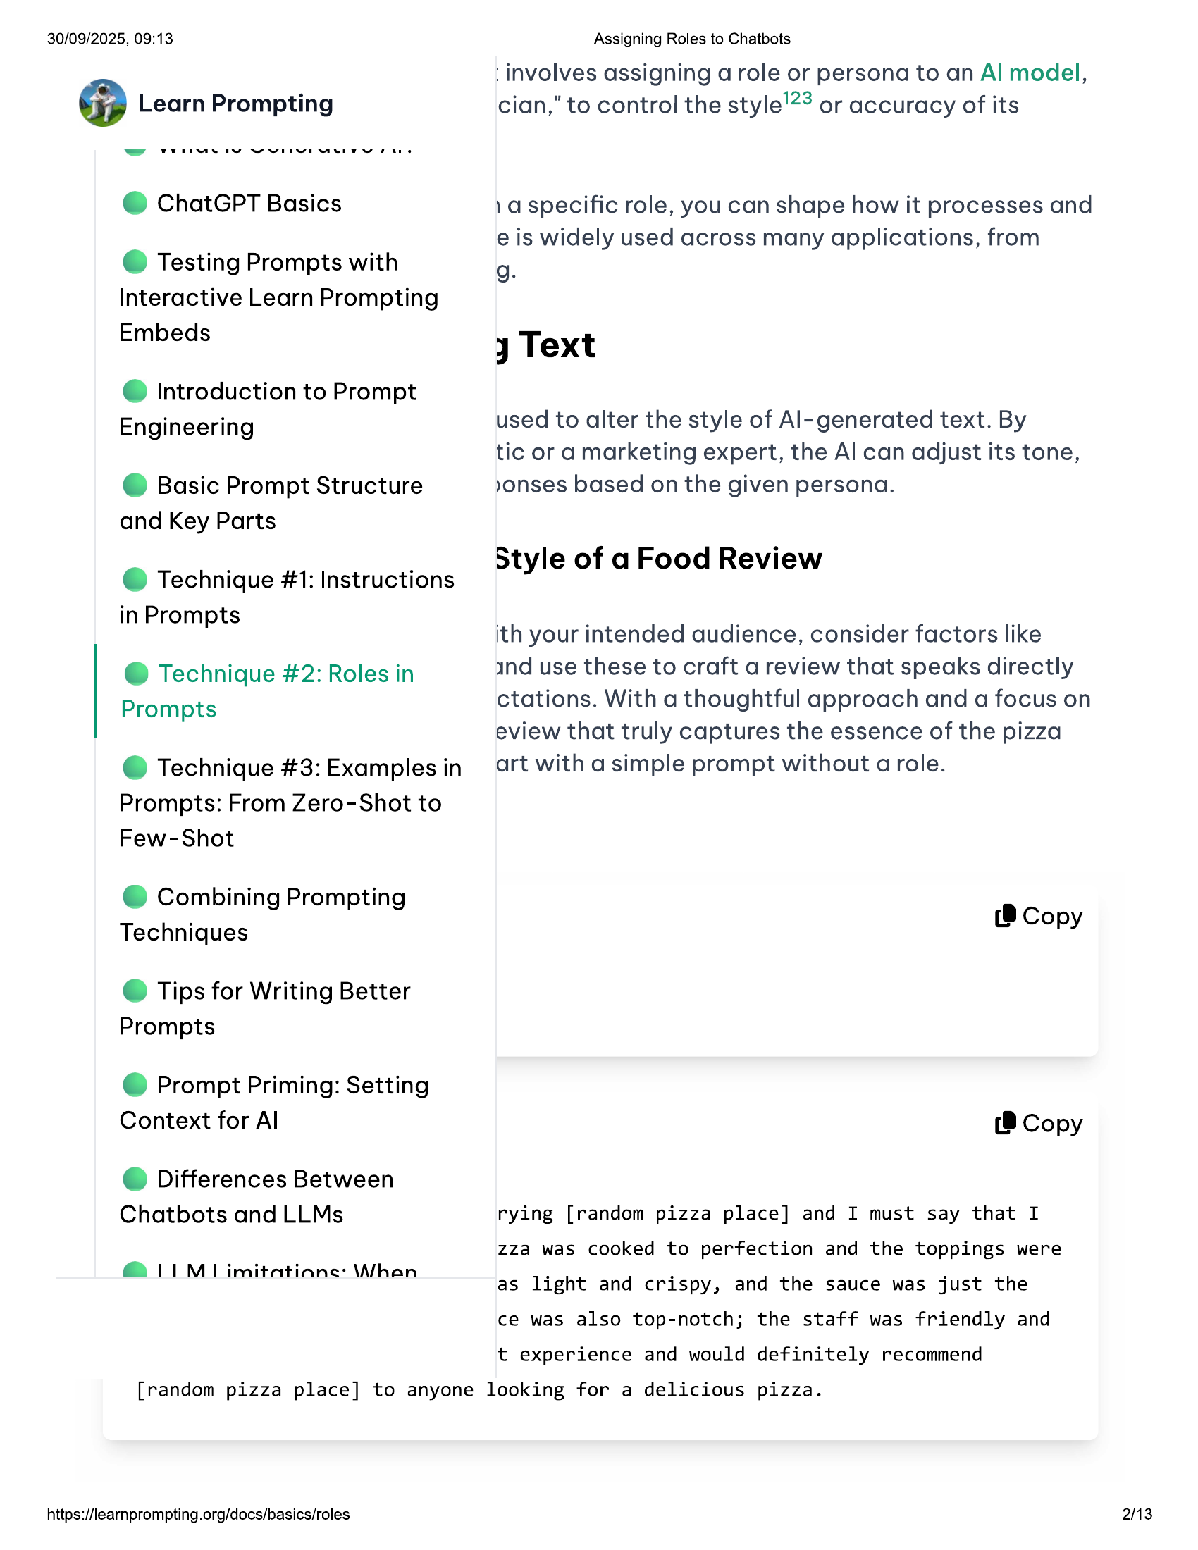

30/09/2025, 09:13  
  
@ Learn Prompting  
  
@ ChatGPT Basics  
  
© Testing Prompts with  
Interactive Learn Prompting  
Embeds  
  
@ Introduction to Prompt  
Engineering  
  
© Basic Prompt Structure  
and Key Parts  
  
@ Technique #1: Instructions  
in Prompts  
  
@ Technique #2: Roles in  
Prompts  
  
@ Technique #3: Examples in  
Prompts: From Zero-Shot to  
Few-Shot  
  
@ Combining Prompting  
Techniques  
  
© Tips for Writing Better  
Prompts  
  
© Prompt Priming: Setting  
Context for Al  
  
@ Differences Between  
Chatbots and LLMs  
  
@ LIM imitatiane: \Whan  
  
Assigning Roles to Chatbots  
  
involves assigning a role or persona to an Al model,  
cian," to control the style’? or accuracy of its  
  
1a specific role, you can shape how it processes and  
e is widely used across many applications, from  
g.  
  
jy Text  
  
used to alter the style of Al-generated text. By  
tic or a marketing expert, the Al can adjust its tone,  
yonses based on the given persona.  
  
Style of a Food Review  
  
ith your intended audience, consider factors like  
  
ind use these to craft a review that speaks directly  
ctations. With a thoughtful approach and a focus on  
eview that truly captures the essence of the pizza  
art with a simple prompt without a role.  
  
(8 Copy  
  
(8 Copy  
  
rying [random pizza place] and I must say that I  
zza was cooked to perfection and the toppings were  
as light and crispy, and the sauce was just the  
ce was also top-notch; the staff was friendly and  
  
t experience and would definitely recommend  
  
[random pizza place] to anyone looking for a delicious pizza.  
  
https://learnprompting.org/docs/basics/roles  
  
2/13

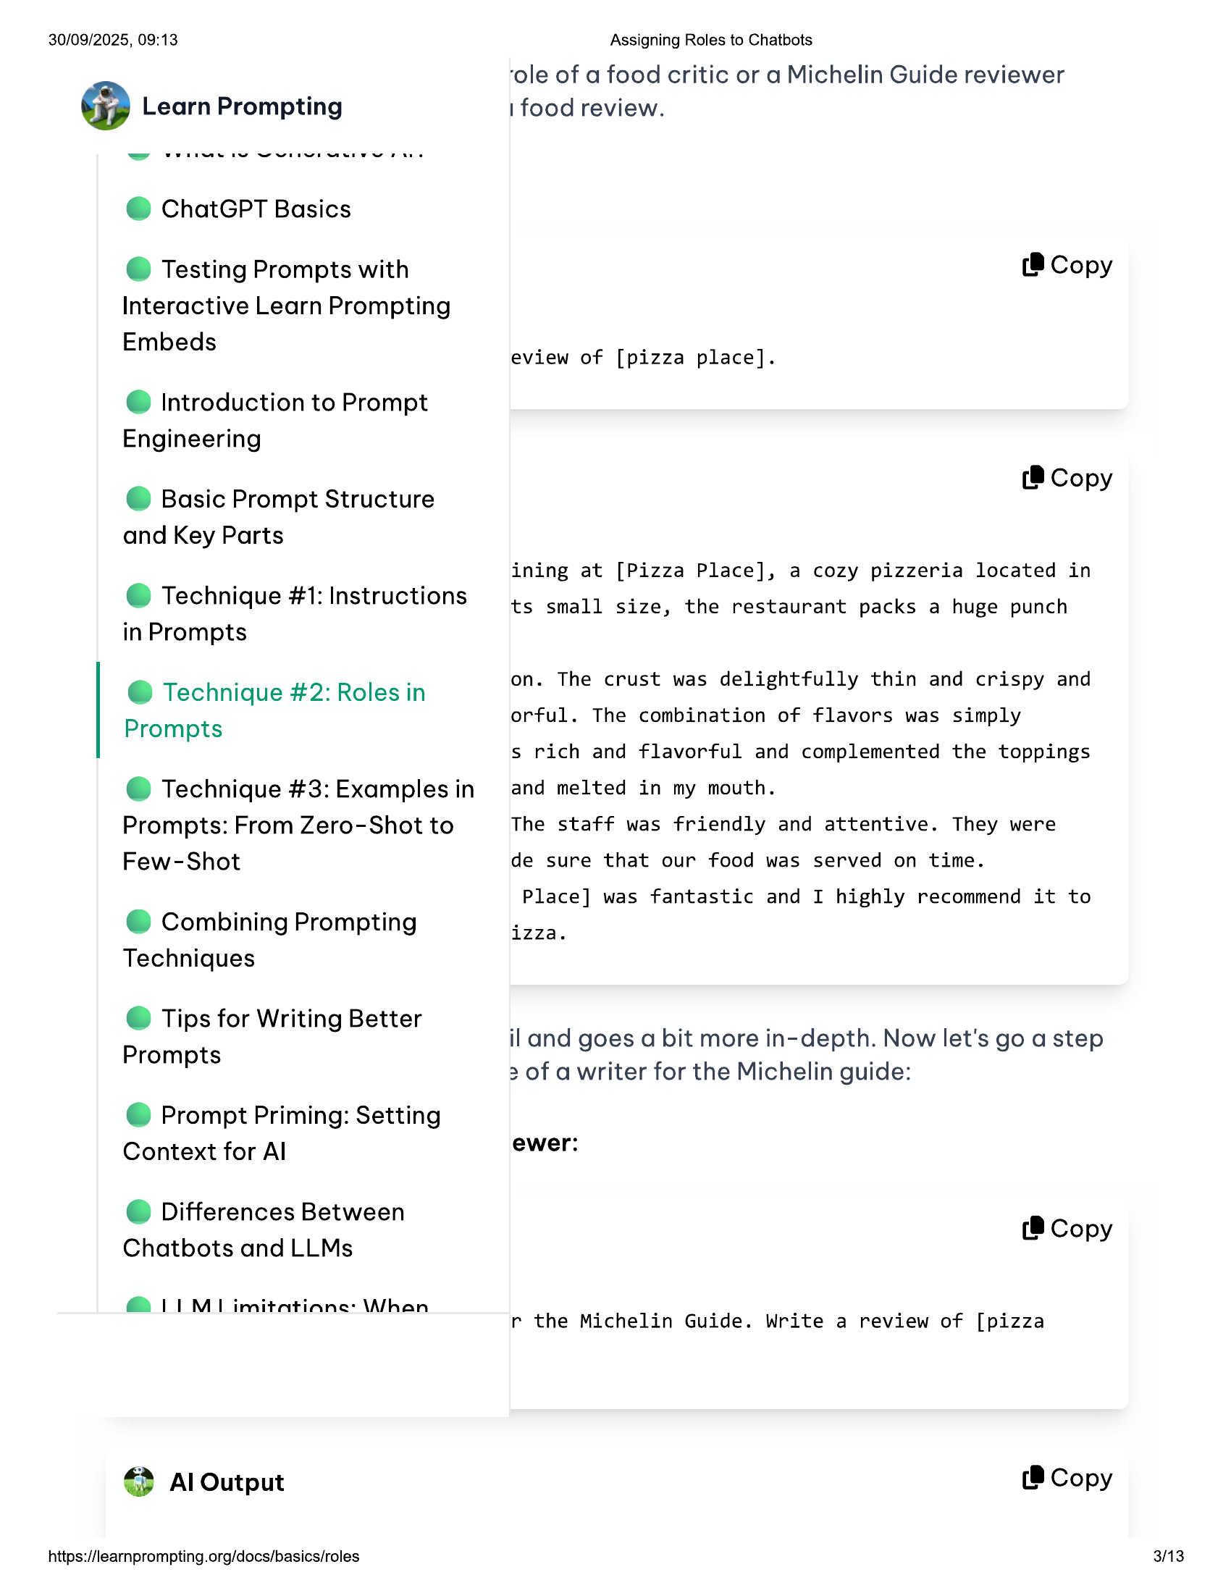

30/09/2025, 09:13  
  
@ Learn Prompting  
  
@ ChatGPT Basics  
  
© Testing Prompts with  
Interactive Learn Prompting  
Embeds  
  
@ Introduction to Prompt  
Engineering  
  
© Basic Prompt Structure  
and Key Parts  
  
@ Technique #1: Instructions  
in Prompts  
  
@ Technique #2: Roles in  
Prompts  
  
@ Technique #3: Examples in  
Prompts: From Zero-Shot to  
Few-Shot  
  
@ Combining Prompting  
Techniques  
  
© Tips for Writing Better  
Prompts  
  
@ Prompt Priming: Setting  
Context for Al  
  
© Differences Between  
Chatbots and LLMs  
  
@ LIM imitatiane: \Whan  
  
4) Al Output  
  
https://learnprompting.org/docs/basics/roles  
  
Assigning Roles to Chatbots  
  
‘ole of a food critic or a Michelin Guide reviewer  
1 food review.  
  
(8 Copy  
  
eview of [pizza place].  
  
(@ Copy  
  
ining at [Pizza Place], a cozy pizzeria located in  
  
ts small size, the restaurant packs a huge punch  
  
on. The crust was delightfully thin and crispy and  
orful. The combination of flavors was simply  
  
s rich and flavorful and complemented the toppings  
and melted in my mouth.  
The staff was friendly and attentive. They were  
  
de sure that our food was served on time.  
  
Place] was fantastic and I highly recommend it to  
  
izza.  
  
il and goes a bit more in-depth. Now let's go a step  
2 of a writer for the Michelin guide:  
  
ewer:  
  
(8 Copy  
  
r the Michelin Guide. Write a review of [pizza  
  
(®@ Copy  
  
3/13

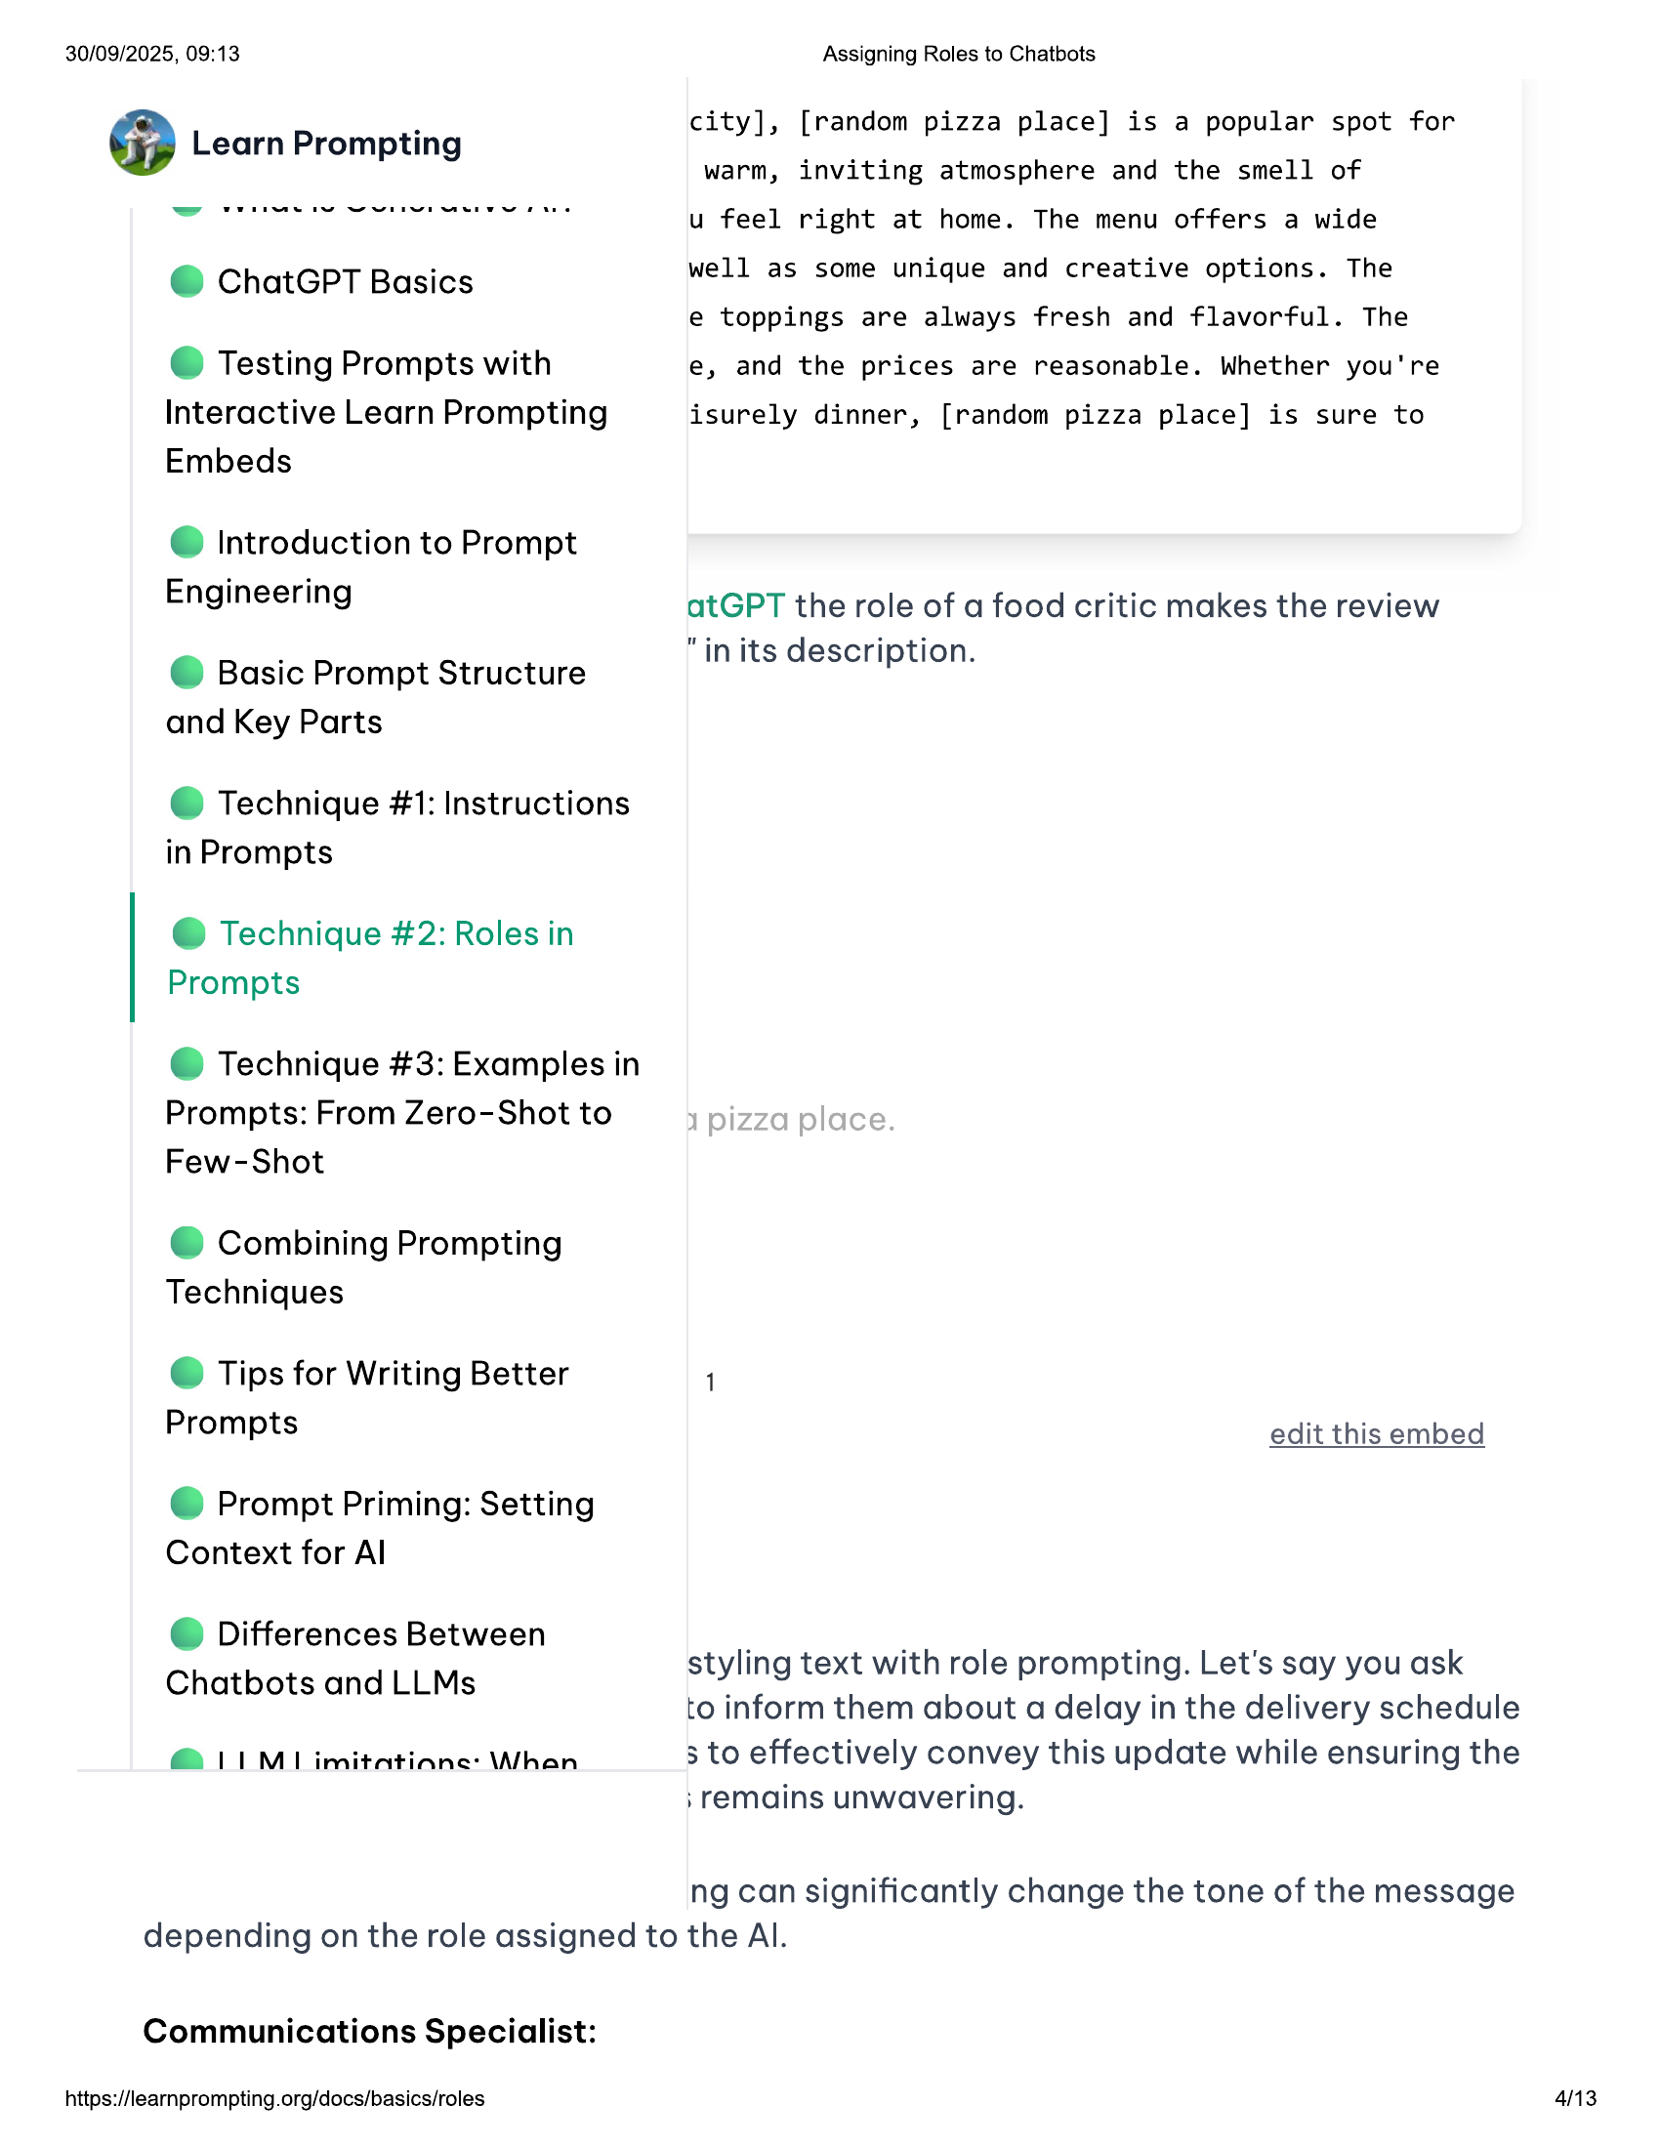

30/09/2025, 09:13 Assigning Roles to Chatbots  
  
. city], [random pizza place] is a popular spot for  
Learn Prompting  
  
warm, inviting atmosphere and the smell of  
ees oe erases u feel right at home. The menu offers a wide  
e ChatGPT Basics well as some unique and creative options. The  
  
e toppings are always fresh and flavorful. The  
© Testing Prompts with e, and the prices are reasonable. Whether you're  
Interactive Learn Promptin isurely dinner, [random pizza place] is sure to  
  
g  
  
Embeds  
  
@ Introduction to Prompt  
Engineering atGPT the role of a food critic makes the review  
  
. "in its description.  
© Basic Prompt Structure P  
  
and Key Parts  
  
@ Technique #1: Instructions  
in Prompts  
  
@ Technique #2: Roles in  
Prompts  
  
@ Technique #3: Examples in  
Prompts: From Zero-Shot to  
Few-Shot  
  
@ Combining Prompting  
Techniques  
  
© Tips for Writing Better 1  
Prompts edit this embed  
  
@ Prompt Priming: Setting  
Context for Al  
  
@ Differences Between  
  
Chatbots and LLMs styling text with role prompting. Let's say you ask  
  
to inform them about a delay in the delivery schedule  
@ 11 MI imitatiane: \Whan 3 to effectively convey this update while ensuring the  
; remains unwavering.  
  
ng can significantly change the tone of the message  
depending on the role assigned to the Al.  
  
Communications Specialist:  
  
https://learnprompting.org/docs/basics/roles 413

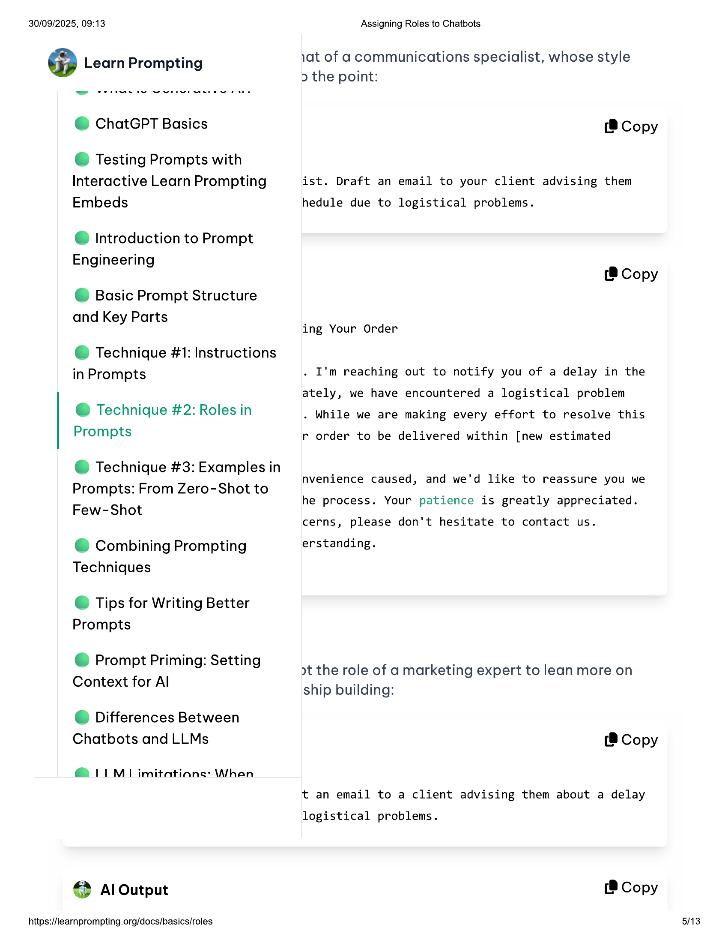

30/09/2025, 09:13  
  
@ Learn Prompting  
  
@ ChatGPT Basics  
  
© Testing Prompts with  
Interactive Learn Prompting  
Embeds  
  
@ Introduction to Prompt  
Engineering  
  
© Basic Prompt Structure  
and Key Parts  
  
@ Technique #1: Instructions  
in Prompts  
  
@ Technique #2: Roles in  
Prompts  
  
@ Technique #3: Examples in  
Prompts: From Zero-Shot to  
Few-Shot  
  
@ Combining Prompting  
Techniques  
  
© Tips for Writing Better  
Prompts  
  
© Prompt Priming: Setting  
Context for Al  
  
© Differences Between  
Chatbots and LLMs  
  
@ LIM imitatiane: \Whan  
  
€ Al Output  
  
https://learnprompting.org/docs/basics/roles  
  
Assigning Roles to Chatbots  
  
vat of acommunications specialist, whose style  
2 the point:  
  
(® Copy  
  
ist. Draft an email to your client advising them  
  
hedule due to logistical problems.  
  
(8 Copy  
  
ing Your Order  
  
. I'm reaching out to notify you of a delay in the  
ately, we have encountered a logistical problem  
. While we are making every effort to resolve this  
  
r order to be delivered within [new estimated  
nvenience caused, and we'd like to reassure you we  
he process. Your patience is greatly appreciated.  
  
cerns, please don't hesitate to contact us.  
  
erstanding.  
  
>t the role of a marketing expert to lean more on  
iship building:  
  
(8 Copy  
  
t an email to a client advising them about a delay  
  
logistical problems.  
  
(® Copy  
  
5/13

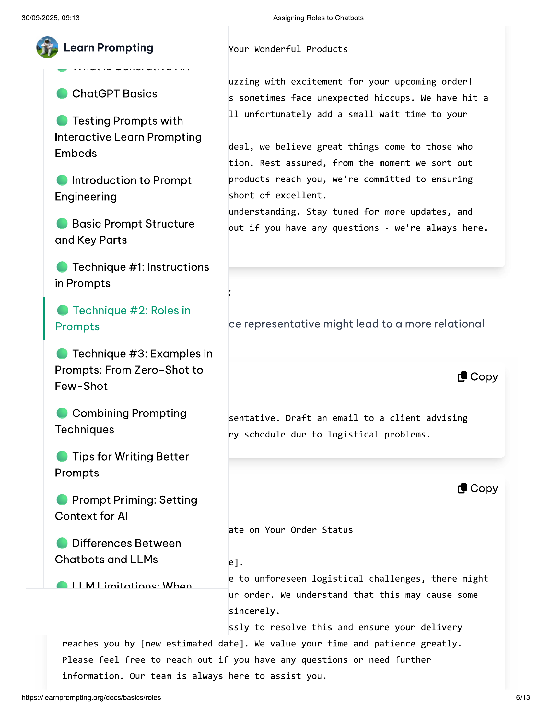

30/09/2025, 09:13  
  
@ Learn Prompting  
  
@ ChatGPT Basics  
  
© Testing Prompts with  
Interactive Learn Prompting  
Embeds  
  
@ Introduction to Prompt  
Engineering  
  
© Basic Prompt Structure  
and Key Parts  
  
@ Technique #1: Instructions  
in Prompts  
  
@ Technique #2: Roles in  
Prompts  
  
@ Technique #3: Examples in  
Prompts: From Zero-Shot to  
Few-Shot  
  
@ Combining Prompting  
Techniques  
  
© Tips for Writing Better  
Prompts  
  
© Prompt Priming: Setting  
Context for Al  
  
© Differences Between  
Chatbots and LLMs  
  
@ LIM imitatiane: \Whan  
  
Assigning Roles to Chatbots  
Your Wonderful Products  
  
uzzing with excitement for your upcoming order!  
s sometimes face unexpected hiccups. We have hit a  
  
11 unfortunately add a small wait time to your  
  
deal, we believe great things come to those who  
tion. Rest assured, from the moment we sort out  
products reach you, we're committed to ensuring  
short of excellent.  
  
understanding. Stay tuned for more updates, and  
  
out if you have any questions - we're always here.  
  
ce representative might lead to a more relational  
  
(8 Copy  
  
sentative. Draft an email to a client advising  
  
ry schedule due to logistical problems.  
  
(8 Copy  
  
ate on Your Order Status  
  
e].  
  
e to unforeseen logistical challenges, there might  
ur order. We understand that this may cause some  
sincerely.  
  
ssly to resolve this and ensure your delivery  
  
reaches you by [new estimated date]. We value your time and patience greatly.  
  
Please feel free to reach out if you have any questions or need further  
  
information. Our team is always here to assist you.  
  
https://learnprompting.org/docs/basics/roles  
  
6/13

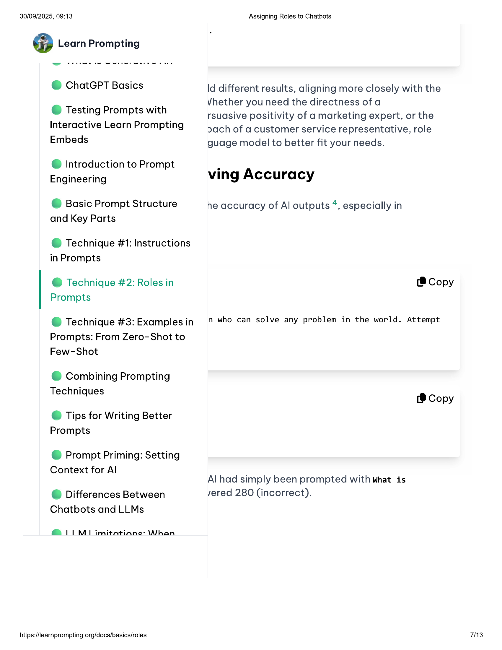

30/09/2025, 09:13 Assigning Roles to Chatbots  
  
@ Learn Prompting  
  
© ChatGPT Basics ld different results, aligning more closely with the  
Vhether you need the directness of a  
  
rsuasive positivity of a marketing expert, or the  
2ach of a customer service representative, role  
guage model to better fit your needs.  
  
© Testing Prompts with  
Interactive Learn Prompting  
Embeds  
  
@ Introduction to Prompt .  
Engineering ving Accuracy  
  
© Basic Prompt Structure ne accuracy of Al outputs \*, especially in  
and Key Parts  
  
@ Technique #1: Instructions  
in Prompts  
  
@ Technique #2: Roles in (@ Copy  
Prompts  
  
e@ Technique #3: Examples in n who can solve any problem in the world. Attempt  
Prompts: From Zero-Shot to  
Few-Shot  
  
@ Combining Prompting  
  
Techniques (8 Copy  
  
© Tips for Writing Better  
Prompts  
  
© Prompt Priming: Setting  
  
Context for Al  
Al had simply been prompted with what is  
  
@ Differences Between sered 280 (incorrect).  
Chatbots and LLMs  
  
@ LIM imitatiane: \Whan  
  
https://learnprompting.org/docs/basics/roles 73

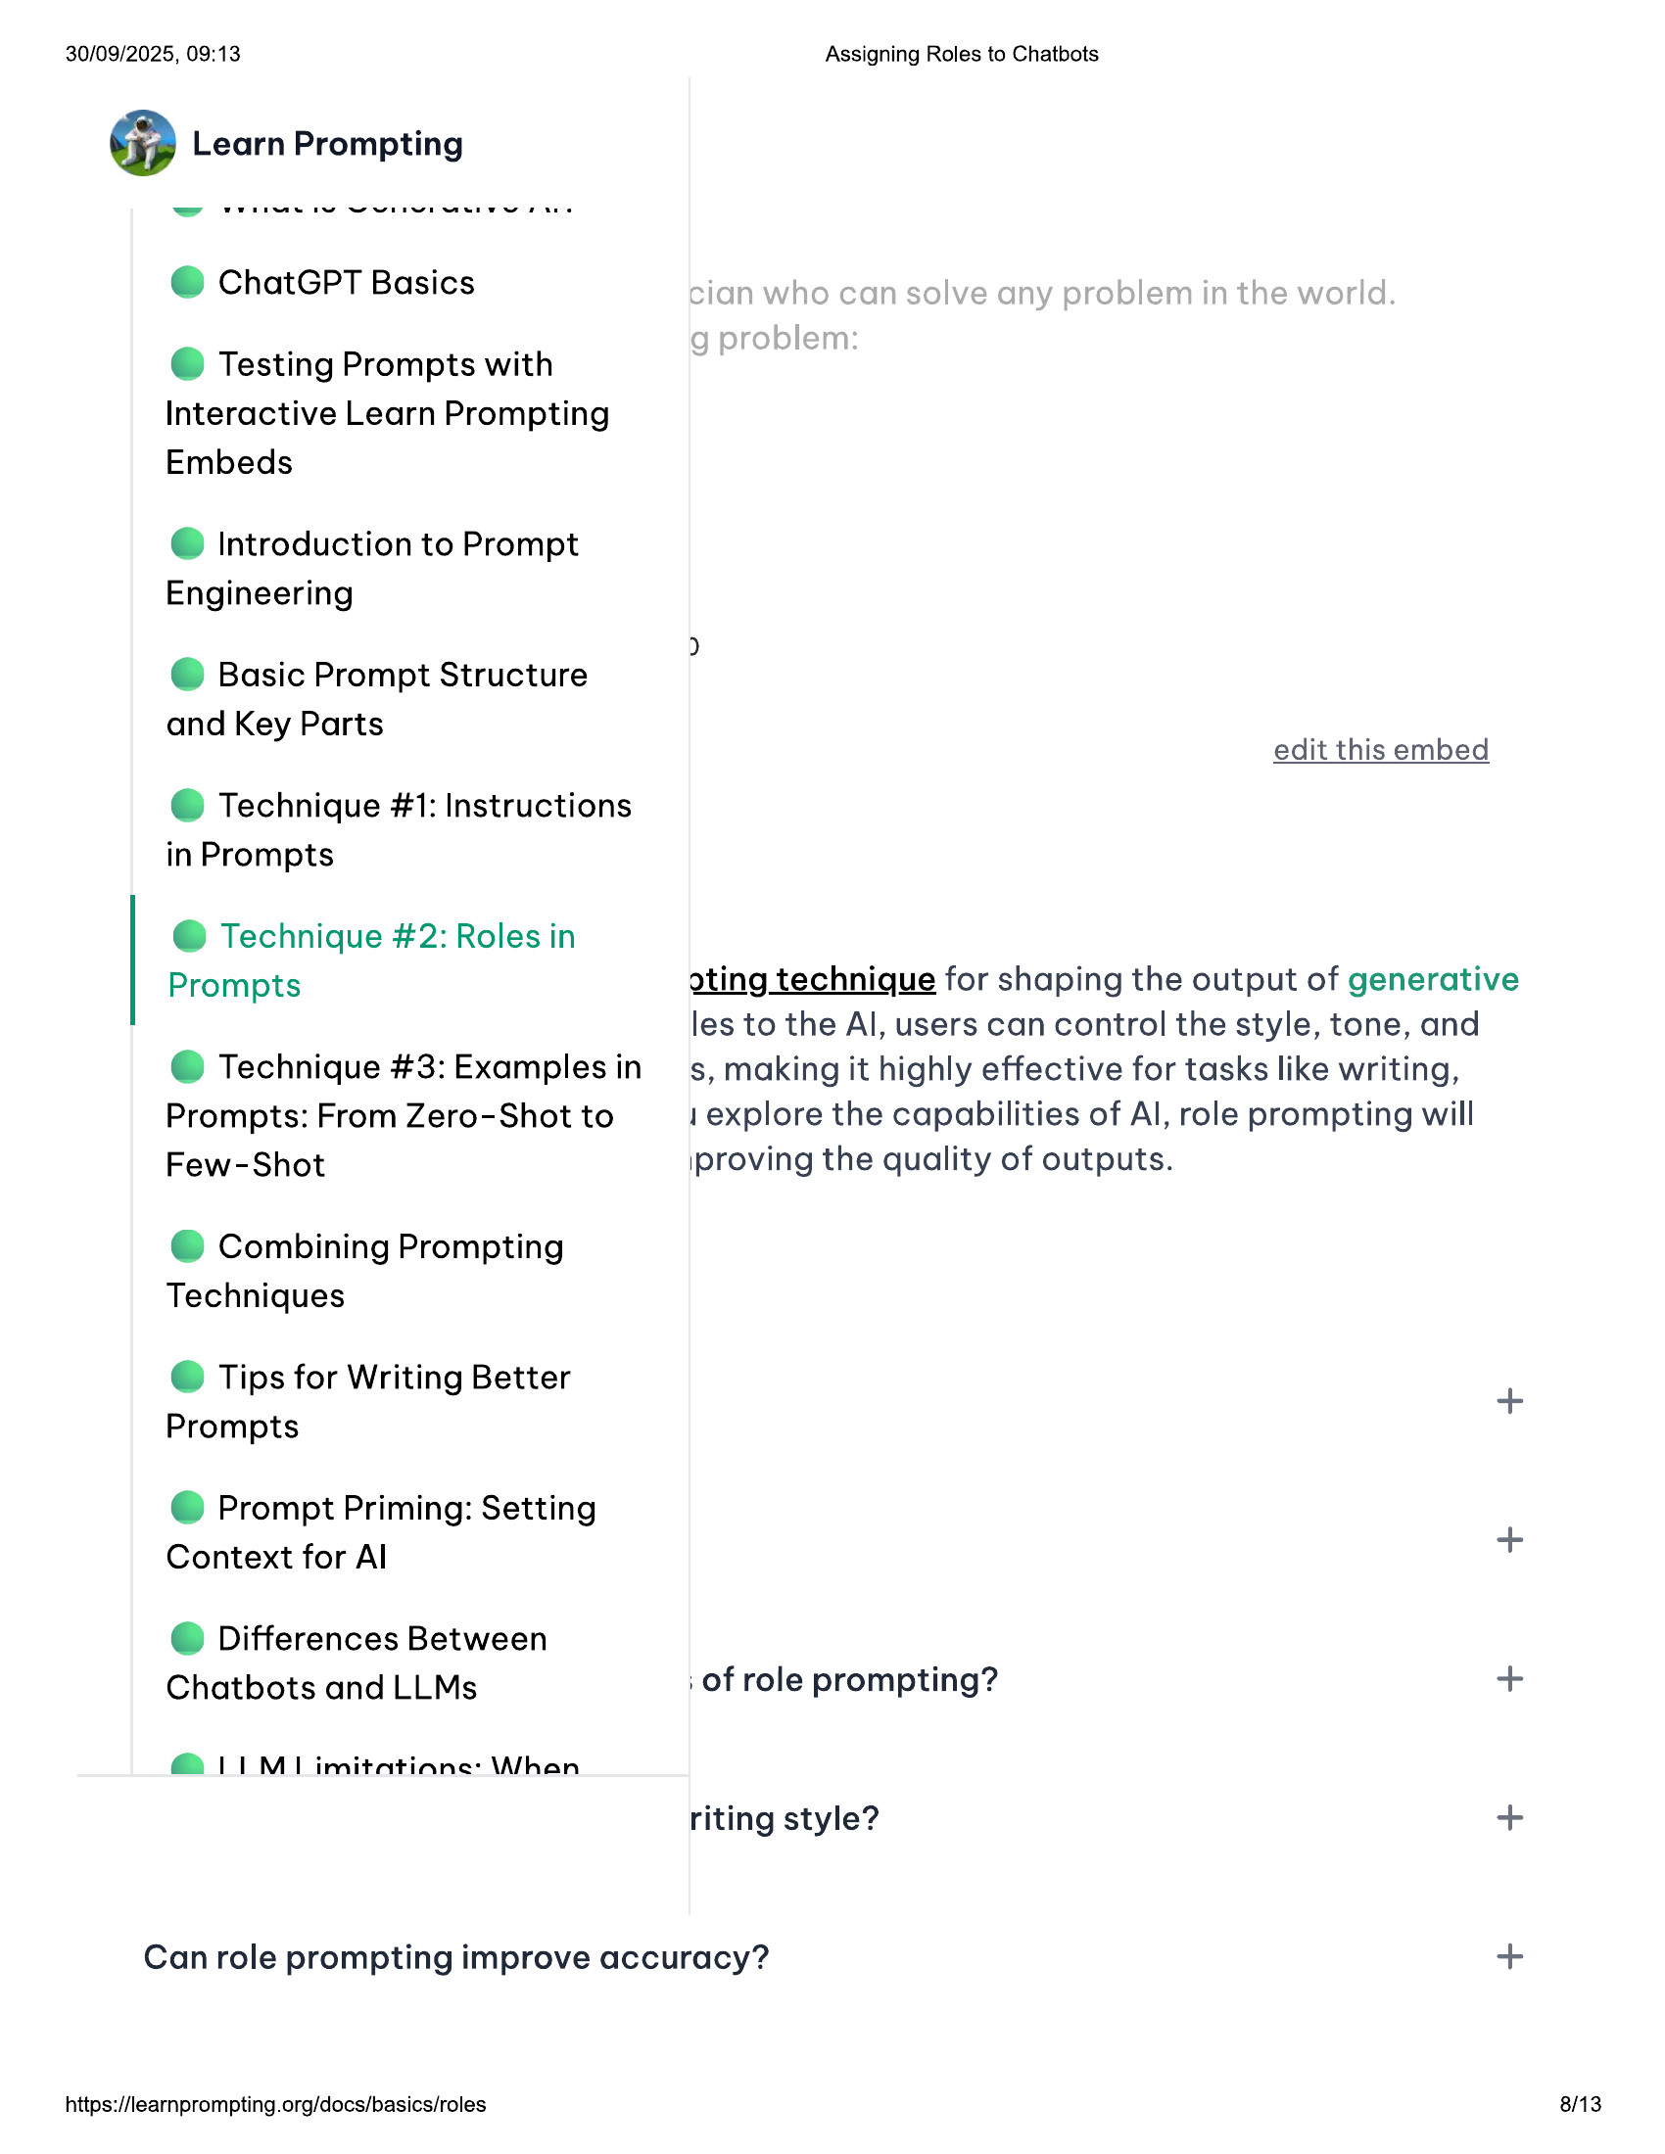

30/09/2025, 09:13 Assigning Roles to Chatbots  
  
@ Learn Prompting  
  
@ ChatGPT Basics  
  
© Testing Prompts with  
Interactive Learn Prompting  
Embeds  
  
@ Introduction to Prompt  
Engineering  
  
© Basic Prompt Structure  
  
and Key Parts a  
edit this embed  
  
@ Technique #1: Instructions  
in Prompts  
  
@ Technique #2: Roles in  
  
Prompts ating technique for shaping the output of generative  
les to the Al, users can control the style, tone, and  
  
@ Technique #3: Examplesin — s, making it highly effective for tasks like writing,  
  
Prompts: From Zero-Shot to 1 explore the capabilities of Al, role prompting will  
  
Few-Shot proving the quality of outputs.  
  
@ Combining Prompting  
Techniques  
  
© Tips for Writing Better  
  
+  
Prompts  
© Prompt Priming: Setting  
Context for Al +  
@ Differences Between  
Chatbots and LLMs i of role prompting? +  
@ IML imitatiane: \Whan  
riting style? +  
Can role prompting improve accuracy? +  
  
https://learnprompting.org/docs/basics/roles 8/13

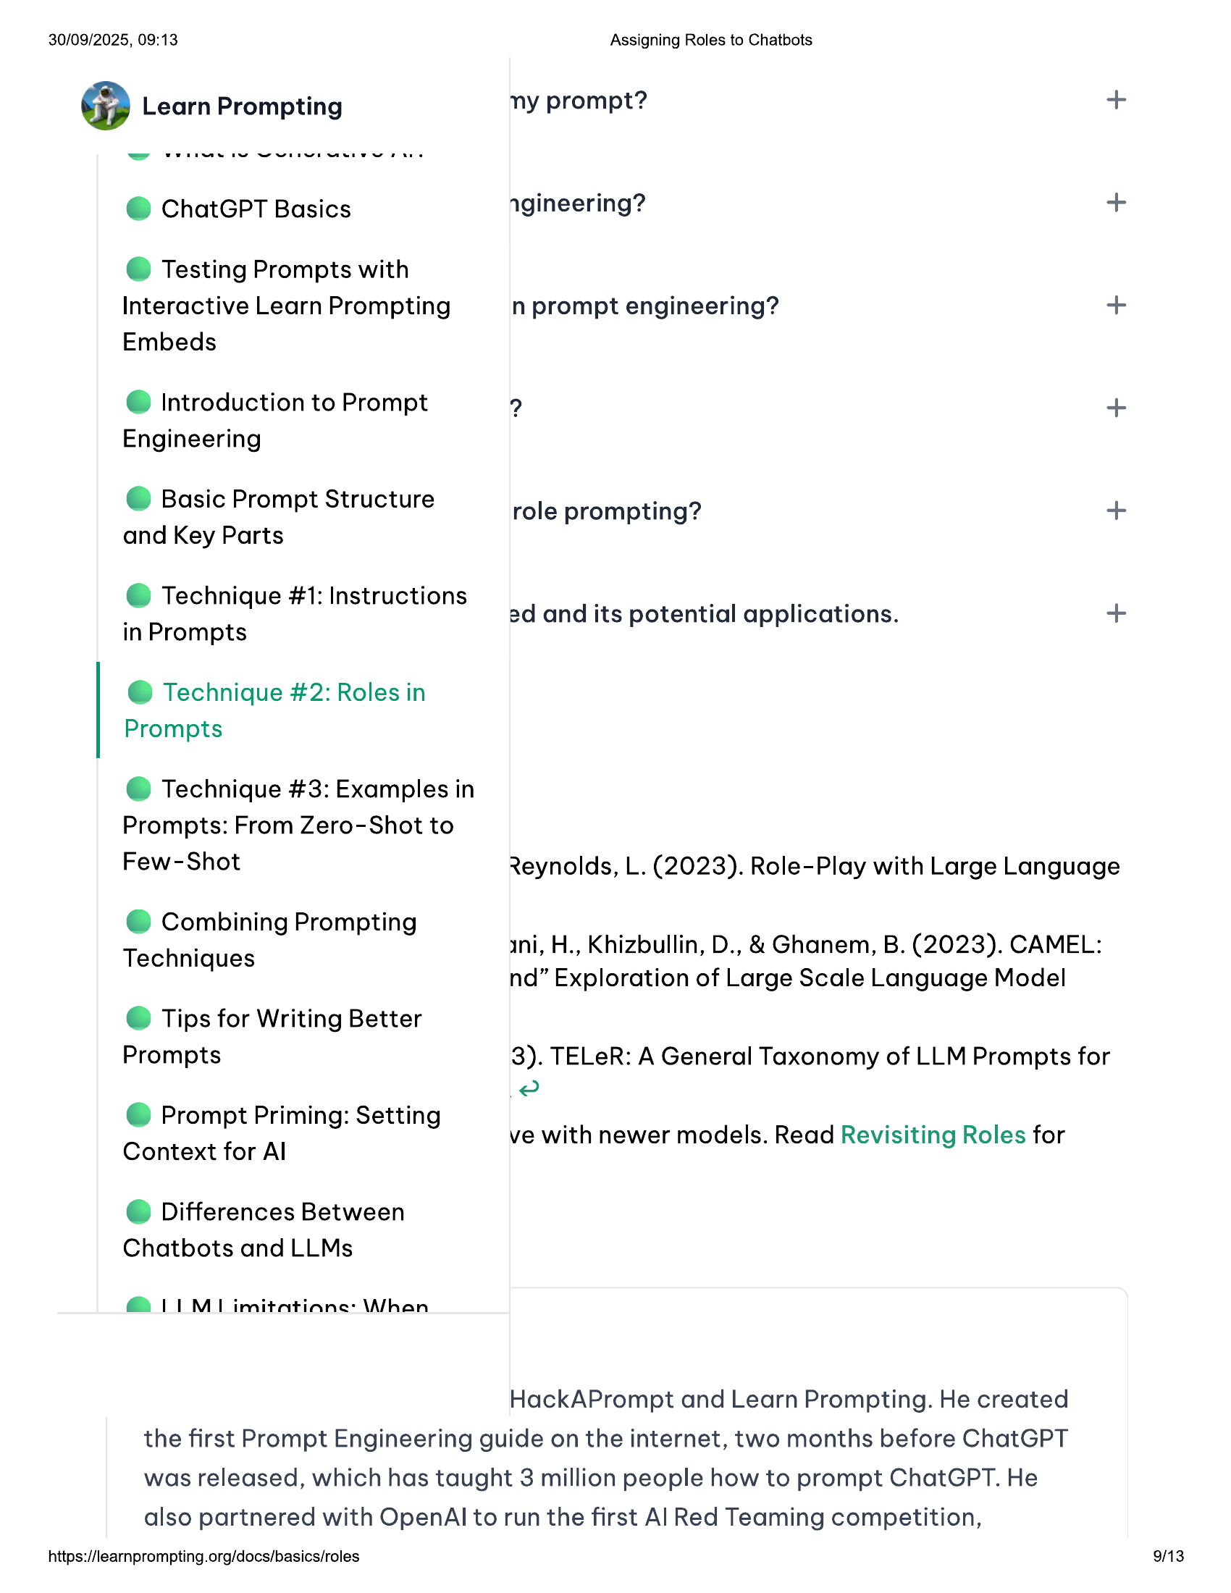

30/09/2025, 09:13 Assigning Roles to Chatbots  
  
@ Learn Prompting ny prompt? +  
  
@ ChatGPT Basics agineering? +  
  
© Testing Prompts with  
Interactive Learn Prompting n prompt engineering? +  
Embeds  
  
@ Introduction to Prompt 2 +  
Engineering  
  
© Basic Prompt Structure  
  
role prompting? +  
and Key Parts  
  
@ Technique #1: Instructions  
  
2d and its potential applications. +  
in Prompts P PP  
  
@ Technique #2: Roles in  
Prompts  
  
@ Technique #3: Examples in  
Prompts: From Zero-Shot to  
  
Few-Shot Reynolds, L. (2023). Role-Play with Large Language  
  
@ Combining Prompting  
  
Techniques ini, H., Khizbullin, D., & Ghanem, B. (2023). CAMEL:  
  
nd” Exploration of Large Scale Language Model  
© Tips for Writing Better  
  
Prompts 3). TELeR: A General Taxonomy of LLM Prompts for  
Pe  
@ Prompt Priming: Setting  
  
ve with newer models. Read Revisiting Roles for  
Context for Al  
  
@ Differences Between  
Chatbots and LLMs  
  
@ LIM imitatiane: \Whan  
  
HackAPrompt and Learn Prompting. He created  
the first Prompt Engineering guide on the internet, two months before ChatGPT  
was released, which has taught 3 million people how to prompt ChatGPT. He  
also partnered with OpenAl to run the first Al Red Teaming competition,  
  
https://learnprompting.org/docs/basics/roles 9/13

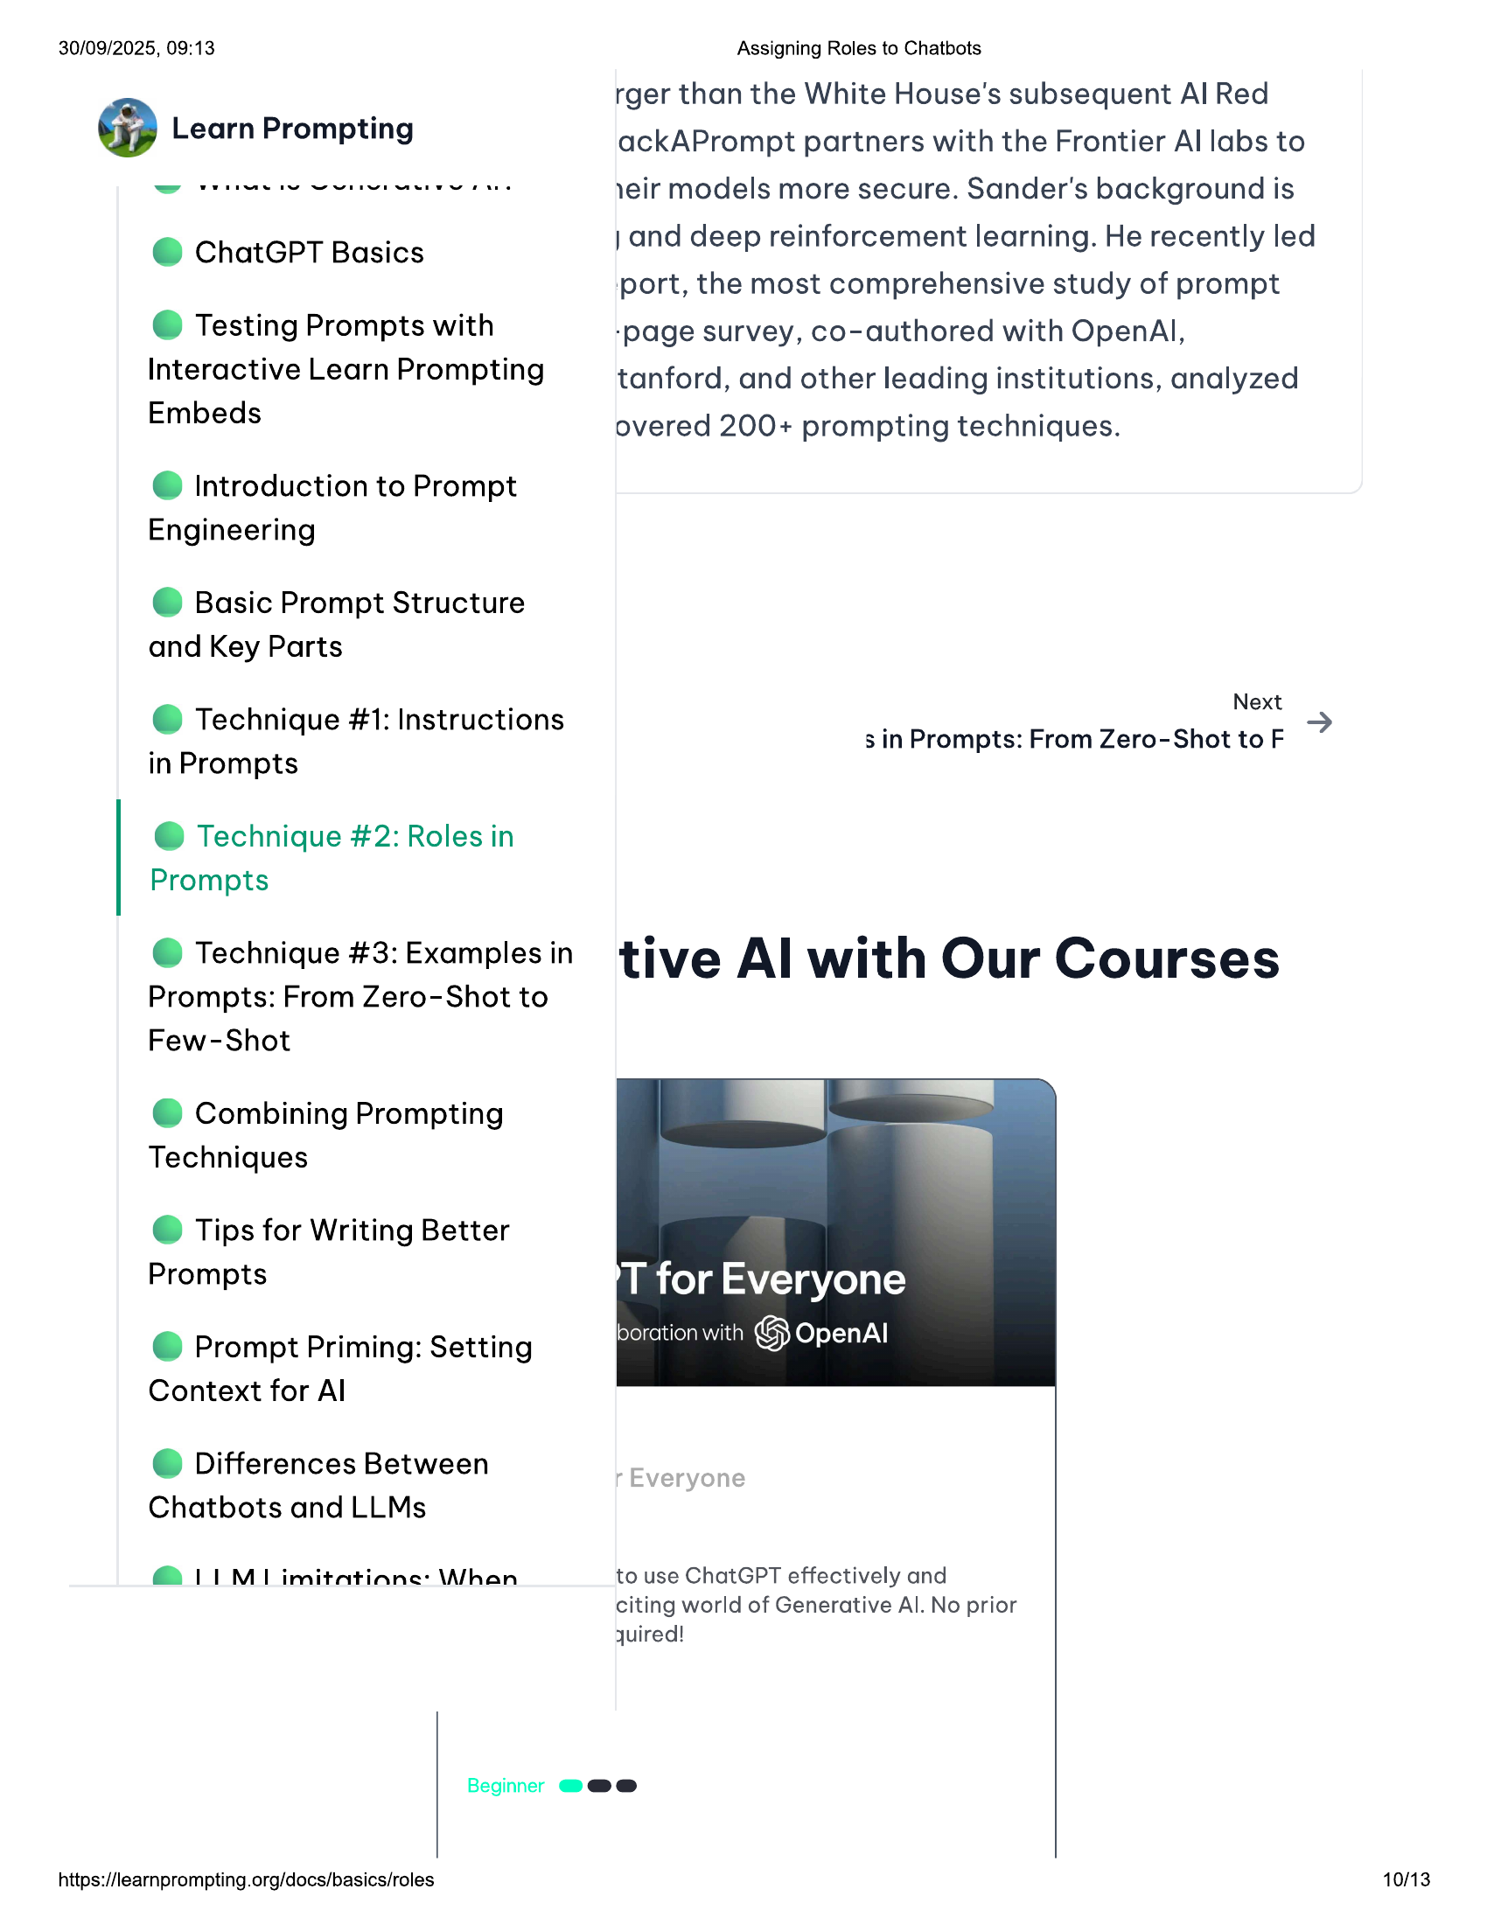

30/09/2025, 09:13  
  
@ Learn Prompting  
  
@ ChatGPT Basics  
  
© Testing Prompts with  
Interactive Learn Prompting  
Embeds  
  
@ Introduction to Prompt  
Engineering  
  
© Basic Prompt Structure  
and Key Parts  
  
@ Technique #1: Instructions  
in Prompts  
  
@ Technique #2: Roles in  
Prompts  
  
@ Technique #3: Examples in  
Prompts: From Zero-Shot to  
Few-Shot  
  
@ Combining Prompting  
Techniques  
  
© Tips for Writing Better  
Prompts  
  
@ Prompt Priming: Setting  
Context for Al  
  
@ Differences Between  
Chatbots and LLMs  
  
@ LIM imitatiane: \Whan  
  
Beginner @@@e  
  
https://learnprompting.org/docs/basics/roles  
  
Assigning Roles to Chatbots  
  
rger than the White House's subsequent Al Red  
ackAPrompt partners with the Frontier Al labs to  
1eir models more secure. Sander's background is  
  
} and deep reinforcement learning. He recently led  
‘port, the most comprehensive study of prompt  
-page survey, co-authored with OpenAl,  
  
tanford, and other leading institutions, analyzed  
overed 200+ prompting techniques.  
  
Next  
s in Prompts: From Zero-Shot to F  
  
tive Al with Our Courses  
  
to use ChatGPT effectively and  
citing world of Generative Al. No prior  
quired!  
  
10/13

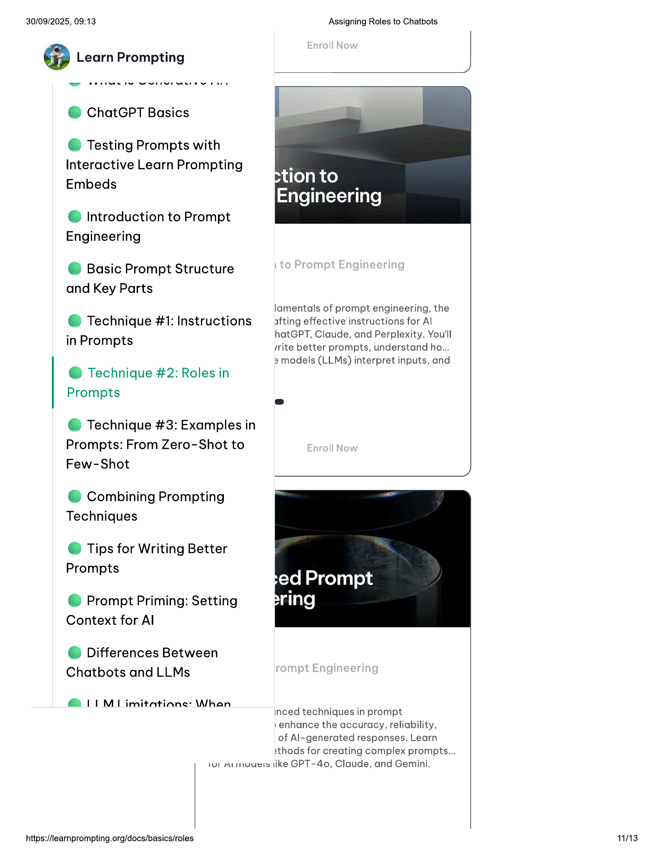

30/09/2025, 09:13 Assigning Roles to Chatbots  
  
@ Learn Prompting  
  
@ ChatGPT Basics  
  
© Testing Prompts with  
Interactive Learn Prompting  
Embeds  
  
@ Introduction to Prompt  
Engineering  
  
© Basic Prompt Structure  
and Key Parts  
  
lamentals of prompt engineering, the  
© Technique #1: Instructions afting effective instructions for Al  
  
in Prompts  
  
@ Technique #2: Roles in  
Prompts  
  
@ Technique #3: Examples in  
Prompts: From Zero-Shot to  
Few-Shot  
  
hatGPT, Claude, and Perplexity. You'll  
/rite better prompts, understand ho...  
3 models (LLMs) interpret inputs, and  
  
@ Combining Prompting  
Techniques  
  
© Tips for Writing Better  
Prompts  
  
© Prompt Priming: Setting  
Context for Al  
  
@ Differences Between  
Chatbots and LLMs  
  
@ LIM imitatiane: \Whan  
  
inced techniques in prompt  
»enhance the accuracy, reliability,  
of Al-generated responses. Learn  
2xthods for creating complex prompts...  
tur ALmuuels like GPT-40, Claude, and Gemini.  
  
https://learnprompting.org/docs/basics/roles  
  
11/13

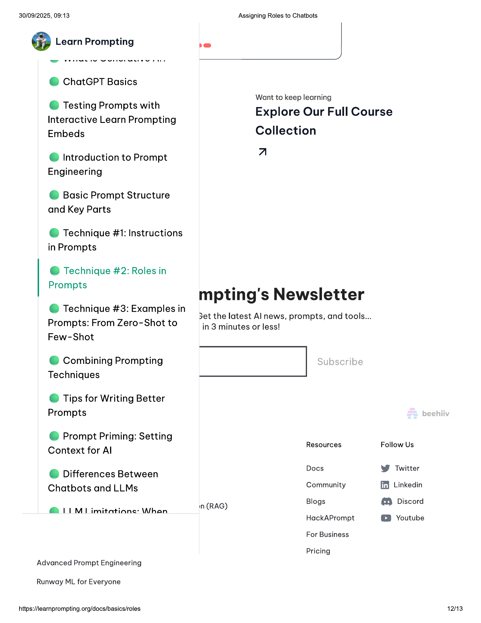

30/09/2025, 09:13 Assigning Roles to Chatbots  
  
@ Learn Prompting be  
  
@ ChatGPT Basics  
Want to keep learning  
  
Testing P ts with  
© Testing Prompts wi Explore Our Full Course  
  
Interactive Learn Prompting  
Embeds Collection  
  
@ Introduction to Prompt a  
  
Engineering  
  
© Basic Prompt Structure  
and Key Parts  
  
@ Technique #1: Instructions  
in Prompts  
  
@ Technique #2: Roles in  
Prompts  
  
mpting's Newsletter  
  
3et the latest Al news, prompts, and tools...  
in 3 minutes or less!  
  
@ Technique #3: Examples in  
Prompts: From Zero-Shot to  
Few-Shot  
  
@ Combining Prompting |  
Techniques  
  
© Tips for Writing Better  
Prompts  
  
@ Prompt Priming: Setting  
  
Context for Al Resources Follow Us  
: Docs Twitter  
@ Differences Between ¥  
Chatbots and LLMs Community ff) Linkedin  
Blogs @® Discord  
@ 11 M1 imitatiane: Whan n (RAG)  
HackAPrompt @© Youtube  
  
For Business  
  
Pricing  
Advanced Prompt Engineering  
  
Runway ML for Everyone  
  
https://learnprompting.org/docs/basics/roles 12/13

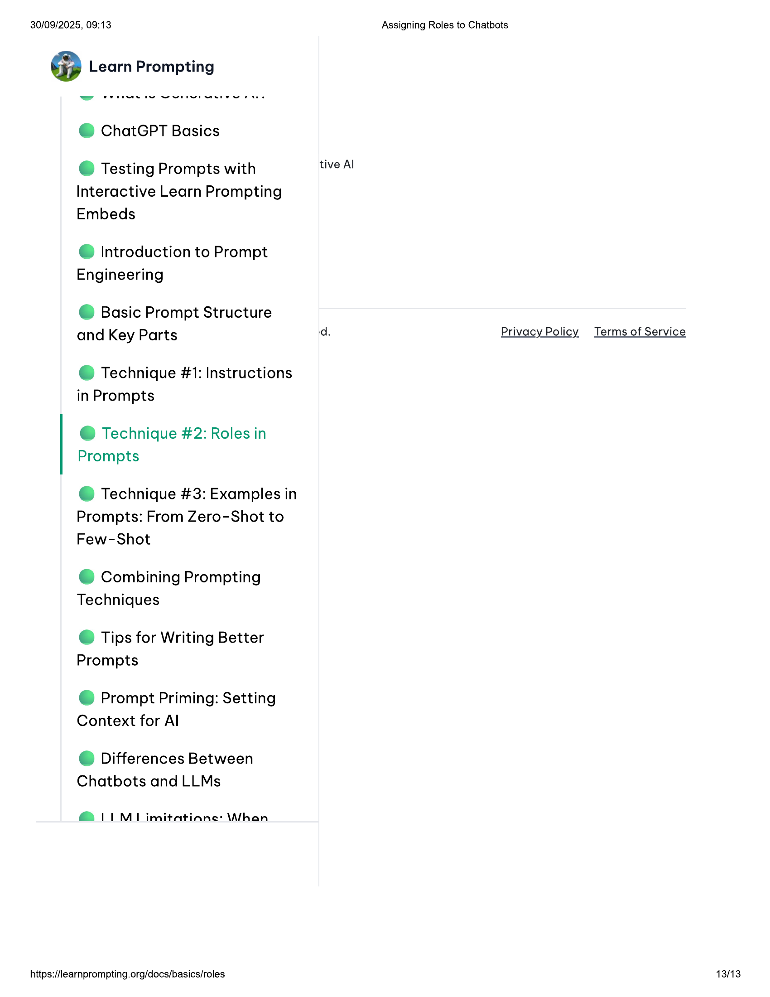

30/09/2025, 09:13 Assigning Roles to Chatbots  
  
@ Learn Prompting  
  
@ ChatGPT Basics  
  
© Testing Prompts with tive Al  
Interactive Learn Prompting  
Embeds  
  
@ Introduction to Prompt  
Engineering  
  
© Basic Prompt Structure  
and Key Parts d. Privacy Policy Terms of Service  
  
@ Technique #1: Instructions  
in Prompts  
  
@ Technique #2: Roles in  
Prompts  
  
@ Technique #3: Examples in  
Prompts: From Zero-Shot to  
Few-Shot  
  
@ Combining Prompting  
Techniques  
  
© Tips for Writing Better  
Prompts  
  
@ Prompt Priming: Setting  
Context for Al  
  
@ Differences Between  
Chatbots and LLMs  
  
@ LIM imitatiane: \Whan  
  
https://learnprompting.org/docs/basics/roles 13/13