新增两行代码
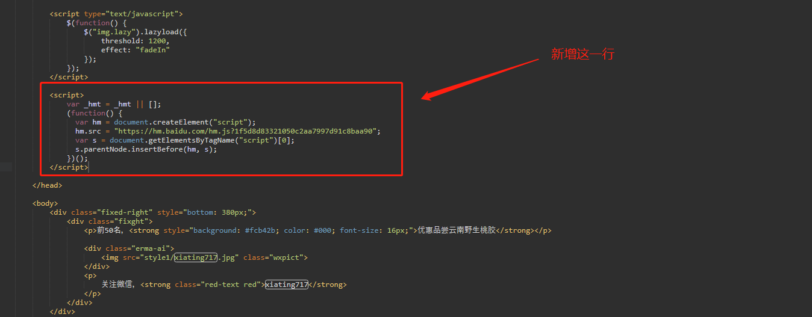
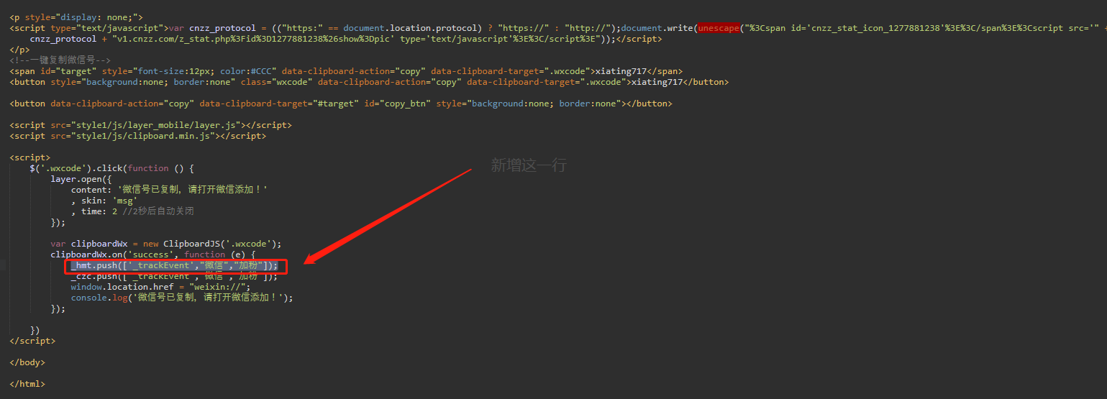

<script>
var _hmt = _hmt || [];
(function() {
var hm = document.createElement("script");
hm.src = "https://hm.baidu.com/hm.js?1f5d8d83321050c2aa7997d91c8baa90";
var s = document.getElementsByTagName("script")[0];
s.parentNode.insertBefore(hm, s);
})();
</script>

_hmt.push(['_trackEvent',"微信","加粉"]);

