Movement in Communication
with AI People Reader Report
Client Name: Local Test
Analysis Date: 2026-03-05
Video Information
Duration: 02:03

Detailed Analysis
1. First impression
• Eye Contact
Scale: Low
• Uprightness
Scale: Low
• Stance
Scale: Low
Remark
First impression happens in the first 5 seconds of meeting someone, and is normally decided from the person's appearance, eye contact, uprightness and stance. However, after the first 5 seconds, the rest (below) are normally taken into consideration.

2. Engaging & Connecting:
• Approachability
• Relatability
• Engagement, connect and build instant rapport with team
Scale: Moderate
Description: Detected 431 positive indicators out of 1370 total indicators

3. Confidence:
• Optimistic Presence
• Focus
• Ability to persuade and stand one's ground, in order to convince others.
Scale: Moderate
Description: Detected 475 positive indicators out of 1370 total indicators

4. Authority:
• Showing sense of importance and urgency in subject matter
• Pressing for action
Scale: Moderate
Description: Detected 445 positive indicators out of 1370 total indicators

Effort Motion Detection Results

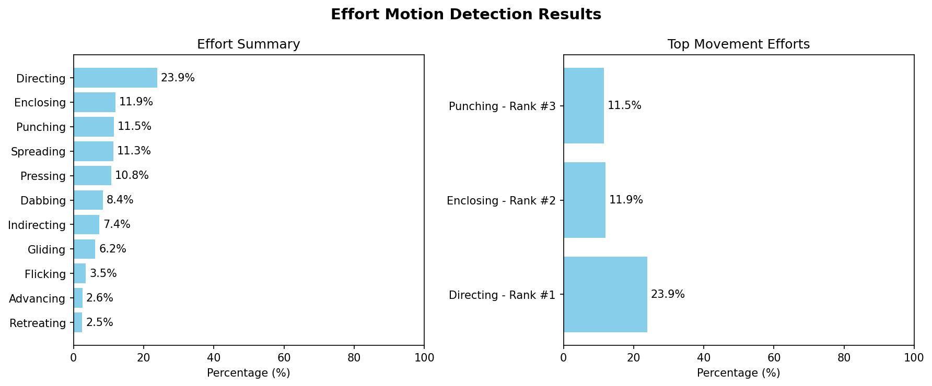

Shape Motion Detection Results

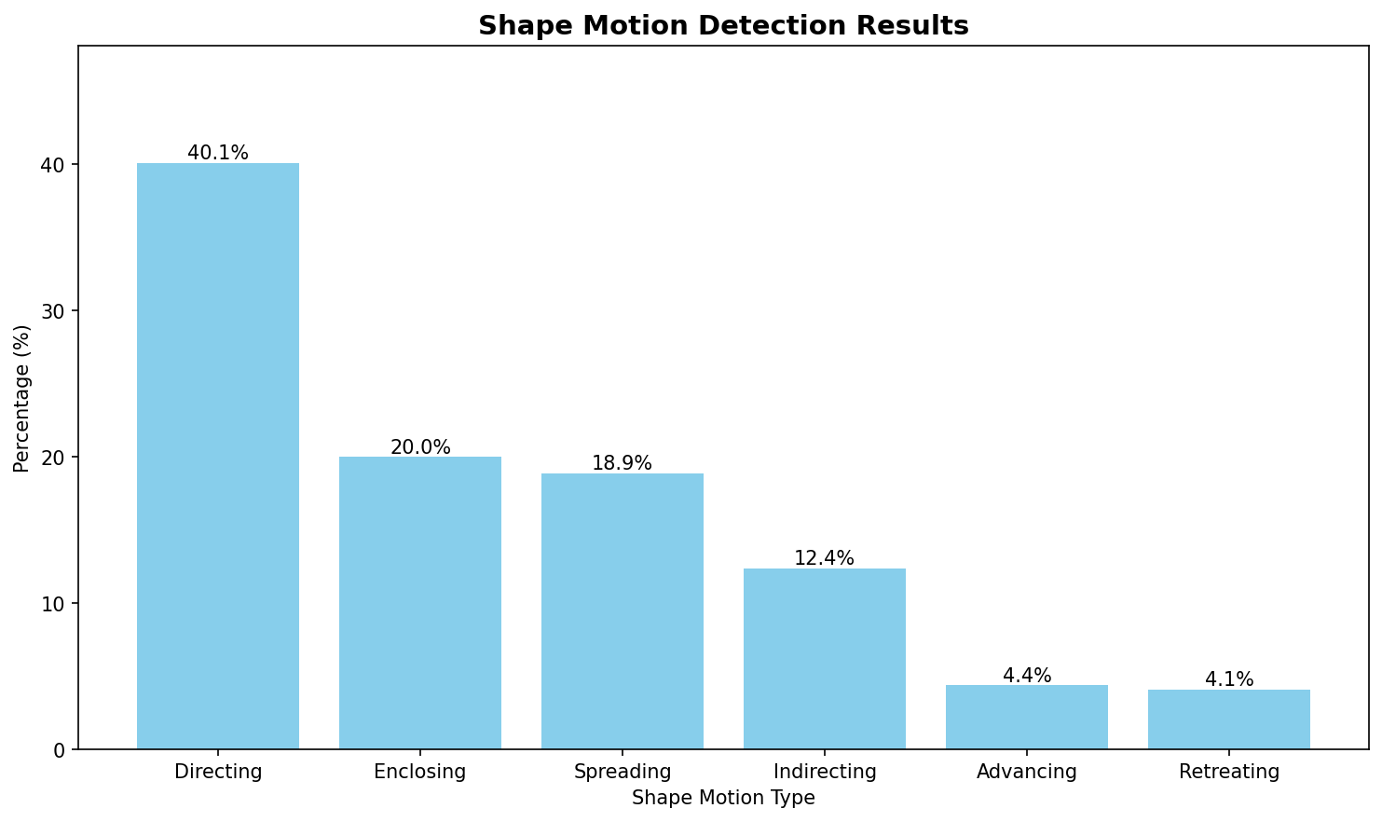

Generated by AI People Reader™

