Contents

Navigate to http://qa.wealth4india.com/site 2

Once Signed up 2

Start Preparing Return 2

# Navigate to <http://qa.wealth4india.com/site>

* Signup

# Once Signed up

* Login to <http://qa.wealth4india.com/site>
* Start Preparing New Return

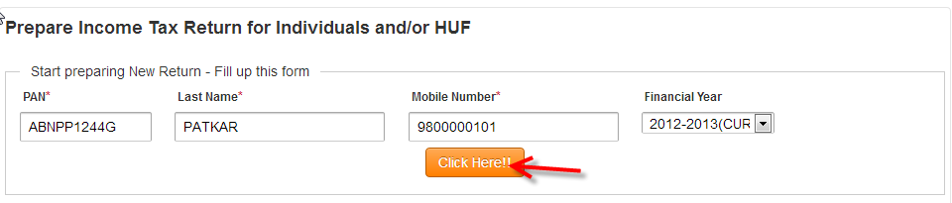

Prepare Income Tax

# Start Preparing Return

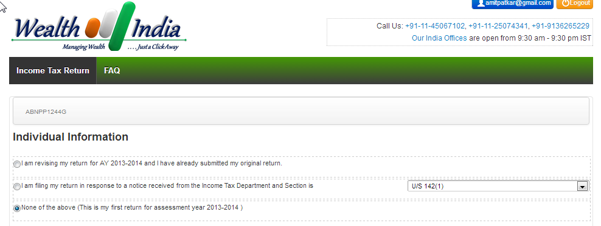

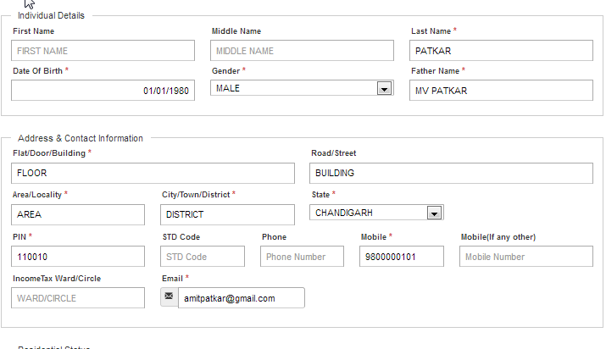

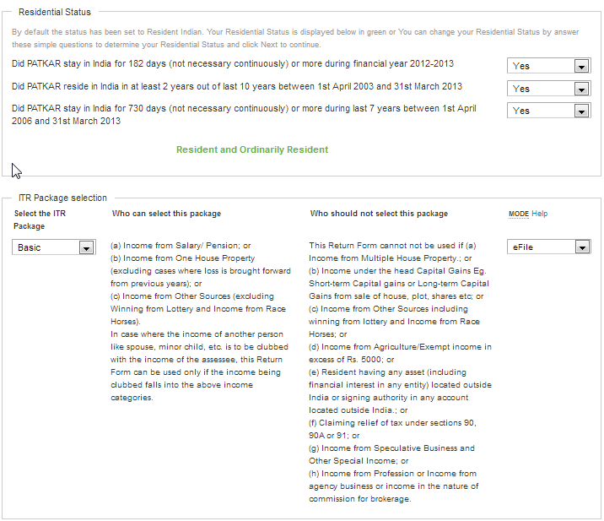

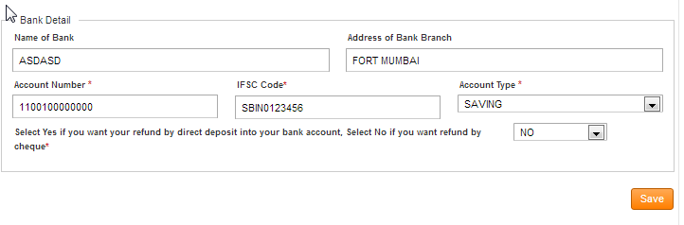

# Invoice

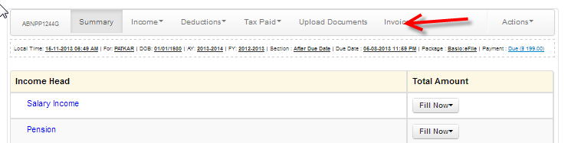

# Invoice Payment Net Banking

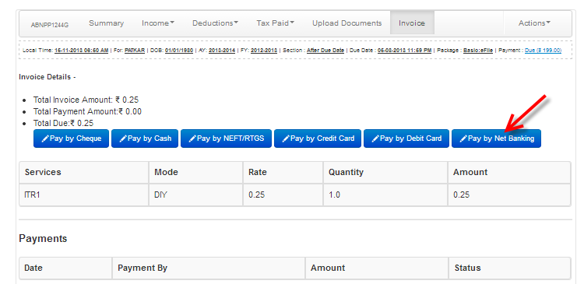

# Invoice Payment Net Banking

Finish your transaction.