# RMAN

1. Introduction

RMAN( Recovery Manager) is a backup and recovery manager supplied for Oracle databases (from version 8). It provides database backup, restore and recovery capabilities addressing high availability and disaster recovery concerns. Oracle Corporation recommends RMAN as its preferred method for backup and recovery.(source: <https://en.wikipedia.org/wiki/RMAN> )

1. Rman target

The database that you backup or restore is the target database. Target option is used to connect to the target database.

Note: rman can only connect to the database by user with sysdba privilege implied.

If a user doesn’t have sysdba privilege then following error prompts up.

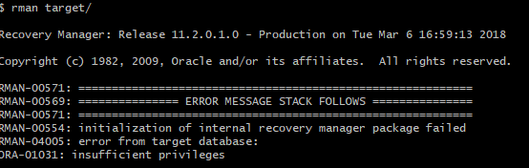

Fig2.1: Error when a user doesn’t have sysdba privilege

Solution:

Grant user with sysdba privilege. For example: for user ‘saman’ grant sysdba privilege by sys.

Code: SQL> Grant sysdba to saman;

Then, Connect to the target by the user

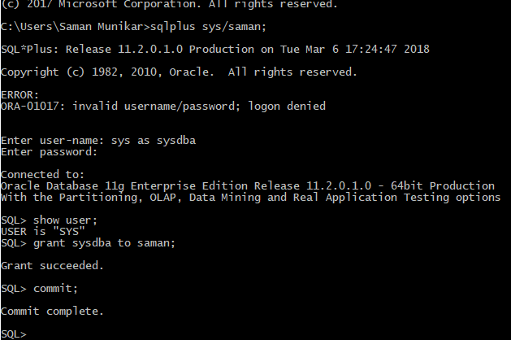

Fig2.2: Grant sysdba to user(saman)

Then, after granting sysdba privilege, connect to the target by that user(saman)

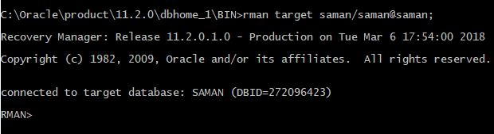

Fig2.3: Rman connected usind saman(user)/saman(password)@saman(service_id)