6.839 Advanced Computer Graphics
Homework 1: From Design to Machine Instructions
Report WriteUp
Runjia Tian
Master in Design Studies, Technology
Harvard University Graduate School of Design

1 Printing with a Virtual Printer

Slicing Pokemon With Repetier Host Slic3r Slicer with default parameters

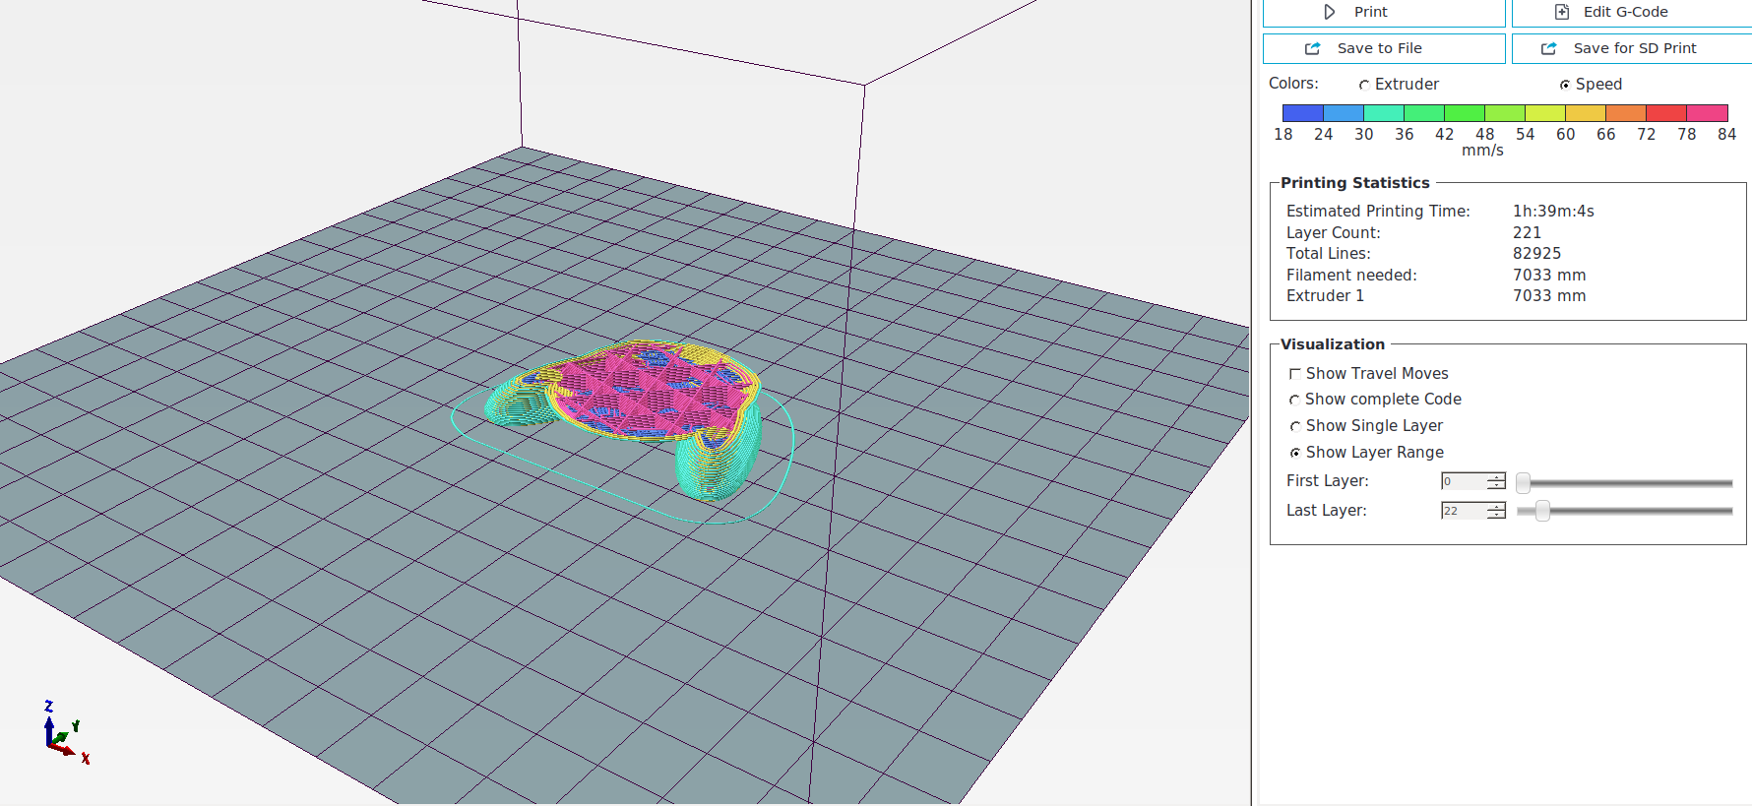

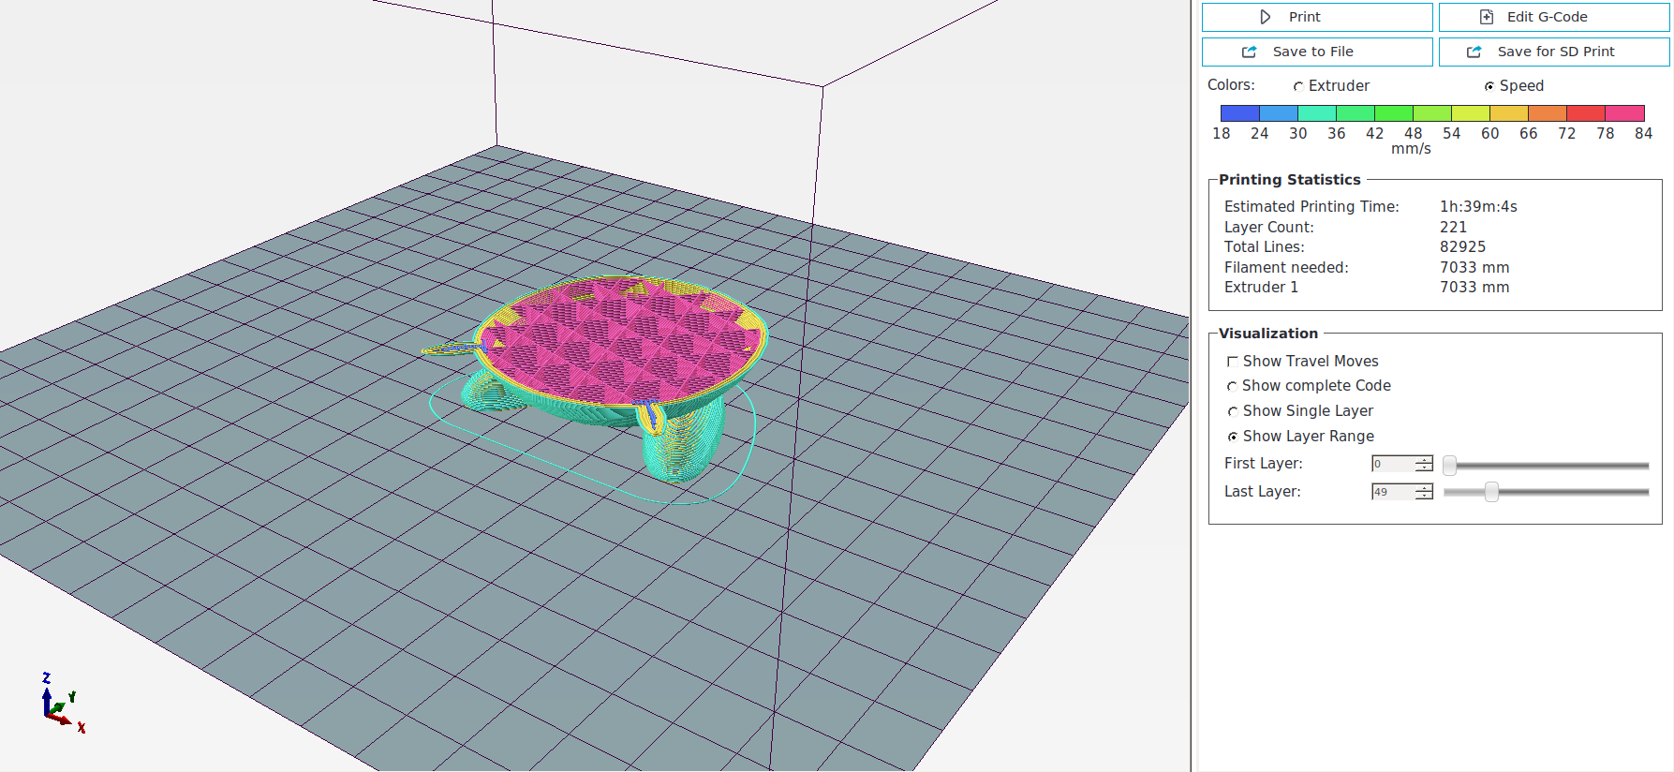

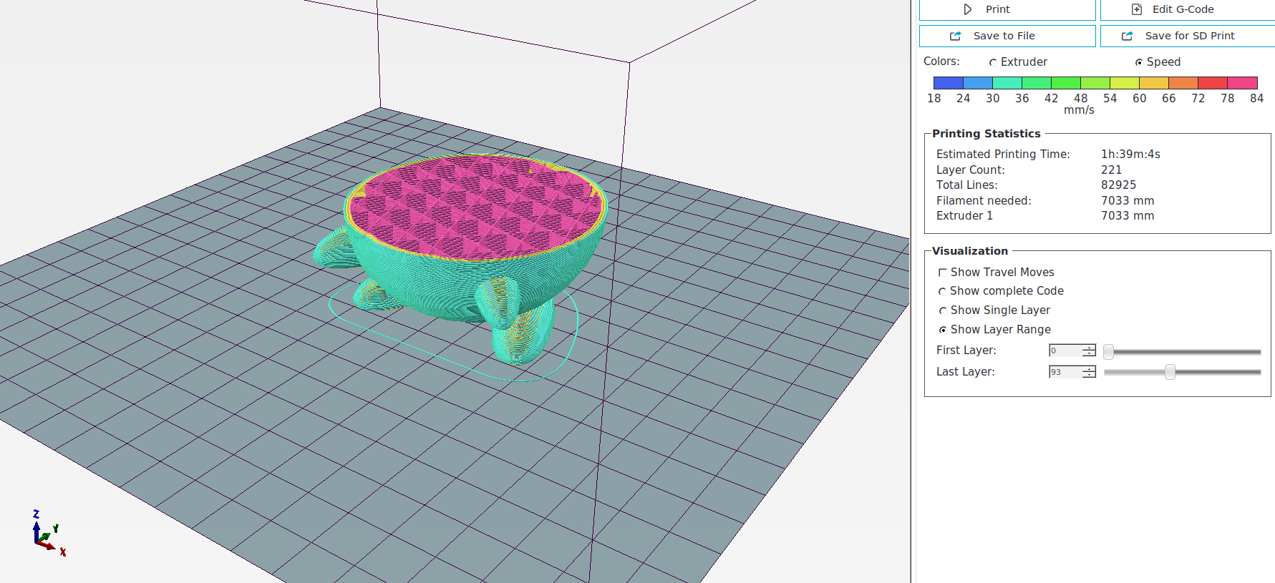

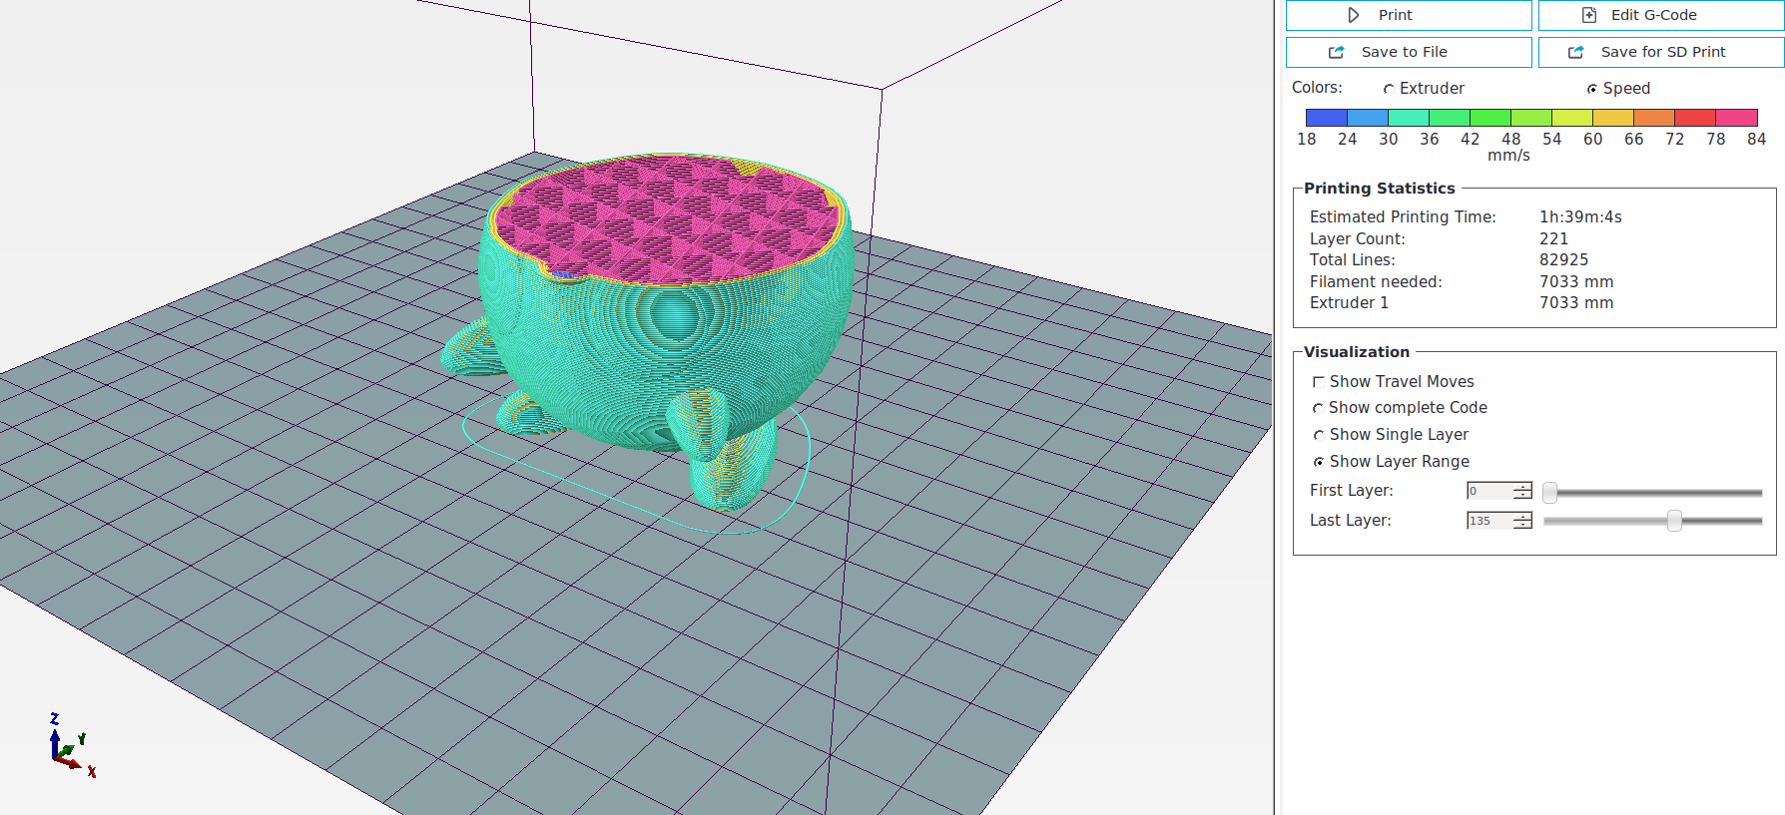

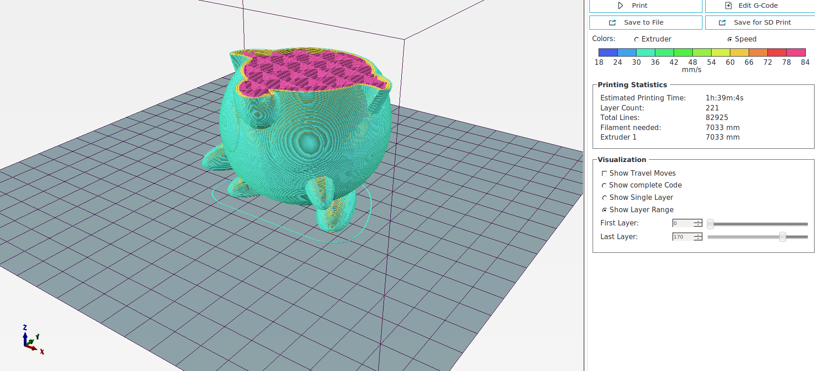

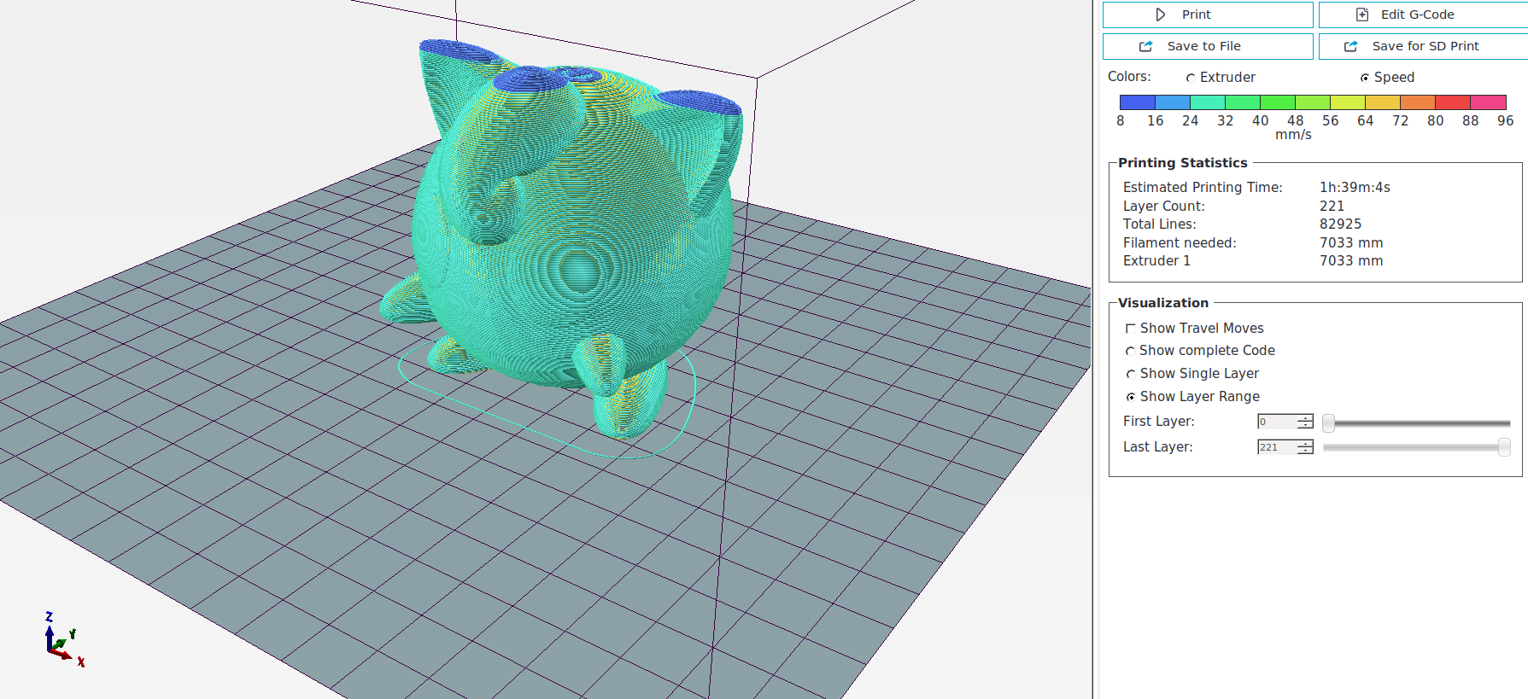

4 High-level Understanding
Question 1 Answer

Failure Input Type 1: Non-Manifold Geometries

This algorithm only works for the case if the input is a two-manifold mesh. If the input is non-manifold, the algorithm will fail, as it will lead to non-closed curves or duplicated contours during the contour construction step.

The way to handle this bug, is to add a sanity check before starting the contour construction to check if there is any vertex that are non-manifold.

Failure Input Type 2: Self-Intersecting Geometries
Another drawback of this algorithm is that it is not prone to self-intersecting geometries. Even if the geometries are self-intersecting, it will still create self-intersecting polygon contours. This does not break the slicing program, but will cause trouble to the real printing process.

To handle this aspect, a sanity check for self-intersecting geometries are necessary even before the slicing algorithm.

