# Asset Prices, Individual Preferences, and Foreclosure Relief

How do asset prices affect voter decisions *in extremis*? Political economy has investigated the impacts of income on voter behavior, labor market risk on social insurance preferences, housing on voter behavior, and home value on welfare demand. But it has not investigated how such policy preferences represent themselves in political decision-making, nor the priority of relative changes in home price versus the absolute level of home prices, dynamics relevant to the Neighborhood Stabilization Program, which aimed to affect neighborhoods in greatest need. This thesis seeks to untie these last two knots by modeling vote outcomes, while this chapter moves from groups to individuals.

This chapter moves from groups to individuals by reviewing the relevant literature on asset-based social insurance preferences, psychology of lost and gained wealth, and American voting behavior. It works towards a model of voting that will be used to analyze returns from the 2010 midterm elections, when the Tea Party experienced its first and greatest victories. To give handles which readers can grasp, I will simultaneously describe the measures and data used for my analysis. This chapter stands logically between my last two. It describes how the financial crisis—whose characteristics were explored in @ref(actors-motive)—mutated individual preferences, preferences which could then be located in the political landscape described in @ref(motive-opportunity).

## The Role of Home Prices

At base, I describe individual consumption preferences from a life cycle/permanent income perspective. Milton Friedman opened his foundational work in life-cycle analysis by noting “Keynes took it for granted that current consumption expenditure is a highly dependable and stable function of current income.”[1] Keynes understood economic fluctuations and crises as products of the past and present, as gluts or dearths of savings.[2] What future tense factored into his understanding was almost immediate—the momentary “animal spirits”, for instance, or the undulations of the business cycle which trigger liquidity traps—rather than the long patterns highlighted by Kuznets. Friedman addressed the idea that individuals’ income derives not simply from current income, or previous savings, but from all future earnings. In an extreme example, a toddler able to form “rational” (some fuzziness on this term’s definition) expectations of future income could finance their upbringing and education by borrowing aginst those predictions, this would be a rational choice for both toddler and financier. This framework sees wealth, and therefore housing, as potentially permanent income.

But housing can also be used as a financial “buffer stock” against emergencies. This refinement is motivated by historical facts about American saving habits.[3] In 2007, about as many households saved for retirement (33.9%) as for unexpected expenses (32.0%). In addition, only 56% of households saved in 2007, with dramatically lower rates at lower levels of the income distribution.[4] Regardless of whatever official statistics can show the trends in labor market risk to be, it is the perception of homeowners that such risks necessitate savings.

I argue that understanding the home doubly as an asset shapes homeowners’ political decisions in light of their perceptions regarding risk, that how one plans to pay for such emergencies feeds into a person’s politics. This claim is supported in no small part by the fact that homeowners are represented worldwide by conservative political parties.[5] Of course, it could simply be the case that high-income people, those who are more likely to own a home, tend to be more conservative. Or, perhaps those who own homes value its refuge from urban corruption, but the idea of leveraging one’s home instrumentally for financial gain is equally vulgar to such a person’s traditional social values. But these alternative narratives cannot embrace certain data points.

Understandings of housing as an asset are not foreign to homeowners. 1982, the year following Reagan’s Economic Recovery Tax Act, simultaneously saw a 35-year high for personal savings and 35-year low for mortgage equity withdrawal (MEW), as a percentage of disposable income. By 2005, these lows and highs had flipped. @ref(fig:mew) shows the outstanding inverse relationship between the ratios of personal saving and MEW to disposable income. For at least the XX% of Americans who use home equity to finance personal consumption, housing expands opportunities.(pretty sure I got this from your book…will find later, at any rate)

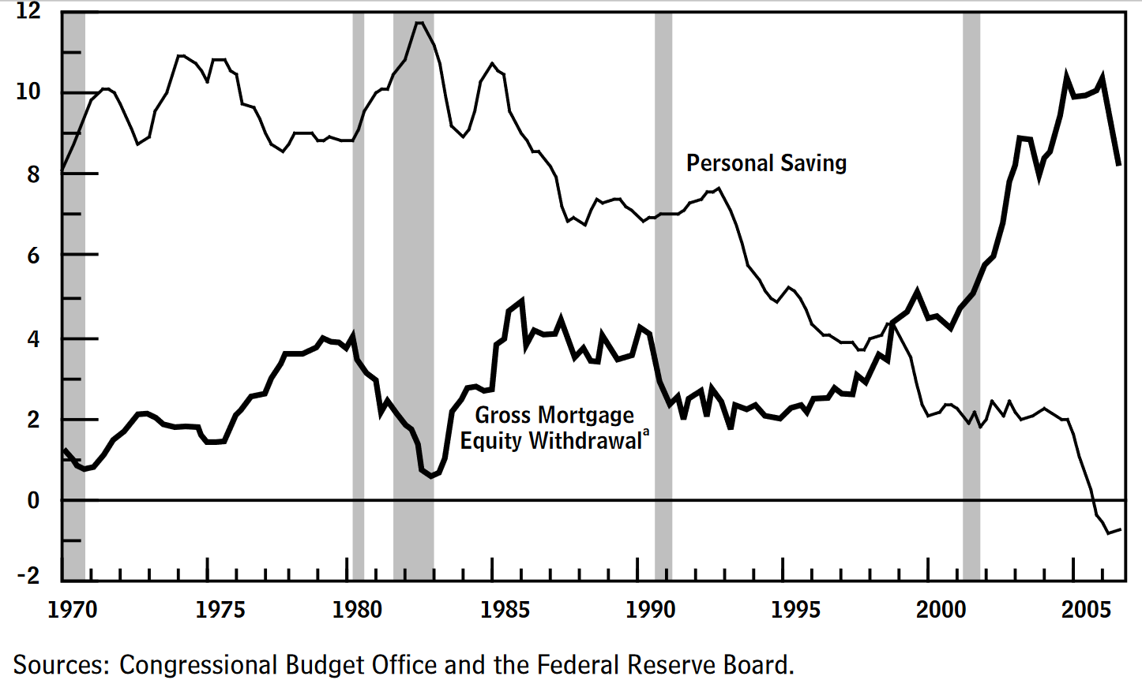

Personal saving and mortgage equity withdrawal as a percentage of disposable income.

While these effects are not unique to housing, they are most significant in housing. Mortgage equity exhibits greater wealth effects than investments in stocks: research by Case, Shiller, and Quigley found statistically significant increases in the cents of new consumption per new dollar of housing income when compared to stock market income. Economists disagree as to the cause and level of this wealth effect, but the fact that this effect is greater than other financial holdings is broadly agreed upon, and fits into the view that America has transitioned into a consumption- and import-oriented economy. Compounding the significance of housing wealth was the sheer size and volatility of housing: Ansell notes that, “between 1985 and 2006, real house price inflation was three times greater than between 1970 and 1985, with a standard deviation almost twice as large.”[6]

Subsidizing housing and home mortgages privatizes government spending otherwise recognizable as welfare. In doing so, the policies and implementations change how citizens view the state’s role in their personal finances. More specifically, individuals’ preferences for welfare depend “on how existing policies shape their experience of individual risk.”[7] A stronger claim would be that policies *train* beneficiaries, a view held by Isaac William Martin. He uses this mechanism to explain the great political diversity of organizers for Proposition 13 in California: homeowners protect the welfare afforded to them.[8] At the local level, homeowners have long lobbied as a class, enclosing their neighborhoods from Black applicants, breaking fervent upzoning factions, and rejecting otherwise welcome industry. Thus, it should come as no surprise that homeowners react to direct and indirect subsidies in similar ways as they react to market-caused fluctuations in their home values.

By privatizing government spending, the subsidies offered by the Neighborhood Stabilization Program individualize housing gains, differentiating this form of “invisible welfare” from the bureaucratic programs debated by the Republican and Democratic parties. Visible welfare programs transfer individual risk to social risk,[9] and make more equitable[10] the public goods of a society (in the Rawlsian sense). These two features distinguish the welfare that is argued about on television from the welfare that is argued about in journals. The political scientist’s point is that they are substitutable: preference for this private form of insurance reduces the demand for social insurance programs.

Then, the task for the individual political actor is simply to follow these preferences to their political implications by stepping back through the argument in @ref(motive-opportunity). This argument says that, under the narrative of balanced budgets and concerns over the national debt, lower expenditure makes possible lower revenue. Therefore, lower preference for social insurance justifies preferences for lower taxation. Tea Party candidates espoused this logic, clearing a spot into which voter preferences could fit.

However, it is important to understand that, just like the contingencies of party platforms, there are contingencies in how individuals process economic data and political propositions. Larry Bartels (2002) accepts this basic assumption while rejecting the idea that ideology or partisanship are static filters through which people see selectively. Rather, he argues, partisanship is a dynamic negotiation between partisanship as exogenous or endogenous variable. His Bayesian learning model presents a different model: people update beliefs as new information becomes available, but people also selectively intake information according to beliefs.[11] Disentangling the two sub-routines is difficult, if not impossible, but the rule of thumb is that long-held beliefs require [relatively] huge inconsistencies to catalyze change.

While the mortgage crisis, financial meltdown, and ensuing Great Recession delivered onto unsuspecting citizens heaps of information—much of it likely inconsistent with individual beliefs about meritocracy, personal financial stability, and government oversight—survey data suggests that the government response delivered similarly-sized heaps of information. Pew Research’s American Values polling series has tracked opposition and support of various political positions since the late 1980s.[12] This longitudinal sureying shows sharp divergence between the economic beliefs of Democrats and Republicans *as well as* between independents who lean either way. For partisan divides, @ref(fig:ideological_social) shows how Republican beliefs regarding social insurance regress to a conservative ideal more aggressively than both Democrats and independents. I split hairs over this behavior with Ansell (2014), that maintains it is self-identifying liberals who maintain an ideological opposition to spending cuts.[13] This position is not exactly borne out in the Pew numbers: while independent support for raising social insurance spending (middle section) falls relative to Democratic support after 2007, independent support for maintaining (left section) or expanding (right section) social insurance spending when disconnected from budgetary imbalances hews closely to Democratic behavior. When these are combined with the polling on ideological slant, the Pew research offers a coherent picture of independent voting behavior between 2007 and 2012.

@ref(fig:ideological_social) shows how independents who lean towards a party compare with those parties on a number of political positions. The larger variance in positions for both sets of “leaners” shows how independents less consistently assimilate perceptions of evolving economic realities into their political positions. Those who identify as Republicans or Democrats are not swayed in their support for social safety net provisions by the eruption of financial and economic turmoil. In contrast, leaners towards both parties are strongly affected by its event, and even more strongly affected by the subsequent increase in spending and its surrounding rhetoric. Partisanship affects how individuals fit economic perceptions into their political positions; not all voters *could* (let alone *would*) be affected by something like rising home prices. Therefore, my model aims at marginal voters, those independents whose picture of the world is more open to alteration.

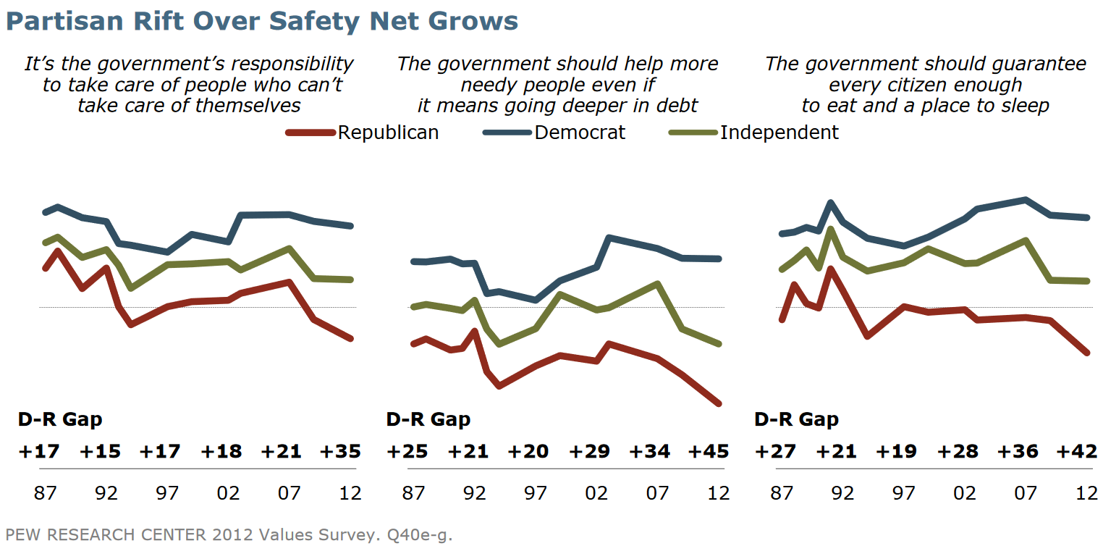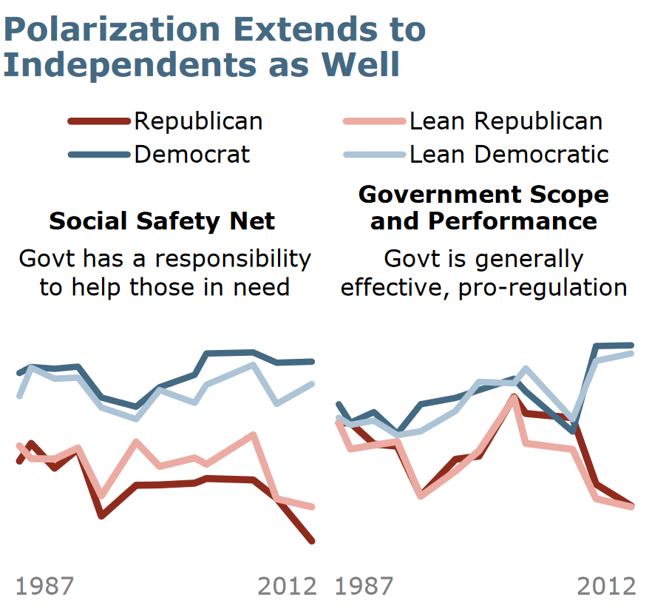

And I expect the effects to be marginal, as the Neighborhood Stabilization Program really enriched no one. If each foreclosure costs, on average, $159,000 in decreased property values,[14] then each surrounding home value decreases by only a fraction of that number. Conversely, if a vacant property is fixed and resold, surrounding home values would only increase by a fraction. Additionally, the hefty oversight on the NSP targeted profiteering by local actors, preventing any get-rich-quick schemes. The Neighborhood Stabilization Program receives high marks methodologically from its under-the-radar nature: if voters knew, and could filter, their wealth gains through an ideological sieve, it could skew results. Rather, its small effects and lack of advertising[15] (and reciprocal press coverage) simplify an analysis that would otherwise seek to account for the media narrative surrounding such a program.

While these factors simplify my analysis and attenuate its potential for strong conclusions, my model is complicated by the way that humans value equal amounts of money lost and gained. In behavioral economics and cognitive psychology, the endowment effect describes the premium that individuals place on ownership. Asked to trade one object given to them for another of equivalent exchange value, people demonstrate a marked preference for the object assigned to them. The endowment effect is tied to loss aversion, which is that people experience a dollar lost much more acutely than a dollar gained.[16] In the permanent income hypothesis, this behavior is not well integrated. Even with “buffer shocks” added in, the hypothesis asserts that wealth shocks will affect spending linearly.

To give a concrete example, consider a home worth $100,000 in 2000. If that home increased in value $50,000, a marginal propensity to consume (MPC)—the economist’s term for the extra spending per dollar—of .06 would predict that $.06×\$50,000=\$3,000$ of extra consumption would result. However, what if that home decresed in value $50,000? Would spending decrease $3,000? It seems unlikely that, in the midst of an event labeled as a ‘crisis’ or the ‘Great Recession’, spending would not decrease even more dramatically, and would be reluctant to rise for fear that momentary gains would be washed away by another crashing wave of home prices. Or, maybe contractions exhibit a linear relationship with the *rate* of price changes, but a second relationship results from the endowment effect. In this second case, consumption is a function not only of price changes, but also of net positions: a homeowner spends freely so long as their home is worth more than their original purchase price, but is averse or highly-sensitive to dips below the original price.

Angrisani et al. (2019) demonstrated that the marginal propensity to consume changed during the recession (2008-2010) from its run-up (2005-2008). That these dates do not align perfectly with those of the foreclosure crisis (2007-2012) is not significant; these dates contain the three phases of the Neighborhood Stabilization Program as well as the 2010 midterms, and overlap significantly with the foreclosure crisis. Angrisani et al. used an instrumental variables approach to estimate the MPC of non-recessionary periods to be statistically insignificant, while that of the recession to be 0.062.[17] His finding that non-recessionary periods exhibit no marginal propensity to consume conforms to the rational expectations model of microeconomic behavior—given an *expected* change in income, individuals will not alter consumption. Rather, it is only during an unexepcted change in expectations (such as a recession) that consumption changes. This understanding integrates Angrisani’s research with most of the work on housing wealth effects pre- and post-crisis.[18] Further, Angrisani et al. is the only approach I have found that disaggregates housing wealth MPC before and after the crisis in the familiar permanent income hypothesis framework.

And, its findings are buttressed by two other pieces of literature. The first is the body of work on endowment effects and the psychological costs of loss versus gain. Angrisani et al. acknowledges this by saying “If, as documented in previous work, wealth losses are more likely to induce changes in behavior than gains, our estimates may reflect a more pronounced sensitivity of household spending to falling house values.”[19] The second piece is the work done by Berger et al. This paper understands data that points to large consumption effects as running contrary to the permanent income hypothesis, which predicts that wealth shocks will be amortized over an individuals’ lifetime. They then build a new model that attempts to model homeowener expectations based on realistic features of the housng market such as debt levels, collateralization, and variable home price expectations. These features result in larger marginal propensities to consume, and larger effects of lost wealth than gained wealth.[20]

The upshot this literature yields for my analysis is that neighborhoods not targeted by the Neighborhood Stabilization Program should see consumption decrease greater from the bust than consumption increased from the boom. This behavior should heighten labor market risk, meaning that, in untargeted areas, lower Republican support should be present. An additional—but less controversial—tension to consider is the relationship between change of wealth and total position of wealth. In general, the marginal propensity of wealth decreases as individuals get wealthier.[21] While there is some squirreliness regarding housing MPC at the very high end of the wealth distribution (second and third homes may truly be just assets, so the purpose would be extra consumption), given the size and location of such high wealth individuals, it is unlikely the Neighborhood Stabilization Program affected those individuals’ houses. This result implies that those tracts targeted by the NSP should be especially sensitive to its marginal price increases and therefore exhibit higher Republican voting returns.

## Control Variables

I turn now to more general models of American congressional voting. Little is made of the controlling variables in academic publications, but anyone who has toyed around with regression analysis knows that the exclusion or inclusion of one or two variables can make or break a hypothesis. Often variables are included without apparent reason, leading to suspicions about the robustness of statistical inference. It is therefore important for the statisical analyst to offer two ways for readers to inspect one’s work. The first way is to explain the inclusion—or sometimes, exclusion—of particular variables used to disaggregate the effects of contributory forces. The second way, shown in the next chapter, is to present analyses that include or exclude particular variables; the common belief that if a significant association can be made despite the inclusion or exclusion of several variables, than the constancy of the association effectively verifies its ability to predict behavior.

As Congressional voting returns will be the object of analysis in my next chapter, it is important to isolate the effects of the Neighborhood Stabilization Program. To do so, I opt to include several variables that also impact a Republican vote. These variables are lumped broadly into three categories: visible identity, including race and age; economic identity, including income and unemployment; and cultural identity, including measures of urbanicity as well as religion. This breakdown acts purely for organizational purposes as the blur between visible, economic, and cultural should make clear, but they nonetheless reflect a view that voting decisions can be reduced to observable characteristics. As the predictive power of my model will make clear, this status is not the case: indiviudal forces cannot explain even half of the variation in voting returns. Nonetheless, without polling microdata, the demographic features provided by the decennial census offer the best chance at understanding voter behavior.

### Visible Identity

Visible identities are those which are involuntarily imposed. They press, as Kwame Anthony Appiah, notes, as “walls that hedge us in.”[22] Since many of these identities have become legally protected categories in the United States, their records are kept precisely and publicly. The upshot of this feature is that records are easily available, but this availability may lead to an overestimation of their effects on voting, as researchers look where the light shines instead of where their object of interest may be found. On the other hand, while partisan voting support may have counter-intuitive logic that necessitates complex research methodologies, rational explanations for identity-based support are often at hand in visible identities.

For instance, Black voters long supported the Republican Party as the party of Abraham Lincoln, Congress’ first Black legislators, and as proponents of programs benefitting African Americans. This support changed first with the New Deal, with Franklin Delano Roosevelt won 71% of the votes cast by African Americans in 1936, though party identification by African Americans reamined even between the two parties over the next ten years. During the Civil Rights Movement this support changed again, when votes for Lyndon B. Johnson’s first elected term commanded 94% of the Black vote.[23] Some of the United States’ pre-eminent segregationists were staunch Democrats, but federal action by Lyndon B. Johnson and subsequent campaigning by Richard Nixon effectively fractured Democratic support in the South. In the contemporary Democratic Party, redistributionist welfare programs aligned with integration to remedy both the economic and social disparities between white and Black Americans, turning the Democratic Party towards the majority of African Americans.

Similar stories cannot be told for American Indians, Asian Americans, or ethnically Hispanic Americans, but each has their *own* story with the Republican or Democratic parties. While American Indians have comprised a small percentage of the United States voting population, a fact owing to their legal disenfranchisement and decimation by civilian and military forces, their vote swings heavily Democratic. This behavior is not due to historical reasons—no party has sustained Indian issues at the national scale—but to reactions for the supply of social welfare programs. On average, 48% more reservation residents receive cash or food stamps from the federal government than do households in the general population.[24] While their turnout rates and absolute population size is low, including a variable for their population could explain the voting behavior of Census Tracts where reservations are located. I will employ a binary cut-off metric: should a Census Tract contain a large population of Native Americans (25%, for instance, compared to the national average of 0.9%), then that tract would be labeled as such.

The stories of Asian Americans and ethnically Hispanic Americans are perhaps the most fractured among racial political narratives. The “Hispanic vote” is often pointed to as a core aspirational piece of the Democratic coalition, though Democratic candidates maintain a checkered record in attracting and serving ethnically Hispanic voters. Nonetheless, there are compelling reasons to include a measure of Hispanic voters. Until a certain point, an increased Hispanic population raises fears of white job loss, increasing conservative—and especially Tea Party—voting, though no consensus regarding this “racial threat” hypothesis has emerged.[25] As white voters compose between 60% and 70% of the national electorate, fears inflected through them lead to significant effects. Interestingly, Republicans used housing policy as a way to attract Hispanic voters. With more than 50% of Hispanic people living in America identifying themselves as Catholic,[26] adding government transfers to conservative social values would further cement the 40% of the “Hispanic vote” achieved by Republicans in the 2004 presidential election.[27] While the motives for voting Republican by Hispanics are complex, the reasons do not cancel out one another, so I will include their population percentages as a predictor.

On the other hand, Asian Americans have pushed back against the “Model Minority” myth to contextualize the fact that the median Asian American income earner—come their families (or they) from India, China, Vietnam, Japan, Korea, Iran, Uzbekistan, or the Philippines—made in 2016 $3,330 more than the average white household. But inequality among Asian Americans is worse than for any other group; Pew notes that income earners in the 90th percentile made nearly 11 times as much as those in the 10th percentile.[28] Across historical, religious, and cultural factors, it is arguable that Asian Americans are the most heterogeneous group of immigrants, which makes their inclusion in Ben Ansell’s 2014 paper puzzling. Given the contemporaneous heterogeneity of voting patterns by Asian Americans, and the shifting patterns of ethnicities throughout time, I find little reason for their inclusion in this model.

Lastly, age comes into play as a proxy for an invisible identity, that of retiree. Fixed-income voters are highly sensitive to home price increases, because asset prices are the only variable piece of their budget. Additionally, a wealth change amortized over a shorter lifespan will present as higher average income, and therefore consumption. Rather than use the median or average age of the U.S. population, the decennial Census tracks the number of people in five-year bins. Therefore, I use the percentage of people 60 years of age or older—401(k) plans can be cashed out tax-free after age 59 1/2—to estimate the amount of retirees (or those whose thoughts are largely on retirement). Additionally, older Americans generally hold more conservative social views. In my view, these forces cannot be disentangled without microdata on labor force participation, which could distinguish a retiree from an old person.

### Economic Identity

To isolate labor market risk from income, I will use both the median household income as well as the *change* in median household income. The change offers a truer picture of employment becoming underemployment and resolves a problem presented by using the unemployment rate: the HUD estimates of foreclosure rate use the unemployment rate as a predictor of foreclosures. Inclusion in the model would re-isolate unemployment from the estimated foreclosure rate, and bias the estimation of the foreclosure rate’s significance on voting in an indeterminate manner. However, the 2010 Neighborhood Stabilization Program uses only the *change* in unemployment rate, leaving open the unemployment rate as a predictor. The inclusion of this predictor captures effects contemporaneous to the election while avoiding the modeling problems described above.

Additionally, the Census Bureau tracks homeownership rate. At first glance, the inclusion of the 2010 homeownership rate would appear to come at an inopportune time, as the very fluctuations in the homeownership rate are captured in the foreclosure rate. But this capture is only partial, and, furthermore, the foreclosure rate tells nothing about the absolute levels of homeownership. Homeownership is associated with conservative voting around the world, and the effects of social capital are well-researched.[29]

### Cultural Identity

Three primary factors flavor voting at the cultural level: religion, urbanicity, and highest level of education attained. Within these factors, which are so grouped because they are in some sense voluntarily elected by the person to which the characteristics are attached, specific levels are significantly associated with Republican voting, while other levels are a mixed bag. Religion exemplifies this relationship. Republican voting by evangelical Protestants and members of the Church of Latter-Day Saints (LDS, or the Mormon Church) is much more predictable than voting by members adherent to any religion.[30] The U.S. Religion Census reports county-level data on adherents to a huge number of denominations, and is the only sub-national source for all fifty states. Conducted contemporaneously with the decennial census (though not connected, organizationally), I will join county-level statistics regarding the level of evangelical Protestants and members of LDS to the Census Tract level.

Additionally, the urban-rural divide has been noted as a political cleavage. Lower-density areas provide fewer international transportation options, educational/translation resources, and less name recognition than do large cities. The populations of many rural areas is implicitly limited by agricultural or industrial land holdings that prevent large turnover of residents. And on the side of push factors, residents of rural areas are often more religious than their urban counterparts, find traditional social institutions more important, and are generally older than cities and suburbs. These factors do not imply that those areas are in stasis, but rather that the rigidity of beliefs is compounded by the institutions and political economy of rural areas. These beliefs, in long historical sweep, are generally better represented by conservative legislators currently residing in the Republican party.

Lastly, the highest level of education attained is a huge predictor of one’s party affiliation, but only for white voters. A 15-point gap persists between white voters with and without a college degree: 45% percent of college-educated white voters cast their ballots for Republicans, while more than 60% of those with a college degree did the same.[31] This trait has worsened since George H. W. Bush’s presidency, before which educated and uneducated voters were more or less aligned. Due to the racial nature of this variable, I will puruse education level *multiplied* by percentage of population white as a predictor.

## A Model of Voting

The discussion above leaves me with a model of Republican voting: $rep_{i}=β_{0}+β_{1}forq_{i}+β_{2}Black_{i}+β_{3}AmerIndian_{i}+β_{4}urbanicity_{i}+β_{5}evang_{i}+β_{6}lds_{i}+β_{7}Hispanic_{i}+β_{8}medHHI_{i}+β_{9}chgHHI_{i}+β_{10}ownhome_{i}+β_{11}unem{10}_{i}+β_{12}old_{i}+β_{13}(somecol_{i}×white_{i})+ϵ_{i}$

Abrajano, Marisa A., R. Michael Alvarez, and Jonathan Nagler. “The Hispanic Vote in the 2004 Presidential Election: Insecurity and Moral Concerns.” *The Journal of Politics* 70, no. 2 (April 2008): 368–82. <https://doi.org/10.1017/S0022381608080365>.

“A Deep Dive into Party Affiliation.” *Pew Research Center’s U.S. Politics & Policy Project*, April 2015.

Angrisani, Marco, Michael Hurd, and Susann Rohwedder. “The Effect of Housing Wealth Losses on Spending in the Great Recession.” *Economic Inquiry* 57, no. 2 (April 2019): 972–96. <https://doi.org/10.1111/ecin.12753>.

Ansell, Ben. “The Political Economy of Ownership: Housing Markets and the Welfare State.” *American Political Science Review* 108, no. 2 (May 2014): 383–402. <https://doi.org/10.1017/S0003055414000045>.

Appiah, Kwame Anthony. *The Lies That Bind: Rethinking Identity*. EBook. New York: Liveright Publishing Corporation, 2018.

Arrondel, Luc, Pierre Lamarche, and Frédérique Savignac. “Wealth Effects on Consumption Across the Wealth Distribution: Empirical Evidence.” Working Paper. Frankfurt am Main: European Central Bank, June 2015.

Bartels, Larry M. “Beyond the Running Tally: Partisan Bias in Political Perceptions.” *Political Behavior* 24, no. 2 (2002): 117–50.

Berger, David, Veronica Guerrieri, Guido Lorenzoni, and Joseph Vavra. “House Prices and Consumer Spending.” Working Paper, November 2016.

Bucks, Brian K, Arthur B Kennickell, Traci L Mach, and Kevin B Moore. “Changes in U.S. Family Finances from 2004 to 2007: Evidence Form the Survey of Consumer Finances.” *Federal Reserve Bulletin*, February 2009, 1–56.

Campbell, Andrea Louise, Cara Wong, and Jack Citrin. “‘Racial Threat’, Partisan Climate, and Direct Democracy: Contextual Effects in Three California Initiatives.” *Political Behavior* 28, no. 2 (June 2006): 129. <https://doi.org/10.1007/s11109-006-9005-6>.

Carroll, Christopher D. “Buffer-Stock Saving and the Life Cycle/Permanent Income Hypothesis.” *The Quarterly Journal of Economics* 112, no. 1 (1997): 1–55.

Friedman, Milton. “Introduction to "A Theory of the Consumption Function".” In *A Theory of the Consumption Function*, 1–6. National Bureau of Economic Research General Series 63. Princeton, NJ: Princeton Univ. Press, 1957.

Gingrich, Jane, and Ben Ansell. “Preferences in Context: Micro Preferences, Macro Contexts, and the Demand for Social Policy.” *Comparative Political Studies* 45, no. 12 (December 2012): 1624–54. <https://doi.org/10.1177/0010414012463904>.

Greenspan, Alan, and James Kennedy. “Sources and Uses of Equity Extracted from Homes.” Working Paper. Washington, DC: Federal Reserve Board, March 2007.

“Guide to Marketing and Selling NSP Homes.” Department of Housing and Urban Development, September 2010.

Harris, Adam. “America Is Divided by Education.” *The Atlantic*. https://www.theatlantic.com/education/archive/2018/11/education-gap-explains-american-politics/575113/, November 2018.

Immergluck, Daniel. *Foreclosed: High-Risk Lending, Deregulation, and the Undermining of America’s Mortgage Market*. Ithaca: Cornell University Press, 2011.

Jackson, Brooks. “Blacks and the Democratic Party.” *FactCheck.org*, April 2008.

Kahneman, Daniel, Jack L. Knetsch, and Richard H. Thaler. “Anomalies: The Endowment Effect, Loss Aversion, and Status Quo Bias.” *Journal of Economic Perspectives* 5, no. 1 (March 1991): 193–206. <https://doi.org/10.1257/jep.5.1.193>.

Keynes, John Maynard, and Paul R. Krugman. *The General Theory of Employment, Interest, and Money*. New York: Palgrave Macmillan, 2007.

Kochhar, Rakesh, and Anthony Cilluffo. “Income Inequality in the U.S. Is Rising Most Rapidly Among Asians.” *Pew Research Center’s Social & Demographic Trends Project*, July 2018.

Kohut, Andrew, Carroll Doherty, Michael Dimock, and Scott Keeter. “Partisan Polarization Surges in Bush, Obama Years.” Washington, DC: Pew Research Center, June 2012.

Lasky, Mark, and Andrew Gisselquist. “Housing Wealth and Consumer Spending.” Congressional Budget Office, January 2007.

Martin, Isaac William. “Welcome to the Tax Cutting Party: How the Tax Revolt Transformed Republican Politics.” In *The Permanent Tax Revolt: How the Property Tax Transformed American Politics*, 126–45. Stanford, California: Stanford University Press, 2008.

Mian, Atif, Amir Sufi, and Francesco Trebbi. “The Political Economy of the US Mortgage Default Crisis.” *American Economic Review* 100, no. 5 (December 2010): 1967–98. <https://doi.org/10.1257/aer.100.5.1967>.

Prasad, Monica. *The Land of Too Much: American Abundance and the Paradox of Poverty*. Cambridge, Mass.: Harvard University Press, 2012.

“Public Assistance Income or Food Stamps/SNAP in the Past 12 Months for Households.” US Census Bureau, 2010.

Schwartz, Herman M. *Subprime Nation: American Power, Global Capital, and the Housing Bubble*. Cornell Studies in Money. Ithaca: Cornell University Press, 2009.

Stern, Stephanie M. “The Dark Side of Town: The Social Capital Revolution in Residential Property.” *Virginia Law Review* 99, no. 811 (April 2013): 68.

1. Friedman, “Introduction to "A Theory of the Consumption Function",” 1.
2. Keynes and Krugman, *The General Theory of Employment, Interest, and Money*.
3. Carroll, “Buffer-Stock Saving and the Life Cycle/Permanent Income Hypothesis,” 1.
4. Bucks et al., “Changes in U.S. Family Finances from 2004 to 2007,” 9–10.
5. Ansell, “The Political Economy of Ownership,” 387.
6. Ansell, 383.
7. Gingrich and Ansell, “Preferences in Context.”
8. Martin, “Welcome to the Tax Cutting Party.”
9. Gingrich and Ansell, “Preferences in Context.”
10. Prasad, *The Land of Too Much*, 229.
11. Bartels, “Beyond the Running Tally.”
12. Kohut et al., “Partisan Polarization Surges in Bush, Obama Years.”
13. Ansell, “The Political Economy of Ownership,” 387.
14. Immergluck, *Foreclosed*, 151.
15. “Guide to Marketing and Selling NSP Homes,” 5.
16. Kahneman, Knetsch, and Thaler, “Anomalies.”
17. Angrisani, Hurd, and Rohwedder, “The Effect of Housing Wealth Losses on Spending in the Great Recession,” 986.
18. Greenspan and Kennedy, “Sources and Uses of Equity Extracted from Homes”; Lasky and Gisselquist, “Housing Wealth and Consumer Spending”; Mian, Sufi, and Trebbi, “The Political Economy of the US Mortgage Default Crisis”; Schwartz, *Subprime Nation*.
19. Angrisani, Hurd, and Rohwedder, “The Effect of Housing Wealth Losses on Spending in the Great Recession,” 987.
20. Berger et al., “House Prices and Consumer Spending.”
21. Arrondel, Lamarche, and Savignac, “Wealth Effects on Consumption Across the Wealth Distribution.”
22. Appiah, *The Lies That Bind*, 189.
23. Jackson, “Blacks and the Democratic Party.”
24. “Public Assistance Income or Food Stamps/SNAP in the Past 12 Months for Households.”
25. Campbell, Wong, and Citrin, “‘Racial Threat’, Partisan Climate, and Direct Democracy.”
26. **???**
27. Abrajano, Michael Alvarez, and Nagler, “The Hispanic Vote in the 2004 Presidential Election.”
28. Kochhar and Cilluffo, “Income Inequality in the U.S. Is Rising Most Rapidly Among Asians.”
29. Stern, “The Dark Side of Town.”
30. “A Deep Dive into Party Affiliation.”
31. Harris, “America Is Divided by Education.”