

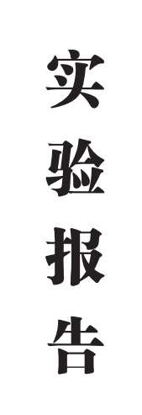

|  |  |  |  |  |  |
| --- | --- | --- | --- | --- | --- |
| **人工智能** | | | **学院** | **2024** | **级** |
| **计科（专升本）** | | | **专业** | **2** | **班** |
| **姓名：** | **钟润柯** | | | | |
| **学号：** | **202435710252** | | | | |
| **实验：** | **CSS与DIV页面布局** | | | | |
| **批阅老师：** | | **文立斌** | | | |
| **日期：** | **2024-10-30** | | | | |
| **成绩：** |  | | | | |

**实验报告内容**

**任务A、CSS文本字体及修饰设置**

|  |
| --- |
| <!DOCTYPE html>  <html lang="en">  <head>  <meta charset="UTF-8">  <meta name="viewport" content="width=device-width, initial-scale=1.0">  <title>钟润柯A</title>  <style type="text/css">  * {  border: 0;  margin: 0;  padding: 0;  }  body {  background-color: lightpink;  }  .zrkp {  background-color: yellow;  height: 66px;  margin: 10px;  padding: 5px;  border: red solid 5px;  border-radius: 20px;  /* 内容盒子 */  background-clip: content-box;  /* 溢出处理方式 */  overflow: auto;  }  .zrkm {  background-color: white;  margin: 20px;  padding: 5px;  border-style: dashed;  /* 上边宽度为10px，左右边框宽度为5px */  border-width: 10px 5px;  border-color: green lime rgb(255, 0, 102) blue;  text-align: center;  position: relative;  }  .zrkx {  border: 1px solid;  width: 100px;  height: 120px;  }  .zrky {  border: 1px solid;  width: 50px;  height: 60px;  }  </style>  </head>  <body>  <p class="zrkp">  网页可看成由一个个盒子（板块）构成。要随心所欲地控制页面中每个盒子的样式，需掌握盒子模型的相关属性：背景颜色、背景图片、边框、外边距、内边距、宽度、高度、位置及定位方式、浮动方式等。  </p>  <p class="zrkm">  <img src="imageszrk/校花1.JPG" alt="" />  <img src="imageszrk/校花2.JPG" alt="" />  <img src="imageszrk/校花3.JPG" class="zrkx zrky"  style="vertical-align: top; position: relative; top: 20px; left: 20px;" alt="" />  <img src="imageszrk/校草1.JPG" class="zrkx zrky" style="position: absolute; left: 5px; top: 5px;" alt="" />  <img src="imageszrk/校草2.JPG" class="zrkx zrky" style="position: absolute; right: 5px; bottom: 5px;" alt="" />  <img src="imageszrk/校草3.JPG" style="position: fixed; left: 85px; top: 20px; opacity: 0.5;" alt="" />  </p>  </body>  </html> |

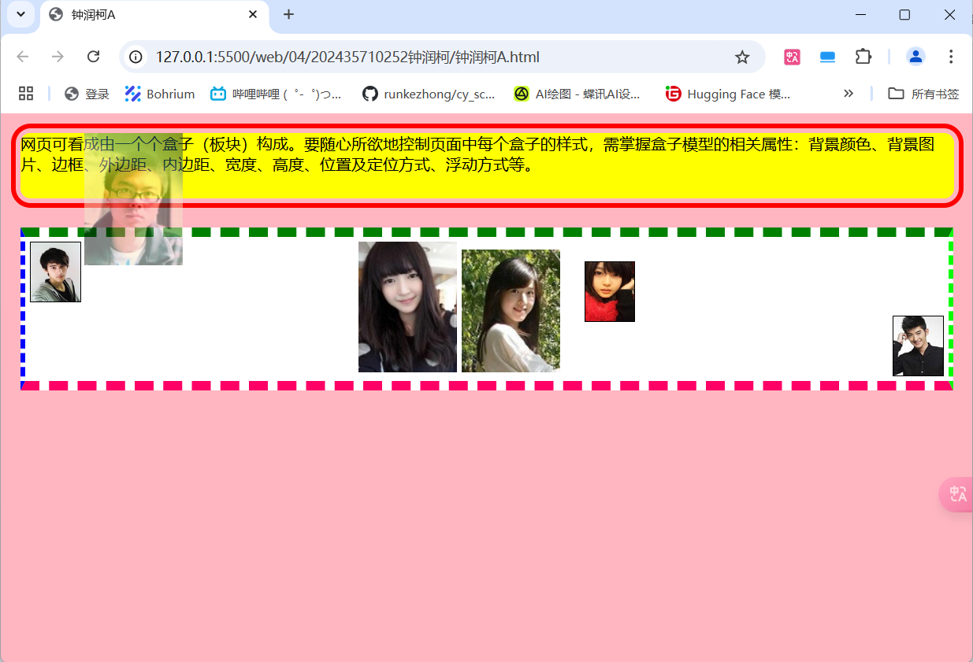

**任务B、CSS段落间距及图文对齐**

|  |
| --- |
| <!DOCTYPE html>  <html lang="en">  <head>  <meta charset="UTF-8">  <meta name="viewport" content="width=device-width, initial-scale=1.0">  <title>钟润柯B</title>  <style>  * {  margin: 0;  padding: 0;  font-size: 20px;  text-align: center;  }  #zrkcontainer{  width: 80%;  margin-top: 20px;  margin-left: auto;  margin-right: auto;  background-color: #666;  }  #zrkheader{  background-color: orange;  border: 2px solid black;  height: 100px;  }  #zrkmain{  box-sizing: border-box;  background-color: #888;  width: 100%;  height: 300px;  }  #zrkleft{  width: 30%;  float: left;  box-sizing: inherit;  border: 2px solid black;  padding: 20px;  height: 300px;  }  #zrkright{  width: 70%;  float: right;  box-sizing: inherit;  border: 2px solid black;  padding: 20px;  height: 300px;  }  #zrkfooter{  background-color: aquamarine;  border: 2px solid black;  height: 150px;  clear: both;  padding: 20px;  }  span{  font-size: 20px;  color: red;  display: block;  }  </style>  </head>  <body id="zrkcontainer">  <div id="zrkheader">页眉</div>  <div id="zrkmain">  <div id="zrkleft">主体左侧</div>  <div id="zrkright">主体右侧</div>  </div>  <div id="zrkfooter">  页脚  <span>（作者：钟润柯）</span>  </div>  </body>  </html> |

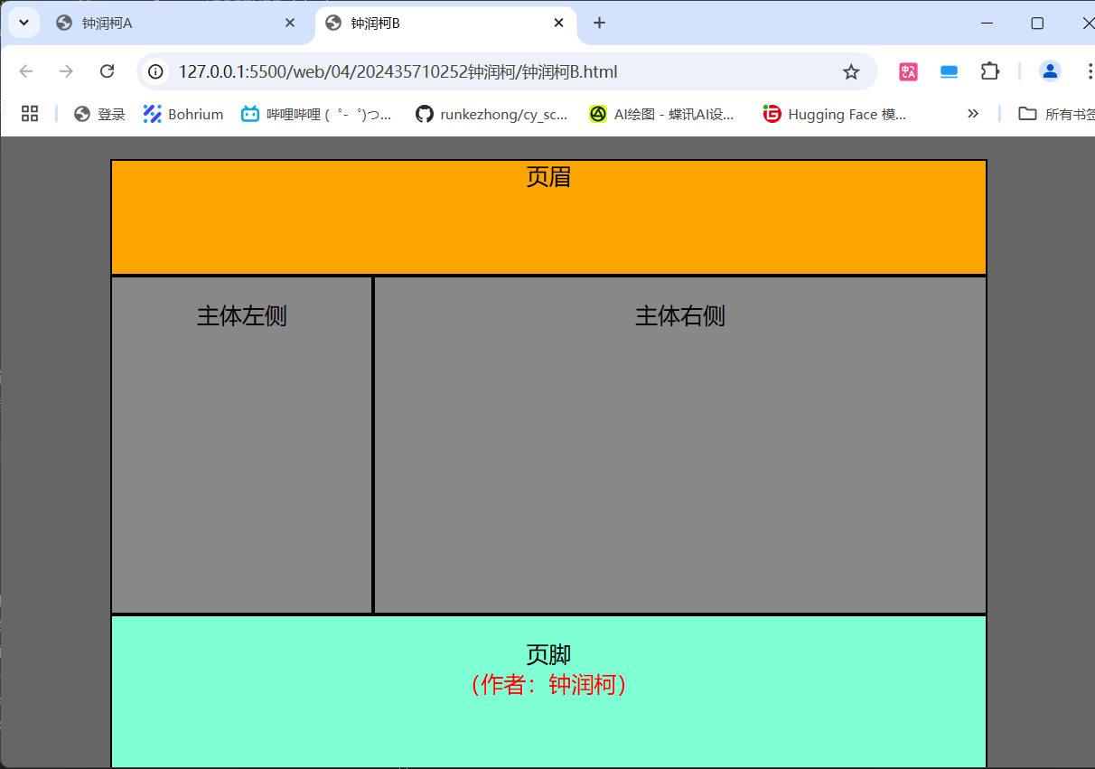

**任务C、CSS段落文字、图像对齐处理**

|  |
| --- |
| <!DOCTYPE html>  <html lang="en">  <head>  <meta charset="UTF-8">  <meta name="viewport" content="width=device-width, initial-scale=1.0">  <title>钟润柯C</title>  <style>  * {  margin: 0;  padding: 0;  list-style: none;  }  .zrkcontainer {  width: 95%;  margin-top: 20px;  margin-bottom: 20px;  margin-left: auto;  margin-right: auto;  text-align: center;  }  .zrkheader {  background-color: yellow;  height: 100px;  }  .zrknav {  width: 100%;  height: 30px;  background-color: red;  line-height: 30px  }  .zrknav ul {  display: flex;  justify-content: center;  }  .zrknav li {  list-style: none;  margin-left: 15px;  margin-right: 15px;  }  .navflag {  font-weight: bold;  color: yellow;  }  .zrkmain{  width: 100%;  /* height: 300px; */  display: flex;  }  .zrkmain .zrkleft {  width: 30%;  height: 400px;  /* display: flex; */  flex-direction: row;  /* background-color: gray; */  }  .zrkmain .zrkleft .left-item {  width: 100%;  height: 100px;  background: linear-gradient(to bottom, #f0f0f0, #808080);  /* background-color: cadetblue; */  }  .zrkmain .zrkcenter {  width: 40%;  height: 400px;  flex-direction: row;  }  .center-item1{  width: 100%;  height: 50%;  background: linear-gradient(to bottom, #f0f0f0, #808080);  }  .center-item2{  width: 100%;  height: 50%;  background: linear-gradient(to bottom, #f0f0f0, #808080);  overflow: auto;  }  .zrkmain .zrkright {  width: 30%;  height: 400px;  flex-direction: row;  }  .right-item1{  height: 33%;  background-color: rgba(0, 155, 255, 0.5);  }  .right-item2{  height: 34%;  background-color: rgba(0, 155, 255, 0.5);  }  .right-item3{  height: 33%;  background-color: rgba(0, 155, 255, 0.5);  }  .zrkfooter {  text-align: center;  height: 120px;  background-color: rgba(0, 0, 255, 0.5);  padding-top: 30px;  font-size: 26px;  }  .zrkfooter span{  display: block;  color: red;  }    </style>  </head>  <body class="zrkcontainer">  <div class="zrkheader">  <h1>zrklogo</h1>  <marquee style="font-size: 20px;" behavior="scroll" direction="left" scrollamount="5">  Welcome to my website  </marquee>  </div>  <div class="zrknav">  <ul>  <li>zrknav</li>  <li class="navflag">导航1</li>  <li>导航2</li>  <li>导航3</li>  <li>导航4</li>  <li>导航5</li>  </ul>  </div>  <div class="zrkmain">  <div class="zrkleft">  <div class="left-item">zrkleft1</div>  <div class="left-item">zrkleft2</div>  <div class="left-item">zrkleft3</div>  <div class="left-item">zrkleft4</div>  </div>  <div class="zrkcenter">  <div class="center-item1">  zrkcenter1  <div>  <img src="imageszrk/girls.jpg" width="30%" height="30%" alt="">  </div>  </div>  <div class="center-item2">  zrkcenter2  <div>  <img src="imageszrk/girls.jpg" alt="">  </div>  </div>  </div>  <div class="zrkright">  <div class="right-item1">zrkright1</div>  <div class="right-item2">zrkright2</div>  <div class="right-item3">zrkright3</div>  </div>  </div>  <div class="zrkfooter">  zrkfooter  <span>作者：钟润柯</span>  </div>  </body>  </html> |

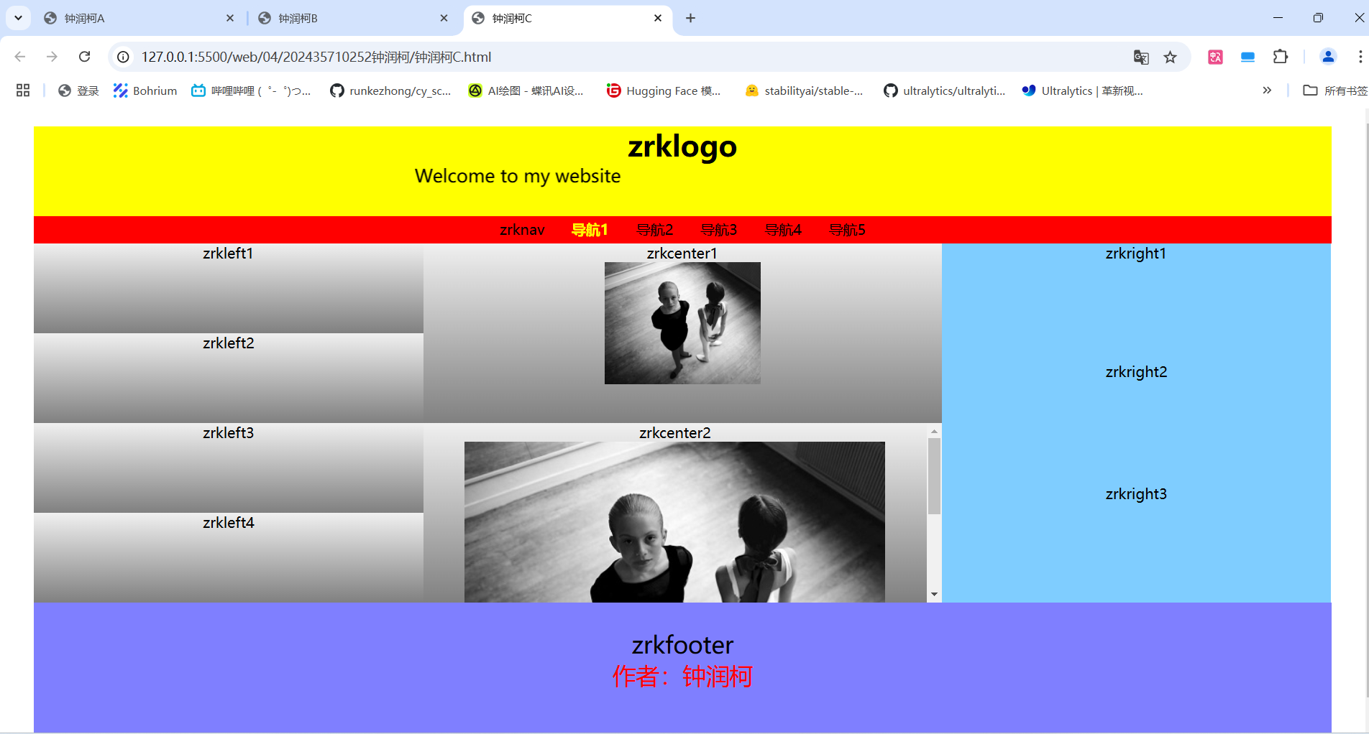

**任务D、背景颜色与背景图像设置**

|  |
| --- |
| <!DOCTYPE html>  <html lang="en">  <head>  <meta charset="UTF-8">  <meta name="viewport" content="width=device-width, initial-scale=1.0">  <title>钟润柯D</title>  <link rel="stylesheet" href="钟润柯D.css">  </head>  <body class="zrkcontainer">  <div class="zrkheader">  唐诗欣赏  </div>  <div class="zrkmain">  <div class="zrkleft">  <p style="margin-top: 20px;margin-bottom: 20px;">静夜思</p>  <p>窗前明月光</p>  <p>疑是地上霜</p>  <p>举头望明月</p>  <p>低头思故乡</p>  </div>  <div class="zrkcenter">  </div>  <div class="zrkright">  李 白（公元701年——762年12月）：字太白，号青莲居士，又号“谪仙人”，唐代伟大的浪漫主义诗人，被后人誉为“诗仙”，与杜甫并称为“李杜”，为了与另两位诗人李商隐与杜牧即“小李杜”区别，杜甫与李白又合称“大李杜”。《旧唐书》记载李白为山东人；《新唐书》记载，李白为兴圣皇帝李暠九世孙，与李唐诸王同宗。其人爽朗大方，爱饮酒作诗，喜交友。  </div>  </div>  <div class="zrkfooter">  唐诗宋词是中国文学史上的两颗璀璨明珠，唐代被称为诗的时代，而宋代则被称为词的时代。词源于民间，始于唐，兴于五代，盛于两宋。在宋代，随着城市的发展和市民阶层的兴起，物质生活的丰富，人们对文化生活的追求也更加强烈。  </div>  </body>  </html> |

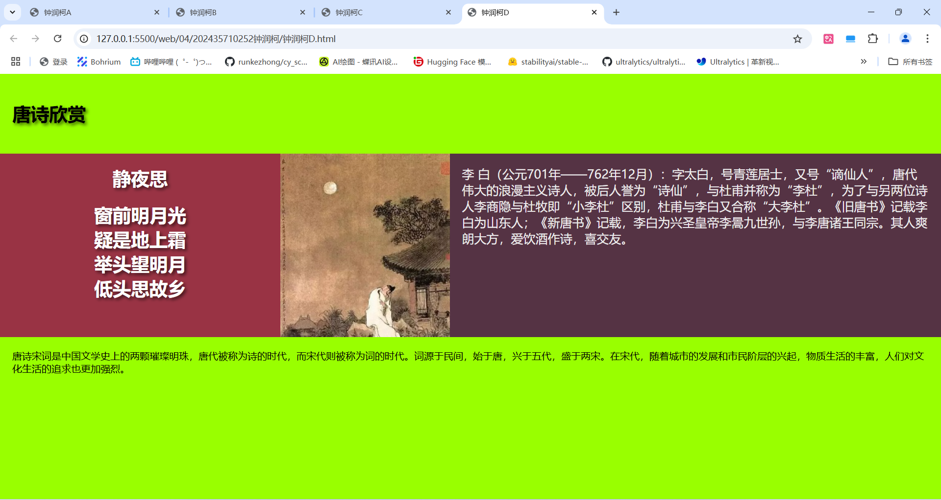

**总结及建议**

在做这四个实验的过程中，我熟悉了CSS的基础样式的使用，以及使用margin:0;padding:0去除默认外内边距样式的方法，熟悉了div标签使用，学会使用flow布局，在这个过程中我也使用了flex布局，这个更为方便，总的来说，经过此次实验，我掌握了更多的前端开发知识，为后续的学习奠定了进一步的基础。