

FROM THE PUBLISHER

‘The Crossing’ tells a powerful story

January 20, 2007

*By John Temple*

*Rocky Mountain News*

In my time as editor, we have covered devastating events – Columbine and 9/11. We’ve shared the loss of war in stories like “Final Salute.”

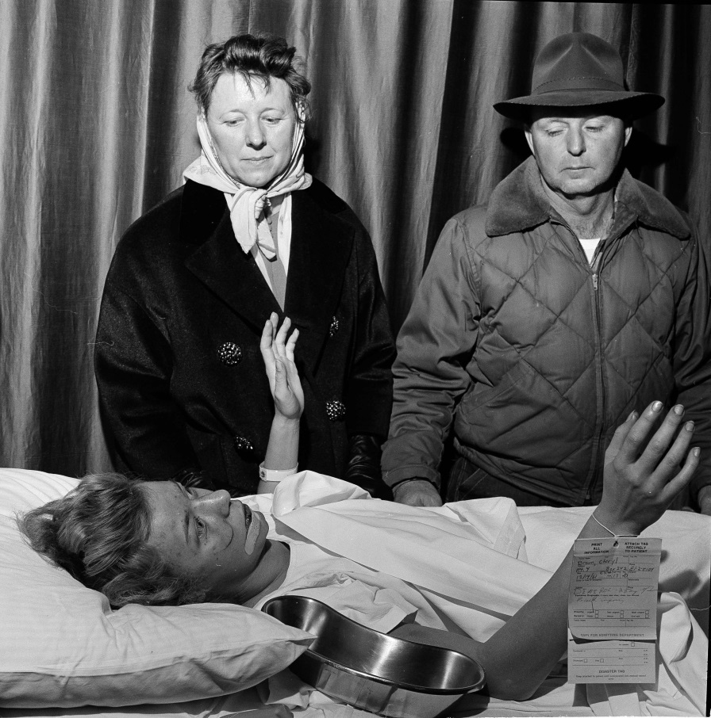  
But we’ve never wrestled with the longterm implications of these terrible tragedies. That is something journalists just don’t ordinarily do.   
  
That is what makes “The Crossing,” a 33-part series starting Tuesday, so unusual.   
  
On the morning of Dec. 14, 1961, a speeding passenger train cut through a school bus in the farm country outside Greeley, killing 20 children. It was the worst traffic accident in Colorado history.   
  
Today, the oldest of the 16 children who survived is 61 and preparing for retirement. Reporter Kevin Vaughan and photographer Chris Schneider have traveled the country to pull together the story of how a few seconds that changed everything still reverberate through the lives of the survivors and the families of those who died.   
  
Their series – and a powerful online presentation – explores how human beings deal with the worst that can be dealt them. It is a moving and dark story – but it is also a story of hope.   
  
I encourage you not to miss it.

**AP/1961**

**Cheryl Brown, 13, gestures as she talks** with her relieved parents, Leah and Morris, on the afternoon of Dec. 14, 1961. Cheryl’s story is one of many being told in “The Crossing,” a 33-part series beginning Tuesday about a 1961 bus crash outside Greeley that killed 20 children.

*Edition: Final  
Section: News  
Page: 2A*

*Donated to the Denver Public Library by the Rocky Mountain News, under the permission of the City and County of Denver, other rights reserved. Copyright © 2007 Rocky Mountain News. All Rights Reserved.*

*Contact the Western History/Genealogy Department, Denver Public Library, for permission to publish.*