

FROM THE PUBLISHER

Survivors’ courage shines through

January 27, 2007

*By John Temple*

*Rocky Mountain News*

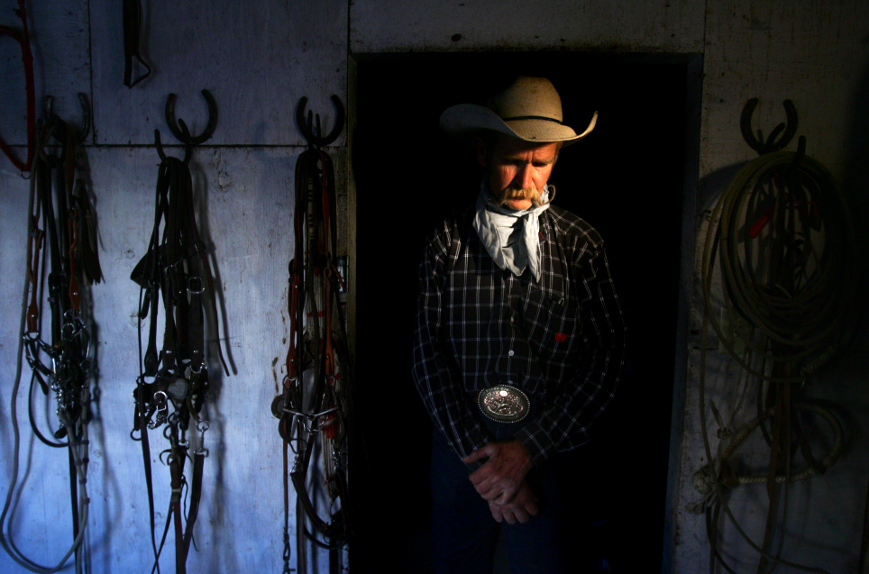Who will live and who will die?   
  
Those are perhaps the most important questions we face. Yet the answer so often appears random, incomprehensible.   
  
Take the morning of Dec. 14, 1961, the central date in Kevin Vaughan’s riveting story, “The Crossing.”   
  
Today, you will learn which of the children aboard Duane Harms’ school bus lived, and which died. That could be the end of the story, as it often is in the pages of a newspaper.   
  
But in fact, it’s just the beginning, the moment lives changed forever.   
  
Going forward, in the next 28 editions of the Rocky Mountain News, you will learn how a few seconds have uncoiled through decades, shaping lives in ways I don’t believe anyone could have imagined at the time.   
  
To make sure you don’t miss what I believe is one of the most powerful stories ever told in the Rocky, we’re reprinting the first four episodes along with today’s fifth chapter, starting on Page News 23. I urge you to take the time to read them.   
  
We began this series on Tuesday, the day we launched what’s being called the “new” Rocky, for a reason. I wanted to send a message about the direction of the paper. I wanted to send a message about the value we place on great storytelling – writing and photography that take you to the heart of the matter.   
  
I also wanted to send a message about the sophistication you can expect in the way we present stories in print and online. No longer is our Web site merely what appeared in the newspaper. Far from it. If you go to “The Crossing” on RockyMountainNews.com, you’ll find a rich presentation that doesn’t look anything like a newspaper. Because it’s not. I hope you’ll take a moment to see what I mean. We view print and Web as independent and complementary, and with this story wanted to show what that can look like at its best.   
  
“The Crossing” got its start 20 years ago, when Kevin was a journalism student at Metropolitan State College of Denver. He was searching through microfilm for a Christmas story his mentor had written in 1961. But before he found it, he happened upon coverage of the terrible crash near Greeley, when a passenger train racing at 79 mph cut through a school bus. He wondered how a reporter would cover a story like that, and how the victims lived through their loss.   
  
Slowly, he learned.   
  
First as a reporter in Fort Morgan. Then in Fort Collins. And finally, here at the Rocky, where Kevin was part of the team that covered the shootings at Columbine High School. On that day, he saw the randomness of who lived and who died. He later got to know the families who lost children. They made him think of the families of the children on the school bus.   
  
The idea started to crystalize that theirs was a story he could tell, a story that needed to be told.   
  
Twenty years ago, Kevin never did look at the Christmas story he was searching for on the microfilm. But since then, he has gathered string for what would become the most challenging story of his career.   
  
In 2002, he interviewed a man who had missed the bus that day, thinking perhaps that one person’s life should be the story. That idea didn’t make it to me.   
  
But in the summer of 2005, Kevin came to me with a proposal. We talked of the time and resources it would take, and whether people would be willing to share their experiences.   
  
In the spring of ‘06, he gave me an outline, and we embarked for good on this long and difficult journey. Kevin teamed with photographer Chris Schneider and by August, it was a full-time job. If not an obsession.   
  
We could only tell this story because so many survivors and family members agreed to talk about the most painful events of their lives. Their courage allowed us to tell a meaningful story, with broad lessons.   
  
Kevin, who is 43, has worked at the Rocky since October 1997. In that time, he’s grown to become a pillar of our staff. He does the title reporter proud. He cares. About the people he writes about. About truth. About writing. About remembering the past.   
  
His story has clearly already touched a nerve. It was the No. 1 story on our Web site last week.   
  
“Thank you for not forgetting,” one person wrote.   
  
“It is a story of our community’s history and thank you for telling it,” wrote another.   
  
That’s our job.   
  
In this case, I hope you’ll agree we’ve done it proud.

CHRIS SCHNEIDER /ROCKY MOUNTAIN NEWS

**Bruce Ford, a survivor** of the Dec. 14, 1961, train-bus accident, is shown at his ranch in Kersey. Bruce’s brother, Jimmy, died. Another brother, Glen, survived.

*Edition: Final  
Section: News  
Page: 2NEWS*

*Donated to the Denver Public Library by the Rocky Mountain News, under the permission of the City and County of Denver, other rights reserved. Copyright © 2007 Rocky Mountain News. All Rights Reserved.*

*Contact the Western History/Genealogy Department, Denver Public Library, for permission to publish.*