

COMMENTARY

Journalism’s journey – ‘Crossing’ author amazed by liberties of earlier era

March 10, 2007

*By Kevin Vaughan*

*Rocky Mountain News*

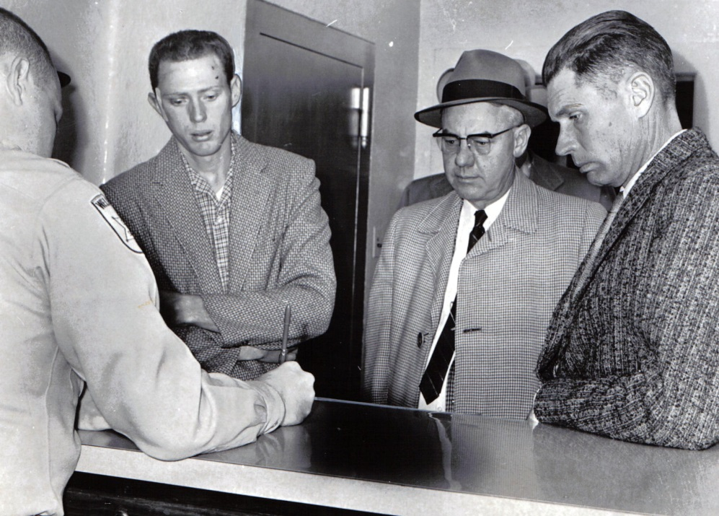Nearly a year ago, I set out on the most challenging and interesting journey of my career, determined to somehow understand the many ways a tragic moment in time can unfurl over generations in the lives of dozens of people.   
  
Along the way, I learned a lot about journalism – seeing the ways it has changed dramatically, and the ways it hasn’t changed at all.   
  
People criticize today’s journalism as omnipresent, and certainly that’s true in many ways. But the surprising thing I found is that two generations ago it was just as intrusive, but in different ways.   
  
It all happened as I researched and wrote “The Crossing,” a serial narrative that ran in the Rocky Mountain News every day from Jan. 23 to March 2. The series examined the lessons of the deadliest traffic accident in Colorado history, the collision of a high-speed passenger train and a school bus outside Greeley on Dec. 14, 1961, that killed 20 children. The bus driver and 16 children survived.   
  
On that cold Thursday morning, it was a huge story, but it was covered very differently than it would be today.   
  
Three newspapers – the Rocky, The Denver Post and the Greeley Tribune – joined local television and radio stations and wire services covering the story.   
  
Two dozen reporters and photographers, tops, tromped around the rural crossing where the accident occurred, wandered the halls of the Greeley hospital, stood outside the temporary morgue, banged on the doors of the homes visited by tragedy.   
  
Some would say it was a simpler time – no cable news, no Nancy Grace, no bloggers – and in many ways it was. It was definitely a different time.   
  
President Kennedy did not issue a message of condolence from the White House. The governor was not photographed somberly walking the scene. The Today show did not awaken us the following morning with tearful interviews with grief-stricken parents.   
  
But it was also a time when the relationship between authorities and the news media was more collegial. When school bus driver Duane Harms sat in prosecutor Karl Ahlborn’s office the day after the accident, where he was told he would be charged with manslaughter, news photographers were in the room, recording the scene. When he filled out the paperwork to post his bond, they stood behind the counter with sheriff’s deputies, snapping pictures.   
  
Some of the other things people in my business did in those days make me shudder.   
  
We showed a shockingly lax attitude about telling readers the sources of our information.   
  
Some stories, for example, mingled testimony given under oath in a courtroom with words uttered in hallways during interviews with reporters. That wasn’t spelled out in the stories. I discovered it only after I found official transcripts of those hearings in an abandoned missile silo outside Greeley.   
  
On Dec. 14, 1961, and in the days that followed, reporters and photographers entered the hospital rooms of injured children, talked to them, snapped their pictures. Sometimes, no one else was around.   
  
One black-and-white print in the Rocky’s photo file shows Joy Freeman, lying in a hospital bed, alone, gazing at the ceiling.   
  
She asked repeatedly for her sister, April Melody, according to the caption that ran the next day.   
  
It appears she was alone. She was 10 that day. Her sister was dead.   
  
The brashness of the media wasn’t much different in 1973, when a Colorado State Patrol trooper named Thomas Ray Carpenter was murdered in Denver. A quarter-century later, I wrote a story about the unsolved killing.   
  
During the research, I spent time talking to the slain trooper’s family.   
  
I’ll never forget a phone conversation with his widow on a Saturday afternoon. She lived in another part of Colorado. As we talked, a yellowing file of the Rocky’s photographs from that story lay on my desk.   
  
She began talking about what it was like to have her family’s loss played out in public. What it was like to grieve in front of others. What it was like to be on the front page of the papers.   
  
She told me, with understandable incredulity, of a photographer who climbed onto the top of the hearse that would carry her husband’s body from the church to the cemetery, snapping pictures as they loaded his coffin in the back.   
  
As she talked, I pulled back the flap on the file in front of me. The picture she described was in it. It had been a Rocky photographer who had clambered onto the roof of the hearse in 1973. I shook my head, unable to imagine what I would do if one of my colleagues did that.   
  
Today, I and my colleagues could not wander the halls of hospitals and interview and photograph children without their parents present.   
  
We would not climb onto a hearse to get a picture.   
  
We are so different.   
  
Or are we?   
  
Certainly, we at the Rocky have very different standards today than we had 45 years ago. We ask more of ourselves from the standpoint of accuracy and fairness. We push ourselves to correct every error, no matter how small. And though it might not seem like it, we carefully consider the impact of our work on others. We sometimes spend a great deal of time talking with families before we cover a funeral, to make sure we understand what they are comfortable with.   
  
We also know that the Internet has made it easier for people to check our reporting, to offer alternative views, to point out publicly when we make a mistake.   
  
At the same time, the spectrum of what we consider the “news media” has stretched a lot since 1961.   
  
Back then, the big three networks, the local newspapers, the wire services, newsmagazines and local radio stations probably were considered by most people to be the entire palette of “news media.”   
  
Today, you can add to that everybody from E! TV to Rush Limbaugh, from the National Enquirer to Nancy Grace, from Howard Stern to some blogger in front of a computer screen in his underwear.   
  
No, “we” don’t climb onto the roofs of hearses anymore, thankfully.   
  
Instead, “we” hover in helicopters over O.J. Simpson’s white Bronco, over the hearse carrying Anna Nicole Smith’s body. “We” breathlessly report the latest developments, which are often not much different from the developments of 30 minutes ago.   
  
“We” ride on an airplane with JonBenet Ramsey murder suspect John Mark Karr and note the kind of wine he drinks, the kind of shrimp he eats.   
  
It’s a different world. Not necessarily a better one, but a different one.

ROCKY MOUNTAIN NEWS / 1961

**School bus driver Duane Harms**, left, waits for his bail to be posted in December 1961 with Assistant District Attorney Karl Ahlborn, center, and his father, Wilber Harms. Harms’ supervisor with the school district posted the $1,000 bond.

*Edition: Final  
Section: Commentary/Editorial  
Page: 32NEWS*

*Donated to the Denver Public Library by the Rocky Mountain News, under the permission of the City and County of Denver, other rights reserved. Copyright © 2007 Rocky Mountain News. All Rights Reserved.*

*Contact the Western History/Genealogy Department, Denver Public Library, for permission to publish.*