

THE CROSSING

Marking a long-ago tragedy – Monument will hallow spot where 20 schoolchildren died

July 27, 2007

*By Kevin Vaughan*

*Rocky Mountain News*

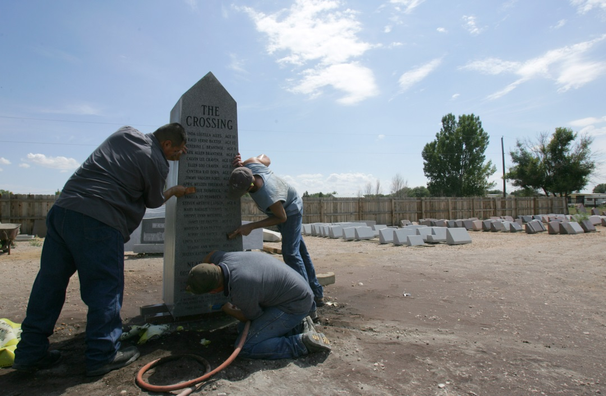The scene of Colorado’s deadliest traffic accident stood lonely and windblown a few miles outside Greeley for more than 45 years, with nothing to help remember the lives of the 20 children who perished there.   
  
That will change Aug. 26, when their families plan to gather to dedicate a 2½-ton granite monument not far from the spot where a Union Pacific passenger train slashed through a school bus on Dec. 14, 1961.   
  
“All of us are happy to see it finally going up,” said Mary Opatril, who was a baby the day her older brother and sister, Mark and Kathy Brantner, died in the crash. “It’s something that needed to be done.”   
  
Dec. 14, 1961, was a bitterly cold Thursday morning, with the temperature just a few degrees above zero when bus driver Duane Harms started out on his route in the Auburn farming community. He did not know that the Union Pacific’s City of Denver streamliner was running an hour and 45 minutes behind schedule.   
  
Just before 8 a.m., with 36 children on the bus, Harms pulled up to an angled railroad crossing, where he had to twist around and look behind him for a train coming from the east.   
  
Frost and condensation fogged the bus windows, the early morning sun hung low in the eastern sky, and a row of utility poles obscured his view. Harms never saw the train, which was moving at 79 mph, and pulled across the tracks.   
  
He was almost clear when the lead locomotive caught the last few feet of the bus, ripping it into two pieces.   
  
In a matter of seconds, 20 children were dead. They included five sets of siblings and cousins from several families.   
  
Harms and 16 children survived, some seriously hurt, others with little more than bumps and bruises.   
  
In spring 1963, work crews ripped out the old crossing and moved the road. Later that fall, a new elementary school, East Memorial, was named in honor of the children, and a brass plaque was hung in the front hall to pay homage to them.   
  
But nothing marked the scene of the accident, save the flowers left from time to time on the anniversary of the crash.   
  
Several years ago, Tim Geisick was working in the area when he decided to look for the spot where the train hit the bus.   
  
“I had stopped fairly close to the tracks there, and I was trying to put it together in my head where it happened, trying to figure it out,” Geisick said. “It seemed to me there should be something there.”   
  
Geisick wasn’t yet born in 1961, but the accident had affected his family on both sides. A cousin, Randy Geisick, was on the bus and came away almost unscathed. But victims Mark and Kathy Brantner were his mother’s younger brother and sister.   
  
Standing along the tracks that day, he got goosebumps.   
  
“I just decided I was going to try to do something,” he said.   
  
But time got away from him and he made little progress.   
  
Then, early this year, he heard a radio advertisement for “The Crossing,” a 33-part series published by the Rocky Mountain News that looked at the long-term ramifications of the accident for both those who lost loved ones and those who survived.   
  
“I said, ‘This is the time – I’ve got to make it happen now,’” Geisick recalled.   
  
He visited his mother, who was terminally ill with cancer, and told her about his idea.   
  
“She gave me her blessing,” he said.   
  
Then he told his grandmother, Katherine Brantner, what he wanted to do. The accident had always been a painful subject in his family, and he didn’t want to do anything to hurt anyone.   
  
His grandmother also backed the idea, so he opened a bank account and sought donations, setting a goal of $6,000 for a proper memorial near the scene.   
  
The money poured in from all over the country. One donation even came from Germany.   
  
“Almost every check I got came with a letter – people thanking me for doing this, saying it’s about time it’s happening,” he said.   
  
Lonnie and Sharon Bunting, whose land abuts the old road, granted an easement onto their property for the monument.   
  
And Thursday, Dave Snyder of Norman’s Memorials in Greeley spent the day with a sandblaster in his hands, etching the names of the children who died into the 6-foot-6-inch granite spire.   
  
“As I was working, I was just reading all the names and thinking about the families and what they had to go through that day,” Snyder said.   
  
He said he felt a sense of honor to work on the memorial.   
  
For Aleta Craven, the idea of a memorial took hold after she drove out to the scene of the accident earlier this year.   
  
“I think it’s time,” she said.   
  
She and her husband, Ralph, lost two children in the tragedy, a son, Calvin, and a daughter, Ellen. She wants to remember them, and hopes others will take something else away from it.   
  
“It’s just a disaster, and people need to realize these things can happen,” she said. “Your life can change in the blink of an eye. Love everybody every minute you can.”   
  
*Edition: Final  
Section: News  
Page: 7NEWS*

CHRIS SCHNEIDER / THE ROCKY

**Norman’s Memorials workers** Ismael Loma, left, Mike Busch, center, and Dave Snyder clean the face of the memorial for The Crossing after it was inscribed in Greeley on Thursday. The monument memorializes the accident where 20 schoolchildren were killed when a train struck their school bus in 1961 in a rural area near Greeley.

*Donated to the Denver Public Library by the Rocky Mountain News, under the permission of the City and County of Denver, other rights reserved. Copyright © 2007 Rocky Mountain News. All Rights Reserved.*

*Contact the Western History/Genealogy Department, Denver Public Library, for permission to publish.*