

THE CROSSING

A promise finally fulfilled to 20 schoolchildren

Saturday, August 25, 2007

*By Kevin Vaughan*

*Rocky Mountain News*

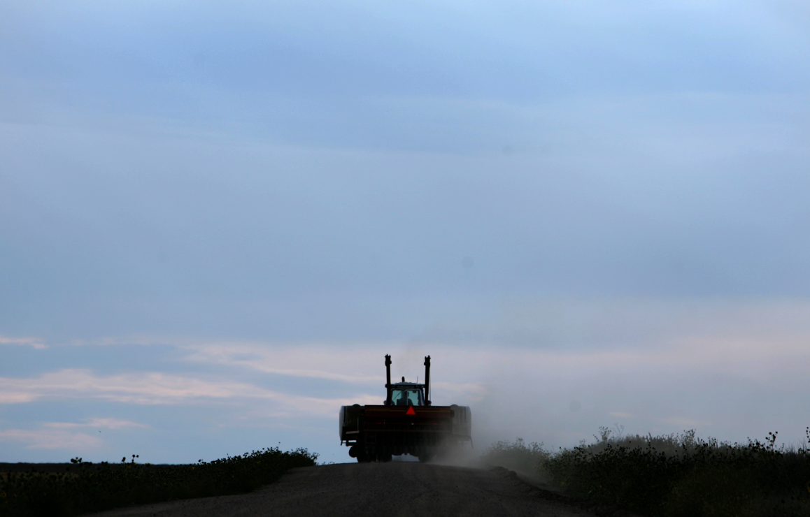As Tim Geisick stood along the railroad tracks, trying to imagine the tragedy that had unfolded in that place many years before, he felt something that he still has trouble describing.   
  
Twenty children had died there – including his mother’s younger brother and sister – and he was bothered that nothing had been erected to remember those young lives lost on Dec. 14, 1961, in the collision of a school bus and a passenger train.   
  
Geisick felt he owed it to them to do something about it, and set about planning a permanent memorial.   
  
“I almost feel like they asked me to do it that day I was standing out there,” Geisick said Friday.   
  
Sunday at 11 a.m., a 2½-ton granite monument will be dedicated at the site of Colorado’s worst traffic accident, the result of Geisick’s resolve, thousands of dollars in donations, and help from many people touched by the tragedy.   
  
Parents who buried children are planning to attend. So are brothers and sisters of those who died and many of the survivors, including at least three who are coming from out-of-state.   
  
Dec. 14, 1961, was a bitterly cold Thursday morning – the temperature stood at 6 degrees – when bus driver Duane Harms started out on his route in the Auburn farming community. He had no idea that the Union Pacific’s City of Denver streamliner was running an hour and 45 minutes behind schedule.   
  
Just before 8 a.m., with 36 children on the bus, Harms pulled up to an angled railroad crossing, where he had to twist around and look behind him for a train coming from the east.   
  
Frost and condensation fogged the bus windows, the early morning sun hung low in the eastern sky, and a row of utility poles obscured his view. Harms never saw the train, which was moving at 79 mph, and pulled across the tracks.   
  
He was almost clear when the lead locomotive caught the last few feet of the bus, ripping it into two pieces.   
  
In a matter of seconds, 20 children were dead, including five sets of siblings and cousins from several families.   
  
Harms and 16 children survived, some seriously hurt, others with little more than bumps and bruises.   
  
A little more than a year later, a county crew ripped out the old crossing and realigned the road. Motorists no longer had to cross the tracks at the spot.   
  
And although East Memorial Elementary School, which opened in 1963, was named to remember the children who died, nothing ever marked the scene of the accident.   
  
From time to time in the past few years, Geisick thought about the accident, and the effect on his family. He wasn’t yet born in 1961, but the accident had been a presence in his life as far back as he could remember. A cousin, Randy Geisick, was on the bus and came away almost unscathed. Mark and Kathy Brantner, who both died, were his mother’s younger brother and sister.   
  
Then came that day along the tracks, and the promise Geisick made to those 20 children.   
  
Sunday morning, it will be fulfilled.   
  
*Section: News  
Page: 6NEWS*

CHRIS SCHNEIDER / ROCKY MOUNTAIN NEWS / 2006

**The prairie of northeast Colorado** has changed little in the half-century since bus driver Duane Harms grew up on a wheat farm outside the tiny town of Fleming.

*Donated to the Denver Public Library by the Rocky Mountain News, under the permission of the City and County of Denver, other rights reserved. Copyright © 2007 Rocky Mountain News. All Rights Reserved.*

*Contact the Western History/Genealogy Department, Denver Public Library, for permission to publish.*