

THE CROSSING

Larson backed driver in deadly bus-train crash

October 1, 2007

*By Kevin Vaughan*

*Rocky Mountain News*

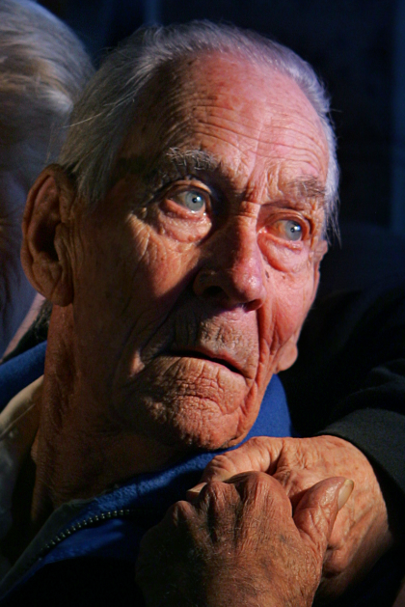Fifteen days after his son was killed in a horrific 1961 school bus-train collision, Art Larson stood up for the man many blamed for the accident.   
  
Mr. Larson had been headed to town in his delivery truck that frigid morning when he saw the Union Pacific streamliner “City of Denver” flash past him. A moment later, he looked to the west and saw the school bus carrying two of his children stopped at another crossing. He figured driver Duane Harms had seen the train, and he drove on.   
  
But Harms hadn’t seen the train, and he pulled in front of it. Twenty children died in the crash, including Mr. Larson’s 9-year-old son, Steve. His daughter, Alice, was critically injured.   
  
But Mr. Larson signed a sworn statement that he’d seen the bus stop and testified for the young bus driver at his manslaughter trial.   
  
Today, Mr. Larson’s family will say goodbye to him in the same chapel where they mourned for Steven more than 45 years ago.   
  
Mr. Larson, 85, died Wednesday at his home in Gilcrest after months of declining health.   
  
“I just loved him so much,” said his wife of 61 years, Juanita.   
  
Arthur Gustaf Larson was born April 11, 1922, in Saguache. He moved to Weld County when he was a boy, was educated in schools there, and served in the U.S. Army in World War II.   
  
Art and Juanita met at a drive-in in south Greeley in the spring of 1946. She had gone there with a girlfriend. He was there with some pals.   
  
They were introduced, and later that night, she told her sister, “That’s the guy I’m going to marry.” Days later, they went to a dance together, and by June, they were engaged.   
  
Arthur Larson and Juanita King were married Nov. 17, 1946.   
  
He was a truck driver, loved baseball and roses, and grew alfalfa and raised animals on the family’s spread in the Auburn community southeast of Greeley.   
  
After leaving the farm, he and Juanita moved to Gilcrest.   
  
A funeral is scheduled for 11 a.m. today at Allnutt Macy Chapel, 702 13th St., Greeley. Burial will be in Sunset Memorial Gardens in Greeley.   
  
In addition to his wife, he is survived by three daughters, Nancy Slater Walker and her husband, Edward, of Davenport, Iowa; Linda Edstrom and her husband, Harold, of Greeley; and Alice Richardson and her husband, Ron, of Greeley; 12 grandchildren; 24 great-grandchildren; four nephews; a niece; and several great-nieces and great-nephews.   
  
A 25th great-grandchild is expected at the end of the month.

**Arthur Gustaf Larson** lost his 9-year-old son in the fatal collision in 1961. 

*Edition: Final  
Section: Business  
Page: 7BUSINESS*

*Donated to the Denver Public Library by the Rocky Mountain News, under the permission of the City and County of Denver, other rights reserved. Copyright © 2007 Rocky Mountain News. All Rights Reserved.*

*Contact the Western History/Genealogy Department, Denver Public Library, for permission to publish.*