What data-driven relaxation of trial eligibility criteria can and cannot promise: an out-of-sample evaluation, and why reliability was not determined by cohort size alone across the mechanisms examined
Author One¹, Author Two², Corresponding Author^{1,*}
¹ Affiliation to be completed. ² Affiliation to be completed.
* Correspondence: runshu.wang@gmail.com

Abstract
Background. Rules that relax clinical-trial eligibility criteria using real-world data make two promises: that more patients become eligible, and that the estimated treatment effect does not suffer. To our knowledge neither has been evaluated out of sample, and no guidance exists on how much data such a rule needs.
Methods. We implemented the published rule — retain every criterion whose Shapley value on the log hazard ratio is negative — and evaluated it by repeated stratified sample splitting in two fully public cohorts: a randomised adjuvant colon-cancer trial (n = 619) and the Rotterdam breast-cancer registry (n = 2982). Because the eligible count is monotone in the criteria removed, the rule was compared not against the full protocol alone but against all 512 subsets scored on the held-out half, matched on eligible count and placed against the empirical held-out frontier, whose optimism is quantified separately in simulation. Every out-of-sample quantity passes through an outer bootstrap split by patient identifier, whose intervals are approximate: they carry the Monte Carlo variance of the inner splits and their coverage has not been established. Simulation with a fixed 100 000-patient scoring set isolated fitting-cohort size in one generating mechanism, and a resolution-IV factorial in six factors varied that mechanism, reported as success probability at fixed sizes, and a further sweep varied how a fixed total of effect modification is arranged.
Results. Matched on eligible count and carried through patient-level resampling, the rule reached a lower hazard ratio than a comparable subset in 63.4% of colon comparisons and 57.1% in Rotterdam, averaging within-split proportions with equal weight, and was near one half on the restricted mean difference; every interval contains one half, so neither an advantage nor its absence is established. Its choice was almost never on the empirical held-out frontier, but that frontier is optimistic: in simulation only 19.5% of apparently dominating subsets genuinely dominate at the population and 37.6% reproduce on an independent half, and in a three-way split of the cohorts themselves, where the comparator subsets are fixed on separate data before evaluation, the rule is left undominated in 21.0% of colon and 12.0% of Rotterdam splits, against 2.5% and 2.7% judged on the selection third of that same design. A variant selecting on the restricted mean difference agrees with the published rule on the criterion set in 7.0% of colon splits and showed no clear or consistent advantage out of sample: the probability of improvement was higher for it on the restricted mean difference and lower on the hazard ratio, with the paired difference between the two rules, carried through the same outer bootstrap, not establishing an advantage for either; no equivalence margin was prespecified. The observed proportion of splits in which the data-driven protocol reached a lower out-of-sample hazard ratio than the original was below one half in colon (0.290) and close to one half in Rotterdam (0.522); with patient-level intervals this establishes neither failure nor success of the effect-estimate promise. Across the factorial the success probability varied by between 0.28 and 0.39 in standard deviation across the fixed sample sizes, and the descriptive dispersion measure we used was similar for the three currencies in these 16 scenarios, which does not establish that they are equivalent. Halving the diluting signal across two criteria cut success from 0.85 to 0.43 at 18 000 fitting patients, but it also roughly halves the attainable improvement, so the two cannot be separated in that design. Omitting one confounder returned apparent reliability to randomised levels while inflating the estimator's population limit by 8.6% and cutting correct selection from 0.280 to 0.116.
Conclusions. Data-driven relaxation widens the eligible population, but that widening follows largely from the structure of the rule, and whether the procedure adds anything at matched inclusiveness is not resolved by cohorts of this size. The direction of the point estimates differs between the two estimands: on the hazard ratio the rule is favoured in both cohorts, while on absolute benefit the two cohorts point opposite ways. No universal data requirement could be determined from cohort size, event count or effective sample size alone across the mechanisms simulated; a requirement can in principle be stated conditionally on an assumed minimum diluting signal, as a power calculation is stated on an assumed minimum effect, but we do not supply that conditional statement here. Incomplete adjustment can make the procedure appear more reliable while its selection is less accurate.
Keywords: eligibility criteria; trial emulation; real-world data; Shapley value; non-collapsibility; restricted mean survival time; out-of-sample evaluation; sample size

Background
Overly restrictive eligibility criteria are a recognised barrier to trial accrual and to generalisability. Criteria are often inherited from legacy protocols rather than justified for the trial at hand, and professional bodies and regulators have called for them to be broadened where they safely can be.^{3,4}
A computational answer has emerged: emulate the trial in a real-world cohort, vary the criteria in silico, and let the data indicate which can be dropped. Trial Pathfinder¹ is the most influential instance. It encodes each criterion as a filter, estimates the treatment effect under every combination, and assigns each criterion a Shapley value⁷ quantifying its contribution to the hazard ratio; criteria with a negative value are retained and the rest relaxed. Across ten advanced non-small-cell lung cancer trials it more than doubled the eligible pool while lowering the hazard ratio by 0.05 on average, and the framework has since been applied to multiple myeloma and to asthma and chronic obstructive pulmonary disease.^{5,6}
Three things motivated this work. The evaluations we are aware of are in-sample — criteria selected and scored in the same patients — the classical setting for optimistic bias; we have not attempted the systematic accounting that would license a claim about the whole literature and do not make one. The procedure makes two promises reported as a pair, more patients and a better effect estimate, with no reason for them to need the same data or to be the same kind of claim. And the hazard ratio is non-collapsible: restricting a cohort moves it even when the conditional effect is identical in every stratum.^{9,10}
We ask three questions. Does the published rule keep its promises when the protocol it produces is scored on patients that had no part in choosing it? If not, is that a property of the rule or of the data available to fit it? And what can an investigator check in advance to know whether their cohort can support the analysis at all?

Methods
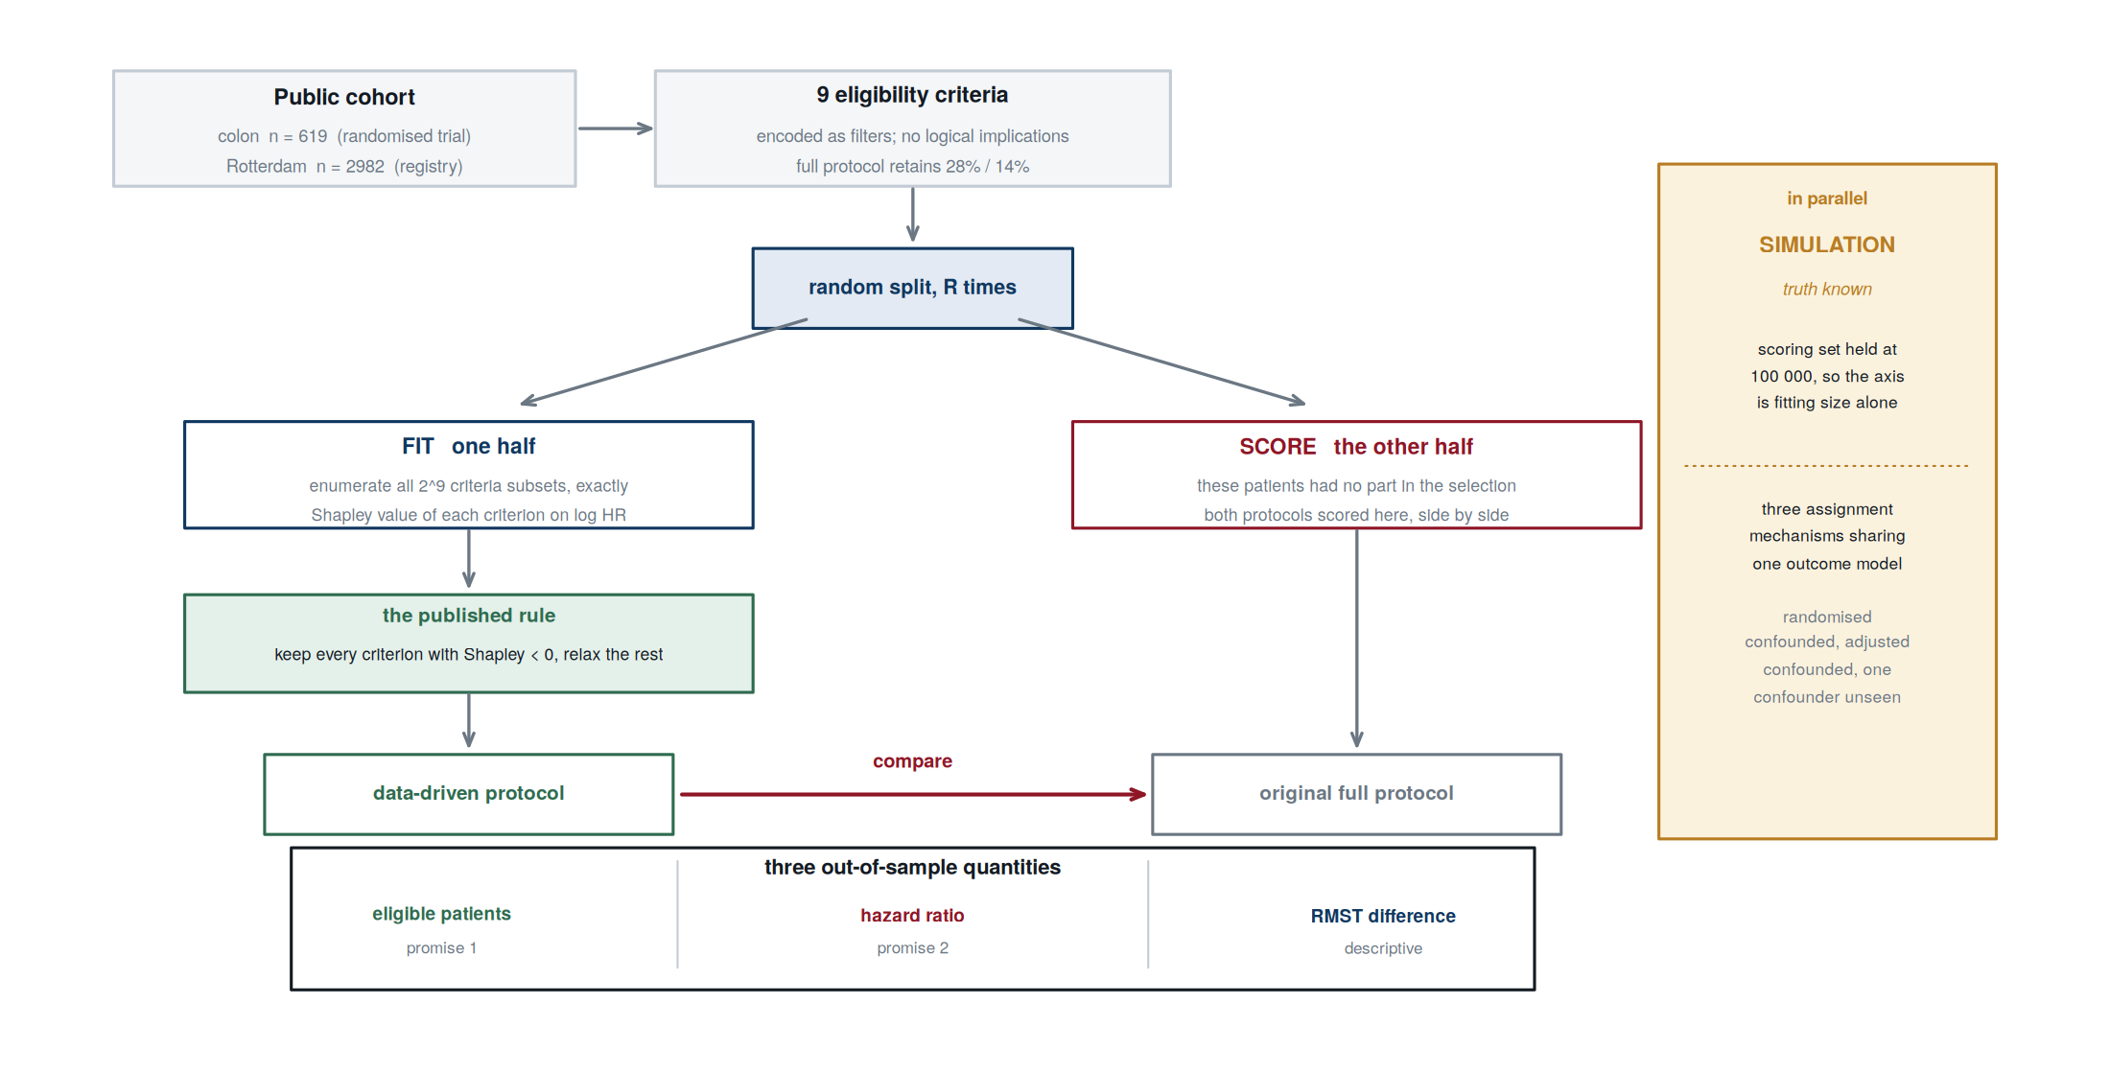
Figure 1. Study design. The rule is fitted on one half of the cohort and the protocol it produces is scored on the other, alongside the original full protocol, so neither candidate had a hand in choosing itself. A full-page version is Supplementary Figure S1. A parallel simulation holds the scoring set at 100 000 patients so that the remaining axis is fitting-cohort size alone, and varies the treatment-assignment mechanism across three arms sharing one outcome model.

Estimand, and what each promise claims
Relaxing a criterion changes the eligible population and therefore the estimand. The target under a protocol S is the marginal treatment contrast in the population S selects — the marginal hazard ratio, and the difference in restricted mean survival time to a horizon^{11,12} — so comparing two protocols compares two estimands, not two estimators of one quantity. A lower hazard ratio under the relaxed protocol is a more favourable estimated contrast in a wider population, not a more accurate estimate of a fixed effect. We use that language throughout and confine claims about estimation accuracy to simulation, where truth is known.
The two promises are also not the same kind of claim. The rule retains a subset of the criteria, so the cohort it admits is a superset of the full protocol's and the eligible count cannot fall. “More patients become eligible” holds whenever a binding criterion is removed, and the probability reported for it describes how often the rule removes a binding criterion rather than validating which criteria it chose to remove. To give that side a test with content we benchmark the rule against random relaxations that drop the same number of criteria.

Cohorts, criteria and weighting
Both cohorts ship with the R package survival²², so every result is reproducible without a data application. The first is the adjuvant colon-cancer trial of levamisole and fluorouracil²⁰, restricted to the Lev+5FU and observation arms (n = 619, 304 treated, 291 deaths), where randomisation makes the mapping from criteria to hazard ratio free of confounding. The second is the Rotterdam breast-cancer registry²¹ (n = 2982, 580 receiving chemotherapy, 1272 deaths).
Nine criteria were constructed for each cohort from available covariates. These are plausible criteria for methodological illustration, not the trials' protocol text, so this studies the general behaviour of the procedure rather than evaluating any trial's criteria. Neither set contains a logical implication. Supplementary Table S1 gives each criterion with its definition, marginal eligibility, missingness, retained events, and retained patients by arm; Supplementary Table S1f gives the full criterion correlation matrix for each cohort. The full protocol retains 176 patients with 56 events in colon and 419 with 191 events in Rotterdam; the event counts are the smaller number in both cases and matter more.
Treatment effects come from a Cox model under inverse-probability-of-treatment weighting^{13,14}, with a main-effects logistic propensity model, unstabilised weights and truncation at [0.05, 0.95] — the specification the original work implies — re-estimated inside every subset, split and bootstrap replicate rather than fitted once and reused.
That specification behaves very differently in the two cohorts. In colon nothing is truncated, no covariate exceeds a standardised mean difference of 0.011 after weighting, and the effective sample size is 98% of nominal. In Rotterdam, within the full protocol, 132 of 419 propensities sit at the truncation bound, six of eight covariates remain above 0.10, and the effective sample size is 37% of nominal, because assignment is near-deterministic: of 182 full-protocol patients aged 55 to 70, 17 received chemotherapy. Splines, stabilised weights and trimming do not repair it (Table S1b, Figure S3). This is a severe lack of empirical overlap — a practical positivity violation, though a finite sample cannot establish that the theoretical assumption fails¹⁵ — so every Rotterdam quantity that involves a hazard ratio — including its matched comparison and its frontier statistics — is reported as descriptive, and the causal reading rests on the randomised cohort and on simulation. Restriction does not create it: across all 512 subsets the weighted effective-sample-size fraction declines only slightly as criteria are added, in colon from 0.989 to 0.976 (Table S1c), far too little to account for the Rotterdam figure. Because colon is randomised we also carried all three weightings — the estimated propensity model, the known assignment probability and none — through the full out-of-sample evaluation. The three schemes are run at the primary analysis's own seed, split count and stratified split, so the estimated-propensity row is the primary estimate rather than a second version of it. The probability of a lower out-of-sample hazard ratio is 0.290, 0.304 and 0.308 respectively. We did not run the nested bootstrap separately for the second and third schemes, so we compare them against the interval carried by the first, [0.04, 0.69], which contains all three: nothing here depends on estimating a propensity model where the assignment probability is known by design.

Value function, and the scale of the decomposition
For a subset S the value function returns the log hazard ratio, the restricted mean difference and the log eligible count on the cohort S selects. Patients missing a criterion's variable are not filtered by it, following the original convention; we compare that with missing-as-ineligible and with imputation, noting that only one criterion in one cohort has any missingness at all (colon diff12, 2.1%), so the check is demonstrated rather than decisive.
On the choice of scale we correct a claim made in an earlier version of this work. The efficiency axiom holds exactly for any real-valued value function computed by exact enumeration, on the hazard-ratio scale as much as on the log scale; it does not require a logarithm. On colon the Shapley values sum to the total to within 2.2e-16 on the log scale and 8.3e-17 on the hazard-ratio scale. What the scale determines is which aggregate is decomposed: on the log scale the total is log(HR under the full protocol / HR under none) = -0.2272, the multiplicative change, and on the hazard-ratio scale the arithmetic difference -0.1485. For a ratio measure the multiplicative change is the interpretable aggregate, which is our reason for the log scale — an interpretive argument, not an axiomatic one. The two scales select an identical criterion set on each full cohort. What does break efficiency numerically is an infeasible subset, whose value is undefined and drops silently from the sum; we ridge-penalise to avoid this and report the count (0 of 512 in colon).

Interaction leverage: attenuation, not invisibility
Pairwise interactions use the Grabisch–Roubens index⁸. Two diagnostics need no outcome data. The first detects criteria that logically imply one another: if i implies j then S ∪ {i,j} selects exactly the cohort S ∪ {i} does for every S, so the pair's contrast is exactly zero and the cell is structurally unidentifiable — the only case in which that phrase is warranted.
The second asks how far the eligibility rates alone attenuate a pair's contrast. For the structure in which extra benefit accrues only to patients meeting both criteria, the contrast is proportional to L(i,j) = 1 − p(ij)/p(i) − p(ij)/p(j) + p(ij). An earlier version overstated its reach, so we derived the coefficient for two further forms; under independent criteria at a common rate q they are (1−q)² for benefit under both criteria, −(1−q)² for benefit under either and −2(1−q)² for benefit under exactly one, all multiples of the same quantity. Simulation confirms the first to within a few per cent, so it is an accurate coefficient for that structure; the other two are over-predicted by 11% to 44% because the derivation ignores reweighting when the bonus reaches much of the cohort, and we treat them as order-of-magnitude diagnostics (Text S1.5).
The reading is attenuation, not disappearance, by a coefficient known for the both-criteria structure and approximate for the others. At q = 0.85 it is 0.022 and at 0.90 it is 0.010, and a contrast shrunk that far remains detectable given enough data and a large enough effect. Leverage says how much signal a pair can carry per unit of effect modification; it does not say that no effect modification exists, and a null interaction in a low-leverage cell is not evidence that none does.

Out-of-sample evaluation, simulation and the factorial
Figure 1 sets out the design. Patients were split at random into a fitting and a scoring set, stratified by treatment arm and event status. The rule was applied to the fitting set alone and its protocol scored on the scoring set alongside the full protocol, over 500 splits in colon and 400 in Rotterdam, at a fitting fraction of one half. These splits reuse the same patients, so a standard error computed across them as though they were independent replicates is too small; we therefore add an outer bootstrap of the cohort with the split procedure run inside each resample. The inner split is taken over unique patient identifiers, so duplicate copies of a patient follow their identifier to one side and no patient contributes to both halves; an earlier version split the resampled rows directly and did not have that property. Every out-of-sample quantity — the two promises, the matched comparison, the frontier statistics — passes through this same loop and so carries patient-level rather than across-split uncertainty. Within a split a proportion over comparator subsets is computed first and splits are then averaged with equal weight, so a split offering more comparators does not count for more. The outer variance contains an inner Monte Carlo term, separated as SD_outer = sqrt(SD_total² − SD_MC²) — a subtraction of variances, not of standard deviations. The Monte Carlo term is estimated from the data rather than assumed: within each resample we take the sample variance s² of the per-split values and average s²/R over resamples. An earlier version used p(1−p)/R, which is correct only for a statistic that is 0/1 within a split; the two promises and the frontier indicators are of that kind, but a matched rank is already a proportion over comparators, so the binomial form overstated its Monte Carlo component and understated the outer-sampling component obtained by subtraction. We call that component outer-sampling rather than between-cohort, since only one cohort is involved. Every interval reported for an out-of-sample PROBABILITY, in the abstract, the main text and the supplement alike, is built from the same object: the 95% percentile interval of this outer bootstrap distribution at the resample counts stated in the result files. Accelerated intervals are not used for this class of quantity, being unstable for a proportion of proportions at this outer count. These intervals are approximate. Each outer replicate is built from fewer inner splits than the point estimate uses, so the raw percentile interval carries the inner Monte Carlo variance as well as the population variance; the supplement reports each one both raw and with that component deflated out, and shows the split-count behaviour the deflation rests on. We have not established the coverage of this nested procedure against a known population, and the Shapley sign step is a non-smooth selection step for which nominal coverage should not be assumed, so we treat these intervals as indicating the order of the uncertainty rather than as calibrated inference. The paper uses several interval procedures, each tied to one class of quantity, and we name them here so no reader has to infer which is which. Out-of-sample probabilities take the percentile interval of the outer bootstrap just described. Interaction and Shapley estimates take bias-corrected and accelerated bootstrap intervals. Located thresholds in the factorial take a percentile interval from resampling the replicate indicators. Simulated probabilities and differences between them take a normal-approximation Monte Carlo interval, labelled as a Monte Carlo interval wherever it appears. The supplement adds three more: the deflated companion to each out-of-sample interval described above, a cluster bootstrap over factorial scenarios for the currency comparison, and the model-based intervals on the coefficients of the interval-censored regression in Table S2b, which we report as unusable and say so there. Seven in all, and each is named where it is used. Two of the seven — the Monte Carlo interval and the regression coefficients — are formed from a standard deviation multiplier; the other five are bootstrap intervals. For every reported quantity we recompute the interval from the first 50, 100 and half of the outer resamples and report the largest movement of either endpoint between half and the full count, so the reader can judge whether the endpoints have settled; we treat them as exploratory at the counts our compute allowed.
Sample splitting also confounds how much data the rule has to find the right criteria with how precisely the result can be scored. To separate them we generated data from a known model and fixed the scoring set at 100 000 patients, varying only the fitting size. Text S1 gives the generating equations and every parameter. No parameter was estimated from either cohort, so the agreement between the simulated curve and the observed colon values reported below is a prediction rather than a calibration. It is a single agreement at a single point, and the same curve does not describe Rotterdam, so it carries very little weight either way.
The threshold that curve locates belongs to one mechanism, which cannot support general guidance, so we re-estimated it across a 2^(6−2) resolution-IV fractional factorial (16 runs) in six factors: number of criteria (6 or 8), full-protocol retention (0.30 or 0.12), effect modification concentrated in one criterion or spread across five, censoring rate, allocation ratio and assignment mechanism. Every scenario contains at least one diluting criterion, since relaxation can lower the hazard ratio only if some retained criterion selects patients who benefit less. The primary analysis is the probability of a lower out-of-sample hazard ratio at FIXED fitting sizes, which every scenario supplies whether or not a threshold is attainable. Estimating a threshold and then summarising only the scenarios where one is observable conditions on the outcome, so threshold estimates — the crossing of a reliability target interpolated on a ladder of fitting sizes, expressed in patients, full-protocol events and effective sample size — are supplementary, alongside an interval-censored regression treating censored runs as interval information. The target is 0.80 by convention from power calculations, with 0.70 and 0.90 reported beside it; runs never crossing it are right-censored, runs already above it at the smallest size left-censored, and medians taken over located runs only. The currency comparison bins all sixteen scenarios into quartiles of each currency and reports the mean within-bin standard deviation of the success probability, so no scenario is dropped.
Three arms sharing one outcome model then isolated the assignment mechanism: randomised; confounded with all confounders in the propensity model; and confounded with one omitted. Because the outcome model is common, the true causal contrast is identical in all three by construction. A separate simulation examined non-collapsibility alone, with the conditional hazard ratio fixed at 0.6 in every stratum of a prognostic covariate and its strength swept from zero, where there is no heterogeneity to collapse over and the artefact must vanish.

Uncertainty and implementation
Interaction and Shapley intervals are bias-corrected and accelerated bootstrap intervals¹⁷ with a grouped jackknife; significance comes from interval inversion and is Benjamini–Hochberg adjusted¹⁸ across the pair family after removing logically determined cells. A global permutation test on the interaction matrix gives a single-degree-of-freedom alternative to many marginal tests. Monte Carlo standard errors accompany every simulated probability. Proportional hazards is assessed with the Grambsch–Therneau test on the treatment term, which gives p = 0.28 in the whole colon cohort and 0.31 within its full protocol, and 0.28 and 0.77 in Rotterdam, so there is no evidence against proportionality in either; had it failed, the Cox coefficient would be a follow-up-weighted average of a changing log hazard ratio rather than a constant effect, and the restricted mean difference carried alongside it is the estimand with an unambiguous reading in that case.¹⁹
Because the model is always one binary covariate with weights, the weighted Cox partial likelihood is solved by Newton–Raphson directly and the weighted restricted mean from the Kaplan–Meier estimator directly, with the cohort sorted by time once so that subsetting preserves order. The kernels agree with the survival package to under 1e-12 and are roughly eighteen times faster, which is what makes exhaustive enumeration with a 2000-replicate bootstrap affordable. Everything is available as the R package trialplate, with correctness assertions covering the efficiency axiom on both scales, matrix symmetry, the null-player axiom, agreement of exact enumeration with permutation Monte Carlo, the implication detector, seed reproducibility and the leverage identities. Every number quoted in this paper is exported from the analysis scripts into a machine-readable file that the manuscript reads at build time. A check runs as the first step of building each document — the manuscript, the supplement and the response letter alike — and refuses to produce it if any decimal or percentage in that document's sources, prose or table cell, is a typed literal rather than a value read from that file; a short whitelist of design constants is declared with a reason for each. The whitelist matches on the value rather than on the place it appears, so a design constant's value would also pass if it were typed as a result. Two further exemptions are worth naming: strings passed to the monospaced-text helper are skipped, which exempts the generating-model specification in Supplementary Text S1, and the check reads decimals and percentages, so a figure written in words or in exponent form — the two in the sentence above among them — is not covered. We note the limitations rather than claim the check is exhaustive. Supplementary Text S1.6 sets out the checks in full. The check does not test bare integers, which are too often legitimate counts to flag usefully, so 18 counts the headline results depend on — both cohort sizes, the criterion and subset counts, both horizons, the split and resample counts behind the primary and three-way analyses, the coverage and frontier-optimism replicate counts and the number of factorial scenarios — are instead asserted individually against the analysis output, and the build stops if any of them changes. Counts behind the supporting tables and the remaining simulations are not in that schema; the tables state them and the scripts set them. We state the scope because an earlier version of this paper claimed more than its checks delivered.

Results

The two promises are different kinds of claim
Table 1 gives the out-of-sample comparison against the original protocol for both cohorts. The eligible count behaved as the monotonicity argument requires: across 500 colon splits the minimum difference was exactly zero, never negative. The rule removed at least one criterion in 99.2% of splits, and the removals bound on the scoring half in 98.8%, so the figure usually reported for this promise describes how often a binding criterion is removed rather than whether the right ones were.
Whether the rule does more than remove criteria needs a comparison at equal inclusiveness, which our first attempt did not provide: it matched random relaxations on the NUMBER of criteria removed, not on how many patients they admitted. We therefore score all 512 subsets on the held-out half of each split, compute the proportion within a split, and average splits with equal weight. The comparator set excludes the rule's own subset, so the proportion is over strictly other protocols. Comparisons are strict inequalities, so a comparator that ties the rule exactly on the hazard ratio or the restricted mean counts against it rather than for it; the frequency of exact ties is reported in Supplementary Table S1d. Point estimates come from the full 500 and 400 splits; the interval is the 95% percentile interval of the outer bootstrap distribution, the procedure used for every out-of-sample probability here and in the supplement, reported alongside a deflated companion in Supplementary Table S3. These intervals should be read as approximate. Each outer replicate is built from a smaller number of inner splits than the point estimate uses, so the raw percentile interval carries the inner Monte Carlo variance as well as the population variance and is wider than a population interval would be; Supplementary Table S3 reports each interval both raw and with that component deflated out, and Supplementary Table S1e shows the split-count behaviour the deflation rests on. We have not established the coverage of this nested procedure against a known population, so we treat the intervals as indicating the order of the uncertainty rather than as calibrated inference. The Methods list the seven interval procedures the paper uses and the class of quantity each covers; simulated probabilities carry Monte Carlo intervals, which are labelled as such wherever they appear.
Matched to within ten per cent on eligible count — a mean of 112 comparators per split in colon and 66 in Rotterdam, sitting symmetrically around the rule's own count (mean relative difference 0.002 and 0.000) — the rule reaches a lower log hazard ratio than a matched subset in 63.4% of colon comparisons, interval [0.31, 0.77], and 57.1% in Rotterdam, interval [0.39, 0.76]. All four tolerances and both estimands are given with their intervals in Supplementary Table S3. The estimates are stable across matching tolerances from 2 to 15 per cent, moving between 62.0% and 63.9% in colon.
On the restricted mean difference the two cohorts disagree. In colon the rule is below one half at every tolerance (41.1% at ten per cent, interval [0.28, 0.66]); in Rotterdam it is above (59.0%, interval [0.37, 0.75]). Every one of these intervals contains one half. Neither an advantage nor its absence is established at equal inclusiveness, on either estimand, in either cohort — and the disagreement between the two estimands in colon is itself worth noting, given that the paper shows hazard-ratio movement need not track absolute benefit.
The frontier comparison must be read with more care than we gave it. A subset dominates the rule if it admits at least as many patients at a log hazard ratio at least as low, judged on the held-out half; on that criterion the rule's choice was on the frontier in 3.0% of colon splits and 1.0% of Rotterdam splits, with a mean of 117 and 85 subsets dominating. Requiring a margin of 0.05 on the log hazard ratio — roughly a five per cent relative change, an investigator-chosen sensitivity margin rather than a threshold with any general clinical meaning, and reported because the bare inequality is sensitive to arbitrarily small differences — raises frontier membership to 11.4% and 7.2%. But this is an EMPIRICAL held-out frontier, taken as the best of 512 noisy estimates on the same data used to judge it, and it is optimistic.
Simulation sizes that optimism, at a bare inequality rather than with a margin. With the population known, a held-out half the size of a colon scoring set shows a median of 73 apparently dominating subsets where the population has 31, and puts the rule off the frontier in 94.4% of replicates against 89.4% at the population. Of the subsets dominating on one held-out half, 37.6% still dominate on an independent half and only 19.5% genuinely dominate at the population. These numbers therefore measure the rule's distance from an optimistic oracle constructed on the same data, not from the true optimum; simulation shows the direction of the bias and its size in one generating mechanism, and does not convert the observed-cohort frontier into an unbiased one (Supplementary Table S3b).
The same question can be put to the cohorts themselves without a generating model, by splitting three ways: the rule is fitted on one third, the subsets that dominate it are identified on a second, and exactly those subsets — fixed before the third is touched — are re-evaluated on a third that has been used for nothing. Three quantities come out of this and they must be kept apart, because we conflated two of them in the previous version. The first is empirical and optimistic: on the selection third a median of 77 subsets dominate the rule in colon and 57 in Rotterdam, leaving it undominated in only 2.5% and 2.7% of splits.
The second is the only quantity here evaluated on patients that took no part in choosing the comparator, because the comparator set was fixed in advance. It is an internally validated estimate from a sample split, not a confirmatory result in an independent cohort: the same patients are reused across all splits, so it addresses selection optimism and not external validity. Of the subsets that dominate on the selection third, a median of 12 in colon and 16 in Rotterdam still dominate on the untouched third — a replication rate of 35.3% and 41.4%, with approximate patient-level intervals [0.29, 0.57] and [0.25, 0.54] whose coverage we have not established — and the single lowest-hazard-ratio dominator carries over in 33.6% and 39.4% of splits, intervals [0.21, 0.57] and [0.26, 0.62]. For that last quantity the variance decomposition attributes the whole of the across-resample spread to inner Monte Carlo noise, leaving no outer-sampling component, so its interval reflects how much the statistic moves between splits rather than how much it would move in another sample of patients (Supplementary Table S3c). Requiring the 0.05 margin on the selection third leaves a median of 52 and 35 candidates and changes the replication rate to 34.7% and 41.2%. Taking the same view of frontier membership, the rule is left undominated by every pre-selected subset in 21.0% of colon splits and 12.0% of Rotterdam splits, intervals [0.04, 0.36] and [0.04, 0.36], from an outer bootstrap over patients wrapped around the whole three-way procedure at 100 resamples by 25 splits, against the 400 and 300 splits behind the point estimates. Those intervals carry the same caveat as the others in this paper and one more: at 100 outer resamples the 2.5% and 97.5% endpoints rest on few draws, and Supplementary Table S3c reports the Monte Carlo error of the endpoints themselves. They indicate the order of the uncertainty; they are not calibrated inference. This is the quantity we ask a reader to carry away, and the comparison that isolates selection optimism is against the selection third of this same design, not against the half-split figures reported earlier, which also use a larger evaluation set.
The third is descriptive only. Re-scanning all 512 subsets on the test third gives a median of 73 and 59 dominating subsets and leaves the rule undominated in 4.3% and 4.7% of splits. These counts are not the survivors of the second quantity (Supplementary Table S3c gives all three blocks separately) — they come from a fresh selection on the very data used to judge it — so this is a second empirical oracle rather than an out-of-sample evaluation, and it should be read only as showing that a similar number of apparent dominators exists in any third of these cohorts. Across all three views the rule is off the frontier in the great majority of splits; what the out-of-sample version changes is the number of subsets one should believe are genuinely better, not the qualitative finding. How far the rule sits from the true best attainable protocol, these cohorts cannot tell us.
Out-of-sample comparison | colon (n = 619) | Rotterdam (n = 2982)
Endpoint; horizon; splits | time, status; 1825 d; 500 | dtime, death; 2555 d; 400
Original protocol, out of sample | n = 88, HR = 0.606, RMST = 69.2 days | n = 210, HR = 0.728, RMST = 151.1 days
Data-driven protocol, out of sample | n = 149, HR = 0.673, RMST = 67.8 days | n = 435, HR = 0.733, RMST = 156.5 days
Eligible patients: difference; P(more) | +60.8; 0.988 | +225.7; 1.000
Hazard ratio: difference; P(lower) | +0.0672; 0.290 | +0.0046; 0.522
RMST: difference; P(greater) | -1.4 days; 0.508 | +5.4 days; 0.580
Table 1. Out-of-sample comparison against the original full protocol, from the single primary analysis that supplies the observed-cohort point estimates the paper's claims rest on, listed in Supplementary Text S1.6; the nested bootstrap supplies uncertainty only. The eligible-count row is monotone by construction and is reported for completeness rather than as a test. Rotterdam estimates are descriptive: that cohort shows a severe lack of empirical overlap inside the full protocol.

Repeated splits are not independent replicates
Resampling the cohort around the whole split procedure separates algorithmic stability from population uncertainty. Because a bootstrap resample contains duplicate copies of a patient, the inner split is taken over unique patient identifiers so that no patient contributes to both halves; an earlier version of this analysis split the resampled rows directly, which allowed copies of one patient to fall on opposite sides, and the numbers below are the corrected ones. Correcting it narrowed rather than widened the intervals.
With 150 outer resamples and 25 inner splits each, the standard deviation of the colon probability of a lower out-of-sample hazard ratio across resamples is 0.194. Of that, 0.084 is the inner Monte Carlo component, estimated from the sample variance of the per-split values within each resample, and 0.174 is the outer-sampling component obtained by subtracting variances. The naive across-split standard error implied by 500 splits of the observed cohort is 0.0203, so the outer-sampling component alone is 8.6 times it.
The 95% percentile interval of the outer distribution runs from 0.04 to 0.69 in colon and from 0.15 to 0.88 in Rotterdam. These cover most of the range: the point estimates of 0.290 and 0.522 are properties of these datasets rather than estimates of how often the procedure would succeed elsewhere, and an in-sample evaluation on a single cohort has access to neither source of variability. The eligibility probability is better determined, interval [0.88, 1.00] in colon, as one expects of a quantity that is monotone by construction.

No data requirement can be read from cohort size alone, and the reason is not sample size
With the scoring set fixed at 100 000 patients, the eligibility promise was kept at every fitting size (Figure 2), between 0.943 and 1.000 across the ladder, though not monotonically: the smallest value falls at 1000 fitting patients rather than at the smallest size. The effect-estimate promise rose from 0.273 to 0.997 over the same range, reaching 0.937 at 5167. At the population level the rule was correct: it identified the diluting criterion, retaining 7 of 8 criteria, and its protocol lowered the hazard ratio from 0.6637 to 0.6327 while raising the eligible count from 55179 to 78847. The observed colon value sits close to this curve, but the interval around it, from the previous section, spans most of the unit interval, so the agreement has almost no power to discriminate and we draw no confirmation from it.
That curve belongs to one generating mechanism, and across the resolution-IV factorial the threshold does not transfer: in 9 of 16 scenarios the crossing lay above the largest fitting size evaluated and in one below the smallest. We therefore report the success probability at fixed fitting sizes, which every scenario supplies; the per-scenario thresholds and their censoring are in Supplementary Table S2.
Fitting patients | Effect modification concentrated: median [min, max] | Spread over five criteria: median [min, max]
600 | 0.54 [0.19, 0.88] | 0.04 [0.00, 0.25]
2 000 | 0.70 [0.45, 0.93] | 0.08 [0.00, 0.41]
6 000 | 0.91 [0.57, 0.99] | 0.13 [0.00, 0.71]
18 000 | 0.99 [0.66, 1.00] | 0.27 [0.00, 0.78]
Table 2. Probability of a lower out-of-sample hazard ratio at fixed fitting-cohort size, across all sixteen factorial scenarios, eight per column. Monte Carlo standard error is at most 0.071. No threshold is estimated, so nothing is censored and no scenario is excluded.
The spread across scenarios at any fixed size is large — the standard deviation of the success probability is 0.33 at 2000 fitting patients and 0.39 at 6000, on a scale bounded by one — and an interval-censored regression cannot resolve it, because the arrangement factor completely separates the design (Table S2b).
We withdraw a claim made in the first revision, that the threshold is more variable in events and effective sample size than in patients: that was computed over the six scenarios in which a threshold was observable, a selected subset. Binning all sixteen by each currency instead, the three summaries are similar — 0.34, 0.35 and 0.34 — but similar descriptive summaries over sixteen scenarios cannot establish that the currencies are equivalent. A cluster bootstrap over the scenarios, which is the resampling unit because each contributes one row per fitting size, puts events minus patients at 0.006 with interval [-0.043, 0.028]: wide and containing zero. What this supports is that none of the three separated these scenarios better than the others, not that they are interchangeable (Supplementary Table S2c).
The 0.80 reliability target is a convention borrowed from power calculations and nothing depends on it: at 0.70 and 0.90 the median located threshold is 2000 and 4811 fitting patients and the separation between the two arrangements is present at all three targets, though not identical across them (1 diffuse scenario reaches 0.70 and none reaches 0.80 or 0.90) (Table S2b).
The factorial contrasted modification concentrated in one criterion with modification spread over five, and describing the result as being about concentration turned out to be wrong. In that design the per-criterion coefficient was simply divided, so the diffuse arm also had a weaker DILUTING coefficient — 0.128 against 0.32 — and dilution is what the rule must detect, since relaxation can lower the hazard ratio only by dropping a criterion that selects patients who benefit less. Concentration and detection strength were confounded.
A separate sweep separates them, holding the total modification fixed at 0.85 and varying only its arrangement. With the diluting coefficient fixed at 0.30, success at 600, 2000, 6000 and 18 000 fitting patients runs 0.26 / 0.37 / 0.58 / 0.85 with the enrichment in one criterion, 0.23 / 0.43 / 0.79 / 0.87 split over two and 0.17 / 0.39 / 0.78 / 0.95 split over four. Spreading the enrichment helps at 6000 patients, by 0.21 (95% Monte Carlo interval 0.08 to 0.34) and 0.20 (0.07 to 0.33) — so it is not, as we first wrote, without effect. At the other three sizes the intervals include zero, and at 600 the point estimates run the other way (-0.03 and -0.09), so the direction is established at one size only. Splitting the DILUTION goes the other way at every size (Supplementary Table S4), with differences from the first arrangement of -0.19, -0.26, -0.39, -0.42, every interval excluding zero.
Two cautions belong with that comparison. The arrangements hold the full-protocol hazard ratio exactly equal, since under the full protocol the treated bonus is the sum of the coefficients, which the design fixes; they do not hold the ATTAINABLE improvement equal. On a separate 120 000-patient evaluation set, larger than the 60 000-patient scoring set used for the success probabilities above, the best subset reaches 0.6698 against a full-protocol 0.6900 in the three arrangements that concentrate the dilution, a gap of 0.0203, and 0.6803 in the one that splits it, a gap of 0.0098. Splitting the dilution halves the prize as well as the coefficient, and the two cannot be separated, because the attainable gap is itself determined by how the dilution is distributed. Arrangements that concentrate it present both a larger coefficient and a larger prize and are correspondingly easier; the sweep does not isolate the coefficient.
The second is that a raw coefficient is unlikely to be the general governing quantity at all: the same coefficient on a criterion retaining 90% of a cohort and on one retaining 30% carries different information, and detectability must also depend on prevalence, correlation among criteria, retained events, censoring and weight variability. A criterion-specific signal-to-noise ratio — the population Shapley value of the diluting criterion over the standard deviation of its estimate at the fitting size — is the more plausible candidate. We report what we were able to test of it in the Discussion and in Supplementary Table S4b, where the ratio is varied across arrangements and fitting sizes together; the short version is that it orders the cells better than the fitting size does, that the comparison which would carry information is between arrangements at a fixed size, and that four arrangements cannot establish a governing quantity. We offer it as the direction a general answer would take rather than as one.
What survives is the consequence for planning. Whatever the right summary turns out to be, it is a property of the effect modification present, which is the quantity the analysis exists to estimate. Positivity, logical implication and interaction leverage can all be computed before any outcome is examined; the strength of the diluting signal cannot. So a data requirement cannot be read off cohort size, event count or effective sample size alone. It can be stated conditionally, on an assumed minimum diluting signal, in the same way that a conventional power calculation is stated on an assumed minimum clinically relevant effect. We do not claim to supply that conditional statement here: Table 2 reports success at fixed fitting sizes across arrangements, which is a sensitivity analysis and not a family of design curves, and we have not established the quantity such curves would have to be indexed by. What the simulations do rule out is a portable cohort-size-only threshold of the kind we ourselves offered in an earlier version: across sixteen factorial scenarios and one arrangement sweep, no single fitting size delivers the effect-estimate promise everywhere. We are careful about the scope of that. Sixteen scenarios and one sweep establish heterogeneity among the mechanisms we examined; they are not an impossibility proof, and we make no claim about generating mechanisms outside them.
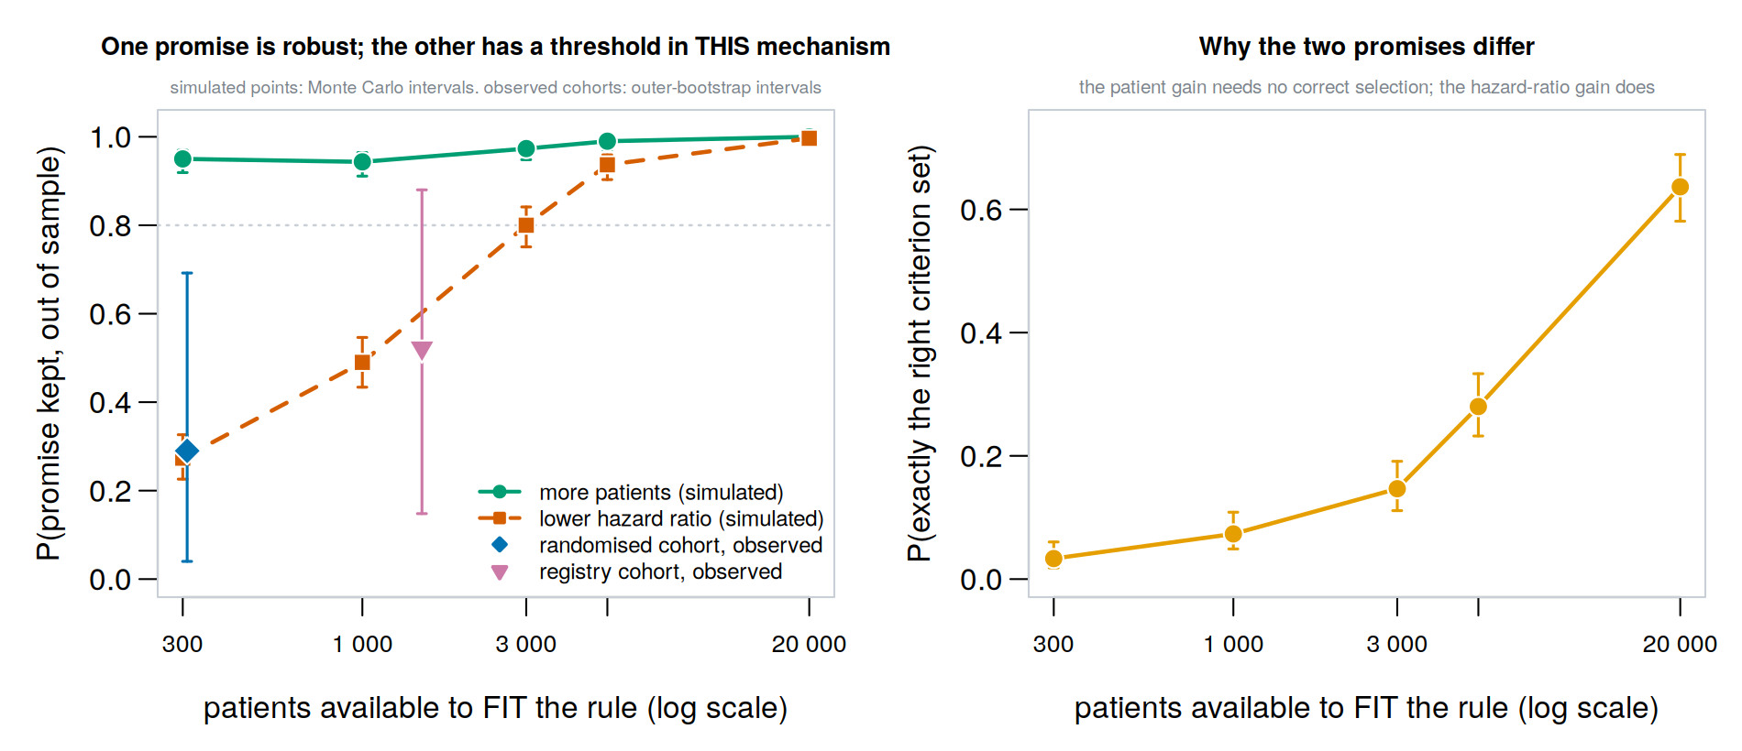
Figure 2. Left: probability that each promise is kept by fitting-cohort size in the single-mechanism simulation, scoring set fixed at 100 000, with Monte Carlo intervals. The observed cohort points carry the outer-bootstrap intervals from the nested resampling, which span most of the unit interval; their apparent agreement with the simulated curve has little discriminating power and we draw no confirmation from it. Right: the probability that the rule recovers the exactly correct criterion set.

Below the threshold the selected protocol can be slightly worse than the original
Exact recovery of the criterion set rose from 0.050 at 300 fitting patients to 0.635 at 20000, but that is an unnecessarily strict standard when several protocols perform almost identically. The softer measures move monotonically: Hamming distance fell from 2.98 criteria to 0.51, Jaccard similarity rose from 0.594 to 0.928, false retention fell from 0.380 to 0.000 and false relaxation from 0.372 to 0.072. Over-relaxation is the error that persists.
Regret needs defining before it is read. Ours is on the log hazard-ratio scale: the difference between the population log hazard ratio under the selected protocol and under the subset that minimises it, both evaluated on the fixed 100 000-patient scoring set. It is a single-objective measure that ignores eligible count, safety and every other clinical consideration, and because different protocols target different populations a larger regret means further from the lowest attainable hazard ratio rather than worse for a patient. The full protocol has a regret of its own, which is what makes the two comparable. In this generating model the rule's population limit set coincides with the minimising subset, so its asymptotic regret is zero; the Shapley-sign rule carries no general guarantee of reaching the global optimum when interactions are present and we claim this for this scenario only. Regret falls from 0.0727 at 300 fitting patients to 0.0078 at 20000. The full protocol's regret is 0.0544. The two cross near a thousand fitting patients: below that, the protocol the rule produces sits slightly further from the lowest attainable hazard ratio than the full protocol does. Read narrowly — as a statement about this one generating model and this one objective — it means the expected outcome for a small cohort is not a smaller improvement but a marginally worse position on that objective, applied to a larger group of patients. It is not a claim that the resulting protocol is clinically worse, which would need the other objectives weighed alongside it.

Confounding moves the threshold, and unmeasured confounding hides itself
Correctly adjusted confounding lowered the curve throughout (Figure 3): at 5167 fitting patients the probability fell from 0.937 to 0.808. How much extra sample that costs depends on the reliability asked for. The randomised arm reaches 0.80 at 3000 fitting patients and the adjusted arm reaches about the same value at 5167, a factor of about 1.7; to reach the 0.94 the randomised arm has at 5167, the adjusted arm needs more than the largest size we simulated, where it stands at 0.96.
The third arm is the more consequential result and requires care with language. Because all three arms share one outcome model, the true causal contrast is identical in all three by construction; what differs is the population limit of the weighted estimator under each adjustment. Omitting one confounder returned the reliability curve to randomised levels — 0.936 at 5167 against 0.937 — which might easily be read as reassurance. The estimator's population limit for the gap between protocols rose to 0.0591 from 0.0544, 8.6% larger, with the whole hazard ratio displaced from 0.677 to 0.749. Meanwhile the probability of recovering the correct criterion set fell from 0.280 to 0.116. The procedure appeared equally reliable while its selection was in fact less accurate, because the quantity it was detecting had itself been inflated by bias.
Observing that the method performs well on real-world data therefore does not by itself indicate that adjustment was adequate. A useful sensitivity analysis compares the estimated gap under richer and poorer adjustment and expects it to shrink as adjustment improves — but that expectation holds only when the added variables are plausibly confounders. Adding an instrument can amplify residual bias¹⁶ and adding a collider or mediator can create it, so the direction of travel is a warning worth heeding among substantively defensible adjustment sets, not a test that settles the question.
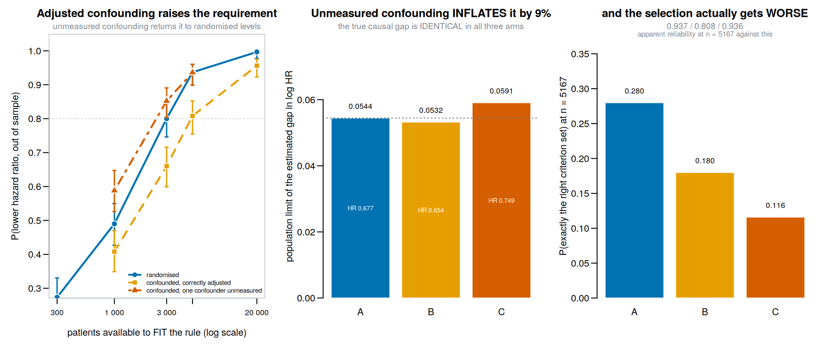
Figure 3. Three treatment-assignment mechanisms sharing one outcome model, with Monte Carlo intervals. Left: correctly adjusted confounding lowers the curve; omitting one confounder returns it to randomised levels. Centre: the population limit of the estimated gap is 8.6% larger under unmeasured confounding — the true causal gap is identical in all three arms. Right: correct selection meanwhile falls by more than half.

Why the hazard ratio is the fragile leg
Under proportional hazards (Figure 4), with the conditional hazard ratio fixed at 0.6 in every stratum, a criterion defined on the prognostic covariate changes no individual's relative benefit, yet its Shapley value on the log hazard ratio grew with prognostic strength, though not monotonically at the top of the range, from -0.0008 with no heterogeneity to -0.066 at the strongest setting, while the marginal hazard ratio drifted from 0.599 to 0.804. The value at zero heterogeneity is the falsification point and the artefact vanished there. The restricted mean difference also moved, and in the opposite direction: it fell from 0.657 in the whole cohort to 0.599 in the selected group at the weakest setting and from 0.425 to 0.322 at the strongest, so its Shapley value is negative wherever there is heterogeneity to collapse over (-0.057 at the weakest non-zero setting, -0.103 at the strongest) and is 0.0095 at zero heterogeneity, where there is nothing to collapse. That is the expected direction and it corresponds to a real fact — a lower-risk group has less absolute survival to gain, because more of it survives the horizon regardless of treatment. The hazard-ratio movement corresponds to no fact of either kind, which is the concrete reason a lower hazard ratio must not be read as a better estimate.
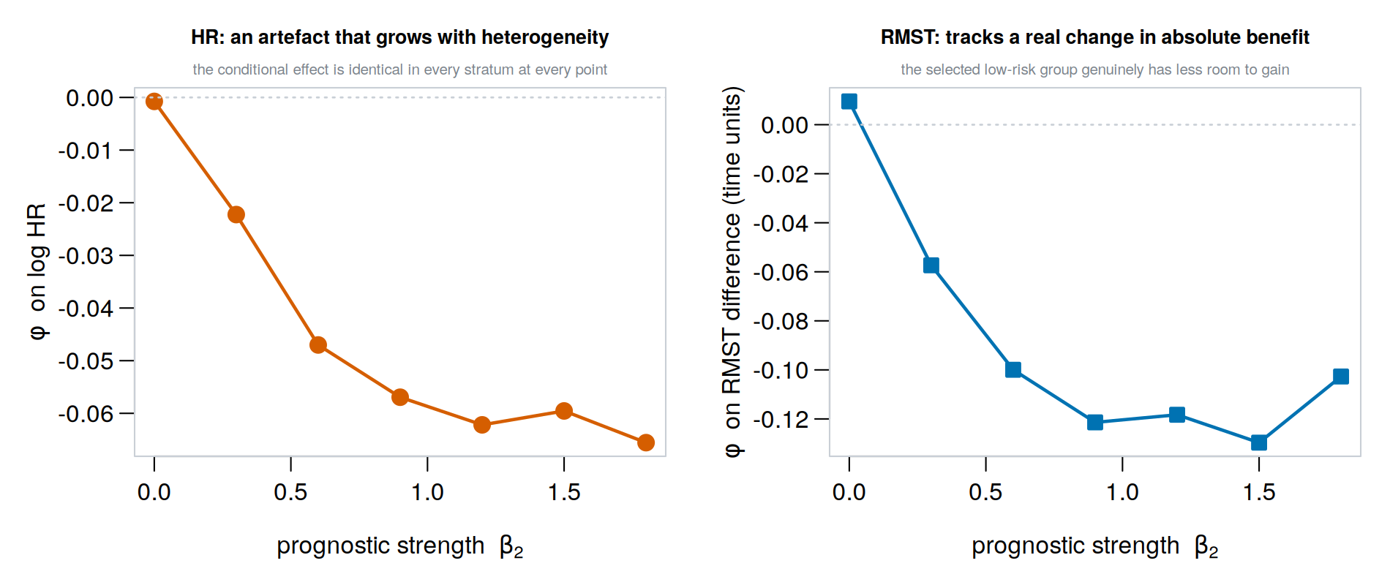
Figure 4. Non-collapsibility as a dose–response. The conditional hazard ratio is 0.6 in every stratum at every point on these curves, so the criterion changes no individual's relative benefit; the Shapley value on the log hazard ratio nonetheless grows with prognostic strength and vanishes where there is no heterogeneity to collapse over.

Pairwise interactions here are attenuated, not absent
The plate plot, adapted here from network meta-analysis², displays both estimands in one panel (Figure 5). Leverage is signed: positive correlation raises the joint eligibility rate above the product of the marginals, and once it rises far enough the factor can become negative, meaning the contrast flips sign rather than vanishing. Magnitude therefore measures attenuation. In colon the median magnitude was 0.013 and the maximum 0.086, with 0 pairs of 36 above 0.10 and 35 of 36 below 0.05; in Rotterdam the median was 0.022, 4 pairs exceeded 0.10 and 26 of 36 fell below 0.05.
The consequence is a power statement, not a structural one. A global permutation test on the colon interaction matrix returned p = 0.26 on the hazard ratio and 0.21 on the restricted mean, and no main effect survived multiplicity adjustment on either estimand. Because the contrast in these cells is attenuated by a factor of order 0.01 to 0.09, those nulls carry little information about effect modification: they bound what could have been detected at this attenuation and sample size and nothing more. The one class of cells about which a null is definitive is the logically implied pair, where the contrast is exactly zero and which the implication detector removes before testing.
Against known truth over 420 replicates at n = 1500, the bias-corrected and accelerated interval attained 0.950 coverage (Monte Carlo SE 0.011) for a null interaction, against a nominal 0.95, while the percentile interval over-covered at 0.964. Since most cells of a real interaction matrix are null and their false-positive behaviour determines what gets reported, that is the comparison that matters. For a genuinely non-null interaction both under-covered, at 0.933 and 0.931 (Monte Carlo SE 0.012). We recommend at least 1000 bootstrap replicates and 50 jackknife groups, and treating intervals for large interactions as mildly anticonservative.
Because the hazard-ratio point estimates favour the rule in both cohorts while the two cohorts point opposite ways on absolute benefit, we asked what happens if the rule selects on the restricted mean difference instead — retaining every criterion whose RMST Shapley value is positive. The two rules are close to different procedures: they agree on the criterion set in a proportion 0.070 of colon splits and 0.207 of Rotterdam splits, and in colon the RMST rule admits 182 patients against the hazard-ratio rule's 149 and the full protocol's 88.
Out of sample the RMST-selected variant exceeded the full protocol's restricted mean difference in 53.2% of colon splits against 50.8% for the published rule, and reached a lower hazard ratio in 15.2% against 29.0%. Carried through the same patient-level resampling, and stated as marginal intervals against the full protocol rather than as a comparison between the rules, these are 53.2%, interval [0.11, 0.92], and 15.2%, interval [0.00, 0.56]; the agreement rate itself has interval [0.00, 0.28]. We therefore do not claim that switching the estimand gains nothing. Nor do we claim the opposite. Both quantities are probabilities of improvement over the full protocol, and they go in different directions: the probability of a greater restricted mean difference is higher for the RMST-selected variant, and the probability of a lower hazard ratio is lower for it. Two intervals each formed against the full protocol cannot settle which rule is better, because the rules share patients and splits and their errors are correlated, so we compute the difference between them inside each split and carry that paired difference through the same outer bootstrap. The paired advantage of the RMST-selected variant is 0.024, interval [-0.200, 0.356] on the restricted mean difference and -0.138, interval [-0.360, 0.160] on the hazard ratio in colon; in Rotterdam they are 0.010, interval [-0.200, 0.160] and -0.010, interval [-0.240, 0.200]. Every one of these intervals contains zero, and the paired intervals are narrower than the two marginal ones, which is the point of pairing. The paired advantage of either rule is therefore not established. We did not prespecify an equivalence margin, so we make no equivalence claim either. What the data do show is that the two decompositions select almost different criterion sets, so the choice of decomposition estimand is a real design decision even though these cohorts cannot say which choice is better.
The horizon matters for both of these comparisons and was not justified in the previous version. The restricted mean must be taken at a time inside the observed follow-up of both arms of every candidate protocol, or subsets are not compared on the same scale; we used 1825 days in colon and 2555 days in Rotterdam, at which at least 50.8% and 49.5% of patients in either arm are still under observation. Repeating the selection comparison at four horizons per cohort, the two decompositions agree on the criterion set in 0.032 to 0.132 of colon splits and 0.098 to 0.273 of Rotterdam splits, with mean Jaccard similarity of 0.529 to 0.724 and 0.631 to 0.763 respectively. The disagreement between the two estimands is therefore a property of the estimands rather than of the particular horizon, but the exact agreement rate is horizon-dependent and should be reported with the horizon attached (Supplementary Table S3d).
The horizon also changes the sign of the absolute-benefit comparison, which we had not looked for. In colon the mean out-of-sample restricted mean difference is 10.0 days for the full protocol at the shortest horizon we tried against 14.5 for the published rule and 22.9 for the RMST-selected variant, so both relaxed protocols are ahead; at the longest horizon the full protocol leads both (113.3 against 104.2 and 95.2). At the horizon used in the main analysis the three are close and the ordering is mixed (69.2, 67.8 and 71.1). A statement that relaxation does or does not improve absolute benefit is therefore not well posed without the horizon, our main-text figures sit in the middle of the range we examined, and the crossing means no single horizon should be read as the answer. We report the horizon everywhere and do not generalise beyond it.
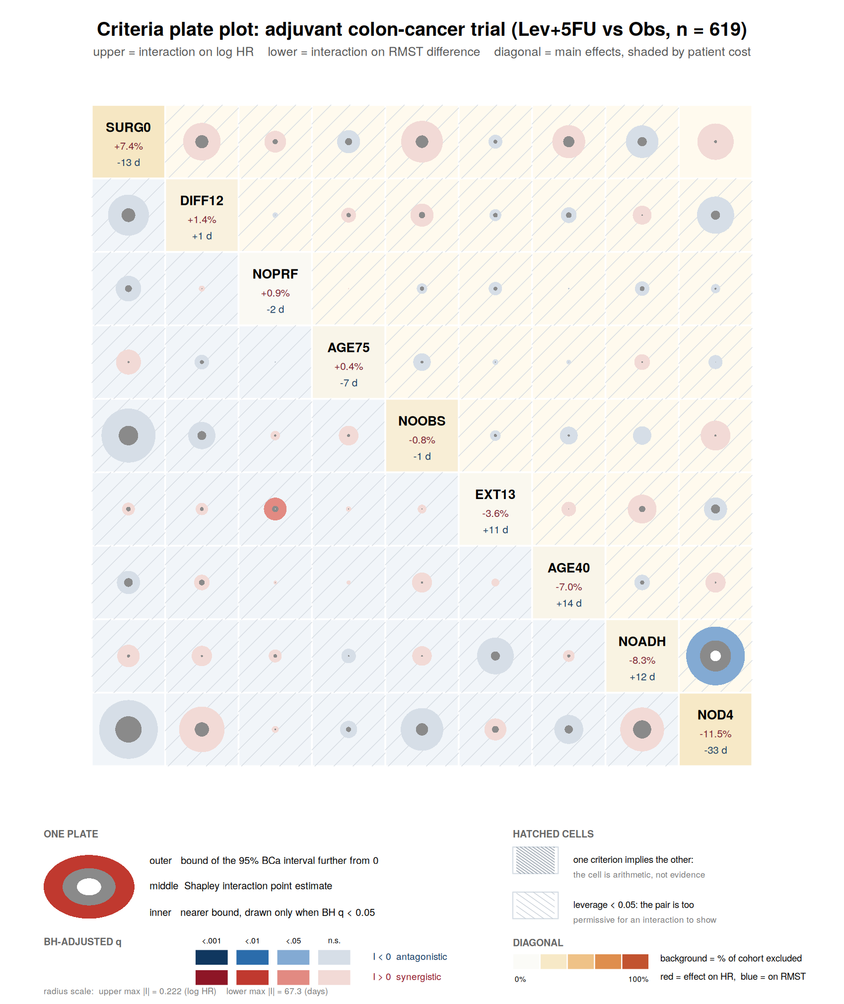
Figure 5. The criteria plate plot for colon. Upper triangle, pairwise interaction on the log hazard ratio; lower triangle, on the restricted mean difference; diagonal, per-criterion main effects on both estimands, shaded by the fraction of the cohort the criterion excludes. Light hatching marks cells whose leverage is below 0.05 in magnitude — 35 of 36 here — and dense hatching cells that are arithmetic identities. A full-page version is Supplementary Figure S2.

Discussion
Data-driven relaxation admits more patients, and it is worth being precise about what that shows. The rule retains a subset of the criteria, so the eligible set can only grow, and the probability reported for this promise measures how often a binding criterion is removed. Scored against all 512 subsets on the held-out half, the rule's choice is almost never on the empirical eligible-count-versus-hazard-ratio frontier. That frontier is itself optimistic, and the size of the correction is not small: when the comparator subsets are chosen on one third of the cohort and the rule is judged against exactly those on a third that has been used for nothing, it is left undominated in 21.0% of colon and 12.0% of Rotterdam splits, against 2.5% and 2.7% judged on the selection third of the same three-way design. The comparison that isolates selection optimism is the one within this design, since the half-split figures reported earlier also use a larger evaluation set and the two effects cannot be separated across designs. The qualitative finding survives — the rule is beaten in most splits on every reading — but the out-of-sample figure is the second one, and quoting only the first overstates the shortfall. Matched on eligible count, its hazard-ratio advantage has an interval containing one half, and on the absolute-benefit estimand the two cohorts point opposite ways. So the rule is not optimising the trade-off between the two promises, and whether it has any advantage at equal inclusiveness is a question these cohorts cannot settle — neither of which a comparison against the full protocol alone can show.
What a wider eligible population is worth clinically is a separate question no outcome model answers, and criteria are not all of a kind: those encoding safety, tolerability, feasibility or pharmacology should be designated non-relaxable before the procedure runs rather than left to a hazard ratio to adjudicate.
Whether the effect-estimate improvement is attainable depends on something that cannot be checked before the analysis, but that does not make planning impossible. Across the factorial the success probability varies by between 0.28 and 0.39 in standard deviation across the fixed sample sizes, averaging 0.34, and grouping scenarios by events or by effective sample size rather than by patients did not reduce that spread in this design (0.34, 0.35 and 0.34), though with 16 scenarios and sixteen rows to a bin, this comparison cannot establish that the three are equivalent: a cluster bootstrap over scenarios puts the difference between events and patients at 0.006 with interval [-0.043, 0.028], which is wide and contains zero (Supplementary Table S2c) — a claim we made in the previous revision and withdraw here, because it was computed only over the scenarios in which a threshold happened to be observable. We are not able to name the quantity that does govern the requirement. A sentence in the previous revision named the magnitude of the largest diluting effect-modification coefficient, and we withdraw it: our own results do not support it. Arranging the same total modification differently is not neutral — spreading the enrichment raised success by 0.21, Monte Carlo interval [0.08, 0.34], at 6000 — and halving the diluting coefficient also roughly halves the attainable gap, so in that design the coefficient and the size of the prize move together and cannot be separated. What can be said is weaker and, we think, still useful: the requirement depends on the strength of the diluting signal relative to the noise at the fitting size, and that strength is what the analysis exists to estimate, so no requirement in patients, events or effective sample size can be given unconditionally. This is the ordinary position of a power calculation, whose sample size also depends on an effect size not yet observed. A criterion-specific signal-to-noise ratio — the population Shapley value of the most diluting criterion over the standard deviation of its estimate at the fitting size — is the candidate we tried, and we report it with the caveat that matters. Pooled over 12 simulated cells it orders success better than the fitting size does (Spearman 0.86 against 0.45), but that pooled figure is not evidence for the ratio: within an arrangement the ratio rises with the fitting size by construction, so the within-arrangement association (0.82 after adjusting for arrangement) says little more than that success rises with sample size. The comparison that would carry information is between arrangements at a fixed size, where the association is weaker (0.63 at the largest size tried) and rests on four arrangements, one of which shows no variation in success at all. We therefore do not claim the ratio as the governing quantity, only as the direction we would pursue next (Supplementary Table S4b). What we can rule out is a portable cohort-size-only threshold of the kind we ourselves offered in a previous version — within the mechanisms examined here, and as a statement about those mechanisms rather than a general impossibility result. Table 2 should accordingly be read as a sensitivity analysis across arrangements at fixed fitting sizes, not as a design curve to read a requirement from. The result also separates cleanly what an investigator can check beforehand — empirical overlap inside the full protocol, logical implication, interaction leverage — from what they cannot.
For small cohorts the regret comparison adds a further caution: the protocol the rule produces sits slightly further from the lowest attainable hazard ratio than the original does. That is a single-objective statement about one generating model, not a claim of clinical inferiority.
The unmeasured-confounding arm is the finding we would most want carried forward. Residual confounding inflated the quantity being detected and thereby made the procedure appear more reliable while its selection became less accurate, which runs against the usual intuition that a clear signal is reassuring. The recommendation that follows — compare adjustment sets and expect the gap to shrink — is a heuristic with real exceptions and should be used among substantively defensible sets rather than as a test.
Rotterdam is a cautionary example of a different kind. Chemotherapy there went almost exclusively to younger, premenopausal women, so within the restrictive full protocol there is very little overlap and no specification we tried restores balance — exactly the check we argue should come first. Restriction does not create it; overlap declined only slightly with the number of criteria applied in both cohorts.
Three by-products may be useful independently. Interaction leverage is a closed-form quantity requiring no outcome data that says how far a pair's interaction is attenuated by the eligibility rates alone; we have corrected the claim made for it — low leverage is attenuation rather than structural invisibility — and derived the coefficient for three interaction forms, all multiples of (1−q)(1−q) under independence, exact for the both-criteria structure and approximate for the other two. The implication detector removes cells that are arithmetic identities, the only cells genuinely uninformative regardless of sample size. And carrying both estimands makes visible where a criterion's relative and absolute effects disagree, a substantive question that should be settled on clinical grounds rather than by a software default.
Several limitations bound these conclusions. The criteria were constructed from available covariates rather than transcribed from protocols, so this demonstrates a general property rather than evaluating any trial, and neither cohort is the database used in the original work. The factorial is resolution IV, so two-factor interactions are aliased in pairs; the criterion-count factor spans only 6 against 8, because exhaustive enumeration costs 2^p evaluations per replicate; and propensity overlap, weight variability, missingness and model misspecification are represented crudely or not at all. All simulated quantities depend on their generating models. The absolute-benefit column depends on an analyst choice of horizon, and in colon its sign flips across a plausible range of that choice. The leverage expressions are derived for three specific interaction forms.

Conclusions
Relaxing trial eligibility criteria from data widens the eligible population, but that widening follows largely from the structure of the rule, and scored against the subsets attainable on held-out patients the rule's choice is rarely on the eligible-count-versus-hazard-ratio frontier, on both the empirical reading and the stricter one in which the comparator subsets are fixed on separate data first, though the two differ by a factor of several and only the second is an out-of-sample statement. Whether it contributes anything at matched inclusiveness is not resolved by cohorts of this size; the point estimates favour it on the hazard ratio in both cohorts while the two cohorts point opposite ways on absolute benefit, and a variant selecting on absolute benefit instead chooses almost entirely different criteria, and showed no clear or consistent advantage on either estimand; the paired difference between the two rules does not establish an advantage for either, and no equivalence margin was prespecified. How much data that contribution requires cannot be determined from patients, events or effective sample size alone: across the mechanisms we simulated it depends on the strength of the diluting signal, which is the quantity the analysis exists to discover. We have not identified what does govern it, and we do not claim that no such requirement can exist. It can in principle be stated conditionally on an assumed minimum such signal, as a power calculation is stated on an assumed minimum effect, though we do not supply that conditional statement here. Incomplete confounding adjustment can make the procedure appear more successful while its selection is less accurate, so apparent success on real-world data should not be taken as evidence of adequate adjustment. What an investigator can establish beforehand is narrower than we previously suggested — empirical overlap inside the full protocol, logical implication among criteria, and interaction leverage — and it does not include whether the effect-estimate promise is within reach.

Declarations
Ethics approval and consent to participate. Not applicable. Both datasets are fully de-identified, publicly distributed with the R package survival, and were previously published; no new human-subjects data were collected.
Consent for publication. Not applicable.
Availability of data and materials. Both cohorts ship with the R package survival and require no application. All analysis code, the R package trialplate, and the machine-readable file of every number quoted in this paper are in the study repository [URL to be supplied at acceptance; an anonymous reviewer link is available on request]. An archived release with a DOI will be deposited on acceptance.
Competing interests. To be completed by the authors.
Funding. To be completed by the authors.
Authors' contributions. To be completed by the authors.
Acknowledgements. We thank the reviewers, whose comments motivated additional analyses and corrections throughout, including the frontier-optimism simulation and the nested resampling reported here.

References
1. Liu R, Rizzo S, Whipple S, Pal N, Lopez Pineda A, Lu M, Arnieri B, Lu Y, Capra W, Copping R, Zou J. Evaluating eligibility criteria of oncology trials using real-world data and AI. Nature. 2021;592(7855):629–633. doi:10.1038/s41586-021-03430-5
2. Ren Y, Wang Z, Lin L, Zhao S, Chu H. A novel visualization approach for network meta-analysis: the plate plot and the nmaplateplot R package. Research Synthesis Methods. 2026;17(5):1045–1053. doi:10.1017/rsm.2026.10088
3. Kim ES, Bruinooge SS, Roberts S, et al. Broadening eligibility criteria to make clinical trials more representative: American Society of Clinical Oncology and Friends of Cancer Research joint research statement. J Clin Oncol. 2017;35(33):3737–3744. doi:10.1200/JCO.2017.73.7916
4. US Food and Drug Administration. Enhancing the diversity of clinical trial populations — eligibility criteria, enrollment practices, and trial designs: guidance for industry. Silver Spring, MD: FDA; November 2020.
5. Jreich R, Zhang H, Meng Z, Wang F. Evaluating the robustness of an AI pathfinder application on eligibility criteria in multiple myeloma trials using real-world data and historical trials. J Comp Eff Res. 2024;13(7):e230164. doi:10.57264/cer-2023-0164
6. Makgoeng SB, Gamalo M, Russo LJ, Pradhan V, Bhattacharjee A, Bhosale N. Data-driven trial design: use of target trial emulation to evaluate eligibility criteria in asthma and COPD. Front Med. 2026;13:1863026. doi:10.3389/fmed.2026.1863026
7. Shapley LS. A value for n-person games. In: Kuhn HW, Tucker AW, eds. Contributions to the Theory of Games, Volume II. Annals of Mathematics Studies 28. Princeton, NJ: Princeton University Press; 1953:307–317.
8. Grabisch M, Roubens M. An axiomatic approach to the concept of interaction among players in cooperative games. Int J Game Theory. 1999;28(4):547–565. doi:10.1007/s001820050125
9. Hernán MA. The hazards of hazard ratios. Epidemiology. 2010;21(1):13–15. doi:10.1097/EDE.0b013e3181c1ea43
10. Greenland S, Robins JM, Pearl J. Confounding and collapsibility in causal inference. Statist Sci. 1999;14(1):29–46. doi:10.1214/ss/1009211805
11. Royston P, Parmar MKB. Restricted mean survival time: an alternative to the hazard ratio for the design and analysis of randomized trials with a time-to-event outcome. BMC Med Res Methodol. 2013;13:152. doi:10.1186/1471-2288-13-152
12. Uno H, Claggett B, Tian L, et al. Moving beyond the hazard ratio in quantifying the between-group difference in survival analysis. J Clin Oncol. 2014;32(22):2380–2385. doi:10.1200/JCO.2014.55.2208
13. Robins JM, Hernán MA, Brumback B. Marginal structural models and causal inference in epidemiology. Epidemiology. 2000;11(5):550–560. doi:10.1097/00001648-200009000-00011
14. Austin PC, Stuart EA. Moving towards best practice when using inverse probability of treatment weighting (IPTW) using the propensity score to estimate causal treatment effects in observational studies. Stat Med. 2015;34(28):3661–3679. doi:10.1002/sim.6607
15. Petersen ML, Porter KE, Gruber S, Wang Y, van der Laan MJ. Diagnosing and responding to violations in the positivity assumption. Stat Methods Med Res. 2012;21(1):31–54. doi:10.1177/0962280210386207
16. Myers JA, Rassen JA, Gagne JJ, et al. Effects of adjusting for instrumental variables on bias and precision of effect estimates. Am J Epidemiol. 2011;174(11):1213–1222. doi:10.1093/aje/kwr364
17. Efron B. Better bootstrap confidence intervals. J Am Stat Assoc. 1987;82(397):171–185. doi:10.1080/01621459.1987.10478410
18. Benjamini Y, Hochberg Y. Controlling the false discovery rate: a practical and powerful approach to multiple testing. J R Stat Soc Series B. 1995;57(1):289–300. doi:10.1111/j.2517-6161.1995.tb02031.x
19. Grambsch PM, Therneau TM. Proportional hazards tests and diagnostics based on weighted residuals. Biometrika. 1994;81(3):515–526. doi:10.1093/biomet/81.3.515
20. Moertel CG, Fleming TR, Macdonald JS, et al. Levamisole and fluorouracil for adjuvant therapy of resected colon carcinoma. N Engl J Med. 1990;322(6):352–358. doi:10.1056/NEJM199002083220602
21. Royston P, Altman DG. External validation of a Cox prognostic model: principles and methods. BMC Med Res Methodol. 2013;13:33. doi:10.1186/1471-2288-13-33
22. Therneau TM. survival: survival analysis. R package. Comprehensive R Archive Network. Available at: https://CRAN.R-project.org/package=survival

