Supplementary material

Table S1. Criteria, eligibility, missingness and retained information
Marginal eligibility is computed before the missing-as-eligible convention is applied. Events and patients retained are those meeting that criterion alone. The full protocol row is the intersection of all nine.
colon: adjuvant colon-cancer trial, Lev+5FU vs observation (n = 619, 304 treated, 291 events)
code | definition | eligible | missing | events kept | treated | control
AGE75 | age ≤ 75 | 0.937 | 0.000 | 275 | 287 | 293
AGE40 | age ≥ 40 | 0.918 | 0.000 | 266 | 278 | 290
NOOBS | no bowel obstruction | 0.811 | 0.000 | 231 | 250 | 252
NOPRF | no perforation | 0.973 | 0.000 | 282 | 296 | 306
NOADH | not adherent to adjacent organs | 0.861 | 0.000 | 242 | 265 | 268
DIFF12 | differentiation ≤ 2 | 0.825 | 0.021 | 230 | 250 | 263
EXT13 | extent ≤ 3 | 0.950 | 0.000 | 272 | 293 | 295
SURG0 | short interval since surgery | 0.730 | 0.000 | 201 | 228 | 224
NOD4 | fewer than 4 positive nodes | 0.732 | 0.000 | 177 | 225 | 228
FULL | all nine applied | 0.284 | — | 56 | 89 | 87
Maximum absolute off-diagonal correlation among the eligibility indicators: 0.250 (NOADH with EXT13).
Rotterdam: breast-cancer registry, chemotherapy vs none (n = 2982, 580 treated, 1272 events)
code | definition | eligible | missing | events kept | treated | control
AGE70 | age ≤ 70 | 0.861 | 0.000 | 1017 | 578 | 1990
AGE30 | age ≥ 30 | 0.989 | 0.000 | 1257 | 569 | 2381
ND9 | nodes ≤ 9 | 0.910 | 0.000 | 1069 | 508 | 2207
NDPOS | nodes ≥ 1 | 0.518 | 0.000 | 877 | 580 | 966
SZ50 | tumour size ≤ 50 mm | 0.898 | 0.000 | 1060 | 502 | 2176
ERP | ER ≥ 10 | 0.764 | 0.000 | 949 | 443 | 1835
PGRP | PgR ≥ 10 | 0.681 | 0.000 | 823 | 428 | 1603
YR85 | enrolled ≥ 1985 | 0.873 | 0.000 | 1022 | 502 | 2101
YR90 | enrolled ≤ 1990 | 0.758 | 0.000 | 1068 | 427 | 1832
FULL | all nine applied | 0.141 | — | 191 | 203 | 216
Maximum absolute off-diagonal correlation: 0.572 (ERP with PGRP); also ND9 with NDPOS at −0.30 and SZ50 with NDPOS at −0.23. Rotterdam has no missingness on any criterion variable.

Table S1b. Propensity-score behaviour inside the full protocol
specification | cohort | max |SMD| | covariates > 0.10 | ESS | truncated | n retained
M1 main effects, unstabilised, truncated (main analysis) | colon | 0.011 | 0 of 5 | 172 | 0 | 176
M2 + natural splines on continuous covariates | colon | 0.026 | 0 of 5 | 166 | 0 | 176
M3 + stabilised weights | colon | 0.026 | 0 of 5 | 166 | 0 | 176
M4 + trimming to common support | colon | 0.058 | 0 of 5 | 165 | 0 | 172
M1 main effects, unstabilised, truncated (main analysis) | Rotterdam | 0.251 | 6 of 8 | 155 | 132 | 419
M2 + natural splines on continuous covariates | Rotterdam | 0.413 | 6 of 8 | 138 | 181 | 419
M3 + stabilised weights | Rotterdam | 0.413 | 6 of 8 | 139 | 181 | 419
M4 + trimming to common support | Rotterdam | 0.215 | 5 of 8 | 111 | 181 | 338
Four covariates in colon are fixed by the criteria themselves inside the full protocol and carry no balance information. No specification restores balance in Rotterdam; splines make it worse. Of 116 full-protocol Rotterdam patients aged 55 to 70, 12 received chemotherapy; 175 of 203 treated patients are premenopausal against 45 of 216 controls.

Table S1c. Overlap does not degrade with restriction
Median over all subsets of each size, across the full 2⁹ enumeration in each cohort. If restriction created the positivity problem, the effective-sample-size fraction would fall from left to right. It does not.
criteria applied | colon: median n | colon: ESS/n | Rotterdam: median n | Rotterdam: ESS/n | Rotterdam: truncated | Rotterdam: max |SMD|
0 | 619 | 0.989 | 2982 | 0.374 | 0.397 | 0.465
2 | 458 | 0.985 | 1968 | 0.383 | 0.366 | 0.436
4 | 341 | 0.981 | 1266 | 0.381 | 0.309 | 0.327
6 | 257 | 0.977 | 694 | 0.380 | 0.294 | 0.252
9 | 176 | 0.976 | 419 | 0.369 | 0.315 | 0.251

Table S2. Threshold across the fractional factorial
run | p | retain | mod | |γ| | cens | alloc | conf | n* | 95% CI | events* | ESS*
1 | 6 | 0.30 | 2 | 0.40 | 0.020 | 0.50 | no | 2000 | 1307–3048 | 422 | 588
2 | 8 | 0.30 | 2 | 0.40 | 0.020 | 0.25 | yes | > 18 000 | — | — | —
3 | 6 | 0.12 | 2 | 0.40 | 0.020 | 0.25 | yes | 4409 | 3633–6770 | 365 | 309
4 | 8 | 0.12 | 2 | 0.40 | 0.020 | 0.50 | no | 3464 | 2242–5080 | 275 | 472
5 | 6 | 0.30 | 5 | 0.16 | 0.020 | 0.25 | no | > 18 000 | — | — | —
6 | 8 | 0.30 | 5 | 0.16 | 0.020 | 0.50 | yes | > 18 000 | — | — | —
7 | 6 | 0.12 | 5 | 0.16 | 0.020 | 0.50 | yes | > 18 000 | — | — | —
8 | 8 | 0.12 | 5 | 0.16 | 0.020 | 0.25 | no | > 18 000 | — | — | —
9 | 6 | 0.30 | 2 | 0.40 | 0.180 | 0.50 | yes | 2462 | 1572–3511 | 236 | 752
10 | 8 | 0.30 | 2 | 0.40 | 0.180 | 0.25 | no | 7228 | 5006–10394 | 721 | 1787
11 | 6 | 0.12 | 2 | 0.40 | 0.180 | 0.25 | no | 3066 | 2209–3738 | 85 | 310
12 | 8 | 0.12 | 2 | 0.40 | 0.180 | 0.50 | yes | < 600 | — | — | —
13 | 6 | 0.30 | 5 | 0.16 | 0.180 | 0.25 | yes | > 18 000 | — | — | —
14 | 8 | 0.30 | 5 | 0.16 | 0.180 | 0.50 | no | > 18 000 | — | — | —
15 | 6 | 0.12 | 5 | 0.16 | 0.180 | 0.50 | no | > 18 000 | — | — | —
16 | 8 | 0.12 | 5 | 0.16 | 0.180 | 0.25 | yes | > 18 000 | — | — | —
n* is the fitting-cohort size at which the probability of a lower out-of-sample hazard ratio crosses 0.80, located by interpolation with a bootstrap interval over replicates. events* and ESS* are the corresponding full-protocol event count and weighted effective sample size. “> 18 000” marks a scenario in which the probability never reached 0.80 anywhere on the ladder; “< 600” one in which it was already above 0.80 at the smallest size, which happens where the full protocol retains so few events that it is the imprecise comparator. Both are excluded from the spread statistics below. mod is the number of criteria carrying effect modification: 2 concentrates it, 5 spreads it.
Of the 16 scenarios, 6 located a threshold, 9 were right-censored at 18 000 fitting patients and 1 left-censored below 600. Among those located, the spread is: fitting patients 2000 to 7228 (coefficient of variation 0.50); full-protocol events 85 to 721 (0.61); effective sample size 309 to 1787 (0.79). Neither information currency is more stable than the patient count.
Completion by factor level (8 runs each):
factor | level | threshold located | right-censored | median n* where located
criteria p | 6 | 4 | 4 | 2764
criteria p | 8 | 2 | 5 | 5346
full-protocol retention | 0.30 | 3 | 5 | 2462
full-protocol retention | 0.12 | 3 | 4 | 3464
effect modification | concentrated (2 criteria, |γ| 0.40) | 6 | 1 | 3265
effect modification | diffuse (5 criteria, |γ| 0.16) | 0 | 8 | —
censoring rate | 0.020 | 3 | 5 | 3464
censoring rate | 0.180 | 3 | 4 | 3066
allocation | 1:1 | 3 | 4 | 2462
allocation | 1:3 | 3 | 5 | 4409
assignment | randomised | 4 | 4 | 3265
assignment | confounded, adjusted | 2 | 5 | 3436
Only the effect-modification factor separates the design: every scenario with diffuse modification failed to reach 0.80 anywhere on the ladder, under every combination of the other five factors.

Table S2b. Threshold analysis without conditioning on an observable threshold
The threshold estimates in Table S2 are censored in ten of sixteen scenarios, so summarising only the six that are observable conditions on the outcome. Two analyses that do not. First, an interval-censored lognormal accelerated-failure-time regression of the threshold on the six factors, in which right-censored runs contribute (18 000, infinity) and the left-censored run (0, 600): the effect-modification factor completely separates the design — all eight diffuse runs are right-censored — so its coefficient is unbounded and not estimable, and the remaining terms are estimated from six exact observations with intervals spanning one to two orders of magnitude. Second, the sensitivity of the pattern to the 0.80 reliability target.
reliability target | threshold located | right-censored | left-censored | median located n* | concentrated located | diffuse located
0.70 | 7 | 8 | 1 | 2 000 | 6 of 8 | 1 of 8
0.80 | 6 | 9 | 1 | 3 265 | 6 of 8 | 0 of 8
0.90 | 6 | 10 | 0 | 4 811 | 6 of 8 | 0 of 8
The separation by effect-modification arrangement is unchanged across targets, so nothing in the main text depends on the choice of 0.80.

Table S3. Matched and frontier comparison against all attainable subsets
Every one of the 512 subsets is scored on the held-out half of each split. “Matched” keeps those whose eligible count is within ten per cent of the rule's. “On the frontier” means no scored subset admits at least as many patients at a hazard ratio at least as low. Intervals are bootstrap intervals over splits and therefore narrower than the population uncertainty reported in the main text.
quantity | colon | Rotterdam
splits | 250 | 200
matched comparators per split (median) | 123 | 66
rule beats a matched subset on log HR | 0.598 [0.568, 0.628] | 0.548 [0.509, 0.585]
rule beats a matched subset on RMST | 0.427 [0.395, 0.459] | 0.515 [0.473, 0.555]
rule on the count/HR frontier | 0.016 [0.004, 0.032] | 0.030 [0.010, 0.055]
rule on the count/RMST frontier | 0.004 [0.000, 0.012] | 0.050 [0.020, 0.080]
subsets dominating the rule (median) | 72 | 60

Table S4. Arrangement of the effect modification, total held fixed
Total modification is 0.85 in every row. Rows A to C hold the diluting coefficient at 0.30 and spread the enrichment over one, two and four criteria. Row D holds the enrichment in one criterion and splits the dilution across two, halving the coefficient the rule has to detect. Entries are the probability of a lower out-of-sample hazard ratio; the scoring set is fixed at 60 000 patients.
arrangement | largest diluting coefficient | 600 | 2 000 | 6 000 | 18 000
A dilution in 1, enrichment in 1 | 0.30 | 0.26 | 0.37 | 0.58 | 0.85
B dilution in 1, enrichment in 2 | 0.30 | 0.23 | 0.43 | 0.79 | 0.87
C dilution in 1, enrichment in 4 | 0.30 | 0.17 | 0.39 | 0.78 | 0.95
D dilution in 2, enrichment in 1 | 0.15 | 0.07 | 0.11 | 0.19 | 0.43
Spreading the enrichment (A to C) leaves success unchanged or slightly improved; halving the diluting coefficient (A against D) reduces it from 0.85 to 0.43 at the largest size. Monte Carlo standard error is at most 0.065.

Figure S3. Propensity distributions inside the full protocol
Estimated propensity scores by treatment arm within the full protocol of each cohort, with the 0.05 and 0.95 truncation bounds marked and the common-support region indicated. The Rotterdam panel shows the near-separation that makes its weighted estimates descriptive rather than causal.
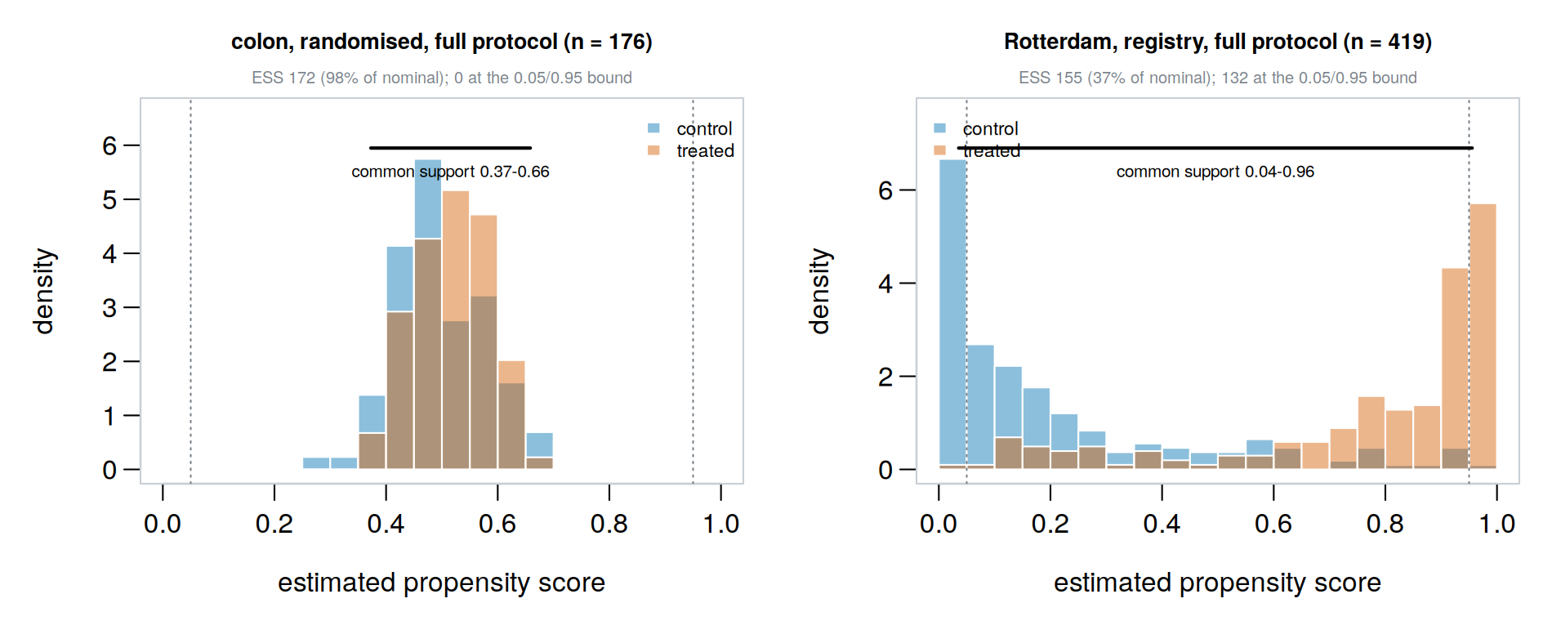

Text S1. Complete specification of every generating mechanism
No parameter below was estimated from either cohort. All were set a priori. Z denotes a vector of independent standard normal covariates, A the treatment indicator, and E the vector of eligibility indicators.
S1.1 Training-size sweep (Figure 3)
p = 8 criteria; per-criterion retention (0.85, 0.75, 0.70, 0.90, 0.80, 0.85, 0.75, 0.90)
Z_k ~ N(0,1), k = 1..8, independent threshold_k = Phi^-1(retention_k)
E_k = 1{ Z_k <= threshold_k } A ~ Bernoulli(0.5)
gamma = (-0.35, -0.25, +0.30, 0, 0, 0, 0, 0) [criteria 1,2 enrich; 3 dilutes]
linear predictor eta = log(0.75)*A + sum_k 0.55*Z_k + A * sum_k gamma_k * E_k
T ~ Exponential(rate = 0.20 * exp(eta)) C ~ Exponential(rate = 0.05)
observed time = min(T, C), event = 1{T <= C} tau = 8, min per arm = 3
Fitting sizes 300, 1000, 3000, 5167 and 20 000 with 300 replicates each; scoring set fixed at 100 000 patients generated once with seed 999; population reference enumerated at N = 300 000.
S1.2 Three assignment arms (Figure 4)
Outcome model identical to S1.1 in all three arms.
arm A randomised A ~ Bernoulli(0.5)
arm B confounded, adjusted A ~ Bernoulli( logit^-1( Z . alpha ) ),
alpha = (0.6, 0.5, 0.4, 0, 0, 0, 0, 0)
propensity model uses V1..V8
arm C one confounder unmeasured: assignment as arm B,
propensity model uses V2..V8 only
250 replicates per cell at fitting sizes 1000, 3000, 5167 and 20 000. Because the outcome model is common, the true causal contrast is identical in all three arms; what differs across arms is the population limit of the weighted estimator.
S1.3 Non-collapsibility sweep (Figure 5)
N = 300 000, tau = 5, conditional log hazard ratio bA = log(0.6)
Z ~ N(0,1) A ~ Bernoulli(0.5)
T ~ Exponential(rate = 0.25 * exp(bA*A + bZ*Z)), bZ swept over
0, 0.3, 0.6, 0.9, 1.2, 1.5, 1.8
criterion under study: Z <= 0 (retains half the cohort)
The conditional hazard ratio is exp(bA) = 0.6 in every stratum of Z at every point on the sweep, so the criterion changes no individual's relative benefit. bZ = 0 is the falsification point: with no prognostic heterogeneity there is nothing to collapse over and the artefact must vanish.
S1.4 Fractional factorial over the threshold (Table S2)
2^(6-2) resolution IV, generators E = ABC and F = ABD, 16 runs.
A number of criteria p 6 vs 10
B full-protocol retention 0.30 vs 0.12
per-criterion retention = retention^(1/p)
C effect modification sparse: gamma_1 = -|g|, gamma_3 = +0.80|g|
dense : gamma_1..5 = -|g|, -0.75|g|, +0.80|g|,
-0.50|g|, +0.40|g|
|g| = 0.40 (sparse, strong) vs 0.16 (dense, weak)
D censoring rate 0.020 vs 0.180
E allocation P(A=1) 0.50 vs 0.25
F assignment randomised vs A ~ Bern(logit^-1(logit(alloc)+0.45(Z1+Z2)))
with the propensity model using all of V1..Vp
prognostic strength 0.55 per covariate; baseline rate 0.20; tau = 8
ladder 600, 2000, 6000, 18 000 fitting patients
replicates 100, 100, 70, 50 respectively; scoring set 60 000, fixed per run
Every scenario contains at least one diluting criterion, because relaxation can lower the hazard ratio only if some retained criterion selects patients who benefit less. A rung on which more than half the replicates encountered an infeasible subset is dropped rather than reported as a low probability. The crossing is located by linear interpolation of the probability against log fitting size between the two bracketing rungs, and its interval by resampling the replicate indicators 400 times.
S1.5 Interaction-leverage verification
p = 4 criteria; criteria 1 and 2 at the stated eligibility rate q,
criteria 3 and 4 at 0.85; g = -0.60; N = 40 000; prognostic 0.20;
baseline rate 0.20; censoring 0.03; tau = 8
bonus indicator AND: E1 & E2 OR: E1 | E2 XOR: E1 xor E2
eta = log(0.80)*A + sum_k 0.20*Z_k + g * A * bonus
Under independent criteria at a common rate q the coefficients multiplying g are (1−q)² for the AND form, −(1−q)² for OR and −2(1−q)² for XOR.

Figure S1. Full-page study design
Figure 1 of the main text at full width.
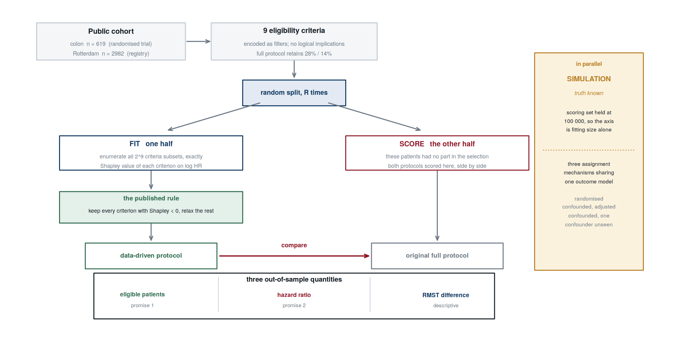

Figure S2. Full-page criteria plate plot
The colon criteria plate plot at full page size, reproducing Figure 6 of the main text.
