**Computer Networks**

**Final Project**

**Summited by :**

**21F-9187 21F-9624 Group # 17**

**RIP**

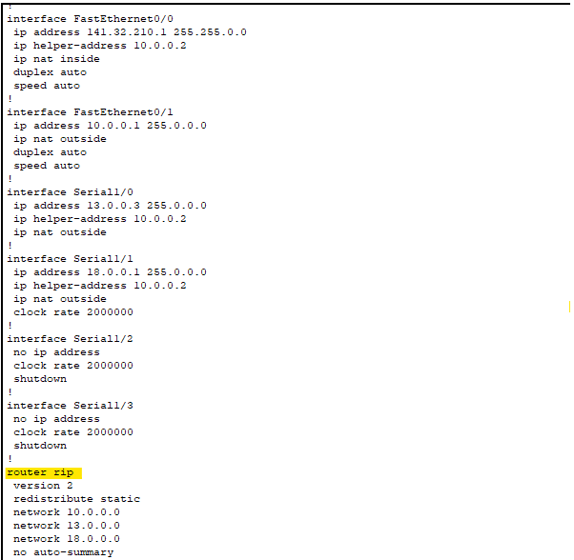

**Redistribute RIP And OSPF**

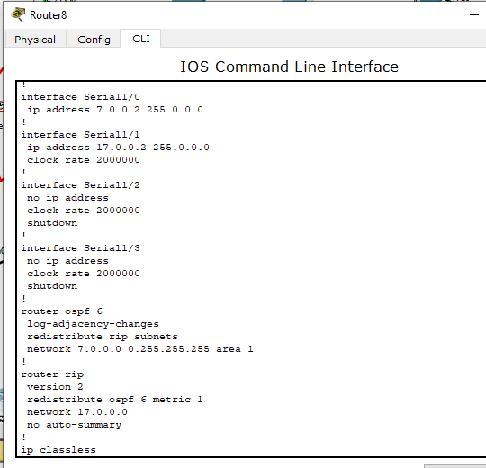

**OSPF Area 0**

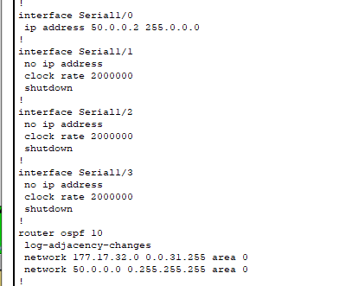

**EIGRP 24**

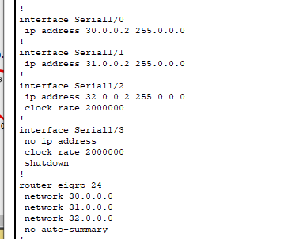

**OSPF Area 1**

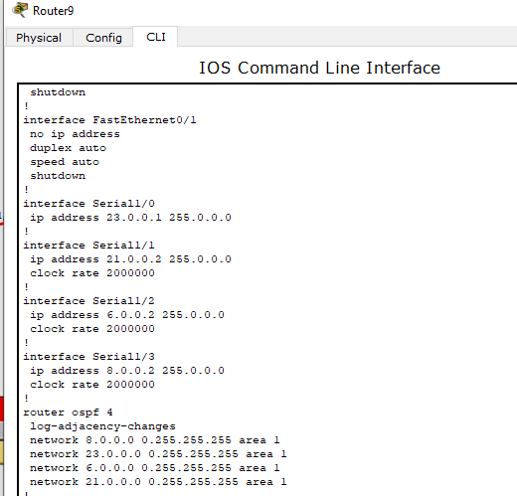

**Redistribute EIGRP And OSPF**

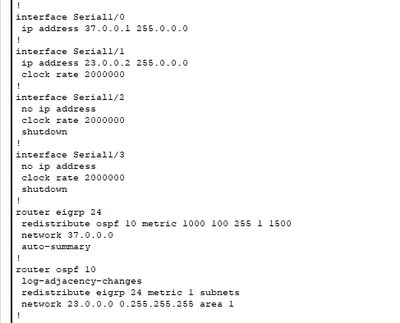

**Multilayer Switch VTY**

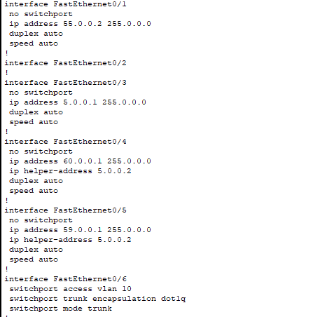

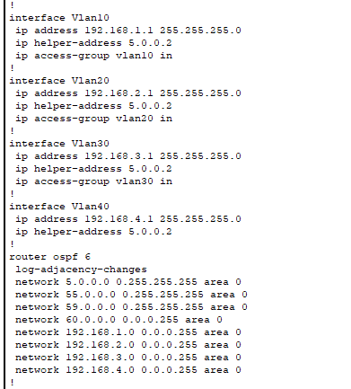

**NAT**



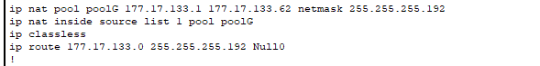

**Blocking**

**BLOCKED PC with TFTP server OSPF Area 1**

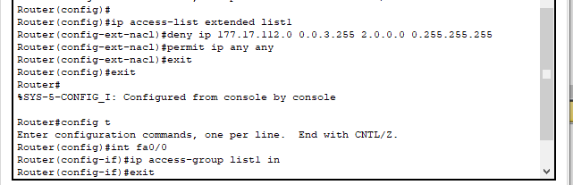

**Routers Security**

