NAME :SAAD ASHRAF  
ROLL NO: 21F-9167  
CLASS :4B  
  
  
QUESTATION NO 1  
  
CREATE OR REPLACE FUNCTION FIND_COUNT(num1 IN OUT number,REM IN OUT number)

RETURN number

IS

result number := 0;

BEGIN

WHILE num1 > 0

LOOP

REM:=MOD(NUM1,10);

result := result*10;

result :=(result)+REM;

num1 := trunc(num1 / 10);

END LOOP;

return result;

END;

DECLARE

param1 number := 897;

param2 number := 5;

result number;

BEGIN

result:=FIND_COUNT(param1,param2);

DBMS_OUTPUT.put_line('Plandrome '||result);

END;  
  
output

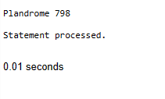

QUESTATION NO 2  
CREATE OR REPLACE FUNCTION ARM(NUM1 IN NUMBER)

RETURN NUMBER

IS

NUM2 NUMBER:=0;

REM NUMBER:=0;

RESULT NUMBER:=0;

BEGIN

NUM2:=NUM1;

WHILE NUM2>0

LOOP

REM:=MOD(NUM2,10);

REM:=REM*REM*REM;

RESULT:=RESULT+REM;

NUM2 := trunc(NUM2 / 10);

END LOOP;

IF RESULT = NUM1 THEN

RETURN 1;

ELSE

RETURN 0;

END IF;

END;

DECLARE

result number:=153;

BEGIN

result:=ARM(result);

if result=1 then

DBMS_OUTPUT.put_line('Number Is Armstrong ');

else

DBMS_OUTPUT.put_line('Number Is not Armstrong ');

end if;

END;  
OUTPUT  
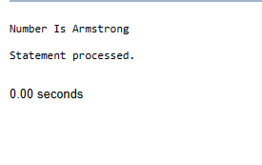  
  
QUESTATION NO 3

CREATE OR REPLACE PROCEDURE Minmax(EMP_NO NUMBER)

IS

MIN_V NUMBER;

MAX_V NUMBER;

BEGIN

SELECT MIN(SAL), MAX(SAL)

INTO MIN_V, MAX_V

FROM EMP

WHERE EMPNO = EMP_NO;

DBMS_OUTPUT.PUT_LINE('The lowest salary of employee ' || emp_no || ' is ' || MIN_V);

DBMS_OUTPUT.PUT_LINE('The highest salary of employee ' || emp_no || ' is ' || MAX_V);

END;  
BEGIN  
Minmax(7369);  
END;  
  
OUTPUT

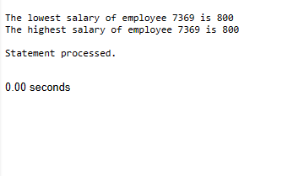  
  
  
QUESTATION NO 4

CREATE OR REPLACE PACKAGE OVER

IS

PROCEDURE ARM(NUM1 IN NUMBER);

PROCEDURE FIND_COUNT(num1 IN OUT number,REM IN OUT number);

FUNCTION Minmax(EMP_NO NUMBER)

RETURN NUMBER;

END OVER;

CREATE OR REPLACE PACKAGE BODY OVER

IS

PROCEDURE ARM(NUM1 IN NUMBER)

IS

NUM2 NUMBER:=0;

REM NUMBER:=0;

RESULT NUMBER:=0;

BEGIN

NUM2:=NUM1;

WHILE NUM2>0

LOOP

REM:=MOD(NUM2,10);

REM:=REM*REM*REM;

RESULT:=RESULT+REM;

NUM2 := trunc(NUM2 / 10);

END LOOP;

IF RESULT = NUM1 THEN

DBMS_OUTPUT.put_line('Number Is Armstrong '|| NUM1);

ELSE

DBMS_OUTPUT.put_line('Number Is not Armstrong '|| NUM1);

END IF;

END ARM;

PROCEDURE FIND_COUNT(num1 IN OUT number,REM IN OUT number)

IS

result number := 0;

BEGIN

WHILE num1 > 0

LOOP

REM:=MOD(NUM1,10);

result := result*10;

result :=(result)+REM;

num1 := trunc(num1 / 10);

END LOOP;

DBMS_OUTPUT.PUT_LINE('PALANDROME IS ' || RESULT);

num1 := result;

END FIND_COUNT;

FUNCTION Minmax(EMP_NO NUMBER)

RETURN NUMBER

IS

MIN_V NUMBER;

MAX_V NUMBER;

BEGIN

SELECT MIN(SAL), MAX(SAL)

INTO MIN_V, MAX_V

FROM EMP

WHERE EMPNO = EMP_NO;

DBMS_OUTPUT.PUT_LINE('The lowest salary of employee ' || emp_no || ' is ' || MIN_V);

DBMS_OUTPUT.PUT_LINE('The highest salary of employee ' || emp_no || ' is ' || MAX_V);

RETURN 0;

END Minmax;

END OVER;

DECLARE

param1 number := 897;

param2 number := 5;

result number:=7369;

result1 number:=153;

BEGIN

OVER.FIND_COUNT(param1,param2);

OVER.ARM(result1);

RESULT:=OVER.Minmax(result);

END;  
  
  
OUTPUT  
  
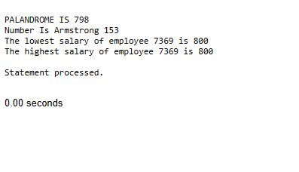  
QUESTATION NO 5

CREATE OR REPLACE PROCEDURE display_employee_info(EMP_NO NUMBER) IS

BEGIN

FOR emp IN (SELECT * FROM EMP WHERE ENAME LIKE '%A%' AND SAL > 60000)

LOOP

DBMS_OUTPUT.PUT_LINE('Employee ID: ' || emp.EMPNO);

DBMS_OUTPUT.PUT_LINE('Employee Name: ' || emp.ENAME);

DBMS_OUTPUT.PUT_LINE('Salary: ' || emp.SAL);

DBMS_OUTPUT.NEW_LINE;

END LOOP;

END;

BEGIN

display_employee_info(1000);

END;

OUTPUT  
