**CODE:**

CREATE TABLE Employee(Employee_number INT Primary Key, Employee_Name varchar(15), Job varchar(15), Hire_DATE DATE, Salary INT NOT NULL, Commission Integer NULL, Department_Number varchar(20) DEFAULT 'COMPUTER SCIENCE', CHECK(Commission > 2000));

**Creating DataBase Table:**

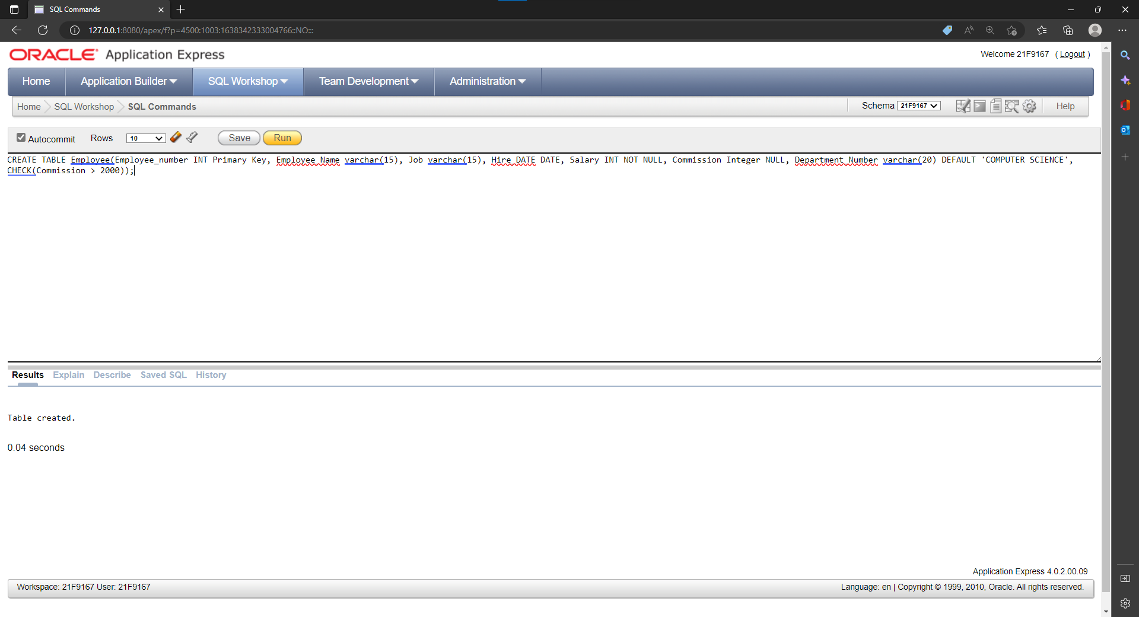

**THE DATABASE TABLE:**

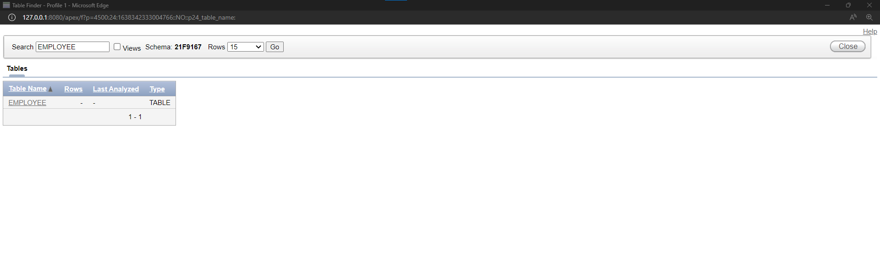

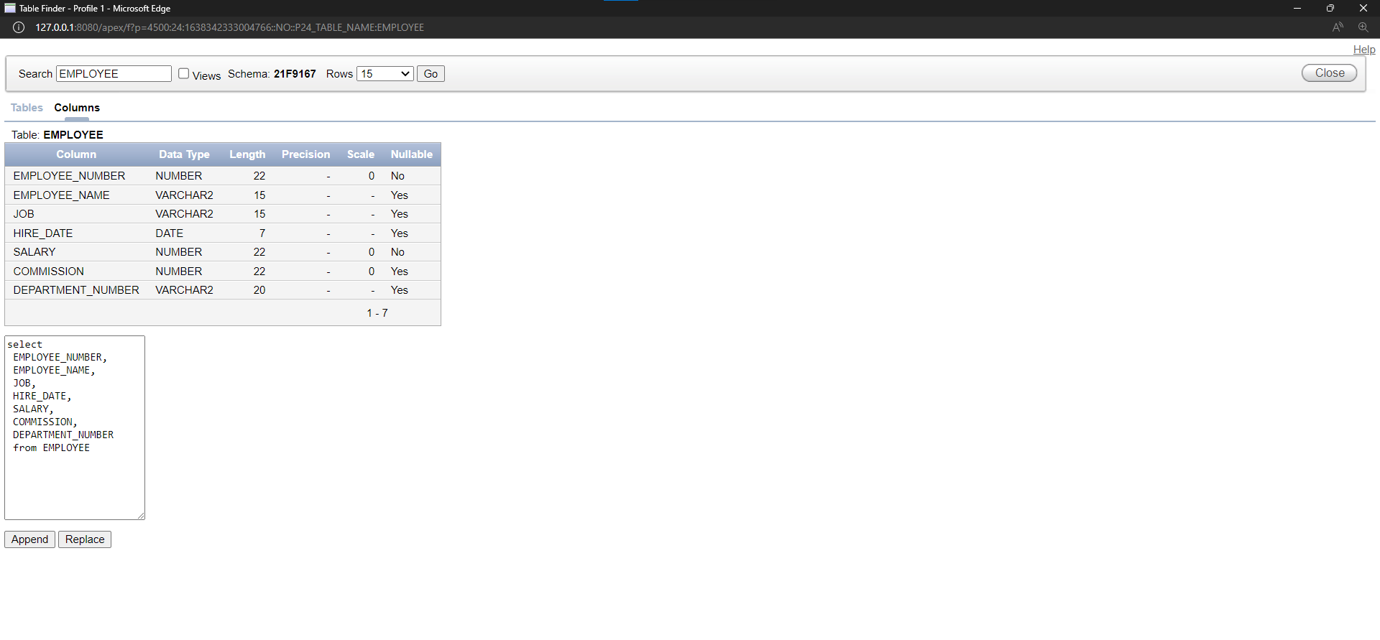

**DROPPING THE TABLE EMPLOYEE:**

