**DEPT TABLE CREATION:**

CREATE TABLE DEPT(DEPTNO INT NOT NULL, DNAME CHAR(14),LOC CHAR(13),CONSTRAINT DEPT_PRIMARY_KEY PRIMARY KEY (DEPTNO));

INSERT INTO DEPT VALUES (10,'ACCOUNTING','NEW YORK');

INSERT INTO DEPT VALUES (20,'RESEARCH','DALLAS');

INSERT INTO DEPT VALUES (30,'SALES','CHICAGO');

INSERT INTO DEPT VALUES (40,'OPERATIONS','BOSTON');

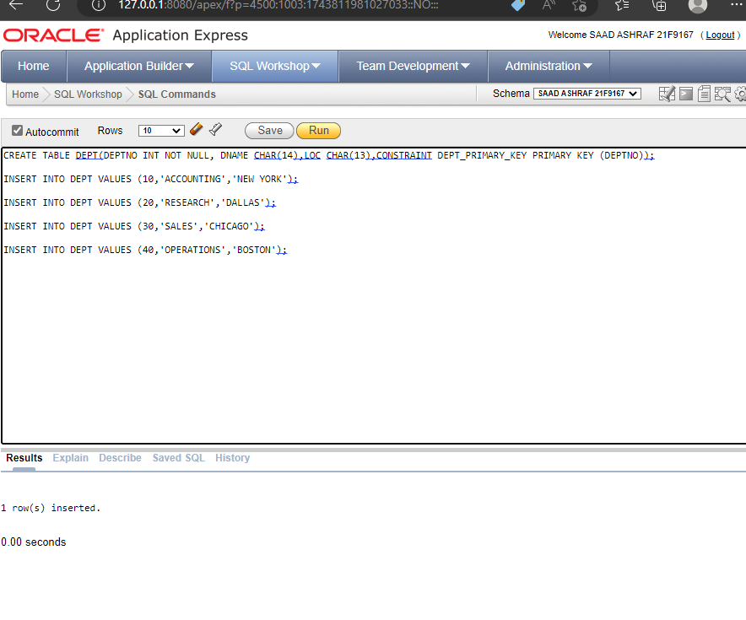

**EMP TABLE CREATION:**

CREATE TABLE EMP(EMPNO INT NOT NULL,ENAME CHAR(10),JOB CHAR(9),MGR INT CONSTRAINT EMP_SELF_KEY REFERENCES EMP (EMPNO),HIREDATE DATE,SAL INT,COMM INT,DEPTNO INT NOT NULL,CONSTRAINT EMP_FOREIGN_KEY FOREIGN KEY (DEPTNO) REFERENCES DEPT (DEPTNO),CONSTRAINT EMP_PRIMARY_KEY PRIMARY KEY (EMPNO));

INSERT INTO EMP VALUES (7839,'KING','PRESIDENT',NULL,'17-NOV-1981',5000,NULL,10);

INSERT INTO EMP VALUES (7698,'BLAKE','MANAGER',7839,'1-MAY-1981',2850,NULL,30);

INSERT INTO EMP VALUES (7782,'CLARK','MANAGER',7839,'9-JUN-1981',2450,NULL,10);

INSERT INTO EMP VALUES (7566,'JONES','MANAGER',7839,'2-APR-1981',2975,NULL,20);

INSERT INTO EMP VALUES (7654,'MARTIN','SALESMAN',7698,'28-SEP-1981',1250,1400,30);

INSERT INTO EMP VALUES (7499,'ALLEN','SALESMAN',7698,'20-FEB-1981',1600,300,30);

INSERT INTO EMP VALUES (7844,'TURNER','SALESMAN',7698,'8-SEP-1981',1500,0,30);

INSERT INTO EMP VALUES (7900,'JAMES','CLERK',7698,'3-DEC-1981',950,NULL,30);

INSERT INTO EMP VALUES (7521,'WARD','SALESMAN',7698,'22-FEB-1981',1250,500,30);

INSERT INTO EMP VALUES (7902,'FORD','ANALYST',7566,'3-DEC-1981',3000,NULL,20);

INSERT INTO EMP VALUES (7369,'SMITH','CLERK',7902,'17-DEC-1980',800,NULL,20);

INSERT INTO EMP VALUES (7788,'SCOTT','ANALYST',7566,'09-DEC-1982',3000,NULL,20);

INSERT INTO EMP VALUES (7876,'ADAMS','CLERK',7788,'12-JAN-1983',1100,NULL,20);

INSERT INTO EMP VALUES (7934,'MILLER','CLERK',7782,'23-JAN-1982',1300,NULL,10);

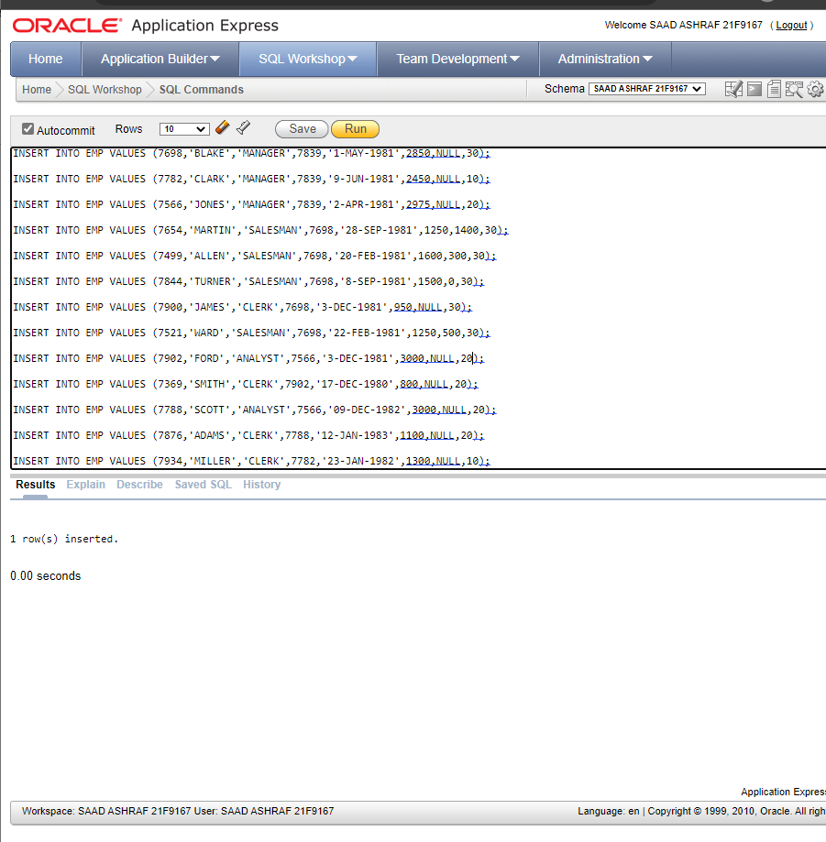

**TASKS:**

Using the emp(employee) and dept (department) table do the following (Using Sub queries):

1. Display the employee who got the maximum salary.

**SOLUTION:**

SELECT EMPNO, ENAME, SAL

FROM EMP

WHERE SAL=(SELECT MAX(SAL) FROM EMP);

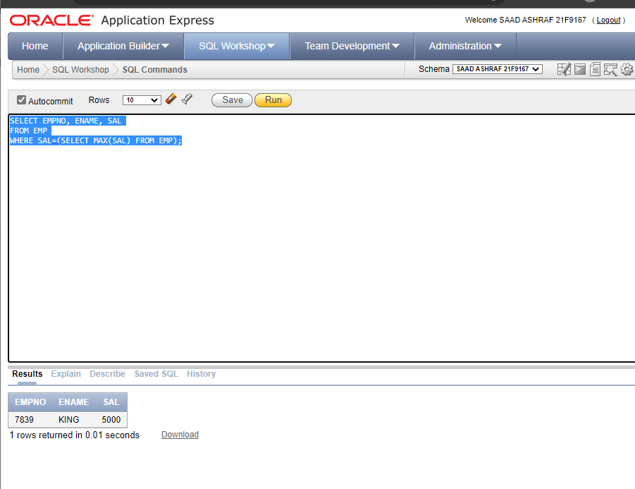

1. Display the employees who are working in Sales department.

**SOLUTION:**

select *

from EMP

where DEPTNO=( select DEPTNO

from DEPT

Where Dname='SALES');

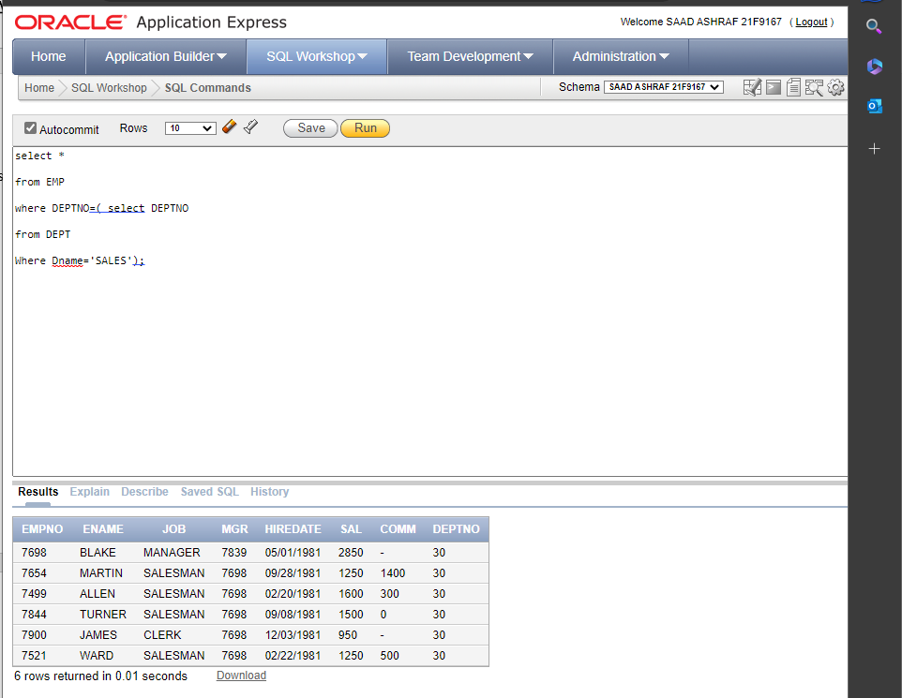

1. Display the employees who are working in “New York”.

**SOLUTION:**

select *

from EMP

where DEPTNO=( select DEPTNO

from DEPT

Where LOC='NEW YORK');

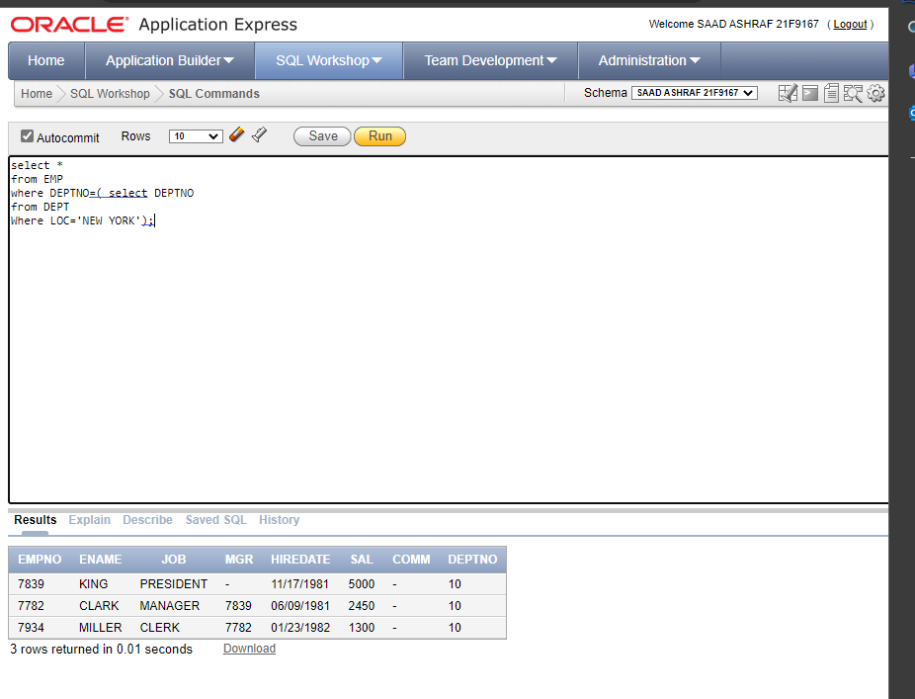

1. Find out no. of employees working in “Sales” department.

**SOLUTION:**

SELECT COUNT(*)

FROM EMP

WHERE DEPTNO = (SELECT DEPTNO FROM DEPT WHERE DNAME = 'SALES');

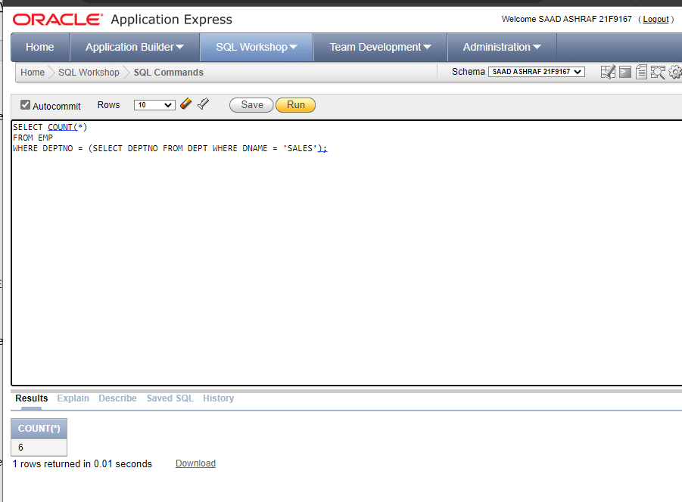

1. List out the employees who earn more than every employee in department 30.

**SOLUTION:**

SELECT *

FROM EMP

WHERE SAL > ALL(SELECT SAL FROM EMP WHERE DEPTNO=30);

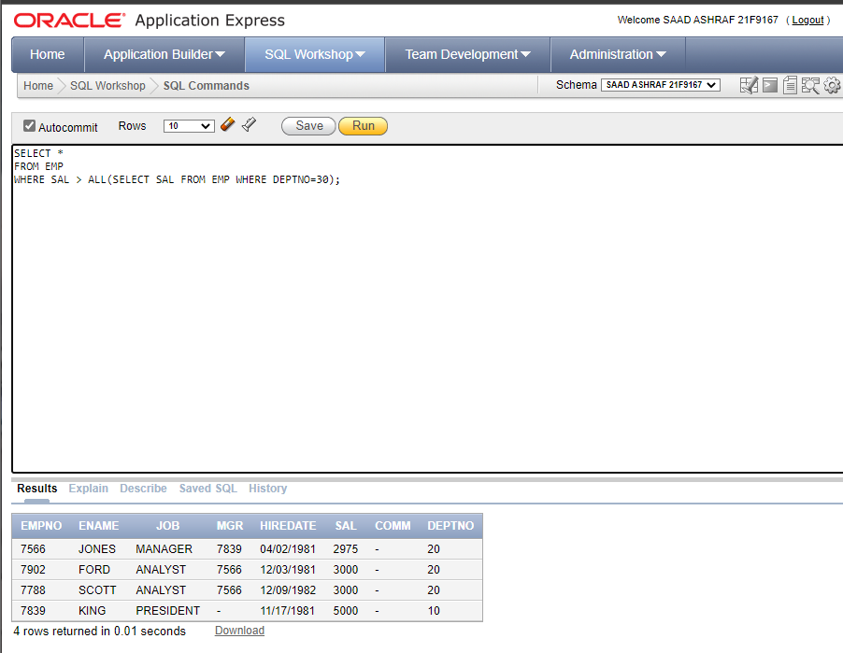

1. List out the employees who earn more than the lowest salary in department 30.

**SOLUTION:**

SELECT ENAME

FROM EMP

WHERE SAL > (SELECT MIN(SAL) FROM EMP WHERE DEPTNO=30);

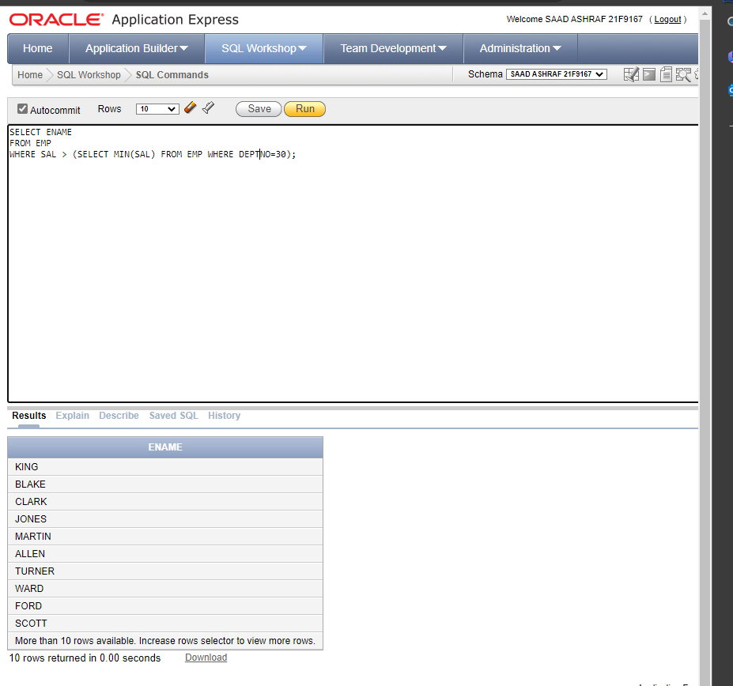

1. Find out whose department has not employees.

**SOLUTION:**

SELECT * FROM DEPT

WHERE DEPTNO

NOT IN (SELECT DEPTNO FROM EMP);

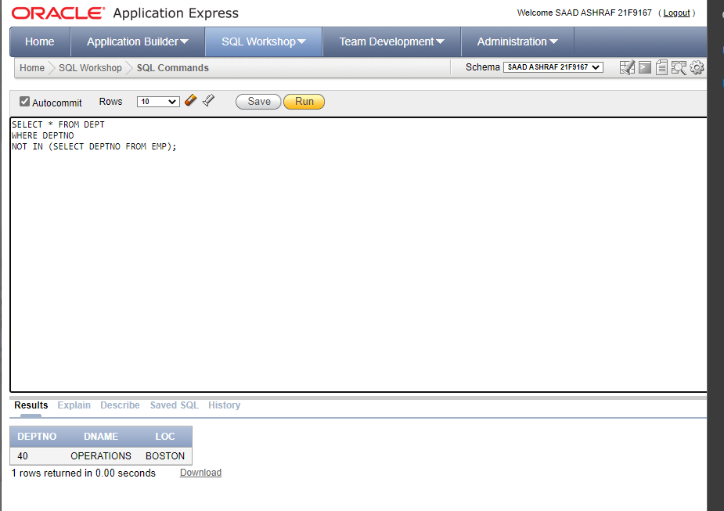

1. Find out which department does not have any employees.

**SOLUTION:**

SELECT * FROM DEPT

WHERE DEPTNO

NOT IN (SELECT DEPTNO FROM EMP);



1. Show the name, region and population of the smallest country in each region.

**SOLUTION:**

select region,name,population from bbc b1 where population<=ALL(select population from bbc a2 where a2.region=b1.region and population>0);

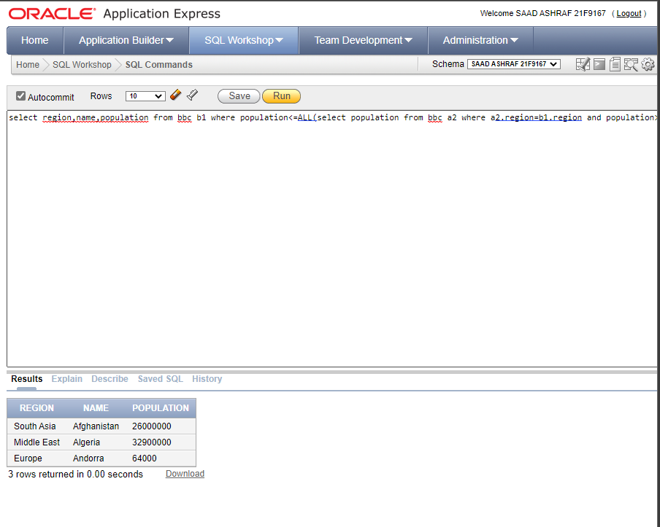

1. Show the countries with a greater GDP then any country in Europe.

**SOLUTION:**

SELECT name

FROM BBC

WHERE GDP > ANY ( SELECT GDP FROM BBC

WHERE REGION = 'Europe');

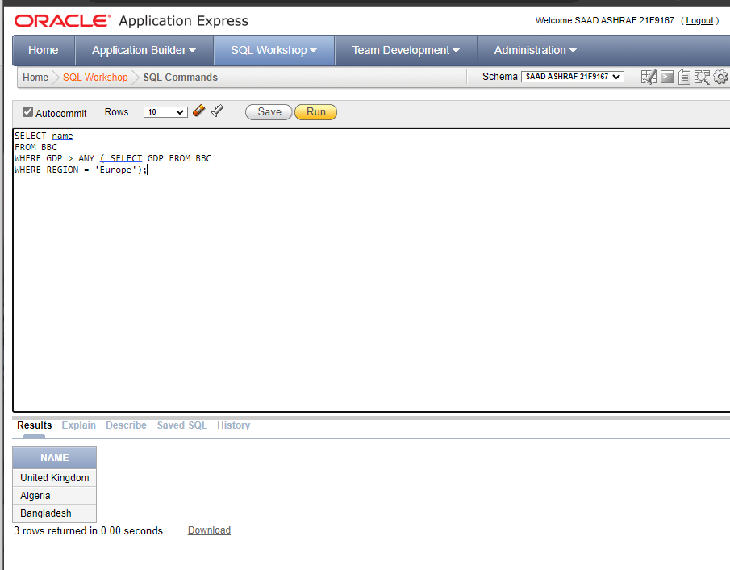

1. Show the countries with population smaller than United Kingdom but bigger than Albania.

**SOLUTION:**

SELECT *

FROM BBC

WHERE POPULATION < ANY (SELECT POPULATION FROM BBC

WHERE NAME = 'United Kingdom')

AND POPULATION > (SELECT POPULATION FROM BBC

WHERE NAME = 'Albania');

