# **Q1**

# **1-**

SELECT d.DNAME,EMPNO,

e.ENAME,

e.JOB,

e.MGR

FROM EMP e,DEPT d

WHERE e.DEPTNO = d.DEPTNO;

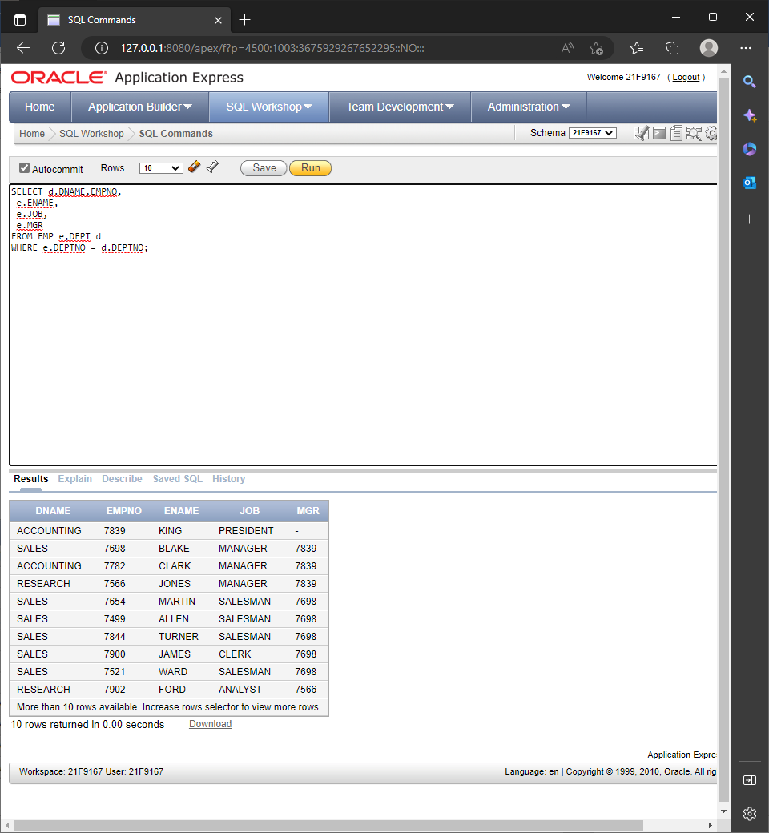

# **2-**

SELECT d.DNAME,EMPNO,

e.ENAME,

e.JOB,

e.MGR

FROM EMP e,DEPT d

WHERE e.DEPTNO = d.DEPTNO;

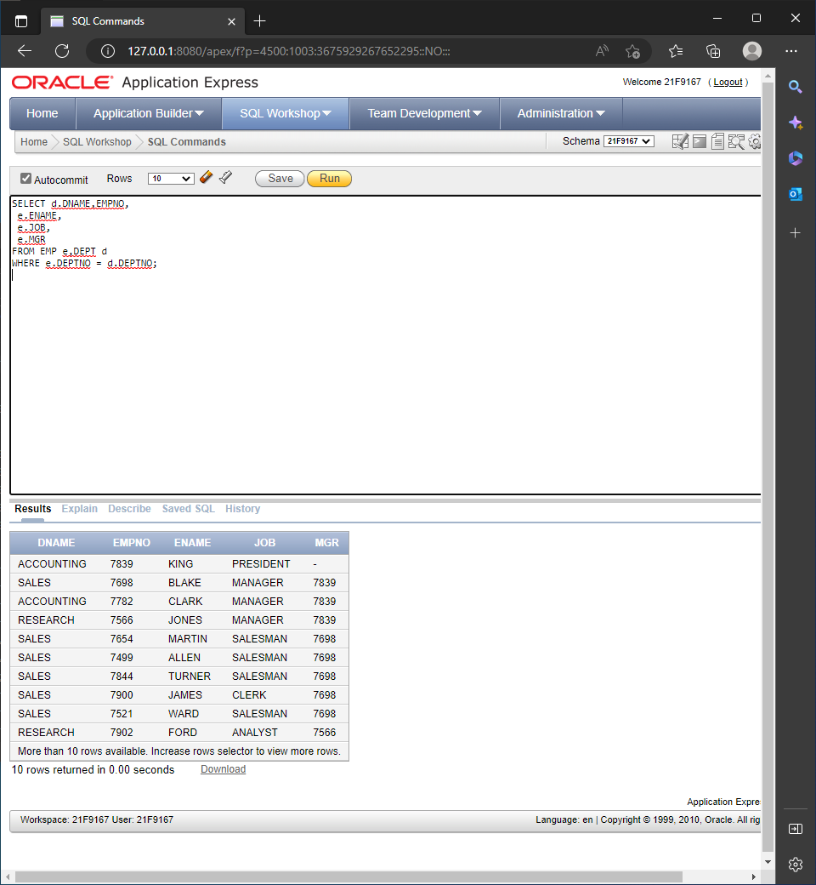

# **3-**

SELECT d.DNAME,COUNT(*)

FROM EMP e,DEPT d

WHERE e.DEPTNO = d.DEPTNO

GROUP BY d.DNAME;

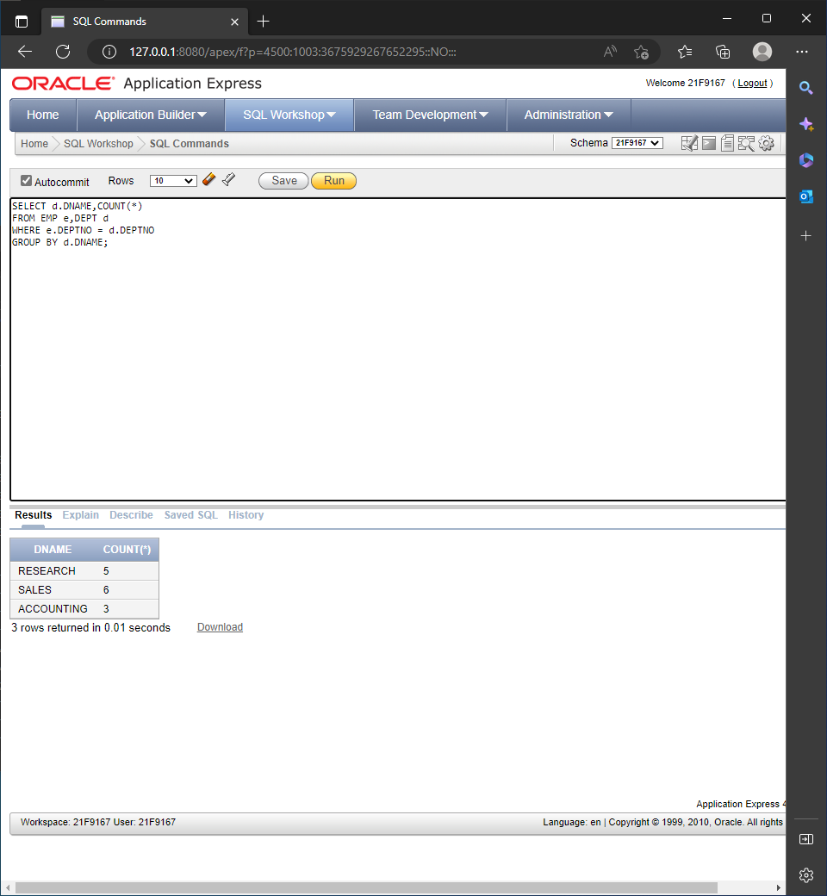

# **4-**

SELECT d.DNAME,COUNT(*)

FROM EMP e,DEPT d

WHERE e.DEPTNO = d.DEPTNO

GROUP BY d.DNAME

HAVING d.DNAME='SALES';

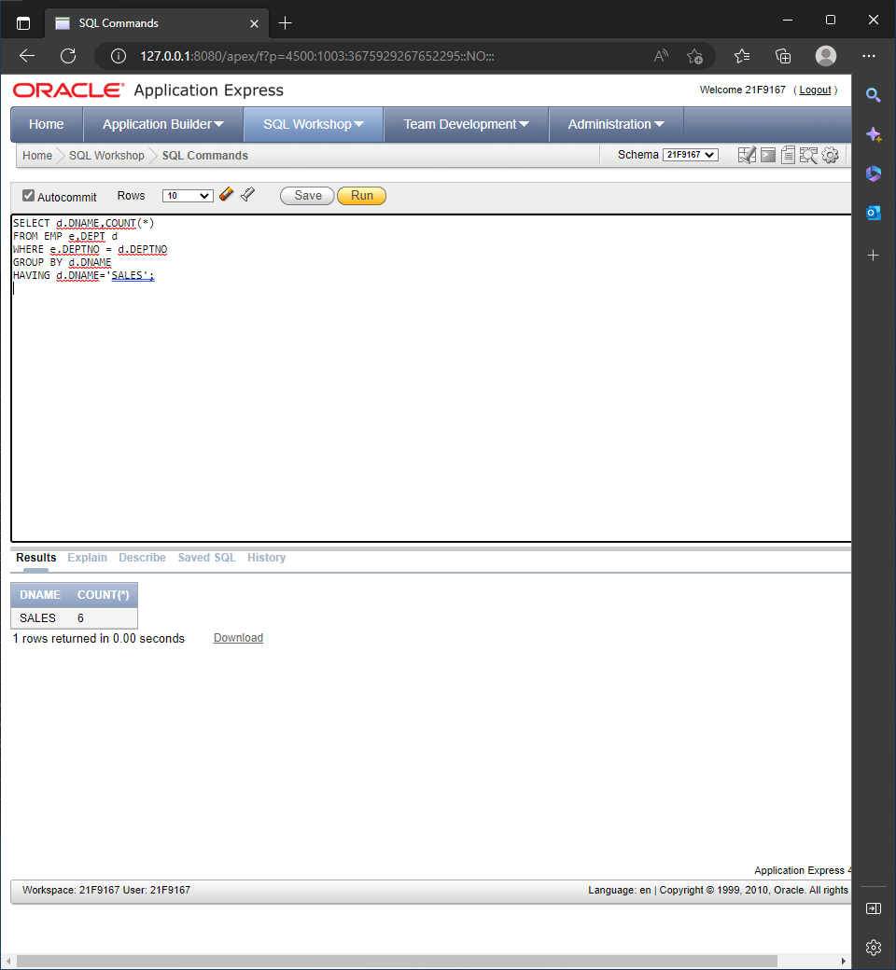

# **5-**

SELECT d.DNAME,COUNT(*)

FROM EMP e,DEPT d

WHERE e.DEPTNO = d.DEPTNO

GROUP BY d.DNAME

HAVING COUNT(d.DNAME)>=5

ORDER BY d.DNAME ASC;

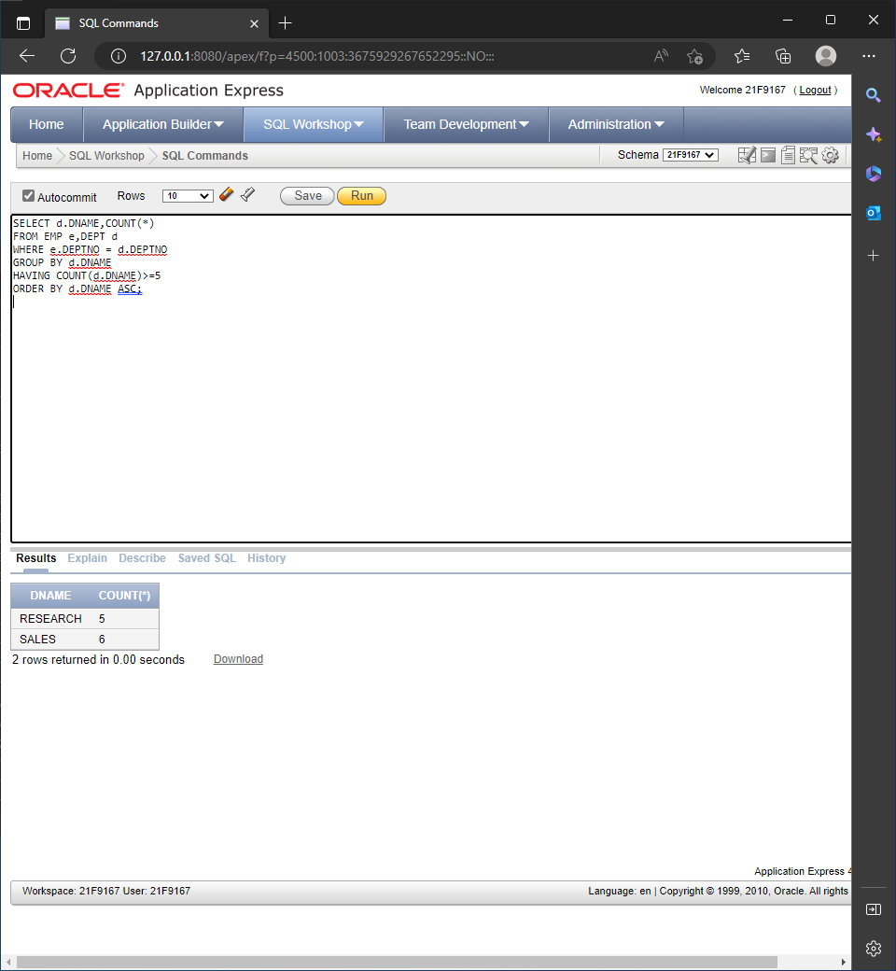

# **6-**

SELECT d.DNAME,SUM(SAL)

FROM EMP e,DEPT d

WHERE e.DEPTNO = d.DEPTNO

GROUP BY d.DNAME;

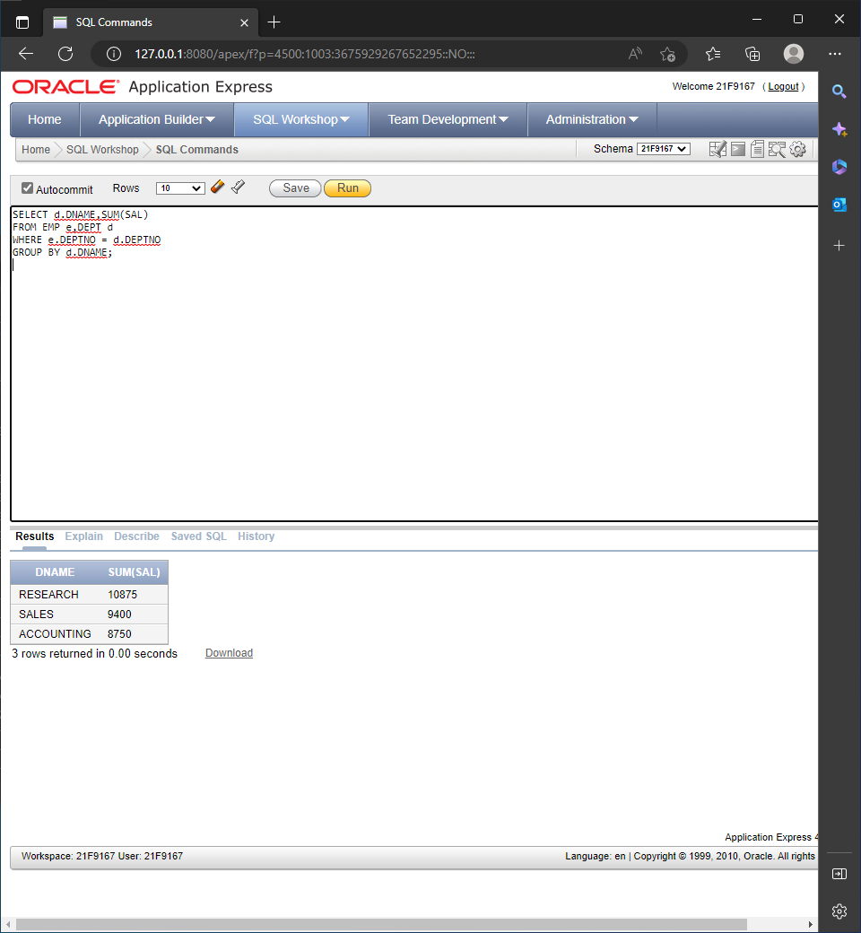

# **7-**

SELECT d.*,e.*

FROM EMP e,DEPT d

WHERE e.DEPTNO = d.DEPTNO;

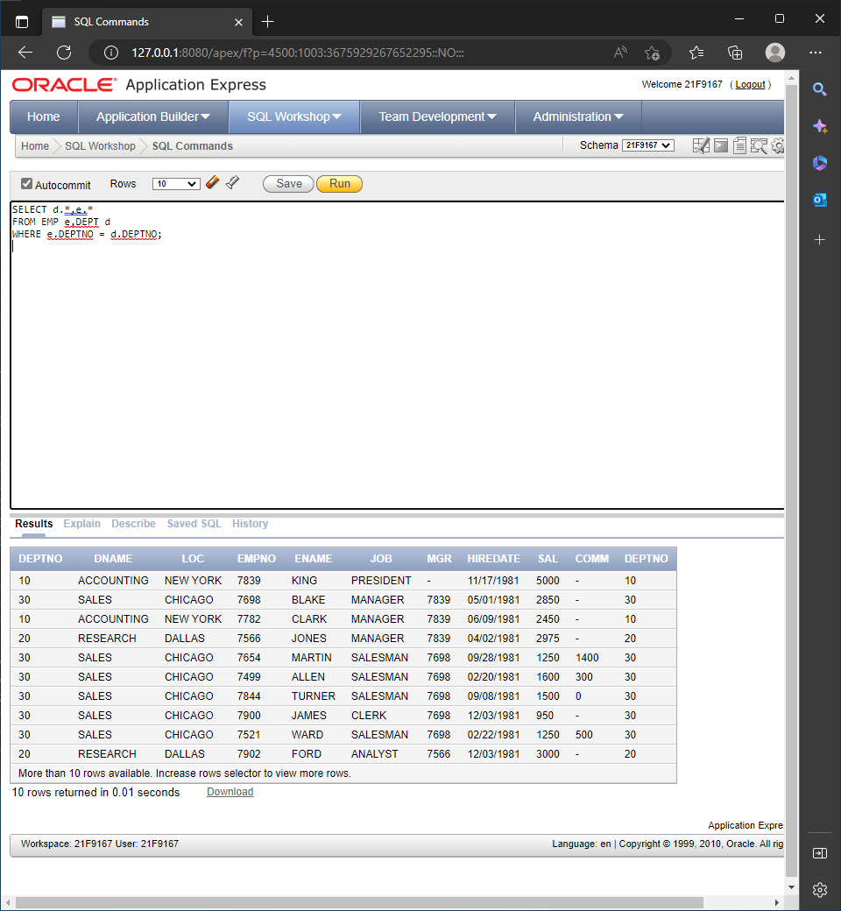

# **8-**

## SELECT D.*

## FROM EMP e INNER JOIN EMP d

## ON e.EMPNO(+) = d.MGR;

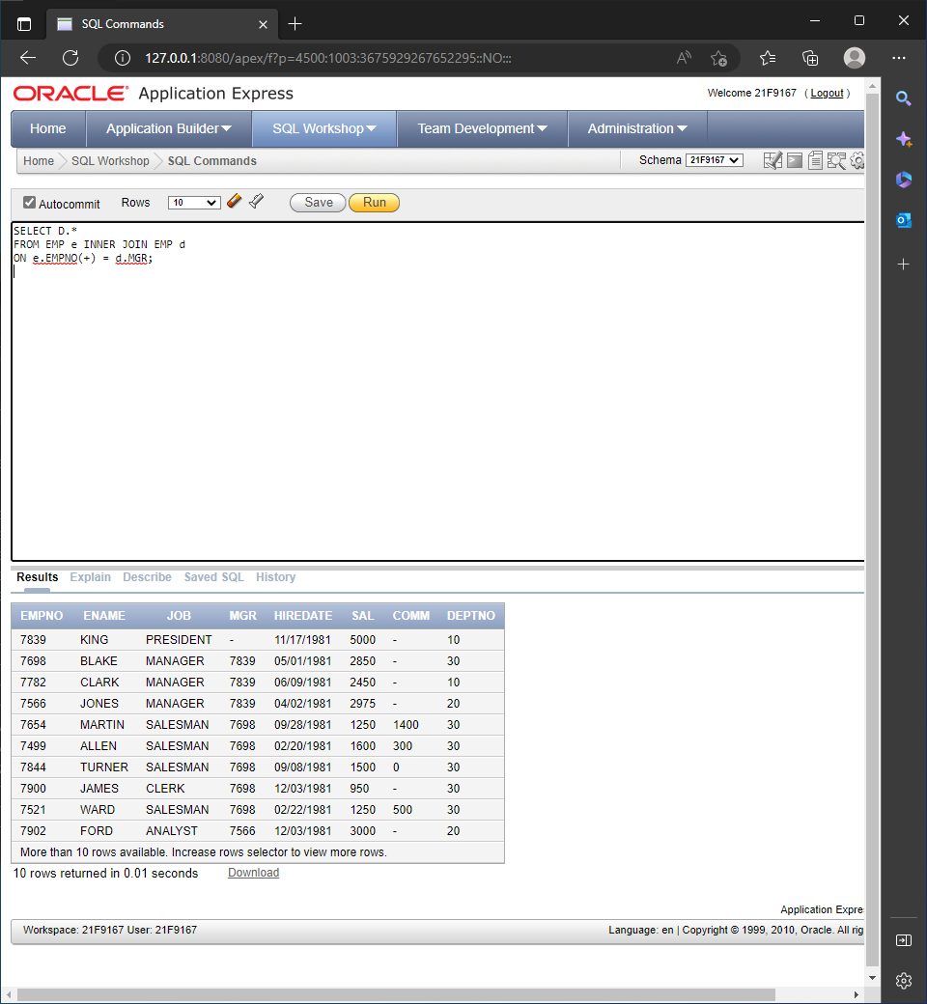

# **9-**

SELECT *

FROM DEPT d, EMP e

WHERE d.deptno=e.deptno

AND e.sal > e.mgr;

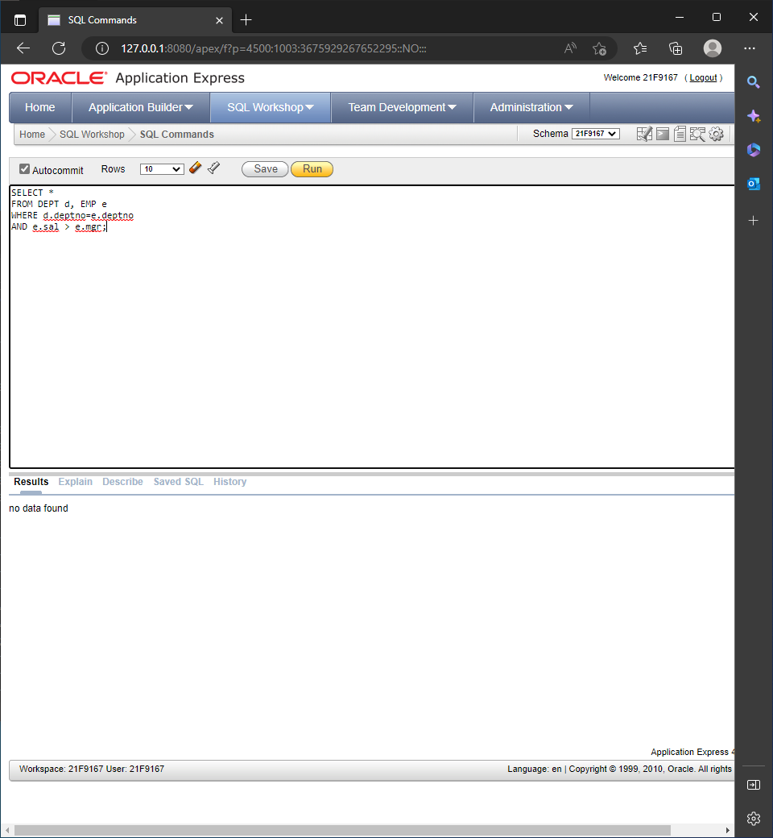

# **10-**

SELECT e.mgr, count(e.mgr)

FROM DEPT d, EMP e

WHERE d.deptno = e.deptno

GROUP BY e.mgr

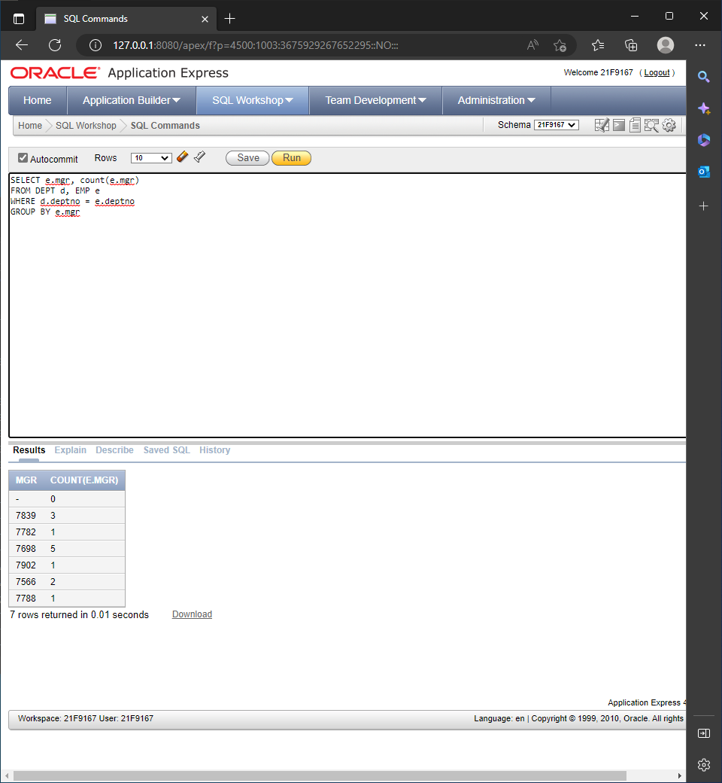

**VIEWS TASK:**

**1-**

SELECT c.cus_lname, i.inv_int, i.inv_date, p.p_descript

from (((customer c,invoice i),product p), line l)

where c.cus_code = i.cus_code

and l.inv_int = i.inv_int

and p.p_code = l.p_code;

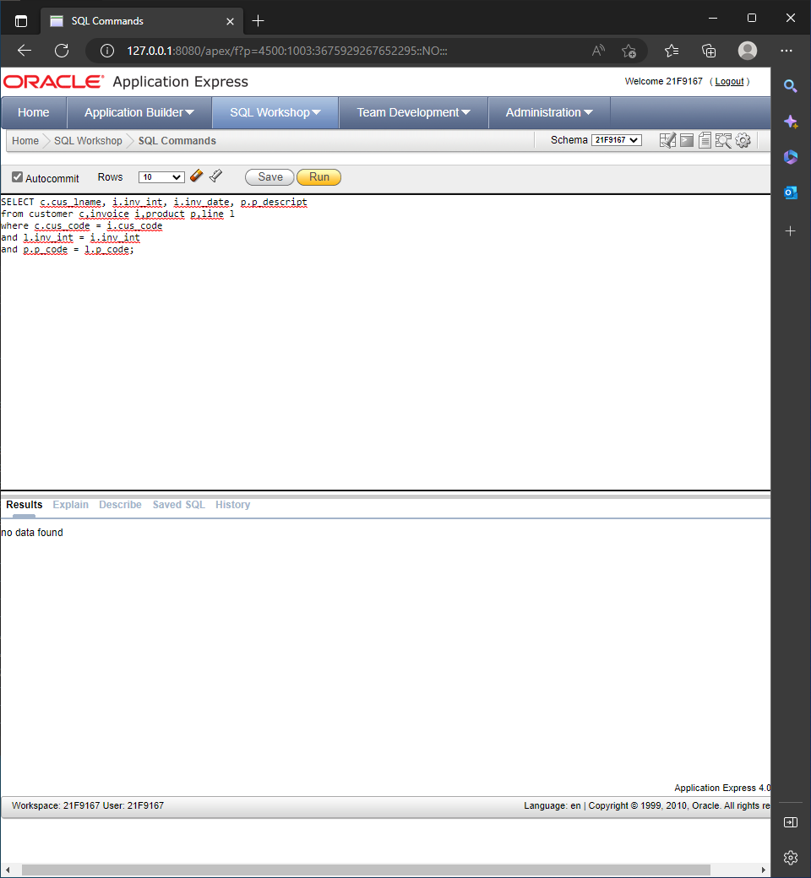

**2-**

select p.p_descript,i.inv_int,i.inv_date

from product p,invoice i,line l

where p.p_code = l.p_code

and l.inv_int = i.inv_int;

