**Question NO 01:**

**CUSTOMER TABLE**

**1NF:** Given table has already 1NF because there is only atomic values.

**2NF:** In 2NF we will remove functional dependency

All non_key attributes must be fully dependent on key. In this postal code is depending on city and address ,contact also. So,

Customer(Customer_ID,customer_name,country)

Contacts(Customer_id,contact_name,contact_email,address,city,postal_code)

**3NF:** No transitive dependency

Customer(Customer_ID,customer_name,country)

Contacts(Customer_id,contact_name,contact_email,address_ID)

Address(Address_id,address,city,postal_code)

**ORDER TABLE**

**1NF:** There is already 1NF in this table

**2NF:** functional dependency in order id, ship via

Orders ( id,customer,id,order date)

Ships (id,shipped date,ship via)

**3NF:** There is No transitive dependency

Orders ( id,customer,id,order date)

Ships (id,shipped date,ship via)

**Order details**

**1NF:** Order (id, price)

Details (id,product_id,quantity)

Product(id,name,unit price)

**2NF:** Price can be predict by unit price and quantity so

Order_Details (id,product_id,quantity)

Product(id,name,unit price)

**3NF:** Already in 3NF.

**Question NO 02:**

**Staff branch table**

**1NF:**

Already in 1NF.

**2NF:**

Staff(satffno,name,pos,salary,branchno)

Branch(branchno,branchAddress,telNO)

**3NF:**

Already in 3NF.

**Staff**

**1NF:**

Already in 1NF

**2NF**

Staff (staffno,name,position,salary)

Branch (branchNo,satffNo,position)

**3NF**

Already in 3NF

**Branch**

**1NF**

Already in 1NF

As there is atomic values

**2NF**

No partial dependencies

**Question NO 03:**

To apply 5NF to the given tables, we need to analyze the functional dependencies and remove the redundancies.

For table 1 CUSTOMER_ORDERS, we can identify the following functional dependencies:

Order ID -> Customer ID, Order Date

Order ID, Product ID -> Quantity

To normalize to 5NF, we can create the following tables:

1. ORDERS

Order ID (PK)

Customer ID (FK)

Order Date

1. ORDER_PRODUCTS

Order ID (PK, FK)

Product ID (PK, FK)

Quantity

For table 2 STUDENT_COURSES, we can identify the following functional dependencies:

student_id, course -> instructor_name, grade

To normalize to 5NF, we can create the following tables:

1. STUDENTS

student_id (PK)

1. COURSES

course_id (PK)

instructor_name

1. ENROLLMENT

student_id (PK, FK)

course_id (PK, FK)

grade

The final normalized tables are:

1. ORDERS

Order ID (PK)

Customer ID (FK)

Order Date

1. ORDER_PRODUCTS

Order ID (PK, FK)

Product ID (PK, FK)

Quantity

1. STUDENTS

student_id (PK)

1. COURSES

course_id (PK)

instructor_name

1. ENROLLMENT

student_id (PK, FK)

course_id (PK, FK)

grade

**Question No 04: Procedures, Functions, PL/SQL (60)**

**1.** Write a procedure to transfer an employee from one manager to another and update the hire date

accordingly.

**SOLUTION:**

CREATE OR REPLACE PROCEDURE TRANSFER_EMPLOYEE(

new_employee_id IN employees.employee_id%TYPE,

new_manager_id IN employees.manager_id%TYPE,

new_hire_date IN employees.hire_date%TYPE

) IS

BEGIN

UPDATE EMPLOYEES

SET MANAGER_ID=NEW_MANAGER_ID,

HIRE_DATE=TO_DATE(NEW_HIRE_DATE, 'MM/DD/YYYY')

WHERE EMPLOYEE_ID=NEW_EMPLOYEE_ID;

DBMS_OUTPUT.PUT_LINE('Employee ' || new_employee_id || ' transferred to manager ' || new_manager_id || ' with hire date ' || new_hire_date);

END;

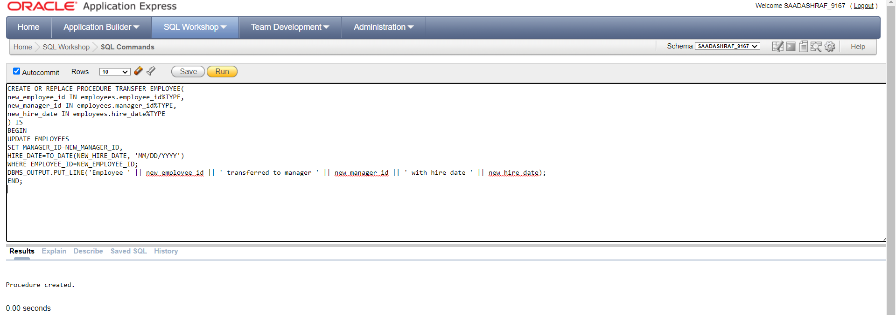

BEGIN

TRANSFER_EMPLOYEE(new_employee_id => 100, new_manager_id => 200, new_hire_date => '02-01-2022');

END;

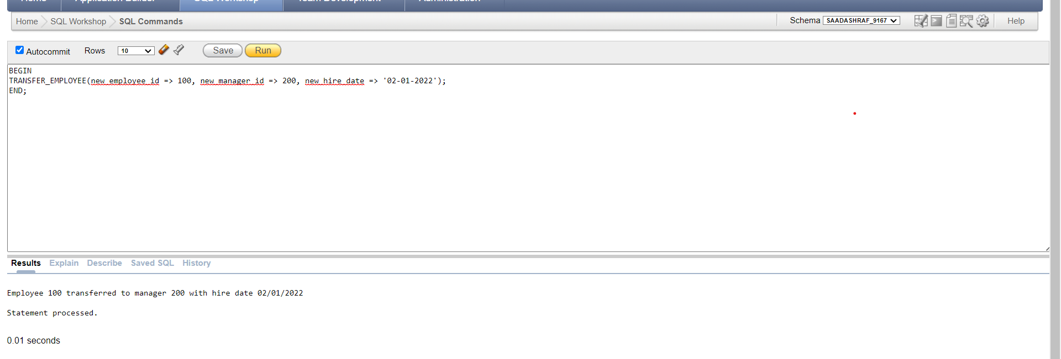

**2.** Write a procedure to generate a report of products that have low inventory level and their

categories’ names using CURSOR.

**SOLUTION:**

CREATE OR REPLACE PROCEDURE inventory_report

IS

CURSOR prod_cursor

IS

SELECT MIN(p.product_name) as p_name, MIN(c.category_name) as c_name, MIN(i.quantity) AS low_level

FROM products p

JOIN product_categories c ON p.category_id = c.category_id

JOIN inventories i ON p.product_id=i.product_id;

BEGIN

DBMS_OUTPUT.PUT_LINE('PRODUCT_NAME' || CHR(9) || 'CATEGORY_NAME' || CHR(9) || 'QUANTITY');

FOR prod_rec IN prod_cursor

LOOP

DBMS_OUTPUT.PUT_LINE(prod_rec.p_name || CHR(9) || prod_rec.c_name || CHR(9) || prod_rec.low_level);

END LOOP;

END;

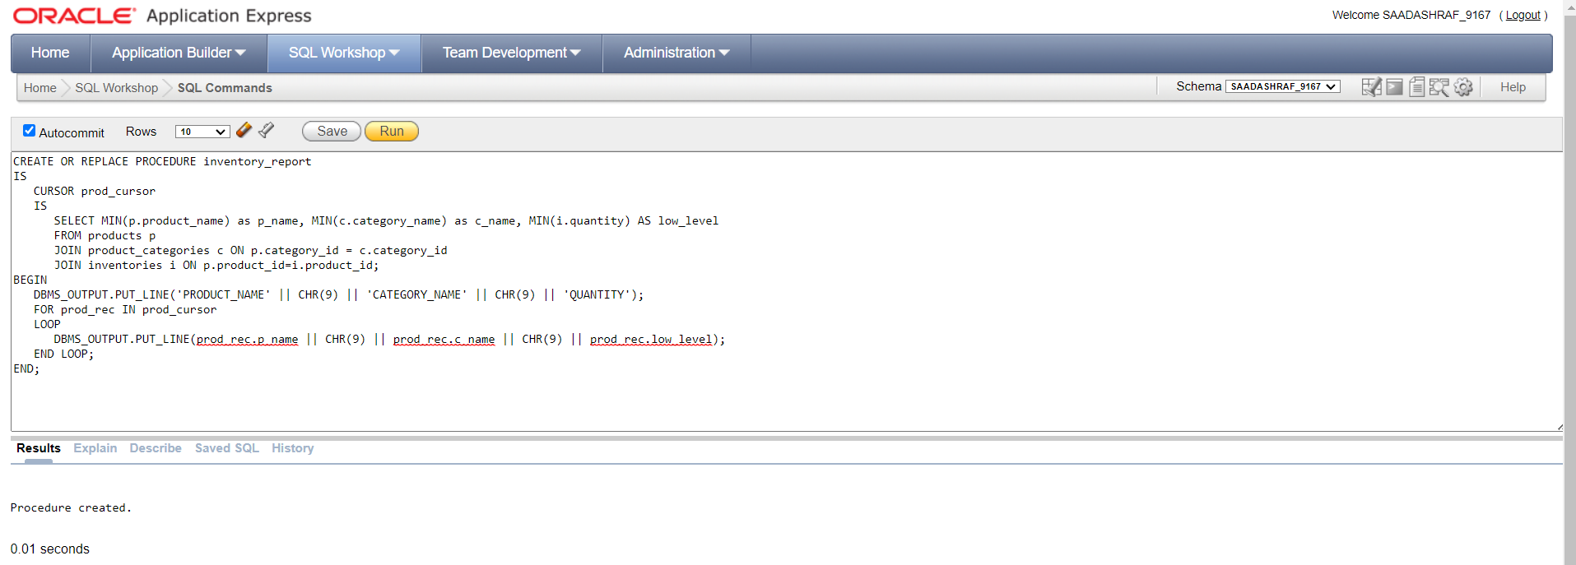

BEGIN

inventory_report;

END;

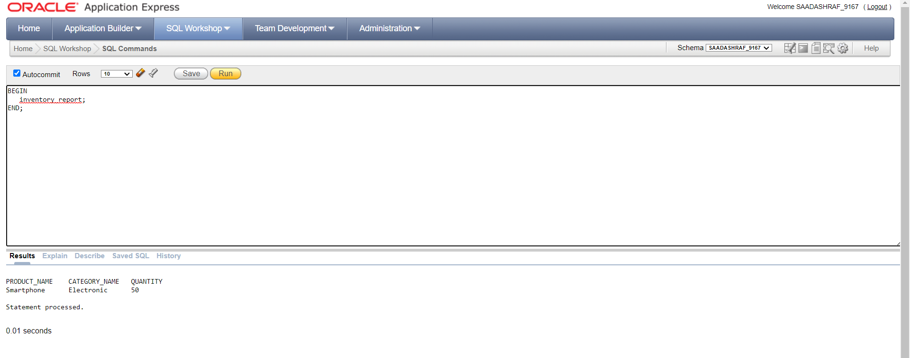

**3.** Create a procedure to display complete information of table employees having employee first

name contain “A” in their name using CURSOR.

**SOLUTION:**

CREATE OR REPLACE PROCEDURE employee_report

IS

CURSOR emp_cursor

IS

SELECT *

FROM employees

WHERE first_name LIKE '%A%';

BEGIN

DBMS_OUTPUT.PUT_LINE('EMPLOYEE_ID' || CHR(9) || 'First name:' || CHR(9) || 'last name:' || CHR(9) || 'email id: ' || CHR(9) || 'contact:' || CHR(9) || 'hire date:' || CHR(9) || 'manager:' || CHR(9) || 'job:');

FOR emp_rec IN emp_cursor

LOOP

DBMS_OUTPUT.PUT_LINE(emp_rec.employee_id || CHR(9) || emp_rec.first_name || CHR(9) || emp_rec.last_name || CHR(9) || emp_rec.email || CHR(9) || emp_rec.phone || CHR(9) || emp_rec.hire_date || CHR(9) || emp_rec.manager_id || CHR(9) || emp_rec.JOB_TITLE);

END LOOP;

END;

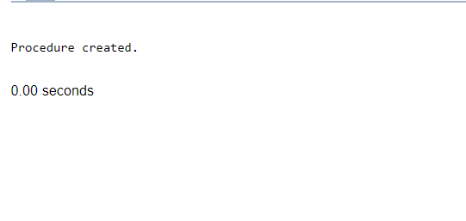

BEGIN

employee_report;

END;

/

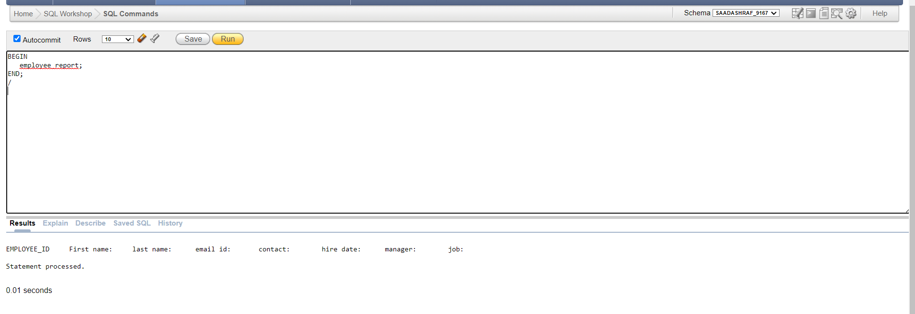

NO DATA DISPLAYED BECAUSE NO EMPLOYEE HAS A NAME THAT STARTS WITH **“A”.**

**4.** Create a Procedure that retrieves the number of employees managed by a given manager.

**SOLUTION:**

CREATE OR REPLACE PROCEDURE get_employee_count (manager_id IN NUMBER, emp_count OUT NUMBER)

IS

BEGIN

SELECT COUNT(*) INTO emp_count

FROM employees

WHERE manager_id = manager_id;

END;

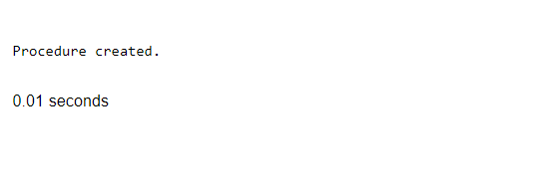

DECLARE

v_emp_count NUMBER;

BEGIN

get_employee_count(100, v_emp_count);

DBMS_OUTPUT.PUT_LINE('The number of employees managed by manager 100 is ' || v_emp_count);

END;

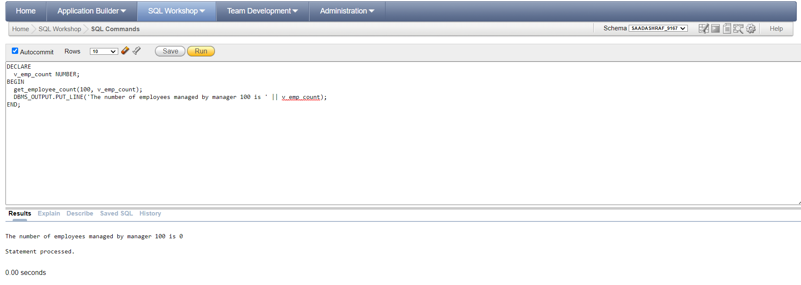

**5.** Create a procedure to decrease the quantity in inventory. Make sure the quantity in inventory do

not become negative.

**SOLUTION:**

CREATE OR REPLACE PROCEDURE decrease_inventory_quantity(

p_product_id IN NUMBER,

p_quantity IN NUMBER

) AS

v_current_quantity NUMBER;

BEGIN

-- Get the current quantity of the product in inventory

SELECT quantity INTO v_current_quantity

FROM inventories

WHERE product_id = p_product_id;

-- Check if there is enough quantity to decrease

IF v_current_quantity >= p_quantity THEN

-- Decrease the quantity

UPDATE inventories

SET quantity = quantity - p_quantity

WHERE product_id = p_product_id;

ELSE

-- Raise an exception if there is not enough quantity

RAISE_APPLICATION_ERROR(-20001, 'Not enough quantity in inventory');

END IF;

END;



BEGIN

decrease_inventory_quantity(289, 5);

END;

If you check in sql table data the amount of product is decreased.

**6.** Write a function to create a new product category with a given name and return its ID.

**SOLUTION:**

CREATE OR REPLACE FUNCTION create_category(new_category_name IN VARCHAR2)

RETURN NUMBER

IS

v_category_id NUMBER;

BEGIN

SELECT MAX(category_id) + 1 INTO v_category_id FROM product_categories;

IF v_category_id IS NULL THEN

v_category_id := 1;

END IF;

INSERT INTO product_categories (category_id, category_name)

VALUES (v_category_id, new_category_name);

RETURN v_category_id;

END;

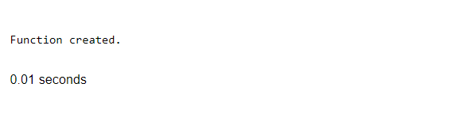

DECLARE

v_category_id NUMBER;

BEGIN

v_category_id := create_category('New Category Name');

DBMS_OUTPUT.PUT_LINE('Pizza ID: ' || v_category_id);

END;

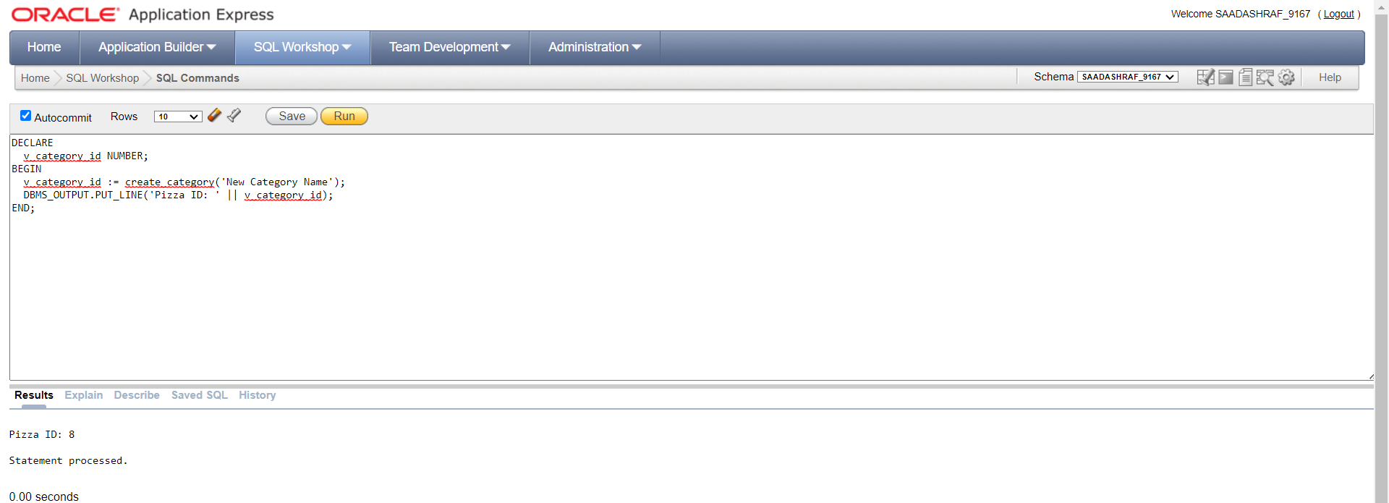

**7.** Create a pl/sql program that will use the function in (7) to create a product category and then use

that id to store a product data.

**SOLUTION:**

DECLARE

v_category_id NUMBER;

BEGIN

v_category_id := create_category('New Category');

INSERT INTO products (product_name, category_id, list_price)

VALUES ('New Product', v_category_id, 10.00);

END;

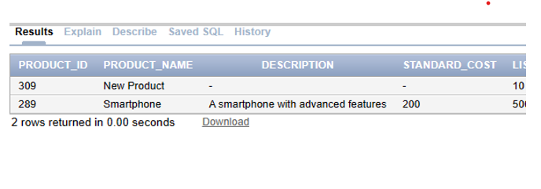

**8.** Write a function that retrieves the total number of products in a given category.

**SOLUTION:**

CREATE OR REPLACE FUNCTION TOTAL_PRODUCT(category_input IN NUMBER) RETURN NUMBER

IS

total_count NUMBER;

BEGIN

SELECT COUNT(*) INTO total_count FROM PRODUCTS

WHERE CATEGORY_ID= category_input;

RETURN total_count;

END;

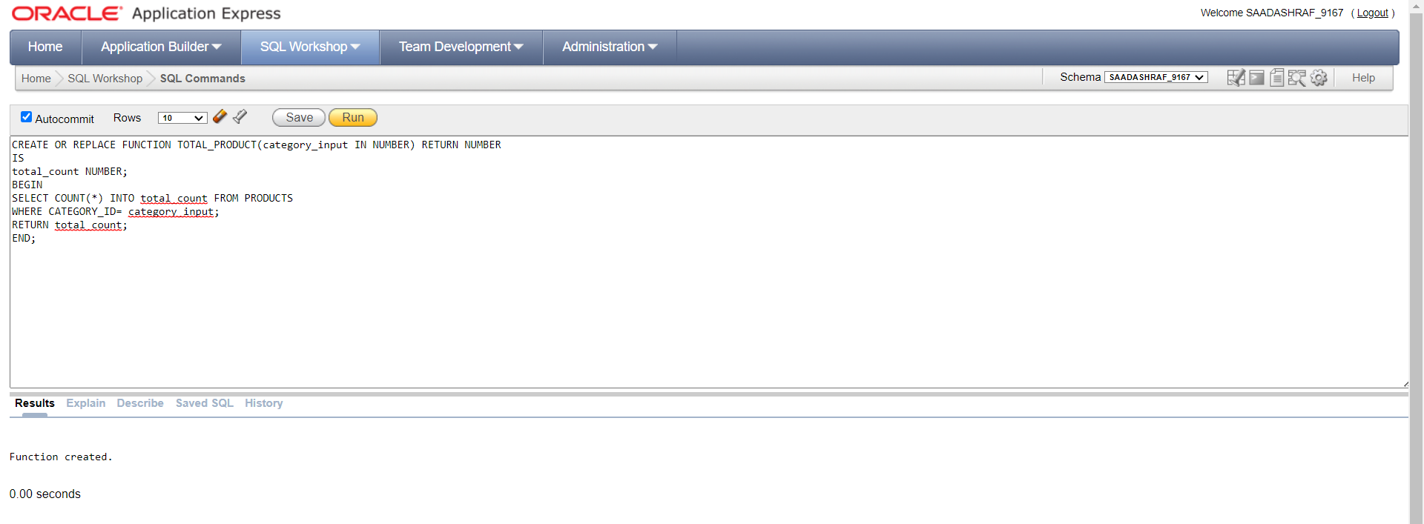

SELECT TOTAL_PRODUCT(1) FROM dual;

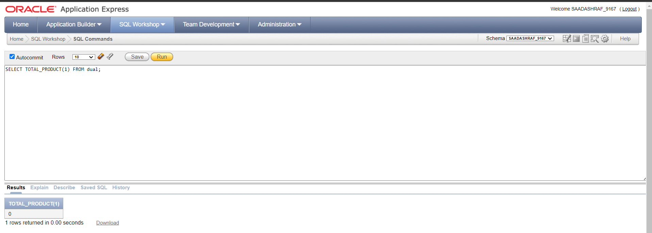

**9.** Create a function that returns the sales total for a given customer.

**SOLUTION:**

CREATE OR REPLACE FUNCTION GET_SALES(cust_id IN NUMBER) RETURN NUMBER

IS

total_sales number(8,2);

BEGIN

SELECT SUM(od.quantity * od.unit_price) INTO total_sales

FROM ORDERS O JOIN ORDER_ITEMS OD ON OD.ORDER_ID=O.ORDER_ID

WHERE O.CUSTOMER_ID =cust_id;

RETURN total_sales;

END;



SELECT GET_SALES(320) FROM DUAL;

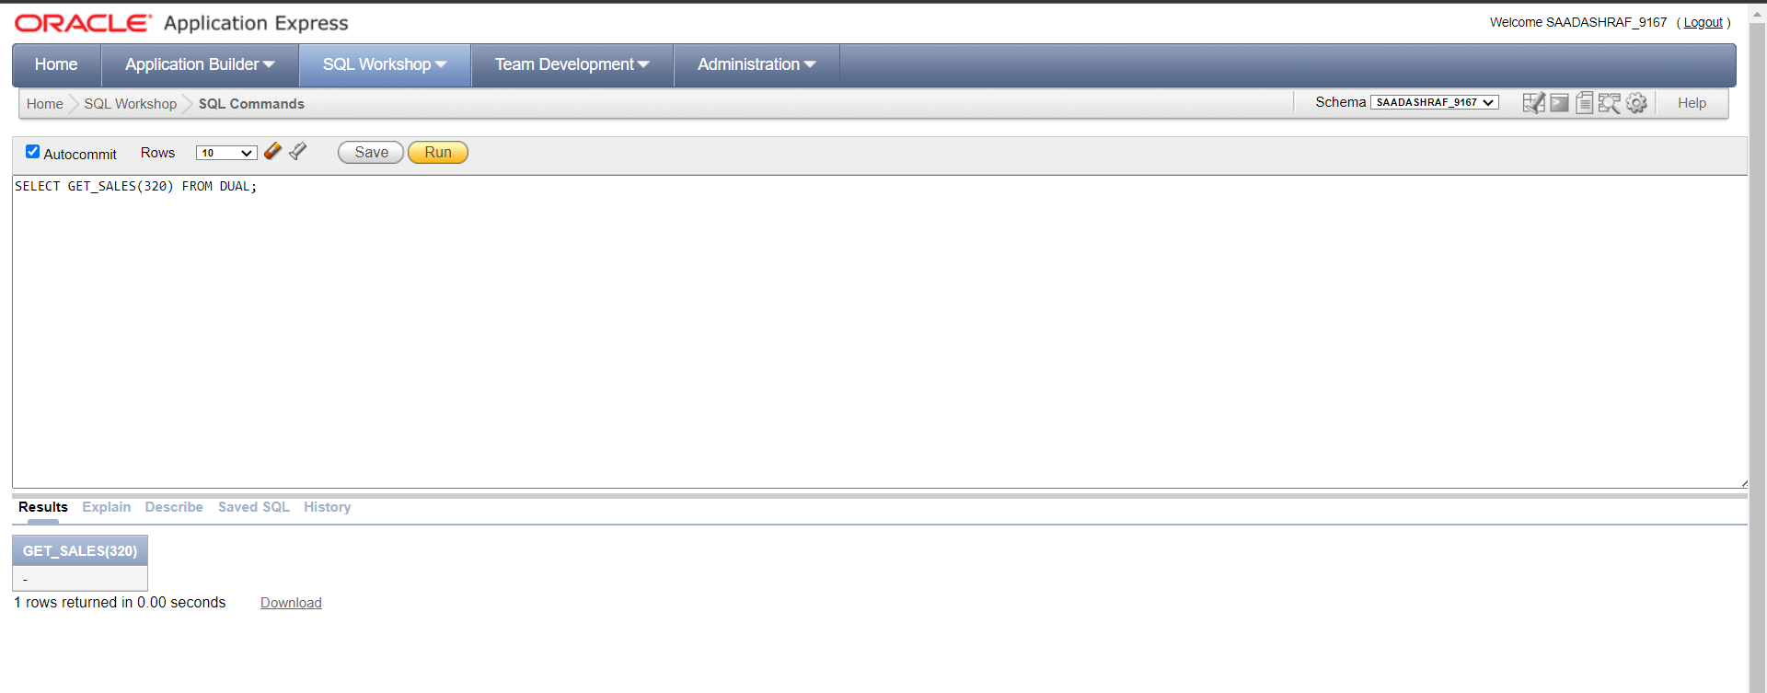

**10.** Call all functions in a pl/sql program and show output.

**SOLUTION:**

DECLARE

CHOICE NUMBER;

RETURNING NUMBER;

EMP_COUNT NUMBER;

BEGIN

DBMS_OUTPUT.PUT_LINE('1- TRANSFER EMPLOYEES ');

DBMS_OUTPUT.PUT_LINE('2- GENERATE REPORTS ');

DBMS_OUTPUT.PUT_LINE('3- DISPLAY EMPLUEES CONTAIN A ');

DBMS_OUTPUT.PUT_LINE('4- NO OF EMP MANAGED BY GIVEN MANAGER ');

DBMS_OUTPUT.PUT_LINE('5- DECREASE QUANTITY ');

DBMS_OUTPUT.PUT_LINE('6- CREATE PRODUCT CATEGORY ');

DBMS_OUTPUT.PUT_LINE('7- STORE PRODUCT ');

DBMS_OUTPUT.PUT_LINE('8- TOTAL PRODUCTS IN GIVEN CATEGORY ');

DBMS_OUTPUT.PUT_LINE('9- RETURN SALES OF CUSTOMER');

DBMS_OUTPUT.PUT_LINE('ENTER CHOICE : ');

CHOICE:=:TEMP;

CASE

WHEN CHOICE=1

THEN

TRANSFER_EMPLOYEE(7499,7486,TO_DATE('2022-05-06', 'YYYY-MM-DD'));

WHEN CHOICE=2

THEN

inventory_report;

WHEN CHOICE=3

THEN

employee_report;

WHEN CHOICE=4

THEN

get_employee_count(108, emp_count);

DBMS_OUTPUT.PUT_LINE('Total number of employees managed by given manager: ' || emp_count);

WHEN CHOICE=5

THEN

decrease_inventory_quantity(289,20);

WHEN CHOICE=6

THEN

RETURNING:=create_category('NEW CATEGORY');

DBMS_OUTPUT.PUT_LINE(RETURNING);

WHEN CHOICE=7

THEN

DBMS_OUTPUT.PUT_LINE('NEW PRODUCT INSERTED');

WHEN CHOICE=8

THEN

RETURNING:=TOTAL_PRODUCT(27);

DBMS_OUTPUT.PUT_LINE(RETURNING);

WHEN CHOICE=9

THEN

RETURNING:=GET_SALES(320);

DBMS_OUTPUT.PUT_LINE('TOTAL SALE IS '|| RETURNING);

ELSE

DBMS_OUTPUT.PUT_LINE('INVALID CHOICE');

END CASE;

END;

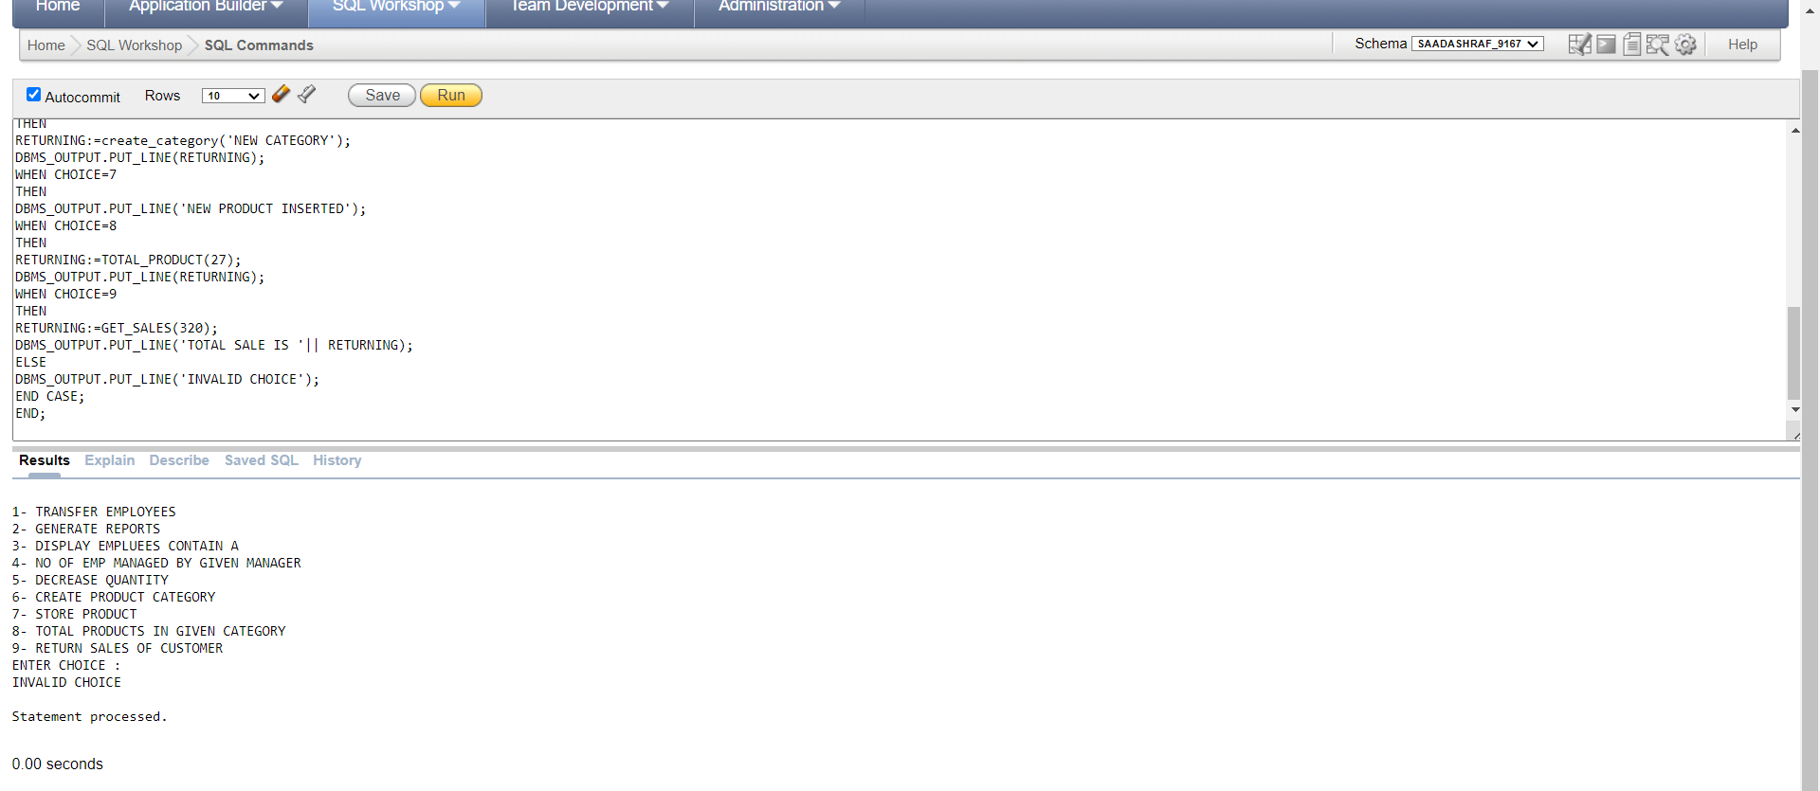

**Question No 05: Triggers (70)**

**1.** Create an Oracle trigger to automatically insert a new region into the regions table when a new

country is added to the countries table?

**SOLUTION:**

CREATE OR REPLACE TRIGGER insert_region

BEFORE INSERT ON COUNTRIES

FOR EACH ROW

DECLARE

v_region_id regions.region_id%type;

BEGIN

SELECT region_id_seq.NEXTVAL INTO v_region_id FROM regions;

INSERT INTO REGIONS(region_id,region_name)

VALUES(v_region_id,:new.country_name);

END;

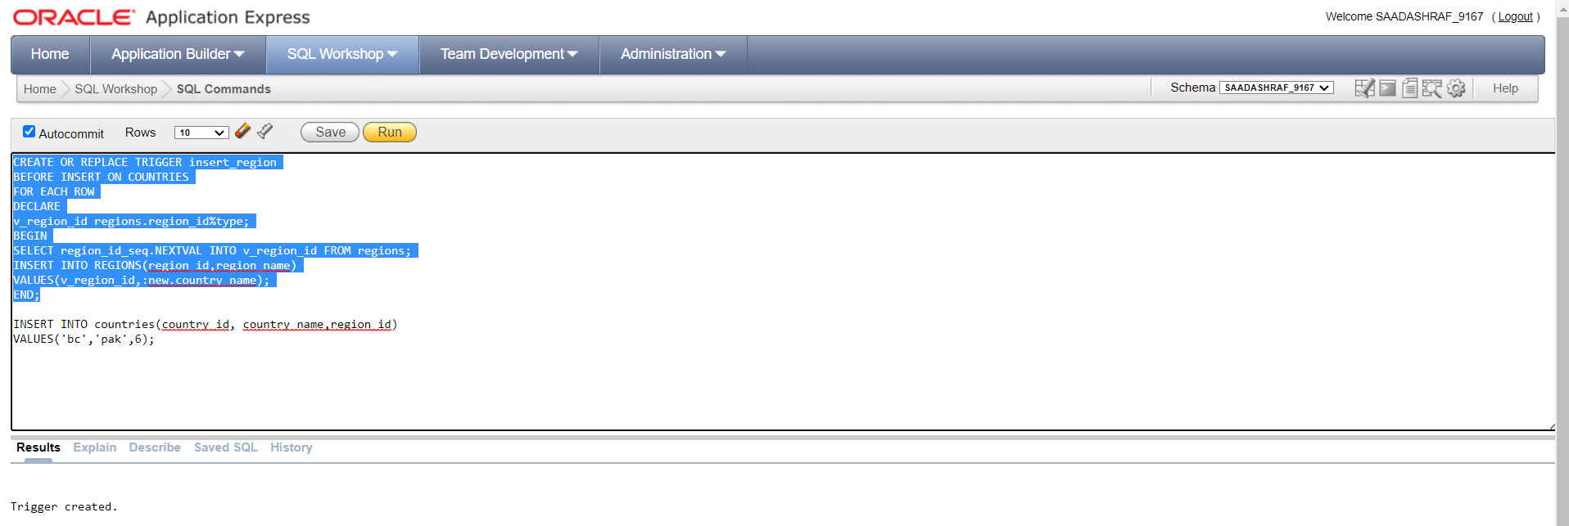

INSERT INTO countries(country_id, country_name,region_id)

VALUES('bc','pak',6);

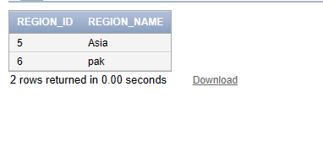

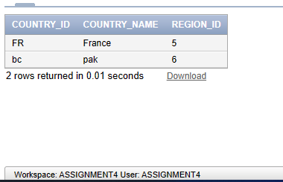

**2.** Create an Oracle trigger to update the quantity of a product in the inventories table after an order

is placed in the order_items table?

**SOLUTION:**

CREATE OR REPLACE TRIGGER update_inventory_quantity

AFTER INSERT ON order_items

FOR EACH ROW

BEGIN

UPDATE inventories

SET quantity = quantity - :NEW.quantity

WHERE product_id = :NEW.product_id;

END;

INSERT INTO ORDER_ITEMS(order_id,item_id,product_id,quantity,unit_price)

VALUES(115,4,289,2,450);

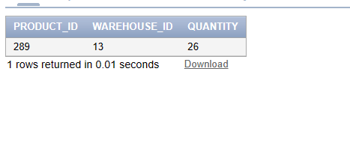

AFTER INSERTING IN ORDER ITEMS and 2 quantities are utlized

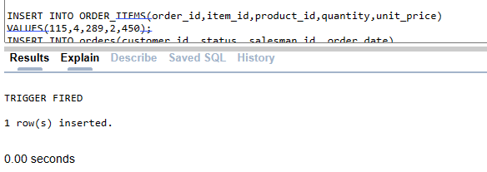

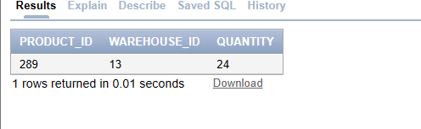

**3.** Create an Oracle trigger to automatically delete all contacts associated with a customer when that

customer is deleted from the customers table?

**SOLUTION:**

CREATE GLOBAL TEMPORARY TABLE temp_customer_ids (

customer_id NUMBER

) ON COMMIT PRESERVE ROWS;

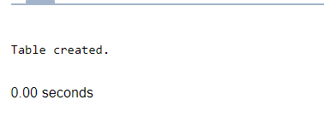

CREATE OR REPLACE TRIGGER delete_contacts

AFTER DELETE ON customers

FOR EACH ROW

BEGIN

INSERT INTO temp_customer_ids (customer_id)

VALUES (:OLD.customer_id);

END;

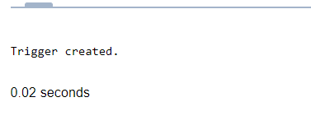

DELETE FROM contacts

WHERE customer_id IN (SELECT customer_id FROM temp_customer_ids);

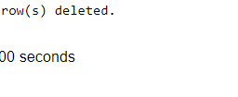

DELETE FROM customers

WHERE customer_id =321;

**Customer table**

before

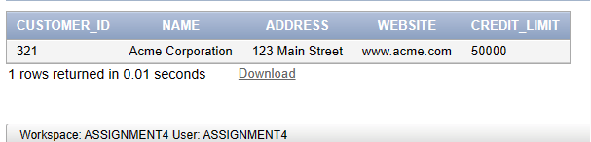

After

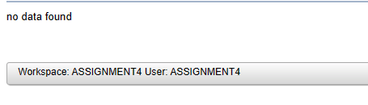

**Contacts table**

**Before**

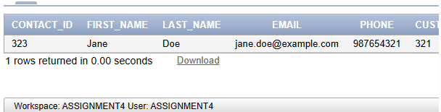

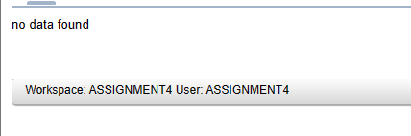

**4.** Create an Oracle trigger to update the credit limit of a customer in the customers table when a

new order is placed in the orders table and the order total exceeds the current credit limit of the

customer?

**SOLUTION:**

CREATE OR REPLACE TRIGGER CREDIT_LIMIT

BEFORE INSERT ON ORDER_ITEMS

FOR EACH ROW

DECLARE

v_customer_id orders.customer_id%TYPE;

total_cost NUMBER;

v_credit_limit customers.credit_limit%type;

BEGIN

SELECT customer_id INTO v_customer_id FROM ORDERS

WHERE order_id=:NEW.order_id;

SELECT credit_limit INTO v_credit_limit

FROM CUSTOMERS where customer_id = v_customer_id;

SELECT SUM(quantity*unit_price) INTO total_cost FROM ORDER_ITEMS

where order_id=:NEW.order_id;

IF total_cost>v_credit_limit

THEN

DBMS_OUTPUT.PUT_LINE('TRGGER FIRED TOTAL COST EXCEEDS');

ELSE

UPDATE CUSTOMERS

SET credit_limit = v_credit_limit - total_cost

WHERE customer_id = v_customer_id;

END IF;

END;

INSERT INTO ORDER_ITEMS(order_id,item_id,product_id,quantity,unit_price)

VALUES(119,3,289,2,450);

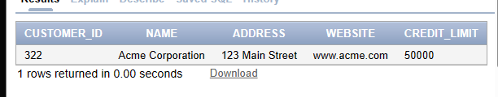

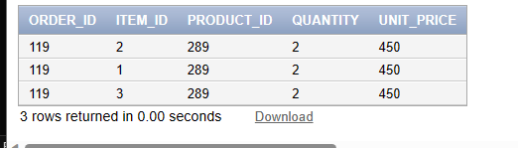

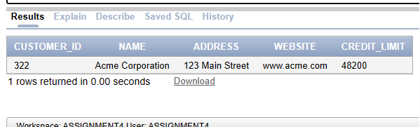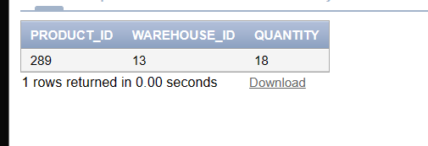

**5.** Create an Oracle trigger to automatically update the product_category column in the products

table when a product is added to the table and the product name contains a name from category?

e.g Cheese Pizza contains category name(Pizza) in its name. (You can use Cursor or arrays for

this purpose).

**SOLUTION:**

CREATE OR REPLACE TRIGGER update_product_category

BEFORE INSERT ON products

FOR EACH ROW

DECLARE

v_category_id number;

v_category_name varchar(50);

TYPE category_list IS TABLE OF VARCHAR2(100);

categories category_list := category_list('Pizza', 'Pasta', 'Wings');

CURSOR c_product_name IS

SELECT product_name FROM products WHERE product_id = :new.product_id;

BEGIN

IF (INSTR(LOWER(:new.product_name), 'pizza') > 0) THEN

v_category_name := 'Pizza';

ELSIF (INSTR(LOWER(:new.product_name), 'Pasta') > 0) THEN

v_category_name := 'Pasta';

ELSIF (INSTR(LOWER(:new.product_name), 'Wings') > 0) THEN

v_category_name := 'Wings';

ELSE

v_category_name := 'Other';

END IF;

OPEN c_product_name;

FETCH c_product_name INTO v_category_name;

CLOSE c_product_name;

SELECT prod_seq.NEXTVAL INTO v_category_id FROM product_categories;

INSERT INTO PRODUCT_CATEGORIES (category_id,category_name)

VALUES (v_category_id,v_category_name);

END;

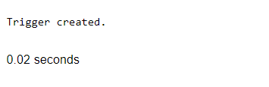

INSERT INTO PRODUCTS

VALUES(296,'cheesepizza','cheesy lovers', 1000,2000,8);

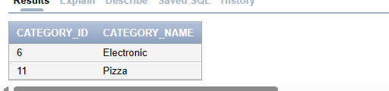

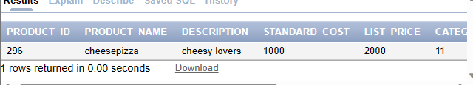

**6.** Create a table contacts_backup using the create query of contacts but do not use any

constraint(make those fields simple). Now Create a Trigger that will run before any contact is deleted. It will save the data of the contact in contacts_backup table.

**SOLUTION:**

SELECT * FROM CONTACTS;

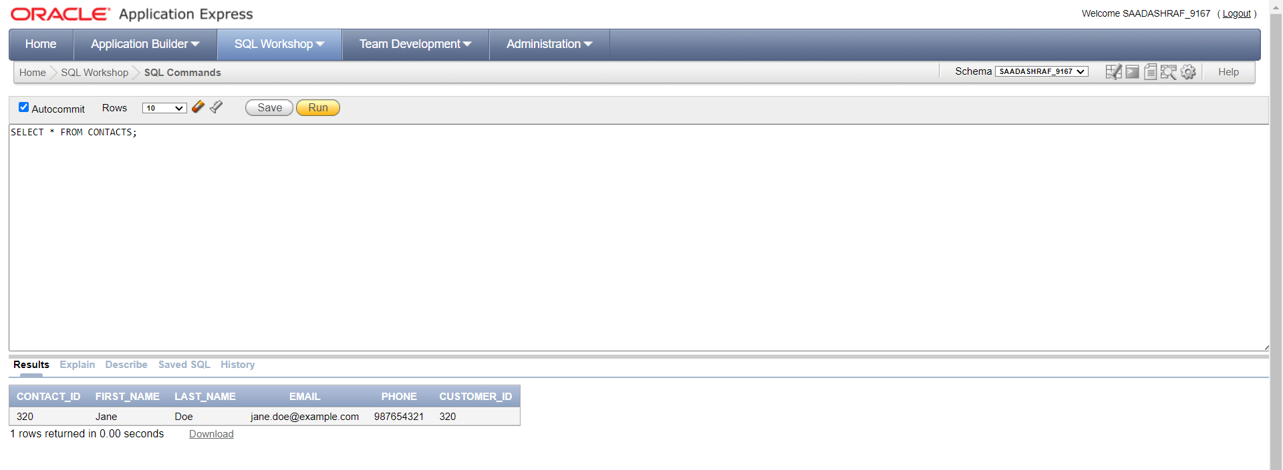

CREATE TABLE contacts_backup (

contact_id NUMBER PRIMARY KEY,

first_name VARCHAR2(50),

last_name VARCHAR2(50),

email VARCHAR2(100),

phone VARCHAR2(20),

customer_id NUMBER,

backup_date DATE DEFAULT SYSDATE

);

CREATE OR REPLACE TRIGGER backup_contact

BEFORE DELETE ON contacts

FOR EACH ROW

BEGIN

INSERT INTO contacts_backup (contact_id,first_name,last_name, email, phone,customer_id)

VALUES (:OLD.contact_id,:OLD.first_name,:OLD.last_name, :OLD.email,:OLD.phone,:OLD.customer_id);

END;

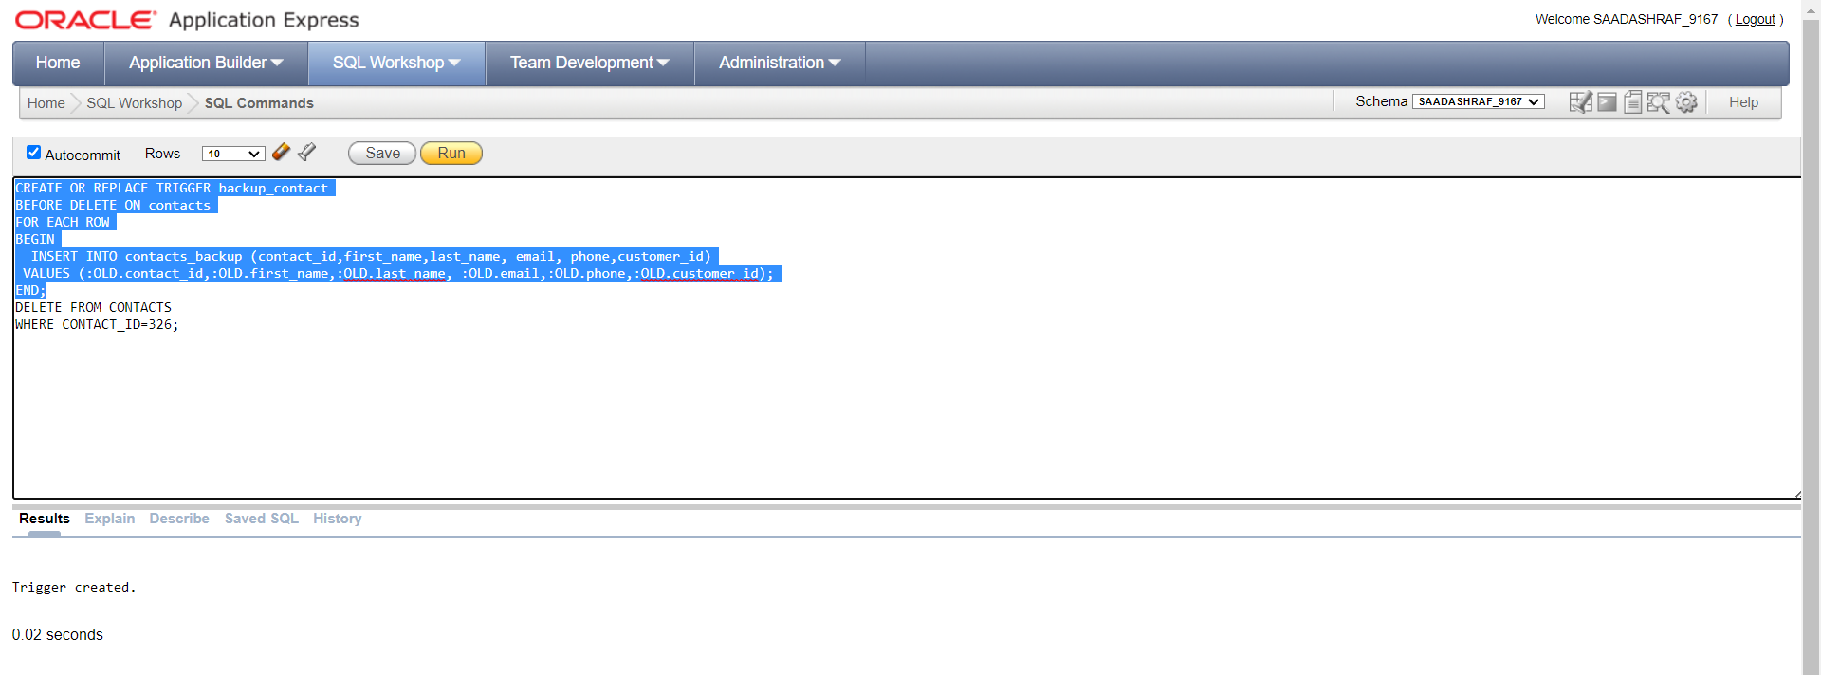

DELETE FROM CONTACTS

WHERE CONTACT_ID=320;

Select * from contacts_backup;

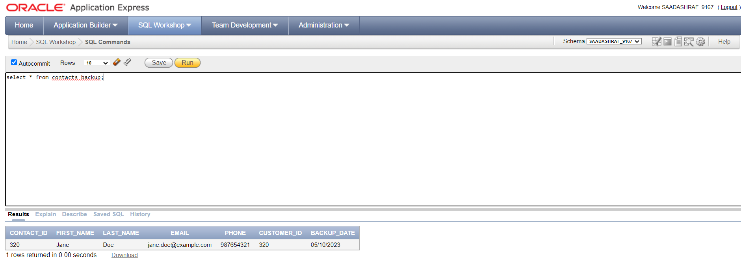

select * from contacts;

