QUESTATION NO 1  
  
CREATE TABLE NEWEMP(

EMPNO NUMBER,

ENAME VARCHAR2(50),

JOB VARCHAR2(50),

MGR NUMBER,

HIREDATE DATE,

SAL NUMBER,

COMM NUMBER,

DEPTNO NUMBER);

CREATE OR REPLACE TRIGGER display_salary_changes

BEFORE DELETE OR INSERT OR UPDATE ON EMP

FOR EACH ROW

WHEN (NEW.EMPNO > 0)

DECLARE

  sal_diff number;

BEGIN

  dbms_output.put_line ('ALERT CHANGE IN EMP_TABLE');

  INSERT INTO NEWEMP (EMPNO,ENAME,JOB,MGR,HIREDATE,SAL,COMM,DEPTNO)

  VALUES (:OLD.EMPNO,:OLD.ENAME,:OLD.JOB,:OLD.MGR,:OLD.HIREDATE,:OLD.SAL,:OLD.COMM,:OLD.DEPTNO);

END;

INSERT INTO emp (empno, ename, job, mgr, hiredate, sal, comm, deptno)

VALUES (1, 'John Smith', 'Manager', null, TO_DATE('2023-05-08', 'YYYY-MM-DD'), 5000, null, 10);

OUTPUT  
  
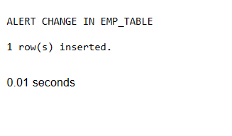

Q2

CREATE OR REPLACE TRIGGER display_salary_changes BEFORE DELETE OR INSERT OR UPDATE ON EMP

FOR EACH ROW

WHEN (NEW.SAL > OLD.SAL*0.1)

DECLARE

sal_diff number;

BEGIN

dbms_output.put_line (:OLD.SAL);

dbms_output.put_line (:NEW.SAL);

dbms_output.put_line (:NEW.EMPNO);

dbms_output.put_line (:NEW.ENAME);

dbms_output.put_line (:NEW.JOB);

dbms_output.put_line (:NEW.MGR);

dbms_output.put_line (:NEW.HIREDATE);

dbms_output.put_line (:NEW.SAL);

dbms_output.put_line (:NEW.COMM);

dbms_output.put_line (:NEW.DEPTNO);

END;

UPDATE emp SET sal = 15000

WHERE ename = 'KING';

OUTPUT  
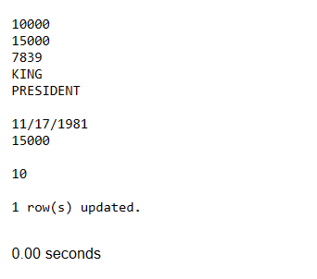  
Q3

Create or replace Trigger DATA_DEL

before delete on dept

For EACH ROW

Begin

  delete from emp where deptno=20;

  dbms_output.put_line('Data Deleted');

END;

delete from dept

where deptno=20;

OUTPUT  
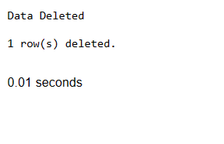  
Q4  
Create view NEW_VIEW as

Select e.empno,e.ename,e.sal,d.deptno,d.dname

from emp e join dept d on e.deptno=d.deptno;

Create or replace Trigger V_TR

Instead of Update on NEW_VIEW

For EACH ROW

BEGIN

    UPDATE emp

    SET sal= :new.sal

    where empno=:old.empno;

      dbms_output.put_line('Data Updated');

END;

BEFORE  
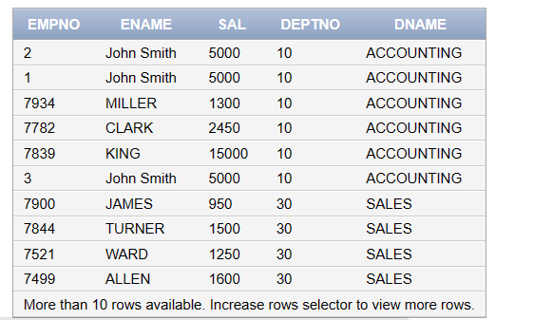  
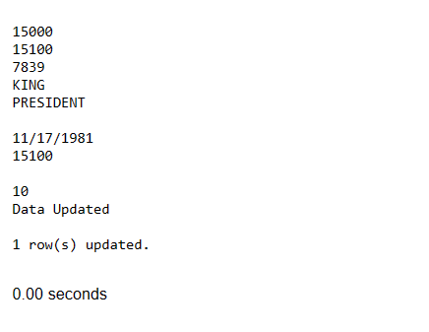  
AFTER  
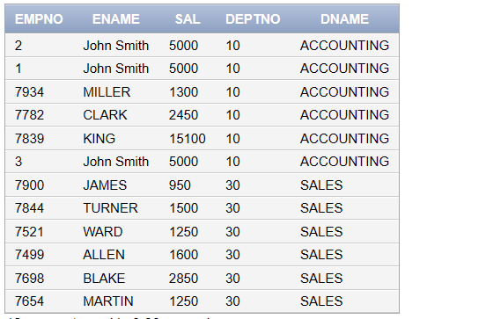  
  
Q5

DECLARE

CURSOR c_emp IS

SELECT * FROM emp ;

BEGIN

FOR v_c IN c_emp LOOP

DBMS_OUTPUT.PUT_LINE(v_c.ename||' '||v_c.EMPNO||' '||v_c.JOB||' '||v_c.MGR||' '||v_c.HIREDATE||' '||v_c.SAL||' '||v_c.COMM||' '||v_c.DEPTNO);

END LOOP;

end;

OUTPUT  
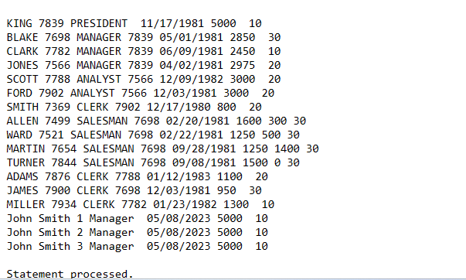  
  
Q6

DECLARE

CURSOR c_emp IS

SELECT * FROM emp where sal >(select AVG(SAL) FROM EMP) ;

BEGIN

FOR v_c IN c_emp LOOP

DBMS_OUTPUT.PUT_LINE(v_c.ename||' '||v_c.EMPNO||' '||v_c.JOB||' '||v_c.MGR||' '||v_c.HIREDATE||' '||v_c.SAL||' '||v_c.COMM||' '||v_c.DEPTNO);

END LOOP;

end;

OUTPUT  
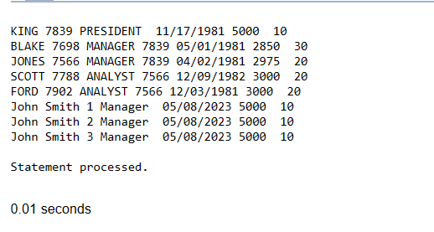

Q7

DECLARE

CURSOR c_emp IS

SELECT * FROM emp WHERE SAL > 3500 AND DEPTNO = 30 ;

BEGIN

FOR v_c IN c_emp LOOP

DBMS_OUTPUT.PUT_LINE(v_c.ename);

DBMS_OUTPUT.PUT_LINE(v_c.EMPNO);

DBMS_OUTPUT.PUT_LINE(v_c.JOB);

DBMS_OUTPUT.PUT_LINE(v_c.MGR);

DBMS_OUTPUT.PUT_LINE(v_c.HIREDATE);

DBMS_OUTPUT.PUT_LINE(v_c.SAL);

DBMS_OUTPUT.PUT_LINE(v_c.COMM);

DBMS_OUTPUT.PUT_LINE(v_c.DEPTNO);

END LOOP;

end;

OUTPUT  
