**TASK 1:**

Write PL/SQL blocks to show the declaration of variables. Follow the following

instructions:

• Declare variables for all attributes existing in employee table.

• Variables datatypes should be defined appropriately and use rowtype for any two

variables.

• Initialize any two variables at time of declaration.

• Assign values to remaining variables by showing the complete employee table’s

attribute data.

**SOLUTION:**

DECLARE

i integer :=0;

empno NUMBER;

ename VARCHAR2(50);

job VARCHAR2(50);

mgr NUMBER;

hiredate DATE;

sal NUMBER;

comm NUMBER;

deptno NUMBER;

emp_row emp%ROWTYPE;

emp_row_2 emp%ROWTYPE;

BEGIN

FOR i in (select * from emp)

LOOP

empno := i.empno;

ename := i.ename;

job := i.job;

mgr := i.mgr;

hiredate := i.hiredate;

sal := i.sal;

comm := i.comm;

deptno := i.deptno;

dbms_output.put_line(empno || ' ' || ename || ' ' || job || ' ' || mgr || ' ' || hiredate || ' ' || sal || ' ' || comm || ' ' || deptno);

END LOOP;

END;

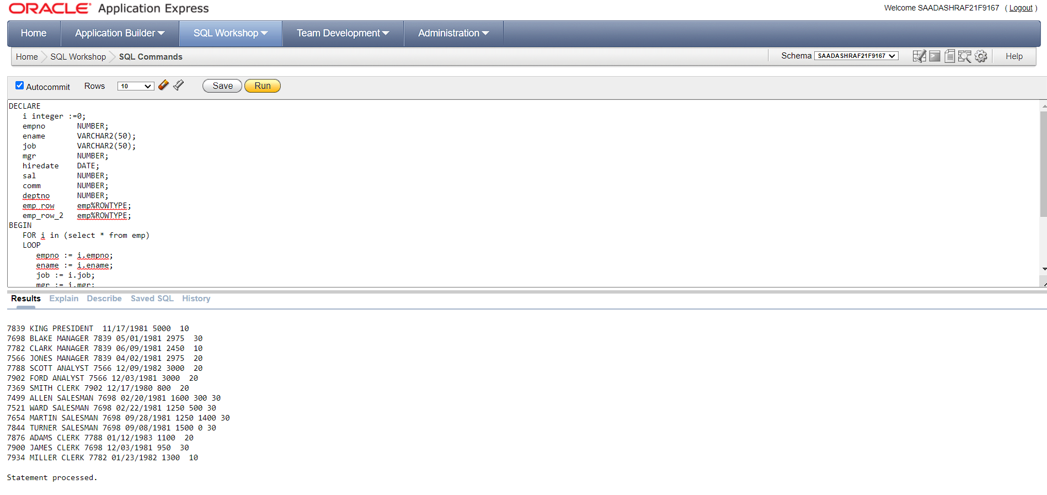

**TASK 2:**

Write a PL/SQL block to calculate the incentive of an employee whose ID is 110.

**SOLUTION:**

DECLARE

v_salary emp.sal%TYPE;

v_incentive NUMBER(8,2);

BEGIN

SELECT sal INTO v_salary FROM emp WHERE empno = 7839;

IF v_salary > 5000 THEN

v_incentive := v_salary * 0.1;

ELSE

v_incentive := v_salary * 0.05;

END IF;

dbms_output.put_line('Employee 7839 salary: ' || v_salary);

dbms_output.put_line('Employee 7839 incentive: ' || v_incentive);

END;

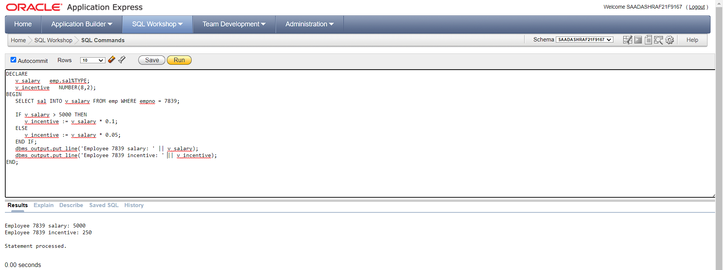

**TASK 3:**

Write a PL/SQL program to check whether a number is even or odd by using IF END.

**SOLUTION:**

DECLARE

num NUMBER := 10;

BEGIN

IF MOD(num, 2) = 0 THEN

DBMS_OUTPUT.PUT_LINE(num || ' is an even number');

ELSE

DBMS_OUTPUT.PUT_LINE(num || ' is an odd number');

END IF;

END;

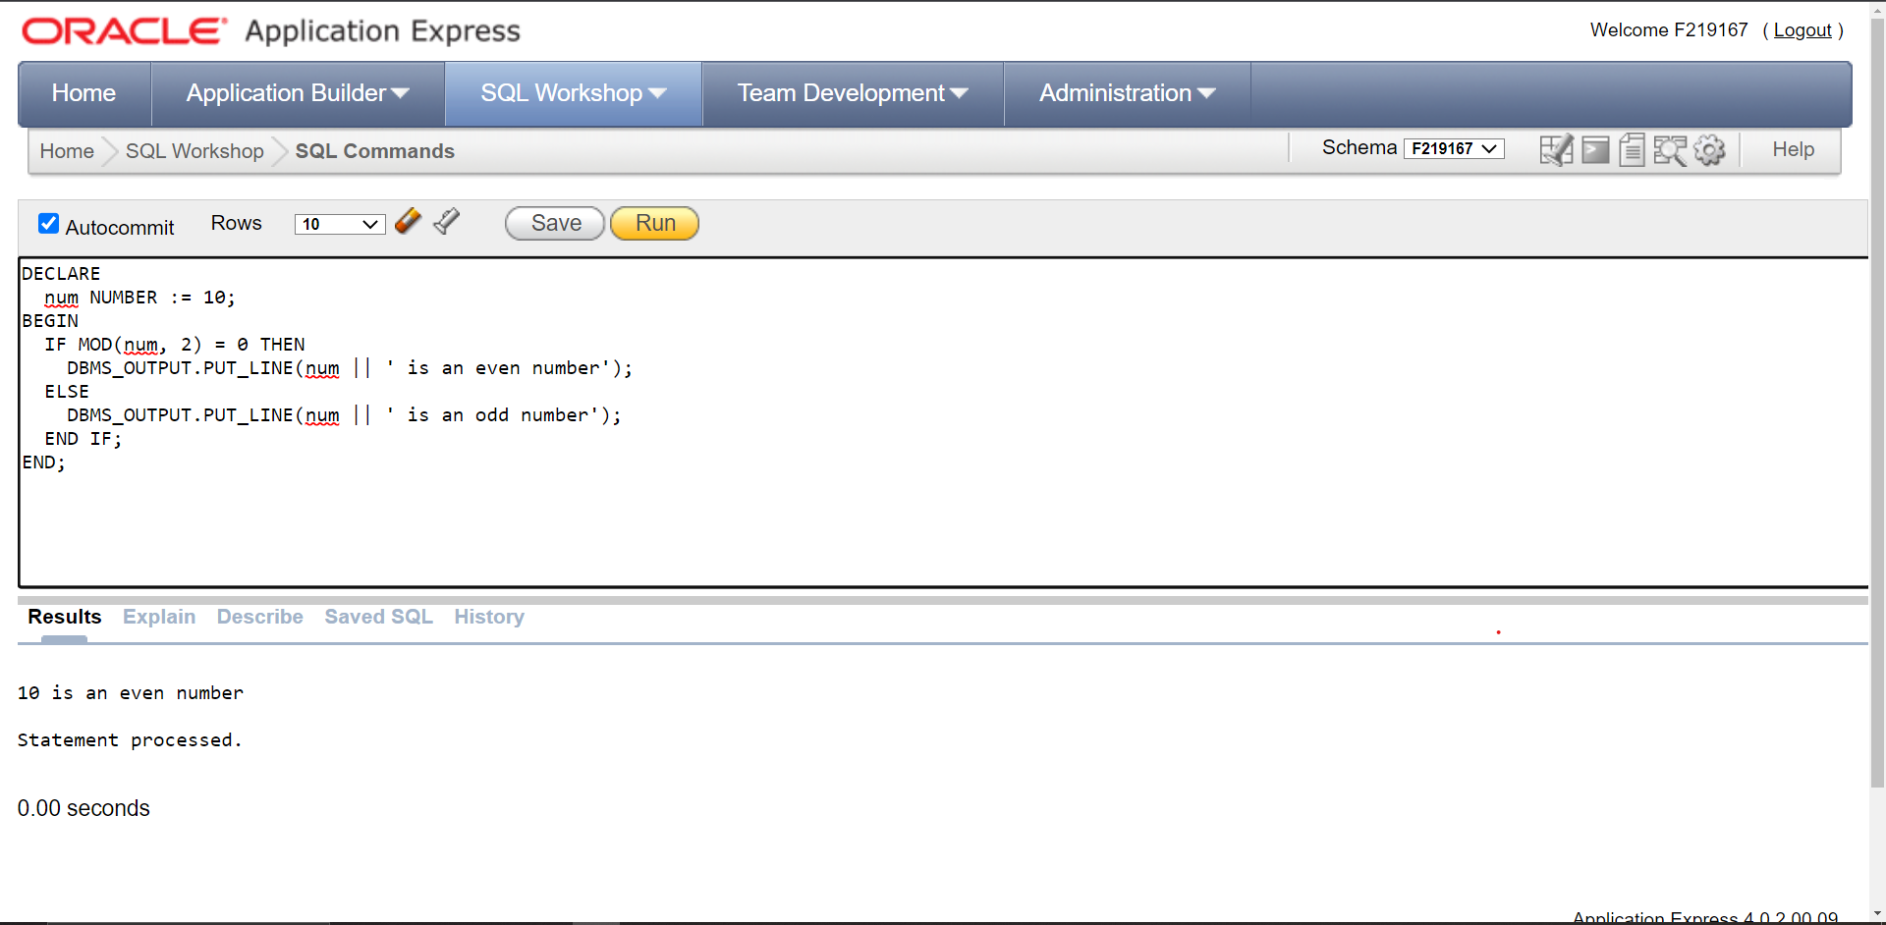

**TASK 4:**

Write a PL/SQL program to check whether a given number is positive, negative or zero IF

ELSE END IF.

**SOLUTION:**

DECLARE

num NUMBER := 10;

BEGIN

IF num > 0 THEN

DBMS_OUTPUT.PUT_LINE(num || ' is a positive number.');

ELSIF num < 0 THEN

DBMS_OUTPUT.PUT_LINE(num || ' is a negative number.');

ELSE

DBMS_OUTPUT.PUT_LINE(num || ' is zero.');

END IF;

END;

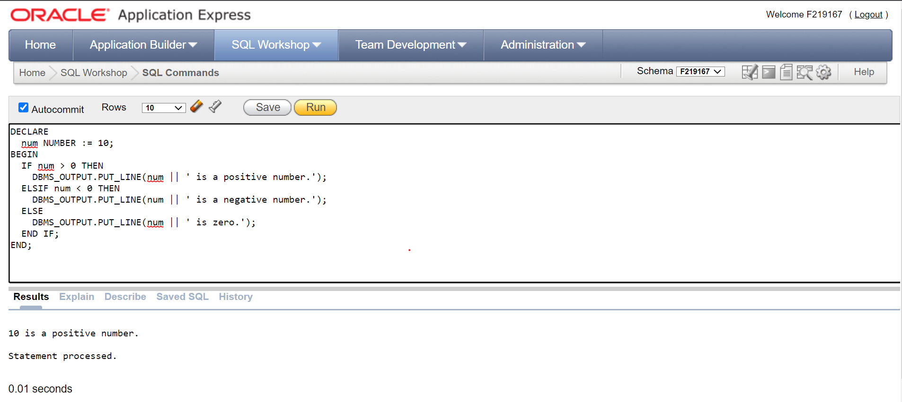

**TASK 5:**

Write a PL/SQL program to count the number of employees in department 50 and check

whether this department has any vacancies or not. There are 45 vacancies in this

department.

**SOLUTION:**

DECLARE

v_deptno emp.deptno%TYPE := 50;

v_num_employees NUMBER;

v_vacancies NUMBER := 45;

BEGIN

SELECT COUNT(*) INTO v_num_employees FROM emp WHERE deptno = v_deptno;

DBMS_OUTPUT.PUT_LINE('There are ' || v_num_employees || ' employees in department ' || v_deptno || '.');

IF v_num_employees >= v_vacancies THEN

DBMS_OUTPUT.PUT_LINE('Department ' || v_deptno || ' does not have any vacancies.');

ELSE

DBMS_OUTPUT.PUT_LINE('Department ' || v_deptno || ' has ' || (v_vacancies - v_num_employees) || ' vacancies.');

END IF;

END;

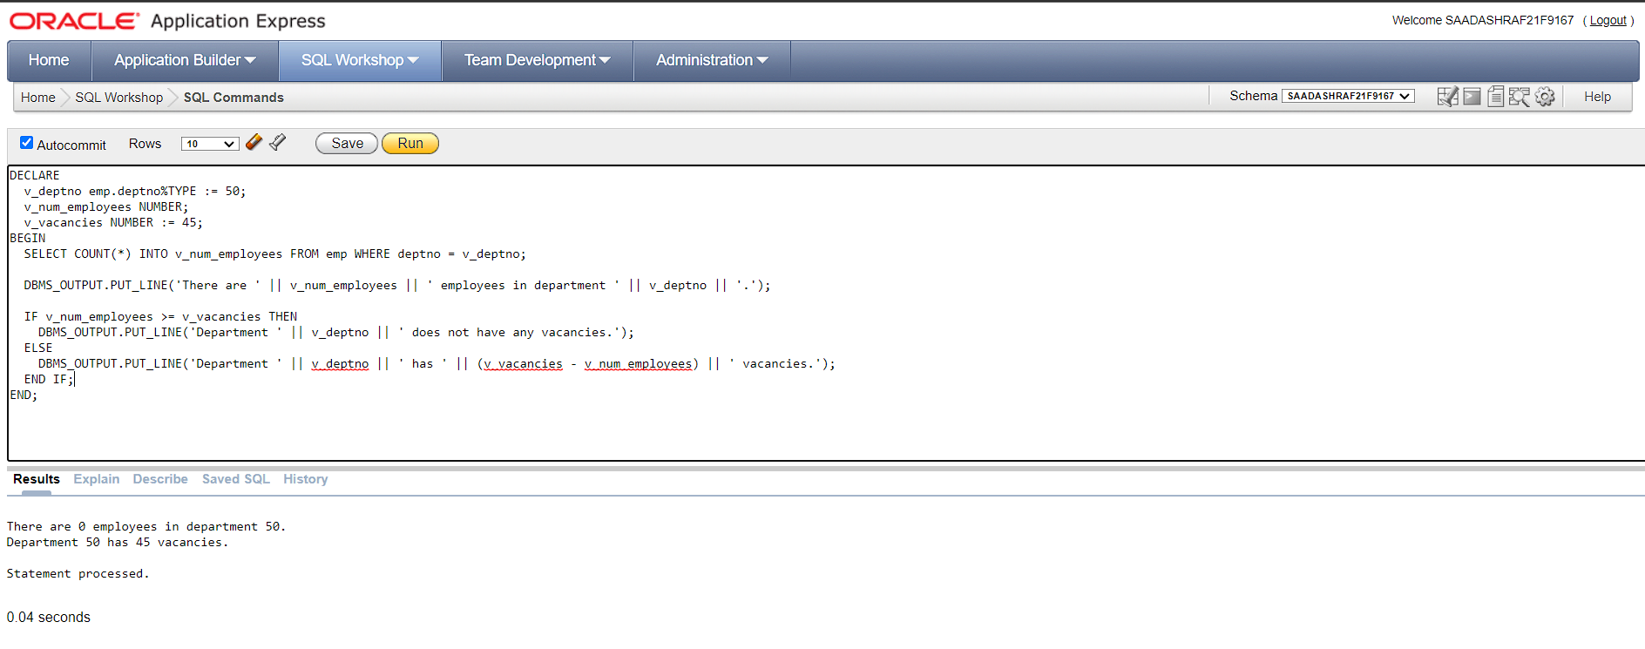

**TASK 6:**

Write a PL/SQL program to make a calculator (DMAS rules) using CASE statement.

**SOLUTION:**

DECLARE

v_num1 NUMBER;

v_num2 NUMBER;

v_operator CHAR(1);

v_result NUMBER;

BEGIN

v_num1 := 5;

v_num2 := 4;

v_operator := '+';

CASE v_operator

WHEN '+' THEN

v_result := v_num1 + v_num2;

WHEN '-' THEN

v_result := v_num1 - v_num2;

WHEN '*' THEN

v_result := v_num1 * v_num2;

WHEN '/' THEN

v_result := v_num1 / v_num2;

ELSE

DBMS_OUTPUT.PUT_LINE('Invalid operator entered.');

RETURN;

END CASE;

DBMS_OUTPUT.PUT_LINE(v_num1 || ' ' || v_operator || ' ' || v_num2 || ' = ' || v_result);

END;

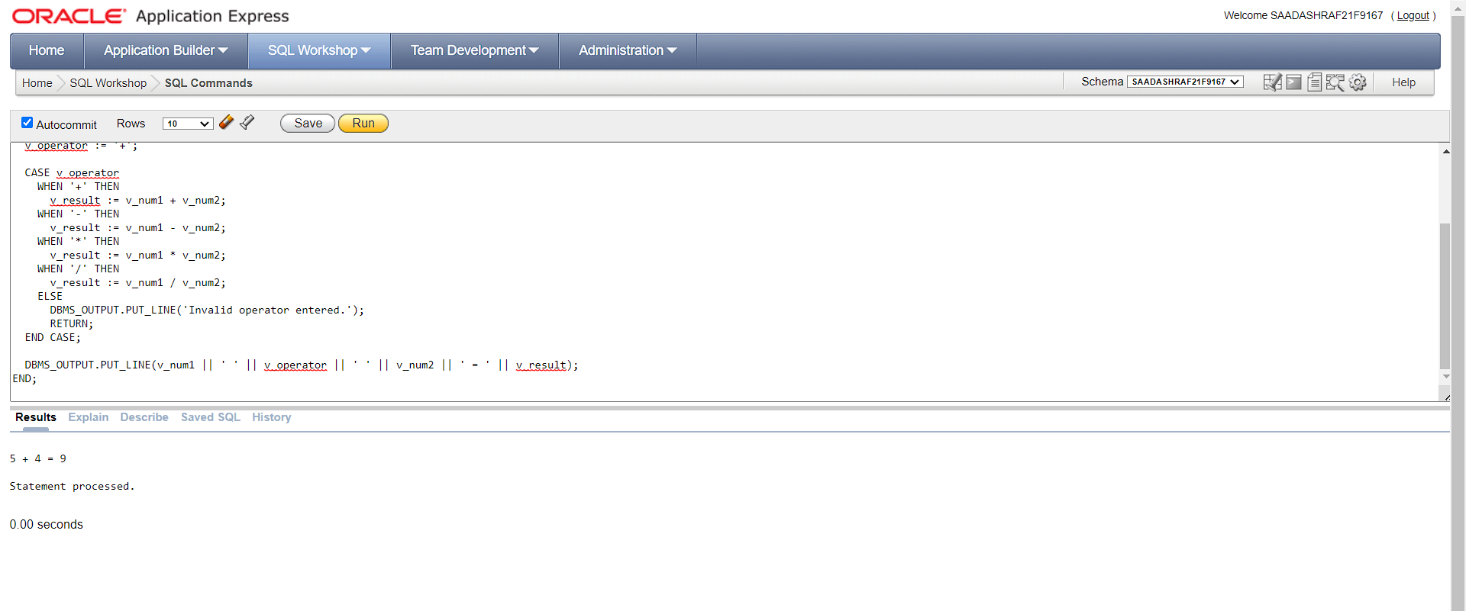

**TASK 7:**

Write a program in PL/SQL to print factorial of given number. (using for loop)

**SOLUTION:**

DECLARE

num NUMBER := 5;

factorial NUMBER := 1;

BEGIN

for i in 1..num

LOOP

factorial := factorial * i;

END LOOP;

DBMS_OUTPUT.PUT_LINE(num || '! = ' || factorial );

END;

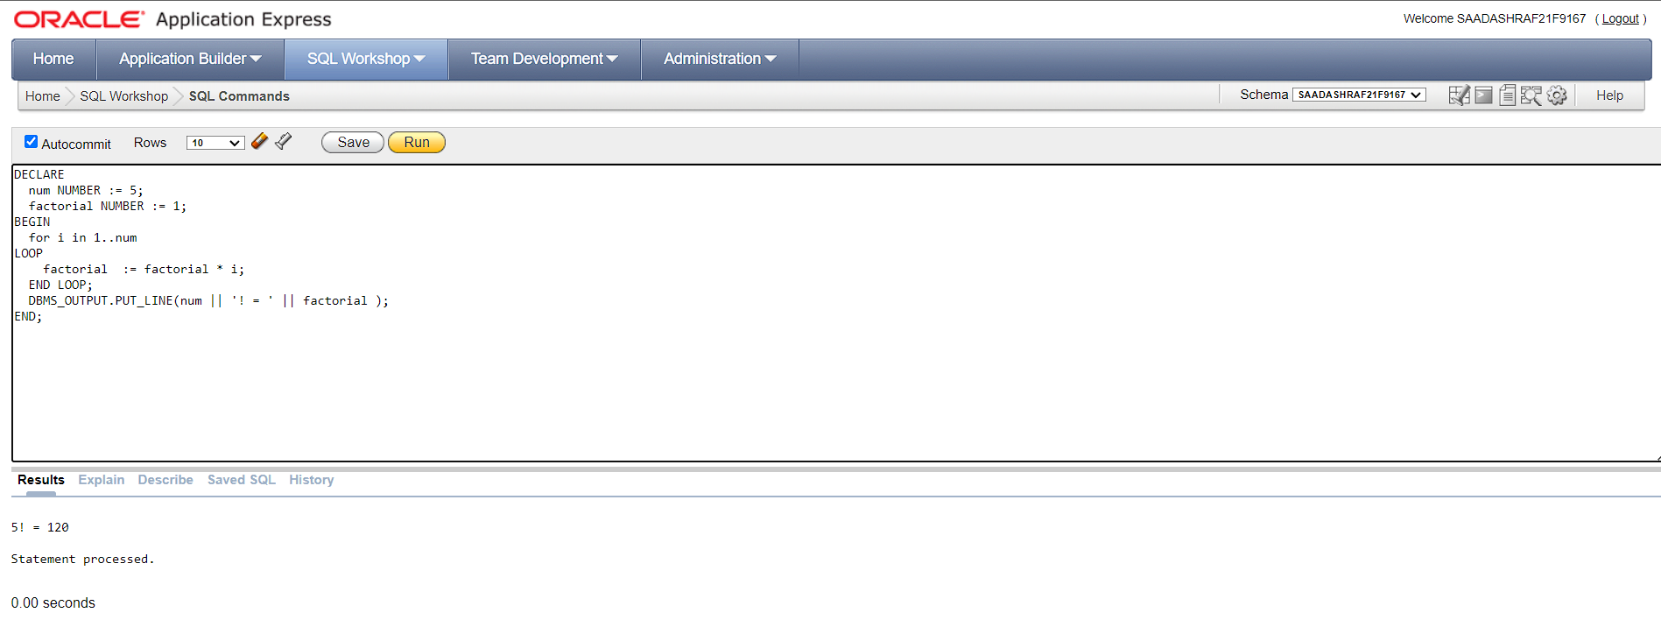

**TASK 8:**

Write a program in PL/SQL to update the salary of a specific employee by 8% if the salary

exceeds the mid-range of the salary against this job and update up to mid-range if the salary

is less than the mid-range of the salary, and display a suitable message.

**SOLUTION:**

DECLARE

v_empno emp.empno%TYPE := 7698;

v_salary emp.sal%TYPE;

v_job emp.job%TYPE;

v_min_salary NUMBER;

v_max_salary NUMBER;

v_mid_salary NUMBER;

BEGIN

SELECT sal, job INTO v_salary, v_job FROM emp WHERE empno = v_empno;

SELECT MIN(sal), MAX(sal) INTO v_min_salary, v_max_salary FROM emp WHERE job = v_job;

v_mid_salary := (v_min_salary + v_max_salary) / 2;

IF v_salary > v_mid_salary THEN

v_salary := v_salary * 1.08;

IF v_salary > v_max_salary THEN

v_salary := v_max_salary;

END IF;

UPDATE emp SET sal = v_salary WHERE empno = v_empno;

DBMS_OUTPUT.PUT_LINE('Employee ' || v_empno || ' salary updated to ' || v_salary || ' (8% increase)');

ELSIF v_salary < v_mid_salary THEN

v_salary := v_mid_salary;

UPDATE emp SET sal = v_salary WHERE empno = v_empno;

DBMS_OUTPUT.PUT_LINE('Employee ' || v_empno || ' salary updated to ' || v_salary || ' (adjusted to mid-range)');

ELSE

DBMS_OUTPUT.PUT_LINE('Employee ' || v_empno || ' salary is already at mid-range (' || v_salary || ')');

END IF;

END;

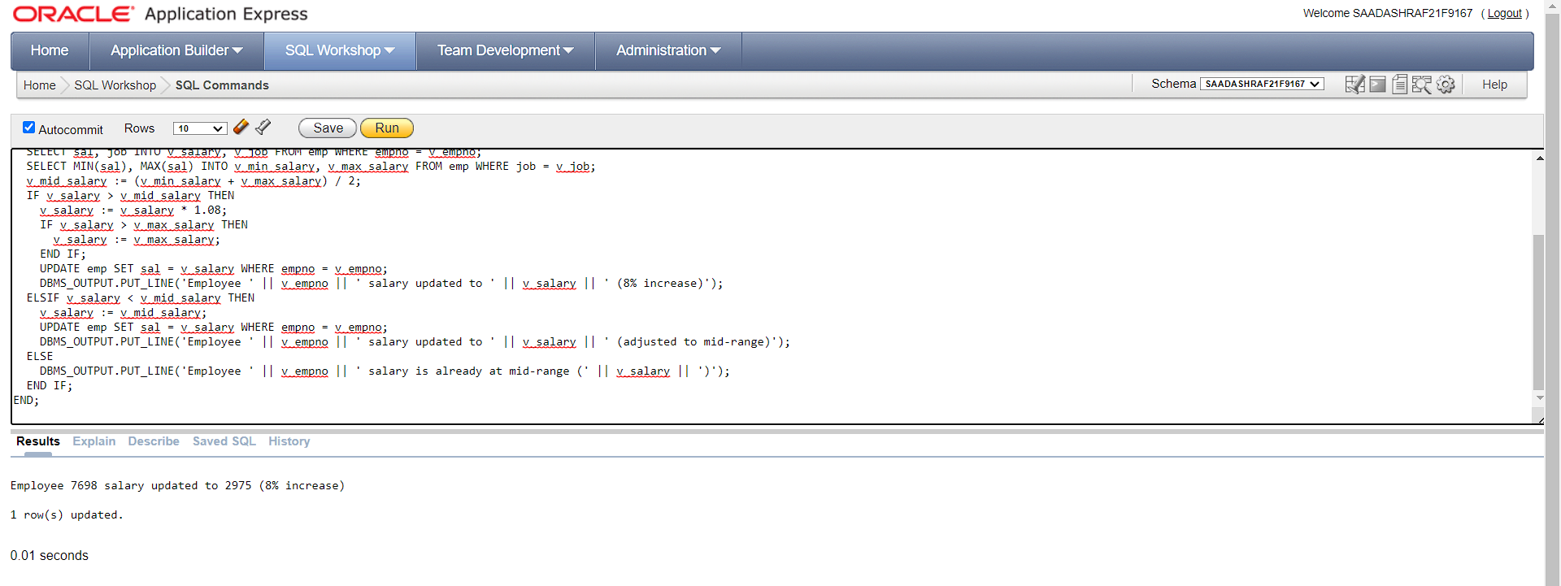

**TASK 9:**

Correct the program and find the output:

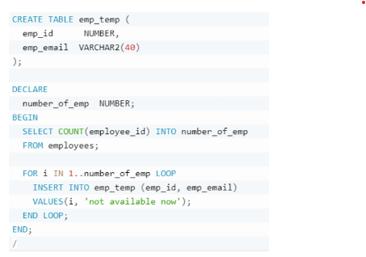

**SOLUTION:**

DECLARE

number_of_emp NUMBER;

BEGIN

SELECT COUNT(**emp_id**) INTO number_of_emp

FROM **emp_temp**;

FOR i IN 1..number_of_emp LOOP

INSERT INTO emp_temp (emp_id, emp_email) VALUES (i, 'not available now');

END LOOP;

END;

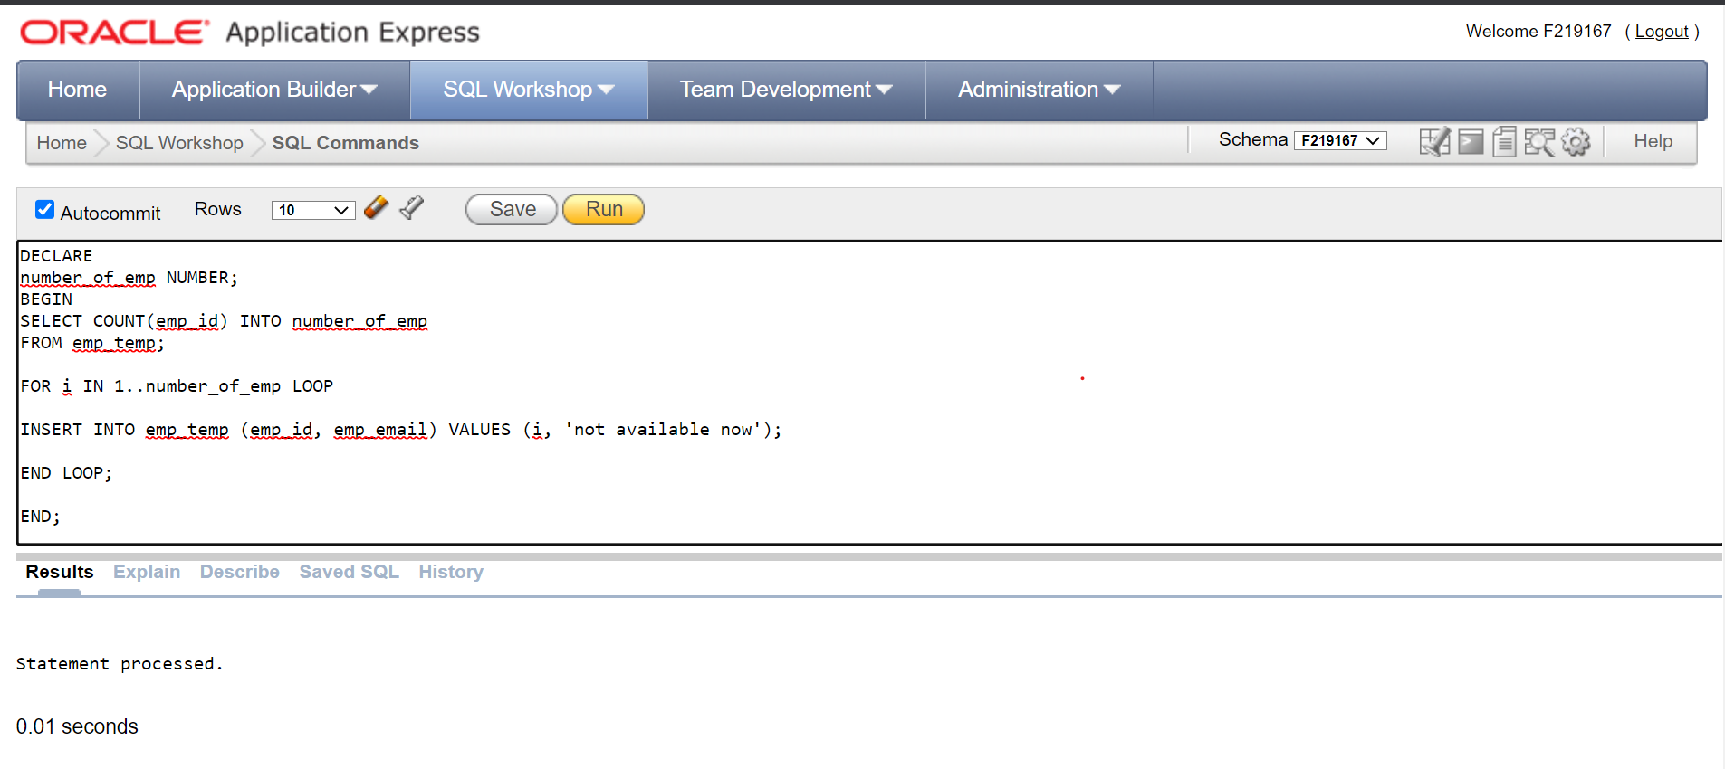

The output of the program will depend on the number of employees in the employees table at the time it is run. For each employee in the table, a row will be inserted into the emp_temp table with emp_id set to a value starting at 1 and incrementing by 1 for each row, and emp_email set to 'not available now'.