# Code 1

#include<iostream>

using namespace std;

int main()

{

int n;

cout << "Please input the size of Array";

cout << endl;

cin >> n;

int* p = new int[n];

int i;

int counter=0;

for (i = 0; i < n; i++)

{

cin >> p[i];

counter=counter+1;

}

for (i = 0; i < n; i++)

{

cout<< p[i];

cout << endl;

}

cout << endl;

cout << counter;

}

# Code 2

#include<iostream>

using namespace std;

int main()

{

bool u = true;

const int n = 3;

int** p = new int* [n];

int i;

for (i = 0; i < n; i++)

{

p[i] = new int[3];

}

int j = 0;

for (i = 0; i < n; i++)

{

for (j = 0; j < n; j++)

{

cin >> p[i][j];

}

}

cout << endl;

for (i = 0; i < n; i++)

{

for (j = 0; j < n; j++)

{

cout<< p[i][j]<<" ";

}

cout << endl;

}

cout << endl;

for (i = 0; i < n; i++)

{

for (j = 0; j < n; j++)

{

cout << p[j][i] << " ";

}

cout << endl;

}

for (i = 0; i < n; i++)

{

for (j = 0; j < n; j++)

{

if (p[i][j] == p[j][i])

{

continue;

}

if (p[i][j] != p[j][i])

{

u = false;

cout << "They are not symtric";

cout << endl;

break;

}

}

if (u == false)

{

break;

}

else

{

continue;

}

}

if (u == true)

{

cout << "They are symmetric";

}

}

# OUTPUT

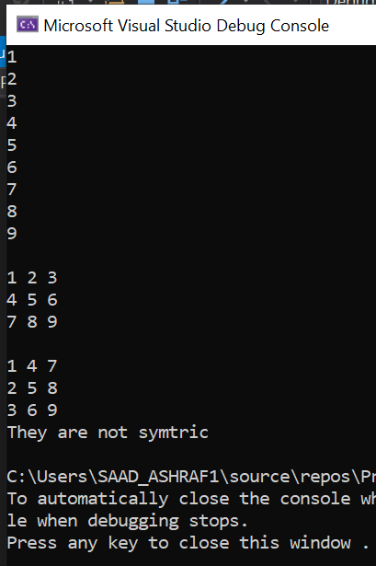

# CODE 3

#include<iostream>

using namespace std;

int main()

{

char** p = new char*[5];

int i = 0;

for (i = 0; i < 5; i++)

{

p[i] = new char[5];

}

int j = 0;

for (i = 0; i < 5; i++)

{

for (j = 0; j < 5; j++)

{

cin >> p[i][j];

}

}

for (i = 0; i < 5; i++)

{

for (j = 0; j < 5; j++)

{

cout << p[i][j] << " ";

}

cout << endl;

}

int counter = 0;

int l = 0;

for (i = 0; i < 5; i++)

{

for (j = 0; j < counter; j++)

{

for (l = 0; l < counter; l++)

{

p[i][j] = 32;

}

}

counter = counter + 1;

}

cout << endl;

for (i = 0; i < 5; i++)

{

for (j = 0; j < 5; j++)

{

cout << p[i][j] << " ";

}

cout << endl;

}

system("pause");

return 0;

}

# Output

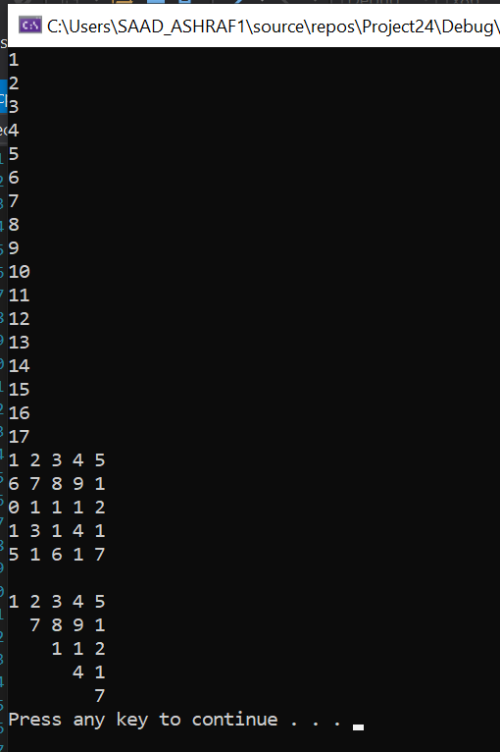

# CODE 4

#include<iostream>

using namespace std;

int main()

{

int l=0;

cout << "Please input the number of the Number of the coulumns ";

cin >> l;

char** p = new char* [l];

int i=0;

int *j=new int[l];

for (i = 0; i < l; i++)

{

cout << "Please input the Number of the column";

cin >> j[i];

p[i] = new char[(j[i])];

}

l = 0;

for (i = 0; i < 5; i++)

{

for (l = 0; l <j[i]; l++)

{

cin >> p[i][l];

}

}

for (i = 0; i < 5; i++)

{

for (l = 0; l < j[i]; l++)

{

cout << p[i][l]<<" ";

}

cout << endl;

}

system("pause");

return 0;

}

# OUTPUT

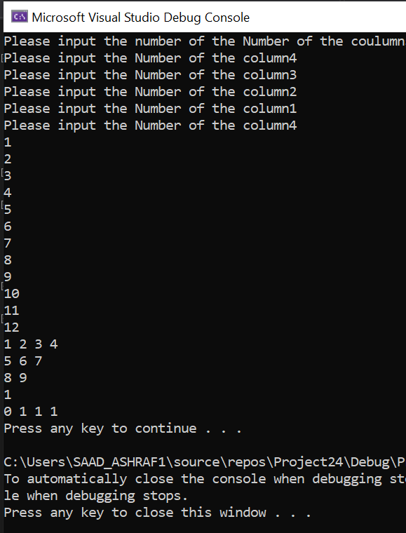

# CODE 5

#include<iostream>

using namespace std;

int main()

{

int l;

int i;

int j;

int* const ptr1=&i;

const int* ptr2 = &j;

// ptr1 = &j;// error

//*ptr2=*ptr2+1// wrong

ptr2 = &i;

int* k;

k = &l;

cout << ptr1;

cout << endl;

cout << ptr2;

cout << endl;

cout << k;

cout << endl;

}

# OUTPUT

