TASK 1:

#include <iostream>

using namespace std;

template <class T>

class Number {

private:

T num;

public:

Number(T n) : num(n) {}

T getNum() {

return num;

}

};

int main() {

string name, list;

int rollnumber;

char section;

cout << "Enter Name : ";

cin >> name;

cout << "Enter rollnumber : ";

cin >> rollnumber;

cout << "Enter course list : ";

cin >> list;

cout << "Enter section : ";

cin >> section;

Number<string> numberInt(name);

Number<int> roll(rollnumber);

Number<string> abc(list);

Number<char> xyz(section);

cout << endl << endl << endl;

cout << "Name : " << numberInt.getNum() << endl;

cout << "Roll NUmber : " << roll.getNum() << endl;

cout << "Course List : " << abc.getNum() << endl;

cout << "Section : " << xyz.getNum() << endl;

return 0;

}

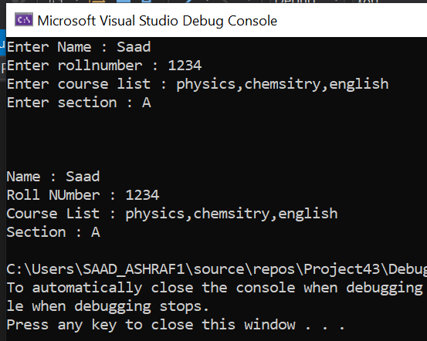

TASK 4:

#include <iostream>

using namespace std;

template <class T>

class Calculator

{

private:

T num1, num2;

public:

Calculator(T n1, T n2)

{

num1 = n1;

num2 = n2;

}

void display()

{

cout << "Numbers are: " << num1 << " and " << num2 << "." << endl;

cout << "Addition is: " << add() << endl;

cout << "Subtraction is: " << subtract() << endl;

cout << "Product is: " << multiply() << endl;

}

T subtract() {

return num1 - num2;

}

T add() {

return num1 + num2;

}

T multiply() {

return num1 \* num2;

}

};

int main()

{

int n1, n2;

float n3, n4;

cout << "FOR INTEGERS DATA TYPE : " << endl;

cout << "Enter Number 1 : ";

cin >> n1;

cout << "Enter NUmber 2 : ";

cin >> n2;

Calculator<int> intCalc(n1, n2);

cout << "The results are :" << endl;

intCalc.display();

cout << endl << "FOR INTEGERS DATA TYPE : " << endl;

cout << "Enter Number 1 : ";

cin >> n3;

cout << "Enter NUmber 2 : ";

cin >> n4;

Calculator<float> floatCalc(n3, n4);

floatCalc.display();

return 0;

}

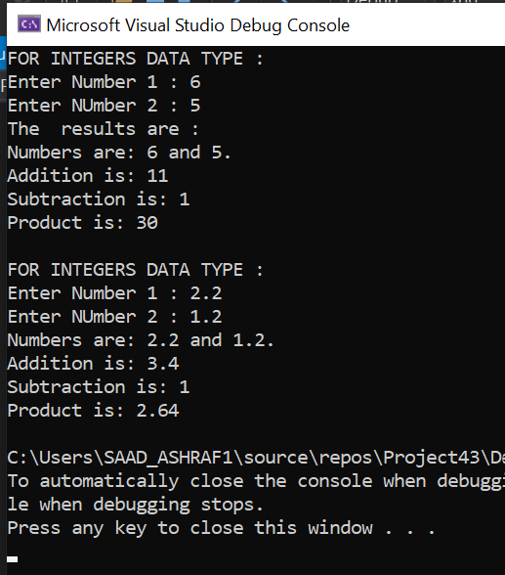

TASK 2 :

#include<iostream>

using namespace std;

template<typename t1>

bool isPrime(t1 num)

{

if (num < 2)

{

return false;

}

for (int i = 2; i < num; i++)

{

if (num % i == 0)

return false;

}

return true;

}

int main()

{

int a, b;

int i = 0;

cout << "enter the number till which you wanna calculate :" << endl;

cin >> b;

while (i <= b)

{

if (isPrime(i) == 1)

{

cout << i << " ";

}

i++;

}

system("pause");

return 0;

}

